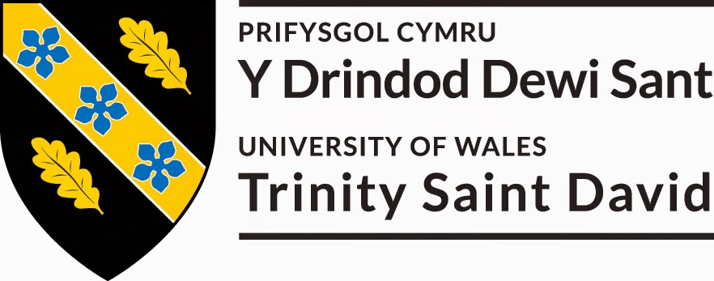

Module: Effective Team Working and Communication

Module code : BMSW4002

Assignment Title: A report on effective team-working

Submission Date : 12TH June 2020

Lecturer: Melanie Squire

Submitted by: Ruji Begum

Student number: 1915094

TABLE OF CONTENTS

INTRODUCTION…………………………………………………………………………………………….1

UNDERSTANDING THE DIFFERENCE BETWEEN TEAMS AND GROUPS………….....2-3

EFFECTIVE TEAMS IN ORGANIZATION……………………………………………………………. 4-5

EFFECTIVE TEAMS & GROUPS DYNAMICS………………………………………………………….6

DELEGATION & CONFLICT................................................................................... 7

REFERRENCES..................................................................................................... 8

INTRODUCTION
My aim of writing this report is about how important teamwork is and how this can improve the performance in an organization. In this report I will be discussing about difference between groups and teams and why is it important to have effective teams working in organizations to achieve goals. I will be also covering about characteristics of group dynamics, handling confliction, and delegating. For my research I have use the theories of Bruce Tuckman (1965) and Meredith Belbin (1981) to define the roles of effective teamwork.

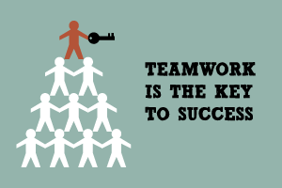

PAGE 1
THE DIFFERENCE BETWEEN GROUPS AND TEAMS
Groups are formed with two or more individuals are put together. Groups made of set individuals who bring in their own individual efforts. Groups have a strong leader who is very clear and focused with a goal. Most business work is performed in groups . Every individual personality is important in this part of the role. Team is when a collection of individuals who are linked together to achieve the same objective. There are also two types of groups. One is formal Groups and Informal Groups.
Formal Groups A formal group is the type of work groups formed by the organization and have been given assignments and tasks to work with. The behaviour of the formal group is directed towards achieving organizational goals. The formal group can be classified into two sub-groups.
- Command Group- this consisting of individuals report directly to the manager.
- Interest Group-this group is formed by individuals, they work tighter to achieve a specific objective.
Informal Groups A informal group is formed with common interest and friendship. The informal can be classified into two sub-groups.
- Task group- These groups work together to finish a task that was given.
- Friendship group- this group is bought together because they share same interest.

Basis to comparison | Groups | Team
Meaning | Collection of individual working together to complete a task | A group of people joined together to accomplish a goal
Leadership | Only one leader | More than one
Members | Independent | Interdependent
Process | Discuss, Decide and Delegate | Discuss, Decide and Do
Work products | individual | Collective
Focus on | Accomplish individual goals | Accomplish team goals
Accountability | Individually | Individually or mutually
page 2
Meredith Belbin 1981 identified nine roles and he categorized those roles into three groups: Action oriented, People oriented and Thought oriented. These roles are linked with a typical behavioral and interpersonal strengths. Belbin (1981) also defined weaknesses that came with each role. Such as characteristic weakness “allowable weakness” are areas to be aware of potentially improve
It has been suggested that by understanding your role within the particular team, there is more chances for you to develop your strengths and improve your weaknesses to contribute to the team.
A successful team is made up of diverse mix of behaviors. Belbin (1981) came up with nine team role models. Each team role has its own strengths and weaknesses.( see description below)
Action Oriented Roles
Role | Strengths | Allowable weaknesses
shaper | Challenging and works on under pressure. Has the ability to drive and overcome obstacles. | Easily provoked and may provoke others.
Completer- finisher | looks out for errors. polishes and perfects. | Reluctant to delegate
implementer | Practical, reliable, efficient. Brings new ideas, organizes work that needs to be done. | Sometimes inflexible and slow to respond to new ideas.

Thought Oriented Roles
Role | Strengths | Allowable weaknesses
plant | Imaginative, thinks freely, creative and brings ideas to solve problems. | might be too preoccupied to communicate effectively
Monitor-evaluator | Strategic, focused and discerning. judges accurately. | Might lack in drive and ability to inspire others
specialist | provide specialist knowledge and skills . They dedicated. | Contribution on a narrow front and lack on technicalities.

page 3

People Oriented Roles
Role | Strengths | Allowable weaknesses
Teamworker | Co-operative, perceptive and diplomatic. | Indecisive in difficult situations and avoids Confrontation
Coordinator | Confident, mature and identifies talent and goals. | Manipulative and might offload own share of the work
Resource investigator | Outgoing, explores and develops contact. | over-optimistic, loses interest once initial enthusiasm passed
Effective teams in working in Organization
Effective teams are very important in organization. They are the key foundation of every successful organization. Effective teams work well together they improve quality, complete a project or a task given with increase productivity and efficiency. And for organization without teams that do not often work well together struggle and will have difficulties in achieving their goals and finish the project given.
Everyone has a different perspective of an effective team it is important to promote interdependence, trust and shared goals. For every organization to succeed, they will need effective individual who can bring in his or her own talents and skills to the team that will give overall success of the group.
Open communication- It is very important in team-building strategies. This allows open and honest communication between members of your team. It is important to seek your teams opinion , thoughts and suggestions as often. This will make them feel like a valued part of the organization and being able for them to take ownership of the work towards your success.
Understanding company goal- Without clearly understanding your company’s goals, your team will not head in the same direction. This is why it is important to interact to your team monthly, quarterly, and yearly to reach your goal and also build action plans to meet each of these targets. The key to build a team strategies is by allowing your team member to have an important input in how they will achieve company objectives.
Also using a SMART analysis to ensure your goals are clear and realistic.
S-Specific M-measurable A-Attainable R-Relevant T-Time-bound
page 4

Diversity- Over the past few years the definition of an effective team has developed. Diversity is one of the hallmarks for these changes. A Powerful team includes members that have a variety of skills, talents, backgrounds, and ethnicities. This will able you to take advantages of different strengths each team member brings to the organization.

Safe Environment- In this context the word “safe” does not refer to physical safety but instead, the emotional safety. It is important that a team member feels confident around their team and not fearing to express their opinion, thoughts and ideas but most importantly, not being judged or belittled.

Solving Problems Together- A strong team is made when they solve problems together. As a team leader, you must encourage your team with order to resolve issues without having to involve management at every problem-solving stage. Giving employees the right to come up with creative solutions is one of the most effective team-building strategies.

Consistently Evaluating Performance- One of the key elements of a team definition is to consistently evaluate the performance to make work more effectively. It is highly effective when team members are able to reflect on themselves, this will also able them to correct any mistakes.

page 5


Effective Teams and Group Dynamics-
I hear, I forgot, I see, I remember, I do, I understand. The best way to learn… is by doing. (as Confucius says)
In order to understand the competencies that are essential develop and lead high performance efficient team, it is ideal to firstly define a team. Here are the following ten characteristics:
Clear direction- Sometimes organization can rush to move their projects and put groups together without discussing the goals and desired outcomes. In the book (Old Man River Publishing, 2013), Richard Spoon Explains that without a clear sense of what the team needs to accomplish and how a successful outcome will be defined, it is impossible to assemble the right group of people to get there.
It is important to decide team goals and what is that you desire as outcome from this. Using this as a direction for the team, will help them the best way to get there.
Open and Honest Communication- Communication is a vital part of a team. In all team communication is very important to build a sense of trust and friendship between the members of the team. Communicating freely and often determines the success of the team. In this vital part of teamwork, the main part of the communication is listening. Listening to another team member is not just a way to find out things but it is a sign of respect for your team member. Show that you are listening. Paraphrase, re-state, and react to what you hear. Get involved.
Defined Roles- Sometimes roles might change within the team but knowing the skills and thinking technique styles are needed on the team. For example, a team needs to develop a new product for the market, the team will need a detail-oriented person(the task master), who will keep the team on track.
Having a clear view of those basics, you will find easy to choose effective and strong team members to work on the project.
page 6
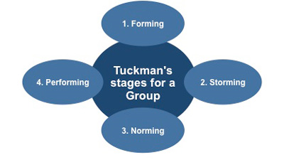

Bruce Tuckman (1965) created a team development model. All these phases are important and inevitable in order for the team to develop, face challenges, solve problems, find solutions, plan and deliver results. Here is a brief Description of each stages of B.Tuckman(1965) model.
Forming- form bond and learn to work effectively, Positive, and polite. Making effort to know each other. Storming -Push against boundaries, conflict around personality and different working style. Norming -Resolve differences, build one another strengths and trust. Performing- You will reach this stage once you have achieved the team goal without a friction. As a leader in this stage you can delegate more work and spend time developing each team member to be the best they can.
Delegation
Delegation is as important as any other roles in any organization. For a manager or a team leader to achieve goals in an effective manner, some of the managers work may be allocated to others ( team members). When delegating the group should be in terms of good expected results. The more concrete or clear the goal, it is easier to understand how much authority someone needs. Sharing a power and authority will be the one with the greatest to influence or lead others to work towards organizational goals.
Conflict
Although Conflict can be normal and a normal part of any workplace, this can lead to staying away from workplace and lost productivity but at the same time conflict can motivate, bring new ideas and innovation. This can also make a better understanding of working relationships. But conflict also needs to be managed properly in order to achieve the organizational goals.

page 7
References
- Annual Return Cardiff: Companies House. 25 March 2004.p.3.Archived from the original (pdf) on 7 June 2019. Retrieved June 2019.
- Timeline www.belbin.com. Comberton : BELBIN Associates. 2018. Archived from the original on 7 June 2019 Retrieved 7 June 2019.
- Profile of Dr Meredith Belbin: The father of team roles Archived 12 October 2008 at the Wayback machine
- jay, Anthony (13 July 2004) (Originally published in observer magazine in 1980). “Nobodys perfect-but a team can be “henry Thornton. Melbourne, Australia: henrythornton.com. Archived from the original on 4 March 2016. retrieved 7 June 2019
- Tuckman, Bruce W (1965) “Developmental sequence in small groups” Psychological Bulletin. 63 (6): 384-399 doi:10.1037/h0022100PMID 14314073

PAGE 8

