'How can we improve pupils’ oracy/writing skills through the use of the “Talk for Writing” strategy?

Aim, Focus and purpose of the assignment
The purpose of this assignment developed from the importance placed within Successful Futured by Professor Donaldson (2015) for the newly formed curriculum for Wales, in addition to pedagogies outlining the need to improve the quality of conversation within the classroom in order to raise standards of oracy and writing significantly (Donaldson, 2015). Therefore, the area that interested me for the purpose of this assignment was an opportunity to research how the strategy of ‘Talk for Writing’ is used within the classroom to improve oracy and writing for pupils. Following on, this assignment intends to explore and discuss ‘Talk for Writing’ strategy and look in depth at surrounding research in order to evaluate the impact this strategy has on oracy and writing skills for pupils. I will also explore lesson study as a method of undertaking classroom-based research. Furthermore, I will discuss the practical implications of planning a lesson study in the classroom in relation to the research question. Discussion of relevant literature surrounding the research question and discussion of suitable methodology will be also explored. I will finally discuss a suitable reflection model and conclude in order to outline recommendations to enhance future teaching and learning steps. I will consider relevant ethical considerations and use an extensive range of literature sources.

Literature review
In order to gain further knowledge of the relevant topic ‘Talk for Writing’ discussed throughout this assignment a comprehensive review of the literature was undertaken. I was able to gain a deeper knowledge and understanding of the importance of developing oracy within the classroom through the strategy ‘Talk for Writing’ as well as reflect and evaluate if the strategy was seen to support improvements in oracy and writing for pupils. This could then go on to result in higher literacy learning outcomes for pupils.
Quigley (2018) outlines that pupils need a broad range of vocabulary and opportunities to develop speech at an early age and without this exposure to regular communicative opportunities, pupils will be at a disadvantage to communicate both verbally and in writing. Quigley (2018) also discusses how schools are faced with the issue ‘word gap’ in classrooms, and how pupils lack the ability to engage in meaningful communication leading to a downward spiral of poor literacy skills that effects all aspects of life. Department of Education (DOE) defines ‘Word gap’ as children who have a lack of vocabulary and its understanding that leads to an impact on their learning experiences (DOE 2018). Alexander (2017) refers ‘talk’ as a fundamental stage of development that supports pupils’ thinking, learning and understanding. During a trial carried out by Alexander (2017) that focused on developing and monitoring the quality of classroom talk in order to improve literacy test scores, it was highlighted that pupils test scores were seen to improve over time after a talk-intensive intervention was put in place.
A recent report carried out by Harley (2018) supports both Quigley (2018) and Alexander (2017) as the report aimed to investigate the issues teachers are faced with in schools, as pupils were lacking the vocabulary needed to access any learning. The report outlines how some pupils’ behaviour and self-esteem are affected by the lack of ability to talk, placing many limitation issues on the pupil’s future and success beyond school. The report defines pupils who lack sufficient vocabulary to maintain classroom talk as demonstrating signs of ‘word gap’. Finally, the report concluded that pupils who fall into the ‘word gap’ bracket are likely to struggle to work independently, pay less attention to the learning environment, display slower than expected levels in other subjects including a higher decrease in pupils expected literacy outcomes (Harley 2018). In order to overcome the barrier teachers are facing in schools today and prevent pupils falling into the ‘word gap’ bracket, the education minister for Wales, Kirsty Williams outlines that language needs to be the heart of our education. Williams (2014) states that more needs to be done in schools to develop children’s vocabulary that will lead to confidence building and higher attainment levels particularly in writing, reading and social skills.
Through research conducted by Cremin et al (2018) it is evident that a rich vocabulary bank and an ever-widening ability to communicate verbally is a central role in developing pupil’s holistic development. Reedy et al (2013) also supports this by stating that pupils who have limited vocabulary are at a disadvantage of those who have experienced enriched communication activities and are highly likely to achieve lower outcomes in areas of the curriculum such as reading and writing skills. Similarly, Johnston et al (2011) suggests that children’s vocabulary bank and ability to communicate can have substantial effects on learning and development, including their outlook on literacy in later life. He emphasises that the role of parents and teachers is to encourage a wide range of talk and provide environments that will influence children’s vocabulary and help support and develop confidence, building relationships, developing morals and the ability to achieve educational outcomes (Johnston 2011). Likewise, Burnnet (2018) outlines how children need an oracy role model, engaging environments and supporting routines in order to develop positive literacy experiences that will support reading, writing and oracy in later life.
An article carried out by Kellet (2009) focuses on the limitations of children achieving literacy standards at early stages of their lives. The article compares two groups of children from different backgrounds including a group of children from a socio‐economic advantage and one in an area of socio‐economic disadvantage. The findings highlighted that children from affluent backgrounds developed literacy confidence. It was observed to be developed from routine support for homework, parental role models, opportunities to develop reading and writing and opportunities to talk about literacy. In contrast, children from a more disadvantage background, who struggled to have a secure role model if any, lacked in confidence and were not given the same literacy opportunities. To conclude the article highlighted that poverty placed a huge impact on literacy standards within schools in the UK (Kellet 2009).
However, research by Waters (2019) disagrees that the poverty background of children develops their ability to strive at literacy skills and emphasis that children develop language at their own pace, through their own exploration of life. The research conducted by Waters (2019) discusses the 5 stages of literacy development which starts with exploration and awareness stage and ends with competent reading and writing stage. Waters (2019) agrees with Burnnet (2018) and Johnston (2011) and encourages parents and teachers to encourage literacy opportunities. However, it is highlighted that children from disadvantaged backgrounds are not necessarily at a disadvantage of achieving higher literacy outcomes in education if they are experiencing a rich stimulating literacy environment including being guided by a role model or a knowledgeable peer.
Through reviewing much literature, it is evident that lower oracy abilities can directly impact children’s life skills, particularly in reading and writing (The Communication Trust 2017). The CT (2017) discusses how by the age of five, children who are at a vocabulary disadvantage are more likely to not meet their expected targets in literacy, as well as other areas within the curriculum at the end of Key Stage 2. As well as this, according to the CT (2017), these pupils are also thought to be twice as likely to suffer with mental health issues relating to lack of confidence and self-esteem. Professor Nation (2003) discusses how a range of language variations are a complex issue within education and it is impossible to highlight a particular cause of the lack of literacy skills in pupils. Professor Nation (2003) discusses how children who have a lack of vocabulary and the ability to communicate often enter the curriculum in a ‘downward spiral’ and therefore need a curriculum that allows flexibility where staff can plan and prepare interventions in order to support and find solutions to overcome these barriers.
Professor Donaldson (2015) states that the newly formed Curriculum for Wales must be manageable and flexible in order to meet the needs of all learners. He places literacy, numeracy and digital competence at the foundations and heart of the newly formed curriculum and schools are encouraged to deliver these through a cross-curricular approach as these are essential to the majority of all learning. The newly formed curriculum, which will be implemented from Donaldson’s Successful Futures report summaries the importance of literacy being a drive throughout the welsh curriculum and highlights the emphasis on the role of parents/teachers in providing enriched literacy opportunities for children to experience and develop the ability in becoming healthy, confident learners (Donaldson 2015). A report carried out by OECD report (2014) became a driver in supporting the development of newly formed curriculum and identified that there was a need for change in the curriculum in Wales, particularly emphasising the need for schools to have a more flexible approach in subjects such as literacy, being able to meet more individual needs through well planned programmes and initiatives.
In the same way, Voice21 (2015) developed the ‘Oracy Framework’ to support schools in overcoming the ‘word gap’ concerns. The framework aims to develop and strengthen pupil’s ability to learn through talk and highlights the importance of talk within the classroom. The framework discusses how lessons need to be well prepared, planned, modelled and designed in order to support and provide scaffolding, encouraging children to use talk to develop further literacy skills such as writing and reading and additional skills across other subjects within the curriculum (Voice 21 2015).
It may be important to recognise that the development of Wales education as highlighted the need for such literacy strategies (WG 2019). As such, the need for the ‘Talk for Writing’ strategy is paramount within todays schools (EEF 2015). ‘Talk for Writing’ was developed by Pie Corbett and supported by Julia Strong as a framework to encourage pupils to replicate language of a particular topic, gaining a deeper oral understanding and insight of a topic in order to support their verbal, reading, writing and listening skills. (Corbett et al 2011). An evaluation report carried out by EEF (2015) discusses how the approach focusses on using a topic or story to develop oracy skills in order to support writing. The report outlines that the approach uses three methods; imitate (learn the topic by repeating), innovation (edit the story and begin to add and create individual parts) and finally invention (children to create independent stories or topic-based texts). The report’s findings highlighted that pupils oracy and writing ability improved significantly in a short space of time (EFF 2015).
Beared (2014) supports the view of the EEF (2015) and summaries in a writing project report how ‘Talk for Writing’ encourages extensive use of classroom talk to support children in becoming familiar with a range of Topic-based vocabulary and a wide range of text genres, that encourages and supports independent writing. The report reflects on research and discusses how the strategy builds confidence and self-esteem within the classroom. The findings discuss although the ‘Talk for Writing’ strategy supports improvements in children’s oracy and writing outcomes the national priorities still remain to improve oracy and literacy standards (Beared 2014). This is an issue the Foundation Phase Profile (2017) has highlighted an ongoing development trend of lower oracy levels during baseline assessments for 4-5 year olds. Similarly, Welsh Government (2018) highlights that education in Wales will need to remain the focus on improving literacy standards both within and out of schools; with many children not achieving end of key stage outcomes and a higher increase in literacy concerns within baselines at nursery the need for further support for parents and teachers will continue.
It is evident through much research that there is a need for strategies such as ‘Talk for writing’ within our education system, in order to support and develop literacy standards. However as highlighted by Johnston et al (2011) and Burnnet (2018) in order for children to develop the ability to use oracy to support other areas of learning children need a role model and enriched literacy environments from birth. With this in mind, it could be argued the need for earlier literacy strategies are needed within pre-school years.
Furthermore, it is evident that the need for literacy strategies and scaffolding from experienced role models; such as the delivery of ‘Talk for Writing’ in classrooms, mirrors the belief of Vygotsky’s (1978) zone of proximal Development (ZPD). Vygotsky focuses on how children learn through exploration and first-hand experiences and he strongly believes that with the correct support children can achieve the best outcomes (Pritchard 2015). Vygotsky highlights how children are the centre of their own learning, however with support and a guide from a peer or experienced role model children can work through the ZPD stage in order to boost confidence and achieve their full potential (Pritchard 2015).
Similarly, B.F Skinners (1957) Imitation Theory highlights that children learn language through imitation of others. Skinner (1985) places strong belief on children mastering language from the experiences they have. However, this theory is arguably different to that of Noam Chomsky (2006), who’s theory suggests that the ability to learn language is built within children. He argues that children do not imitate language and have a built in Language Acquisition Device (LAD) that is confined within children’s brains and it simply allows children to learn language regardless of any factors (Chomsky 2006). Nevertheless, it could be argued that children imitate some language around them as countries and regions adapt to different languages and accents. This linking closely to Skinners (1957) imitation theory that outlines when children’s mouth and jaw muscles have been mastered, they begin copying language they hear from primary role models (Skinner 2015).
In the same way as Skinner, Vygtosky and Chomsky, Bruner (1976) proposed the Language Acquisition Support System (LASS) that supported Chomsky’s LAD theory but also favoured both Skinners and Vygotsky’s theory of the more ‘knowledgeable other’ and scaffolding approach as he highlighted that children have the ability to learn and acquire language naturally, however they need stimulating interaction and enriched environments to excel and support learning further (Bruner 1976).
In the Australian curriculum (QCCA 2018), similarly to that of the UK literacy is seen as an indicator that supports and drives all other subject areas. The Australian Curriculum advocates literacy progression and prioritises listening, speaking and writing modes of communication and plans and prepares measures in order for teachers to target and develop learning programmes to support literacy throughout the curriculum (QCCA 2018).
From all research gathered and discussed it may be considered that the drive to improve literacy skills is a priority for our pupils. The use of ‘Talk for Writing’ strategy yields positive impacts on pupils oracy and writing outcomes. The gathered research has developed my understanding of not only the importance of ‘Talk for Writing’ but the need for developing early communication skills from birth, in order to overcome the ‘word gap’ issue faced in today’s schools.
Methodology
According to Kumar (2014) Researching in education is understood to provide opportunities to explore and question what is observed, in order to understand and develop future practice. Similarly, Cohen (2003) discusses in order to gather effective data to influence future learning experiences, the need for research and observations in education is essential. An article written by Reddy (2012) defines research in education as a way in which practitioners gain a deeper insight into a particular topic. The article discusses how researchers can use observations to reflect and conclude on findings in order to develop future experiences. Similarly, Kerlinger (1970) outlines research as a way in which you discover findings through a controlled systematic form of observation.

Depending on the purpose of the research, the methodology will vary in order to meet the purpose of the proposed research. In order to gather enough data, if I were to carry out this research question, I would consider using a lesson study. According to EEF (2015) a lesson study is an effective form of professional development, that is used by teachers to work in small groups in order to observe, reflect and improve practice. McKernan (2013) defines lesson studies as a form of action research carried out by teachers to solve a problem and improve future practice. Mckernan (2013) highlights that action research is an effective form of research for teachers as it allows teachers to overcome daily factors in education, solving them quickly and effectively.

Dudley (2014) was one of the first researchers to carry out a lesson study in 2001 and is an advocate of lesson studies in education. He outlines that there are many benefits in using lesson studies as a form of research in the classroom. Dudley describes a lesson study as ‘new eyes’ within the classroom that creates an influential approach in observing pupils learning alongside the development of teachers own professional practice (Dudley 214).
The Teacher Development trust (2017) discuss how lesson studies are seen to have a positive impact on progression within the classroom as it provides opportunities for teachers to create a team that work together to improve future learning through observation and reflection. Dudley (2014) discusses the advantages of how lesson studies can influence the building of a strong team as it promotes discussions, investigation and opportunities to enhance Continuous Professional Development (CPD) for teachers.

With the many benefits highlighting the success of lesson studies in the classroom, particularly the impact they have on developing both pupils and teacher development, I would consider using lesson study as a form of methodology as it would allow me to gather enriched information and date for the purpose of this research in the near future. However, I will also keep in mind the disadvantages of a lesson study as Anders (2019) highlights that often lesson studies can create a conflict in relationships if sharing ideas and concerns are not efficient during the process. With this in mind, I would ensure to maintain professional relationships and ensure to take on board all opinions from research partners.

Through researching and past observation experiences, I have decided that the most suitable form of data collection methods that could be used to support the findings of this research question if it were to be carried out in the near future would be; observation, a focus group interview and reflection. Wile (2003) discusses how observations offer the opportunity to sit back and observe the environment around you in order to gather information to make improvements. Similarly, Watson-Davies (2009) outlies how observations play a fundamental role in developing learning and teaching. The use of observation yields many benefits as both Wile (2003) and Watson-Davies (2009) discuss the advantages for learners and teachers as ‘remarkable’. Estyn (2015) highlight how through the use of observations the need for change or implementation of situations can be quickly addressed as findings are immediately gathered. In many reports by Estyn (2015) observations are seen to support faster improvement for learners, allow adjustments to teaching methods that can be easily managed and support quick effective form of data collection. Donaldson (2015) agrees and placed observations as a form of assessment within the ‘assessment guide’ that appears in the newly formed curriculum. He highlights observation as an effective form of assessment in supporting and improving children’s learning. Donaldson states, that the regular use of observation in schools will correlate with high standards of learning outcomes for all children (Donaldson 2015).

According to Kumar (2014) there are two types of observations, participant observations and non-participant observations. Tripp (2012) discusses how a participant observer takes part in the activity being observed and appear as an anonymous observer. In contrast, a non-participant observer, observes from a distance remaining as a passive observer. In future, I would consider the non-participant form of observation as this way as the observer I could gather as much detail as possible as the observation unfolds. This type of observation would yield many advantages in gathering data to answer the research question as it would provide opportunities to sit back, observe and record as the activity unfolds. However, as discussed by Tripp (2012) the non- participant observer sits back from a distance and therefore could be seen as a disadvantage as the pupils become aware of the observer. Kumar (2014) agrees and outlines that non- participant observers can have a negative effect on the impact of the observation if the observation group become aware of the observer. Kumar (2014) highlights this as being called the Hawthorne effect. I would ensure that I am aware of the impacts of these negative effects suggested by Kumar (2014) and be mindful when observing.
In order to gather information on the effects of the strategy ‘Talk for Writing’ impacts on pupils oracy and writing, I feel using a focused group observation would be a more beneficial way of collecting data as there are many advantages to this method. Using this method will allow me to maintain a focus on a target group such as ‘Talk for Writing’ groups in order to gain as much information as possible and record immediately.

As discussed by Dudovskiy (2018) the use of focus group observation is more beneficial within research. He discusses how focus group observations can be an effective form of data collection when there is a focus research question. In this case, the need of a focus group observation would be an effective tool, as it would allow me to observe the pupil’s involvements, progression and experiences related to the research question. Similarly, Webster (2017) agrees that the use of focus group interviews support pupil voice and involves pupils in supporting teachers in leading their learning forward. Cohen (2005) highlights that researchers should focus more on open ended questions and avoid closed questions, in order to gather more detailed findings. Additionally, Dudovskiy (2018) agrees that the use of interview questions allow researchers to gather a detailed account of information from a focus group in order to support future improvements. Furthermore, Mitchell (1998) highlights that employing both interviews and focus group observations can generate a more detailed understanding of the research question and further support future developments. With this in mind and the plan to carry out this research within the future, I would consider using both focused group and interview methodology. As suggested by Mitchell (1998) the use of these methods combined allow a more detailed understanding of the research question.

Through the use of the interview method, I would plan to ask semi-structured questions that would involve the pupils using their own views and opinions on the ‘Talk for Writing’ strategy as suggested by Webster (2017) this benefits and leads the learning forward. I would ensure to avoid closed questions to avoid the lack of detail as Cohen (2005) highlights closed questions often lead to a lack of results. In order to follow BERA guidelines the focus group will be selected when they have provided consent t participate in the research study. I would randomly select a range of children with a range of abilities such as; 3 high, middle and low attainers in order to avoid any bias decisions as discussed by Dudley (2014).

Tripp (2012) suggests that researchers should have a focus before carrying out observations. I feel that the aim of this research question would provide a detailed focus and using the methodology; observation, focus group and interviews combined would yield many advantages in collecting data in order to reflect and improve future learning and teaching experiences. Throughout observations, I would plan on observing a particular focus group and measure their engagement and involvement during their ‘Talk for writing’ lesson. I would consider following and observing the same focussed group in additional lessons in order to compare the difference and improvement (if any) of the ‘Talk for writing’ strategy and the effects it impacts on their oracy and writing. I would observe and compare their writing and oracy skills at the start of the term and the end of term where ‘Talk for Writing’ has been implemented.

An effective way of measuring pupil’s involvement is through the use of Leuven Scale of involvement developed by Dr Ferre Leavers (Blackstone 2014). This scale involves using a 5-point measuring tool to measure the pupil’s involvements, 1 being extremely low and 5 being extremely high. If I were to use this scale of involvement in the future, it would support measuring the pupil’s involvement during their ‘Talk for Writing’ lessons including being able to identify and record any stages of distraction or lack of engagement. This could be used to suggest if the pupils are more engaged using both oracy and writing skills during ‘Talk for Writing’ lessons compared to other literacy lessons. Furthermore, I could measure peer engagement using the Leavers scale during the ‘Talk for writing lesson’ and again compare to other literacy lessons. As suggested by Leavers (2003) observing pupil’s involvement is vital in order to make improvements in learning experiences. Whilst carrying out the interview methodology I would consider using open ended questions as Cohen (2005) suggested in order to gain more detailed data. I would consider carrying out the interviews immediately after the ‘Talk for writing’ lessons in order to gain an immediate response from learners.

In order to improve future practice, Mailick (1994) emphasises that reflection before, during, and after observations is key for teachers and their pupils. Likewise, Hattie (2002) highlights that teachers who learn from their own teaching are seen to create the biggest impacts on their pupils learning. Palaiologou (2008) discusses how reflection is essential within the classroom and highlights how teachers should reflect regularly in order to improve future learning and teaching experiences. As suggested by Mailick (1994), Hattie (2002) and Palaiologou (2008) reflection is essential in improving learning experiences, therefore in the future I would consider using the Brookfield’s reflection model (1998) identified as the four lenses. Brookfield (1998) identifies the four lenses as the autobiographical lens, the colleagues view lens, the pupil lens and the theoretical lens. I would consider using the pupil lens and colleagues view lens in the future. As I mentioned above pupils would firstly be observed and then interviewed allowing the pupils to give their opinion and views on the research topic. The use of the ‘colleagues view lens’ could also be used for the purpose of this research as discussing findings with research partners would help support and improve both the learners and my future teaching experiences.
Furthermore, another reflection model that could be used to support this research could be that of Gibbs (1988). Gibbs reflection focusses on a six-stage model that allows researchers to reflect on previous experiences in order to gain a deeper understanding. He outlines that learning is gained from reflective experiences. Gibbs reflective model is particularly useful for repeated experiences (Gibbs 1988). This could be an effective reflective model to use as it would provide opportunities to change and implement any issues that could arise from observations before repeating the observation in other lessons in order to compare the impact of the ‘Talk for Writing’ lessons.
Before research can take place, ethical considerations must be taken into account. Therefore, in the future I would consider completing an ethics form to minimise the risk of ethical considerations before carrying out any research. I would take into consideration the BERA Ethical Guidelines for Educational Research before conducting any research (BERA 2018). To ensure that these guidelines are adhered to, I would ensure to provide the research information to all involved prior to the research taking place and highlight that they have the right anonymity and confidentiality. I would continue to keep the pupils and staff up to date with any information as the research was carried out ensuring they understood the purpose of the research and the impact it would create from conducting the research. With BERA (2018) highlighting the importance of participants understanding all steps of the research in which they are involved in, I would ensure to make clear steps to ensure that the focus pupils understood that they were going to be involved in method data collection such as observations and interviews. In order to carry out any research consent needs to be requested prior to research and all involved must be assured, they have the right to withdraw at any point.
Recommendation’s
From the literature gathered, it appears that research is an effective tool that influences future practice. As Dudley (2014) suggests research involves observations that will highlight areas that are working effectively or in need of improvement. Similarly, Donaldson (2015) highlights that practitioners need to observe, reflect and carry out research in order to improve teaching and learning standards. As a result of this, I will plan to carry out the proposed research question in order to gather enough data to evaluate and conclude on the impact ‘Talk for Writing’ places on oracy and writing in the classroom. This will not only be beneficial for the children but for my personal professional development. Carrying out this research, would develop a deeper understanding of the ‘Talk for Writing’ strategy and through researching, observation and reflection I could incorporate the strategy into my future teaching experiences.
Furthermore, the literature highlighted the importance of developing pupils’ broad range of vocabulary at an early age in order to see higher outcomes in oracy and writing. As discussed by Quigley (2018) schools are faced with the issue ‘word gap’ in classrooms, and pupils lack the ability to engage in meaningful communication leading to a downward spiral of poor literacy skills that effects all aspects of life. In the future, I would look at strategies and programmes that aim to impact oracy skills within the early years, such as speech links. Speech links is a programme that was developed in 2004 and aims to target improving speech and language within children under the age of five. Like ‘Talk for Writing’, speech links focuses on developing oracy in order to build confidence and self-esteem that will impact on future literacy skills. With the use of programmes like speech links in the early years it could be seen as an effective tool in improving oracy standards leading to higher literacy outcomes. According to a report carried out by 4000 schools using speech links, the benefits of the implementation of the programmes both in school and home were seen to improve literacy outcomes by an average of 36% (speech link 2004).
Finally, throughout the literature it is evident that pupils who experience regular literacy opportunities and have are influenced by a role model that encourages a stimulating literacy environment are highlighted as achieving higher literacy outcomes. As a result of this, a recommendation would be to encourage parents to support literacy at home in order to support the learning they will achieve within the classroom, this could be developed through the use of home school learning programmes such as seesaw or google classrooms. Furthermore, I would ensure to provide a cross curricular approach when delivering literacy skills as suggested by Donaldson (2015) this is an effective way of filtering literacy throughout the day and not just for a selected lesson, leading to a more fulfilled literacy experience.
Conclusion
In light of the detailed literature review it is evident that the proposed research question would be a worthy topic to research and gain a deeper understanding in order to improve future learning and teaching experiences. The literature review highlighted the issues teachers are faced with in schools today with many pupils lacking the vocabulary needed to access any learning. Additionally, the education minster placing literacy at the heart of curriculum outlines the importance of achieving successful literacy standards in Wales as paramount (WG 2014). Furthermore, the newly formed curriculum discusses the need for an enriched literacy focus to help support and achieve healthy confident learners. The curriculum additionally outlines how schools have the role of ensuring literacy is delivered as a cross curricular approach in order to embed literacy into our pupils throughout all subjects (Donaldson 2015).
Moreover, much literature discusses how lower oracy abilities directly impact children’s life skills, particularly reading and writing (CT 2017). As suggested by both Voice 21 (2015) and Beared (2014) ‘Talk for Writing’ supports schools in overcoming the ‘word gap’ concerns and should be used as a literacy strategy to overcome these issues within all schools. With many report findings highlighting how ‘Talk for Writing’ improves oracy by encouraging children to talk about a detailed topic, gaining a deeper understanding. Additionally, the strategy was seen to improve writing standards, as it supports and develops children’s confidence and self-esteem. It is evident that ‘Talk for Writing’ is a successful strategy that I would use in future practice in order strengthen pupil’s ability to learn through talk and help support the importance of oracy and writing skills within the classroom. As discussed by voice 21 (2015) children need to receive enriched literacy lessons that need to be well planned, prepared and modelled. I will ensure to prepare a classroom that includes enriched areas that will deliver high standards of literacy experiences that will support and develop a wide range of vocabulary. I will set clear learning objectives, prepare and plan well organised resources through a cross curricular approach.
Through research it was evident that the use of a lesson study was an effective tool in order to gather data from research (Dudley 2014). Additionally, the use of observation, focus group, interviews and reflection were a successful way of gathering data. As discussed in the methodology section I would consider the use of these methods to collect data in order to carry out this research in the near future. As highlighted by Mitchell (1998) the combination of using these methods yields many benefits. The importance of reflection in improving future practice was highlighted throughout this assignment. I will continue to include reflection models such as Brookfield’s reflective model (1998) and Gibbs (1988) in any future research I carry out in order to support research questions and set aims for future professional developments. I will ensure to adhere to all BERA guidelines when carrying out any future research.

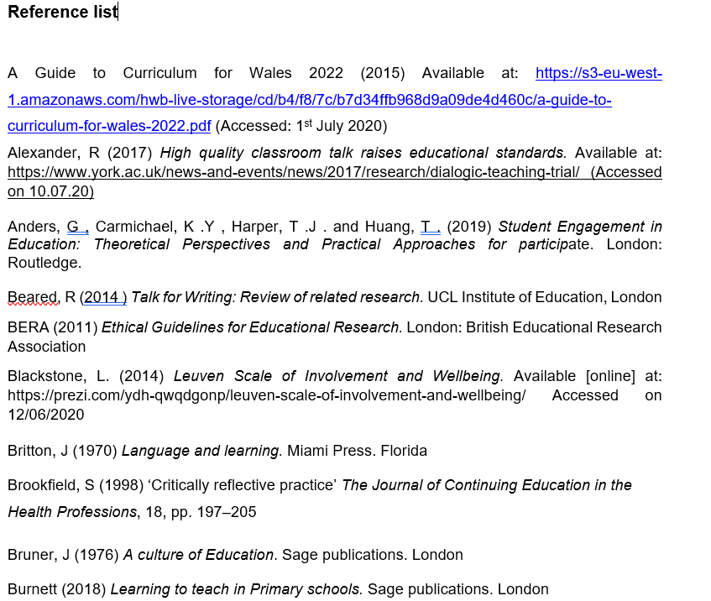
. 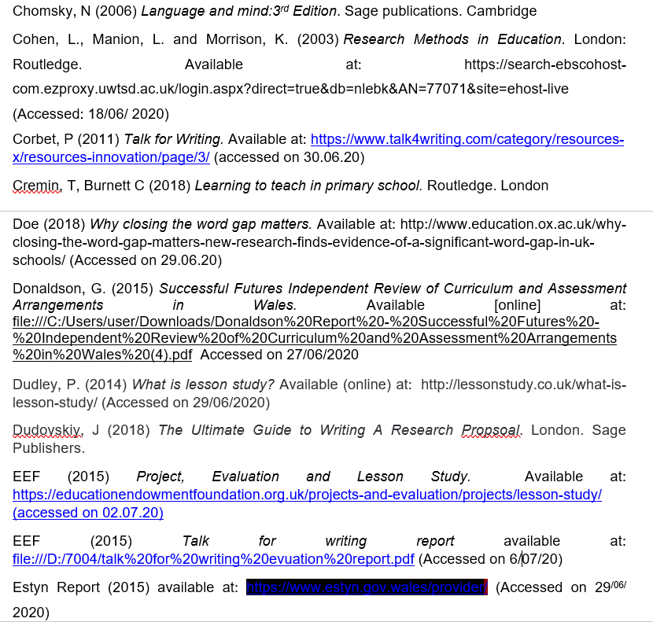
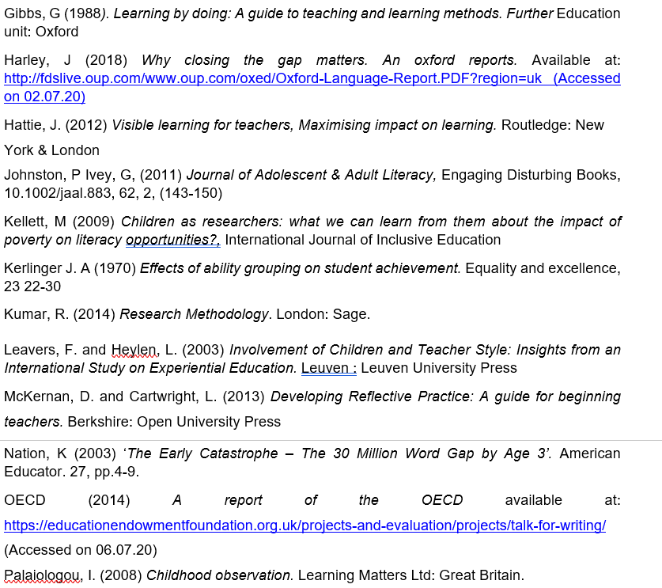
Mitchell, L (1998) Research design explained. Available at : https://books.google.co.uk/books?id=--3rmWYKtloC&printsec=frontcover&dq=mitchell+1998+research+methods&hl=en&sa=X&ved=2ahUKEwiV2PWQ7tzqAhVCrHEKHWu6Bg8Q6AEwAHoECAEQAg#v=onepage&q=mitchell%201998%20research%20methods&f=false (Accessed on 16/07/20)



