Module name: LCBB5000 – Data Handling and business intelligence
Assignment title: Component 2 – Written report

Module tutor: Zahra Mohammadnazzari
Student: Danut Purcarea
Student ID: 2130914
Word count Part: 1993

Table of Contents
Part 1 3
Introduction 3
Dataset explaining 4
Microsoft Excel use 13
SPSS use 14
Conclusion 16
References 17

Part 1

Introduction

This report aims to examine how Microsoft Excel and SPSS software can improve a company's ability to analyze data. The report will present evidence to support the hypothesis that the utilization of these software programs is beneficial for companies, as they enhance operational efficiency (Wolberg, 1997).
The abbreviation SPSS stands for "Statistical Package for the Social Sciences." It is a tool developed by IBM and was initially released in 1968. This software package serves the primary purpose of statistical analysis of data. SPSS is widely utilized in various fields, including but not limited to healthcare, marketing, and educational research. It is frequently used by market researchers, health researchers, survey companies, educational researchers, government organizations, marketing firms, data miners, and other related industries (Jasrai, 2020).
This particular software is designed to offer a comprehensive range of data analysis services, including descriptive statistics, the prediction of numerical outcomes, and the identification of groups. Additionally, it offers useful tools such as data transformation, graphing, and direct marketing features, which streamline the data management process (William, 2003).
One of the software programs included in Microsoft's 365 suite is Excel, along with other programs such as Word, PowerPoint, Teams, and Outlook. Excel is a spreadsheet program that enables users to sort, format, and evaluate data within a spreadsheet. In addition, users can create pivot tables and graphs to assist with the analysis and visualization of intricate data sets.
The spreadsheet software, Microsoft Excel, is composed of cells organized in rows with numerical identifiers and columns labeled with letters. This configuration of a grid facilitates the effortless management and conversion of data into mathematical equations. Microsoft Excel is usually bundled with the Microsoft Office 365 suite of software (Suman, 2023).
Excel is a versatile tool that extends beyond fundamental computations. It also provides the capability of visually representing data with an array of charts, such as bar charts, scatter plots, graphs, and histograms, derived from data sets. Furthermore, Excel enables you to perform data analysis with the help of pivot tables. Additionally, it offers macro programming using Visual Basic for Application (VBA), a programming language that automates tasks across Microsoft Office applications.

Dataset explaining

GreenMed Healthcare's dataset offers a comprehensive breakdown of processing times for every tool utilized (Seale, 2004). The data for data analytics processing from January 1st to February 19th is meticulously recorded in Microsoft Excel and transposed into SPSS. While Microsoft Excel documents the exact processing time for each period, SPSS employs a value system that rates the data analytics processing, assigning a value of 0 for under 1, 1 for over 1, 2 for over 2, 3 for over 3, and 4 for over 4 (Curwin and Slater, 2007). Furthermore, to track dates, January and February are allocated values of 1 and 2, respectively.
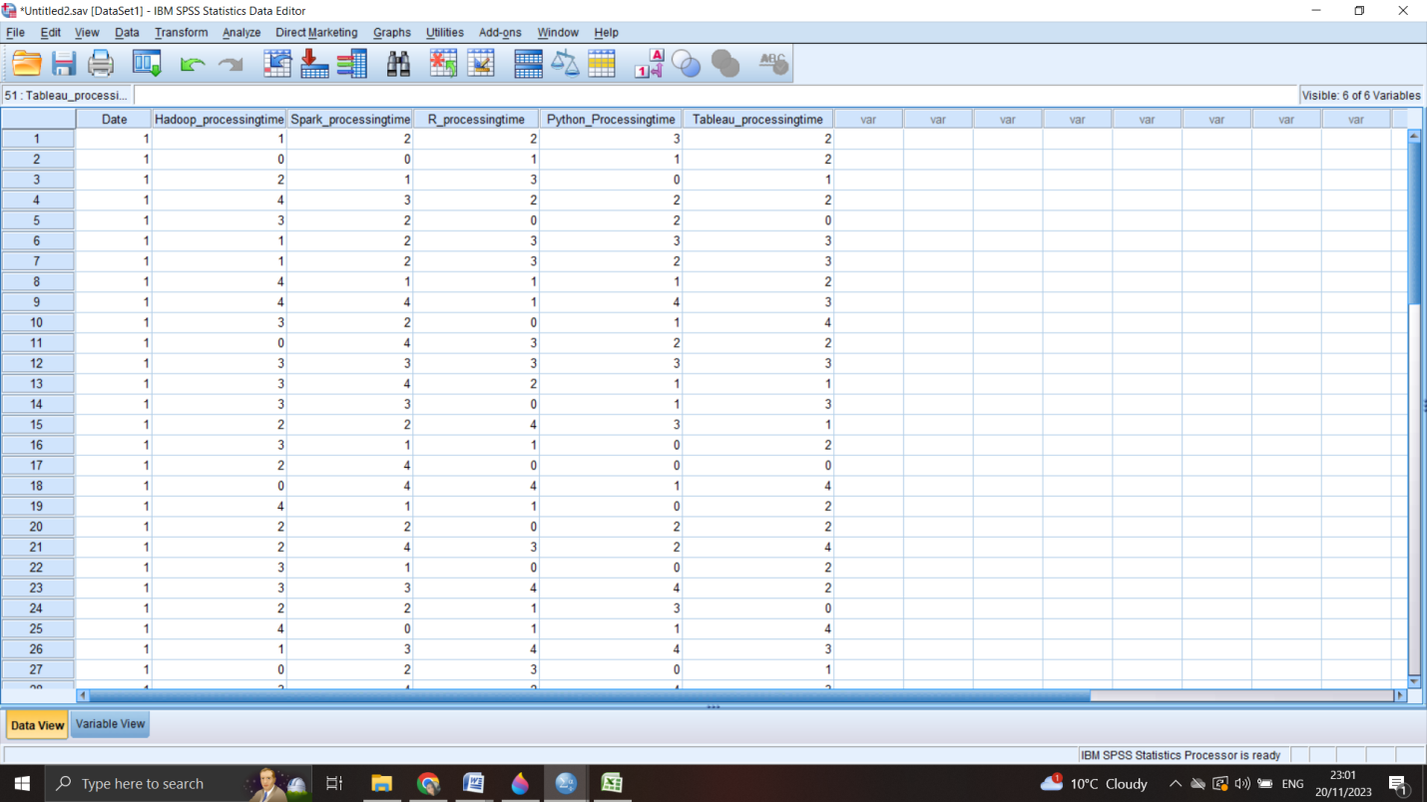
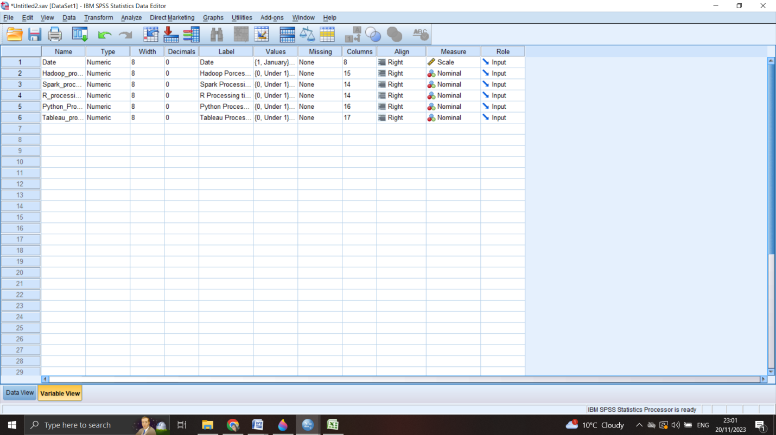

The SPSS application provides a comprehensive view of the 6 unique platforms and tools utilized by the company, including the specific dates on which they were utilized. Each of these 6 tools is assigned 5 corresponding values, whereby a value of 0 is assigned for processing times under 1, a value of 1 is assigned for processing times exceeding 1, a value of 2 for processing times exceeding 2, a value of 3 for processing times exceeding 3, and a value of 4 for processing times exceeding 4. To display the values assigned to each platform, the SPSS program utilizes the data view, which serves as the groundwork for the required calculations (Bradbard, Alvis and Morris, 2014). The six questions were addressed with the use of the SPSS program, and the resulting data is presented below.

Q1: What is the average duration (mean) required for processing when utilizing Hadoop?

Statistics
Hadoop Porcessing Time
N | Valid | 50
N | Missing | 2
Mean |  | 2.24
Std. Error of Mean |  | .189
Minimum |  | 0
Maximum |  | 4

Hadoop Porcessing Time
 |  | Frequency | Percent | Valid Percent | Cumulative Percent
Valid | Under 1 | 8 | 15.4 | 16.0 | 16.0
Valid | Over 1 | 5 | 9.6 | 10.0 | 26.0
Valid | Over 2 | 14 | 26.9 | 28.0 | 54.0
Valid | Over 3 | 13 | 25.0 | 26.0 | 80.0
Valid | Over 4 | 10 | 19.2 | 20.0 | 100.0
Valid | Total | 50 | 96.2 | 100.0
Missing | System | 2 | 3.8
Total |  | 52 | 100.0

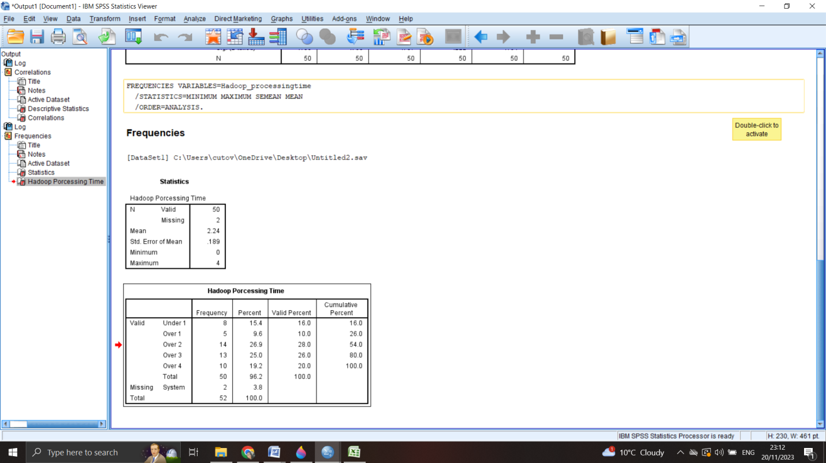

Within the given timeframe, Hadoop was observed to have an average processing duration of 2.24, with values ranging from less than 1 to over 4, indicating a moderate average. Utilizing the SPSS data analysis tool confirmed the utility of Hadoop as a resource as per Garth's research in 2008.

Q2: What is the typical amount of time it takes to process data using Spark's median processing method?

Statistics
Spark Processing Time
N | Valid | 50
N | Missing | 2
Median |  | 2.00
Minimum |  | 0
Maximum |  | 4

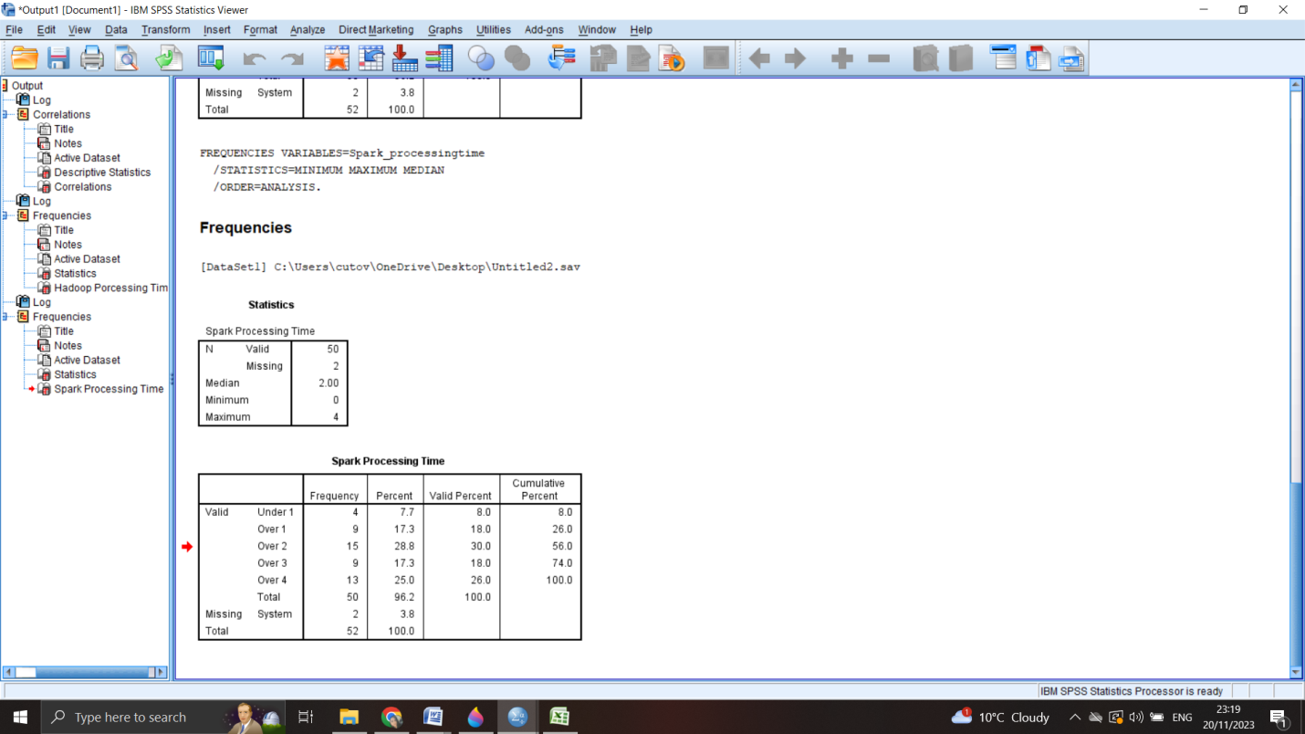

When a set of numbers has an odd quantity, the median is the value located precisely at the midpoint. However, if the set of numbers has an even quantity, the median is determined by calculating the average between the two values located at the center of the set after it has been arranged in numerical order. While means are only applicable to quantitative variables, medians can be used to evaluate ordinal variables. However, ordinal variables frequently contain ties, which are values that repeat. The Spark processing time has a median of 2, which falls within the range of 1 to 5. This suggests that GreenMed Healthcare can make use of Spark as a valuable tool for analyzing patient data analytics (Stokes, 2023).

Q3: What specific date did R experience the longest processing time?

Case Processing Summary
 | Cases
 | Valid |  | Missing |  | Total
 | N | Percent | N | Percent | N | Percent
Date * R Processing time | 50 | 96.2% | 2 | 3.8% | 52 | 100.0%

Date * R Processing time Crosstabulation
Count
 |  | R Processing time |  |  |  |  | Total
 |  | Under 1 | Over 1 | Over 2 | Over 3 | Over 4 | Total
Date | January | 6 | 8 | 4 | 8 | 5 | 31
Date | February | 2 | 2 | 8 | 3 | 4 | 19
Total |  | 8 | 10 | 12 | 11 | 9 | 50
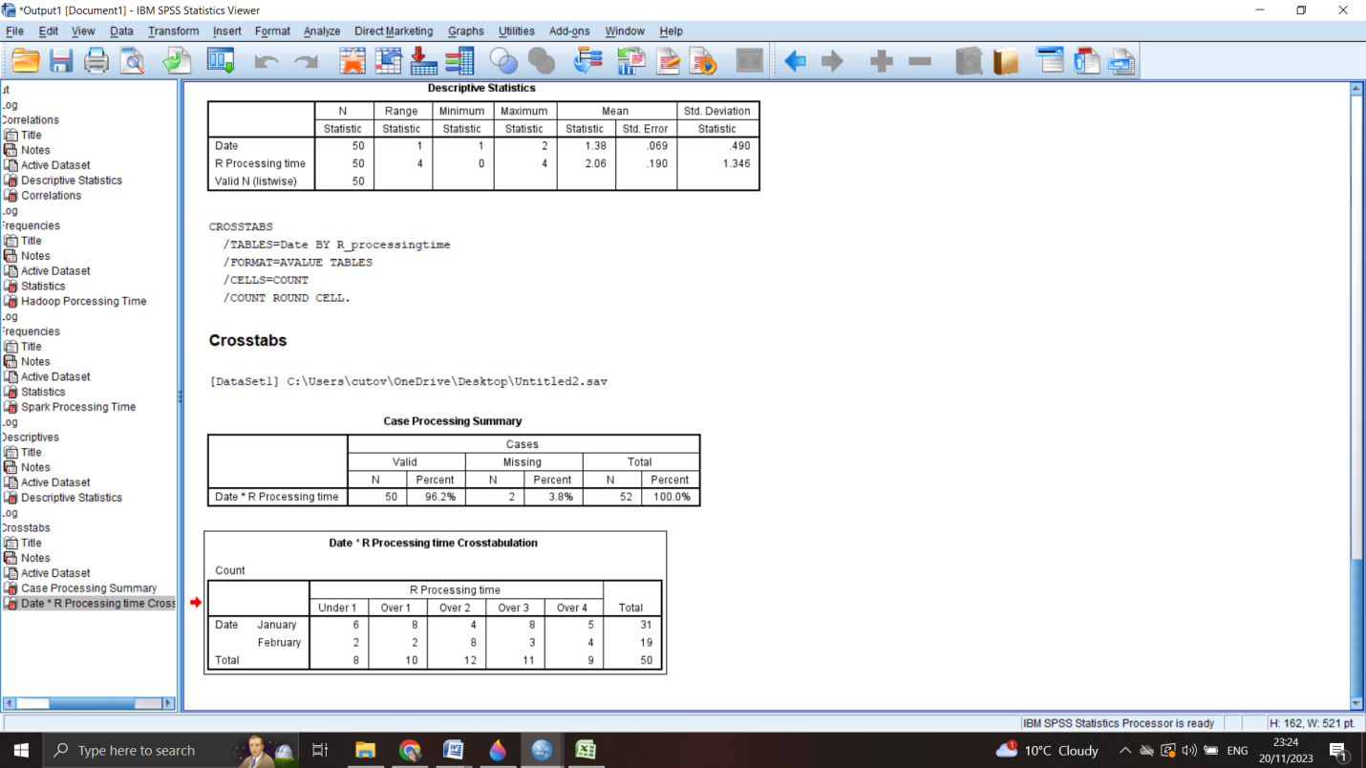

As per the data presented in the following findings, the R platform was predominantly utilized in the month of January. This is due to the fact that it demonstrated a higher level of efficiency as compared to the other five platforms that the organization employs, according to Field's report in 2013.

Q4: What is the value of the standard deviation for processing time when utilizing Python?

Descriptive Statistics
 | N | Minimum | Maximum | Std. Deviation
Date | 50 | 1 | 2 | .490
Python Processing Time | 50 | 0 | 4 | 1.317
Valid N (listwise) | 50
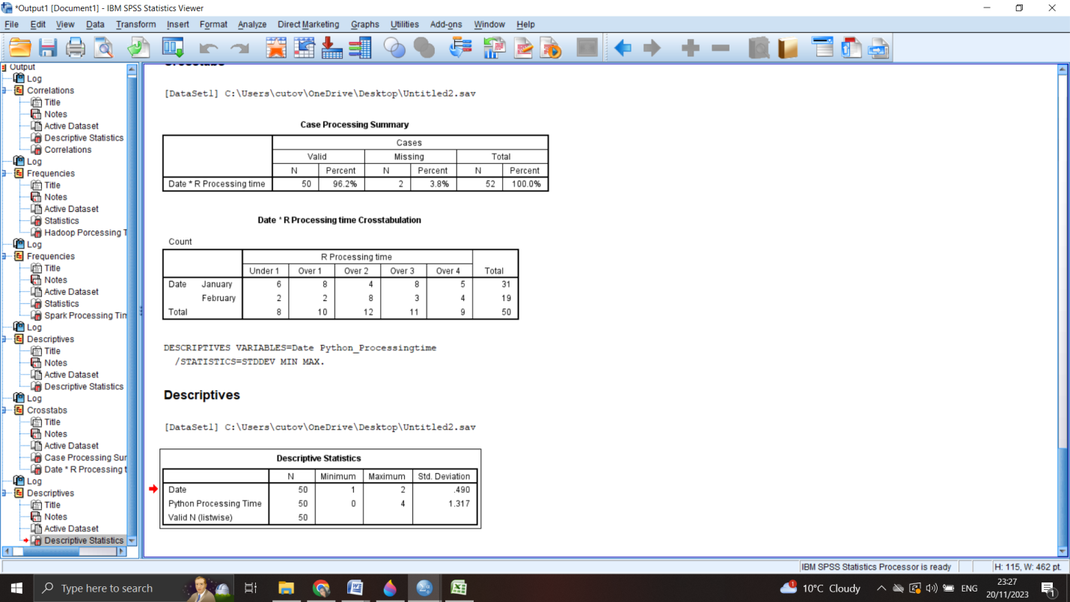

The method of measuring the distribution of a set of observations is commonly referred to as the standard deviation, which is essentially the square root of the variance. The extent of the distribution can be determined by the value of the standard deviation. Larger standard deviations indicate that the observations are more dispersed across the range. In comparison to other programs and tools used by the company, Python's processing time displays a lower standard deviation of 1.31 (Sarantakos, 2005).

Question 5: Out of all the tools and platforms present in the data set, which one had the shortest average processing time?

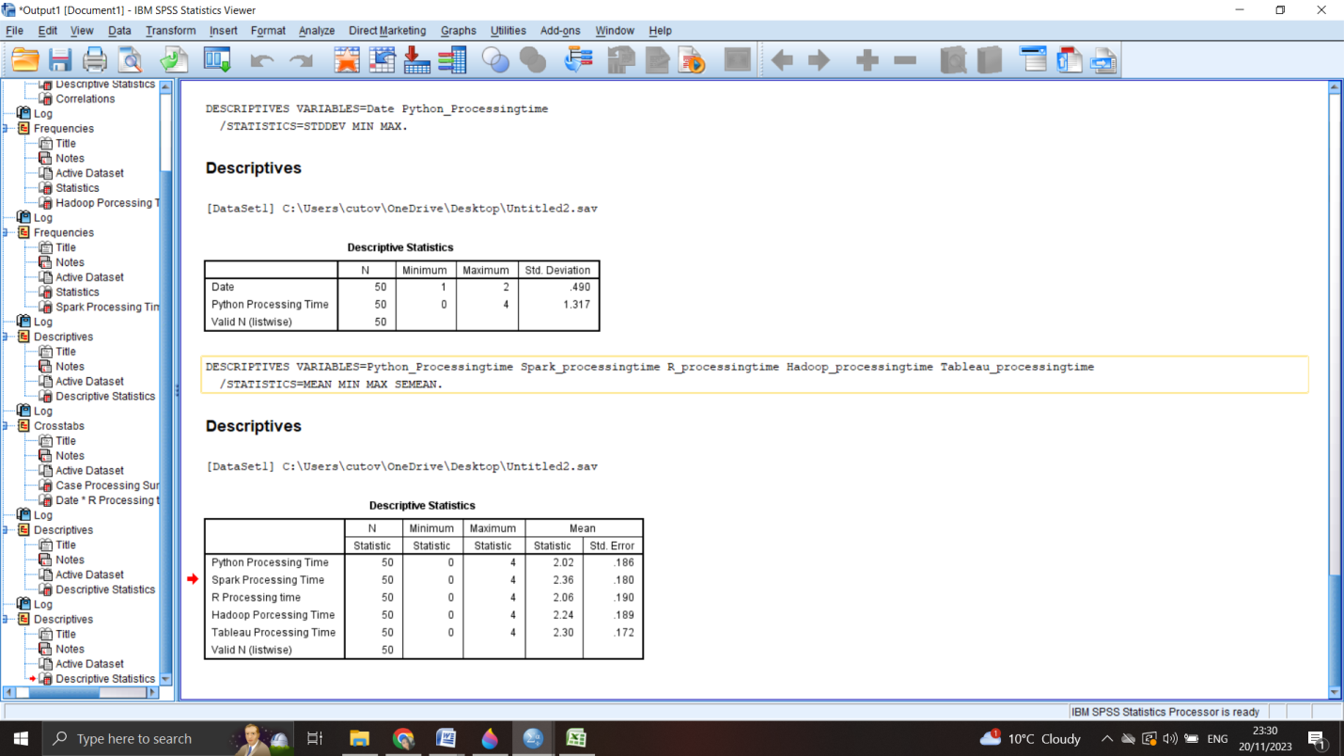

Based on the data presented in the table, it can be discerned that Python had the shortest processing time among all the platforms. The mean processing time for Python is 2.02, which is lower than the mean processing times of the other 4 platforms. Conversely, Spark and Tableau had the longest processing time with a mean of 2,36 and 2,30 respectively (Lewick and Thomas, 2008).

Question 6: Is there a discernible contrast in the duration it takes to process information between various tools or platforms?

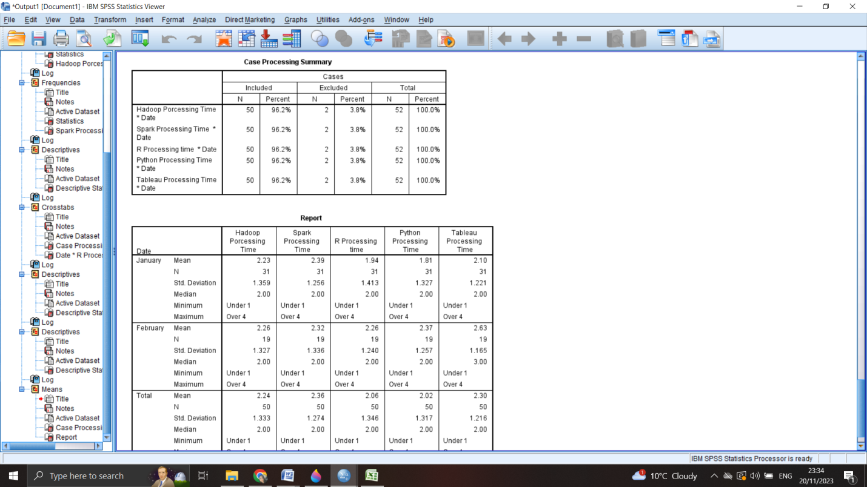
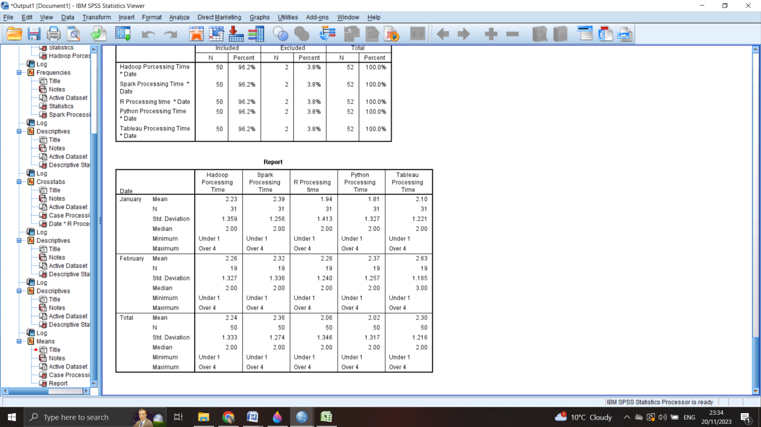

When measuring the difference between variables in SPSS, the Compare Means function is utilized. While the gap between values may appear to be similar, it is important to note that they are not identical. This suggests that each program is utilized in a unique way based on the time it takes to process data. As per the tables provided, R and Hadoop had the most favorable rates (Franfort, Nachmias and Nachmias, 1992).

Microsoft Excel use

Numerous enterprises find Microsoft Excel to be a valuable tool. The software's capabilities consist of the ability to construct spreadsheets containing essential data analytics such as tables, charts, functions, and organizational tools. GreenMed Healthcare, for instance, utilized Excel to create a pivot table for tracking the usage of all company programs (Dreher, 2023). This enabled them to evaluate the overall usage of each tool. Based on the data presented in the pivot table, it is evident that GreenMed Healthcare utilizes both Spark and Tableau as their primary tools. However, upon closer examination, it becomes clear that Spark is being utilized to a greater extent than Tableau.
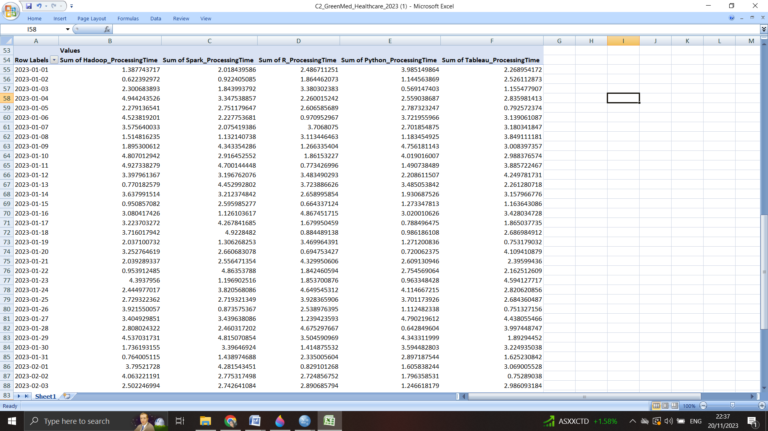
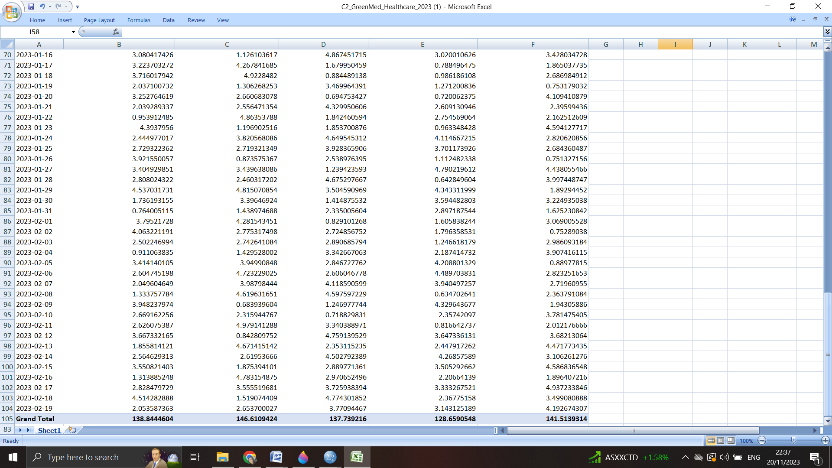

SPSS use

SPSS is an extensively utilized software in the field of social sciences, particularly as a statistical analytical tool. It is commonly employed in various industries such as competitor analysis, market research, and surveys. The software is designed to be flexible and comprehensive, with a specific focus on effective data management and statistical analysis. It is one of the most commonly used statistical packages that can manage and analyze even intricate data sets. The SPSS software caters to the needs of both interactive and non-interactive users, providing a wide range of functionalities. When measuring a linear correlation, the Pearson correlation coefficient (r) is the most commonly used method. This coefficient is a numerical value that ranges from -1 to 1, which gauges the strength and direction of the relationship between two variables (Curwin and Slater, 2007).
Descriptive statistics are used to provide a summary of the features of a dataset. One such statistic is the Pearson correlation coefficient, which specifically highlights the intensity and orientation of the linear connection between two quantitative variables (Muijs, 2010).

Descriptive Statistics
 | Mean | Std. Deviation | N
Date | 1.38 | .490 | 50
Hadoop Porcessing Time | 2.24 | 1.333 | 50
Spark Processing Time | 2.36 | 1.274 | 50
R Processing time | 2.06 | 1.346 | 50
Python Processing Time | 2.02 | 1.317 | 50
Tableau Processing Time | 2.30 | 1.216 | 50

Correlations
 |  | Date | Hadoop Porcessing Time | Spark Processing Time | R Processing time | Python Processing Time | Tableau Processing Time
Date | Pearson Correlation | 1 | .014 | -.027 | .119 | .209 | .216
Date | Sig. (2-tailed) |  | .925 | .850 | .409 | .145 | .133
Date | N | 50 | 50 | 50 | 50 | 50 | 50
Hadoop Porcessing Time | Pearson Correlation | .014 | 1 | -.076 | -.179 | .044 | .043
Hadoop Porcessing Time | Sig. (2-tailed) | .925 |  | .600 | .214 | .763 | .768
Hadoop Porcessing Time | N | 50 | 50 | 50 | 50 | 50 | 50
Spark Processing Time | Pearson Correlation | -.027 | -.076 | 1 | .189 | .105 | -.045
Spark Processing Time | Sig. (2-tailed) | .850 | .600 |  | .188 | .468 | .757
Spark Processing Time | N | 50 | 50 | 50 | 50 | 50 | 50
R Processing time | Pearson Correlation | .119 | -.179 | .189 | 1 | .264 | .176
R Processing time | Sig. (2-tailed) | .409 | .214 | .188 |  | .064 | .222
R Processing time | N | 50 | 50 | 50 | 50 | 50 | 50
Python Processing Time | Pearson Correlation | .209 | .044 | .105 | .264 | 1 | .200
Python Processing Time | Sig. (2-tailed) | .145 | .763 | .468 | .064 |  | .164
Python Processing Time | N | 50 | 50 | 50 | 50 | 50 | 50
Tableau Processing Time | Pearson Correlation | .216 | .043 | -.045 | .176 | .200 | 1
Tableau Processing Time | Sig. (2-tailed) | .133 | .768 | .757 | .222 | .164
Tableau Processing Time | N | 50 | 50 | 50 | 50 | 50 | 50

According to the tables above, the correlation has the value 1 which means it is positive for all of the platforms. All of them can be used by the company in an effective manner.

Conclusion

When it comes to SPSS and Excel, they are vastly different from each other, and it is not advisable to draw any comparisons between the two. Excel is a program primarily intended for the creation of spreadsheets, whereas SPSS is software that is specially crafted for statistical analysis. While Excel offers a range of features for statistical analysis, it falls short when compared to the powerful and comprehensive statistical analysis software provided by SPSS. SPSS is a standout option for data analysis, with its built-in data manipulation tools that enable the recording and transformation of variables. These features make it the perfect choice for any serious data analyst seeking to maximize their statistical analysis capabilities. Excel falls short in terms of built-in functions, necessitating a significant amount of time and effort to accomplish certain tasks. In contrast, SPSS treats each column as a distinct variable, whereas managing columns and rows deviates from this standard.

References



