Gwyndaf Charles Rees

HND Computing

Student P Number: P1603201

System Specification
Contents
Amendment Index 3
System Description 3
System Operation 3
Benefits and Implications 4
Hardware and Equipment 4
Costs 5
Hardware/Hosting 5
Software 5
Personnel and Training 5
Benefits 5
Output Specification 6
Home Page 6
Search Page 6
Guide Page 7
Categories Page 7
Category Page 8
Revenue Page 8
Design 9
Input Specification 10
New Guide Page 10
Guide Approval Page 10
File Specification 11
Implementation Plan 11
References 12
Appendix 13

Amendment Index
- Page 2: System Description. Embedding of videos in user uploaded guides will not be supported as this creates an additional and unnecessary layer of complication to an already complex guide creation process. (Authorisation) – 25/03/2018
- Page 2: System Description. Advertisement from external companies and the payment API for paying content creators will not be implemented despite the management sections for these being included. This is to ensure a fully functional system before handling automatic revenue and payments. Will be required in later iterations. (Authorisation) – 25/03/2018

System Description

System Operation
The system will operate under the name ‘GRate’ and will accommodate the creation, rating, editing, and viewing of guides. The primary objective will be the easy delivery of existing guides to visiting users and growing the system’s consumer base; secondarily promoting the creation or management of guides.
The home page will display featured guides and offer easy navigation through both a text search bar and links to category, sign up and guide creation pages. Links to these pages will also be available on the footer of every page. The categories page enables users to choose a category and a subsequent sub-category to find resulting guides that fit their desired niche. Guides, when viewed, will be displayed using one of a set of pre-designed layouts that is selected by the creator. The ability to embed videos into user submitted guides as suggested in the project proposal will not be included in first release. These designs will accommodate images and any number of user submitted text fields and headings.
Users who wish to upload guides will follow the link on the homepage or footer to the guide creation form which will be split into sections for ease of completion. Users will enter a title, keywords, a summary, text fields, headings, images and choose a layout. They will then be able to choose to submit for publishing or save as a draft. Permissions to upload will not be automatically granted as the user must accrue enough reputation (Rep) to publish, therefore submitting for publishing will not initially be instantly approved and will require approval from an admin or user with sufficient rep. Rep will be a user visible score that determines their responsibility and quality of writing. Rep is gained by making minor edits to guides, which also requires approval through the same process as guide creation for users with low Rep; and uploading successful guides. Every guide that is approved gains a user Rep unless removed in which case the Rep gain is reverted. A user with sufficient Rep to approve guides will choose categories and sub-categories from which the list of guides they are set to approve will be populated.
Each guide can be rated by users and approval can be revoked if significant negative rating is received and the guide is deemed inappropriate or poor quality by an admin.
The system will have an account and guide management sections. The guide management section allows guides to be edited using the same form as they created with. Users with insufficient Rep to upload guides without admin or reputable user approval will require second approval after editing. The account management section allows the user to edit basic account settings as well payment and advertisement settings: a guide creator can earn money by claiming a percentage of the revenue earned from advertisements on their guide pages and paying them a percentage of the revenue from the ads as per the Revshare (revenue sharing) model. In the guide management section users can purchase feature space on the homepage where a guide of their choice is advertised for a price dependant on the size, position and duration of the feature. Advertisements (such as from AdSense) and the chosen payment API for paying guide creators will not be implemented in the first release, however the management sections for these will be implemented with limited functionality.
A Data Flow Diagram demonstrating the basic flow of data around the system has been created (Appendix A). The first process involves the reader requesting a guide from the system, receiving, reading and rating it, and the advertisement viewing statistics for the guide being updated. The next shows an advertiser paying for the views that their advertisement has received. The following process is that of guide creation or edit processing including the reference to the user reputation system to decide whether the guide will be published immediately or will require approval, which is the next process, demonstrating a reputable user or moderator approving guides for publishing. The sixth process involves a guide creator receiving statistics on their guide and requesting payment for advertising impressions on their guide, which connects to the next process, handling this payment by using the payment API. The final process involves a guide creator paying for their guide to be featured, once again using the payment API. This procedure checks the existing featured guides and ensures that the requested tier and time frame doesn’t conflict with existing featured guides.✓ comprehensive DFD included

Benefits and Implications
The system creates a platform for users to earn money by sharing their knowledge and experience, while also building an online portfolio of written pieces. It allows guide writers to earn money providing services they otherwise may have been doing for free. The high standard required to publish guides incentivises creators to write informative and useful content, which helps to grow the systems user base; and continue creating content for the system to sustain an income from their writing. The community the system aims to create will sustain the system with minimal or no input from admins which reduces the number of employees required for content moderation, which in turn reduces the need for training.

Hardware and Equipment
The system will require web hosting on a server with .NET and Internet Information Services (IIS) installed. A dedicated server will be required to ensure the best performance from the server and to increase the time before the first server upgrade. The server will begin with a disk space of 1TB comprised of two 1.2TB SAS 10,000 RPM disks in RAID 1 for the increased read performance and fault tolerance. 1.2TB of disk space for web hosting (not including database hosting) will allow for 500,000 guides with an average of two images at 1MB each, leaving approximately 224GB for MS Server and IIS, which require a minimum of 32GB disk space; .NET and hosting the system, including a system backup. The server will start with 16GB DDR4 RAM.✓ good specs
The system will also require a dedicated SQL server for the database. The Intel Xeon E5-1620 v4 processor will be used for this with a minimum starting figure of 64GB RAM, DDR4 DIMM. DIMM memory will be used due to its high performance for its price, however this may be upgraded in the future to RDIMM or LRDIMM. Two 1.2TB SAS 10,000 RPM disks both in RAID 0, one for Backups and OS and one for the live database will be used.
Both servers will use a 750W power supply to begin with. These specifications will need upgrading with the growth of the system.
Calculating the bandwidth required for the system isn’t viable until it is live, and activity can be assessed. Once the system is established, the average page size, multiplied by the average number of visitors then multiplied by the average number of page views per visitor gives an estimate of the system’s current bandwidth use which can be used to determine whether server upgrades are required.

Costs

Hardware/Hosting
The SQL server processor will cost approximately £300 and DDR4 DIMM RAM at an average of £150 per 16GB would cost approximately £600 for the SQL server and £150 for the web server.
1.2TB SAS 10,000RPM HDDs with error recovery control (ERC) or equivalent cost approximately £250 on average which totals £1000 for all four, two in each server.
At constant max power consumption with a 750W power supply each server will consume a maximum of 6,570 kWh per year which would cost £854.10 per year at an average price of £0.13/kWh excluding VAT. This doesn’t include a standing charge and may be different for businesses.

Software
Microsoft Server 2016 costs £1216.28 for a five-client standard license.

Personnel and Training
The system will eventually require at least one content moderator to be paid an hourly rate of £9 which would rise as the site grows, as would the number of hours per week. On first release content moderation and administration will be done in-house and no staff will be hired until the size of the system warrants it. Once the system is well established, qualified system community members will handle large portions of content moderation and it may be unnecessary to employee more than one person for this.
When it becomes necessary to employ a content moderator, they will require training in the system’s function and the policy on guide quality. This will be handled in-house and will take no more than a day’s basic training, and then a three month, fully paid probationary period.

Benefits
Reasonably high specification components have been chosen for the servers as these will constantly need upgrading with the systems growth, therefore, purchasing more capable equipment from the beginning avoids having to upgrade cheap equipment quickly and spending more money overall.
An alternative cheaper option would have been to use a Virtual Private Server (VPS). However, these are generally too small for the systems requirements and even the more expensive packages would be outgrown quickly. By purchasing parts and building a server, the ability to upgrade in small steps is gained which means that, although some parts may be replaced relatively quickly, some may last for years. It also allows for complete freedom in server setup and security, and all sensitive information can be kept within the organisation.
By hiring an employee specifically for content moderation, it is cheaper than using developer hours to perform this necessary action and a dedicated employee will have more time and perform better at the task.

Output Specification
The following section contains wireframes made in lucidchart, which was used because of the many wireframe elements it offers. A design mockup made in photoshop is also included.

Home Page
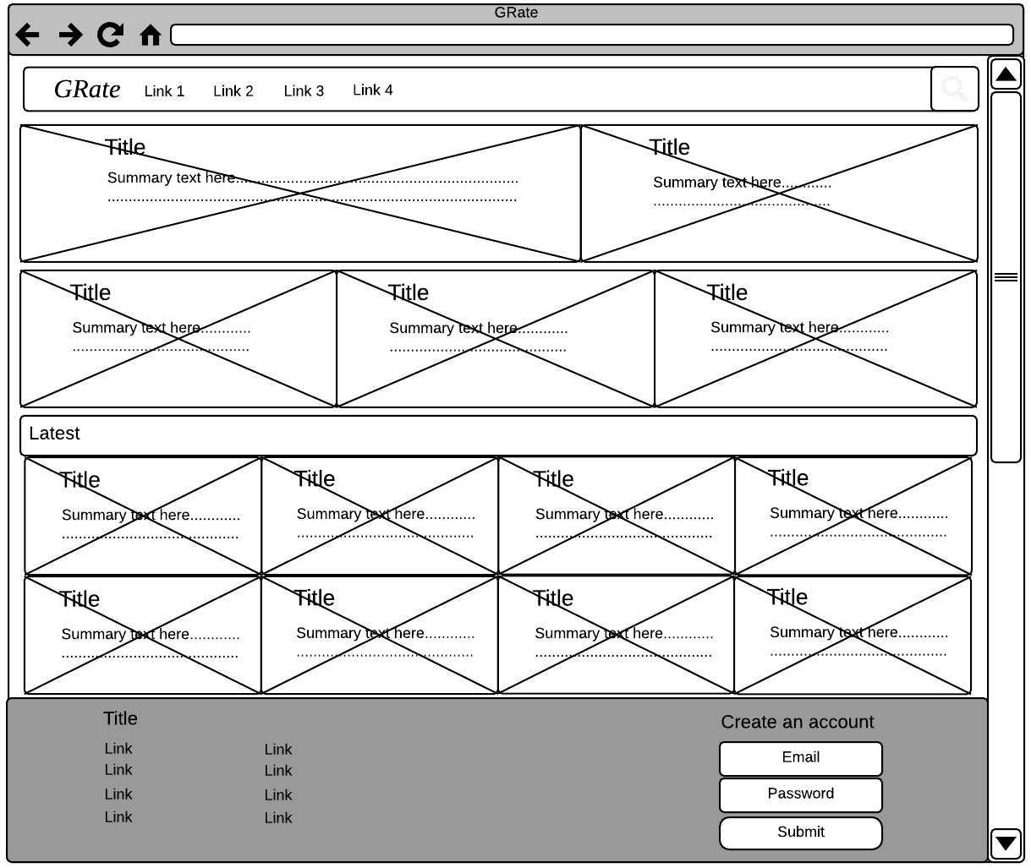
The home page will output information about featured guides and the latest published guides, including an image, title and summary text for each. Featured guides receive different space depending on the tier paid for.

Search Page
The search page outputs a list of guides including an image, title, and summary text. The page will be paginated and solely based on text criteria on first release.
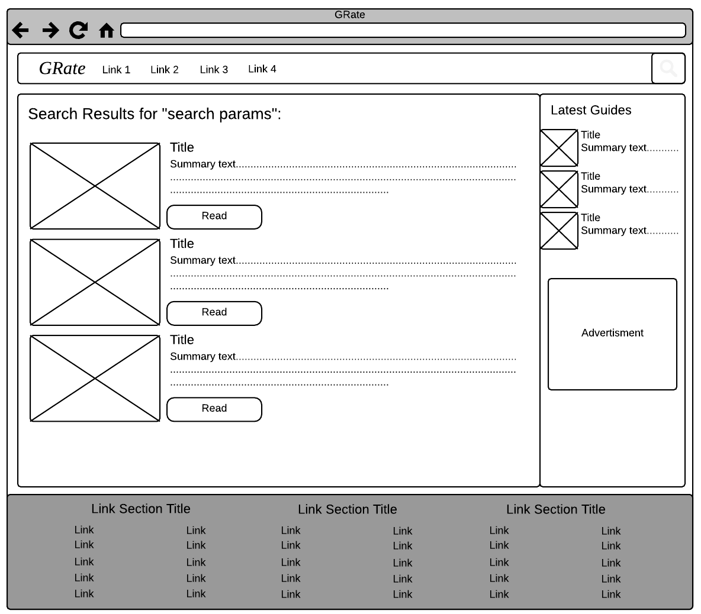

Guide Page
The guide view page simply outputs the content of each guide. The sidebar has space for advertisement that the site’s, and therefore guide creator’s, revenue comes from.
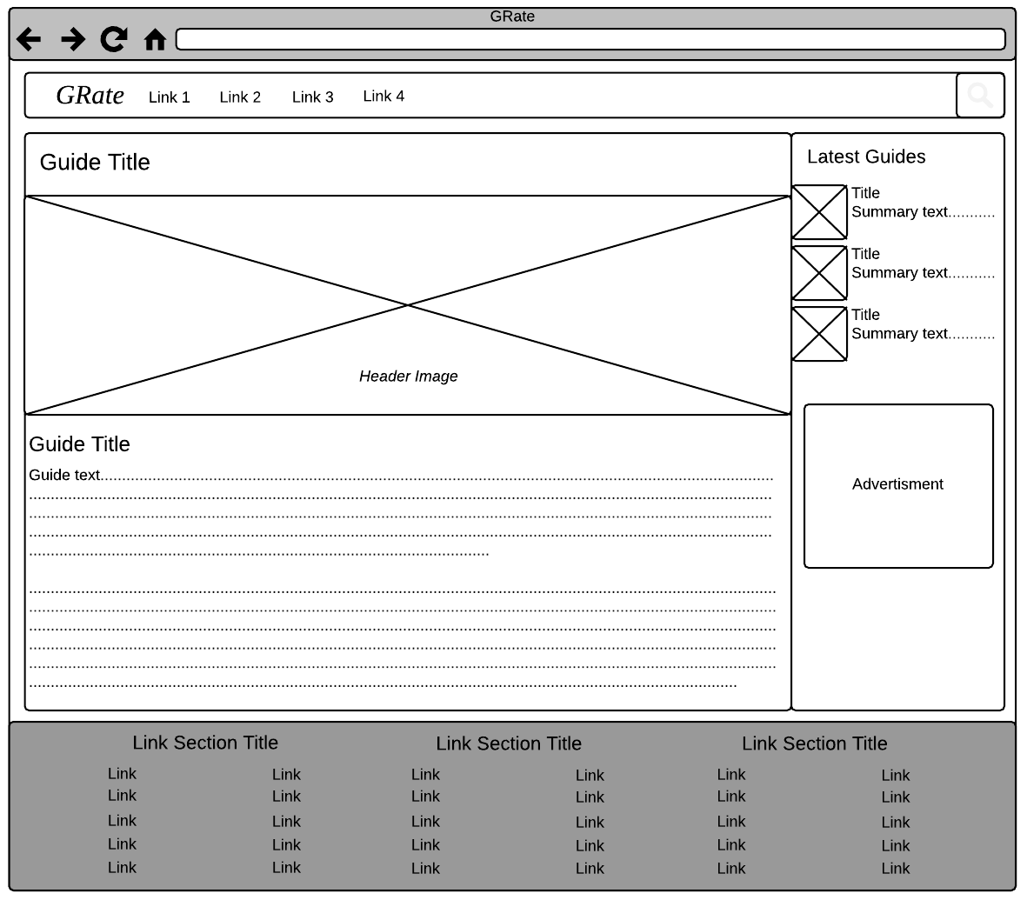

Categories Page
The categories page is a simple list of all the categories with links to view guides in the category and the sub-categories, the page for which will be layed out the same way. Each category has an image from the highest rated guide in the category.

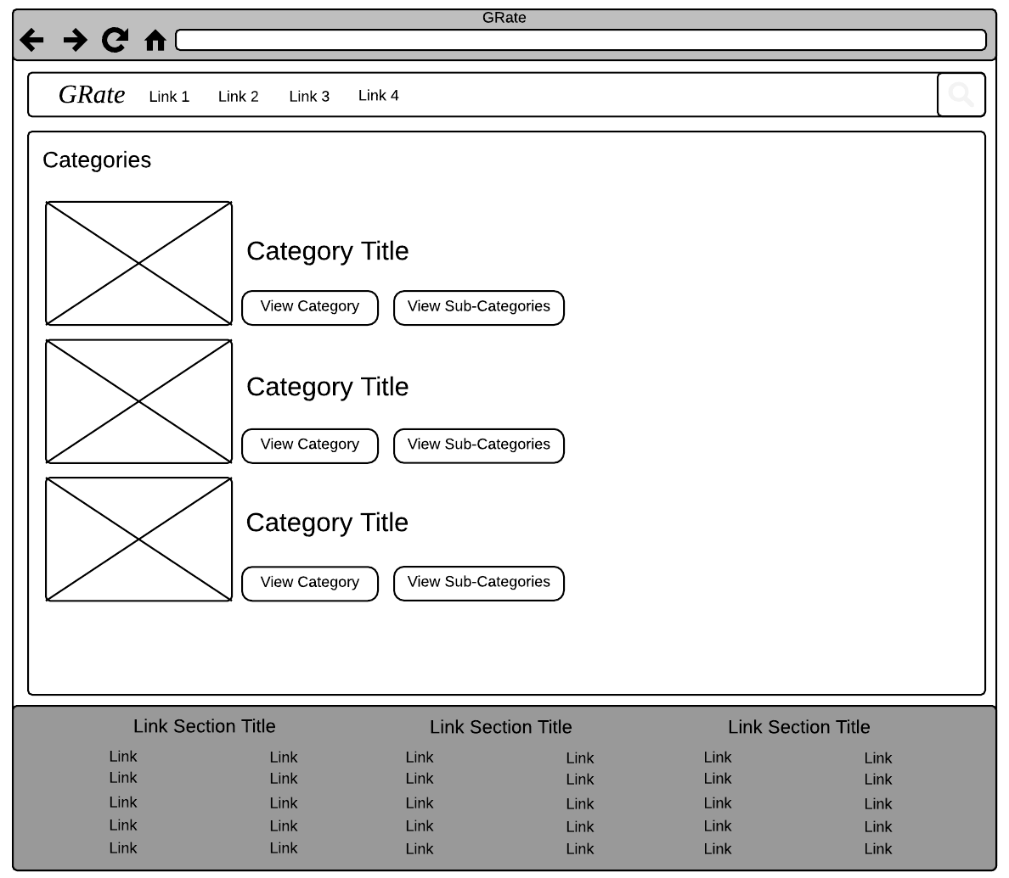

Category Page
The category page lists all guides in a category with an image, title and summary text, ordered by date.
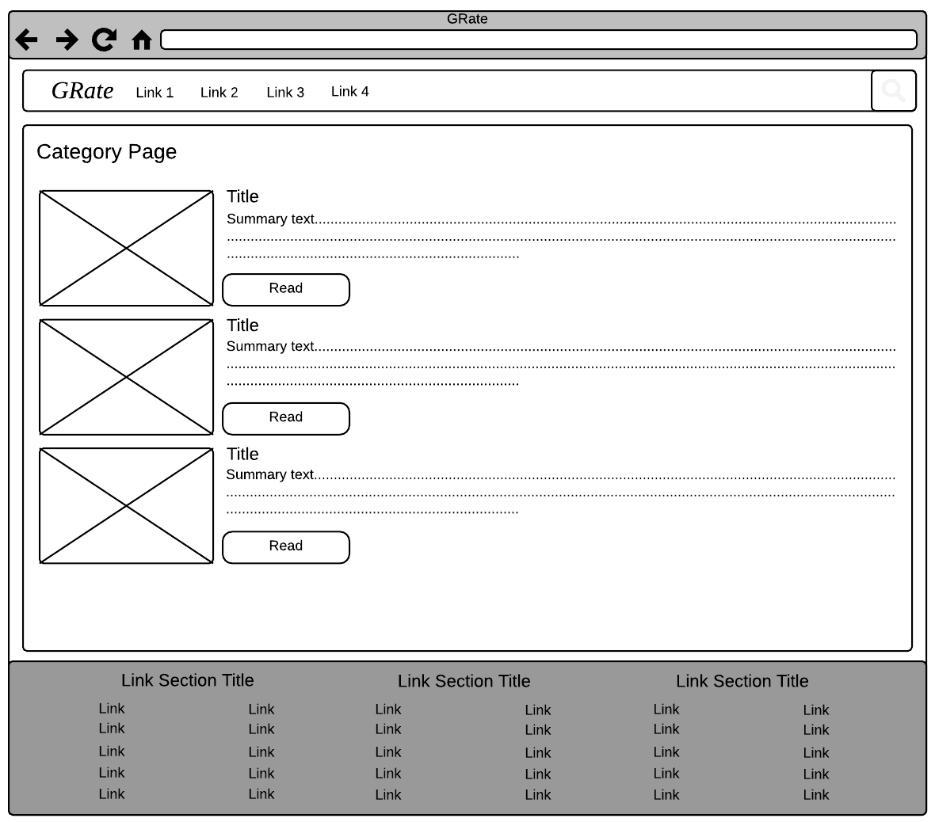

Revenue Page
The revenue page will display the amount the creator has earned, give the option to withdraw the money and also displays information and statistics about when and on what guides the money was earned, potentially in the form of graphs and raw tabular data.
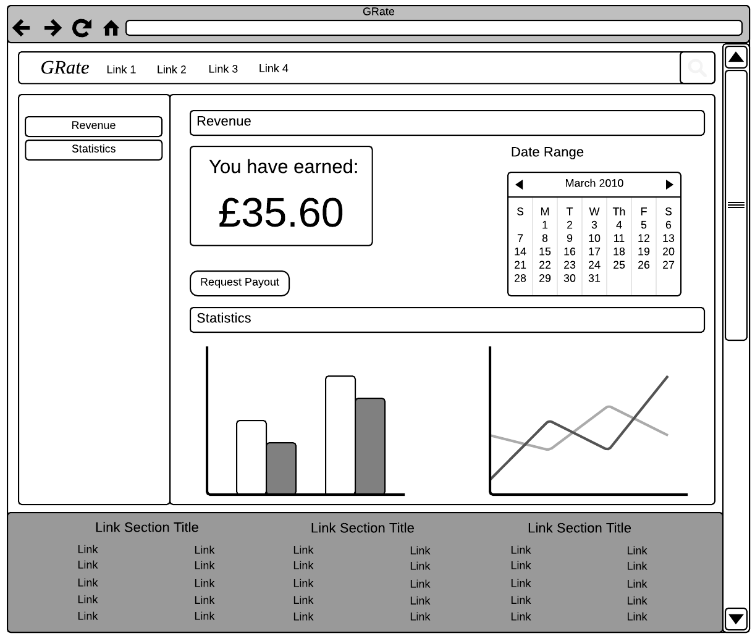

Design
The following image is a mock-up design of the system, detailing the guide viewing page.
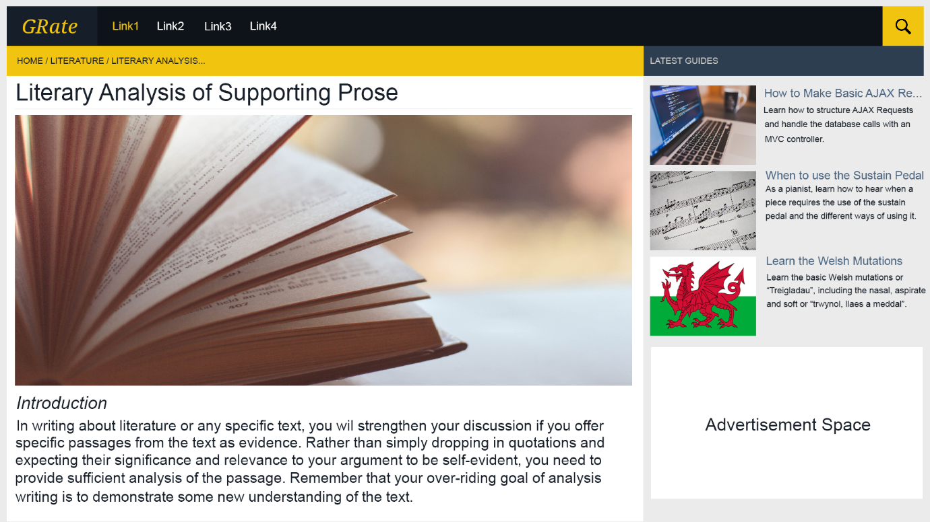
The mock-up shows the rough colour scheme that will be used, primarily revolving around yellows and dark greys. Yellow was chosen as the main colour as it helps learning and perception, the primary purpose of the site’s content.

Input Specification

New Guide Page
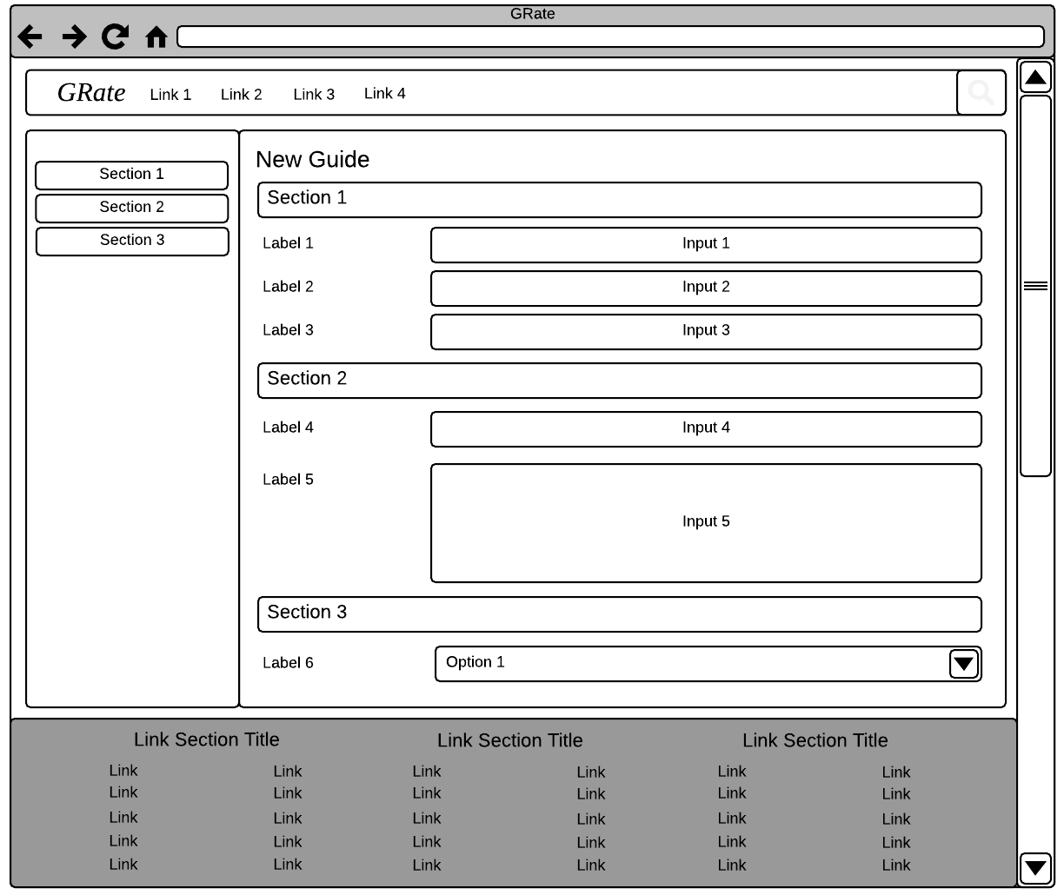
The wireframe below depicts the form for creating a new guide with navigation on the left which scrolls to the section selected. Each required input will be validated to ensure a value was entered. Dropdown lists will have a default value and will therefore not require any validation.

Guide Approval Page
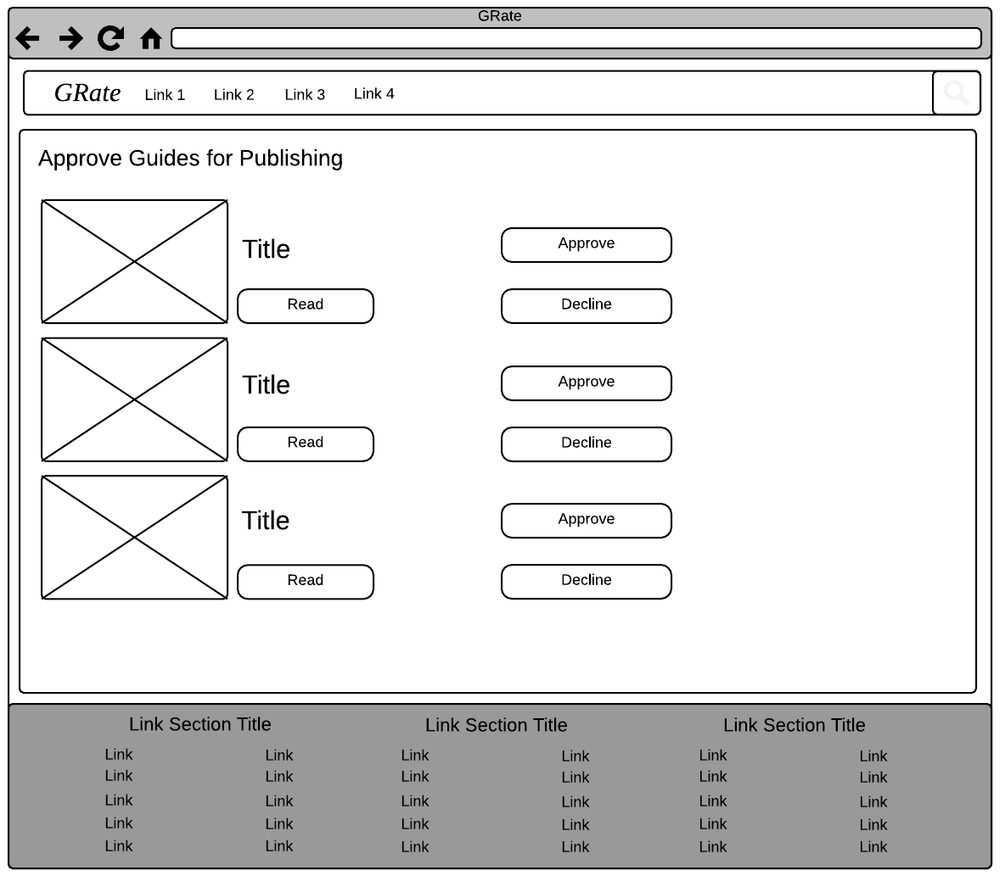
The guide approval page is used by moderators and reputable users to approve guides from users with insufficient rep for publishing. This simply involves clicking the approve or decline button for each guide after reading. No input validation is required but a feature that detects whether the user has viewed the guide before passing judgement may be implemented.

File Specification
As an MVC project alone can contain hundreds of files, this section will not address every file individually.
The entire MVC project will be backed up weekly, as well as being committed to an online git repository, git clones on multiple machines and copies on the live server. These will be updated as regularly as bugs are fixed or new features are added.
The SQL database will be backed up daily at off peak time to limit the performance impact. Backups will be retained for 7 days; however, this may be increased as the database size increases, the data becomes more valuable, and the system is more profitable, requiring greater storage volume.

Implementation Plan
A Gantt chart (Appendix 2) has been created to aid in the implementation of the system and the hardware or software required. The chart includes the setup of a Git repository for the project to track separate branches and record old versions; server building, physical server installation, server software installation and server settings configuration are also included and once these are done a backup schedule for the SQL server is implemented and the servers are then tested to ensure they are working correctly and are fully secure. Once this is done the database for the system will be added to the SQL server and the system will be developed until it is ready for demonstration. Once it’s ready it will be uploaded to the web server and demonstrated.

References

Appendix
Appendix A – GRate Data Flow Diagram:
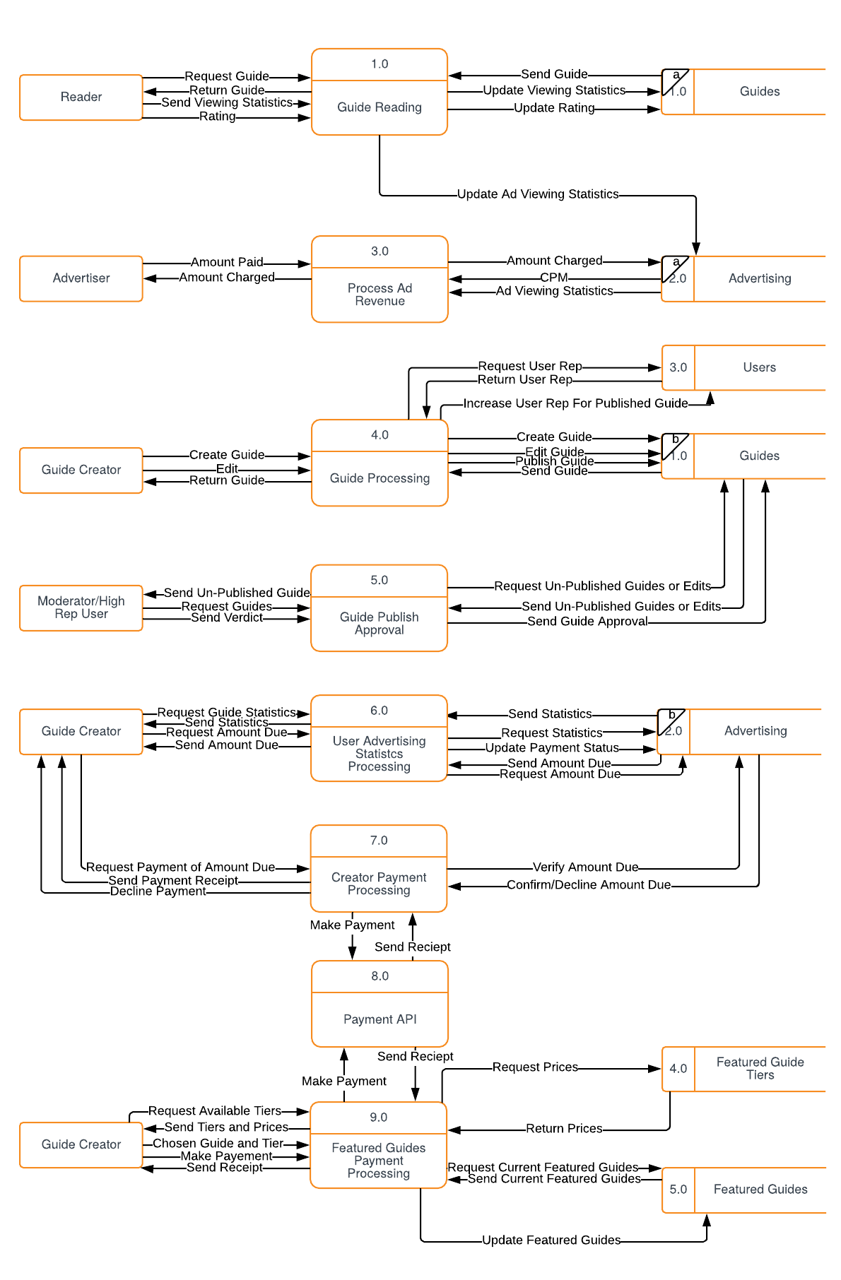

Appendix 2 – Implementation Gantt Chart:
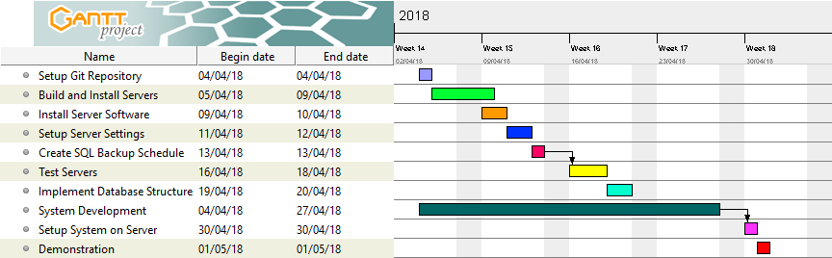

Data Packet. Advantages and Disadvantages of Various RAID Levels, Cited: 01/04/2018, https://datapacket.com/blog/advantages-disadvantages-various-raid-levels/
Microsoft. Windows Server 2016 - System Requirements, Cited: 01/04/2018, https://docs.microsoft.com/en-us/windows-server/get-started/system-requirements
Intel. Intel Xeon Processor E5-1620 v4, Cited: 01/04/2018, https://ark.intel.com/products/92991/Intel-Xeon-Processor-E5-1620-v4-10M-Cache-3_50-GHz
Who Is Hosting This. How Much Bandwidth Do You Really Need? Probably Not “Unlimited”, Cited: 01/04/2018, https://www.whoishostingthis.com/blog/2010/04/14/bandwidth-needed/
UK Power, Gas & Electricity Prices per kWh, Cited: 01/04/2018, https://www.ukpower.co.uk/home_energy/tariffs-per-unit-kwh
Microsoft. Buy Windows Server 2016 Standard, Cited: 02/04/2018, https://www.microsoft.com/en-gb/store/d/windows-server-2016-standard/dg7gmgf0ds12/0005
Glassdoor. Content Moderator Salaries, Cited: 02/04/2018, https://www.glassdoor.co.uk/Salaries/content-moderator-salary-SRCH_KO0,17.htm
Color Psychology. Yellow Color Psychology and Meaning. Cited: 03/04/2018, https://www.colorpsychology.org/yellow/

