ECGE7008Q Assignment 1 - Exemplar
Assessment 1 – Weighting 50%:
Undertake a critical evaluation of a Journal Article relevant to your discipline of study.
Guidance:
- You will be provided with examples of Journal Articles and/or guidance on identifying relevant peer reviewed articles.
- Critical evaluation is a systematic way of considering the value and robustness of a piece of research, the results and how relevant and applicable they are.
- Carrying out a review of a research article will be discussed in the lectures and guidance provided.

Introduction
- Overview of the Whole submission
- Explain that there will be a brief exploration of the literature review which will then help identify gap in knowledge.
- Identify the Research Question.
- Submission will focus mainly on methodology, methods and ethics within the article – focusing on your chosen article and critiquing each area (using other sources to critique)
Literature Review - no more than 300 words max -
- Identity
  - the Context of the research.
  - The reason the research is important.
  - And the gap in knowledge this article aims to fulfil.
  - Identity the Research Question.
- To support your submission, you will need to ‘quote directly from the articles’ and references including page numbers (Author, year, p.x).
- In addition, you can also compare with other research articles and again reference these articles in your work.
- Show an understanding of any gap in knowledge evident
Identify the research question, either surmise if not given, or state if provided (if there is no research question, you’ll need to make a judgement on what it may be)

Methodology
- What methodological position did they take and why?
  - Was it an appropriate position?
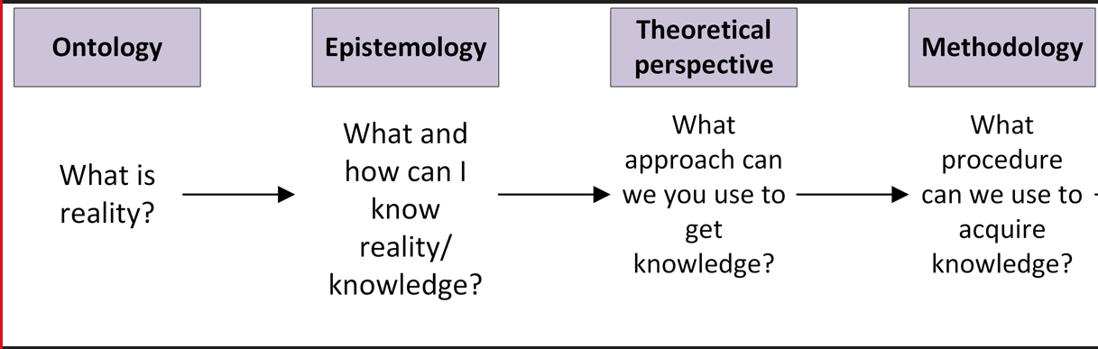
A clarity of research question is essential to underpin a clear research plan ‘xxxxxx’ (Author, year, p.x). The research question also clearly links with the methodological position and data collection methods (REF). They have not stated their MP although it appears to be ‘Interpretative’ as ‘xxxxxxxxxx’ (Author, year, p.x; Author, year, p.x). Data collection also further underpins this type of methodological position (REF). later on in the article it talks about grounded theory yet does not give much to support the rationale for this – so weave that in too. Thus, one of the challenges with this paper is ‘xxxxxxxx’ (Williams et al, 2020, p.x).

Data Collection Methods
- What methods did they use and why?
  - Were they appropriate to answer the Research Question?
The limitations of this study surround the use of online and social media engagement with participants.
- Now tell us what the limitation of the study is and what the implications are.
The article explored the use of focus group with ‘10 out of the 25 participants’ (Smith, 2018, p. 32). Interestingly there was little discussion of the power relationships between the researcher and the participants (Author, year). Although, Smith (2018) indicates that he acknowledge that he was the employer and that there was a need to consider the implications for data collection (Denzin & Lincoln, 2017, p. 15); he did not consider the impact upon employee to employee relationships might be disrupted (Cresswell, 2019). This is important because xxxxxxx; the researcher could have xxxxxxxxxx which would have resolved the ‘power relationships’ within the research (Author, year, p.xx).

Ethical Considerations
- Ethically how did this research ‘stand up’ to requirements.
  - Power relationships between researcher and participant
  - Gatekeepers – tell me potential challenges and how you would overcome them
  - Data Protection/GDPR – relevance for Research
  - Letter/oral account of the research
  - Consent to the research
  - Anonymity
  - Confidentiality
  - Right of withdrawal

Conclusion 300 words:
So what?
Resume of what you have found out
Main issues good and could do better
Who cares?
Who is impacted upon the above?
Research specific Participants
Overall has the research helped society - Support a client group/industry/society/culture/community
What next?
What would you change?
To make it better

Reference List:
Smith, P (2020) title of book, Place of Publication: Publisher.

