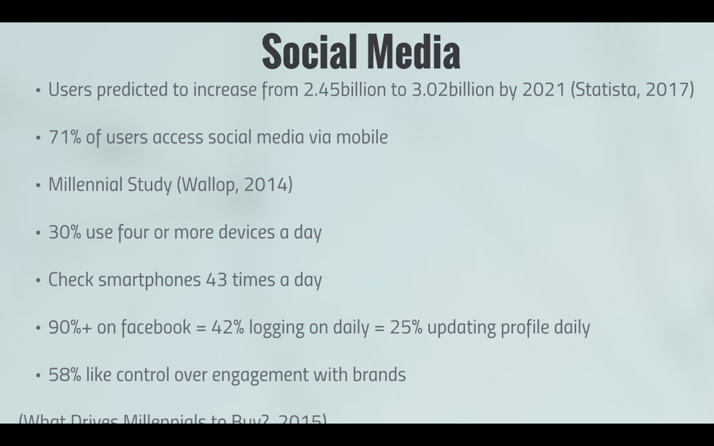
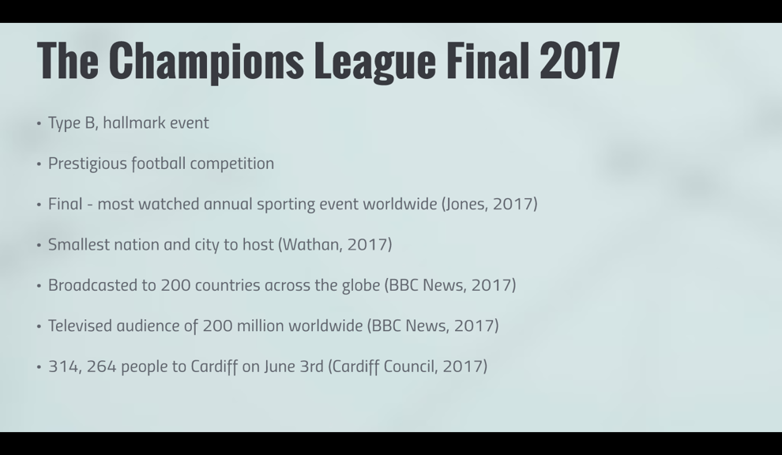
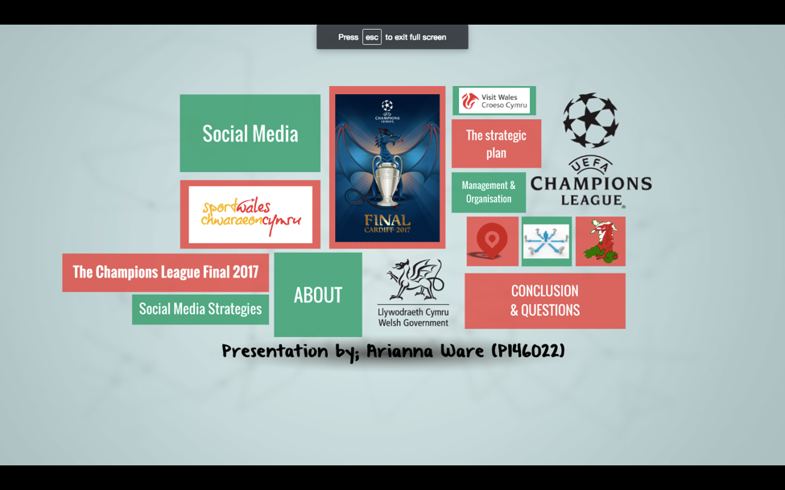
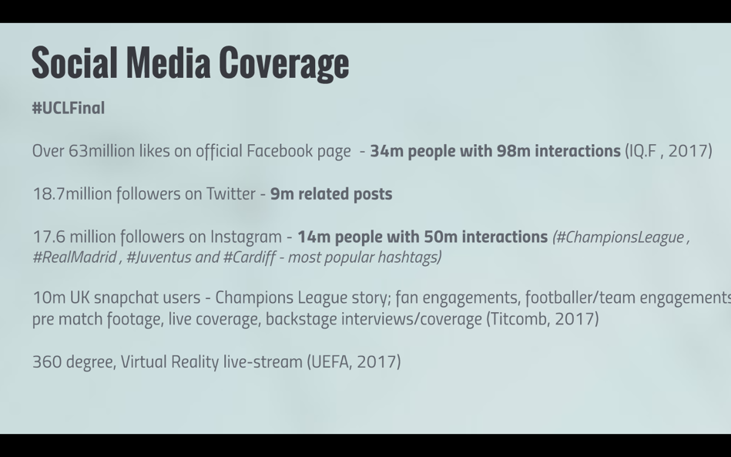
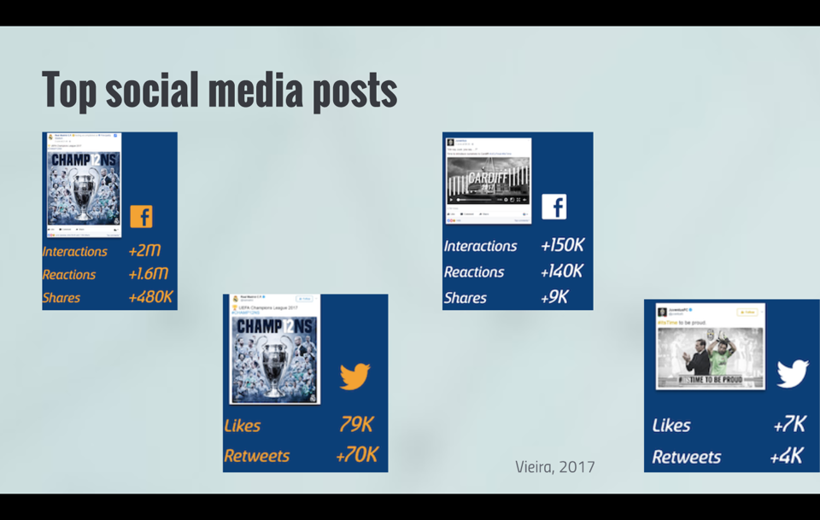
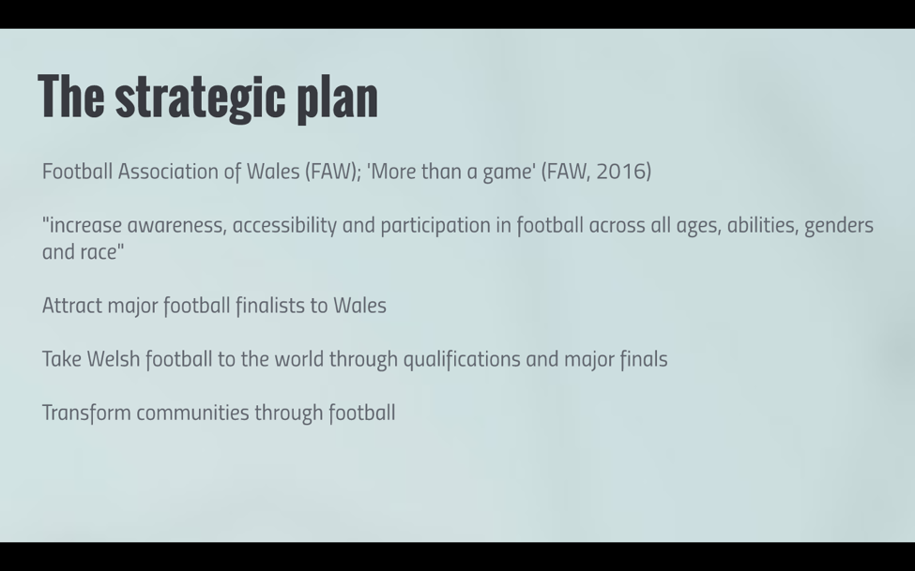
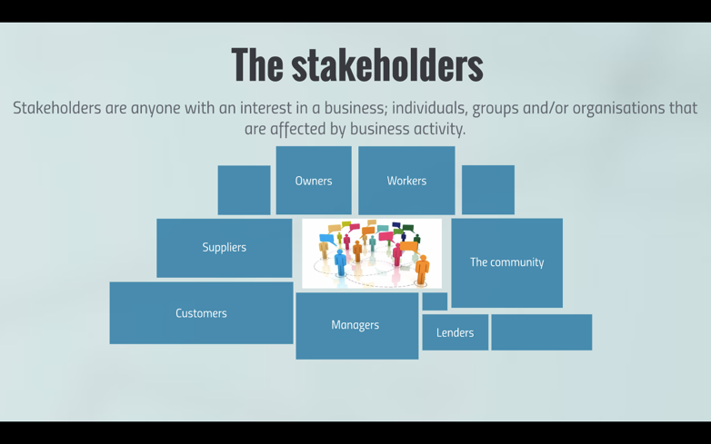
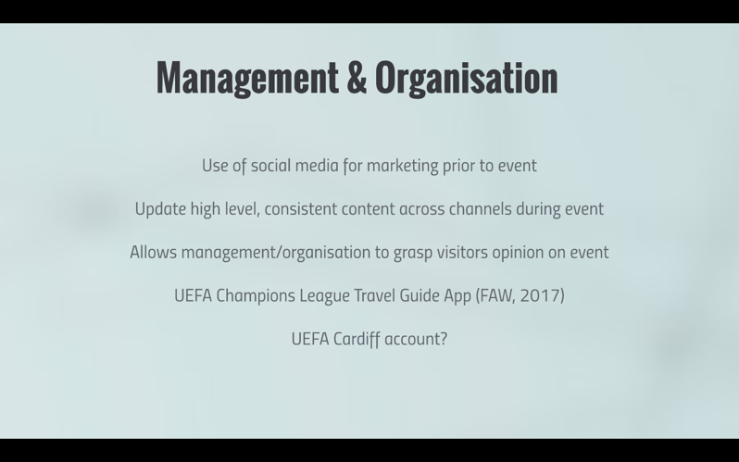
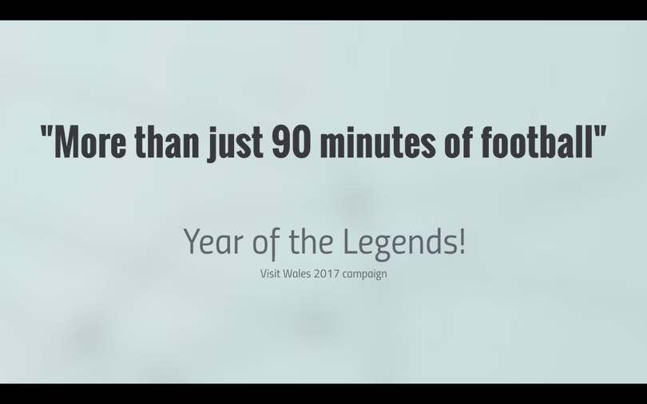
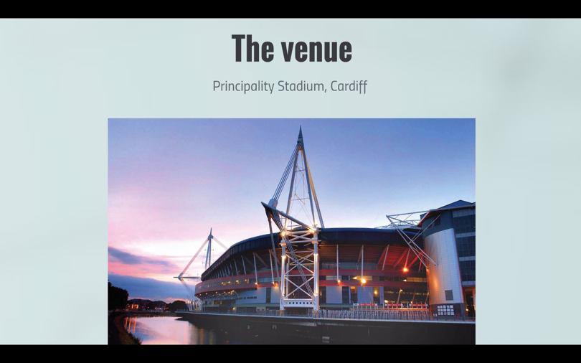
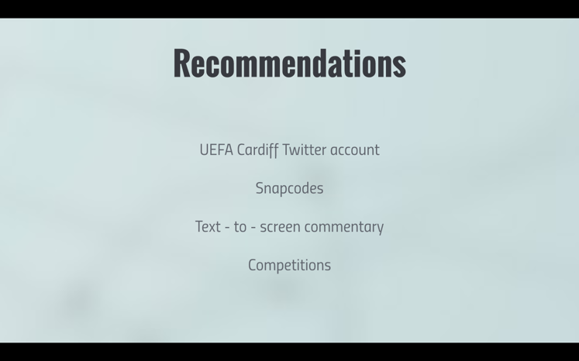
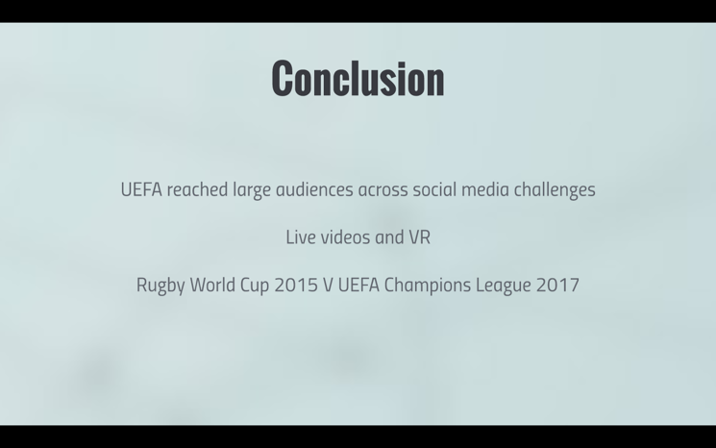
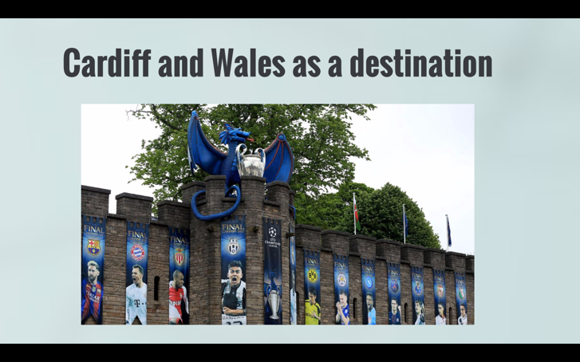
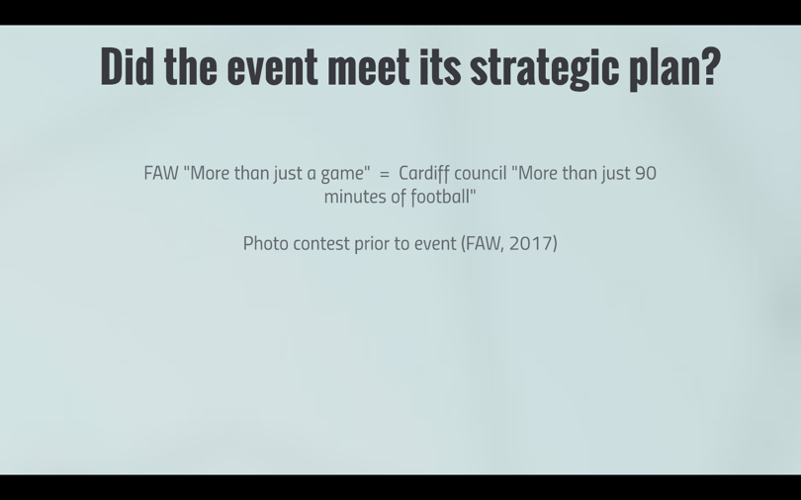
Hello and welcome to this presentation based on the success of the Champions League Final of 2017, and its Social Media strategies.
The Champions League final, a prestigious football competition, is considered a Type B, Hallmark event, which means not only is it a stand out, international event, it’s one that generates mass spectators and major economic activity and this presentation will investigate whether the event did just that for Cardiff, and Wales as a host country, as well as investigating the events strategic plan, management and organisation and the role of the organisers, venue and stakeholders.
On June 3rd 2017, during the Men’s UEFA Final, Cardiff welcomed 314, 264 people to its city centre, and was broadcasted on television to 200 countries with an audience of 200 million worldwide. The final is the most watched, annual sporting event in the world, and this year Cardiff acted as the smallest nation and city to ever host the event.
Social media has immense coverage and allows for strong connectivity on an international basis. Currently standing at 2.45 billion users, it is predicted that social media will continue to increase user interest to an estimated 3.02 billion by 2021 (Statista, 2017). It has been recorded that 71% of technology users access social media on their mobile, meaning the use of social media combined with mobile developments allows for people to keep in touch on the go. Identifying the millennial study, otherwise known as Generation Y, alongside Generation Z, addresses when technology and social media took a drastic incline. Generation Y representing those born between 1980 and 2000, were brought up with the vast developments of technology from the founding of Google, to the creation of Facebook. Generation Z on the other hand have been born into a world heavily reliant on technology (Wallop, 2014) resulting in statistics boasting figures such as 30% using four of more devices a day, with the typical user checking their smart phone 43 times a day, 90% owning a Facebook account, 42% logging into social media daily with 25% of those updating their profile at least once a day These figures allow for the understanding that the current state of the world is technologically advanced, and individuals rely on technology to communicate, share information, shop and get involved with brands and high-profile individuals. Individuals nowadays prove technology to play importance to their personal and professional lives, meaning organisations and in this instance, events, must acknowledge their technological environment to meet and connect with their stakeholders whilst giving them the freedom to get involved with that business environment as and how they wish – resulting in the 58% of individuals who like control over their engagement with brands.
With such demand for social media, the Champions League final were able to reach large audiences across their channels on the day of the event, and leave a legacy on them afterwards. Champions league social media channels reached audience numbers of millions worldwide, with their facebook account having the biggest audience of 63 million likes accounting for 61% of UEFA’s overall social media mentions, their twitter at 18.7 million and Instagram at 17.6million accounting for 35% of their social media mentions. 58% of UEFA’s Facebook fans came from outside of Europe, showing the international scale of social media coverage. What went well was the organisations recognition of the interest and impact of ‘live’ videos, allowing audiences to feel even more a part of the event, and seeing exclusive footage only on social media (Kabrovski, 2017). Across Facebook, audiences could immerse themselves in live videos of pre-final training, press conferences and team arrivals, featuring a variety of star additions of high profile sport and entertainment figures. During the final week, Facebook reigned a total of 56 million video views. Many of the social media engagements were with high-profile sport and entertainment stars, where they participated in #AccessAllAreas campaigns sending well wishes to players, backstage previews and more (James and Tsimpouli, 2017).
However, with 10 million users within the UK alone, Snapchat was the channel for the biggest push in live coverage; having a Champions League story in partnership with BT where users could flick through pre match footage, backstage interviews and footage, live coverage and the ability for anyone involved in the event whether that be at the stadium, on the pitch, in Cardiff, at the pub or at home watching the match, to be able to add to the story – allowing viewers to see the event unfold from every different angle.
UEFA acknowledged such technological advances and went above and beyond to offer 360 degree, virtual reality video coverage direct to user’s mobiles, tablets and/or virtual reality headsets, again, bringing fans closer to the event than ever before (UEFA, 2017).
The strategic plan of Football Association of Wales for the next 5 years is that football is “more than a game”, where they published an advert addressing that the meaning of football is different to every individual, but in Wales they want to raise awareness that it is more than just a game, having the aim to increase awareness, accessibility and participation of football across all ages, abilities, genders and race whilst transforming communities with the sport, attracting major finalists to Wales and taking Welsh football to the world.
Football Association of Wales strategy of “More than a game” was further reflected by a member of Cardiff Council, saying the event was “more than just 90 minutes of football” relating to the scope and scale of the event, from the operations to the event day, to the legacy left afterwards. Another way the event has met its strategic plan was through the running of an online photo contest prior to the event. Using the hashtag #ThisIsWelshFootball , clubs, schools and communities across Wales were able to share photos relating to football either on or off the pitch to be entered into a draw judged by a variety of FAW and UEFA professionals, to win a selection of prizes including the opportunity to attend a private opening of the UEFA Champions League Gallery at the Wales Millennium Centre prior to the big event. The aim of this contest was for UEFA and FAW to recognise football at grass root level which is local level football amongst communities and schools (supporting FAW’s strategy to increase awareness, accessibility and participating for all) and give them the ambition to train towards elite level (FAW, 2017)
In regards to the management and organisation of the event, social media plays an important part in marketing the event beforehand, producing high level, consistent content across the event day and allowing an organisation to review overall success and/or issues post event. It is hard for social media to be managed and organised, due to its environment, however, organisations can use it to their advantage by using it as a communications tool which can ultimately deal with any possible issues before they arise. The UEFA app allowed for effective sharing of information regarding the event and local area, with real time notifications alerting users of changes in any form of arrangements (FAW, 2017). However, the management and organisation could have operated an extra mile through the creation of a UEFA Cardiff twitter account, where visitors to Cardiff and attendees of the match could communicate easier with the event itself, instead of UEFA as a whole, tweeting any questions/queries which ultimately would enhance the overall fan engagement and customer service experience through faster responses, better connectivity with the brand and allow for the brand to create a better experience through interactivity such as competitions, sharing of photos, etc. (Hospitality Net, 2015).
In regards to the impact social media has on the venue, the Principality Stadium, yes it will put the venue on the map, and will be the main focus throughout the event, however, as a result of UEFA taking over all forms of Principality branding, even to the extent of changing the name of the stadium, it can defer the attention to the stadium in the long run.
The main stakeholder UEFA will be targeting in regards to their social media content is their customers, who will be the ones creating content which ultimately will have an impact on UEFA and some of its stakeholders such as the community being portrayed in posts, and its suppliers who are likely to have sponsorships and want their brand published.
When an event is hosted, it has major impacts on the host city and country, impacts everyone hopes to be positive. Social Media as previously mentioned, reaches large audiences meaning it plays an important aspect in the overall image of the destination photographed; the more people that use social media hashtags and location sharing tools, the more acknowledgement the destination will have, and if such posts are positive, it’s putting that destination “on the map” and in both the short and long term, should attract future visitors to the area. Although the social media posts and engagements across the Champions League were a success and reached large audiences, I do not think it had the same impact and legacy that followed the Rugby World Cup success. Likewise to the events Ball in the Wall at Cardiff Castle, UEFA used the castle to display a dragon and a giant champions league trophy, however it was the Ball in Wall that was a social media phenomenon (Owen, 2015). I believe what differed the attraction of the UEFA’s castle display was the overall image of the display not being as attractive as the Ball in the Wall, but also that locals and visitors were somewhat expecting it, whereas for the Rugby World Cup it was a complete surprise and quickly became a focal point of the city (Rosenblatt and Sands, 2015).
In conclusion I believe the event really did perform well in its social media strategies; allowing the event to reach large audiences internationally, encourage grassfoot football, and really engage customers into the UEFA brand, whether they were at the match, in the city, or watching coverage “on the go”. UEFA performed really well in the acknowledgement of the rise and demand for live coverage, however when comparing content to the Rugby World Cup in 2015, I do not believe content reached such a craze/large audience. In order to further enhance the social media experience, UEFA as previously mentioned, could’ve created a Cardiff specific twitter account which would allow them to have an additional marketing channel prior to the event, but have an easy and effective way to communicate and offer strong levels of customer service to visitors and attendees on match day. Two other recommendations I’ve taken from personal experience of attending events in America is the usage of ‘snapcodes’ and text – to – screen commentary. Snapcodes are snapchats version of QR codes, making it easy and convenient for individuals, in particular big brands and celebrities to post their snapcode onto a marketing material e.g. poster, advert, etc., and gain immense follower numbers in seconds. Text – to – screen commentary is something else events in America excel in, getting visitors to share on social media using tags and/or hashtags, then having them displayed on the big screens at and around the event, increasing fan engagement and making them feel more of a part of the event. Social media competitions during the event will also increase fan engagement and experience, hosting things such as seat competitions where certain seats from a selection of tweets win free food, etc.

Reading list
Bashford, S. (2017). What you need to know about sports marketing in 2017 and beyond. [online] Campaignlive.co.uk. Available at: https://www.campaignlive.co.uk/article/need-know-sports-marketing-2017-beyond/1424873 [Accessed 30 Nov. 2017]
BBC News. (2017). Champions League 'ring of steel' in city. [online] Available at: http://www.bbc.co.uk/news/uk-wales-south-east-wales-39457792 [Accessed 18 Nov. 2017].
Cardiff Council. (2017). Highest footfall ever recorded in Cardiff on June 3rd. [online] Available at: http://www.cardiffnewsroom.co.uk/releases/c/15295.html [Accessed 18 Nov. 2017].
Constine, J. (2015). How Snapchat Made QR Codes Cool Again. [online] TechCrunch. Available at: https://techcrunch.com/2015/05/04/snapcode/ [Accessed 1 Dec. 2017].
FAW. (2016). More Than A Game. [online] Available at: http://www.faw.cymru/files/9114/6004/1927/More_than_a_game.pdf [Accessed 6 Dec. 2017].
FAW. (2017). FAW / Travel Guide App. [online] Available at: http://www.faw.cymru/cardiff2017/visiting/mobility-app/ [Accessed 24 Nov. 2017].
FAW. (2017). FAW / Photo Competition. [online] Available at: http://www.faw.cymru/cardiff2017/whatson/photo-competition/ [Accessed 20 Nov. 2017].
Hospitality Net. (2015). The Impact of Social Media on the Tourism Industry. [online] Available at: https://www.hospitalitynet.org/news/4071855.html [Accessed 23 Nov. 2017].
IQ, F. (2017). 2017 UEFA Champions League final on Facebook and Instagram. [online] Facebook IQ. Available at: https://insights.fb.com/2017/06/05/2017-uefa-champions-league-final-on-facebook-and-instagram/ [Accessed 18 Nov. 2017].
James, A. and Tsimpouli, N. (2017). UEFA Champions League continues impressive digital growth. [online] UEFA. Available at: http://www.uefa.com/uefachampionsleague/news/newsid=2476408.html#/ [Accessed 20 Nov. 2017].
Jones, V. (2017). This is why the Champions League final being held in Cardiff. [online] walesonline. Available at: http://www.walesonline.co.uk/news/wales-news/champions-league-final-being-held-13130263 [Accessed 20 Nov. 2017].
Kabrovski, R. (2017). How social live video has transformed the Champions League final into a field day for brands. [online] The Drum. Available at: http://www.thedrum.com/opinion/2017/06/02/how-social-live-video-has-transformed-the-champions-league-final-field-day-brands [Accessed 23 Nov. 2017].
More than a game - FAW 2020 vision and strategic vision for Welsh Football. (2015). [video] FAWales.
Neomobile. (2017). How and Why Brands use Social Media on Mobile - Neomobile. [online] Available at: http://www.neomobile-blog.com/brands-mobile-social-media-usage/ [Accessed 1 Dec. 2017].
Owen, C. (2015). The Ball in the Wall is staying put for longer than planned. [online] walesonline. Available at: http://www.walesonline.co.uk/news/wales-news/rugby-world-cup-ball-wall-10275972 [Accessed 1 Dec. 2017].
Rosenblatt, K. and Sands, K. (2015). Cardiff's Ball in the Wall to be taken down today. [online] walesonline. Available at: http://www.walesonline.co.uk/news/wales-news/cardiffs-ball-wall-taken-down-10368721 [Accessed 1 Dec. 2017].
Statista. (2017). Number of social media users worldwide 2010-2021 | Statista. [online] Available at: https://www.statista.com/statistics/278414/number-of-worldwide-social-network-users/ [Accessed 20 Nov. 2017].
The Telegraph. (2015). The importance of social media in sport. [online] Available at: http://www.telegraph.co.uk/investing/business-of-sport/social-media-in-sport/ [Accessed 1 Dec. 2017].
Titcomb, J. (2017). BT to show Champions League final clips on Snapchat. [online] The Telegraph. Available at: http://www.telegraph.co.uk/technology/2017/06/01/bt-show-champions-league-final-clips-snapchat/ [Accessed 18 Nov. 2017].
UEFA. (2017). 360°virtual-reality filming at the Cardiff final - bringing fans closer to the action. [online] Available at: https://www.uefa.com/insideuefa/about-uefa/news/newsid=2474273.html#/ [Accessed 20 Nov. 2017].
Vieira, R. (2017). UEFA Champions League Final: A Social Media Success. [online] Teleperformance Global blog. Available at: https://teleperformanceblog.com/social-media/uefa-champions-league-final-a-social-media-success/ [Accessed 1 Dec. 2017].
Wallop, H. (2014). Gen Z, Gen Y, baby boomers - a guide to the generations. [online] Telegraph.co.uk. Available at: http://www.telegraph.co.uk/news/features/11002767/Gen-Z-Gen-Y-baby-boomers-a-guide-to-the-generations.html [Accessed 24 Nov. 2017].
Wathan, C. (2017). How the Champions League final ended up being held in Cardiff. [online] walesonline. Available at: http://www.walesonline.co.uk/sport/football/football-news/full-inside-story-how-champions-12928557 [Accessed 18 Nov. 2017].
What Drives Millennials to Buy?. (2015). [Blog] Agonzo_O. Available at: https://marketingtrendsblogdotcom1.wordpress.com/2015/01/27/what-drives-millennials-to-buy/ [Accessed 28 Nov. 2017].

