
Leading and implementing workplace change (BMSW6103)

Julia Mansell 2110746
Cultural Influences on Change Management: A Case Study of Energy Power's Acquisition of Universal Elect Plc
Lecturer: Masoud Keimasi
Number of words:5526
Submission date: 22 March 2024

Table of Contents
Introduction 3
Lewis Model 4
Comparison of Linear-active and Multi-active Cultures 5
Communication Style and Negotiation of UK & UAE 6
Management, Hierarchy and Attitude Towards Authority 8
Conflict Resolution Approaches 9
Feedback practices between UK & UAE 11
Ethnocentric and Polycentric Model in People Management 12
Change Management – Lewin Model 15
Stakeholder Analysis 16
Interview Analysis on the Validity of the Lewis Model 18
Conclusion and Recommendations 22
References 23
Appendix 24

Introduction

In the fast-paced world of global business, mergers and acquisitions often serve as strategic moves to expand market reach and build up competitiveness (Gupta, 2012).

Recently, Energy Power made a significant leap by acquiring Universal Elect Plc, a prominent player in the United Arab Emirates (UAE) and the United Kingdom (UK). This acquisition indicates a new chapter for both organisations, marking a significant moment in their trajectory towards growth and innovation. As Energy Power sets its sights on integrating Universal Elect Plc into its operations, various departments are tasked with collaborating closely with their counterparts in the UAE to ensure a seamless transition in the UK. One of the critical factors that can significantly influence the success of this venture - cultural differences.

This report explores the complexity of culture and its influence on communication, negotiation, and feedback procedures between the UK and the UAE, specifically within the framework of the Energy Power-Universal Elect Plc acquisition. Utilising Lewis's model of cultural categorisation, the objective is to reveal the subtle factors that could shape cross-cultural exchanges during this period of transition.

Furthermore, this report critically examines the ethnocentric and polycentric models of management, exploring their relevance and applicability in navigating the diverse cultural landscapes essential in multinational acquisitions. By identifying key areas of people management, insights into effective strategies for fostering collaboration, understanding, and synergy across cultural boundaries are provided.

Additionally, to validate the findings of the Lewis model, an interview was conducted with my partner, representing Linear Culture as British citizen. Through his perspectives and experiences, deeper insights into cross-cultural communication and management complexities are provided.

As Energy Power begins the path of integration and growth, embracing and recognising the richness of cultural diversity is the key to leveraging it as a catalyst for innovation, collaboration, and sustainable success. This report serves as a roadmap for navigating the cultural complications of the Energy Power-Universal Elect Plc takeover, offering practical insights and recommendations to foster a harmonious and thriving organisational culture in the face of change.

The impact of culture on communication and negotiation

In the communication sphere, culture has an extensive influence, continually shaping and reshaping individual behaviours and societal norms. As socio-economic conditions evolve, so too do the patterns of communication, reflecting the dynamic interaction between cultural backgrounds, past experiences, and perceptions. This symbiotic relationship between culture and communication underscores the significance of understanding how cultural context shapes communication styles. Culture serves as a guiding framework, inspiring its members with implicit knowledge of appropriate behaviours and interpretations in various social contexts. It influences how individuals communicate and contributes to the evolution of cultural norms through the collective exchange of ideas and practices. By recognising and appreciating the role of culture in shaping communication dynamics, individuals and organisations can encourage greater understanding and collaboration across diverse cultural contexts. Culture undergoes continuous evolution, remaining dynamic rather than static. Just as change is a natural phenomenon, so is culture's evolution. Therefore, it can be proposed that individuals are not solely subject to the dictates of culture; rather, they actively engage in ongoing negotiations and reinterpretations of cultural principles and values (Giri, 2006).

Lewis Model
The Lewis Model, developed by linguist and cross-cultural expert Richard D. Lewis (1996), arose from extensive research conducted during his travels to 135 countries, professional engagements in over 20 nations, and surveys involving 50,000 executives through residential courses and 150,000 online questionnaires spanning 68 nationalities. Through this exploration, Lewis distinguished that human behaviour could be categorised into three distinct groups, not predicated on nationality or religious connection, but on observable behavioural patterns. Although Lewis's typologies - Linear-active, Multi-active, and Reactive - are outlined, each incorporates elements of behaviour from the other categories. Recognising the complexity essential in defining cultural categories, which could potentially lead to numerous variations, considering factors such as nationality, geography, religion, and generation, Lewis sought to offer a concise and explicit model to facilitate understanding (Red Tangerine, 2024). Lewis’s model is illustrated in Figure 1 below.
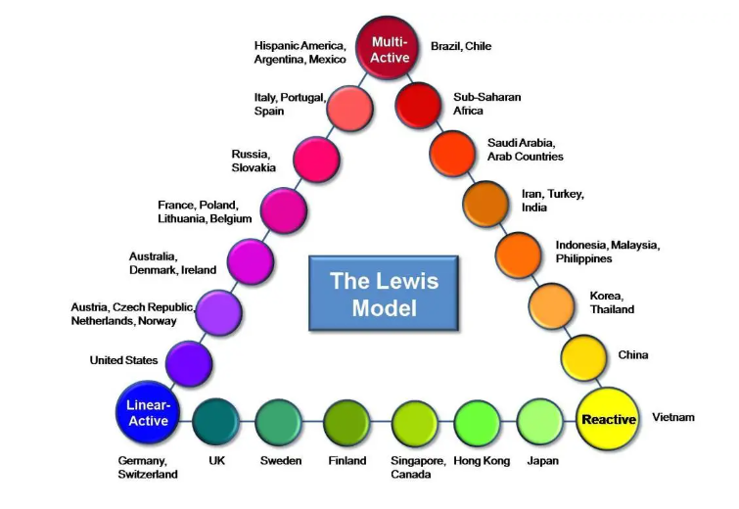
Figure 1: Lewis Model, Source: Red Tangerine, 2024.
Based on the above model UK is classed as a Linear-Active Culture, whereas the UAE is a Multi-Active Culture.

Comparison of Linear-active and Multi-active Cultures
In terms of Time Orientation:
  - Linear-active cultures, such as those typically found in Western countries, view time as a linear and segmented concept, organised by schedules and calendars for efficiency and productivity.
  - Multi-active cultures, such as those in Arab and Latin spheres, perceive time as event- or personality-related, focusing on the present reality and prioritising the significance of interactions over strict adherence to schedules.
Approach to Time Management:
  - In linear-active cultures, punctuality and adherence to schedules are highly valued, with time often segmented into specific tasks or appointments.
  - Conversely, in multi-active cultures, individuals prioritise the completion of human transactions and may be less concerned with punctuality or strict scheduling, preferring to focus on the significance of each interaction.

Attitude Towards Simultaneous Activities:
  - Linear-active cultures generally prefer to focus on one task at a time, valuing concentration and efficiency in completing individual activities.
  - Multi-active cultures, on the other hand, thrive on simultaneous engagement in multiple activities, deriving fulfilment from the ability to handle various tasks concurrently.
Overall, while linear-active cultures prioritise efficiency and adherence to schedules, multi-active cultures place greater emphasis on the significance of interpersonal interactions and flexibility in time management, reflecting differing cultural values and priorities (Lewis, 2010).

Communication Style and Negotiation of UK & UAE
In the Gulf States, therefore UAE, the perception is that a fine manager equals a fine Muslim. Unlike, the quiet tone, characteristic of the UK, the raised voice is a sign of authentic feelings and encouragement in the UAE (Lewis, 2010). In Emirati culture, communication tends to be indirect, and negotiations are often based on building relationships. Social networks play a vital role in business culture, offering opportunities for making connections through social interactions. Honour and reputation are highly valued, so it's crucial to be mindful of this to make a positive impression and establish trust. Addressing individuals by their titles and surnames, such as "Sheikh" or "Dr.," using appropriate titles, is essential. Emiratis prioritise being present in the moment, valuing relationships and the quality of interactions over strict adherence to schedules. Emiratis integrate business and social aspects, often inviting colleagues to social gatherings to strengthen personal connections, contributing to a relaxed and inclusive business environment (Jordaan, 2023).

The English communication style is characterised by a preference for understatement, reservation, and politeness. Rather than engaging in confrontation, they may concede points early in an argument to defuse tension while subtly implying their righteousness. English speakers are skilled at being vague to maintain politeness or avoid conflict, and they may employ waffling tactics to procrastinate or obscure issues. This communication style often involves a quiet tone, with an emphasis on remaining low-key.
When collaborating with individuals from the UK, it's crucial to recognise their tendency to employ sarcasm and humour in their communication. Misinterpreting their remarks could lead to misunderstandings regarding their underlying intentions. To exemplify this, please see Table 1 provided below.
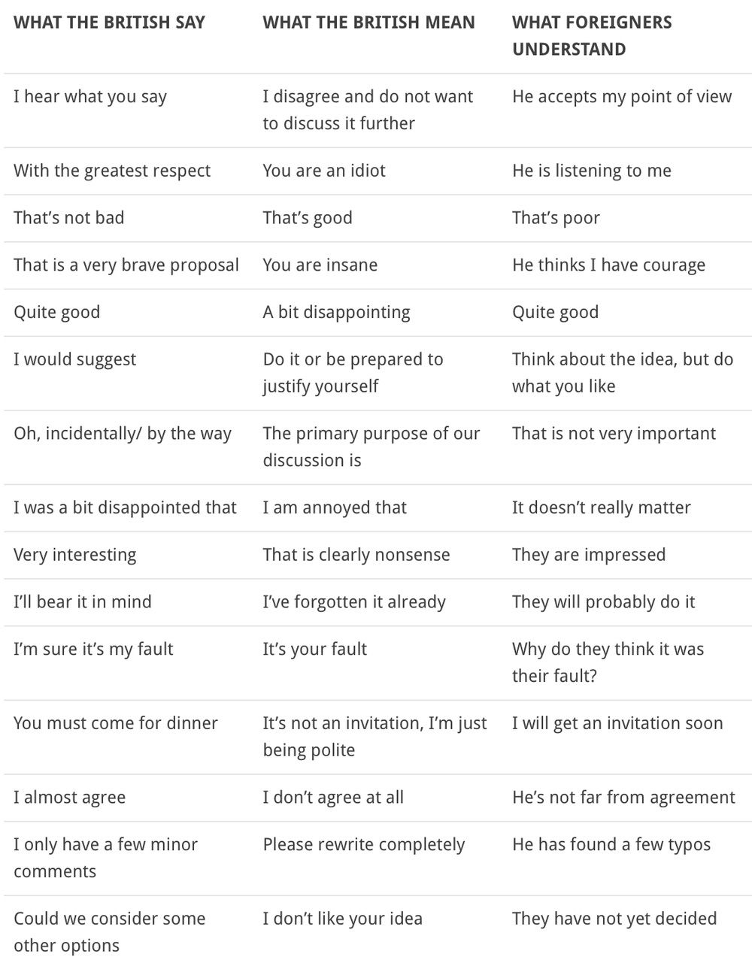
Table 1 Possible Meaning of What British Say and How it can be perceived by an individual from a different culture (Skarbek, 2021).

Management, Hierarchy and Attitude Towards Authority
According to Lewis (2010), British management still reflects feudal and imperial influences, with a lingering pride from its colonial past. The class system persists, although efforts towards meritocracy are evident. British managers are described as diplomatic, laid-back, and inventive, valuing debate and compromise. Despite a veneer of refinement, they possess pragmatism and can be resilient when necessary. However, their adherence to tradition sometimes leads to insularity and a failure to understand other cultures. While British delegates excel in charm, they may miss opportunities to learn from their international counterparts due to linguistic arrogance and cultural misunderstandings.
Emirati managers, like their counterparts in other multi-active cultures, prioritise leadership with a human touch, blending Islamic values of respect and harmony with a tendency to be firm on issues but gentle with people. While bureaucratic structures in larger organisations can hinder access to decision-makers, Emirati leaders impress with their hospitality, integrity, and adherence to tradition. Their communication style tends to be implicit, requiring newcomers to read between the lines, and they prioritise diplomacy and timing over speed, avoiding conflict whenever possible. Understanding these cultural nuances is crucial for successful collaboration, especially in the context of ambitious Gulf development projects involving multinational joint ventures (Cross-cultural factors in leadership in the Middle East, 2015).
The UAE's business culture adheres to a hierarchical structure, characterised by a prominent top-down approach shaped by factors like age, wealth, and familial ties. When entering a meeting with Emiratis, it's crucial to recognise the significance of the seating arrangement, where the chair to the right of the manager holds particular importance. Anticipate engaging in casual conversation before delving into business matters, as Emiratis seek to strike a balance between professional obligations and personal life. Family values take precedence for Emiratis, with loyalty to one's family being a cornerstone of their identity, potentially impacting work relationships (Jordaan, 2023).

Conflict Resolution Approaches
Over the past two decades, there has been an increase in research on cross-cultural conflict management. However, there remains a lack of understanding of how professionals handle interpersonal disagreements with counterparts from different cultures in business relationships. While some studies address organisational implications, the individual level—how professionals manage such disagreements given their cultural identities—has been largely overlooked. Additionally, there is a shortage of research on conflict resolution strategies in cross-cultural contexts, with most studies focusing on individual countries rather than regions or multiple countries.
Intercultural competence is crucial for employees to effectively navigate culturally diverse environments and prevent conflicts with stakeholders from different cultures. Cultural differences can increase the likelihood of misinterpretation and conflict, potentially leading to lost clients or decreased productivity. These differences not only affect negotiation and communication but also impact relationship-building and conflict-management strategies among stakeholders. Due to variations in identity and culture, stakeholders may not share the same beliefs, traditions, values, and norms as their transnational counterparts (Hartl, 2020).

The UAE is highly diverse, with native Emiratis forming only a small portion of the population. This diversity means interactions in the country involve people from diverse global backgrounds, requiring more than just understanding Emirati culture for effective engagement in business. Contributions from individuals from various nations enrich the cultural landscape of the UAE. However, understanding Emirati culture remains crucial, especially given the prevalence of Emirati-owned businesses (Jordaan, 2023).

Based on the Lewis Model, the summary of the typical cultural differences between the UK and the UAE and how they might influence acquisition processes is provided in below Table 2.

Cultural Differences | UK | UAE
Communication Styles | Direct communication style, often preferring clarity in communication. | Indirect communication style, often relying on gestures, context, and implicit cues.
Decision-Making Processes | Decisions may be made quickly and efficiently, often with emphasis on data and analysis. | Decisions may involve consultation with various stakeholders, including family and business connections.
Hierarchical Structures | Hierarchical structures exist but are often more fluid, with openness to feedback and suggestions from subordinates. | Hierarchical structures can be deeply established, with strong respect for authority and seniority.
Time Orientation | Often adhere to strict schedules and deadlines, valuing punctuality and efficiency | Time may be viewed more flexibly, with emphasis on relationships and the present moment rather than strict adherence to schedules.
Relationship Building | Relationships are important but may be built more gradually over time through shared experiences and mutual trust. | Relationships are crucial and often prioritised over transactions, with an emphasis on personal connections and hospitality.
Table 2 Cultural differences between UK and UAE (Lewis, 2010)

To navigate these differences effectively, negotiators from both sides should invest time in understanding each other's cultural norms, communication styles, and decision-making processes. Flexibility, patience, and a willingness to adapt strategies accordingly are key to successful negotiations between companies from the UK and the UAE. Additionally, engaging cultural experts or local advisors can provide valuable insights and help bridge cultural gaps during the negotiation process.

Feedback practices between UK & UAE
Feedback practices between the UK and the UAE may differ significantly due to cultural differences. Typical aspects are provided in below Table 3.

Aspect | UK | UAE
Relationship Building | Feedback fosters trust and accountability in the UK. | Feedback aims to strengthen relationships and mutual respect.
Directness vs. Indirectness | British culture values direct and explicit feedback. | Emirati culture favours indirect communication to maintain harmony.
Cultural Sensitivity | UK Feedback is focused on objectivity and performance metrics. | Emirati Feedback considers cultural sensitivities and emphasises maintaining relationships.
Communication Styles | Feedback is prompt and specific in the UK. | Feedback is subtle and often wrapped in politeness.
Hierarchy | Feedback flows both upwards and downwards in the hierarchy. | In UAE, criticism may be softened to maintain respect for authority.
Table 3 Feedback practices between the UK and the UAE (Lewis, 2010)

Overall, while both the UK and the UAE recognise the importance of feedback in organisational settings, the cultural context shapes how feedback is given, received, and acted upon.

The next segment dives into the ethnocentric and polycentric models within international human resource management (IHRM), assessing their suitability for managing personnel throughout the acquisition procedure. It pinpoints and scrutinises areas of personnel management where these models find relevance.

Ethnocentric and Polycentric Model in People Management
In today's interconnected world, many organisations find themselves engaged in international business activities as a standard practice. However, as companies move into global expansion, they must cultivate a mindset engaged towards conducting business on a worldwide scale. Among the various approaches, two prevalent attitudes emerge: ethnocentrism and polycentrism. These mindsets significantly influence how a company navigates global business ventures, impacting areas such as marketing strategies and human resource management. This section will delve into the complexities of each attitude, examining their respective strengths and weaknesses in the extent of global business operations. Furthermore, it will explore the relevance of Ethnocentric and Polycentric Models in the context of the recent acquisition of Universal Elect Plc in the UK by Energy Power, within the UAE.

An ethnocentric orientation refers to a perspective in which a company views its own culture, products, and management methods as superior to those of other countries. In the aspect of global business, an ethnocentric organisation usually exports its products and practices directly from its home country to international markets with little modification. Polycentrism represents an approach advocating for the adaptation of products, strategies, and management practices to each distinct market or host country. In a polycentric model, subsidiaries or divisions in various countries operate with significant autonomy to meet local market demands (Qureshi, 2023).

The advantages and disadvantages of the ethnocentric and polycentric approaches are described in below Table 4.

 | Advantages | Disadvantages
Ethnocentric | Efficiency: uniformity in products and practices can grant cost efficiencies in manufacturing and management  Robust brand identity: Consistency can lead the development of a strong, recognisable brand on a global scale  Economies of scale: Standardising products can lead to cost savings through the benefits of economies of scale | Cultural insensitivity: Ethnocentric organisations may disregard local cultural nuances, resulting in communication breakdowns and misunderstandings.  Resistance to change: Customers in international markets may reject products that fail to cater to their specific needs or preferences.  Limited market penetration: Failure to adapt to local tastes and preferences can restrict market share and growth.
Polycentric | Tailored to local markets: By customising products and strategies to local requirements, polycentric organizations can gain a competitive advantage.  Enhanced customer satisfaction: Local customers are more likely to be content with products and services aligned with their preferences.  Deeper cultural understanding: Companies embracing a polycentric approach tend to develop a deep understanding of local cultures, facilitating smoother operations | Duplication of efforts: Managing operations independently in each country might result in redundant resources and increased expenses.  Lack of global uniformity: Maintaining a consistent global brand image becomes challenging when each subsidiary operates autonomously.  Limited knowledge exchange:  Knowledge and best practices may not readily transfer across the organization.
Table 4 Advantages and Disadvantages of Ethnocentric vs. Polycentric approach (Qureshi, 2023).
Considering the acquisition of Universal Elect Plc in the UK by Energy Power within the UAE, a polycentric model for people management is advisable.

Here's why:

Adaptability: The polycentric model allows for flexibility in HR practices to cater to the unique needs and regulations of each country. This adaptability is particularly valuable during the transition period following the acquisition, ensuring smoother integration of personnel and processes.
The polycentric approach to international management involves prioritising the hiring and promotion of employees who are citizens of the host country. This approach is characterised by lower recruiting and training costs and fewer challenges related to adjustment and communication, as all employees come from the same region (Tiwari, 2013).

Local Expertise: By leveraging the knowledge and expertise of employees within each country, Energy Power can better understand and navigate the specific requirements and expectations of the UK and UAE markets. This local insight is crucial for effective people management post-acquisition.

Employee Engagement: Embracing a polycentric model encourages employee empowerment and involvement in decision-making processes. This approach allows a sense of ownership and commitment among staff members in both the UK and the UAE, which is essential for successful integration and performance.

Cultural Sensitivity: The UK and the UAE have distinct cultural differences in terms of business practices, communication styles, and workplace norms. Adopting a polycentric approach would allow Energy Power to respect and accommodate the cultural nuances of both countries (Qureshi, 2023).

While ethnocentrism may seem tempting due to the centralised control it offers, it could lead to cultural clashes, resistance from employees, and inefficiencies in operations, especially when managing a diverse workforce across different countries like the UK and the UAE. Therefore, adopting a polycentric model in people management would likely be more effective and conducive to the success of the acquisition.

In the next section, the implementation of a change is outlined, following the Lewin Model.

Change Management – Lewin Model

Lewin Model involves a structured process to ensure smooth transition and integration. Organisational change involves transitioning an organisation from its current state to a desired future state, which involves uncertainty and potential concerns regarding individuals' value, coping skills, and competencies. Employees typically resist change unless they are convinced of its necessity and benefits. Resistance to change can arise because the organisation has heavily invested in maintaining the current way of doing things. People may be hesitant about changing because they fear what the future of the organisation might look like if they abandon the current practices. Therefore, motivating employees becomes crucial to facilitate change. To address this, the process is initiated following Lewin's three-step change model, which entails unfreezing, changing, and refreezing. Through this approach, employees are engaged and guided by leaders to navigate the challenges associated with the change process effectively (Hussain, et al., 2018).

The first step, unfreezing, requires communication and transparency to prepare employees for the upcoming changes and address any concerns and uncertainties. Leadership from both companies should clarify the rationale behind the acquisition and outline the vision for the future. Collaboration among all involved parties will facilitate a smoother transition process. Effective preparation and communication are paramount in this regard. In the metaphorical comparison, this stage is like melting ice from its initial form, such as a cube (Channell, 2021).

Next, during the changing phase, efforts focus on aligning organisational cultures, systems, and processes. This involves collaboration between teams from both entities to identify synergies and best practices, fostering a sense of unity and shared purpose. Employee participation leads to high-quality change and overcomes resistance during implementation. Leaders are required to support employee involvement to accelerate organisational change. Transparency and open discussion enhance employee trust and involvement during the change process. Knowledge sharing among employees is essential for organisational learning and innovation during the change process. Overall, employee involvement, leadership, and knowledge sharing are crucial elements in effectively implementing organisational change according to Lewin's model (Hussain, et al., 2018).

Finally, the refreezing stage solidifies the integration by reinforcing new norms, procedures, and values. Continuous feedback mechanisms and training programs help employees adapt to the new environment, ensuring sustainability and long-term success. Additionally, maintaining a positive attitude and celebrating the execution of the change is essential. This serves to maintain the initial purpose behind the change and ideally fosters a sense of optimism among the team regarding the ongoing success of the organisation. This step resembles setting the mould to create ice in a new configuration, like a sphere (Channell, 2021). Through careful implementation of the Lewin Model, the acquisition can lead to a harmonious blend of expertise and resources, driving innovation and growth for the combined entity.

Lewin’s model of 3-Step Change Management is provided in below Figure 2.

F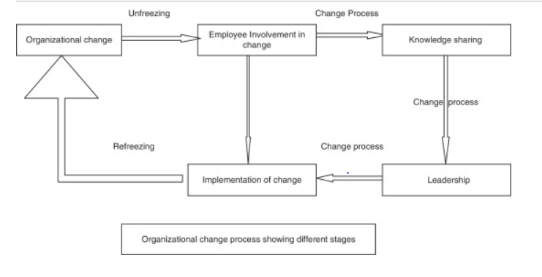

Figure 2 Lewin’s Three Step Model (Hussain, et al., 2018).

In the next section, the stakeholder analysis is provided. The connection between Lewin's model of change management and stakeholder analysis lies in their complementary roles in understanding, engaging, and managing stakeholders throughout the change process to increase the likelihood of successful organisational change.

Stakeholder Analysis
This section will uncover stakeholder analysis. It defines stakeholders as individuals, organisations, or groups that can influence or be influenced by the acquisition, emphasising their significance as "people who matter." Neglecting the needs and interests of stakeholders, including their cultural and economic realities, is highlighted as a major cause of failure. Stakeholder analysis is described as a process that involves identifying and characterising stakeholders, exploring their relationships, and planning for their involvement. It is essential for understanding the social and institutional context of the acquisition, identifying potential impacts, and determining who needs to be engaged and how. The process highlights the importance of continuous monitoring and adjustment to ensure effective stakeholder engagement throughout the project lifecycle (Reymond, 2014).
The Power-Interest Grid is a valuable tool for categorising stakeholders based on two critical factors: their level of power and their level of interest. This grid allows organisations to effectively visualize and analyse stakeholders, providing insights into how best to engage with each group.
Mendelov (1991) suggests, that the stakeholder should be analysed and taking into consideration two areas:

Power outlines a stakeholder's ability to influence the outcome. Stakeholders with high power, such as senior executives, regulatory bodies, or key customers, possess decision-making authority and can shape the project's direction, therefore need to be kept satisfied. Conversely, stakeholders with low power have minimal influence and are typically less involved, just need monitoring with minimum effort.

Interest reflects the extent to which a stakeholder is impacted by or interested in the outcome. Those with high interest directly benefit from or are affected by the project's success or failure and need to be managed closely. Conversely, stakeholders with low interest may have only a peripheral interest or be indirectly impacted by the outcomes and, therefore need to be kept informed.

Steps include:
- Identifying of stakeholders.
- Assessing their power and interest.
- Categorising stakeholders into four groups.
- Developing a stakeholder engagement plan tailored to each group. Using this grid helps prioritise efforts, customize engagement, mitigate risks, allocate resources efficiently, and improve decision-making. Stakeholder analysis using the Power-Interest Grid is essential for success and should be an ongoing process (Abdalla, 2023).

Stakeholder analysis of Universal Elect Plc and Energy Power is revealed in below Table 5.
High  POWER  Low | Keep satisfied  Senior management  Regulatory bodies  Suppliers | Manage Closely  Acquisition Manager & Team Members  Involved (HR Department, IT Department, Project Management)
High  POWER  Low | Monitor  Government  Potential Customers | Keep Informed  Employees not directly involved in the acquisition  Customers
High  POWER  Low | Low I N T E R E S T High
Table 5 Stakeholder Analysis of Universal Elect PLC and Energy Power
The last section discusses the findings from an interview conducted to validate the Lewis model. It covers the interview methodology, responses concerning cultural differences in communication, negotiation, and feedback practices, as well as the analysis of the interview findings.

Interview Analysis on the Validity of the Lewis Model
Based on Lewis's model, the Interview was conducted with the British citizen representing Linear Culture. The questions asked are built as a guide in determining the validity of the Lewis Model. Key Points and findings are presented below.

Cultural background
The response reflects certain cultural aspects that align with Lewis's categorisation of Linear-Active cultures, such as:
- Valuing tradition
British people value their traditions and respect monarchy. These royal traditions have been established in England for over a millennium and remain integral to the cultural fabric of the UK. The Royal family continues to wield significant influence within the United Kingdom's legal framework. A celebrated English tradition is the roast dinner, notably the Sunday roast, including roast meat accompanied by roasted potatoes, vegetables, and gravy.

- Humour
In the British managerial landscape, humour stands out as a powerful tool, with adept individuals capable of earning the trust and respect of Britons by demonstrating their wit. The top of this skill lies in dry humour, complemented by a calm and relaxed manner. Humour serves as a lifeline in British culture, often attributed to the unpredictable climate, and many English individuals maintain that as long as humour persists, total hopelessness remains at bay. Humour is commonly used when injecting unpredictability into overly rigid negotiations or to accelerate discussions when excessive formality is present. It is also beneficial when easing tension in situations where stubbornness is emerging.

Cultural Background and Perspective on Work and Business

- The emphasis on obtaining the necessary education and skill set for the job role aligns with the Linear-Active cultural tendency towards structured planning and adherence to rules and regulations.
- Flexibility and Adaptability: While there is a commitment to planning and adherence to schedules, there is also a willingness to adapt to changes in business needs, demonstrating a balance between structure and flexibility, which is characteristic of Linear-Active cultures.
- Customer Interaction: The emphasis on speaking to customers with respect and ensuring their satisfaction reflects the importance placed on professionalism and customer service in Linear-Active cultures.
- Self-Confidence and Expectations: The belief in one's skills and experience, as well as the expectation of higher salary based on qualifications and ongoing training, reflects the emphasis on individual achievement and meritocracy often seen in Linear-Active cultures.

Cross-cultural communication in a business environment
- Emphasis on Communication: The acknowledgement of good communication as a key factor aligns with Lewis's emphasis on communication styles as a crucial aspect of cultural differences.
- Cultural Awareness and Adaptability: The recognition of cultural awareness, open-mindedness, and adaptability as important factors reflects Lewis's categorisation of cultural orientations and the need for individuals to navigate cultural differences effectively.

Cultural Misunderstandings and Miscommunication
- Language Barrier: The acknowledgement of misunderstandings and miscommunication due to a language barrier aligns with Lewis's model, which emphasises the impact of language differences on communication styles and effectiveness. British individuals find it comfortable interacting with other English-speaking nationalities, fostering a relaxed yet productive relationship without much difficulty

Collaborating with different cultures
- Observations of Cultural Differences: The description of a colleague from Romania as less goal-oriented and easily distracted suggests a cultural difference in work styles, which corresponds to Lewis's categorisation of different cultural orientations.
- Individual Work Style Preferences: The British citizen's preference for working independently to prioritise their own goals reflects a focus on individual achievement and efficiency, which is characteristic of Linear-Active cultures according to Lewis's model.
- Preference for Shared Objectives: The acknowledgement that working with someone who shares the same objectives is beneficial suggests an appreciation for alignment in work styles and goals, which can facilitate collaboration, another aspect discussed in Lewis's model.
- Remaining Professional: The commitment to professionalism indicates an awareness of the need to uphold standards of behaviour and communication, which is a characteristic of Linear-Active cultures according to Lewis's model. Professionalism helps mitigate misunderstandings and fosters respect in diverse work environments.
- Focusing on Satisfaction: The goal of completing the project to the satisfaction of UK stakeholders underscores a commitment to meeting expectations and achieving common objectives, which aligns with Lewis's emphasis on shared goals and collaboration across cultures.

Situational Behavioural Approach
- Time Management and Deadlines: The emphasis on adhering to deadlines and the importance of time management aligns with the Linear-Active cultural tendency towards structured planning and efficiency, as described in Lewis's model. The flexibility to adjust work schedules, when necessary, reflects an adaptable approach often seen in Linear-Active cultures.
- Hierarchy in the Organisation: The approach of consulting contractors and seeking mutually beneficial plans of action demonstrates a collaborative and egalitarian approach, which may diverge from hierarchical structures often found in Reactive or Multi-Active cultures but aligns with the professionalism and cooperation valued in Linear-Active cultures.
- Making Decisions: The ability to make decisions based on facts and figures reflects a logical and analytical approach typical of Linear-Active cultures, according to Lewis's model.
- Problem-Solving: The strength in problem-solving and willingness to provide advice aligns with the Linear-Active cultural orientation, which values expertise and practical solutions to challenges.
- Investment: The openness to exploring new opportunities suggests a forward-thinking mindset, which is characteristic of Linear-Active cultures that prioritise progress and innovation.
- Teamworking: The preference for working independently while still being open to collaboration aligns with the individualistic yet cooperative nature of Linear-Active cultures, where individual achievement is valued alongside teamwork.
- Taking a Risk: The willingness to take risks aligns with the proactive and initiative-taking tendencies often associated with Linear-Active cultures.
- Negotiation: The approach of making suggestions while being open to reasonable agreements reflects a pragmatic and assertive negotiation style typical of Linear-Active cultures.
The summary of the key points from the interview with the British citizen are provided in below Table 6.
Aspect | British (Linear Culture) Approaches
Cultural background | Valuing tradition  Importance of Humour
Perspective on Work and Business | The focus on acquiring the required education and skill set for a particular job role  Planning and adherence to schedules, with room for adaptability and flexibility  Aim in customer satisfaction  Self-confidence and expectations
Cross-cultural communication | Cultural Awareness  Emphasis on good communication
Cultural Misunderstandings and Miscommunication | Recognition of misunderstandings and communication challenges arising from differences in language proficiency.
Collaborating with different cultures | Observations of Cultural Differences  Preference for Individual Achievement  Appreciation for Shared Objectives  Remaining Professional  Focus on satisfaction with the stakeholders
Time Management and Deadlines | Adherence to deadlines and time management while demonstrating adaptability when necessary.
Making Decisions | Decisive based on facts and figures rather than social aspects
Problem-Solving | Emphasis on valuing expertise and prioritising practical solutions when faced with challenges
Investment | The willingness to explore new opportunities
Teamworking | Preference for working independently while still being open to collaboration
Hierarchy in the Organisation | Collaborative, professional and democratic approach
Taking a Risk | Proactive approach to risk
Negotiation | Pragmatic and assertive style
Table 6 Key Points of the Interview with a British individual representing Linear Culture

The interview analysis underscores the validity of the Lewis Model in understanding cultural differences and behaviours, particularly within Linear-Active cultures like that of the British citizen interviewed. The British citizen's responses mostly align with the model's traits, valuing tradition, professionalism, structured planning, and individual achievement. Specific examples provided in the interview confirm the model's accuracy.

Conclusion and Recommendations
The impact of culture on communication and negotiation is profound and complex. Culture shapes individual behaviours and societal norms, influencing communication styles and negotiation approaches. The Lewis Model categorises cultural behaviours into Linear-active, Multi-active, and Reactive groups. In terms of time orientation, linear-active cultures prioritise schedules and efficiency, while multi-active cultures focus on interpersonal interactions. Communication styles in the UK emphasize understatement and politeness, while in the UAE, communication tends to be indirect and relationship-oriented. Management approaches reflect cultural values, with British managers valuing diplomacy and debate, while Emirati managers prioritise harmony and tradition. Conflict resolution strategies must consider cultural differences to prevent misunderstandings and maintain productive relationships. Feedback practices also vary between cultures, with the UK favouring directness and objectivity, while the UAE values indirect communication and cultural sensitivity. To navigate these differences successfully, negotiators must understand and respect each other's cultural norms, communication styles, and decision-making processes.

The report outlined various aspects of the Ethnocentric and Polycentric models in people management, as well as Change Management according to Lewin's Model and Stakeholder Analysis. Here are the key findings:
- Ethnocentric vs. Polycentric Models: The Ethnocentric model emphasizes the superiority of home country practices and products, while the Polycentric model advocates for adapting to local markets. Each approach has its advantages and disadvantages, with Polycentrism being more suitable for international acquisitions due to its adaptability and cultural sensitivity.
- Change Management - Lewin Model: Lewin's three-step model of unfreezing, changing, and refreezing is crucial for implementing organizational change smoothly. Effective communication, collaboration, and employee involvement are essential to navigate the challenges associated with change.
- Stakeholder Analysis: Stakeholder analysis involves identifying and categorising stakeholders based on their power and interest in the project. This analysis helps prioritise efforts, customise engagement, and mitigate risks, ensuring successful project outcomes.

Overall, the summary provides comprehensive insights into the complexities of managing international acquisitions and emphasises the significance of cultural awareness, effective communication, and stakeholder engagement in ensuring successful outcomes. The interview analysis confirms the utility of the Lewis Model in comprehending cultural differences and behaviours, especially within Linear-Active cultures such as the British citizen interviewed.

References
Abdalla, E. (2023) Stakeholder Analysis: Using the Power-Interest Grid. Available at: https://www.linkedin.com/pulse/stakeholder-analysis-using-power-interest-grid-elhagag/ (Acessed:

Channell, M. (2021) Lewin’s Change Management Model: How To Implement Organisational Change. Available at: https://www.tsw.co.uk/blog/leadership-and-management/lewins-change-model/ (Accessed: 17 March 2024).

Cross-cultural factors in leadership in the Middle East (2015) Available at: https://blog.crossculture.com/crossculture/2015/05/cross-cultural-factors-in-leadership-in-the-middle-east.html (Accessed: 9 March 2024).
Giri, V. (2006) ‘Culture and Communication Style’, Review of Communication, 6:1-2, pp.124-130. Available at: DOI: 10.1080/15358590600763391 (Accessed: 6 March 2024).
Gupta, P. (2012) ' MERGERS AND ACQUISITIONS (M&A): THE STRATEGIC CONCEPTS FOR THE NUPTIALS OF CORPORATE SECTOR, Innovative Journal of Business and Management, 1: 4 July – Aug (2012), pp. 60-68. Available at: http://www.innovativejournal.in/index.php/ijbm (Accessed: 5 March 2024).
Hartl, S. (2020) Rethinking Cross-Cultural Conflict Management Strategies—A Triangulation of Dispute Resolution Styles in Transnational Organisations. Available at: https://scholar.archive.org/work/u22vyttuxjczbaofydnolrkjhq/access/wayback/https://s3-ap-southeast-2.amazonaws.com/pstorage-mq-9738860830/36383475/01whole.pdf?X-Amz-Algorithm=AWS4-HMAC-SHA256&X-Amz-Credential=AKIA3OGA3B5WIXFT74VL/20220730/ap-southeast-2/s3/aws4_request&X-Amz-Date=20220730T183637Z&X-Amz-Expires=10&X-Amz-SignedHeaders=host&X-Amz-Signature=3d62b24ddcf628808948963821faaa9caf062ade0e2423c0ff77314d50a72617 (Accessed: 12 March 2024)
Hussain, S., et al., (2018) Kurt Lewin's change model: A critical review of the role of leadership and employee involvement in organizational change. Journal of innovation & knowledge, 3(3), pp.123-127.
Jordaan, E. (2023) UAE Business Culture. Available at: https://www.linkedin.com/pulse/uae-business-culture-emma-jordaan-assoc-cipd/ (Accessed: 10 March 2024).
Lewis, R., (2010) When cultures collide (pp. 29-211). London: Nicholas Brealey Publishing.
Mendelow, A. L. (1991) ‘Environmental Scanning: The Impact of the Stakeholder Concept’. Proceedings From the Second International Conference on Information Systems 407-418. Cambridge, MA
Red Tangerine (2024) Lewis Model. Available at: https://redtangerine.org/the-lewis-model/ (Accessed 6 March 2024).
Reymond, P., et al., (2014) Stakeholder analysis. Faecal Sludge Management: Systems Approach for Implementation and Operation, pp.319-340.
Qureshi, M. (2023) Ethnocentric, Polycentric, and Geocentric Attitudes toward Global Business. Available at: https://www.linkedin.com/pulse/ethnocentric-polycentric-geocentric-attitudes-toward-global-qureshi/ (Accessed: 16 March 2024).
Skarbek, R. (2021) Cultural Types - The Lewis Model. Culture Triangle. Available at: https://en.empowerment-coaching.com/post/cultural-types-the-lewis-model (Accessed: 10 March 2024).
Tiwari, N. (2013) Managing human resources in international organizations. Global Journal of Management and Business Studies, 3(4), pp.355-360.

Appendix

Interview with Daniel Mansell

- Can you describe your cultural background?
As a white British citizen, my cultural background is deeply rooted in British heritage. Growing up in the United Kingdom, I was raised surrounded by our language and traditions. I am proud to be British and I honour aspects of British culture such as afternoon tea, Sunday roast, the monarchy, and a dry sense of humour.
- Can you describe how your cultural background shapes your perspective on work and business?
In the United Kingdom, it is essential to obtain the education and skill set required for the job role. I adhere to regulations given by regulatory bodies and Health and Safety is always my number one priority. My work schedule is always planned; however, I am willing to adapt to any changes and amend my schedule to navigate the business needs efficiently. I speak to customers with respect and provide them with the necessary information while making sure they are satisfied. I take pride and believe in my skills and experience and therefore, my salary expectations are above the standards as I am highly qualified and up to date each year with any additional training necessary to be an expert at my job.
- In your experience, what factors do you believe contribute to successful cross-cultural communication in a business environment?
In my business environment, I deal mainly with UK stakeholders, however, I believe good communication is key. Factors such as cultural awareness, open-mindedness, effective listening, adaptability, clarity, empathy, respect, awareness of nonverbal cues, building trust, and continuous learning are important for collaboration and the overall success of business interactions.
- Can you share an example of a cultural misunderstanding or miscommunication you've experienced?
Most of the misunderstandings and miscommunication occurred due to a language barrier with the customer from a different background.
- Have you had a colleague from a different cultural background and how would you describe your experience?
I have worked with very few individuals from a different cultural background, I have had mostly British co-workers. I had once a colleague from Romania, who seemed to be less goal-oriented and easily distracted. My goals are my number one priority and I tend to work on my own to avoid any delays and conflicts, however, I am grateful if working with someone with the same objectives.
- How do you navigate cultural differences when working with colleagues or clients from diverse backgrounds?
Although this is an unusual setting, as previously mentioned, I work mostly with UK stakeholders, the key is to establish trust, remain professional and complete the project to their satisfaction.
- What do you think or How do you behave in the following situations:
1. time management and deadlines- I adhere to deadlines and time management is important for me, but I am flexible to an extent and able to change my work schedule if required.
2. Hierarchy in the organisation- I am a subcontractor, always consulting contractors to agree on a plan of action beneficial for both parties
3. Making decisions- I can make decisions easily based on facts and figures
4. Problem-solving- This is one of my strengths and priorities and due to my expertise, I can resolve issues and often provide advice to others in my profession.
5. Investment- I am open to exploring new opportunities
6. Taking a risk- I am not afraid to take a risk.
7. Teamworking- I prefer to work on my own, but I am happy to collaborate with others as long as their objectives are in line with mine.
8. Negotiation- I make a suggestion and expect approval, but I am willing to come to a reasonable agreement

