UNIVERSITY OF WALES TRINITY ST. DAVID

POLICY BRIEF
____________________________________________________________________________________________________
===============================================
Enhancing Support for Civil Society Organizations (CSO) to meet Sustainable Development Goals in localize Communities

XAVERNA BLACK

29th OCTOBER 2022

Changemakers: Building your Personal Brand for Sustainable Employment (ECGE5002T)
PROF. Lina Malagon

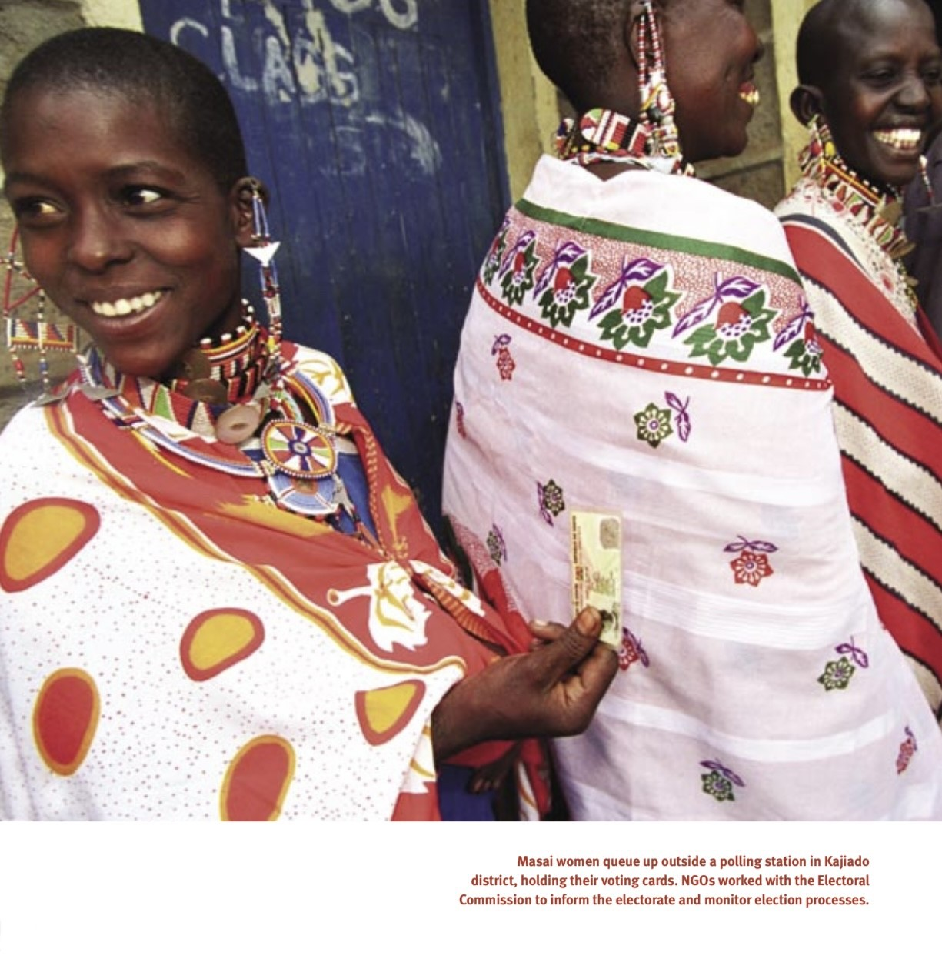

Executive Summary

Civil Society Organizations (CSOs) contribute to worldwide development. They offer development and humanitarian assistance, innovate in care provision, create local capacity, and campaign with and for the disadvantaged. Yet, operating individually, their influence is restricted in breadth, size, and sustainability. More emerging economies have the potential for progressive collaborations between CSOs and governments as democratic reform, violence abatement, and improvements in information and communication technology. This policy brief, on the other hand, addresses the relevance of CSOs and the effects they have on local communities. We also discuss the worldwide difficulties that CSOs confront. This brief suggests practical approaches to advance and engage support for CSOs in local communities, as governments should collaborate to fulfill the objective of sustainable, inclusive, and country-owned development. Any strategy to civil society engagement must acknowledge the importance of their diversified responsibilities and ensure that they have a powerful seat at the table as development partners.

Introduction

Civil society is a critical component of growth and national cohesiveness. Civil society fills the void left by the government and the private sector. Civil society encompasses any social action carried out by individuals or groups that are not linked with or governed by the state. A civil society organization is comprised of individuals who collaborate to advance the public welfare via democratic methods and act as a conduit between the government and the people. (Cooper, 2018) Moreover, social movements emerge in civil society to represent a wide range of social interests, some of which are at odds. In this way, it provides as a forum for interests to compete, reach agreements, and find solutions prior to the necessity for government. Civil society is an important player in the implementation of the SDGs, as well as in the reaction to the COVID-19 epidemic and recovery efforts. Conversely, civil society faces ever-increasing obstacles, such as dwindling public sphere, attacks on human rights, and creeping

Roles | Examples
Advocate/campaigner | Lobbying governments or businesses on topics such as Indigenous rights or environmental protection
Watchdog | Monitoring government compliance with human rights treaties
Fostering active citizenship | Encouraging civic involvement at the local level as well as participation in municipal, regional, and national governance
Participating in global governance processes | Civil society organizations, for example, are on the advisory board of the World Bank's Climate Investment Funds

autocracy. Humanitarian providers should increase their support for civil society in order to close gaps in effectiveness and allow its members to strengthen their accountability mechanisms. A nation needs civil society organizations because they are essential to community development. CSO is responsible for a variety of duties.

The Responsibilities Of CSOs Are:

Types of Beneficiaries CSOs Support & WHY?

NGOs, community groups, research institutes, think tanks, advocacy groups, trade unions, academic institutions, segments of the media, professional associations, farmers, and faith-based organizations are all examples of civil society. (Copper, 2018) Civil society groups seek to promote the general public's rights and preferences, including but not limited to economic, environmental, and health rights. In democracies, they carry out critical evaluations and tasks, have influence over the administration, and may hold it responsible. As a result, thriving civil societies are indicative of a robust participatory democracy. They can, however, only be used in locations where the right to free expression and assembly is guaranteed.

Civil society organizations help to achieve goals and raise public awareness of common problems such as accountability, climate change, and human capital. It promotes democracy not only via voting but also through real participation. It encourages variety and offers a voice to a group of individuals that are typically ignored and discriminated against. The volunteer sector has made significant contributions to the fight against discrimination, poverty, exclusion, and deprivation via initiatives that promote awareness, education, social mobilization, research, service provision, and lobbying. To address poverty and inequality constructively, we must include civil society in social concerns. Their role is to educate the impacted populace. As a result, non-governmental organizations (NGOs) have functioned as the nation's engine and an organized component of civil society

Closing Spaces: Challenges That CSOs Faces

Closing space refers to governments imposing regulatory, legal, or practical constraints on civil society, such as prohibitions on foreign funding for CSOs and restrictions on the freedoms of association, assembly, and speech. (Copper, 2018). According to OpenGlobalRights (CSOs) throughout the world are under tremendous pressure as limits on foreign funding, registration difficulties, intrusion in CSO internal affairs, and other types of harassment proliferate. (OpenGlobalRights, n.d.) Civil society spaces are being closed not only in southern nations, but also in Russia, Hungary, and Israel (Kreienkamp, 2017, p. 7). According to Poppe and Wolff (2017), discussions regarding civil society and restricting spaces are part of a larger trend, a "backlash against democracy promotion" and contestation of the current international order. However, they highlight how there can be tensions between the promotion of human rights and democracy (which is the normative basis for many CSOs receiving funding from governments and international organizations in the global north) and state claims to sovereignty, self-determination, and non-interference (Poppe & Wolff, 2017). For example, in 2018, Uganda's President Museveni blamed political demonstrations on civil society, foreign involvement, and the media.

Civil societies are being confronted with several issues. They are as follows:

- Volunteerism has declined throughout the years.

- Employees capacity is declining since many CSOs cannot afford to pay staff owing to a lack of funds, thus they cannot hire more people to accomplish the essential work. CSOs are non-profit organizations, they rely heavily on donors and funding agencies. Civil society is sometimes plagued by a reliance on donor financing, which impedes sustainability, diverts attention away from its aims, and fosters a short-term strategy of chasing funds. As organizations face a global drop in donor financing, questions of reliance and sustainability become more pressing. Organizations have a propensity to spend their energy and attention on getting additional money rather than focusing on accomplishing their goal to secure financial security. These groups faced increasing pressure from both state and non-state actors, such as restrictive regulations that made simply forming groups difficult in many states. Funding constraints prohibited those with the capacity to make a significant effect from functioning. States degrade CSO credibility, financial stability, and legal protection through a combination of official and informal means (Kreienkamp, 2017). For example:
• In India, at least 30 (NGOs), including Greenpeace India, were denied a government license to receive foreign financing in 2016 because their activities were not regarded to be in the national interest.

- Authorities' increased surveillance of civil society, notably journalists and human rights activists, has alarmed both the media and academics. The Citizen Lab at the University of Toronto, for example, claims that Pegasus malware has been used to eavesdrop on individuals using their mobile phones, notably in Mexico41.

- Increased violence: Over 1,000 human rights defenders were killed, harassed, imprisoned, or subjected to smear campaigns in 2016, with Latin America accounting for more than 75% of those killed (Kreienkamp, 2017, p. 3).

- Governments restrict information transmission to manage, monitor, or suppress civil society (Kreienkamp, 2017, p. 8). This includes journalists and media outlets being driven into self-censorship (for example, by the prospect of costly lawsuit or personal risk), the state gaining control over digital technology, and concerns with social media.

- According to Florence Adong (Basic Needs Uganda), donor application and due diligence processes in Northern Uganda CSOs are cumbersome. Donors are being asked to meet onerous standards and criteria. For example, the requirement for letters of recommendation places CSOs in a more vulnerable position and empowers the government more power and control over what type of work CSOs should be doing and which donors CSOs should work with, potentially limiting CSOs who have not had good relationships with governments or CSOs who have been critiquing governments' work.

These issues must be addressed in order to make society a better place to live.

How Can CSOs Meet Sustainable Development Goals In Localize Communities

Sustainable development is the concept that human civilizations must survive and satisfy their needs without jeopardizing future generations' ability to meet their own needs. The United Nations established 17 Sustainable Development Goals (SDGs) and 169 objectives in 2015 2015. It was adopted by 193 nations. The mission of the UN is for these goals to be accomplish by 2030.

The 17 Sustainable Development Goals are placed below:
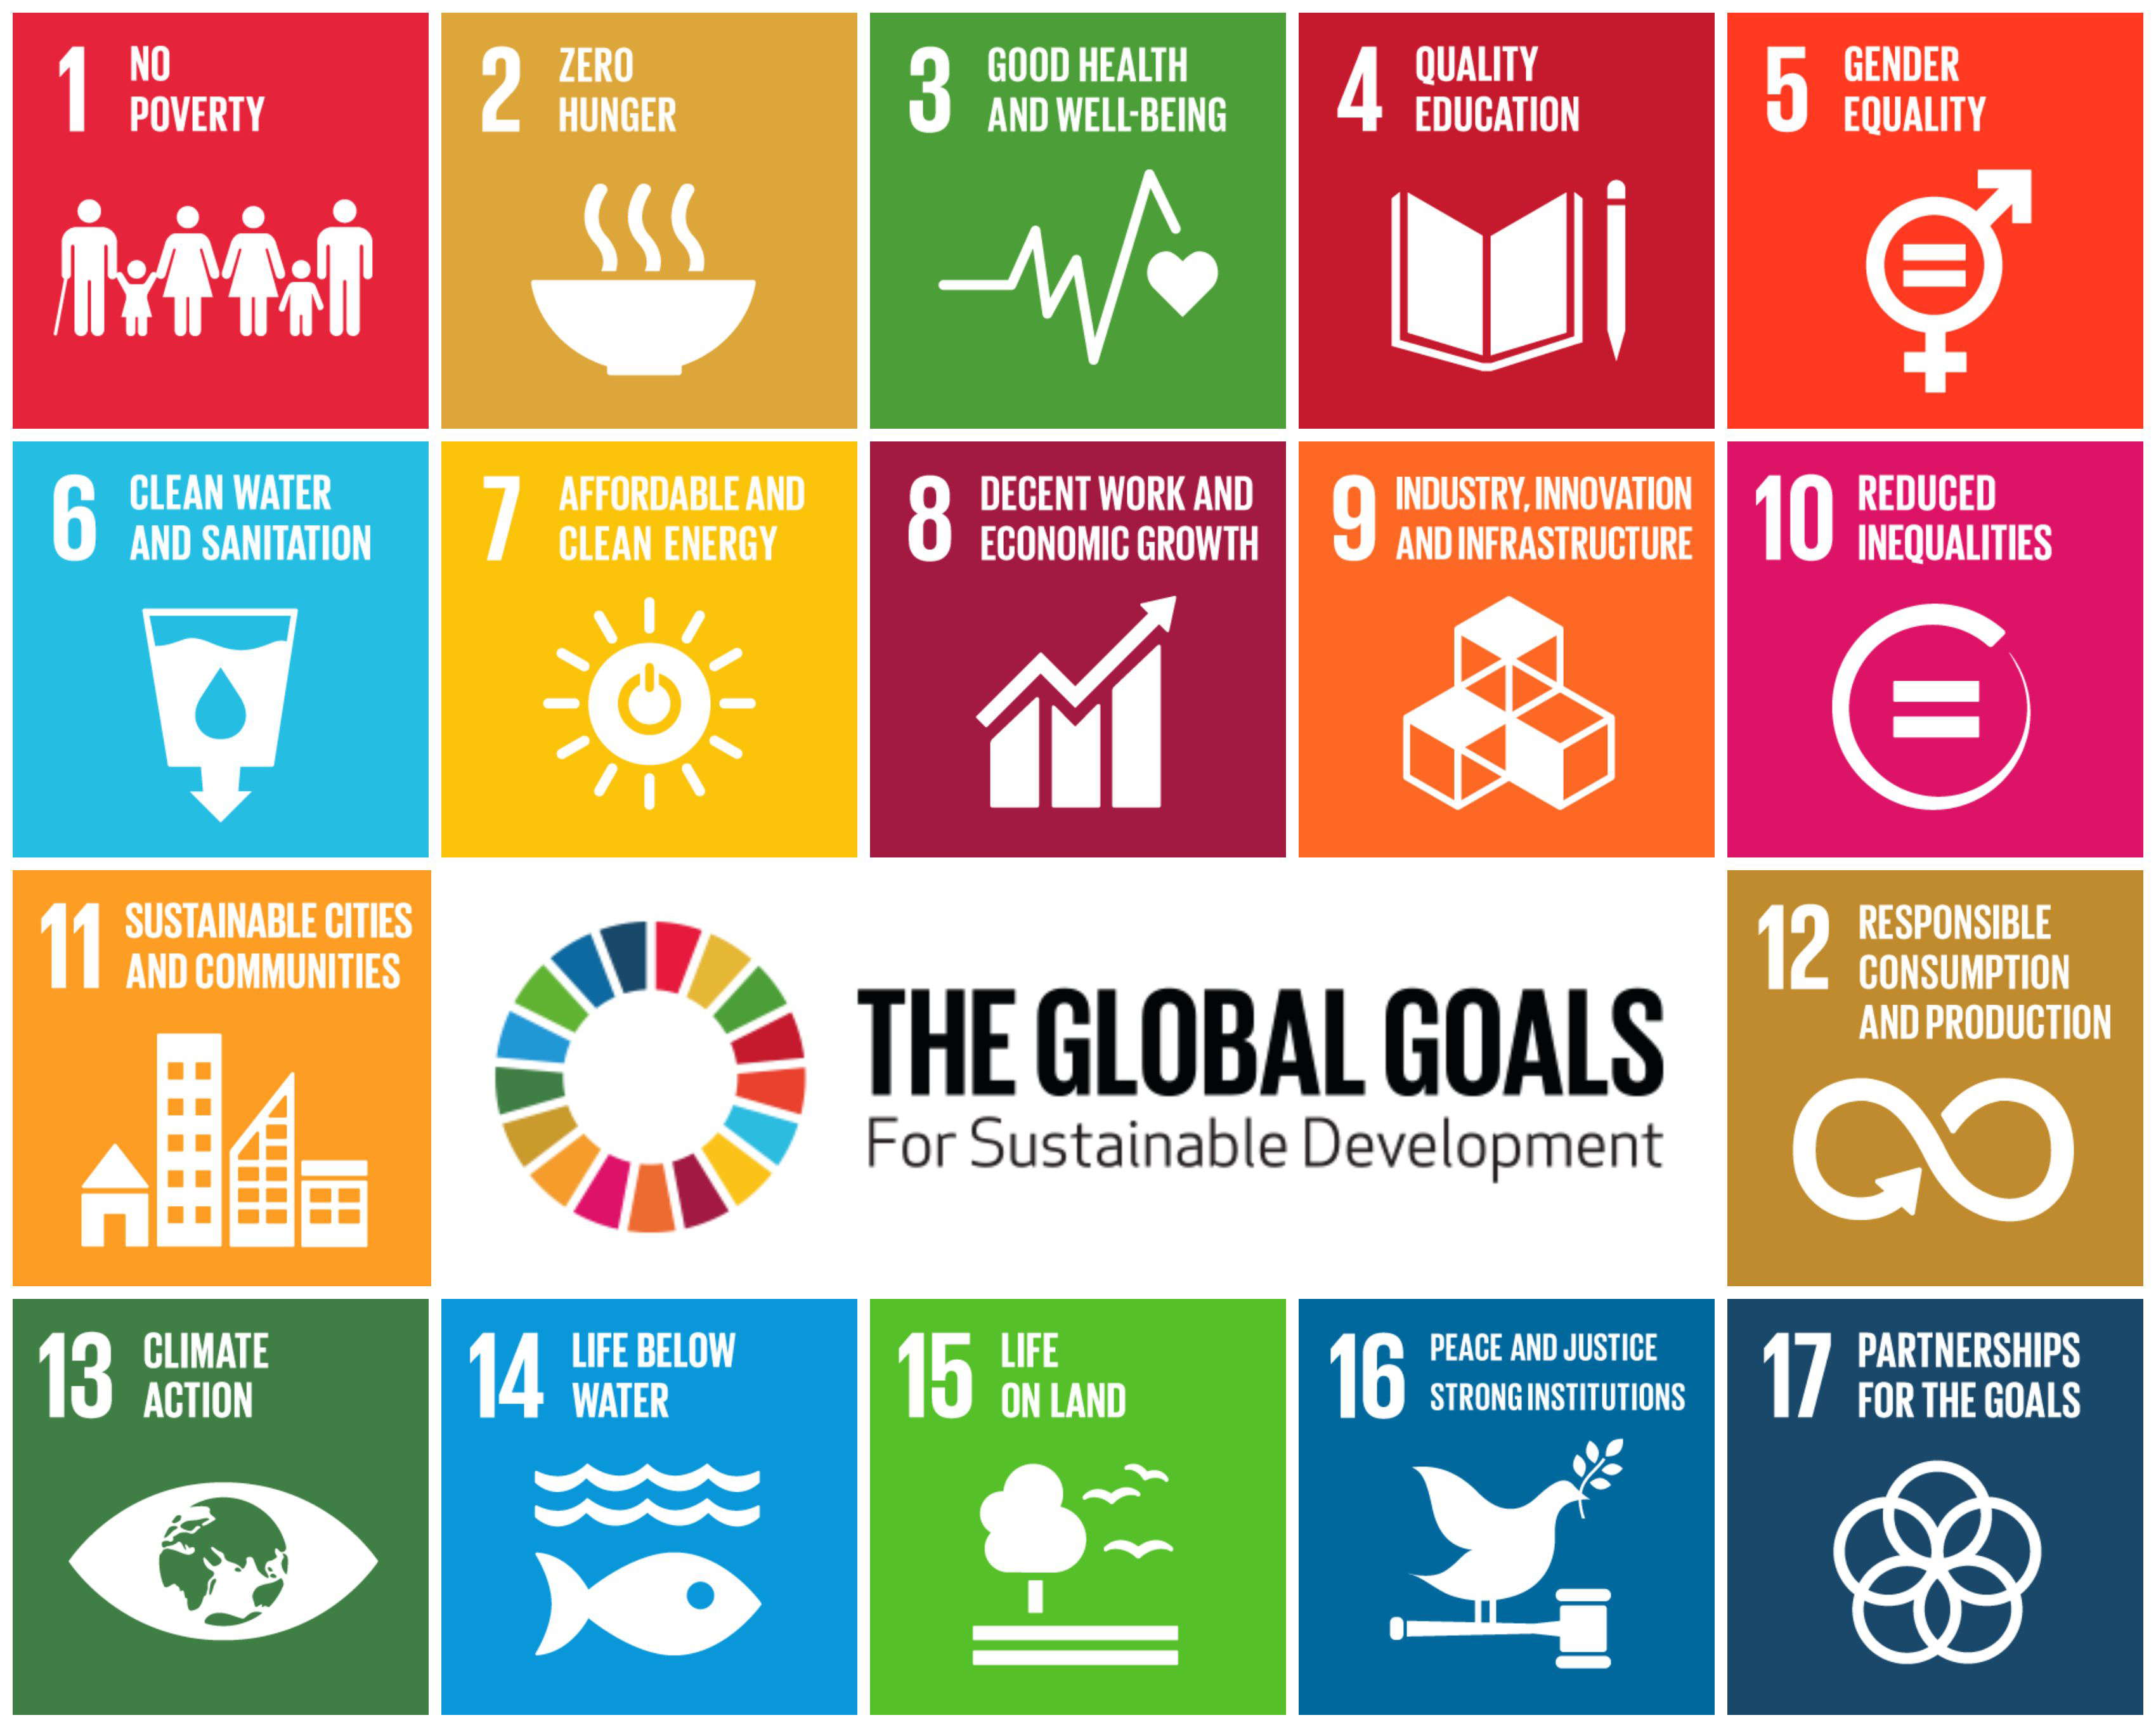

One of the Sustainable Development Goals is to eliminate poverty in all its forms worldwide. Poverty should be defined as a set of interrelated characteristics that contribute to physical and psychological poverty, a lack of involvement in decision-making, vulnerability to environmental shocks, and low self-esteem and confidence. In such a context, civil society groups can aid government programs to eliminate poverty by offering community-based, individualized assistance and implementing evidence-based, creative, and long-term solutions to help individuals escape poverty. Data collection and reporting procedures are weak, but data are required to measure progress because of their significant local presence, civil society organizations may assist in localizing sustainable development goals and monitoring progress. A web-based electronic monitoring system will enable government agencies to report on how the SDGs are being achieved. While it is essential to ensure the accuracy of this data, the capacity to collect data to analyze nationalized sustainable development goals indicators will be the true gauge. Co-production is a notion that refers to a strategic approach in

which individuals construct or improve pre-existing services that they utilize without relying on governmental organizations. Residents become active participants in public services rather than passive recipients through co-production. It is the driving force behind transparent, cooperative governance, ensuring the delivery of more inclusive public services. CSOs may put pressure on governments to determine development priorities so that policies and programs are based on local needs as well as opportunities and resources. Furthermore, they could persuade governments to use new, more effective techniques for tackling poverty and other social ills.

It is critical to create an environment that allows CSOs & NGOs to function and engage in decision-making that is responsive, inclusive, participatory, and representational, therefore enabling women to take climate action. Social cohesion, which is feminine, is one method that a group of individuals might work together for their mutual gain. Women's natural propensity to develop trust fosters a sense of community, which may be a valuable tool for promoting resistance to climate change.

SPECIFIC PRINCIPLES AND RECOMMENDATIONS FOR A STRATEGY ON ENGAGING LOCAL CIVIL SOCIETY BY The U.S. Agency for International Development (USAID).
Civil society organizations must actively participate in determining development priorities and goals to promote country self-sufficiency. When communities in poor nations have a say in their development, it opens the door to greater influence and long-term consequences. Donors should collaborate as partners with local civil society organizations to promote sustainable development.
Promote diverse and inclusionary civil society participation in priority setting.
Invest in local civil society actors.
Donors should support local civil society actors, notably marginalized organizations, to strengthen their operational ability and raise their visibility in-country. Building strong civil society institutions need core support as well as project-based cooperation. Investments should be adapted to each civil society group's unique goals, objectives, and priorities. Depending on the local context and needs, assistance may include assisting in risk mitigation and enhancing advocacy, analysis, budgeting, and management activities.
Civil society requires a political, financial, regulatory, and cultural context that allows it to successfully offer public services, mobilize people, hold the government accountable, educate communities, and advocate for change.
Strengthen and protect civic space.

Recommendations: An Integrated Framework For Action

Civil Society Organizations can expand their role and contribute to the advancement of SDGs in localize communities by:

- Civil Society Organizations on a local, regional, and international level should come together to form a large and strong unified front globally that can speak for the rights of all CSOs and therefore interact with governments, anti-government organizations, and thereby play a rightful role in one's country's social and economic development.

- Work to improve and safeguard the enabling environment for civil society. In many nations, civil society and democratic practices are under threat and suffer greater constraints. USAID must confront governmental limitations, corruption, and disdain for basic human rights so that civil society groups may play their critical roles.

- Invest in civic society's capacity. In addition to assisting various programming aspects, USAID should provide aid for CSOs operational capability, customized to the individual aims and priorities of each organization.

- Collaborate with a wide variety of and diversified civil society players. USAID may leverage their investments in civil society organizations to battle the inequity that keeps some groups out of a country's economic, political, and social life. USAID and the business sector should provide special attention to organizations that advocate underrepresented communities and solicit their views.

- Extend Community Initiatives and other locally led development projects. Concentrate assessment and evaluation on locally determined success metrics. Create capacity-building standards for a more dynamic and varied civil society. As part of any assistance transition, assess the strength and durability of local civil society and civic space, and look for methods to alleviate potential switchover effect.

- CSOs must start using social media platforms and innovative tools like podcasts for generating awareness and fundraising, as well as technology tools to boost the effectiveness of their job.

- Diversifying funding; Forming links with international business.

- CSOs can overcome these limits by either increasing their own capacity or collaborating with other stakeholders to get access to external capacity.

- Implement strategies to make volunteering easier and more rewarding to increase volunteering capacity.

- Donors can promote and help recipient countries in opening political environments. Encourage and support effective policy procedures to render them more progressive (forward looking, outcome oriented, evidence-based, joined up and inclusive). Ensure that assistance is delivered in ways that foster collaboration and networking among CSOs rather than duplication (systemic capacity building). Ensure CSOs' informed participation is supported. Facilitate and encourage the creation of policy research networks to deepen the links between research policy and practice.

Appendices

Civil society organizations include the following:
- International Oxfam
- Amnesty International
- Doctors without borders
- CIVICUS

Also, CSOs devise policies that benefit civil society. In the case of a violation of public rights, they also extensively scrutinize the private sector, such as offices and schools. They are also important to a country and even local communities since they engage in a number of activities that have an influence on civil society. Although many CSOs are also financed by companies, they play a vital role in stabilizing the country's civilian population during challenging periods such as the epidemic and the global health crisis. CSO also strives to enhance the country's politics and environment. When the government imposes environmental limitations or corrupts civil society, the CSO responds by developing human rights standards and acting as a human rights advocate.

Legal and regulatory measures used by governments to curtail international financing include: • Requiring prior government approval for the receipt of international funding
• Enacting ‘foreign agent’ legislation to stigmatize internationally funded CSOs
• Caps on the amount of foreign funding a CSO can receive
• Requirement for foreign funding to be routed through government-controlled entities
• Restricting activities that can be undertaken with foreign funding
• Prohibiting CSOs from receiving funding from specific donors
• Constraining international funding through the overly broad application of anti–money laundering and counterterrorism measures
• Taxing the receipt of international funding
• Imposing onerous reporting requirements on the receipt of international funding
• Using defamation, treason, and other laws to bring criminal charges against recipients of international funding (Rutzen, 2015, p. 31).

Legislation governing foreign finance, including reporting requirements for CSOs. Delegitimization initiatives incur reputational costs as well as additional regulatory and administrative barriers. Governments develop 'loyal voices,' such as the Myanmar Development Foundation, to produce 'loyal voices.'

Examples on funding restrictions
• In Ethiopia, stringent limits on foreign financing imposed in 2009 resulted in the closure of 25% of local organizations within three years. When imposing limits on foreign funding for domestic CSOs, governments and policymakers typically argue the necessity to defend national security and sovereignty (Kreienkamp, 2017).

Many countries, notably Russia, Hungary, and Israel, are regulating or limiting their support for civil society, which includes making funding contingent on governmental permission, instituting a cap, forbidding funding from certain donors or for specific types of activities, mandating that donor cash be channeled via government channels, or outright blocking foreign funding (Kreienkamp, 2017, p. 7).

In Botswana and Kenya, LGBT rights groups have successfully challenged government refusals to allow them to register (Kreienkamp, 2017, p. 10). In 2014, UN Special Rapporteur, Maina Kiai launched a project to support strategic litigation in domestic and regional courts for cases related to the right of freedom of peaceful assembly and of association (Kreienkamp, 2017, p. 10). However, this like other strategies to resist closing spaces, has some limitations: litigation is costly, the likelihood of success is dependent on the independence of the judiciary, and if successful, states can refuse to follow court orders (Kreienkamp, 2017, p. 10).

Strategies for closing spaces

• Third-party states voicing concern over civil society restrictions and exerting pressure on governments.
• Development of early warning mechanisms, including a suggested EU ‘Shrinking Space Early Warning’ mechanism that would allow Member States to respond to new restrictive legislation before it is passed (Kreienkamp, 2017, p. 11).

CIVICUS (2018) argue that ‘the fightback is on’: there are signs that citizens are organizing and mobilizing in new and creative ways to defend civic freedoms (p. 4). They cite El Salvador and the Dominican Republic as examples. In El Salvador, following years of civil society advocacy, the government passed a law banning environmental and socially harmful gold-mining practices (CIVICUS, 2018, p. 16). In the Dominican Republic, the Green March Movement brought people from all sections of society together to protest corruption (CIVICUS, 2018, p. 16)

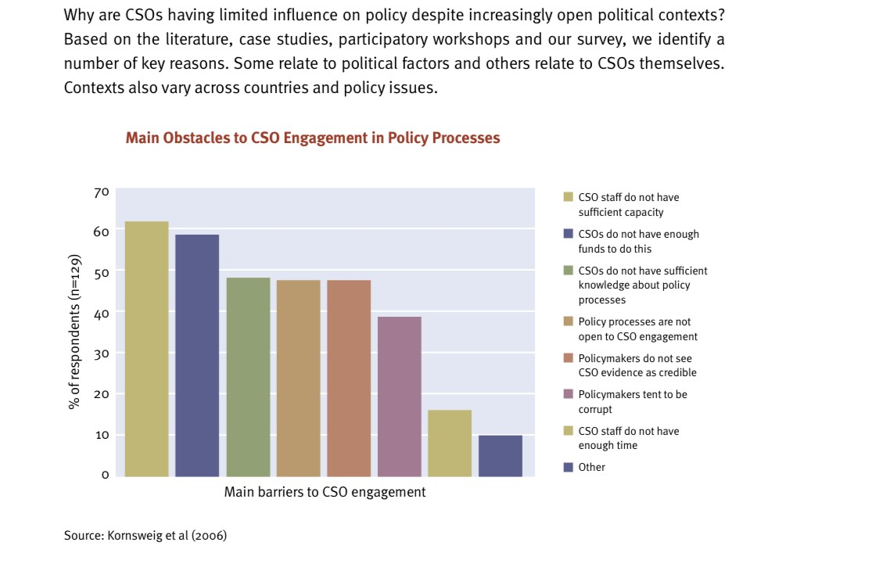
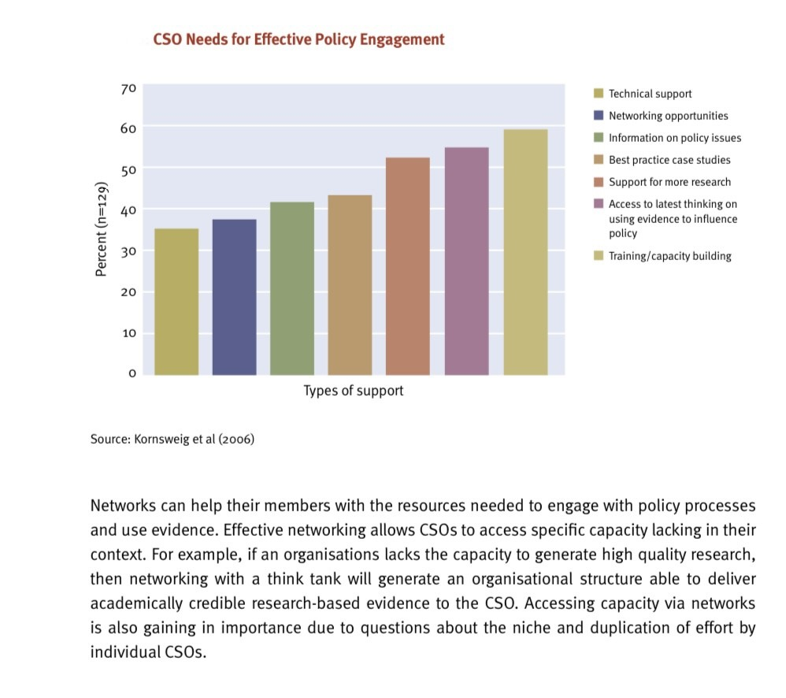
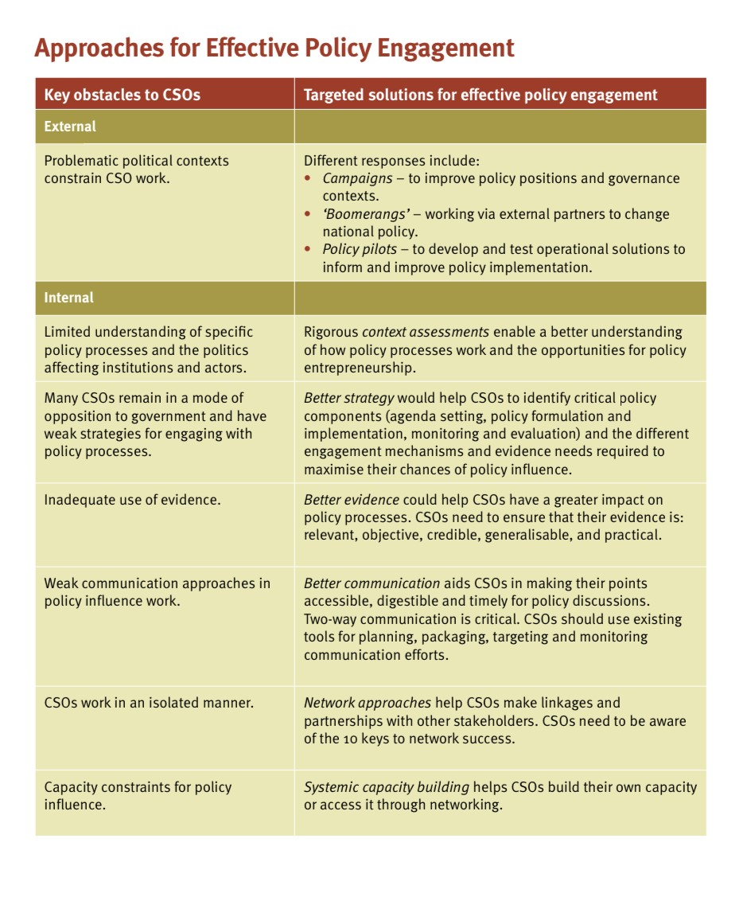

Recommend and Consulted Sources
- Bank, A.D. (2018). Engaging Civil Society Organizations in Advancing the Sustainable Development Goals. [online] Asian Development Bank. Available at: https://www.adb.org/news/events/engaging-civil-society-advancing-sustainable-development-goals [Accessed 8 Nov. 2022].

- Cooper, R. (2018). What is Civil Society, its role and value in 2018? [online] Available at: https://assets.publishing.service.gov.uk/media/5c6c2e74e5274a72bc45240e/488_What_is_Civil_Society.pdf#:~:text=Civil%20society%20roles%20include%3A%20service%20provider%20%28for%20example%2C [Accessed 9 Nov. 2022].

- Court, J., Mendizabal, E., Osborne, D. and Young, J. (n.d.). Policy Engagement How Civil Society Can be More Effective. [online] Available at: https://cdn.odi.org/media/documents/200.pdf [Accessed 1 Nov. 2022].

- Ingram, G. (2020). Civil society: An essential ingredient of development. [online] Brookings. Available at: https://www.brookings.edu/blog/up-front/2020/04/06/civil-society-an-essential-ingredient-of-development/ [Accessed 10 Nov. 2022].

- OpenGlobalRights. (n.d.). Closing Space for Civil Society? [online] Available at: https://www.openglobalrights.org/closing-space-for-civil-society/ [Accessed 9 Nov. 2022].

- press.un.org. (2017). Civil Society Vital to Protecting Human Rights while Fighting Terrorism, Ensuring Judicial Independence, Experts Tell Third Committee | UN Press. [online] Available at: https://press.un.org/en/2017/gashc4207.doc.htm [Accessed 7 Nov. 2022].

- PRINCIPLES AND RECOMMENDATIONS FOR A STRATEGY ON ENGAGING LOCAL CIVIL SOCIETY. (n.d.). [online] Available at: http://modernizeaid.net/wp-content/uploads/2020/03/Principles-for-Engaging-Local-Civil-Society.pdf [Accessed 9 Nov. 2022].

- Suzanne Nazal (2018). 5 ways civil society organisations can help advance the SDGs. [online] Eco-Business. Available at: https://www.eco-business.com/opinion/5-ways-civil-society-organisations-can-help-advance-the-sdgs/ [Accessed 9 Nov. 2022].
- Kreienkamp, J. (2017). Responding to the Global Crackdown on Civil Society. Policy Brief, Global Governance Unit, UCL. Retrieved from https://www.ucl.ac.uk/globalgovernance/sites/global-governance/files/policy-brief-civil society.pd

- Nazal, S. (2018). 5 ways CSOs can help advance the SDGs. Asian Development Blog, 24 September 2018, retrieved from https://blogs.adb.org/blog/5-ways-csos-can-help-advance-sdgs

- O’Driscoll, D. (2018). Civil Society in Authoritarian Regimes. K4D Helpdesk Report. Brighton, UK: Institute of Development Studies.

- Poppe, A. E., & Wolff, J. (2017.) The contested spaces of civil society in a plural world: norm contestation in the debate about restrictions on international civil society support, Contemporary Politics, 23:4, 469-488, DOI: 10.1080/13569775.2017.1343219 Privacy International. (2018).

- Lone voices leading the way: How civil society in Africa is successfully countering government narratives on cyber security. Article, 11 July 2018, retrieved from https://privacyinternational.org/blog/2160/lone-voices-leading-way-how-civil-society-africasuccessfully-countering-government

- www.youtube.com. (n.d.). Challenges Civil Society Organisations in Uganda face accessing funding | Florence Adong. [online] Available at: https://youtu.be/JvhiwfJmEMg [Accessed 9 Nov. 2022].

- www.youtube.com. (n.d.). Challenges Caribbean Civil Societies Face. [online] Available at: https://youtu.be/HIy74hd2E7s [Accessed 10 Nov. 2022].

