Effective Teamworking and Communication

Student name: Nicoleta Elena Ispas
Student number: 2113247
Module code: BMSW4002
Lecturer name: Muhammad Islam
Assignment title: Component 1 Report Effective Teamworking for team succes

Summary:
There is given a scenario which is about Next who is a clothing brand which wants to launch new clothing items. To do this, a team needs to be created. People from various backgrounds will have to work together to support Next and make this project actually happen. Everyone is different and because of this, people can have misununderstandings and other conflicts when working together as a team. This report is all about effective team and as per the discussion focus will be paid on what teamwork is, how people can end up having unbreakable relationships among each other when working as a team by using specific models like Tuckman’s model or from role viewpoint Belbin’s team roles. Finally conclusion will be offered following recomendation to why effective teamwork is important and what are the things which can improve teamworking.

Table of content
Contents
Summary: 2
Introduction: 4
What defines a team: 4
What contributes to effective teamwork: 5
Model of teamwork: 6
Role for creating effective team: 7
The theory has 3 important cateories. Each category has 3 roles: 7
Impact of effective teamwork on team success: 9
Barriers to effective teamworking 9
Impact of effective teamworking 10
Conclusion/Recommendation: 11
Reference 12

Introduction:
Effective team has a huge importance on organisational success. All the team members need to play an effective role to make the team a success and all need to pay their role
accordingly.
In this report, it will be discussed what a team is, what a teamwork means and the characteristics a team can have. A team is a group of people which work together to complete a certain task. Teamwork is the skill which makes people be willing to work together so they could achieve a goal they have set as a team.
This report will also be about the theoretical models which can be used and how a team can be developed. For example, one of the models is called Tuckman model and this model has 5 big steps that should be followed if the teams wants to achieve the goal they have set: Forming, Storming, Norming and Performing. Belbin’s team roles will be used too which is divided into 3 sections which are thought-oriented, action-oriented and people-oriented.
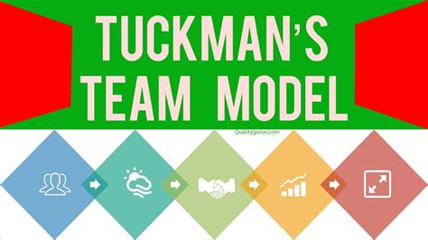

What defines a team:
Kozlowski and Bell (2003) is defining the team as a group of people ‘‘who exist to perform organizationally relevant tasks, share one or more common goals, interact socially, exhibit task interdependencies, maintain and manage boundaries, and are embedded in an organizational context that sets boundaries, constrains the team, and influences exchanges with other units in the broader entity’’
This definition says that people usually connect with each other in order to achieve a certain task they have been asked to do. In order to do this, they will have to interact with each other in any way possible.
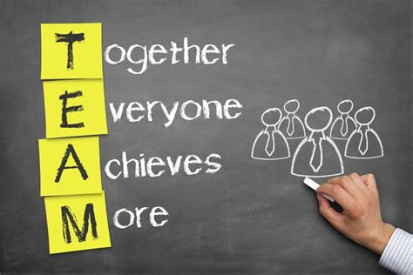

What contributes to effective teamwork:
Interdependance - when individuals believe that they can accomplish their goals, vision and missions by sharing with others of their group, they experience positive interdependance. As a result of interdependance, a group’s work is the results of interpersonal interactions. Practicing and giving priority to each of the individuals of the team is another characteristic which indicates the social interaction.
Open communication - communication is one of the key points for a succesful team. Open communcation can encourage a lot the people in a team. This also helps the members of the team deal with any types of conflicts because open communcation encourages people to trust each other, be comfortable with each other and also be friendly.
Positive feedback - this is one of the most important attributes because this helps the members of team be more productive and this will also help them stay motivated and improve their work.
Team processes - The purpose of working as a team is to make the job easier and faster for the team members.
Leadership and accountability - being the leader of a team is a very big responsibilty because that person needs to look after all the members and also make sure that the tasks are done on time.
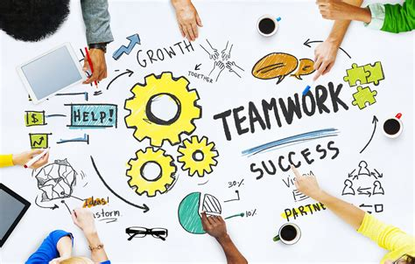

Model of teamwork:
Tuckman’s model could be used for this scenario because it is really easy and really fast to understand. It is one of the most influential models used over the past 50 years or even more. It was first published in 1965 and it only had first four stages: Forming, Storming, Norming and Performing.
This model has become ‘the most predominantly referred to and most widely recognized in organizational literature’ (Miller 2003, 122).
This model was created to help people understand what it is like working as a team and how people can grow together when working as a team.
Tuckman’s model steps:
Forming – each members of the team focuses their attention on the leader only and pushes everyone else away, but they try to do it as politely as possible. Strengths, weaknesses and other boundaries will be tested for each member of the team, also including the leader. The leader must be ready to provide the team with all the answers they will need. There is more likely for the team to have some clinging because of the past conversations they have had.
Storming – this step is a difficult one. The members of the team tend to care more about the impressions they make than the project they are working on. They will overthinking every situation because they will want to find out who is going to stick by their side, who is going to be against them and so on. Because of things like this happening, certain individuals will start isolating themselves which is very common, especially nowadays because they might feel left out when their opinions are not heard the way they wanted.
Norming – when the team reaches this stage, this is when everything is going on the right path. Everyone can take part in making big decisions without being too worried about going back to the Storming stage because the relationships between the co-workers are strong now.
Performing – because of the strong and healthy relationships the co-workers and team leader have with each other, the team is unbreakable. Nothing can really damage the connections because everyone is comfortable with everyone and everything now just seems fun and enjoyable.
Adjourning – at this stage, the members of the team will look back and realise how much they have progressed comparing to when they first joined the team. This will help the people a lot in their future team collaborations because it will be easier for some of the people to adapt in a type of environment which requires teamworking.
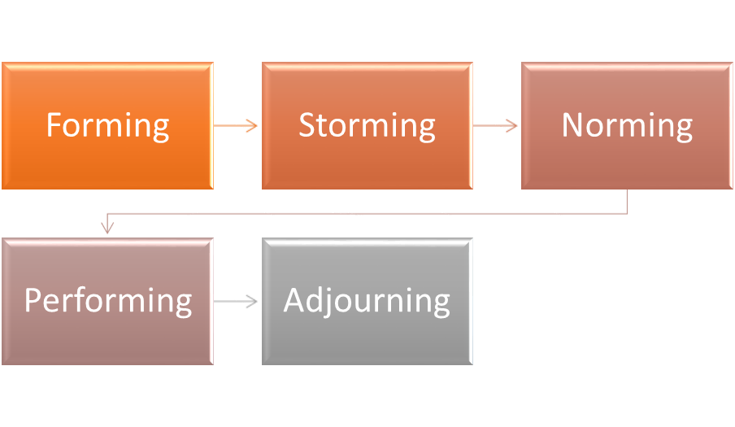

Role for creating effective team:
Belbin’s Team roles is one of the theory which can be used here.
This is more than just a theory; it's a tool that people, teams, and organizations can use to work more effectively together to achieve business objectives.

The theory has 3 important cateories. Each category has 3 roles:
- Action-oriented
- Shaper - Extroverts are usually good at this role and are confident challenging others. Shapers embrace the chance to shake up the status quo in search of better solutions.
- Implementer - Implementers are doers: people who work hard when they've been assigned a task. The best execution of plans comes from methodical systems.
- Completer-finisher - Finishers are perfectionists by nature, and are responsible for ensuring projects are completed on time and to the best possible quality. Meeting deadlines is important to them, and they avoid errors at all costs.
- People-oriented
- Coordinator - Coordinators play a similar role to traditional leaders. Coordinators guide their teams toward the objective in a controlled and proficient way by understanding the team's overall goals and delegating tasks to the right people.
- Team-worker - When working in a group, the team member excels in overcoming differences and avoiding conflict while working towards a common goal. Team workers are popular at work because they strive to provide an environment of support.
- Resource investigator - Roles in this category are associated with those who are good at building contacts. The best resource investigators are frequently extroverts and skilled negotiators who collaborate with external suppliers.
- Thought-oriented
- Plant - Plants generate original and interesting ideas for the team. They are generally introverted, preferring to solve problems and develop new ideas alone.
- Monitor-evaluator - Monitor-evaluators are expert at analysing ideas and assessing them strategically. A number of factors need to be considered when looking at each option.
- Specialist - Specialists are experts in their area of expertise and pride themselves on their knowledge and expertise. Their expertise serves as an invaluable resource to the team, bringing technical and practical knowledge to bear on the topic.
It is very important to cosider these roles when recruiting staff because some business organizations use team role theories in order to create what they believe is the best team for the project.
In 1981, Belbin proposed a widely recognized team role theory. Depending on how people behave in relation to one another, he believes people exhibit behaviour patterns that facilitate the progress of a team.
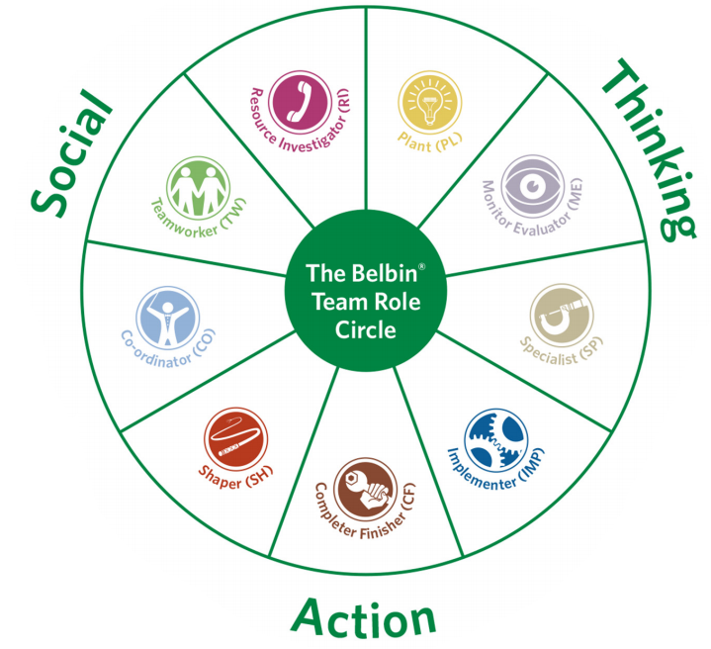

Impact of effective teamwork on team success:
Advantages of effective teamworking
- Increased productivity - A team that contributes to producing results will feel valued, committed, and supported. Staff will be more motivated, happy, and productive.
- Deadlines met - Unless people work alone, they can only achieve so much. By bringing people together to work as a team, they can be more productive, more effective, and better able to meet deadlines.
- Problem solving - Teamwork combines thinking styles, levels of expertise, and ways to approach problems. Finding solutions can be more effective when many people are working together on a problem.
- Strong relationships - Strong bonds are built by teamwork. Learning strengths, weaknesses, and personal characteristics of team members. A stronger relationship builds trust, leading to more natural, open and free communication.
- New ideas and opportunities - By working together, people can create new ideas, products or services or identify new business opportunities that will lead to the organization's success.
- Flexibility - Transferring skills and knowledge between individuals is easier when working in teams. Individuals will be able to cover for each other, which could lead to greater flexibility.
- Conflict resolution skills - While personality conflicts often occur between individual team members, cooperation towards a shared goal can enable employees to resolve disagreements in a way that benefits the whole group.
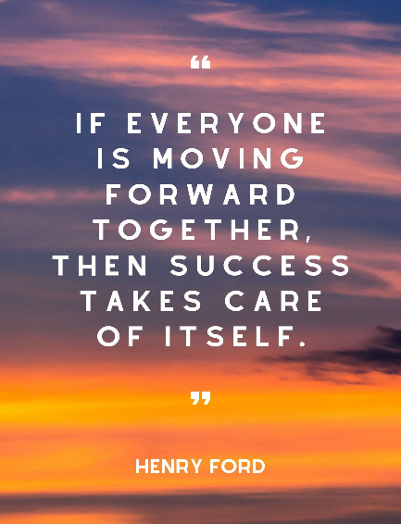

Barriers to effective teamworking
There are some barriers in this scenario which affect the effective teamworking. One of them is communication. Some people were really confident about the ideas they had and because of this, other people were quite unsure about their own opinions and weren’t contributing that much to help the team. This usually happens when people see that there is someone who has better ideas than them becauswe this makes them feel like they are not good enough, when in reality everything is just in their head. Everyone has a different way of thinking and all the ideas shold be taken in consideration the same way.
This problem led to misunderstandings and even conflicts because of the lack of communication the team had. The team came to the conclusion that the montly meetings they were having were a waste of time because they couldn’t get to an agreement in any ways.
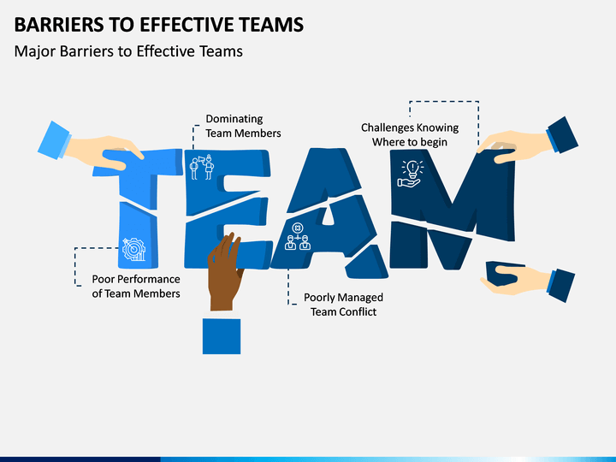

Impact of effective teamworking
The team keeps wasting their time when having montly meetings because there is a big lack of communication between the team-workers.
This can be clearly seen because some of the team-workers didn’t really contribute to helping the team as much as the others did because every team-worker has different personalities and different ways of thinking, so the team-workers were viewing the preoject in different ways. Because of this lack of communication, conflicts and other misinterpretation took place. This made the whole team came to the realisation that they all wasted their time when they were attending the montly meetings because they couldn’t get to the same agreement.
If the team had better communication skills, then they would’ve not wasted their time during montly meetings and the team-workers would’ve not had to take part in conflicts or have other misunderstandings and misinterpretation.

Conclusion/Recommendation:
Effective teamworking has a huge importance when it comes to teamwork. The more effectiveness exists, the more success a business will have. Working effectively helps the team in making stronger relationships because when people get to know each other, the individuals will start learning about each other’s strengths, weaknesses and other personal characteristics. This also helps the team meet their deadlines because when everyone works together, it increases the level of productivity which means that things will be done in a shorter amount of time.
One of the most important things that people need to know about effective teamworking is that communication is the main factor which contributes in helping the team achieve the goals they have set in the beginning because when people communicate, the individuals tell each other their own opinions and this helps a lot because everyone has different mindsets and personalities, so they all see a certain problem in different ways.

Reference

1. Griffith and Dunham - Working In Teams.pdf
2. Teamwork(2020) Attributes that contribute to effective team work.
Available at: https://studydriver.com/attributes-that-contribute-to-effective-team-work/
(Accessed: 17 June 2022).
3.https://moodle.uwtsd.ac.uk/pluginfile.php/173913/mod_resource/content/1/BruceTuckman_Team_Development_Model.pdf
4. Denise A. Bonebright (2010) 40 years of storming: a historical review of Tuckman’s model of small
group development
Available at: https://moodle.uwtsd.ac.uk/pluginfile.php/499259/mod_resource/content/1/tuckman%20model.pdf
(Accessed: 17 June 2022).
5. Belbin(2022) Belbin team roles.
Available at: https://www.belbin.com/about/belbin-team-roles
(Accessed: 22 June 2022).
6. Matthew Channell (2021) Belbin’s Team Roles: How Can Team Roles Improve Performance In The Workplace?
Available at: https://www.tsw.co.uk/blog/leadership-and-management/belbins-team-roles/
(Accessed: 22 June 2022).
7. Peter Mackechnie (2003) Belbin Team Role Theories
Available at: https://www.businesscoaching.co.uk/files/belbin_team_role_theories.pdf
(Accessed: 24 June 2022).
8. nibusinessinfo (2022) How to build and manage an effective team
Available at: https://www.nibusinessinfo.co.uk/content/advantages-effective-teamwork
(Accessed: 27 June 2022).

