Database design (The Book Store)
Sam Wattis (1804612)

School of Applied Computing
Computing (Computer Networks and Cyber Security)

Introduction
This report looks at the stages required to create a database in MS Access to meet the requirements of the City Book Store, Swansea to provide fast and efficient customer service to their increasing customer base. Access is a good choice for them as it ensures that the same piece of data can only be stored in one place which leads to greater levels of data accuracy. The report produced of customer orders can be sent out to customers as an invoice, giving a convenient, fast response that is also environmentally friendly.
Creating tables in Structured Query Language (SQL) View
All tables were created using SQL as shown in the Below figures these will be modified at the next stage to allow the query to be modified and match the primary keys with foreign keys in separate tables Lepkowski [1]. As a bit of background on the SQL terms a constraint is a control that is imposed in the columns data of a table to limit the type of data that can be entered. Not null is a type of constraint that data must be entered into a column as this is not the case by default. A table can only have one primary key and it must not be a null value. Primary keys must contain unique ids and identify each record/row in a database. A foreign key is a constraint that must be not null and is a record that is referred to as a primary key in another table.
Figure 1 (Customer Table)
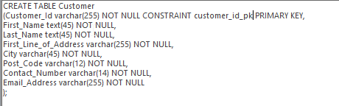
Figure 1 shows the creation of the customer table using SQL. The first column is set as the Customer_id. This is set as a varchar and has a maximum length of 255 characters. Varchar is short for variable characters that means letters, numbers and special characters can be used for this field. The customer is set as a primary key and a constraint is made that there must be a value inputted. The second and third column records are First_Name and Last_Name which are both 45 characters and text which means only letters can be used and a constraint of not null. The fourth column is First_Line_of_Address which is 255 characters and set as a varchar with a constraint as not null. The fifth column is City set as a varchar 45 characters and constrained as not null. The sixth column is Post_code its set as a varchar (12) characters and a not null constraint. Contact_number is the seventh column set as a varchar of 14 characters with the constraint of not null. The eighth column is Email_Address which is 255 characters with the constraint of not null.
Figure 2 (Customer Order Table)
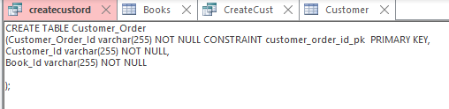
Figure 2 shows the customer order table being created. Customer_Order is set as a varchar to a length of 255 characters and is set with a constraint as the primary key. The second two columns are set as Customer_Id and Book_Id which are both set as varchar to a maximum of 255 characters and have a not null constraint.
Figure 3 (Books Table)
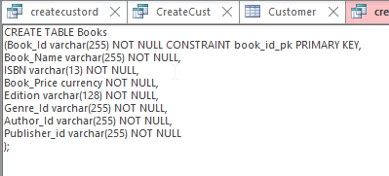
Figure 3 shows the construction of the Books table. Book_Id is put with a constraint of private key and is set as a varchar of 255 characters. Next column is Book_Name which is a varchar of 255 characters with the constraint of not null. The third column is labelled ISBN which is set with the constraint of not null and a varchar of 13 characters. The fourth column is called Book_price and is set as currency that allows it to be set to two decimal places with the constraint of not null. The Edition column is the fifth set as a varchar of 128 characters with the constraint of not null. The sixth column is the Genre_id, seventh column Author_id and finally the eighth column is called Publisher_Id. All of these last 3 columns are set as a varchar of 255 characters with the constrain of not null.
Figure 4 (Genre Table)
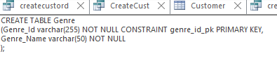
Figure 4 show the creation of the Genre table. Genre_id is set with the constraint of the primary key and a varchar of 255 characters. The second column to be created is the Genre Name which is set as a varchar to 50 characters and has a constraint of not null.
Figure 5 (Author Table)
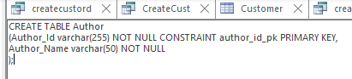
Figure 5 SQL creates the Author table. The first column is the Author_id that is identified as the primary key and is set as a constraint. It is also set as a varchar with 255 characters. The second column Author_Name is set as a varchar of 50 characters and has a constraint of not null.

Figure 6 (Publisher Table)
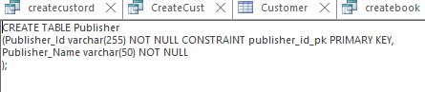
Figure 6 creates the table publisher. The first column to be identified as the primary key with a constraint is the Publisher_Id this is set to a varchar of 255 characters. The second column Publisher Name is set as a varchar of 50 characters as not null.
Figure 7 (Foreign Key Attempt)
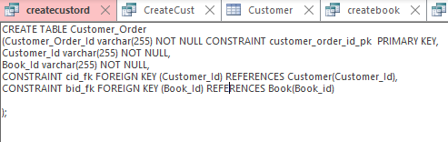
In figure 7 unfortunately, the Constraint for the foreign key was unrecognised when the query was ran, so another approach was taken to link the private to foreign keys in the relationship view shown below in figure 14.
Tables Created
Figures 8-13 Show the newly formed tables after the SQL queries were ran although the data populated inside was added at a later stage.
Figure 8 (Author Table)
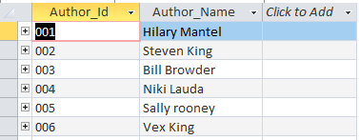
Figure 9 (Books Table)
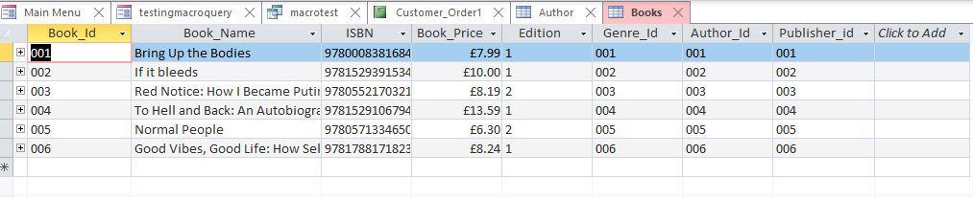
Figure 10 (Customer Table)
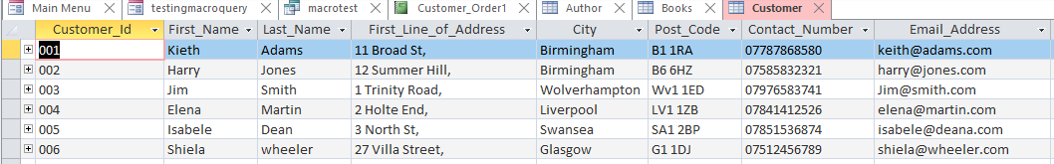

Figure 11 (Customer Order Table)
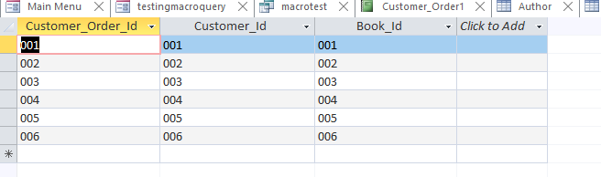
Figure 12 (Genre Table)
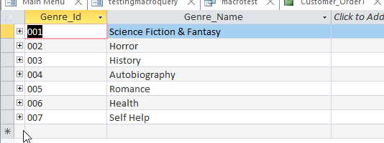

Figure 13 (Publisher Table)
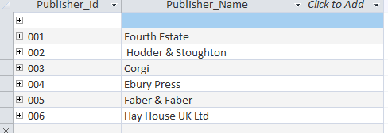
Figure 14 (Relationship Diagram)
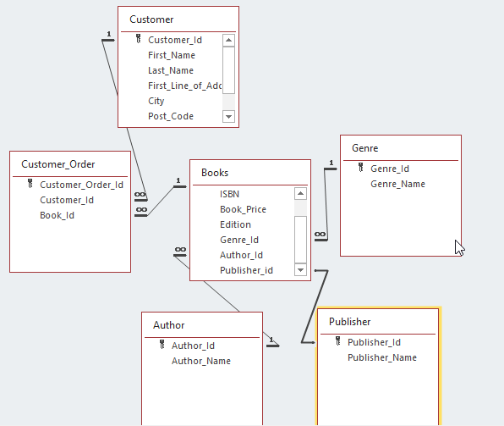
Figure 14 shows a view of the relationship table once the tables have been created and shows how they are linked by both primary and foreign keys. As stated earlier the author had trouble creating foreign keys in SQL so used to view to alter the table design by selecting the properties and changing relevant keys to foreign keys so the tables could link together.

Forms
Figures 15-20 Cary N [2] forms have been created for allowing user entry and constructed using their retrospective tables that where generated by the SQL queries. Directional buttons have been added to allow the user to navigate around the form such as go to the last record, go to the previous record, go to the first record, and go to the next record. If the fields are empty, there are buttons below that have been added to add the record, save the record, or delete the record. Two other buttons have been added to go back to the main menu form and another to close the form entirely.

Figure 15
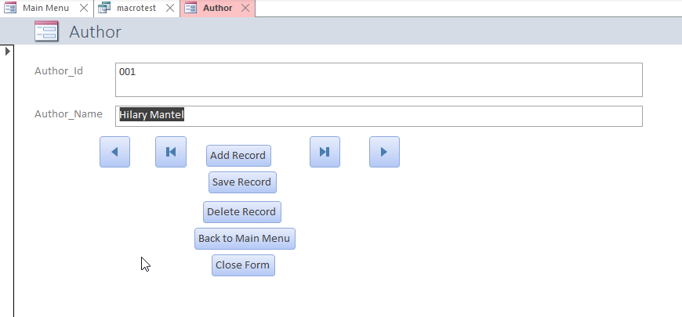

Figure 16
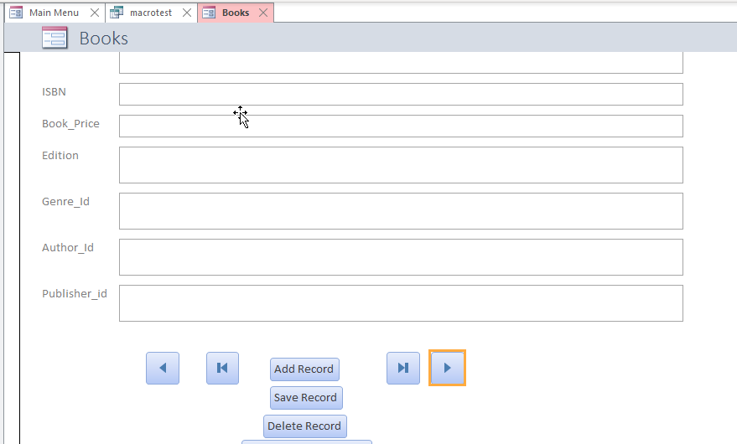

Figure 17
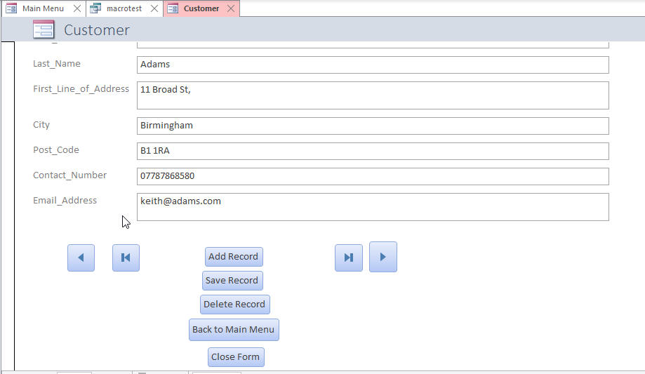

Figure 18
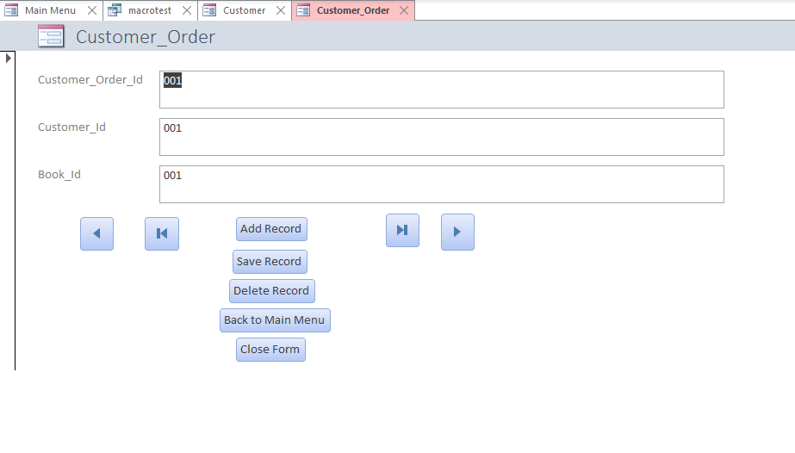

Figure 19
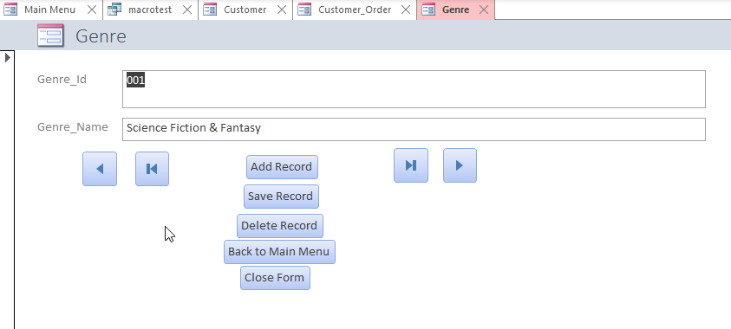

Figure 20
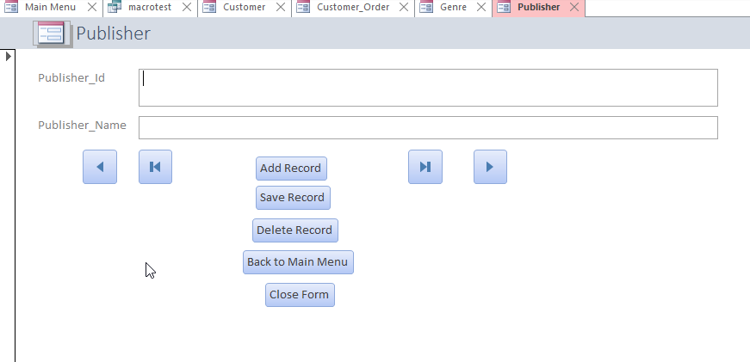

Figure 21
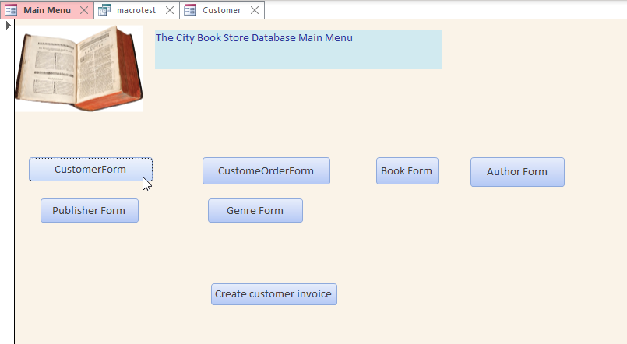
Figure 21 shows the main menu of the database of how to navigate around all the forms currently on the database by clicking the buttons to link to the relevant forms.

Figure 22

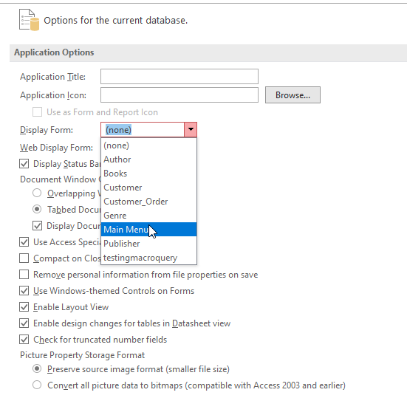
Figure 22 show the process taken to add the Main Menu as the first form to open when the Book Store database is opened for ease of navigation.
Figure 23 Creating a Query in Design view
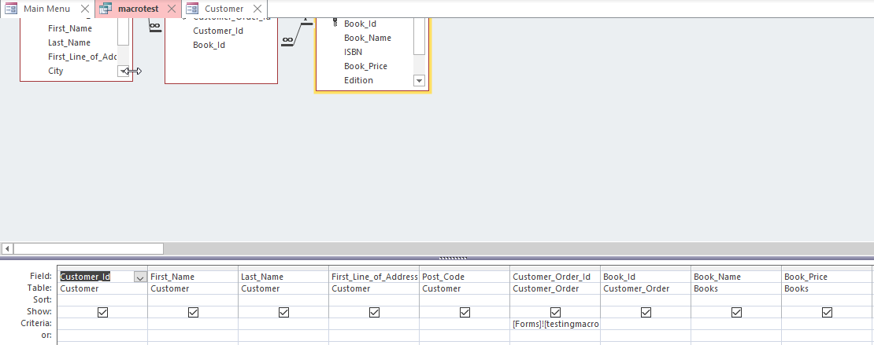
Figure 23 shows how a blank query was designed in the relationship view. First the 3 tables were selected of which the information was required from. Then the relevant fields. The expression builder was then used from the Customer_order_Id field to then select the query which in turn links the unbound button in figure 24 and the query is saved.
Figure 24 (Customer Invoice Form)
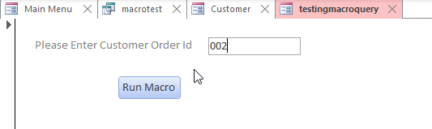
Figure 24 shows the form created for the customer invoice where the user must input a valid customer order then click the run macro button to gain results. Further information on how the macro was developed will be explained in figure 26. This form was created as a blank form by adding an unbound text field and opening the properties and labelling it OrderID. A caption was added as “Please enter customer order Id.”
Figure 25 (Query Results in Design View)
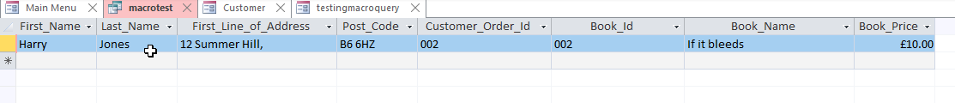
Figure 25 displays the query results as a result of using the macro and will later be used to generate a report as explained in Figure 27.

Figure 26 Creating Macro
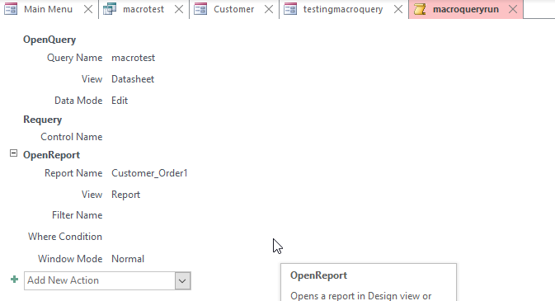

A Macro was created opening the query and selecting the query name macrotest. The datasheet view was then selected. Requery was set and the OpenReport is selected customer_Order1. This will then open the form in normal view and the macro has been saved as macroqueryrun.
To fit this all together on the form a button (see figure 24) was added and the miscellaneous category with the action taken as run macro. The button on the form displays the text run macro.

Figure 27 (Report (Customer Invoice))
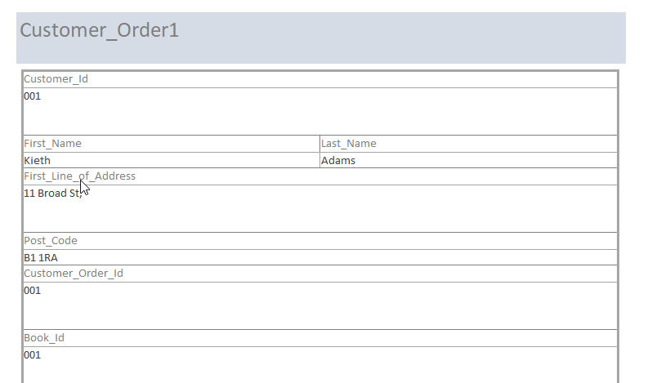
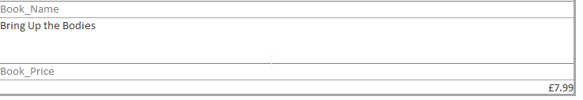

Figure 27 shows the report has been generated by using the report wizard, selecting the macro query, and sending all the details across. The results are sorted by customer order id. The user can now type in a customer order id to generate a report S, Roman [3].

Figure 28 (Entity Relationship Diagram (ERD))
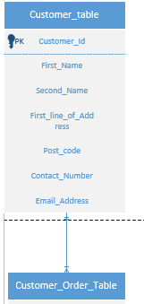
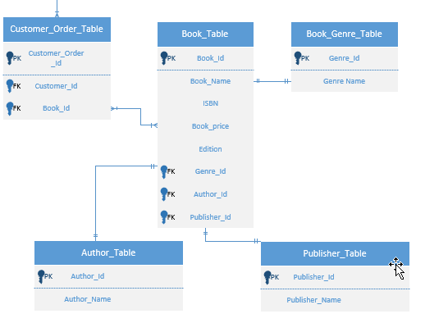
Figure 28 Chilton [4] shows the ERD which has been designed in vision in two separate screenshots to fit the page. This was the first stage in the database design and shows all the table names private and foreign keys and also the relationships between tables such as one to one, one to many or many to many.

Brief User Guide
When Access is opened, and the bookstore database is opened there is presented a main menu. The main menu presents a form for each table within the database. To select any of these forms such as author, Books, Customer, Customer_Order, Genre, Publisher there is a button which will take the user straight to the form.
Once within any of these forms mentioned above the user can navigate between the fields table information by using the directional arrows. If the form shows a blank field this means the table is ready for the user to input new data into the field.
There are also buttons clearly labelled that allow the user to enter data into the database, save that data, delete data and to close the form or go back to the main Menu.
There is also another form within the main menu called customer invoice which allows the user once has been clicked to generate a report/invoice by searching by the customer order number.
Data can also be added manually and searched by selecting the table the user wishes to use in the left-hand side menu.

Conclusion
Overall, the implementation of the database for The City Bookstore was a success. All the queries worked after testing and were identical to the original designs in the ERD. The forms were easily navigable and easy to use, buttons were clearly labelled and all relationships between tables were correctly formed. The query that was created could produce a successful invoice to be sent to a customer the details of their order. On reflection the database however had scope for improvement where that further queries could be added to enhance the user experience where the user as the database stands would have to go into the tables to read the information. For example, these queries could be searches for customer details. These queries could be added to the main menu for ease of access.

References

[1] | L. J, "Complementing Database Design for Microsoft Access with MySQL," Northeast Decision Sciences Institute 2017 Annual Conference, pp. 401-418, 2017.
[2] | C. N. P. M. R. Irwin, Microsoft Access 2000 bible, Foster City: IDG Books Worldwide 2000, 2000.
[3] | S. Roman, Access database design and programming, Beijing, 2002.
[4] | M. A. Chilton, "Data Modeling Using Entity Relationship Diagrams: A Step-Wise Method," Journal of Information Systems Education, vol. 17, no. 4, pp. 385-394, 2006.

