
Report on STRATEGIC MANAGEMENT
Developing an Innovative Customer Care for Future Resilience and Sustainability-Case of RYANAIR

December 16, 2022
theodore toko manzambi- 1904060
UNIVERSITY OF WALES TRINITY SAINT DAVID
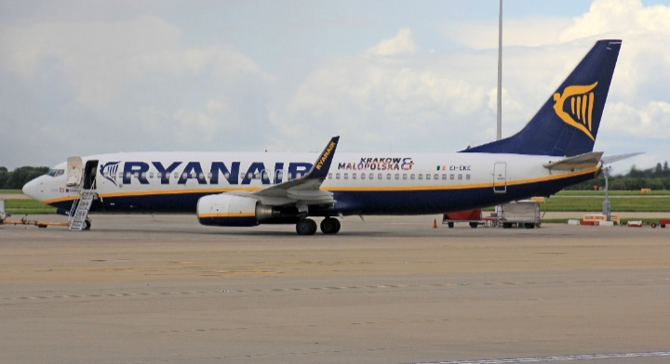
Executive Summary
At the request of their Senior Management Team, Ryanair must implement new methods to foster innovation for the long-term sustainability and resilience of customer care.
Strategic management, argued by Lamb Robert (1984), is an ongoing process that evaluates and controls the company's business and industries; assesses its competitors and sets goals and strategies to meet all existing and potential competitors; and then reassesses each strategy annually or quarterly (i.e., regularly) to determine how it has been implemented and whether it has succeeded or needs replacement by a new strategy to meet changed conditions.
To assess Ryanair's position in the post-pandemic market environment, tools and approaches were applied to this definition and contrasted with others offered by other authors.
To identify areas for improvement for greater future resilience and sustainability, the Strategic Process Model, SWOT, PESTEL, and Porter's Five Forces analysis were used as the tools in the report.
Customer care has been clarified in-depth, and suggestions have been given for future consideration of the word and understanding by front-line staff, as there is still some uncertainty among people regarding customer service-customer experience and customer care. The report has clarified, however, that customer care affects everyone in the company, from the lowest-ranking employee to the highest-ranking Senior Management Team member.
A study has shown that customer care should be considered as a future indicator owing to a lack of understanding between the word, even though Ryanair continues to be among the top airline businesses in terms of cost and daily flight volume.
The knowledge that immigration regulations have changed and will be influenced by Brexit has also demonstrated that Ryanair employs knowledgeable personnel.
The Senior Management Team should be able to fully understand the various requirements of the aviation industry, where customers are valued for fostering trust, loyalty, and long-term engagement with employees who are emotionally aware and able to adapt to any change or behavioural characters. This should be possible with the help of adaptability to change, customer behaviours, and regular training.

Table of Contents
1.0 Introduction 3
2.0 Understanding Strategic Management 4
2.1 Strategy 4
2.1.1 Definition of Strategy 4
2.1.2 Strategic Management 4
2.1.3 Importance 5
2.1.4 The Three Levels of Strategy 5
2.1.5 Strategy Management Process 6
2.2 Application of Strategic Management tools to Ryanair 9
2.2.1 Background of Ryanair 9
2.2.2 SWOT Analysis of Ryanair 10
2.2.3 PESTEL Analysis of Ryanair 13
2.2.4 Analysis of Porte’s Five Forces on Ryanair 15
3.0 Conclusion 16
4.0 Recommendations 17
5.0 References 18

1.0 Introduction
To find a new strategy for providing innovative customer care while assuring long-term resilience and sustainable competitive advantage in the event of a post-pandemic, the top management of Ryanair Group commissioned the investigation that led to the creation of this report.
Before anything else, it's critical to realise that corporate management has radically changed over time, moving from a focus on products and profits to one on customers.
This is in line with Deloitte's 2019 Global Contact Survey results that businesses emphasise upgrading the human experience to set themselves apart from rivals. The customer experience (85%) and service development (78%) were cited as the top investment drivers by businesses in the Deloitte poll. In real terms, this entails focusing on the needs of the customer and providing better customer service.
Although the term customer care is always confused with other terms, such as customer service, customer experience, or customer relations, the term customer care involves, according to Dr. Jan Louise Janes, a way of dealing with customers when they interact with your brand, products, or services to keep them happy and satisfied. Customer care goes beyond customer service and support because it focuses on building emotional connections between brands and customers.
According to Dr Jan Louise Janes (2014), the term "customer care" refers to a method of interacting with customers when they link with your brand, products, or services to keep them happy and satisfied, even though it is frequently confused with other terms like "customer service," "customer experience," or "customer relations." Because it focuses on creating emotional relationships between customers and brands, customer care extends beyond customer service and support.
In addition, McKinsey & Company (2018) asserted that consumers today are increasingly choosing to buy into a notion and experience of the care they have been delivered rather than only purchasing goods or services.
It is the responsibility of leaders to develop strategies and carry them out in a way that will better support the business in the implementation of customer care for long-term sustainability, Ryanair included.
This is because environmental forces have a significant impact on the market environment as well. To provide regular customer care and its relevance to customers, as well as to adapt to change brought about by internal and external forces, all stakeholders should be involved in this process.
Strategic management tools like Swot, Pestel, and Five Forces Analysis will be analysed and applied to the chosen organisation, Ryanair, to better compile this report. The aviation industry continues to be the best testing ground for customer care, where customers also care about their lives considering all the resources, articles, reports, journals, books, and so forth that are readily available.

2.0 Understanding Strategic Management
2.1 Strategy
An organisation can share a single, distinct vision, identify biases by probing the motivations behind goals, and monitor performance using quantifiable key performance indicators by developing an effective plan (KPIs) (Landa, 2021).
This helps the organization to understand its strengths and weaknesses and what they are good at and improve its weaknesses aspects at every stage for more effectiveness and efficiency. However, there is no strategy for each type of business, but a strategy applied should match the purpose of the organisation and managers should be able to adapt to change whenever businesses are affected by internal or external forces.
2.1.1 Definition of Strategy
Several definitions of strategy from various authors are provided below, including:
Peter L. Wright, Mark Kroll, and John Parnell's definition in 1997 is, strategy is the collection of goals that top management sets to accomplish the mission and goals of the organisation.
While Mintzberg and Quinn (1991) describe strategy as the purposeful search for an action plan to develop and adjust the competitive advantage of an organisation. The contrasts between the organisation and its competitors are the basis of its competitive advantage.
However, the concept put forth by Von Neumann, J., and Morgenstern, O. in 1947 was more pertinent to modern business, where managers must be adaptive to any situation that might arise. They described strategy as a set of actions made by a business in response to a specific circumstance.
For instance, snow delays a planned flight by Ryanair, which has additional negative effects in other airports where passengers were waiting for the flight at a specific time. However, Ryanair should quickly adapt by being flexible with refunds for future flights that customers will take or by compensating them with another flight that is ready to maintain its reputation.
David Garvin, a professor at Harvard Business School, asserted that implementing and carrying out strategy well entails providing what is planned or promised on schedule, within budget, with high quality, and with slight variation—even in the face of unforeseen circumstances.
2.1.2 Strategic Management
The current business world still faces challenges with the environment, technology, and politics; it is more important that top management get fully involved by dealing with long-term issues, offering competitive advantages, positively affecting operationally long-term challenges, and being future-oriented to provide value to customers.
In doing so, Lamb Robert (1984) defined strategic management as an ongoing process that evaluates and controls the company's business and industries; assesses its competitors and sets goals and strategies to meet all existing and potential competitors; and then reassesses each strategy annually or quarterly (i.e., regularly) to determine how it has been implemented and whether it has succeeded or needs replacement by a new strategy to meet changed conditions.
Similarly, Teece (1990) has defined strategic management as the formulation, implementation, and evaluation of managerial actions that enhance the value of a business enterprise.
Furthermore, Fred David (2020) proposed that strategic management can be defined as the art and science of analysing and formulating. Implementing and evaluating any cross-functional decisions that enable an organisation to achieve its goals. As it is all about gaining and maintaining a competitive advantage.
2.1.3 Importance
The development and implementation of practical and effective management strategies are the main concerns of strategic management. A management strategy's viability is determined by how well it makes a company more able to adapt to its external environment and how well it accomplishes its strategic goals, rated according to preferences for success.
A firm regularly updates its management strategies to be able to cope with the shifting trends of its external environment because the external environment of a business is likely to change after a specified length of time. The core goals of a management strategy, which are related to the principles of developing competencies, cooperation, and cost value for customers, have not changed despite these changes.
2.1.4 The three levels of strategy
The following diagram represents the three levels of strategy:
Corporate strategy: is an organization's highest level of strategy. It outlines the organization's overarching goals, detailed plans for implementing the strategy, and the distribution of resources. The Strategic Plan often contains this information. Typically, the board and top management figures develop the firm strategy.
Business Strategy: describes the approach that each business unit will take to support the broader corporate strategy and direct its success while sitting underneath corporate strategy. Within each business unit, middle managers often develop the business unit strategy.
Functional Strategy: is effectively the day-to-day strategies and activities being carried out to achieve the broader corporate and business unit strategies. It comes beneath business unit strategy.

Left intentionally empty.

Fig.1: The three Levels of Strategy
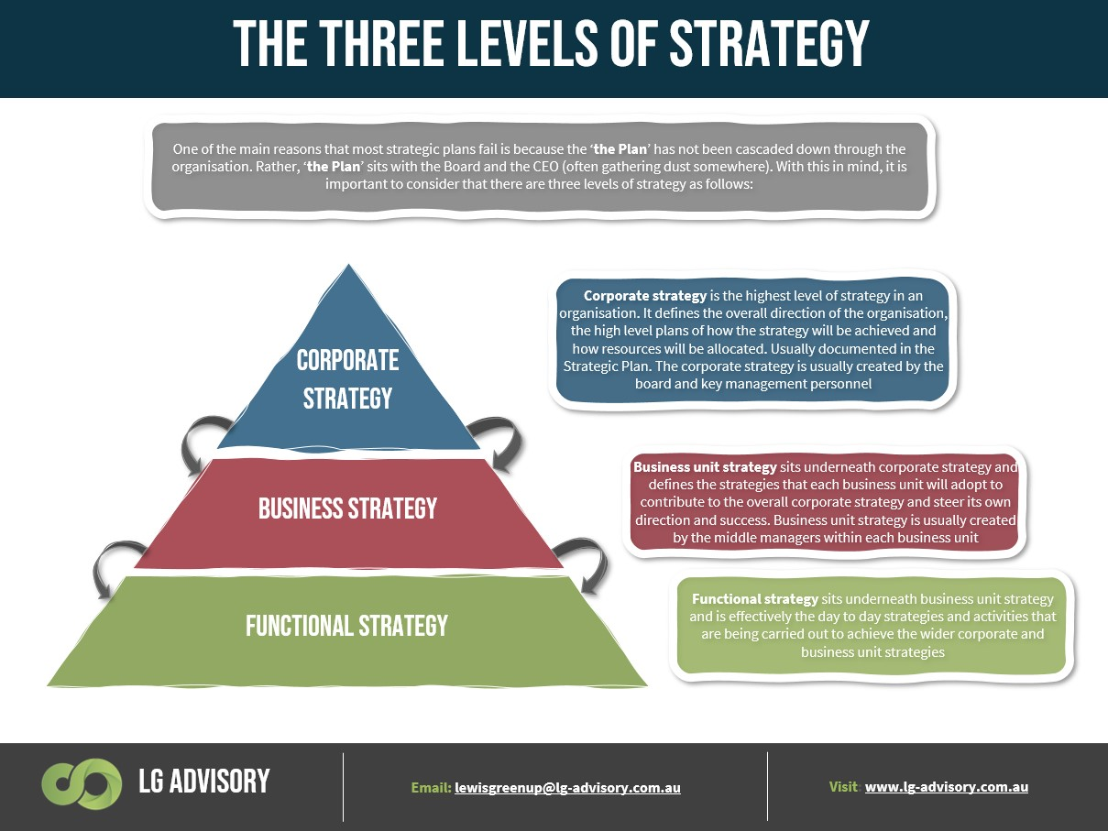
It is crucial to first comprehend the organisation to better deploy management tools in the chosen organisation, Ryanair, and to create strategies for improved customer service implementations within Ryanair.
2.1.5 Strategic Management Process
Strategic Management as defined above by Lamb Robert is an ongoing process that also has been adopted by other authors and studies can be illustrated by the Strategic Management Model in the figure below developed by two Spanish Authors Navas- Lopez, and Guerras- Martin in their fifth edition of the book entitled Fundamentals of Strategic Management published in 2015.
Setting corporate goals for a company is just one of the responsibilities of senior managers; nevertheless, achieving those goals requires continual monitoring because internal and external factors as well as people-related issues can have an impact on the market environment.
Furthermore, forming alliances with local businesses, as well as having skilled employees who participate in various training and soft skills such as emotional intelligence, will contribute to future orientation with the creation of values for customers.
As was already mentioned, strategic management has many benefits for the firm because it helps with determining corporate objectives, enhancing brand management, defining SWOT, exhibiting a solid labour supply, boosting stability, fulfilling board member obligations, offering an organisational viewpoint, and creating frameworks for decision-making.
However, there are some disadvantages to strategic management, including time requirements, difficulty adapting to global changes, difficult processes, unexpected results, and a lack of immediate rewards.

SPACE INTENTIONALLY LEFT EMPTY
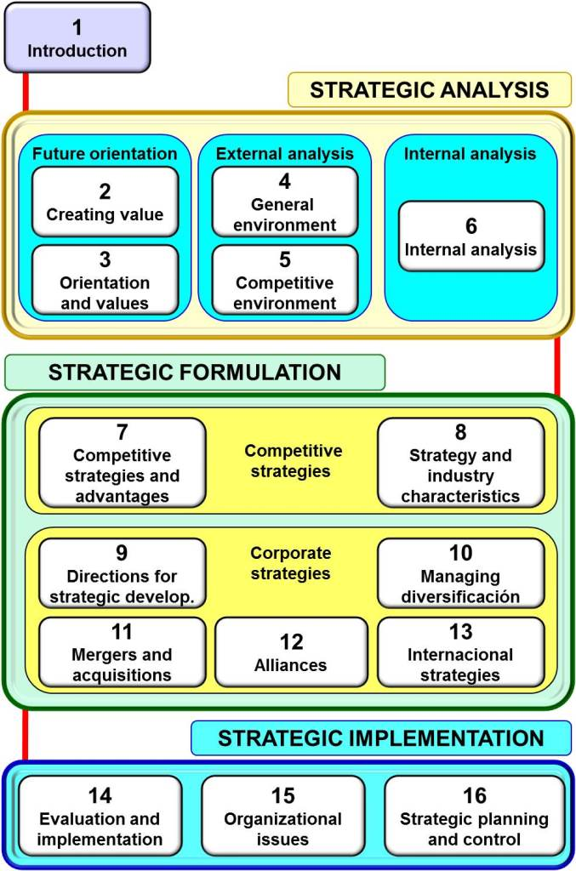

2.2 Application of Strategic Management Tools for Ryanair
2.2.1 Background of RYANAIR
Dublin, Ireland serves as the home base for the Irish airline Ryanair, which was founded in 1984. It is the busiest airline in Europe by passenger volume and is distinguished mostly by the effective application of the low-cost business model.
As a pioneer in providing low fares to its customers on brief European routes, Ryanair has developed a reputation for having the lowest fares in the business, making it the toughest competition for up-and-coming airlines.
Ryanair operated as a short-haul, point-to-point airline in Europe during the 1990s. Later it entered the Dublin-London route hitting the market with its attractive strategy of lowest fares and increased routes between Ireland and the UK.
Ryanair gradually expanded into new markets while adhering to a simple business model centered on offering the lowest fares with increased frequency to destinations and emphasising customer safety and security.
Ryanair managed to be a low-cost carrier and became the first European airline to fly with more than 1 billion passengers in 2017, despite dealing with several internal and external issues. In recognition of its ongoing efforts to develop innovative supplementary revenue sources, Ryanair received the Future Travel Experience Ancillary Silver medal at the 2018 FTE Europe and FTE Ancillary awards.
Ryanair achieved a record load factor and profit of 95% and €1.45 billion, respectively, in 2018. This was the consequence of strategic capacity expansion over the previous few years, ultra-low operational costs supported by growth in passenger volumes, and an overhaul of the customer experience.
Ryanair's stock prices have reached all-time highs because of these challenges. By 2020, Ryanair employed approximately 16,000 people that have increased to 19,000 highly skilled aviation professionals by the end of March 2022 with post covid decrease in passengers from 149 million pre-covid to 97 million post-covid. However, they are planning to increase the number to 225 million by 2026.
The unique selling proposition, or USP (Unique Selling Proposition), of Ryanair, is to offer the lowest prices in the aviation sector with greater frequencies for brief point-to-point trips.
According to Ryanair's mission statement, it is its goal to "provide low fares that boost passenger volume while continuously focusing on cost containment and efficient operation."
According to Ryanair's mission statement, it is their goal to "firmly establish themselves as Europe's premier low-cost scheduled passenger airline by ongoing improvements and extended offerings of their low-fares service."

2.2.2 SWOT Analysis of Ryanair
- Strengths
The SWOT analysis of Ryanair is a framework to evaluate the factors that create an impact on the airline industry at large and employ its influence on Ryanair. The SWOT analysis provides insight into Ryanair's internal and external factors, specifically its strengths, weaknesses, opportunities, and threats.
Ryanair's internal factors are strategically analysed, revealing strengths that are also key success factors.
Low cost, low fares, leadership and strategy innovation, and increased routes and frequencies to destinations are some of these. Operating with one type of aircraft, Boeing 737-800.
These factors give Ryanair a competitive advantage and keep it ahead of its competitors and rivals in the ever-changing and competitive aviation industry, where airlines compete for the smallest of market shares.
Although Ryanair's business plan is straightforward and prioritises inexpensive rates, on-time service, and passengers' safety, it receives bad marks from customers due to issues like subpar customer service, hidden fees, vague agreements, and inaccurate fare advertisements.
These are undoubtedly some of the main limitations of all low-cost airlines. Ryanair has observed along its journey that, despite all the difficulties, some fantastic chances will support its growth.
Examples of factors in the macro environment of Ryanair that act as realistic opportunities include acquisition and mergers with other airlines, code sharing and industry consolidation, a significant increase in the number of short-distance travellers coupled with a swelling market share, and market growth. Ryanair faces many external concerns, including an increase in fuel prices, changes in currency, competition from local carriers, and natural calamities.
- Weaknesses
Changes in employee compensation arrangements and labor relations could have an impact on Ryanair's business: Employees of Ryanair in Europe, except the United Kingdom, work under Irish employment contracts, as required by Irish tax laws because Ryanair's aircraft are registered in Ireland.
Many governments have initiated challenges to these contracts and if Ryanair is forced to concede to the challenges it may result in increased compensation, insurance, and other benefits. Ryanair's pilots had also gone on strike for better terms and conditions in the middle of 2018, resulting in the cancellation of hundreds of flights and affecting thousands of customers.
In addition, the airline suffered significant financial losses as well as a loss of trust and reputation in the face of a challenging operational climate and high oil prices. After the Brexit vote, the U.K. will be leaving the EU, which could amend employment contracts under different jurisdictions, as necessary. As a result, it is believed that Ryanair needs to focus on improving its labor relations as a top priority.
Overcapacity may soon be a result of aggressive fleet expansion: By 2026, Ryanair estimates its annual passenger volume to reach close to 225 million and has planned fleet expansion accordingly.
However, if growth in passenger volumes slows due to competition or political or economic factors, Ryanair's financials may suffer. Furthermore, the impact of Covid-19 as the pandemic unfolds is unknown, but it is expected to have a significant impact on the airline industry, particularly Ryanair, and may put at risk its expansion plans.
- Opportunities
Ryanair has a good opportunity to boost ancillary revenue through My Ryanair the redesigned my Ryanair app includes a smoother booking process and more pertinent content. By using these digital channels to advertise supplementary services, Ryanair may boost its segment revenue.
An increase of flights 225 flights to and from with around 97 M Passengers during the year ending March 2022.
Ryanair has the potential to expand further in this segment due to its strong digitalization and innovative offerings.
Through the Always Getting Better (AGB) program, prioritise the customer experience: Ryanair's strategic initiatives under "Always Getting Better" ("AGB") cover the entirety of the carrier's operations. Ryanair has achieved ex-fuel unit cost reductions of more than 2% in the two years since the initiative's inception. Customer experience has also improved significantly through digital channels, and the airline has maintained the lowest fares.
According to data from its website from February 2022, the airline has one of the highest punctuality rates in the sector (90% excluding ATC delays). The emphasis on further improving customer experience through AGB drive in areas such as reliability, safety, and an enjoyable experience has the potential to strengthen Ryanair's market share and overall brand.
Despite this, Ryanair, with its large fleet infrastructure and low costs, can easily capitalise on the situation and reverse the trend. Ryanair Sun, the new Polish charter airline, was launched in April 2018 with this goal in mind. It has a Polish Air Operator Certificate ("AOC") and currently operates 5 aircraft.
It will offer travel to and from Poland throughout the 2018 summer vacation season and is well-positioned to become Poland's top charter airline. Ryanair can also develop this market in other European nations.
- Threats
Weaker GBP after Brexit to put downward pressure on prices: The GBP has depreciated significantly since the Brexit referendum in 2016, by 20% as of 2020. Ryanair earns a massive portion of its annual revenues in GBP, and it is estimated that every 1p movement in Ryanair GBP/USD will affect its income by up to €7 million in FY2020. As a result, significant fluctuations in GBP will have a significant impact on Ryanair's financials and operations.
The business strategy and profitability of the company may be impacted by changes in Jet prices: Low fuel prices, a factor over which Ryanair has no influence, are crucial to the low-cost airline's ability to remain in business. Fuel costs have remained low for the past two years, which has allowed Ryanair to keep expenditures in check. However, a rise in fuel costs brought on by international geopolitical or economic factors could endanger Ryanair's low-cost business strategy and profitability.
Ryanair is experiencing escalating competition from other state-owned and regional carriers that offer cheap flights. Ryanair is facing tougher competition from Wizz Air, a low-cost airline based in Hungary. Another significant rival to Ryanair is the UK-based low-cost carrier EasyJet.
Additional low-cost airlines include Alitalia and Air Berlin, which are owned in part by Etihad Airways of Abu Dhabi. Due to the coronavirus issue, certain EU governments have begun to flood their former flag carriers, including Air France/KLM, Alitalia, Lufthansa, SAS, and TAP, with illegal State Aid.
The Covid-19 pandemic's effects on the aviation sector: Aviation has never seen something like COVID-19, and even Ryanair had a horrific existential crisis in 2020. The stringent imposition of numerous flying restrictions and/or travel bans by the European Union caused Ryanair's flights and operations to be abruptly halted beginning in mid-March.
Discussion:
Swot analysis used on Ryanair has demonstrated how competitive the businesses are in a microenvironment aspect, but it is crucial to emphasise that additional customer care improvements will be required in the future because customers should be valued throughout every step of their trip.
Tall people will not feel comfortable on flights lasting longer than 2.5 hours when social demographic characteristics are considered. This is because all low-cost airlines shorten the space between seats to add more seats, hence limiting the number of passengers who can travel comfortably.
As it is argued in marketing, "it is difficult to create loyalty to a single passenger but easy to lose a hundred passengers." This can lead passengers to select their future flights, losing the fact customers.

2.2.3 PESTEL Analysis of Ryanair
Given that Ryanair operates in over 225 airports across Europe, with 90 base airports and up to 3,000 daily flights, they are subject to other external forces that can have a negative or positive impact on their business, and it is worthwhile to examine those forces in a macro-environment. The following table will represent some of the areas of PESTEL analysis without being exhaustive.
Political | Economic
1. The new business climate regulation has added to the uncertainty surrounding Brexit.  2. Frequent terrorist incidents in Europe will have a negative influence on the demand for air travel, which will hurt Ryanair.  3. The conflict between Russia and Ukraine has had a global impact on business. | 1. Oil prices are anticipated to stay at around $50 per barrel, helping operational margins  2. Brexit-related weaker GBP to increase pressure on ticket pricing.  3. Inflation  4. Effect of the COVID-19 epidemic on aviation and the economy
Social | Technical
1. Short-haul high-speed rail is preferred by consumers overflying.  2. If tickets are less expensive, consumers will spend more on ancillaries. | 1. improvements to mobile and online platforms to enhance the user experience.  2. Customer experience  3. Cybersecurity, data privacy threats
Legal | Environmental
1. The European Commission is suing Ryanair for getting state aid at specific European airports.  2. Brexit might make it necessary for Ryanair to adhere to both UK and EU laws.  3. Requirements on Civil Aviation laws and (IATA-ICAO) | 1. EU emission regulations for airlines may increase Ryanair's costs.  2. Runs a young fleet of Boeing 737-800NG aircraft with the lowest emissions intensity among peers.  3. Significant emphasis on environmental initiatives

Comments
Political
Brexit has created uncertainty in some political areas where laws and policies have been altered. A decline in customers for Ryanair was brought on by the need for personnel to undergo rapid training to comply with new standards for an aviation firm operating in Europe. Different Covid-19 limitations between nations have given travelers more reason to be afraid over time.

Economic
The war and conflict between Russia and Ukraine have had a detrimental effect on Europe and the rest of the world, leading to inflation where customers avoid traveling because of the speed but still consider the average cost of travel. Several online businesses that were started during the pandemic and offer more comfort services for less money, such as Blablacar and coaches where private persons use their means for long distances, have been formed, even though Ryanair continues to be a low-cost company. Moreover, the impact of the post-pandemic on the economy, the populace, and the suppliers in Jet A1, where costs have soared.
Social
Political actions and the implementation of security procedures because of Brexit have had an impact on consumer behaviour. In addition to the previously listed concerns, other important ones include the requirement for visas for non-European citizens, along with the long waiting lists for appointments.
Traveling in a group or with a family is still expensive despite Ryanair's low prices because many extra expenses help the airline make more money, such as meals, luggage, and packed flights. Traditional competitors like British Airlines, Air France, or SN, allow a minimum of 46 kgs per passenger plus 10 kgs for hand luggage in contrast to Ryanair, where a passenger is only allowed to have a small bag and pay for all additional luggage, the low cost is more advantageous to people traveling alone or for workers who do not need much luggage.
Technological
As the business world is moving quickly with technology, digitalization should be constantly upgraded to keep customers informed. Customers are informed of any flight reminders, delays, or cancellations thanks to Ryanair, which was established three years ago. However, there is still room for improvement as front-line staff members are still ignorant of the diverse types of travel documents that people have depending on their nationality or background, which causes frustration, delays, and fear while detracting from the future clientele requirements for business success.
Legal
As a result of Brexit and new regulations, legal requirements for handling, checking, and security checks must be adapted in different airports, resulting in inflated costs for Ryanair as employees must be trained globally. To avoid penalties in other countries, senior management should become proficient in standards in a fleeting period. Hiring locally may be preferable but finding appropriate people who can easily adhere to the business vision may be difficult. Furthermore, because of Brexit, Ryanair must adhere to various regulations across the EU and the UK. Furthermore, the UK-EU open skies agreement may be terminated, causing Ryanair to suspend its UK flights.

Environmental
The EU's control of aircraft emissions may result in higher expenses for Ryanair. The EU has passed legislation requiring airlines to participate in the Emissions Trading Scheme. If Ryanair exceeds the allotted CO2 limits, the difference must be filled through the market or government agency auctions.
Fortunately, Ryanair operates a young fleet of Boeing 737-800 aircraft and retains the lowest emissions among its competitors. Therefore, Ryanair is also willing to become Carbon Neutral by 2050 with its decarbonisation strategy.
2.2.4 Analysis of Porter’s Five Forces on Ryanair
Fig.3 Ryanair positioning- Adapted from M.E Porter (1979)- How Competitive Forces shape strategy
Bargaining power of Suppliers

Threat of new entrants
Threat of Substitutes
Rivalry among existing firms

Bargaining power of customers

Porter's Five Forces framework will provide a detailed view of Ryanair and its attractiveness, therefore a microeconomic point of view, by examining 5 main factors: the threat of entry, the threat of substitutes, the bargaining power of suppliers, the bargaining power of buyers, and the competitive rivalry (Porter, 1979).
However, due to the word counts and time limitations, this analysis has been summarised as follows:
Ryanair operates in a highly competitive and complex environment where they must exercise caution and adjust their strategy, as necessary. First off, the fierce competition will only grow, with rivals launching new routes and providing affordable fares on the one hand and a constant fear of substitutes caused by a rise in demand for environmentally friendly transportation options like high-speed electric trains on the other. Additionally, the corporation must take bargaining strength into account.
Particularly of the suppliers, where labour unions and fuel suppliers are the key issues. Finally, Ryanair needs to be mindful of the new competitors and the potential effects they could have on the market. Fortunately for Ryanair, the scarcity of airport spaces and high start-up costs make it challenging for new airlines to be successful.
Force | Factors | Impact
The threat of New Entrants | Capital requirements, limited airport slots, Loyalty programs | Medium
Treat of Substitutes | Increased demand for sustainable transport, High-speed trains, Blablacar, and Loyalty programs | High
Bargaining Power of Suppliers | -Boeing-Fuel Suppliers-Unions-Catering Suppliers-Air bus | Medium-High
Bargaining of Customers | Price-sensitive leisure travelers | Medium
Rivalry amongst Existing firms | Constant launching of new routes- Flight over lowest fares | High

3.0 Conclusion
Considering everything that has been developed above, as well as the Ryanair Senior Management Team's strategy, it has been discovered that Ryanair is not getting full passengers because of the Customer Care that they provide, but rather because of the low-cost tariff strategy that the Senior Management Team has implemented.
Additionally, studies have revealed that Ryanair employees continue to conflate the ideas of customer service, customer experience, and customer care. Even though their flights are always finished, they should continually solicit input because they have a long way to go before providing future customers with the care that depends on their viability.
Easy Jet, one of their main rivals, is having difficulties due to a lack of specific understanding of certain immigration, which is another advantage for Ryanair.
However, given that word-of-mouth advertising is more effective and spreads quickly, providing excellent customer service should be carefully considered.
Additionally, when communicating with their clients, they should consider cultural differences and passenger behaviour. They are continually improving, as evidenced by numerous indications and facts, and their planes are built to fly in the air with a variety of connections, which adds value and increases their profitability. However, they must also consider all the services that are related to the consumer, including service, experience, and most importantly, caring that goes beyond emotions, in addition to profit.
In conclusion, as they continue to use the same model of aircraft, the Boeing 737-800, they have been able to increase both their tangible and intangible assets. This is due to the established strategy. They have also earned the loyalty of their supplier, which they should pass along to their customers by offering excellent customer care.
4.0 Recommendations
Despite being one of the first Europe Airlines and the second Global Airlines, retaining their place should be one of the Senior Management team's top responsibilities by repairing and adjusting as rapidly as possible to every change, regardless of what it is.
Given the rising cost of living, they need constantly push their employees to prevent further strikes, but they should also make sure that they feel valued and could deliver excellent customer service to their customers.
Increase the technological advancements already being made to fully engage passengers and establish a loyalty program after a certain number of flights to build a community of customers who will subsequently serve as constant brand ambassadors for the company because loyalty will foster lived experiences among them.
Maintain your commitment to sustainable practices so that, by 2050, you can achieve the goal of 0 carbonisation.
Finally, instill a sense of responsibility in all business personnel so that they can provide customers with the best possible service and experience while also continuously thinking about the company's long-term viability and setting a new standard for compassion in the aviation industry.

5.0 References
Anderson, K. & Keer, C. (2002), Customer Relationship Management, McGraw-Hill.
Asch, D. & Bowman, C. (1989), Readings in Strategic Management, The Open University.
Bowman, C. & Asch, D. (1987), Strategic Management, Macmillan Education
Bowman, C. (1990), The Essence of Strategic Management, Prentice Hall.
Brooks, I. (2009), Organisational Behaviour, 4th edition, Prentice Hall.
Corbert, J.M (1994), Critical Cases in Organisational Behaviour, MacMillan.
Coyle, D. (2018), The Culture Code, The Secrets of Highly Successful Groups, Penguin Random House, UK.
Cravens, D. & Piercy, N. F. (2009), Strategic Marketing, Ninth Edition, McGraw Hill.
Dawson, P. & Andriopoulos, C. (2014), Managing Change Creativity & Innovation, Second Edition, Sage.
Fred R. David, Forest R, David, Meredith E. David (2020), Strategic Management: A Competitive Advantage Approach, Concepts, and Cases. 17 Edition, Pearson
Hill, C.W.L & Jones, G.R. (2007), Strategic Management, An Integrated Approach, Houghton Mifflin Company.
Hill, J. (2008), Theory of Strategic Management with cases, 10th edition, South-Western, Cengage Learning.
Hill, J. (2010), Theory of Strategic Management with Cases, International Edition, 9th edition, CTSL.
Holpp, L. (2012), Win-Win, Performance Appraisals, What to Do Before-During-After, the Review to Get the Best Results for Yourself and Your Employees, McGraw-Hill.
Jansson, H. (2020), International Business Strategy in Complex Markets, 2nd Edition, FSC.
Mullins, L.J. (2010), Management & Organisational Behaviour, Ninth Edition, Prentice Hall.
Peppers, D. & Rogers, M. (2004), Managing Customer Relationships, A Strategic Framework, John Wiley & Sons, Inc.
Pitts, R.A. & Lei, D. (2006), Strategic Management, Building and Sustaining Competitive Advantage, 4th edition, Thomson South-Western.
Pradeep, A.K. et Al. (2019), AI for Marketing and Product Innovation, Powerful New Tools for Predicting Trends, Connecting with Customers, and Closing Sales, John Wiley & Sons.
Robinson, J.F. (1999), Building Customer Loyalty, David Grant Publishing Limited.
Sandell, S. (2013), Digital Leadership, How Creativity in Business Can Propel Your Brand & Boost your Results, FSC-PEFC.
Stacy, R.D (1993), Strategic Management and Organisational Dynamics, Pitman Publishing.
Stockdale, S & Steeper, C. (2012), Cope with Change at Work, Cenveo Publisher Services.
Suskind, R. (2004), The Price of Loyalty, George W. Bush, The White House, And the Education of Paul O’Neill, Simon & Schuster.
Szwarc, P. (2005), Researching Customer Satisfaction & Loyalty, How to Find out What People Think, The Market Research Society.
Navas-Lopez, J.E & Guerras- Martin, L.A. (2015), Fundamentals of Strategic Management, Theory and Applications, 2nd Edition, Thomson Reuters.
Business Strategy Raynair==.pdf (Accessed on 10/12/2022- 12/12/2022)
Cases in Strategic Management (guerrasynavas.com) (Accessed on 22/11/2022-09/12/2022
Microsoft Word - Mapa de casos 2014.docx (guerrasynavas.com) (Accessed on 12/12/2022)
Principles-of-Marketing-Kotler-Armstrong=.pdf(Accessed on 13/12/2022)
Ryanair-.pdf (Accessed on 09/12/2022-10/12/2022)
Ryanair-2022-Annual-Report.pdf (Accessed on 10/12/2022, 25/11/2022, 26/11/2022/14/12/2022)
Strategic Management - Features, Importance and Four Phases (toppers4u.com)(Accessed on 15/12/2022, 10/12/2022)
Strategic Management. Theory and Applications (guerrasynavas.com) (Accessed on 16/12/2022-15/12/2022)
Strategic Management: Definition, Meaning, Concept, Process & Benefits (yourarticlelibrary.com) (Accessed on 12/12/2022)
The Three Levels Of Strategy - LG Advisory (LG-advisory.com.au)(Accessed on 15/12/2022-14/12/2022)
What is strategic management? - Entrepreneur Handbook(Accessed on 10/12/2022-13/12/2022)

