STUDENT | EVEREST MGBUJI
STUDENT NUMBER | 1806829
MODULE NO: | BMSK4003
MODULE TITLE: | DIGITAL SKILLS AND RESEARCH METHODS
LECTURER: | JOY BOTU

Introduction
This report will be based on a given out survey’s to teenagers and above to get input of information on how Action Games can contribute to aggression and increase of crimes rates.
In the process of doing so, I had to conduct a primary research, by questioning the teenagers starting from the ages of 16 years and above. Furthermore, I researched on how it also contributed in the increase of crime rates. I will conduct a survey on a few people regarding on the information to satisfy my work.
My results will be showing from every step I started, from the stage of conducting the survey, gathering of information and by using Bar graphs to analyse the different aspects and factors of my secondary sources. Therefore, as a result I will give a summary to the findings I researched. This will give a better understanding of how action games can contribute to aggression and increase crime rates.

Satisfaction of Game Playing
Today having a glance at youngsters playing with the computers for sale at a large department stores specifies that children and youths, including some adults are now attracted to computer games and other electronic media products. (Feierabend & Klingler, 1999). In Britain alone children and most of the youths have a computer game or console in their various homes and spend more time playing these games than indulging in any other activities around them. Surveys confirm this impression and add that the use of computers and computer games has rapidly increased over the last few years.
From gathered evidence for the extraordinary past trend that computer ownership-in an illustrative sample of German households with school-age children-doubled between 1990 and 1999 (Feierabend & Klingler, 1999) and increased in the 2 years between 2000 and 2002 by another 10%. By now 81% of the households within the age of 12 and 13years old own a computer or game console in Germany, and 23% of these youngsters can work and play on a computer of their own.
Figures from a representative sample of 8 to 13-years old from the United States are about the same, related to community income (Roberts, Greenfield, & Gross 2001). Computers are mostly used for playing computer games, in Germany as well as in the United States. By middle of their ages, playing computer and video games has become one of the favourite leisure time activities for boys and less for the girls in Western industrialized countries (Subrahmanyam, 2001).

Now what is Qualitative and Quantitative data research?
Qualitative data research is to do with words, people talking and also can lead to a solution whilst Quantitative data is to deal with numbers, like how many people, focuses on the problem at hand, whilst learning, I learnt about using this data methods of Empirical and Non-Empirical data to conduct a qualitative data and quantitative data research that is with Empirical is when gathering information through experiments and or observation which primary source (Quantitative data) whilst Non- Empirical is already available which is Secondary source (Qualitative data). Now by knowing this I was able to continue my researches on my survey.
To collect My Data (Information).
To start the survey, I had to think of what questions will correspond with my research on the topic “How action games can contribute to aggression and increase of crimes rates”.
I made my questions based on the topic of my work and collected information by asking with the following yes, don’t know and no. with this it will allow my questions to be answered by anyone I present my survey and with the information, I will be able to measure it in time and can have a good idea of what I want to complete my data to go ahead with my graphs for a better data information.
It is important when humans are to participate in study that you get approval or consent before collecting an information towards my conducting my survey. It is prior to the data protection act. (Gelling, 2016) so for this I had anonymous names to the people I asked. And I made it clear to them that it was to do with my Assignment at the University I was attending which is University of Wales Trinity Saint David by showing my school Id.

My Findings, Analysis and Discussions
Survey questionnaire
- Do you think computer games contribute to aggression?
Yes | No | Don’t Know
6 | 1 | 3

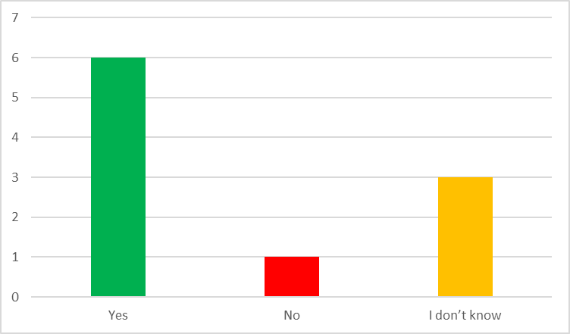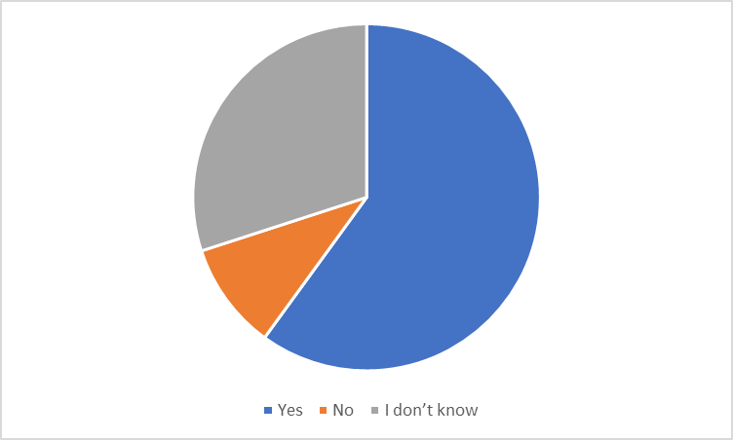Q1). Graph Analysis: from the graphs you can see that 60% of people do agree that games do contribute aggression. While 30% of people are unsure of what the causes of these games are, then 10% of people disagree.
10%
60%
30%

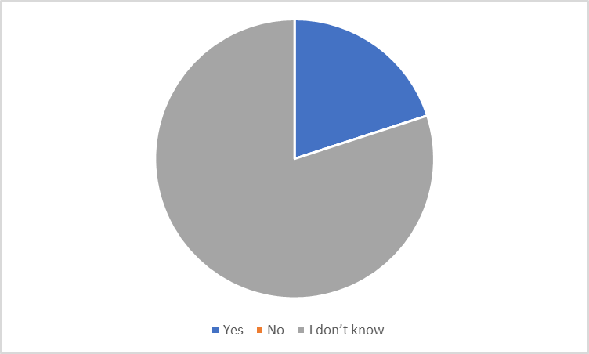
2. Do you think that criminals are more likely to have played aggressive computer games before they commit a crime?
20%
80%
yes | No | Don’t Know
2 | 0 | 8
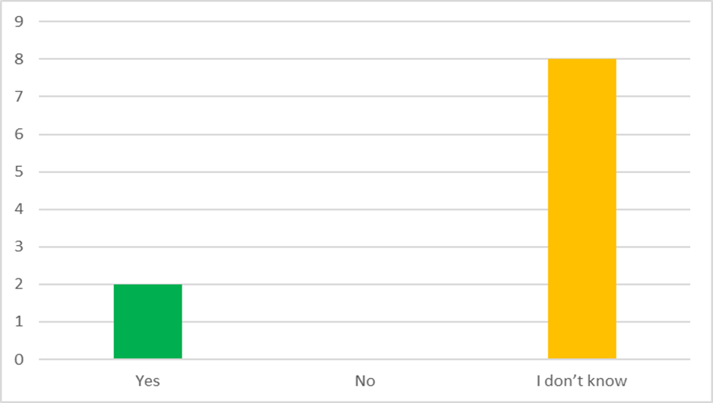
(Q2) Graphs Analysis: As stated in the graph, 80% of the people that answered to the survey were unsure of if criminals did gain aggression from these games. 20% of them thought that it was a definite had an impact on them, the criminals. This really proves that the people believe that criminals have meet an aggressive game.

3.Do you think that the amount of time you play can influence how aggressive you become?
Yes | No | Don’t know
5 | 4 | 1
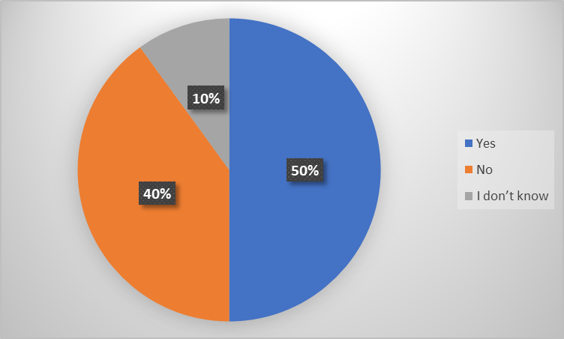

Q3)Graph Analysis: As revealed in the graph provided 50% of people say that the amount of time you play influences how aggressive you may become, which is half the people.40% of the people said they do not think that the amount of time you spend on an aggressive game, influences how aggressive you will be. Meaning 10% are unsure of weather it has an impact on aggressiveness, by saying that more of the people think aggressive games and the amount of time you are spending on it will influence how aggressive you might be.

4. Do you think that excessive gore in computer games should have an age restriction
Yes | No | Don’t know
5 | 3 | 2

Q4 Graph Analysis: from the observation of the graphs, you can see that 50% agree that action games should have a restriction, while 20% were not sure and 30% said no to the option.

5. Do you think violent computer games should be removed from the market all together?
Yes | No | Don’t Know
4 | 4 | 2

Q5 Graphs Analysis: By observation you can see that both 40% of the ones agreed and the other 40% that did not agree are of the same value, only 20% just said no to it.

Summary
From the breakdown and data gathered, I can in fact say that Action games do influence our young youth and contribute to the rate of crimes in the society. Consequently, from the survey most people have had related issues of there youths these days just being indoors playing games than getting up and getting involved with activities outdoors like going to parks to play or even going to the cinema for a movie or going to sports clubs to participate in sports etc.
It has now become a kind of issue for the generation, were parents also contribute as well to this by giving them these game technologies. Also, from what we have learnt at the beginning of this assignment, that both technology and the media has contributed to the great increase of violence in human nature both with playing of games and other means of communication.
These games companies are to take these issues into consideration while creating games, especially about our youths, and bearing in mind about the younger generation and not mostly about their profits.
Companies in charge of creating these games should also conduct survey’s on the public regarding making of new games, and having the such they will have more ideas of the impact and time these youths spend on games and how it contributes aggression in there behaviours and also influences them to commit certain crimes or take such actions on one another, believing it is right to do so, by playing action games all day results by (Przybylski. 2014) from his current study shows that children that spend up to three hours playing in a day, result to more harmful adjustment, for those who play less than three or less hours a day are ok. Whilst non-gamers reportedly higher levels to both expressing and adopting problems and lower levels of prosocial behaviour to life pleasures.
Our Parents really need to reconsider the fact of approach to the electronic media of nowadays. The good vs bad moralistic approach might be comfortable, but it seems to be out of content specially to do with our kids critical thinking skills that we really consider to be in the best interest of our children.
Conclusion:
The aggression influenced by playing these action games are what most of these companies should think of the values of our next generation.
Our children are growing and developing knowledge as well and we all as their parents or guardians should give them the best education of the best way we can or know, both if we let them play games, then companies or game programmers and software’s should create educational games that intends to teach. For example; Nintendo created sports games etc, and Xbox created a game called fortnight which makes kids always demanding for money to buy characters, from this alone you can see that it puts more stress on most parents due too the kids get very miserable when some parents reject to give this money to them. Good games produced will help kids to learn about behaviours, socializing in the community, schools etc, teaching the next generation that they need to educate themselves in order to live a better life in the society, having knowledge of the basic morals to survive in the true world, and not the world presented to them in their games. Make games that will teach about not having to kill one another, mostly these games that have gangs etc.
I do believe also that parents also have a role to play with kids playing games for hours, just to have their time after a long day. They should create time for other games to play, take them out go for a work, go bike riding and read with them or even make time tables for certain things to do before letting them play games. Occupy the kids with other activities.
Companies that create these Games really need to think about the future and not more concentrating on profits. Companies should realizes that most of these kids will be adults soon and would be applying for certain jobs as well and need a standard education.

