

PAPUR ARHOLIAD / EXAMINATION PAPER

LLEOLIAD / LOCATION: | ABERTAWE / SWANSEA
CYFNOD ARHOLIADAU / EXAMINATION PERIOD: | MAI 2026/ MAY 2026
LEFEL / LEVEL: | 4

MODIWL / MODULE: ENTER ABCD1234
ENTER MODULE TITLE

AMSER / TIME: | 1 HOUR
CYFARWYDDIADAU / INSTRUCTIONS: | answer all questions

Adnoddau neu ddefnyddiau sydd eu hangen / Equipment or materials required:
Dewiswch o'r canlynol os gwelwch yn dda / Please select from the following:
Cyfrifiannell / Calculator
Llyfr Agored / Open Book
Llyfr Fformiwla / Formula Book
Arall nodwch os gwelwch yn dda / Other please specify …………………………
Office Use Only:
Author: |  |  | Semester:
Internal Verifier: |  |  | R Y/N? | Yes / No (Please delete as applicable)
Contribution to Overall Module Assessment (%):

ANSWER ALL QUESTIONS

QUESTION ONE (20 marks total)

- Provide the name for each of the following symbols (5 marks)

- 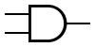 ------------and--------------------
- 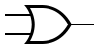 ----------------or----------------
- 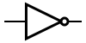 -----------------not---------------
- 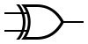 ---------------------exclusive or-----------
- 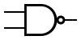 ---------------nand-----------------

- Give a representation of the truth table for an AND gate given the inputs A and B (5 marks)
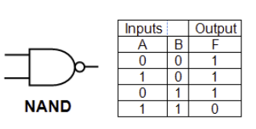

- Indicate the output at each of the stages labelled in Figure 1. Inputs A and C are at logic level 1 (4 marks)

D at logic level 1 is 1
E with input of C1 and D1 results in E1

- A domestic light can be illuminated by two different switches. Each of the switches may turn the light on independently of one another, not dissimilar to a stairs light. Represent this scenario using a logic circuit (6 marks)

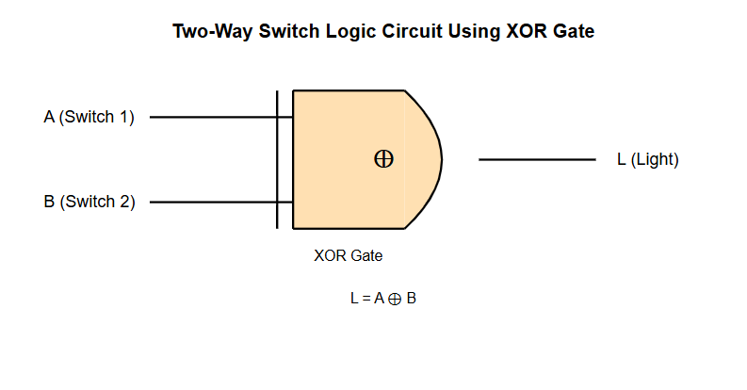

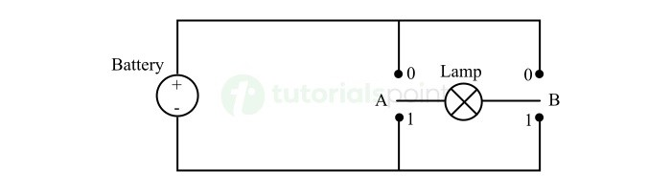

QUESTION Two (20 marks total)

Attempt all of the following. Do not simply use an Electronic Calculator and just present the final answer. Write down and show all your manual calculations in your exam book.

- Convert the following binary numbers to base 10 (2 marks each)

- 1101 0111
1101 0111₂ = (1 × 2^7) + (1 × 2^6) + (0 × 2^5) + (1 × 2^4) + (0 × 2^3) + (1 × 2^2) + (1 × 2^1) + (1 × 2^0)
= 128 + 64 + 0 + 16 + 0 + 4 + 2 + 1
= 215₁₀

- 0010 0101
0010 0101₂ = (0 × 2^7) + (0 × 2^6) + (1 × 2^5) + (0 × 2^4) + (0 × 2^3) + (1 × 2^2) + (0 × 2^1) + (1 × 2^0)
= 0 + 0 + 32 + 0 + 0 + 4 + 0 + 1
= 37₁₀

- Convert the following hex numbers to binary (2 marks each)

- 6F – 0110 1111
- EA – 1110 1010

- Convert the following decimal numbers to Binary (2 marks each)

- 84 - 1010100
- 246 - 11110110

- Convert the following Hex numbers to decimal (2 marks each)

- A1 - 161
- F5 - 245

- How many unique values can be represented by a 6- bit number ? (2 marks)

2^6 = 64 unique values
These range from 000000₂ (0₁₀) to 111111₂ (63₁₀)

- Using the base 2 number system write the number of bytes in 1 Kilobyte (2 marks)

1 Kilobyte = 2^10 bytes = 1024 bytes
In base 2 (binary):
1024₁₀ = 10000000000₂ bytes
Or expressed as a power of 2:
2^10 bytes

QUESTION THREE (20 marks total)

Give a typical, cost effective specification for a typical PC that could be used for 3D animations and software development. Provide details for:
- A suitable CPU – multiple cores, a clock speed of at least 3ghz
- What is a sensible amount of RAM 16GB+
- What type and size of non-volatile storage would be suitable 512GB HD/SSD
- The input/output features/ports needed USB, display ports
- The features a suitable graphics card would require. Video memory, and a GPU chip, potentially ray tracing compatibility with ada lovelace+ architecture for RTX
For all of the above areas, you should justify your choice with reasoning and where possible, explain why you chose that particular option, over the alternatives.

Diwedd / End

