Instrumentation and Control
ACDB5011

John Gallacher

Analysis the effects Instrumentation and Control
has on the output of a system.

Wales Institute for Science and Art
University of Wales Trinity Saint David



Acknowledgement

I would like to thank the University of Wales trinity Saint David for hosting the Instrumentation and control module. I would also like to thank Jacob Stalin the lecturer throughout the course who provided a vast variety of content and support in delivering the module, I have been able to fully enhance my understanding of the subject area with before having no prior knowledge. From this I have used the lectures provided and independent research to create this assignment.

Abstract
This assignment has been developed by the writer to develop an understanding into the key concepts of instrumentation and control. The writer has researched various industries and adopt the methodology to generate the overall outcome of what a instrumentation and controlled system is by providing suitable examples and ideology that supports this. From this a simulation will be created using industry known MATLAB and further add-on within the software SIMULINK for further analysis. Before completing these practical steps, the writer has created a component or equipment list that details the specification of each element within the circuit design, this will give an overall insight into how the circuit operators but keep a clear statement of ensuring the systems inputs and outputs are they key takeaways in the instrumentation and control world.
From this the writer has drafted a conclusion from the research stage through to the final product of the simulation results, these values are vastly different to what the literature suggest but due to the lack experience in using the software this could be an issue the writer has came across. From this report the errors created or analysed will be used in the future to gain more credible values.

Introduction

The aim of this assignment is to develop an understanding of instrumentation and control systems in terms of measurement systems, instrument design and system responses using practical exercises and software simulation.
Instrumentation and control are an engineering tool used to generate a system that can be reliable, safe and efficient in its operation. An Instrument is primarily used to manipulate various factors such as, flow, temperature, pH, pressure etc [1]. Instrumentation is applied to systems that have a variety of different processes, and the equipment can be as simple as a valve to a complex analyser which will be used in a process.
Control Instrumentation is used to reduce the complexity of the operations allowing for remote or controlled capabilities [2], this includes equipment such as circuit breakers, relays etc another way of manipulating the systems operations.

This assignment will reference a “System” frequently. It is relevant to determine the definition and it can be said to be, an arrangement of parts or components uniformly working to obtain a certain object [3].
However, operation capability is critical in obtaining a desired product it must be appropriately monitored to provide the best results. This is essentially pressing the espresso button on your coffee machine; it operates as intended however it has no sensory data to recognise the cup is full and the reciprocal of the coffee spilling elsewhere. This is a basic example but take this into a bigger context such as a chemical processing plant, this can be the difference in saving millions of pounds or even prevent fatalities in hazardous areas [4].
This is where control systems are introduced, we can define this as an interaction of various components creating a system that will provide a response based on its input [3].
In this definition it gives a clear representation into the key differences of a system to a controlled system, as an Instrumentation and control engineer there is a recognition of the importance of each individual component however the main concern is the numerical values of the Input and outputs for analysis (This is shown in figure 1).

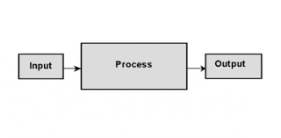
(Figure 1- Basic Input to output concept)

Instrumentation and control are used in various industries to develop automated process, processing and highlighted earlier with manufacturing and chemical plants. A good example to highlight is an electric motor that has various component parts such as a commutator, stator, coil wires, brush assembly etc. However, in instrumentation and control it’s not the key inner working of the components that are necessarily the concern or the magnetic field generated by the coil wire to create a force that in turn torques the motor system and derives to it operating. The main priority of the instrumentation is to generate a numerical value that can be monitored in respect to its input and out.

P_{mech} = P_{out} = τ * ω
Where,
- P_{out}: output power, measured in watts (W);
- τ: torque, measured in Newton-meters (N•m) or foot-pounds (ft/lbs);
- ω: angular speed, measured in radians per second (rad/s) [5].

However, in a fast-working environment rotary torque sensor the instrumentation that is commonly used for measuring these values. Due to the error margin and only around 50-60% efficiency this impressive equipment can gage a centre point and predict these failure rates and predict them before distributing its final output value for the operator to analyse. (See appendix 1)

Another example of instrumentation that has been continually used is the black box found in an aircraft cockpit despite it being a misnomer from its distinctively bright orange aesthetic due to regulation it’s a common piece of equipment relied upon. Despite the examples given mainly being value driven and for industry benefit, the communication recorder is adopted for maintaining this data to determine, the aircrafts condition, potential landing zone and route cause in the event of an incident. The device has an aircraft recorder and cockpit recorder, with components such as a power supply, memory unit, control boards etc, however again the key aspects is to obtain the communication as an input and have a managed data centre output that controls and monitors the state of the aircraft.
The examples provided give a basic insight into the types of methodology, industries practice and an insight into the equipment used within a suitably controlled system environment.
The next section of this assignment will further identify various different components or equipment that will be adopted for use in creating the circuit on MATLAB Addon SIMULINK and further analysed.

Equipment
STEP FUNCTION:

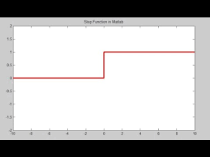
(Figure 2- Step Function shown on Scope)

A step function allows teams to work quickly and effectively using containers of existing code as building blocks, it can use multiple Lambda forms to easily manipulate or change the system flow [6]. In mathematical terms it is common for the step function to be identified as a staircase function, it can be the domain for various functions and essentially waits for a process to be completed before moving on to the next step, hence the name for the component.
This function is used within an industry powerhouse Amazon, they adopt this methodology in security system to identify any breaches, there simple queue services (SQS) and is a reliable tool in sending, storing or receiving messages via or between services [7]. The Step block inputs a JSON type Java script to initiate the circuit and provide the desired values in the system.

SUM BLOCK:
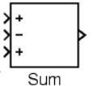
(Figure 3- Sum Block Matlab)

The block can be changed to add or subtract scalar, vector or matrix [8]inputs, from the example above you can see the sum block has been adopted to provide a (+-+) inputs respectively. Due to the 3 characters present, there would have to be 3 inputs present within the system. The use of the Sum block is to gather all the elements presenting an input whether that be positive or negative and collate these values to in turn gain a summation or figure to be outputted.

PID CONTROLLER:
The PID controller stands for Proportional, Integral and Derivative. It is an exceptional piece of kit that is used in technology such as computers and used in over 90% of closed loop operations within the automated manufacturing [9].
They are highly reliable and flexible pieces of equipment and are commonly used in control applications, temperature control in scientific fields and chemistry practices. The PID controller operators under 3 main concepts which are explained as follow,

Proportional Controller - This provides an output appropriate to the circuits current error, it develops a desired set point, it generates the current error and multiplies it with an appropriate value that will generate an accurate output. The proportional controller will remain stable however will never give a consistent value due to its incapability to achieve a steady state on its own accord.

Integral Controller - Due to the steady state error highlighted in the proportional controller this is eliminated in the integral controller. The error value created is expanded over a length of time before reaching the zero value through integration. This value is held before the final control device before outputting its accurate value. However, the integral controller also has its own limitation, this is covered under the name Integral windup conditions which essentially causes an output to happen even when the steady state reaches the zero margin. This concept can be further explored in Appendix 2 which provides a good insight into its complications however it is not relevant in this report.

Derivative Controller- The derivative controller acts for the integral controller as a behavioural analysis. The derivative controller has a proactive approach and can determine the future behaviours of the systems operations, it depends on the error margins with respect to time and can be derived as a constant. As this can determine future values of the system it acts as a starting point when considering how fast a system responds to change.

TRANSFER FUNCTION:

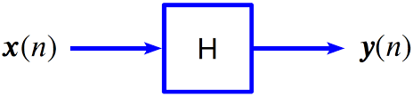
(Figure 4 - Transfer function Linear display) [10]

The transfer function block is used to represent the input/output relationship without considering the time scale of the process. Transfer functions are frequently used in MATLAB circuit designs as they give a good indication of performance in utilising the time/frequency graphs that will be adopted for analyses in this assignment and the data can be easily transferable for future systems designs. This is the adopted methodology for engineering as simplified algebra can be used instead of complex integrals that can be time consuming and costly to companies in industry [11].

SCOPE:
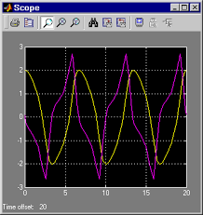
(Figure 5- Scope representation) [8]

The scope of a system is the coded area in which can be displayed but not manipulated to have any effects on the systems output. The scope can be manipulated to show different amplitudes, frequencies and display outputs of your results, for example shown in a sin wave form. Other components can be looked at as the build of your TV set and the Scope is the output signal that broadcasts the picture and gives you a live feed without any disruptions to the other components [12].
This section is to give an insight into the equipment that will be used within the specified circuit in this assignment. It must be noted that all of the components can be changed and used in different ways depending on the industry or customer requirement. This section is just to give some background information for the reader to understand the basic concepts of a circuit and what they specified components are there for,

Method
From the equipment listed above the following system has been generated for analysis:

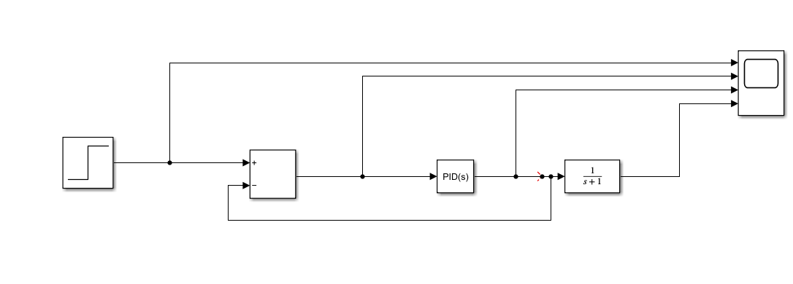
(Figure 6- Circuit Design)

The writer will generate a simulation using the circuit design on a first basic, setting each of the PID values to 1 and generating a value for the Transfer Function before manipulating some of the parameters,
- The theoretical value of the Transfer function will be determined using the last 3 digits of the writer’s Student number for an example to develop a mathematical calculation and compared it to the simulated value,
- The parameters within the PID controller will be tuned to meet the required under 2 second margin and within a 5% tolerance,

Results

STEP 1:

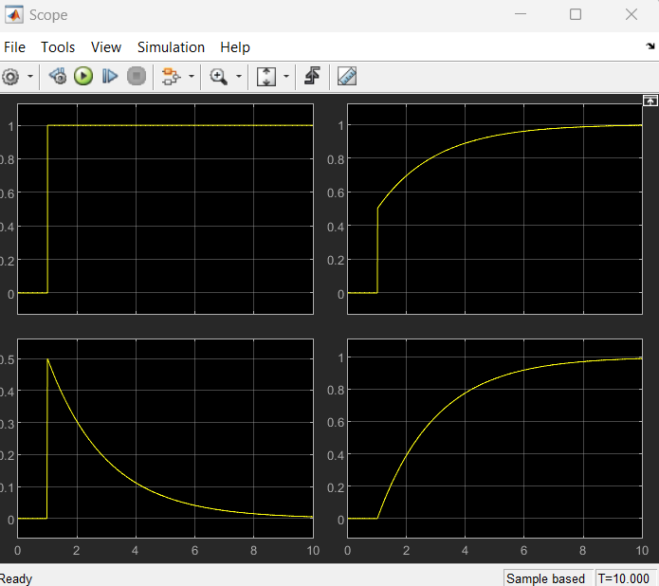
(Figure 7- Initial Simulation)

STEP 2:
From this a basic calculation can be shown to generate a value for the Transfer function:
G= Transfer Function
Numerator= (1,0)
Denominator= (0,6,2,0)
Staff Number= 2114620
Therefore,
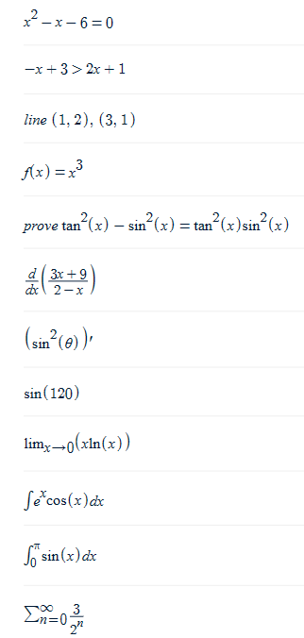

Therefor,
G= 1/3 OR 0.33333…

STEP 3:
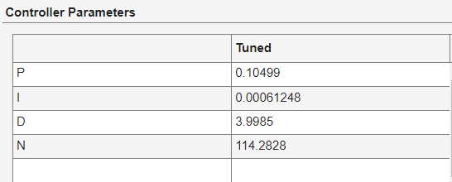
(Figure 8- PID simulated values)

The tuned values are within the time frame and overshoot, of around 2 seconds and 4.7% generating the values shown in Figure that will be implemented back into the PID, reset the Transfer function and similarities in its wave form should be created from the simulation completed shown below:
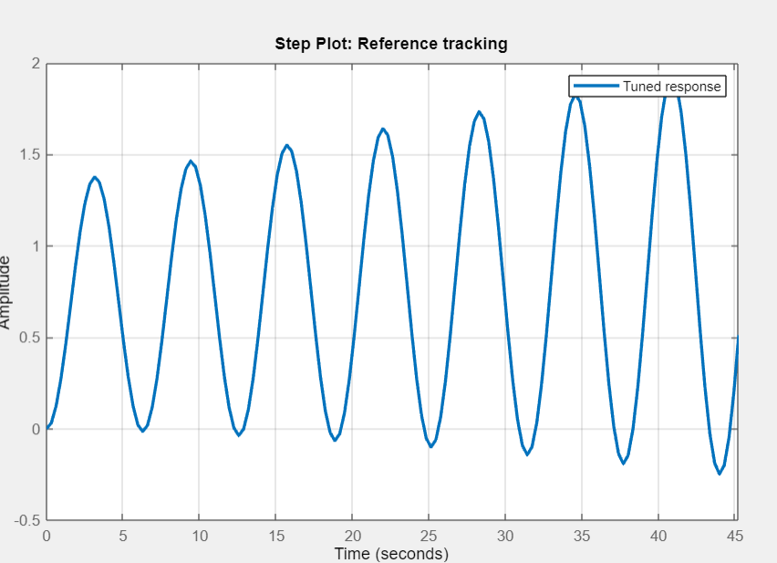
(Figure 9- Tuned Values)
STEP 4:

The PID values will be implemented back into the original circuit and the initial Transfer function will be utilised to compare previous results,
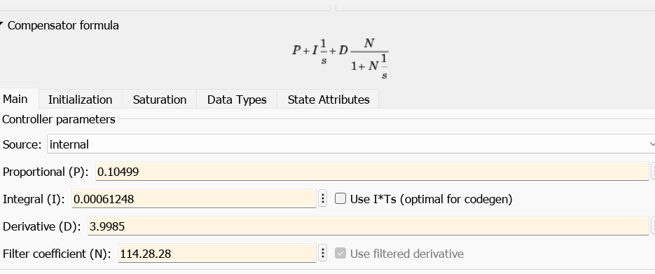
(Figure 10- Inputted PID simulation values)

The oscillation in figure 9 shows a simulation pictorial when the system was set to its appropriate parameters, the values obtained in the PID controller have been inputted back into the original circuit seen in figure 10.
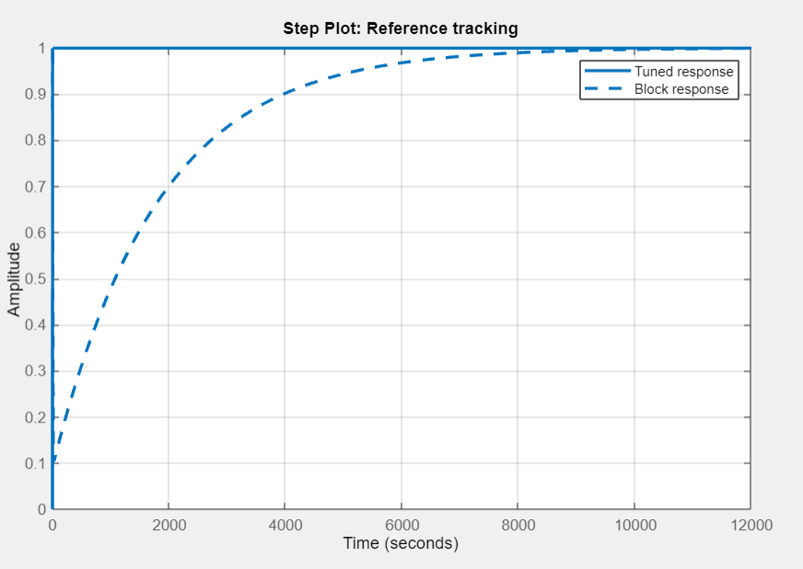
(Figure 11- PID tuned values and original Transfer Function simulation)

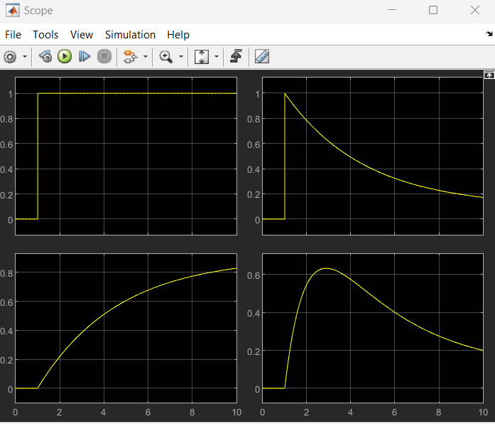
(Figure 12- Simulations results expressed by Scope)

Discussion
In the initial simulation completed it has shown the circuit to operate as highlighted in the literature, the step function performing appropriately with its amplitude shooting from 0 to 1 and the other functions continually increase or decrease before an inevitable plateau. From this the theoretical value had been calculated for the transfer function in which G= 0.033333. From this the PID values where inputted again to gain the simulated function value which came out at G=6, the transparency in these results showed vast differences and the tuned scope in figure 11 being well out of the parameters suggests the writer had incorrectly implemented the threshold values of 5% and 2 seconds. However a level of consistency was further shown in the simulation in figure 12 with the Step function acting appropriately and the other components reaching somewhat of a steady state provided the discrepancy in the tuned values.

Conclusions

In conclusion of this report the writer has identified key points in the instrumentation and control subject area. As a complex subject the main points still stand, there must be a clear emphasis on the input and output values, with a level of understanding of the circuit to be able to manipulate these values in such a way that the three criteria are met. Safe, that are controlled system is Safe, Reliable and Efficient in meeting its required task. The writer developed relevant examples and highlighted various instruments that are critical for industry use, with additional insight into specific components that were adopted for the designed circuit. From this the simulations were developed using MATLAB and SIMULINK, the circuit was developed correctly with-it providing simulation data that aligned with the literature, however once the components were manipulated or tuned, some values were extremely off and can be considered unreliable. This will be put down to the writer’s lack of experience with the software and referenced for any other future results.
However, the writer provided key insights into Instrumentation and control, while demonstrating how to generate a circuit, and simulate using appropriate industry standard tools/software.

References

[1] | W. Bolton, “Instrumentation and Control,” Elseiver Ltd, Oxford , 2021.
[2] | Inst Tools , “What is Instrumentation and Control ?,” [Online]. Available: https://instrumentationtools.com/what-is-instrumentation-and-control-engineering/. [Accessed 2023].
[3] | S. Jacob, “Insutrmentation and Control,” Swansea, 2023.
[4] | M. C. F. L Evans 1, “Potential fatality reductions through eliminating occupant ejection from cars,” Accid an prev, pp. 169-82, 1989 .
[5] | T. Irvine, “Basic concepts of electric motor efficiency,” [Online]. Available: https://www.futek.com/Electric-Motor-Output-Power. [Accessed 2023].
[6] | BYJU'S, “STEP FUNCTION,” [Online]. Available: https://byjus.com/maths/step-function/#:~:text=In%20Mathematics%2C%20a%20step%20function,indicator%20functions%20of%20given%20intervals.. [Accessed 2023].
[7] | S. Randive, “What is AWS Step Functions?,” [Online]. Available: https://www.datadoghq.com/knowledge-center/aws-step-functions/#:~:text=AWS%20Step%20Functions%20is%20useful,defining%20a%20security%2Dincident%20response.. [Accessed 2023].
[8] | NorthWestern University , “SUM Simulink Reference,” 2023. [Online]. Available: http://www.ece.northwestern.edu/local-apps/matlabhelp/toolbox/simulink/slref/sum.html.
[9] | EL PRO CUS, “What is a PID Controller : Working & Its Applications,” [Online]. Available: https://www.elprocus.com/the-working-of-a-pid-controller/. [Accessed 2023].
[10] | VRU, “Transfer Function Mathematics,” [Online]. Available: https://vru.vibrationresearch.com/lesson/transfer-function-mathematics/. [Accessed 2023].
[11] | MathWorks, “Transfer Function,” [Online]. Available: https://uk.mathworks.com/discovery/transfer-function.html. [Accessed 2023].
[12] | Computational Data Science Lab , “Data Science In MATLAB,” 2022. [Online]. Available: https://www.cdslab.org/matlab/notes/program-units/variable-scope/index.html#:~:text=MATLAB%20scripts-,Scope%20of%20variables%20in%20MATLAB,to%20other%20functions%20in%20MATLAB.. [Accessed 2023].
[13] | J. C. Drury, Ultrasonic Flaw Detection for Technicians, Silverwing Ltd., 2004.
[14] | P. D. -I. V. Deutsch, “History of NDT - Instrumentation,” Rome, 2000.
[15] | “History of Ultrasonics,” Iowa State University, [Online]. Available: http://www.ndt-ed.org/EducationResources/CommunityCollege/Ultrasonics/Introduction/history.htm. [Accessed 17 February 2011].
[16] | Simulink Reference, “Scope, Floating Scope,” [Online]. Available: http://www.ece.northwestern.edu/local-apps/matlabhelp/toolbox/simulink/slref/scope.html. [Accessed 2023].

Appendices
Appendix 1: 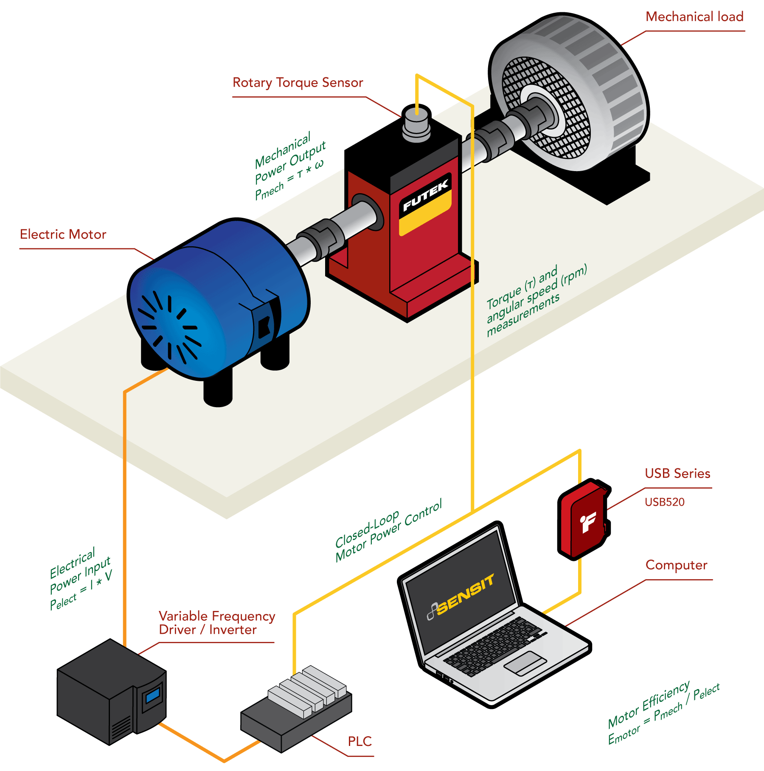
[5]
Appendix 2:

Advances in Control Education 1994
IFAC Symposium, Tokyo, Japan, 1–2 August 1994
IFAC Postprint Volume
1995, Pages 141-144

