  Component One:  What are the key skills required when working in the housekeeping team? 750 words (+/- 10%)  Contribution to Overall Module Assessment: 25% | Student No: | 2128507
 | Module Title: | Operating Hotel Facilities
 | Module Code: | BMIH4006
 | Lecturer: | Lola Villard
Housekeeping is considered the backbone of the hotel industry as we are all looking for a nice, clean and safe environment when we are travelling.
The responsibility of housekeeping staff is to service and clean rooms and other areas of the establishment up to standards, in order to provide a pleasant and comfortable experience for guests. Housekeeping staff make sure all rooms are spotlessly clean and inviting, but they also address guest queries politely and knowledgeably. I think the main skills for a housekeeping team member are: attention to detail, time management and organisational skills, flexibility, customer service skills and ability to work both individually and as a team, interpersonal and communication skills, flexibility and ability to work under pressure. Housekeeping staff need to be knowledgeable about the amenities and attractions within the hotel and answer guest questions when needed. They also have to be friendly and pleasant, promote a positive image of the hotel and show that they care about the guests. Jones (2007) notes that “professional housekeeping needs staff with a sense of pride”. Staff must show genuine concern for their guests through demeanour and attitude. This concern will make guests feel valued and will want to come back, creating loyal and returning customers which contribute to increase in occupancy and hotel growth.

During my time working on the cruise ships, in hotels and while travelling on my holidays I always notice the hard work of people working in hospitality, weather in the restaurants or the housekeeping department. No matter how busy it is they always have to pay attention to maintaining the standards of service as the smallest mistake may result in guest dissatisfaction, a complaint or a bad review. Missing a towel, a creased bed or dust on the furniture, stained linen are things that guests notice immediately and can change their impression and ruin their experience. Through empowerment, housekeeping staff can easily rectify mistakes and resolve problematic situations to benefit the guests experience, without having to escalate to management level. I think this is a good opportunity for housekeeping staff to show their skills and concern and turn the situation into a wow moment that will impress the guest. According to data provided recently by Trivago, room and hotel cleanliness have high significance for the guests’ overall rating of their accommodation. Hotels and restaurants where guests find clean tablecloths, linen and bedding are more likely to receive positive reviews, shows another survey conducted on behalf of one of the largest consumer goods corporations in the world (BigHospitality, 2023).
At Premier Inn, new employees go through an award-winning, online induction programme developed by Whitbread. The company prides itself with “industry-leading training and development as a part of the culture at Whitbread.” (Whitbread, 2023). Integral part of their Force for Good strategy is to support and give opportunities for development to their staff. In Whitbread’s vision this enables a good, positive team experience and allows the company to employ exceptionally trained team members. The programme has different modules for basic skills, where staff learn general, important information about working in the hotel industry. Every year, staff go through it again as a refresher. I think this is a very good procedure as the company wants staff to be always up to date and able to maintain standards of service.
As placement students we had to go through the same process. I found the housekeeping module was the most complex one; I have learned about health and safety procedures, Fire safety, what chemicals are used to clean and where/how to safely store them. One of the important topics was storing the linen appropriately. In the past few years, two Premier Inn hotels have burned down because the laundry cages filled with linen were stored outside the buildings and not in secured, locked areas. I have learned how to set up a housekeeping trolley/ caddy, how to handle them, how to clean a room according to Whitbread standards, how to make a bed and replenish a room to be ready for new guests and how to check a ready room from a supervisor position.
Marriott hotels run a similar induction programme. It starts with an orientation class where all new staff are introduced to The Marriott culture, where they learn about brand, the standards and their particular hotel/area. This training was designed to make sure all new employees master the skills they need to perform their duty at high company standards.
I have thoroughly enjoyed learning how the housekeeping department works but also working alongside housekeeping staff at Premier Inn and have realised the hard work of the staff. I learned that a clean room is the first step to a memorable guest experience and that is why it is so important to pay attention to every small detail.

Word Count | 800

Component Two:
Contribution to Overall Module Assessment: 25%
In this scenario – You have just been promoted to team leader for a floor within the hotel. A guest complains that on their arrival, their room had not been properly cleaned. Create an action plan and answer the following questions.

Problem | Why did it happen? | What are you going to do? | How will you prevent this from happening in the future? | What measures would you introduce to improve team effectiveness?
- Guest complains that they are 3 in the room, and they only have 2 cups and 2 glasses. | - As per Premier Inn brand standards, the rooms are set up with 2 cups and 2 glasses, even if room has 3-4 occupants. Guests can ask housekeeping team or front desk staff for extra cups and glasses. | - Apologise to guest and explain brand standards; it was not a mistake but that is how rooms are set up. Staff will gladly provide extra supplies upon request. Thank the guest for understanding. | - Situation might happen again as it is not something that can be changed. Reception staff could be advised to inform guests that room is only set up with a limited number of cups and glasses and if they extra ones, they can ask any staff to get more. | - Housekeeping staff have supplies on their trolleys and in store room and they can always replenish or add extra cups/ glasses upon request. Front desk should inform guests upon check-in and offer extra supplies if requested.
- Couple complains that they have asked for extra pillows and have not got them. | - All rooms in Premier Inn hotels have a set of extra pillows ready and safe to use. They can be found in a storage bag on top of the shelves. | - Accompany guest to room and show them where they can find the extra pillows; inform guests this is standard procedure and they will always have an additional set available. | - Reception staff could inform guests about the availability of the extra set of pillows. Hotel could print on the key card holders this information or it could be printed on one of the leaflets available on the desk of each room. | - Upon check in front desk staff should advise guests to read the useful information printed on the leaflet found on the stateroom desk.
- Family goes to room and finds it in a mess, it has not been cleaned since departure of previous guests. | - Housekeeping staff misread the daily cleaning sheet. Cleaned a different room and left that one undone. Staff reported room was ready for check in, so room was allocated to guests. | - Sincerely apologise to guests and go to room to check situation. If there are other rooms available that meet the guest’s requirements allocate another room to them and immediately send housekeeping staff to clean the other room. Make changes in the system and keep that room for a later check in. If there are no empty rooms, kindly ask the guests to wait at the bar/lobby and offer them a round of drinks on the house while they wait for the room to be cleaned. Once room is ready, accompany guests to the room, apologise again and wish them a great stay. | - At the beginning of shift, housekeeping staff receives the list of rooms allocated for them to clean for new check-ins or daily cleaning. Supervisor should check on staff during shift to see progress and discuss with them number of the rooms that have been done. At the end of the shift when staff reports all rooms cleaned, supervisor should check and sign off all rooms. | - Supervisor has to check and sign off all rooms ready for check in, to make sure they all are clean and set up according to standards and guest requirements.
- Single traveler checks into her room and finds hair on the duvet cover. | - Both housekeeping staff and supervisor have to check there are no hairs on bed linen, towels, sink or bathtub. Even though they check thoroughly, sometimes hair can fall off one’s clothes or from a cloth and settle on a visible surface. | - Apologise to guest and ask if they want the linen changed or the surface cleaned again. | - Supervisor checks all ready rooms, paying attention to these aspects. Supervisor should keep a record of any complaints of this nature to be able to find out who cleaned the room. | - Staff should be advised to take a last look before they leave the room, to see if they can spot any hair. Supervisor will give a last check and sigh off the room as clean, or note down any mistakes and raise them with staff.
- Couple complains their room was very noisy, they could not sleep well because of noise. | - Hotel was full with families with children as there was a dance competition nearby. The couple booked last minute, and they were allocated one of the last available rooms. | - Apologise for the noise and explain that hotel was fully booked for this dance competition. | - Ask guests to speak to reception in case there is any other room available in a quieter area of the hotel. | - Advise reception of the complaint and ask them to speak to the guests.

Component Three:
Contribution to Overall Module Assessment: 50%
Your task is to create and prepare a presentation following the detailed scenario provided below.

As the floor housekeeping manager and given the recent guest complaints you need to put together a basic training presentation for your colleagues within the housekeeping team to get the best out of them, ensure that brand standard is being achieved and that Health and Safety procedures are also being followed.

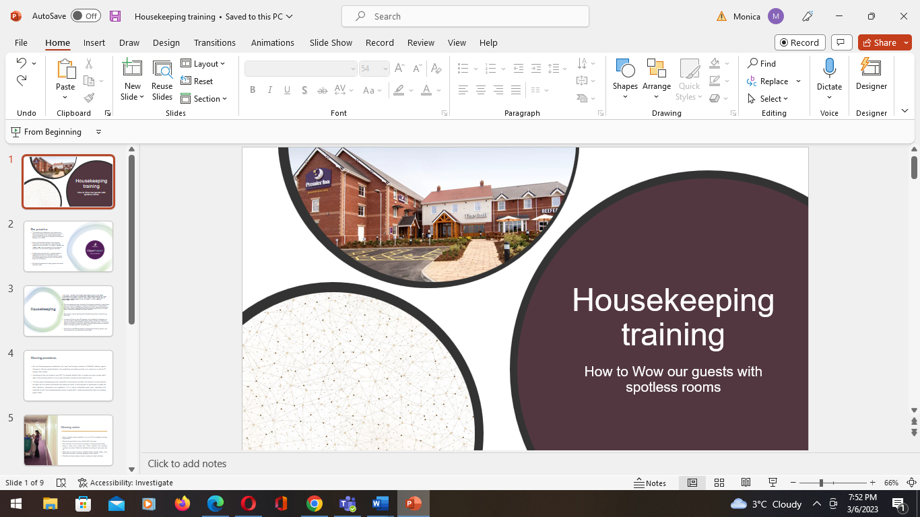

Training Notes:
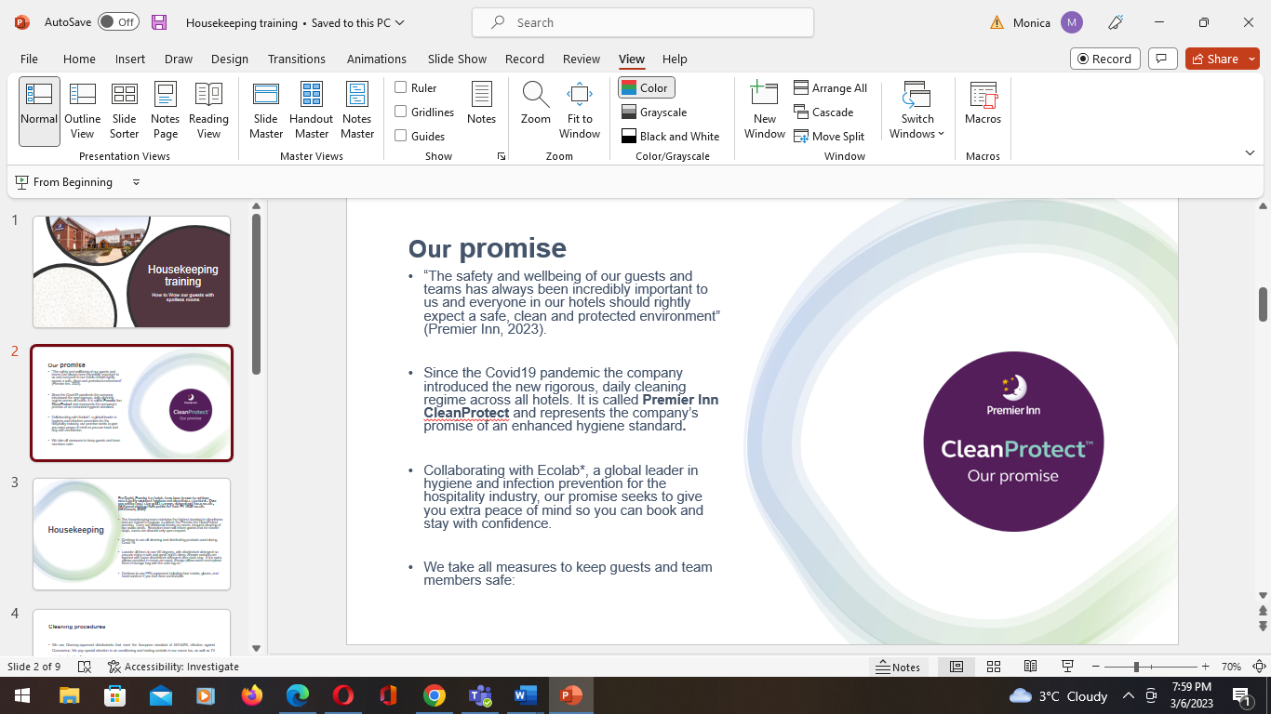

Training Notes: Recently we have had a number of complaints regarding cleanliness in the rooms and we need to address this situation as we do not want bad reviews influencing our bookings. Most of the complaints regard finding hairs on bed linen, stained towels or linen, finding rubbish and small objects under bed, dirty carpets or hir in the bathrooms.
- People are still recovering from the effects of Covid 19 and are still cautious regarding health and safety measures when travelling.
- We have to carry on using the same routine as after the 2020 reopening, keeping focus on high-touch locations, such as lift buttons and door handles, desks, TV and AC remote controls, using products effective against COVID-19.

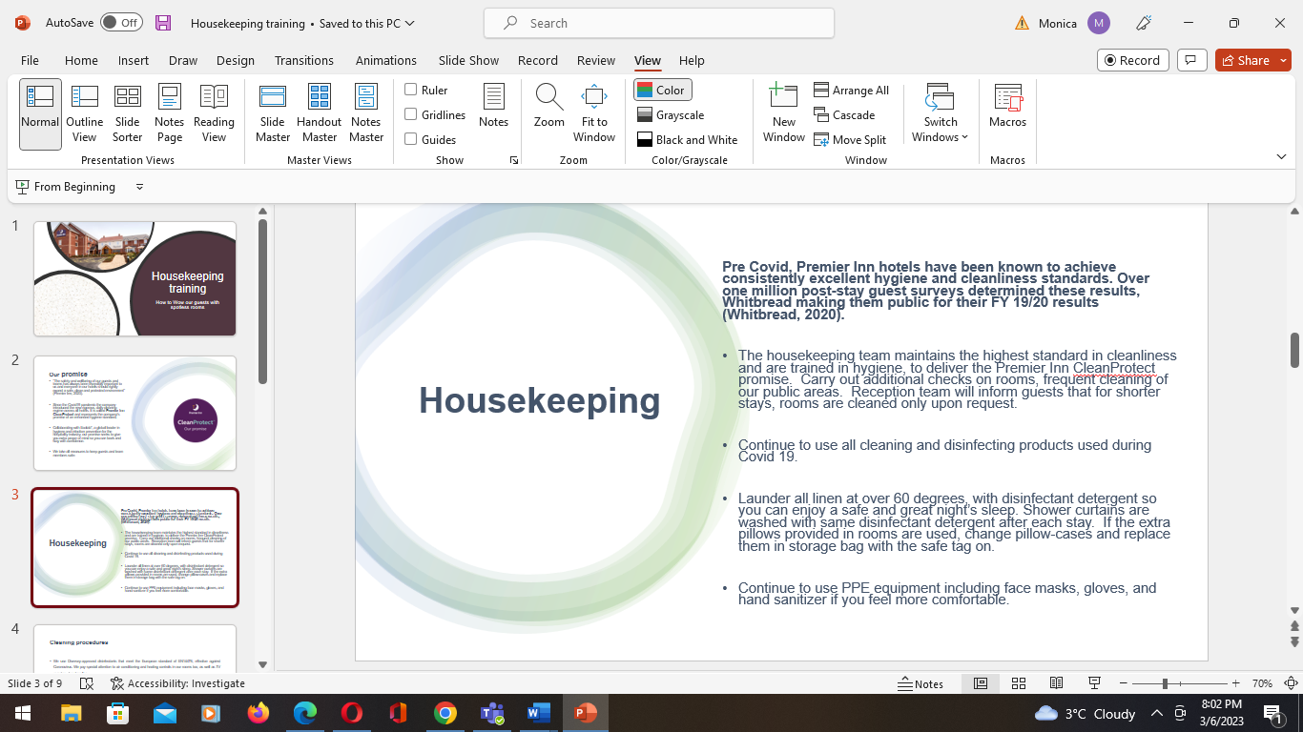

Training Notes: We all know what we have to do and how to clean the rooms assigned to you. Make sure you double-check the information on your sheet at the beginning of the shift: check-outs, re-makes, new room set-up.
- It is your responsibility to check that information and carry out your tasks accordingly. If you have questions or need help with something do ask before you go to your assigned area.
- Focus on early check-in rooms if you have any, then carry on with rest.
- When you have finished o room, tick off your list and move on to the next.
- Housekeeping supervisor will randomly check the progress of your work.
- When you have submitted your room schedule, ticking off all rooms, housekeeping supervisor and/or manager will carry out the final room check to make sure everything is ready and spotless for the new guests.

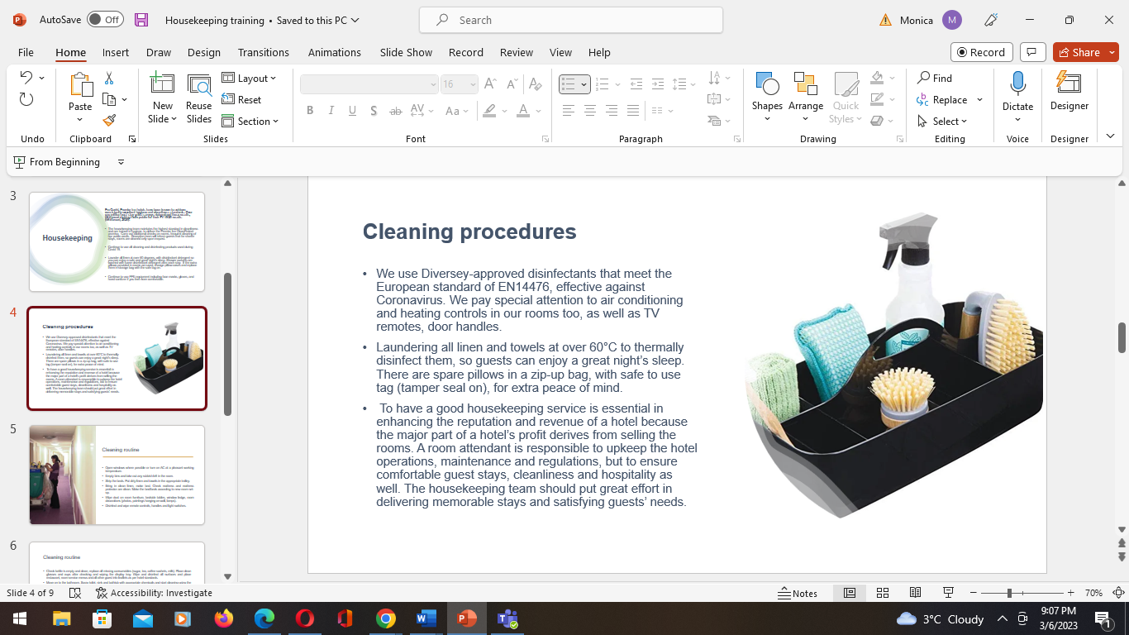

Training Notes: According to the Housekeeping standards manual, updated for this year you have to:
1. When entering the room, knock twice announcing ‘housekeeping’ with each knock 2. Bedroom door should close quietly without force or interference 3. Furniture, fixtures and fittings are clean, dust free and never damaged 4. There is no evidence of previous guests in the room 5. Carpets look as new; vacuumed, hair, mark and debris free 6. Bedroom bin is clean inside and out placed under the tea/coffee tray. The bin is always lined with an empty liner that reaches the bottom of the bin 7. Electrical products such as the TV and hairdryer are in working order. They must be sourced from approved suppliers and maintained in line with company guidelines 8. When the TV is first switched on, correct, brand approved welcome message is the first thing the guests see 9. Hairdryers are fitted with a nozzle (clean/dust free) placed in the holder and working 10. Main curtains are clean, no rips, holes or tears. They are left evenly open on both sides for guest arrival (1/3 of the way across the window on both sides) 11. Net curtains fit the window neatly, they are clean/ironed with no rips. tears or holes.

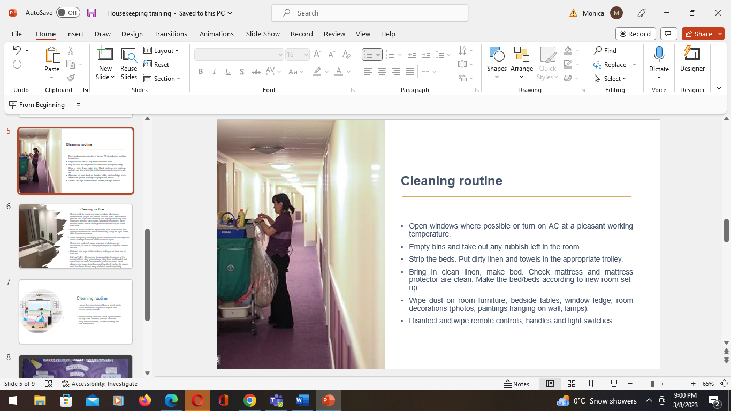

Training Notes:
Strip the beds. It is recommended to start by stripping the sheets. You can use the dirty sheet to wrap up the rest of the bed linen, keeping everything together.
- If guests are staying more than one night, we will not be servicing rooms, unless the guest specifically requests it. We will not be checking each day to see if guests need anything. They have to request bed change and fresh towels at reception.
- If a guest is staying for more than 6 nights we follow the COVID-19 Secure Mulit-Night Stay Process.
- If guests request fresh linen or towels, room will be serviced when guest are away.
- Trolley set up must include hand sanitiser.
- Trolleys must be emptied at the end of the shift and cleaned with SUMA BAC D10 chemical.
- Trolleys can be set up for the next day, but do not overstock them.
- Bed bugs check carried out following the SOP, recorded on CoPilot.
- Inspect beds for damages or stains and smooth out the mattress. Make the bed following hotel standards and make sure to check sheets, covers and pillows have no stains, tears or any hairs.
- Mattresses have to be turned/rotated every three months.
- Check mattress protectors are clean, stain-free and not damaged.
- Room should be well dusted from top to bottom including windowsills, lamp shades, skirting boards and any hanging artwork.
- Check if pillows, throws and curtains look in perfect condition, in the correct configuration and according to hotel standards.
- Use the recommended colour coordinated cleaning system to prevent cross contamination (blue cloth – dust, surfaces; red cloth-sink and bath; yellow cloth – toilet). A clean set of cleaning cloths should be used for each room.
- It is very important to sanitise high contact areas/items: remote control, light switches, door handles and telephones and particularly devices in the bathroom area.
- Special attention when cleaning the bathroom including toilet seats and handles. All traces of the previous guest must be removed, especially any hair!
- Chrome items to be polished, to remove watermarks, change the shower curtain if dirty and replace towels.
- Replace all consumables provided: tea, coffee, sugar, milk, laundry bags, do not disturb signs, notebooks and guest guides, clean glassware and mugs.
- Vacuum last and check the carpet for any damage or stains. Remove any marks from food, drink or makeup using the stain remover. Vacuuming is important because it helps maintain carpets, prevent dust build-up.
- Leave the room with a neutral odour and at a pleasant temperature.

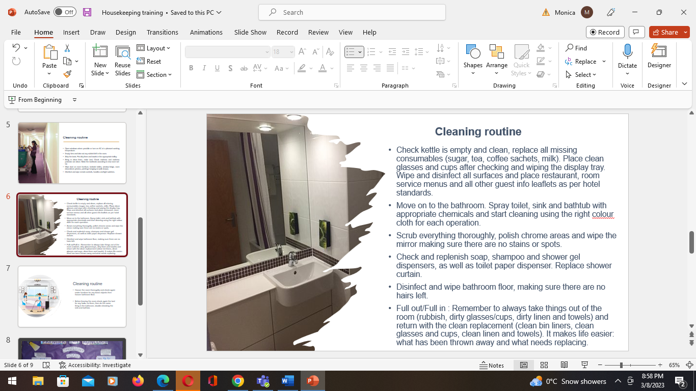

Training Notes: It’s always important to remove rubbish left behind by previous guests. Make sure to empty the bins and replace them with bin liners, as well as remove anything else left behind. You’ll need to also check for this in hidden areas, such as under the beds and in the shelves. Any food that has been left behind by guests should also be removed. Bathroom cleanliness is essential, staff must focus on this:
- Bathroom smells fresh, no lingering odours
- Bath plug is always attached to the chain and sink plug is left open
- Small bathroom bin must be clean and polished. positioned by bathtub to be accessible for the guests. Bin liner should be tied safely and not be visible from the outside. not be visible from the outside.
- Bathmat is folded and placed over the edge of the bath rail.
- The shower curtain is pulled to the middle of the bathtub, allowing towel rack to be visible.
- Shower curtain is replaced after each stay, must be clean and crease free.
- If rooms have shower-screens they have to be damage free, smear free and buffed.
- In rooms with hinged shower doors, door must be left open into the bathroom, ready for guests.
- Shower head must be clean, not dripping, limescale free, fully working.
- Shower tray, plug and walls are clean, no hair or residue.
- Bath mixer taps to be set to ‘bath’ and ‘warm’ for guest arrival.
12.Sink and bath are clean and free from hairs, limescale, residues or water marks.
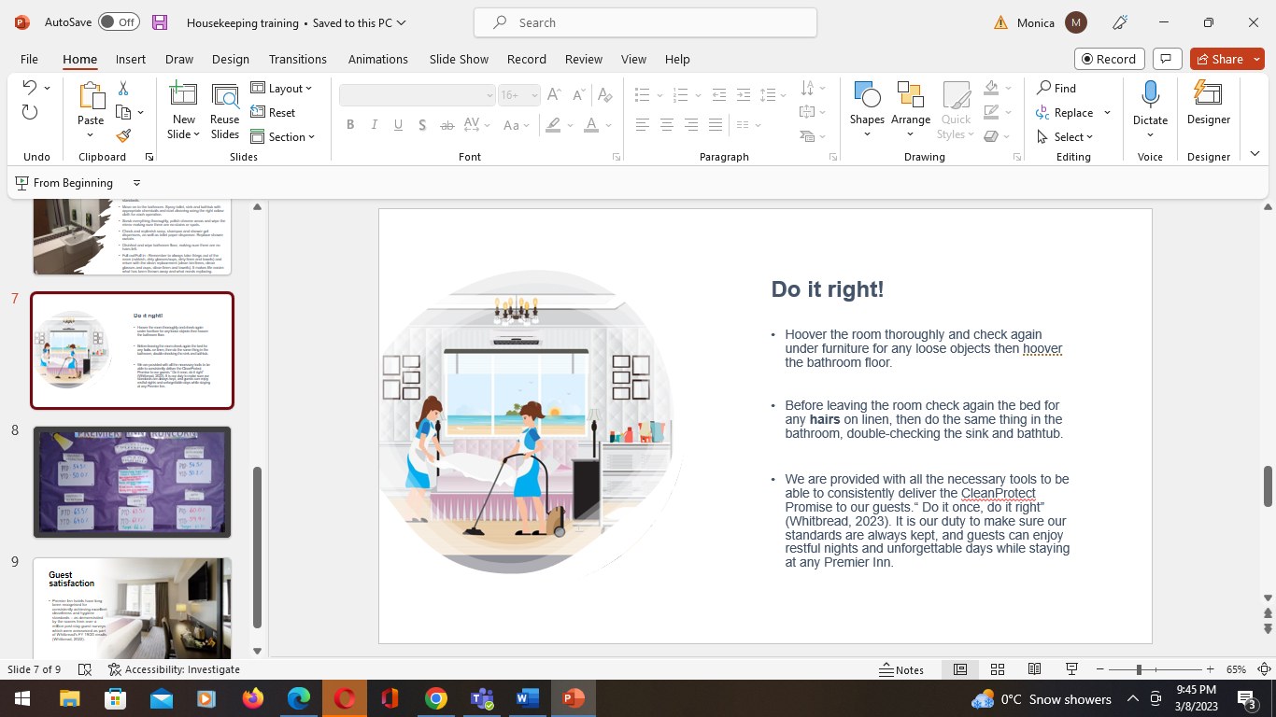

Training Notes:
- One hand towel and one bathmat per room, bath sheets are dictated by occupancy.
- All towels are clean and measured against current reject guidelines
- Towels are only changed in line with ‘Force for good’ policy. Towel reuse POS is in every bathroom.
- The towels should be centred on the rack.
- The fold of the towels must face the door, open end facing in towards the tiles
- Where baths are present the bathmat should be placed over the edge of the bath rail, in line with the shower curtain.
The presence of hair on bed linen and in the bathtub or sink were the most common complaints lately. It is not always our fault (we know hairs can fall off our clothes, could be a lash or a thread. Many times, clean linen comes back with hair from the laundry, so it is our duty to double, even triple-check when we put the new sheet, pillowcases and duvet cover. We must make sure there are no stains, rips or hair on them.
Another issue mentioned in the reviews was regarding the carpet in the room, which did not seem clean. Hoover the carpet properly, pay attention to skirting board areas where dust can clutter if not cleaned regularly.

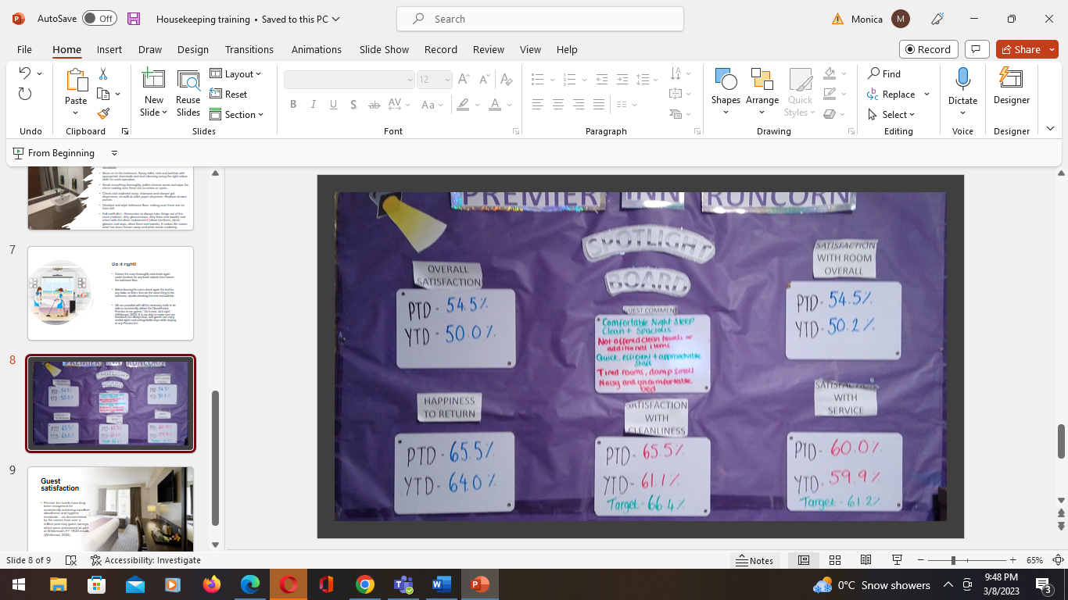

Training Notes: Our guests always leave feedback, either at departure at the front desk or leaving comments on our website.
A lot of our guests are returning ones, with business accounts, who stay with us several times a year: we have to impress them every time they come to stay with us. For guests who stay with us for the first time, we have to impress them as well, and make them come back.
These are the latest figures regarding guest satisfaction. We have done well, but I know we can do better and reach those targets.

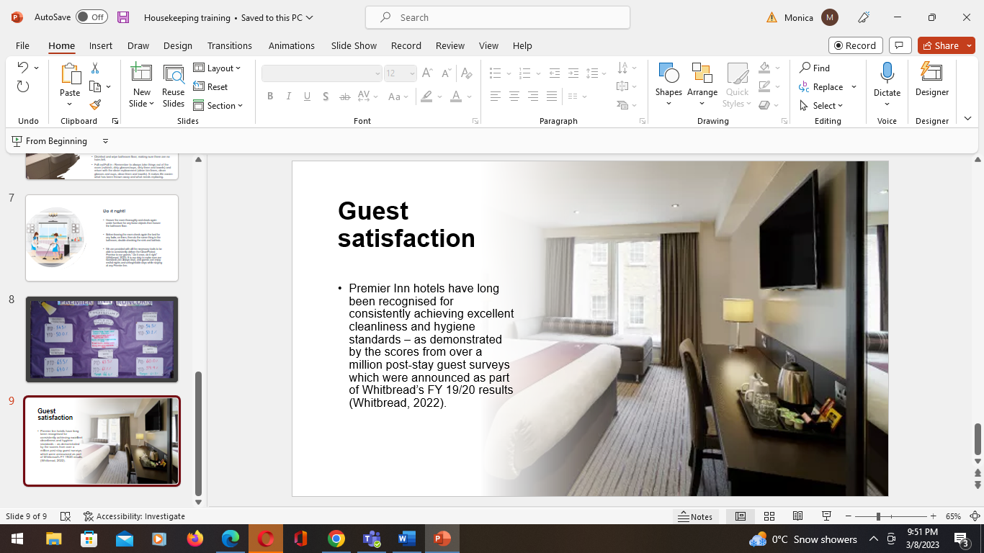

Training Notes:
To ensure the success and growth of the hotel management industry, it is necessary to implement various operational strategies. Among these strategies, providing comprehensive training programs to the housekeeping staff is of utmost importance. It is essential for the housekeeping department to fully comprehend and establish standard procedures and service protocols to provide the best possible services to customers. Through effective training, housekeeping staff can enhance their skills and become well-versed in the industry's best practices. This will enable them to offer high-quality services to guests, which is crucial for the hotel's success and reputation. Therefore, investing in a robust training program for housekeeping staff is a wise decision for any hotel looking to achieve long-term success in the industry.

Training Notes:

References
Component 1:
Betterteam (2023) Job description: Room Attendant. Available at: https://www.betterteam.com/room-attendant-job-description, (Accessed :20 January 2023)
Bighospitality (2023) Clean linen has significant impact on guest satisfaction. Available at: https://www.bighospitality.co.uk/Article/2016/03/16/Clean-linen-has-significant-impact-on-guest-satisfaction-finds-survey, (Accessed: 7 February 2023).
Hotel Management (2023) Marriott employee training program. Available at: https://www.hotelmanagement.net/human-resources/hr-marriott-employee-training-and-development-program, (Accessed: 9 February 2023).
Jones, T.J.A., & Jones 2007, Professional Management of Housekeeping Operations, John Wiley & Sons, Inc., Hoboken. Available from: ProQuest Ebook Central. [23 January 2023].
National Careers Service (2023) Job profiles. Available at: https://nationalcareers.service.gov.uk/job-profiles/hotel-room-attendant, (Accessed: 23 January 2023).
Component 2:
Good Housekeeping (2005). The Housekeeping Handbook. Hearst Books.
Jones, P. (2018). Handbook of hospitality operations. Oxford, Uk ; Burlington, Ma: Butterworth Heinemann.
Owen, Kayleigh (2023). Premier Inn Runcorn, Deputy Manager.
Sunter, Emma (2023). Premier Inn Runcorn, Housekeeping Supervisor.
Whitbread (2023) Training and development. Available at: https://www.whitbread.co.uk/sustainability/opportunity/training-and-development/, (Accessed:4 February 2023)

Adam, J. (2017). International journal of hospitality management. Oxford: Pergamon Press.
Fullagar, S. and Wilson, E. (2012). Journal of Hospitality and Tourism Management. Journal of Hospitality and Tourism Management, 19(1), pp.1–6. doi:https://doi.org/10.1017/jht.2012.3.
Good Housekeeping (2005). The Housekeeping Handbook. Hearst Books.
Jagels, M. and Ralston, C.E. (2020). Hospitality management accounting. Student workbook and study guide. Hoboken, N.J.: Wiley ; Chichester.
Jones, P. (2018). Handbook of hospitality operations. Oxford, Uk ; Burlington, Ma: Butterworth Heinemann.
Schneider, M., Tucker, G. and Scoviak, M. (2018). The Professional Housekeeper. John Wiley & Sons Incorporated.
Webster, T. (2017). Clean: The Humble Art of Domestic Housekeeping. Anon.

Component 3:
Envirodri (2018). 10 Steps to clean a hotel room. Available at: https://envirodri.com/News/156-/10-Steps-to-clean-a-hotel-room-in-under-30-Minutes (Accessed:28 February 2023).
Getty Images (2012). Available at: https://www.gettyimages.co.uk/detail/news-photo/chambermaid-prepares-her-cleaning-trolley-at-a-premier-inn-news-photo/143159893?utm_medium=organic&utm_source=google&utm_campaign=iptcurl , (Accessed: 27 February 2023).
Pinterest (2023). Pin: Maid cleaning hotel room. Available at : https://www.pinterest.co.uk/pin/maid-cleaning-hotel-room-with-housekeeping-trolley-with-bed-clothes-linen-in-cart-and-vacuum-cleaner-hotel--573434965049379221/, (Accessed: 6 March 2023).
Premier Inn (2021). News. Available at: https://www.premierinn.com/gb/en/news/2021/life-skills-academy.html, (Accessed:27 February 2023).
Schneider, M., Tucker, G. and Scoviak, M. (2018). The Professional Housekeeper. Hoboken: John Wiley & Sons Incorporated.

