Assessment – 2

Design and Deploy a Web Application for UWTSD

Introduction 3
Chapter 1: Deployment of the Web Application on Microsoft Azure 3
1.1. Creating a Microsoft Azure Account 3
1.2. Deploying the Web Application on Azure 4
1.3. Setting up Application Insights 5
1.4. Setting up Continuous Deployment 5
Chapter 2: Setting Up the PostgreSQL Database 6
2.1. Deploying a PostgreSQL Server on Azure 6
2.2. Configuring the PostgreSQL Connection String 6
Chapter 3: Interacting with the Web Application 7
3.1. Navigating the Web Application 7
3.2. Managing Student Records 7
3.3. Managing Library Records 7
3.4. Managing Staff Records 8
Chapter 4: Performing CRUD Operations 8
4.1. Creating Records 8
4.2. Reading Records 8
4.3. Updating Records 9
4.4. Deleting Records 9
Chapter 5: Conclusion and Support Resources 9
5.1. Conclusion 9
Deployment and Database Setup 9
Scaling and Enhancing Performance 10
Resources and Support 10
Staying Informed and Future-Proofing 10
5.2. Additional Support Resources 10

Introduction
The University of Wales Trinity Saint David (UWTSD) Birmingham has developed a web application to manage student, staff, and library records. Built using the Python Flask framework and PostgreSQL database management system, this application streamlines academic and administrative tasks, improving efficiency and reducing errors.
This comprehensive user guide aims to help users deploy and use the UWTSD Birmingham web application hosted on Microsoft Azure, a leading cloud computing platform. By following the steps outlined in this guide, users can effectively manage and interact with the application, performing essential operations on records.

Chapter 1: Deployment of the Web Application on Microsoft Azure

1.1. Creating a Microsoft Azure Account
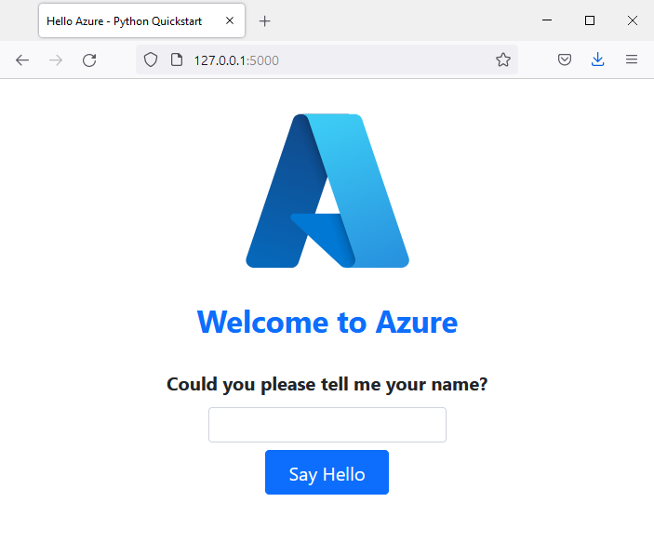
Figure 1: Welcoming screen when accessing from the browser

Before we can deploy our web application on Microsoft Azure, we need to create an Azure account. Microsoft Azure is a cloud computing platform that allows you to build, test, deploy, and manage applications through Microsoft-managed data centres.
To create an Azure account, follow these steps:
- Navigate to the Microsoft Azure website (https://azure.microsoft.com) and click on "Start free."
- You will be prompted to sign in with a Microsoft account. If you don't already have one, you can create one by clicking on "Create one!"
- Once you're signed in, you'll need to provide some personal information and verify your identity with a phone number.
- After verification, you'll need to provide a valid credit card for billing purposes. Note that you won't be charged during the free trial period, and you can cancel your subscription anytime.
- Once your account is set up, you'll have access to the Azure Portal, where you can create and manage your resources.

1.2. Deploying the Web Application on Azure
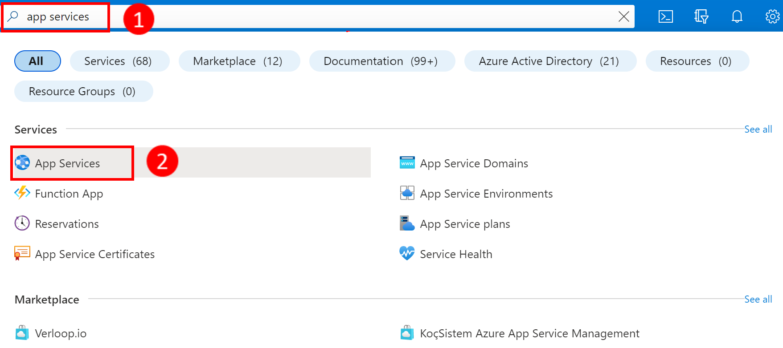
Figure 2: Creating Azure app service resource
Now that we have our Azure account, we can deploy our web application. Here's how:
- In the Azure Portal, click on "Create a resource" in the left-hand menu.
- Search for "Web App" in the search bar, and click on the "Web App" result.
- Click "Create" to start configuring your web app.
- Fill in the necessary information, such as the subscription, resource group, name, operating system, and runtime stack. Be sure to choose a unique name for your app, as this will be part of the app's URL.
- Choose a region for your app, ideally one close to your target users.
- Click "Next: Monitoring" to set up Application Insights (we'll cover this in the next section) and then "Next: Deployment" to configure continuous deployment (we'll cover this in section 1.4).
- Review your settings and click "Create" to deploy your web app.
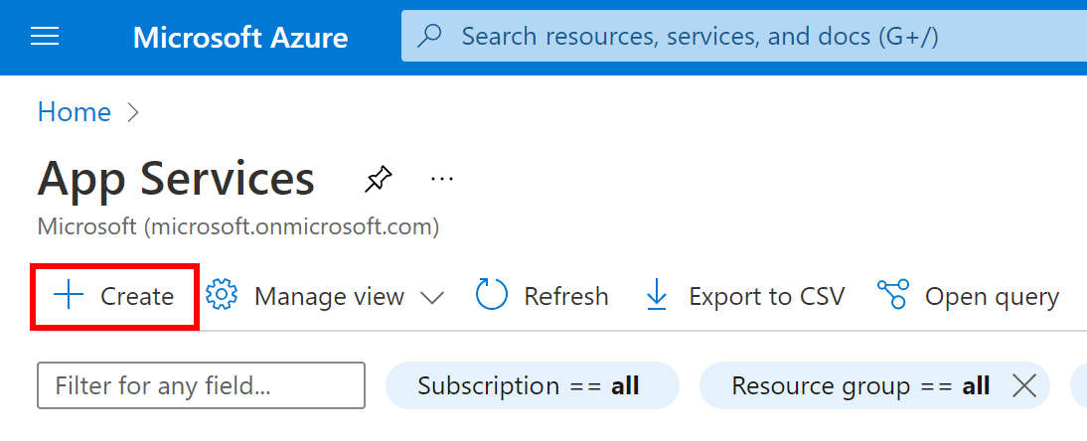
Figure 3. Creating the app service

1.3. Setting up Application Insights
Application Insights is a feature of Azure Monitor that provides comprehensive monitoring and diagnostics for your web application. It helps you detect and diagnose performance issues and understand how users are interacting with your app. To set up Application Insights, follow these steps:
- In the Azure Portal, navigate to your web app's resource page.
- In the left-hand menu, click on "Application Insights."
- Click on "Enable Application Insights."
- Select the appropriate settings for your app, such as the resource group and location, and click "Apply."
Now, Application Insights will start collecting data from our web app, providing us with valuable insights to improve its performance and user experience.

1.4. Setting up Continuous Deployment
Continuous deployment allows us to automatically deploy new versions of your web application whenever changes are pushed to a specified repository. This ensures that your app always runs the latest code and minimises downtime during updates. To set up continuous deployment, follow these steps:
- In the Azure Portal, navigate to your web app's resource page.
- In the left-hand menu, click on "Deployment Center."
- Choose your source control provider (e.g., GitHub, Azure Repos, Bitbucket) and click "Continue."
- Authorise Azure to access your repository by following the on-screen instructions.
- Select the repository and branch that you want to deploy from and click "Continue."
- Choose a build provider (e.g., Azure Pipelines, Kudu) and configure the build settings as necessary.
- Click "Continue" and review the deployment configuration.
- Once you've reviewed the deployment configuration, click "Finish" to set up continuous deployment for your web app.
With continuous deployment configured, Azure will automatically deploy the latest version of your web application whenever you push changes to the specified repository and branch. This process will help you keep your web application up-to-date and minimise downtime during updates.
Now that we have successfully deployed our web application on Microsoft Azure, set up Application Insights, and configured continuous deployment, we're ready to move on to the next chapter. In Chapter 2, we'll explore how to set up the PostgreSQL database for our web application.

Chapter 2: Setting Up the PostgreSQL Database

2.1. Deploying a PostgreSQL Server on Azure
To store and manage our web application's data, we will use a PostgreSQL database. Microsoft Azure offers managed PostgreSQL servers through Azure Database for PostgreSQL, which provides a fully managed and scalable database service. Steps to deploy a PostgreSQL server on Azure:
- In the Azure Portal, click on "Create a resource" in the left-hand menu.
- Search for "Azure Database for PostgreSQL" in the search bar, and click on the "Azure Database for PostgreSQL - Single Server" result.
- Click "Create" to start configuring your PostgreSQL server.
- Fill in the necessary information, such as the subscription, resource group, server name, location, and administrator username and password. Be sure to choose a unique name for your server, as this will be part of the server's connection string.
- Choose the desired compute and storage configuration for your server. You can start with the "Basic" tier and scale up later if needed.
- Click "Next: Networking" to configure the server's network settings. It is recommended to enable "Allow Azure services and resources to access this server" to simplify integration with your web app.
- Review the additional settings, such as backup and security, and click "Review + create" to review your server configuration.
- Once you've reviewed the configuration, click "Create" to deploy your PostgreSQL server.

2.2. Configuring the PostgreSQL Connection String
After deploying the PostgreSQL server, we need to configure the connection string for our web application to access the database. Follow these steps to obtain the connection string:
- In the Azure Portal, navigate to your PostgreSQL server's resource page.
- In the left-hand menu, click on "Connection strings."
- Copy the appropriate connection string template for your application's programming language (e.g., Python, Node.js, PHP, etc.).
- Replace the placeholders in the template with your server's administrator username and password, which you set during the server configuration.
Now, we can integrate the connection string into our web application's code or configuration to connect it to the PostgreSQL server.

With the PostgreSQL database set up and connected to our web application, we can move on to Chapter 3, where we will learn how to interact with the web application, including managing student, library, and staff records.

Chapter 3: Interacting with the Web Application

3.1. Navigating the Web Application
Now that our web application is deployed and connected to the PostgreSQL database, we can start using it. To navigate the web application, follow these steps:
- Access our web application's URL, which should be in the format "http://<app_name>.azurewebsites.net" where <app_name> is the unique name we chose during deployment.
- The homepage should provide an overview of the available features and functionality, as well as links or a menu for navigating to different sections of the application.

3.2. Managing Student Records
The web application should include a section for managing student records. This section should allow us to:
- Add new students with relevant information such as name, date of birth, address, and contact details.
- Search for existing students using filters or search criteria.
- View and edit student records, updating information as needed.
- Delete student records if necessary.

3.3. Managing Library Records
Another section of the web application should be dedicated to managing library records. This section should enable us to:
- Add new books or resources to the library, including information such as title, author, publication date, and genre.
- Search for existing books or resources using filters or search criteria.
- View and edit library records, updating information as needed.
- Track book loans, including borrower information and due dates.
- Delete library records if necessary.

3.4. Managing Staff Records
Finally, the web application should also include a section for managing staff records. This section should allow us to:
- Add new staff members with relevant information such as name, role, contact details, and employment start date.
- Search for existing staff members using filters or search criteria.
- View and edit staff records, updating information as needed.
- Delete staff records if necessary.
Now that we know how to interact with the web application and manage various records, we will move on to Chapter 4, where we will delve deeper into performing CRUD (Create, Read, Update, Delete) operations on these records.

Chapter 4: Performing CRUD Operations

4.1. Creating Records
To create new records in the web application, such as student, library, or staff records, follow these steps:
- Navigate to the relevant section of the web application (e.g., student, library, or staff).
- Click on the "Add New" or "Create" button, which should open a form for entering the record's information.
- Fill in the required fields with the necessary information. Some fields may have validation rules to ensure data consistency.
- Click on the "Save" or "Submit" button to create the new record.
- The web application should display a confirmation message to indicate that the record was successfully created.

4.2. Reading Records
To read or view existing records in the web application, we will follow these steps:
- Navigate to the relevant section of the web application (e.g., student, library, or staff).
- Use the search functionality or filters to find the specific record(s) you are looking for.
- Click on the record to open its detailed view, which should display all the information associated with the record.

4.3. Updating Records
To update existing records in the web application, follow these steps:
- Navigate to the relevant section of the web application (e.g., student, library, or staff).
- Use the search functionality or filters to find the specific record(s) you want to update.
- Click on the "Edit" or "Update" button next to the record, which should open a form with the record's current information.
- Modify the fields as needed, ensuring that any validation rules are followed.
- Click on the "Save" or "Submit" button to update the record.
- The web application should display a confirmation message to indicate that the record was successfully updated.

4.4. Deleting Records
To delete records from the web application, follow these steps:
- Navigate to the relevant section of the web application (e.g., student, library, or staff).
- Use the search functionality or filters to find the specific record(s) you want to delete.
- Click on the "Delete" or "Remove" button next to the record.
- The web application may prompt you to confirm the deletion, as this action cannot be undone. Click "Yes" or "Confirm" to proceed with the deletion.
- The web application should display a confirmation message to indicate that the record was successfully deleted.
Now that we know how to perform CRUD operations on student, library, and staff records, we can efficiently manage our web application's data. In the next chapter, we will wrap up this guide with a conclusion and provide additional support resources.

Chapter 5: Conclusion and Support Resources

5.1. Conclusion
In this comprehensive guide, we've covered the process of deploying a web application on Microsoft Azure, a leading cloud computing platform, and setting up a PostgreSQL database for efficient data management. To make this guide easier to follow, let's break it down into smaller sections.

Deployment and Database Setup
We've delved into the details of deploying our web application and setting up a PostgreSQL database, an essential component for managing data effectively. Throughout this process, we've explored the user interface and key features of the web application, offering valuable insights into performing CRUD operations on various records, such as students, library resources, and staff.

Scaling and Enhancing Performance
As we continue to develop and maintain our web application, we may face new challenges or opportunities for growth. Microsoft Azure provides a range of services and features to help us scale our application, improve performance, and strengthen security measures. This ensures our web application remains agile and responsive to the ever-evolving demands of the digital landscape.

Resources and Support
It is important to keep in mind the multitude of resources and support available. The Azure documentation, developer community, and technical forums provide valuable assistance in navigating the intricate landscape of web application development and management. These resources can prove to be immensely helpful in resolving technical challenges and keeping up-to-date with the latest trends and best practices in the field.

Staying Informed and Future-Proofing
To ensure success in web application development, it's important to stay up-to-date with the latest trends, best practices, and technological advancements. This includes understanding the latest programming languages, frameworks, and design patterns.
By staying current, individuals can future-proof their web application and unlock its full potential. This can lead to a superior user experience and streamlined management of various records, creating a more effective and efficient academic environment.
To achieve these benefits, it's recommended that we utilise available resources and seek assistance from the community or additional resources when needed. By following this guidance, we will be well-equipped to develop and maintain a powerful web application on Microsoft Azure, leveraging the full capabilities of a PostgreSQL database.
For example, taking advantage of Azure's built-in monitoring tools can help us identify and troubleshoot issues quickly. Additionally, incorporating responsive design principles can optimise user experience across multiple devices and platforms.
In conclusion, keeping up-to-date with the latest trends and best practices is critical to developing a successful web application. By utilizing available resources and seeking assistance when needed, we can effectively future-proof our application and achieve maximum potential.

5.2. Additional Support Resources
To further support our web application development journey, here are some additional resources:
Microsoft Azure Documentation (https://docs.microsoft.com/en-us/azure/): The official Azure documentation provides comprehensive information on all Azure services, including guides, tutorials, and best practices.
Azure Database for PostgreSQL Documentation (https://docs.microsoft.com/en-us/azure/postgresql/): This resource offers in-depth information on using Azure Database for PostgreSQL, including data migration, performance tuning, and backup and recovery.
Azure Web Apps Documentation (https://docs.microsoft.com/en-us/azure/app-service/): Here, you can find detailed guidance on managing and scaling your web application on Azure, as well as integrating with other Azure services.
Azure Application Insights Documentation (https://docs.microsoft.com/en-us/azure/azure-monitor/app/app-insights-overview): This documentation provides insights into using Application Insights for monitoring and diagnosing your web application's performance and user experience.
Azure Developer Community (https://techcommunity.microsoft.com/t5/azure-developer-community-blog/bg-p/AzureDevCommunityBlog): The Azure Developer Community blog offers articles, case studies, and tutorials contributed by Azure developers, providing real-world examples and solutions.

