Marketing Fundamentals (LCBB4004)

Florin Adrian Fizesan
ID-2116189
Lecturer : Piyumika Kithulgoda Gamage

Table of Contents
Introduction 1
Background of Coca-Cola 2
Targeting 6
Positioning 8
Marketing Mix Strategy 9
Product 10
Price 12
Promotion 13
Place and Distribution Channels 14
Conclusion and Recommendations: 15
References 16

Introduction

Welcome to the blog dedicated to the world's most iconic soft drink, Coca-Cola! In this space, we will embark on a journey through the history, culture, and impact of this legendary beverage that has become a global symbol of happiness and refreshment. From its humble beginnings to its remarkable evolution into a cultural phenomenon, we invite you to delve into the fascinating world of Coca-Cola.

Background of Coca-Cola

Coca-Cola, one of the most iconic and globally recognized brands, has a rich history that dates back to the late 19th century. The company was founded in 1886 by pharmacist John Pemberton in Atlanta, Georgia, with the creation of a carbonated beverage that would later become known as Coca-Cola. Since its inception, Coca-Cola has become a symbol of refreshment, happiness, and global unity,(Greising, D. 2012).
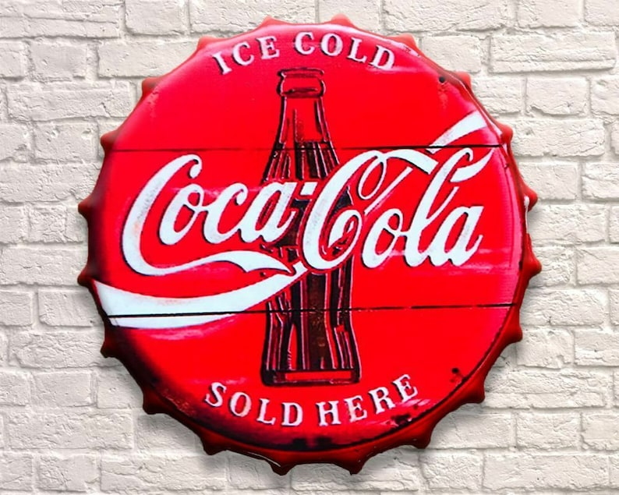
The success of Coca-Cola can be attributed to its strong brand image, effective marketing strategies, and continuous innovation. Over the years, Coca-Cola has expanded its product portfolio to include a diverse range of beverages, including Coca-Cola Classic, Diet Coke, Sprite, Fanta, and a variety of juices, teas, and energy drinks. The company operates in more than 200 countries and territories,
Source: (coca cola 2023)
serving billions of consumers worldwide,Keating, (T. E. 2019).
In order to maintain its market leadership, Coca-Cola has focused on strategic partnerships and acquisitions. The company has entered into various agreements with bottling partners to ensure efficient production and distribution of its products. Additionally, Coca-Cola has made significant investments in marketing and advertising campaigns to build brand equity and maintain a strong presence in the minds of consumers.

Marketing segmentation

Marketing segmentation is a strategic approach that involves dividing a broad target market into smaller, more manageable segments based on specific characteristics or behaviours (Kotler & Keller, 2021). It allows businesses to better understand their customers and tailor their marketing efforts to effectively reach and engage with each segment.According to Kotler and Keller (2021), segmentation is a crucial step in marketing strategy development, as it enables
Source: from bing

businesses to identify distinct customer groups with unique needs, preferences, and behaviours. By understanding these segments, companies can create targeted marketing campaigns that resonate with specific customer groups, leading to improved customer satisfaction and increased sales, (Kotler & Keller, 2021).
In addition, the journals like the "Journal of Marketing" and "Journal of Consumer Research" also provide valuable insights into marketing segmentation strategies. These journals feature scholarly articles that explore the latest developments and best practices in marketing segmentation. For example, a study by Wedel and Kamakura (2012) in the "Journal of Marketing"
Cluster Analysis: Cluster analysis is a popular method used to identify groups of customers with similar characteristics. This technique groups customers based on similarities in their behavior, preferences, or purchase patterns. By using cluster analysis, businesses can identify distinct segments within their customer base and design targeted marketing strategies for each group , (Kotler & Keller, 2021).
Factor Analysis: Factor analysis helps identify underlying factors that influence customer behavior. It allows businesses to reduce a large number of variables to a smaller set of factors, simplifying the segmentation process. Factor analysis helps in understanding the key drivers that influence customer decision-making.
Conjoint Analysis: Conjoint analysis is used to determine how customers value different attributes or features of a product or service. By understanding the relative importance of these attributes, businesses can develop products and marketing messages that resonate with specific customer segments, , (Kotler & Keller, 2021).


When Coca-Cola's segmentation strategy is considered, it is based on various factors such as demographic, geographic, psychographic, and behavioural variables, allowing the company to effectively target and cater to a diverse customer base (Kotler & Keller, 2016). Demographic segmentation involves dividing the market based on factors suchas age, gender, income levels, and lifestyles. For example, Coca-Cola targets different age groups, including children, teenagers, and adults, by offering specific product variations and packaging designs
Source : from bing
that appeal to each segment, , (Kotler & Keller, 2021).
Geographical segmentation is a marketing strategy that involves dividing a market or target audience based on their geographic location. This approach recognizes that different regions or countries may have distinct preferences, needs, and cultural influences, which can impact consumer behavior and purchasing decisions,(Kotler & Keller, 2016).When the coca cola is considered, they are selling products. Geographic segmentation also helps Coca-Cola understand regional preferences and adapt its marketing efforts accordingly. This includes considering factors such as climate, cultural differences, and local tastes. For instance, Coca-Cola conducts region-specific flavours or launch campaigns that align with local festivals or events. For example, (Kotler & Keller, 2016).

Psychographic segmentation focuses on consumers' attitudes, values, interests, and lifestyles (citation), (Kotler & Keller, 2016). Coca-Cola recognizes that different consumer groups have distinct preferences and perceptions. By understanding psychographic traits, the company can create targeted messaging and positioning that resonate with specific segments. For example, they may tailor advertisements to
Source: from bing

highlight the social aspect of
consuming Coca-Cola, appealing to individuals who value connection and shared experiences.
Behavioural segmentation involves analysing consumers' purchasing behaviours, product usage, and brand loyalty. Coca-Cola identifies consumer behaviours such as frequency of consumption, brand loyalty, and usage occasions. This helps them develop strategies to encourage increased consumption, retain loyal customers, and create tailored experiences based on specific usage contexts (Fill, 2013).

Targeting

Building upon its segmentation analysis, Coca-Cola identifies specific target markets where its products can achieve maximum impact (Lamb, Hair, &McDaniel, 2017). One of the key target markets for Coca-Cola is teenagers, who form a significant consumer segment. The company recognizes that teenagers are a vital demographic with their own distinct preferences and purchasing power. Coca-Cola creates marketing campaigns that appeal to this target market by leveraging youthful imagery, music, and popular influencers to establish a strong connection with teenagers (citation).
Coca-Cola Classic (Regular Coke): Coca-Cola Classic, the original and most widely recognized product, is targeted at a global audience. It is the flagship product that is available in almost every country where Coca-Cola operates.
Coca-Cola Light/Diet Coke: To target health-conscious consumers and those seeking low-calorie options, Coca-Cola introduced Diet Coke (Coca-Cola Light in some regions). This variant is popular in many countries, especially in Western markets and regions with a growing focus on health and wellness.

Coca-Cola Zero Sugar: Coca-Cola Zero Sugar is another low-calorie option that is targeted at consumers who want a sugar-free cola experience. This product has gained popularity worldwide, particularly among health-conscious individuals, (Lamb, Hair, & McDaniel, 2017).

Another important target market for Coca-Cola is young adults. This segment includes individuals in their twenties and early thirties who are transitioning into adulthood and often seek products that align with their active lifestyles and socializing habits. Coca-Cola positions its products as refreshing and energizing beverages that complement social gatherings, sports events, and other activities that young adults commonly
Source: from bing
engage in(Lamb, Hair, & McDaniel, 2017).

Families are also a significant target market for Coca-Cola. Recognizing that families consume beverages together, Coca-Cola emphasizes the importance of sharing special moments and creating memories through its products. They often portray Coca-Cola as a drink that brings people together and enhances family experiences
Source : from bing


Coca-Cola Family Packs: Coca-Cola offers family-sized packs of its beverages, which are designed specifically for family gatherings and shared moments. These larger packs are more cost-effective and convenient for families to enjoy together.

Positioning
Source: from bing
Coca-Cola has successfully positioned itself as a global brand known for happiness, refreshment, and moments of joy (Aaker, 2014). The company's iconic products, including Coca-Cola Original and Coca-Cola Zero Sugar, play a vital role in its market positioning strategy. These products have become synonymous with the brand and serve as the foundation for Coca-Cola's market presence.
Coca-Cola's positioning strategy revolves around establishing emotional connections, creating
memorable experiences, and associating the brand with desirable lifestyles. Through its marketing campaigns, Coca-Cola aims to evoke positive emotions and elicit a sense of happiness and enjoyment among consumers
,(Aaker, 2014). The brand often portrays moments of togetherness, celebration, and sharing, emphasizing the role of Coca-Cola in enhancing these experiences.
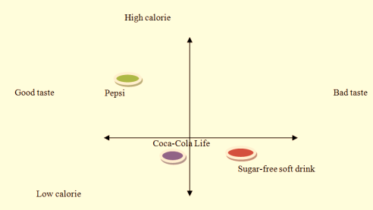
By consistently promoting its classic and iconic products, Coca-Cola maintains its market position and reinforces its brand identity. The enduring popularity of Coca-Cola Original demonstrates the brand's ability to withstand
Source :from bing

the test of time and remain a beloved choice for consumers seeking a refreshing beverage.

Marketing Mix Strategy

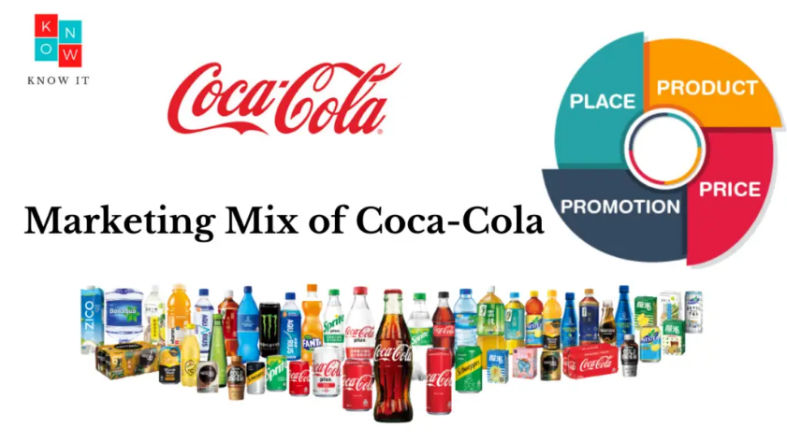
Marketing mix strategies refer to the combination of elements that a company utilizes to promote its products or services effectively in the market. These elements, known as the 4Ps (product, price, place, and promotion), are strategic components that companies adjust and optimize to achieve their marketing objectives
Source: from bing

(Kotler, P., & Keller, K. L., 2016).The first element, products
involves decisions regarding the features, design, packaging, and branding of the offering. It encompasses both the tangible and intangible aspects of the product or service, aiming to create value and meet customer needs.
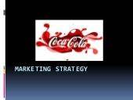
The second element, price, refers to the monetary value attached to the product or service. Pricing decisions consider factors such as cost, competition, demand, and perceived value, with the goal of achieving profitability while remaining attractive to customers, (Kotler, P., & Keller, K. L., 2016).
The third element, place (or distribution), focuses on the availability and accessibility of the product or service to the target market. It involves decisions related to distribution channels, inventory management, logistics,
Source: from bing

and retail partnerships to ensure the product
reaches the right customers at the right place and
time.
The fourth element, promotion, involves various marketing activities aimed at communicating and persuading customers about the product's value and benefits. This includes advertising, public relations, sales promotions, direct marketing, and digital marketing strategies.

Product

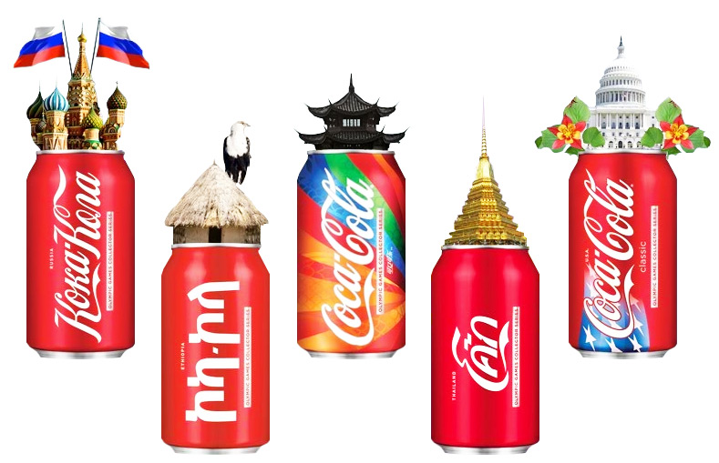
Coca-Cola offers a diverse range of products to cater to different consumer preferences (Kotler & Keller, 2016). The company's product portfolio includes carbonated soft drinks, non-carbonated beverages, and bottled water. Coca-Cola recognizes the importance of product innovation to remain competitive and meet changing consumer demands.
To stay relevant in the market, Coca-Cola continually introduces new Flavors and packaging options (Doyle, 2017). This allows the company to capture the attention of consumers who
Source: (coca cola 2023)
seek variety and novelty in their beverage choices. By expanding their flavour offerings, Coca-Cola can cater to different taste preferences and target specific consumer segments.
Furthermore, Coca-Cola's packaging innovations play a significant role in attracting consumer attention and enhancing the overall product experience. They introduce unique bottle designs, packaging materials, and label designs that align with current trends and consumer preferences. These packaging innovations not only differentiate Coca-Cola's products on the shelf but also contribute to creating a positive brand image and enhancing the overall consumer experience,(Doyle, 2017).

Price
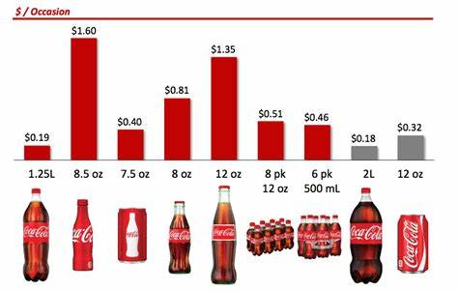
Coca-Cola adopts a competitive pricing strategy that takes into account various factors, including market demand, production costs, and competitor pricing (Nagle & Hogan, 2016). By analysing these factors, Coca-Cola aims to set prices that strike a balance between affordability for consumers and profitability for the company.
Market demand plays a crucial role in Coca-Cola's
Source: (coca cola 2023)
pricing decisions. The company assesses the willingness of consumers to pay for its products based on factors such as perceived value, brand loyalty, and the overall market dynamics. By understanding consumer preferences and price sensitivity, Coca-Cola can determine optimal pricing levels that align with market demand, (Nagle & Hogan, 2016).
Production costs are another important consideration in Coca-Cola's pricing strategy. The company takes into accountfactors such as raw material costs, manufacturing expenses, packaging costs, and distribution expenses. By carefully evaluating these costs, Coca-Cola ensures that its products are priced to cover expenses and generate a reasonable profit margin, (Nagle & Hogan, 2016).
Competitor pricing is also a significant factor that Coca-Cola considers. The company assesses the pricing strategies and positioning of its competitors to remain competitive in the market. Coca-Cola strives to offer products at prices that are in line with or slightly below its competitors' pricing, while still maintaining perceived value and quality, (Nagle & Hogan, 2016).

Promotion
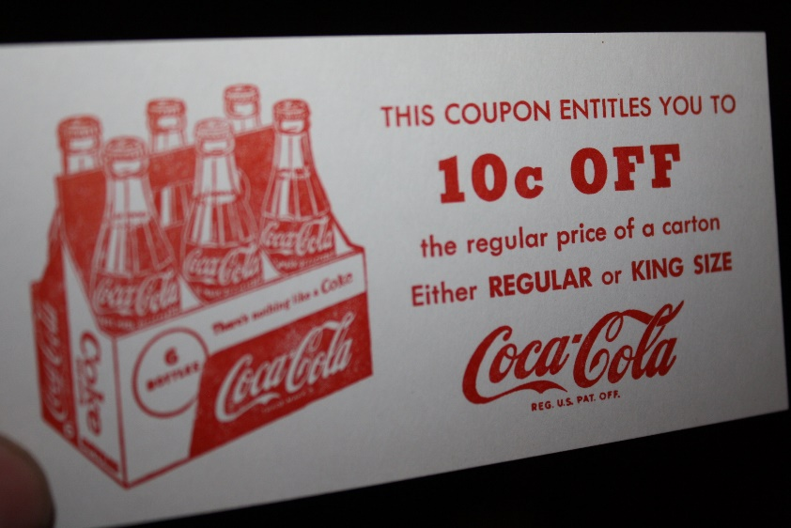
Coca-Cola has mastered the art of promotion through its iconic advertising campaigns (Belch & Belch, 2017). The company allocates significant resources to marketing and advertising activities as a crucial part of its brand-building strategy. Coca-Cola aims to create strong brand awareness and effectively engage with its target audience through these promotional efforts.
Source: (coca cola 2023)
Television advertising has been a cornerstone of Coca-Cola's promotional success. The company produces captivating commercials that resonate with consumers and evoke positive emotions. These advertisements often feature memorable storytelling, catchy jingles, and images of people enjoying Coca-Cola beverages, creating a strong emotional connection with viewers, (Belch & Belch, 2017).
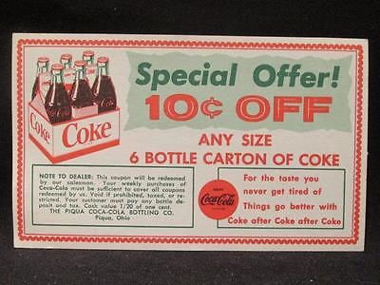
In addition to television, Coca-Cola utilizes digital platforms to extend its reach and connect with consumers in the digital age. The company leverages social media, online videos, and interactive campaigns to engage with a broader audience and encourage user participation. By embracing digital marketing, Coca-Cola stays relevant and effectively communicates its brand message to a tech-savvy consumer base.(Belch & Belch, 2017).Sponsorships and partnerships are another key aspect of Coca-Cola's promotional strategy. The company collaborates with popular events, sports teams, celebrities, and influencers to enhance its brand visibility and connect with target consumers. These partnerships allow Coca-Cola to reach a wide range of audiences and leverage the influence and appeal of associated personalities or events.(Belch & Belch, 2017).
Source: (coca cola 2023)

Place and Distribution Channels

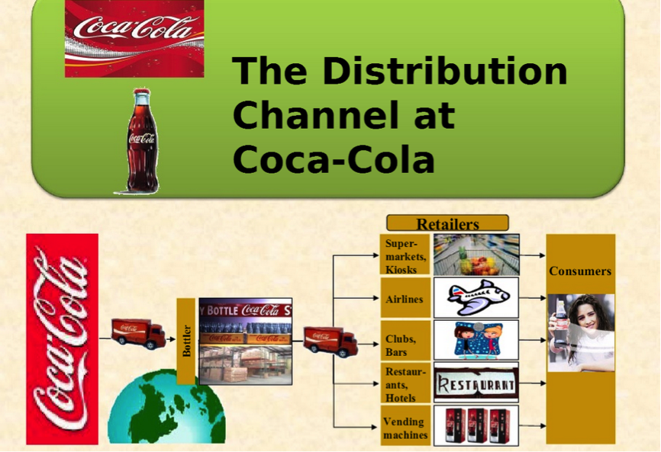
Coca-Cola ensures that its products are readily available to consumers through an extensive distribution network (Kotler & Keller, 2016). The company employs a mix of distribution channels to reach customers worldwide and maintain a strong market presence.
Direct sales play a significant role in Coca-Cola's distribution strategy. The company directly sells its products to large retailers, supermarkets, convenience stores, and restaurants. This allows Coca-Cola Source: (coca cola 2023)
Source: (coca cola 2023)

to have better control over product placement, pricing, and promotions in these key retail outlets, (Kotler & Keller, 2016).
Partnerships with retailers and distributors are also crucial for Coca-Cola's distribution network. The company collaborates with various retail partners and distributors to expand its market reach and ensure that its products are available in a wide range of locations. By partnering with local distributors, Coca-Cola can tap into their expertise and knowledge of specific markets, enabling efficient distribution and faster access to customers, (Kotler & Keller, 2016).
Furthermore, Coca-Cola strategically places vending machines in high-traffic areas such as shopping centres, airports, and public spaces. Vending machines provide convenient access to Coca-Cola products, allowing customers to purchase beverages on the go,(Kotler & Keller, 2016).
Efficient logistics and supply chain management are key focus areas for Coca-Cola to maintain product availability and freshness. The company emphasizes timely delivery and proper inventory management to ensure that its products are consistently replenished on store shelves. By optimizing its supply chain, Coca-Cola minimizes the risk of stockouts and maximizes the freshness of its beverages for customers.
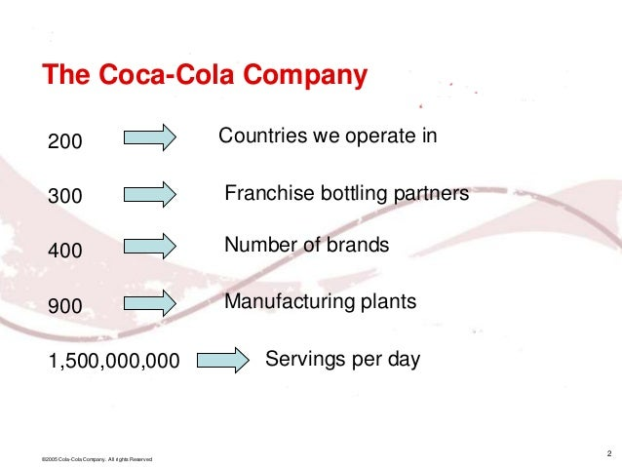
Through its extensive distribution network, Coca-Cola can effectively reach customers across the globe (Kotler & Keller, 2016). The company's emphasis on direct sales, retail partnerships, vending machines, and efficient supply chain management enables it to maintain a strong market presence and ensure that its products are readily accessible to consumers, promoting customer satisfaction and brand loyalty.
Source: (coca cola 2023)

Conclusion and Recommendations:

In conclusion, Coca-Cola's success can be attributed to its effective segmentation, targeting, and positioning strategies. The company excels in understanding its diverse customer base and tailoring its marketing efforts to connect with specific consumer segments. Additionally, Coca-Cola's marketing mix strategies, encompassing product, price, promotion, and place, ensure its products remain relevant and accessible to consumers worldwide.
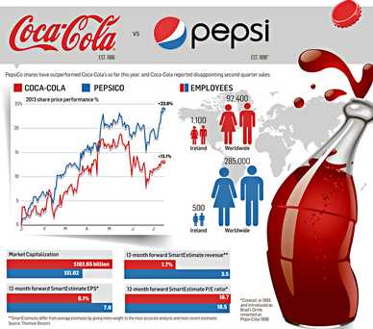
To further enhance its market position, Coca-Cola should continue investing in product innovation, adapting to changing consumer preferences, and leveraging digital marketing channels to engage with a younger demographic. Moreover, the company should explore sustainability initiatives to align with growing consumer concerns about the environment.
By continuously evaluating and adapting its strategies, Coca-Cola can maintain its leadership position in
Source: (coca cola 2023)
the beverage industry and continue to delight consumers with refreshing and enjoyable experiences.

References
Kotler, P., & Keller, K. L. (2016). Marketing Management. Pearson.
Fill, C. (2013). Marketing Communications: Interactivity, Communities, and Content. Pearson.
Lamb, C. W., Hair, J. F., & McDaniel, C. (2017). Marketing. Cengage Learning.
Keller, K. L. (2016). Strategic Brand Management: Building, Measuring, and Managing Brand Equity. Pearson.
Aaker, D. A. (2014). Aaker on Branding: 20 Principles That Drive Success. Morgan James Publishing.
Doyle, P. (2017). Value-Based Marketing: Marketing Strategies for Corporate Growth and Shareholder Value. Wiley.
Nagle, T. T., & Hogan, J. E. (2016). The Strategy and Tactics of Pricing: A Guide to Growing More Profitably. Routledge.
Belch, G. E., & Belch, M. A. (2017). Advertising and Promotion: An Integrated Marketing Communications Perspective. McGraw-Hill Education.
Rosenbloom, B. (2016). Marketing Channels: A Management View. Cengage Learning.
Greising, D. (2012). I'd Like the World to Buy a Coke: The Life and Leadership of Roberto Goizueta. Harvard Business Press.
Keating, T. E. (2019). The Business of Coca-Cola: How a Beverage Giant Became the World's Most Famous Brand. ABC-CLIO
Wedel, M., & Kamakura, W. A. (2012). Market segmentation: Conceptual and methodological foundations (2nd ed.). Springer Science & Business Media.
The Coca-Cola Company. (2023). Home. Coca-Cola. Available at: https://www.coca-colacompany.com/ (Accessed: 15 July 2023).
Available at: https://www.bing.com/images/search?q=cocacola+&FORM=HDRSC4

