Student Name: Irj Hussain
Student number: 2419541
Tutor Name: Helen Parsons
Module Code: LCHS4003
Task 1: Community Antenatal Midwifery Services
Task 2: Domiciliary Care
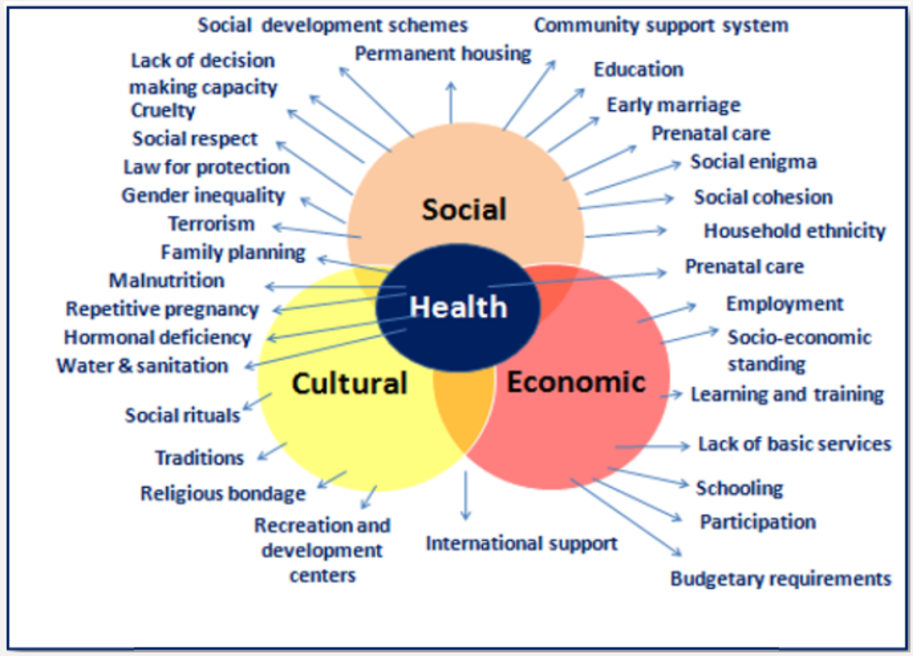

Task 1: Community Antenatal Midwifery Services Community antenatal midwifery services provide personalised pregnancy care and support outside of hospitals, from early pregnancy through to postnatal care. Community antenatal midwifery services are healthcare services delivered by qualified midwives in local settings such as GP surgeries, community clinics, or children’s centres. They are designed to support pregnant women and their families throughout pregnancy, childbirth, and the early weeks of parenthood, focusing on both medical and emotional wellbeing.
Uses:
All pregnant women in the UK are eligible, including those with low-risk pregnancies, women with additional needs, teenagers, women from minority ethnic backgrounds, and those planning home or birth centre deliveries. It also supports partners and families in preparing for parenthood ( Royal College in Midwives, 2024).
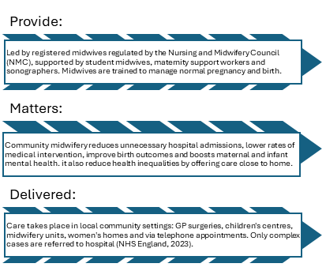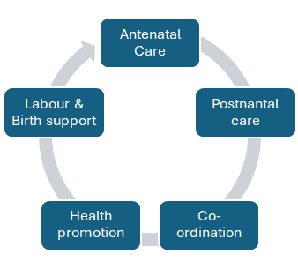 The UK faces a national shortage of midwives in 2024; there were 3,500 unfilled posts across England. Heavy workloads mean midwives often care for 40+ women at once, reducing time for individual support.
Women from deprived areas, black, Asian and minority ethnic groups and those living rurally face poorer outcomes. Barriers include travel distance, language gaps, and lack of culturally appropriate care.
Pre-1900s birth was almost entirely a community, home-based service, with a regulated profession.
1902 Midwives Act: formalised training and registration, creating a regulated profession.
1948: NHS launched integrated midwifery into state care, though most births moved into hospital from the 1950s to the 1970s.
1993 Changing childbirth: Policy shifted focus back to community care, choice, and continuity of carer.
2021 Maternity transformation programme: Committed to continuity of care – the same midwife team throughout pregnancy, birth and postnatal period – to improve safety and satisfaction (RCM, 2022).

Task 2
Domiciliary care
Domiciliary care, commonly referred to as home care, is a social care service that enables individuals to receive support within their own homes rather than in residential or institutional settings. Before the development of the welfare state, support for older adults, disabled people, and those with chronic illnesses was largely provided by family members, charities, or religious organisations. Individuals unable to care for themselves often entered workhouses or long-term institutions, which were frequently criticised for promoting dependency and social exclusion (Means, Richards and Smith, 2008).
The establishment of the National Health Service (NHS) in 1948 improved access to healthcare but did not fully address long-term social care needs. During the 1970s and 1980s, increasing criticism emerged regarding institutional care, particularly concerns about loss of independence, poor quality of life, and high costs. These concerns contributed to a policy shift towards community-based care. The National Health Service and Community Care Act 1990 was particularly influential, as it required local authorities to assess individuals’ needs and prioritise care within the community where possible (Glasby, 2017). Later, the Care Act 2014 strengthened this approach by emphasising wellbeing, personalisation, and individual choice. The development of domiciliary care was therefore shaped by demographic changes, including an ageing population, advances in medical treatment, and increasing recognition of the rights of disabled people to live independently within society (Department of Health and Social Care, 2014).
Today, domiciliary care provides a broad range of services, including personal care, medication support, meal preparation, mobility assistance, domestic tasks, and companionship. This reflects contemporary social care values that prioritise autonomy, dignity, and empowerment. Furthermore, remaining in a familiar environment can reduce anxiety and preserve social connections, particularly for individuals living with dementia (NICE, 2023). However, a critical evaluation reveals significant limitations. Although policy promotes person-centred care, financial constraints often undermine its delivery. Local authorities face increasing demand for services while operating within restricted budgets, resulting in limited care packages and short visit durations. In some cases, care workers may be allocated only 15–30 minutes per visit, making it difficult to provide holistic and relationship-based care. Consequently, support can become task-focused rather than genuinely person-centred (Glasby, 2017).
Workforce issues represent another major challenge. The sector experiences high staff turnover, recruitment difficulties, and relatively low wages compared with the responsibilities involved. According to Skills for Care (2024), workforce shortages continue to affect continuity of care across England. Frequent changes in carers may reduce trust, consistency, and emotional security for service users.
Despite these challenges, domiciliary care remains highly significant in enhancing quality of life. Physically, it enables individuals to maintain personal hygiene, nutrition, mobility, and medication management, reducing the likelihood of health deterioration and hospital admissions. Emotionally, regular contact with care workers can help alleviate loneliness and provide reassurance, which is particularly important given the growing prevalence of social isolation among older adults (Age UK, 2023). Socially, domiciliary care enables individuals to remain active within their communities, maintain family relationships, and participate in meaningful activities. Such opportunities contribute positively to self-esteem, identity, and overall wellbeing.
In conclusion, domiciliary care emerged from a historical shift away from institutional care towards community-based support. Although the service promotes independence, dignity, and social inclusion, its ability to achieve these outcomes is often constrained by workforce shortages, funding pressures, and inconsistencies in service delivery. Nevertheless, it remains a crucial component of modern health and social care, significantly enhancing the quality of life of many vulnerable individuals.

References
https://www.myhsn.co.uk/top-tip/what-is-a-community-midwife.
House of Commons Health and Social Care Committee (2024) Maternity services: workforce and safety. London: The Stationery Office.
NHS England (2023) Community midwifery: delivering safe, personalised care. Available at: England.nhs.uk/maternity (Accessed: 18 June 2026).
Age UK (2023) Later Life in the United Kingdom 2023. London: Age UK.
Department of Health and Social Care (2014) Care Act 2014. London: The Stationery Office.
Glasby, J. (2017) Understanding Health and Social Care. 3rd edn. Bristol: Policy Press.
Means, R., Richards, S. and Smith, R. (2008) Community Care: Policy and Practice. 4th edn. Basingstoke: Palgrave Macmillan.
NICE (2023) Home Care: Delivering Personal Care and Practical Support to Older People Living in Their Own Homes. London: National Institute for Health and Care Excellence.
Skills for Care (2024) The State of the Adult Social Care Sector and Workforce in England. Leeds: Skills for Care.

