LCBB5000 Data Handling & Business Intelligence Assessment 2

Student ID: 2119900

Student name: Daniela Jicmon

Module Title: Data Handling & Business Intelligence

Module code: LCBB 5000

Module Tutor: Xavier Matieni

Microsoft Excel is a useful software as pre-processing of data provides various benefits like user-friendliness, easy and quick data manipulation, etc. which are useful for a data analyst (Advantageslist, 2022). Different analyses such as in-demand built-in formulas, pivotable etc. make the analysis quick and effective, even visualizing and presenting the data becomes effective and allows to customize the charts (Advantageslist, 2022).
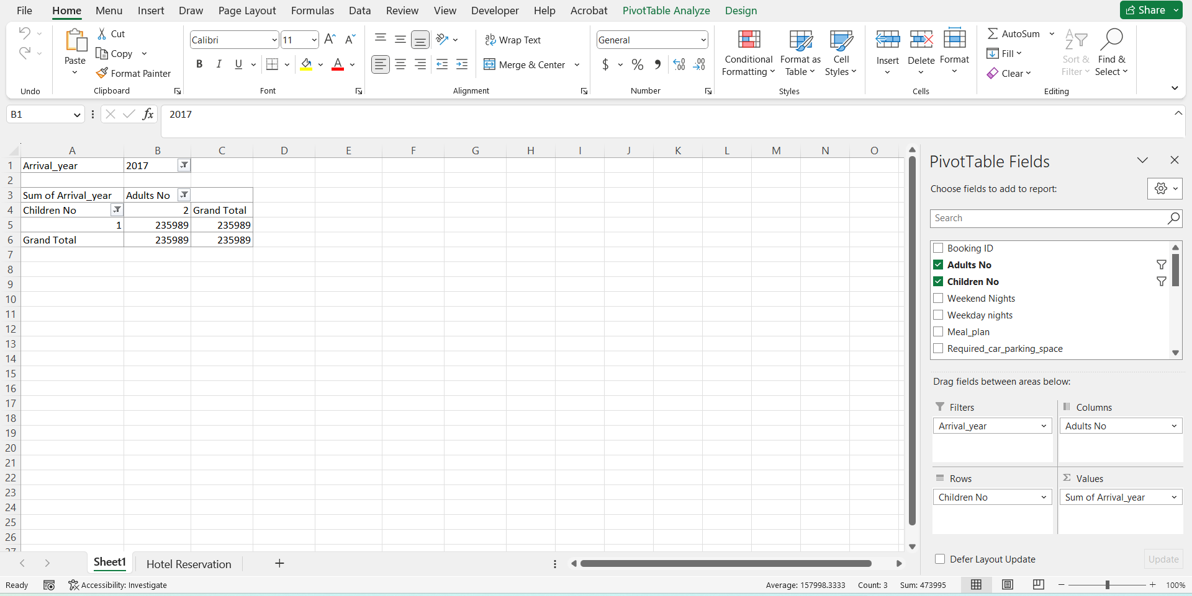
By opening the Hotel Reservation file that was provided, two sheets were found which were previously created. Among these two sheets, the first sheet is called Sheet1 where the PivotTable was found to be readily available, but changes are needed here to get the required results that are anticipated in this task (Harvey, 2007). To be able to perform the necessary tasks, all the columns, rows, filters, etc. are removed first from the PivotTable so that the PivotTable can be used freely.
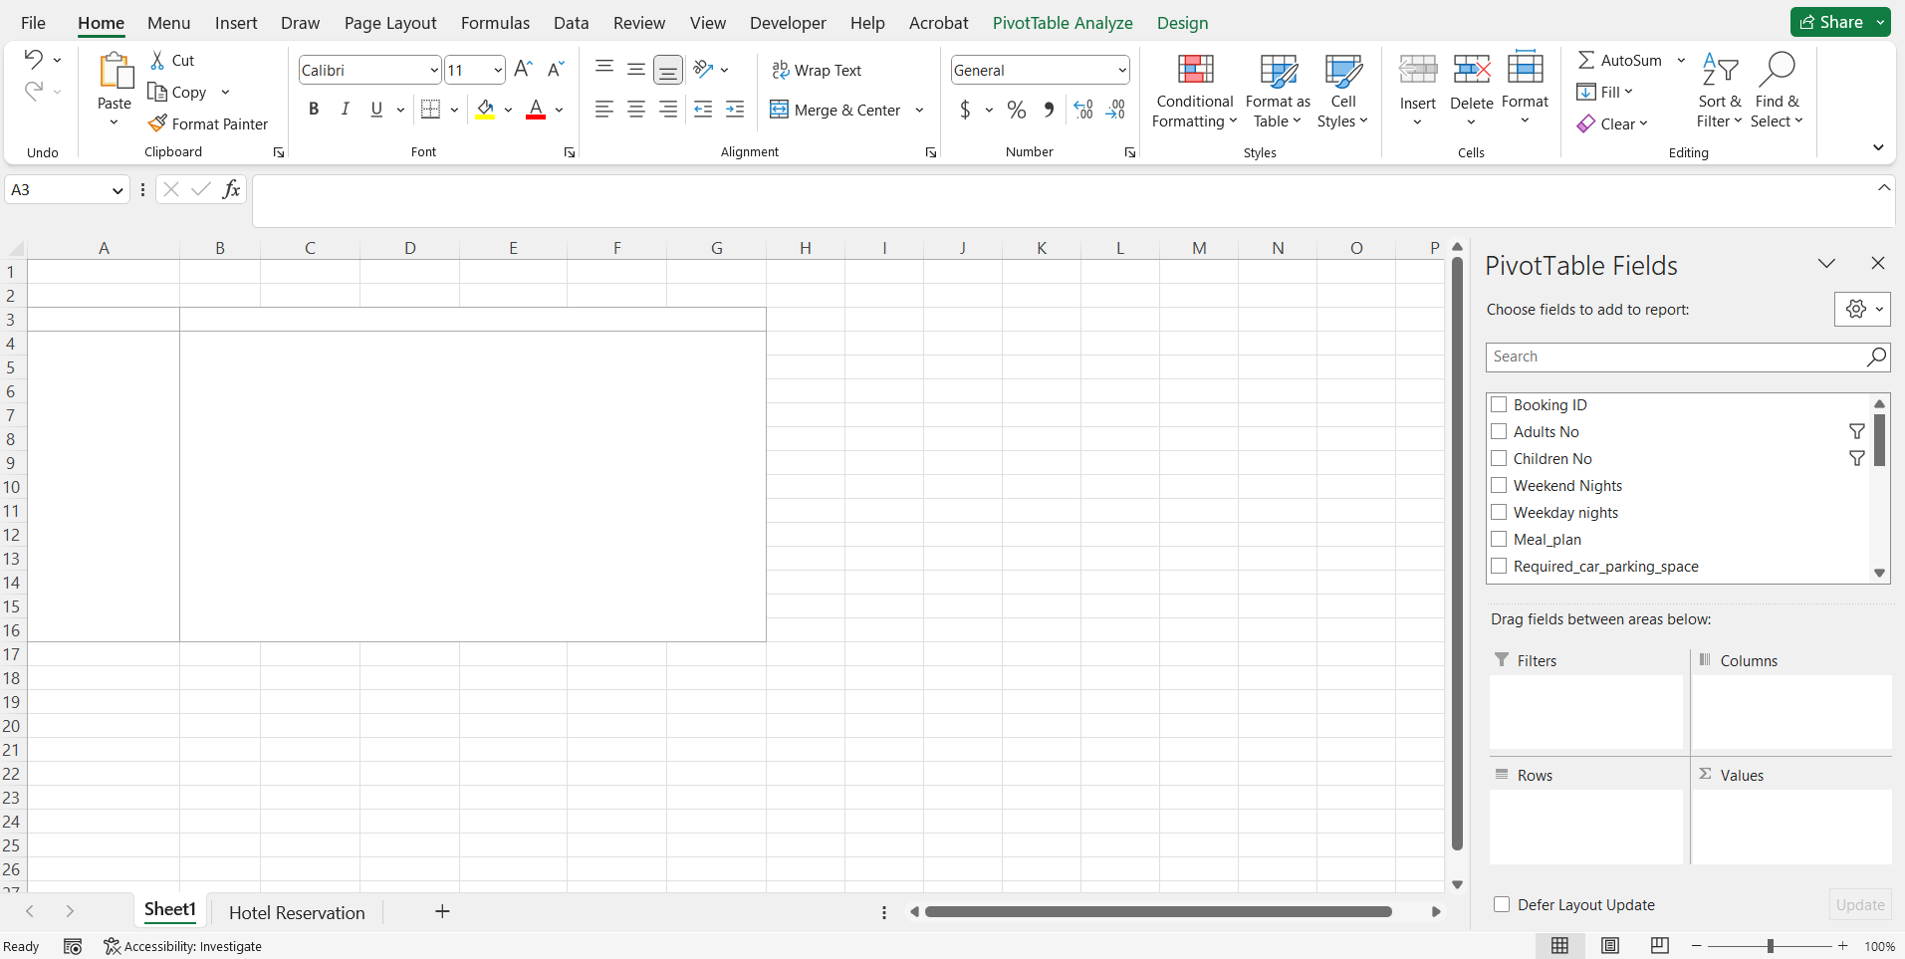
This is how Sheet 1 looked after removing all the fields from the PivotTable, so the sheet is now ready to start inputting the required data for this project (Dierenfeld and Merceron, 2012).
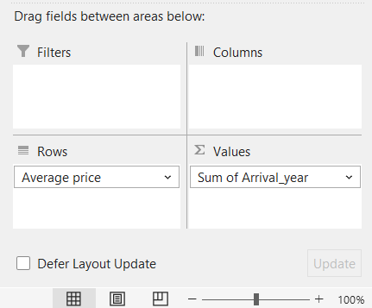
The main task of this project is to find out the average price and how the average price changes over the year. Also, efforts will be made to find out whether the price goes up or down over the years through this analysis. To get such results, these two fields were inputted in the PivotTable as shown in the above picture so that a relationship can be created between the Average Price and Arrival year. However, the Σ Values field is set as a Sum of Arrival year which will not be helpful to get the desired result. Required changes need to be made in the PivotTable Fields so that necessary changes can be made and required data can be extracted (Dierenfeld and Merceron, 2012).
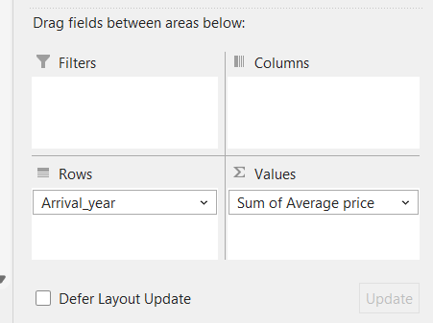
With some adjustments, these fields were chosen in the PivotTable where Arrival year will be placed as Rows, and for the values fields, Sum of Average price was used (Dierenfeld and Merceron, 2012).
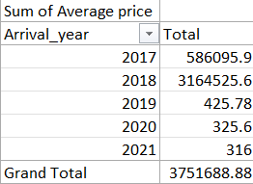
By setting the Σ Values field as Sum of Average Price, this is the table that was found which shows the average price of each year separately. However, these values might not be correct, as to consider the sum value, the number of guests needs to be equal. In this data, the number of guests was not equal per year, so the result that was extracted from here may not be accurate.
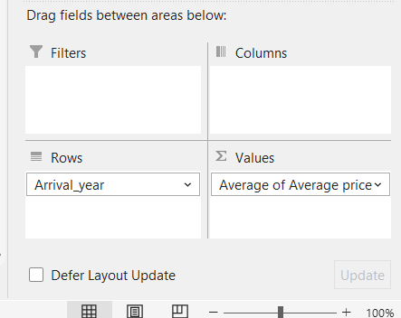
To get more accurate results, the average value of the average price can be more useful, so these data were considered for this report. In the PivotTable, the Σ Values field was set as an Average of Average Price which will average out all their values based on each year separately. With the average values, the extracted result can be considered to be more accurate.
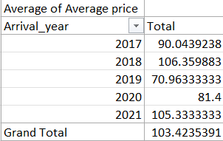
This was the value of the average price found at this point and these values can be considered to be accurate in terms of the data given here. However, the data that PivotTable have considered might not be ideal as the values in the PivotTable were changed over and over. Even the PivotTable was created by someone else as the PivotTable was already created in the Excel file which was provided. So, the PivotTable values need to be refreshed to ensure that the values that the PivotTable provided are accurate.
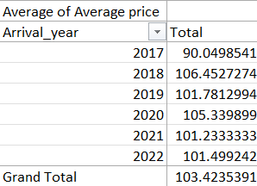
From PivotTable Analysis Tab, a drop-down option called Refresh was chosen, which provided the option to Refresh all the values that were in the PivotTable. With the Refreshed values, the result was updated which changed significantly from the values that were shown in the table values.
With the updated values, it is found that the lowest average price occurred during 2017 when the record of the dataset was started. The highest average price that the guests paid is recorded in the year 2018 which was 106.4527274, and no other year had been able to gather as much money as this year on average.

A trend can be found that if the business of a year goes bad, the next year they cover it up and increases the average price, but the price drops the next year again, and so on. To justify this trend, the above chart is provided where the price trend can easily be seen and by reviewing the curve, it can be easily spotted that the columns are short in 2017, raises significantly in 2018, drops the next year in 2019, increases in 2020, drops in 2021, and increases again during 2022.
As mentioned in the report, the average values for each year need to be calculated using some other formulas, so IF is one of the basic formulas that can be used to extract the result here, however, it may require several additional columns to get the expected result. This method was chosen to be applied to get the results of this project and checks will be provided at the end of the task so that the values can be claimed to be accurate for sure.
The IF formula requires three conditions to get the result and it will only check one cell at a time, so the same formula needs to be applied over and over again to get the required results.
=IF($J2=2017,$Q2,"")
This is the if formula written which will help to extract the data that are related to 2017 and write the average price value that is related to the 2017 value (Bluttman, 2013). Among the three conditions that are provided for this IF formula, the first condition is written as $J2 which will read the value that is written in J2 and check whether this value is equal to 2017. If the value condition is found to be true in this case for J2 cell, then the formula will output the Q2 value which is the average price related to that J2 cell. If J2 does not contain 2017, then the output will be an empty cell which is why the "" value is provided which is useful to put an empty cell (Bluttman, 2013). Here, $ sign has been used with J and Q so which are the column number so that when these formulas will be copied to get the value for 2018,2019, and so on, the column that the formula is tracking does not change.
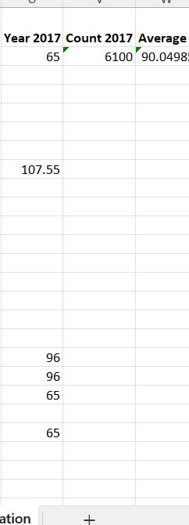
Once the formula was written, the same formula was applied to each cell on that column with the help of Ctrl+D shortcut that is available in Excel which helped to apply the same formula on that whole column, but the number of cells written on the formula will change (Bluttman, 2013). For example, the formula became
IF($J3=2017,$Q3,"")
when the formula was put in the next cell in the column, and it can be seen that the output was empty cell, as the value in the J3 cell was 2018, so J3 is not equal to 2017, thus output is empty cell (Bluttman, 2013). Similarly, all the average price values that were related to the year 2017 were written in this column automatically with the help of Excel Function.
At this point, the next column was created where the values that have been inputted in the Year 2017 column have been counted. To count the values COUNT formula available in Excel was used which will count only the cells that contain the input in the Year 2017 column.
=COUNT(U:U)
This is the formula written and writing the formula in only one cell was good enough to count the whole column by using this formula. With the values and the total number, the average value can easily be calculated. To do that, the average column was created, where another formula is inputted to get the expected result.
=(SUM(U:U))/V2
This is the formula used to get the average where the formula will first add all the values that have been found under Year 2017 column, after that, the formula will divide the value found after addition by the value found through Counting the values. By doing so, the average value can be found which basically represents the average price of the year 2017.
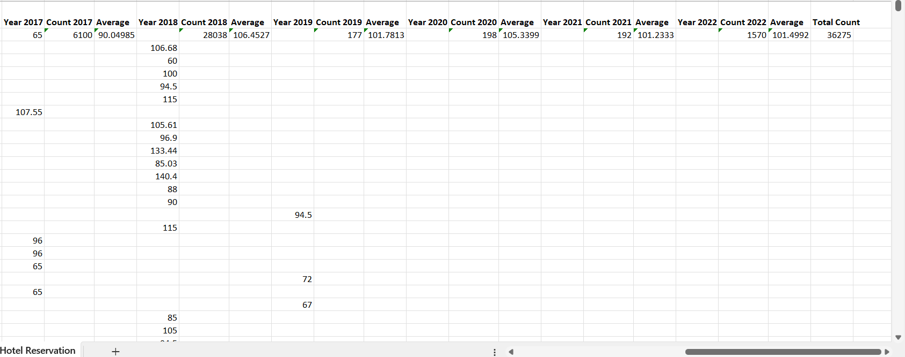
Similarly, the same formulas were copied and three additional columns were created for each year till 2022. In these formulas, the only change was the value to be checked was changed to the relevant year.
During 2018, the formula became =IF($J2=2018,$Q2,"")
During 2019, the formula became =IF($J2=2019,$Q2,"")
During 2020, the formula became =IF($J2=2020,$Q2,"")
During 2021, the formula became =IF($J2=2021,$Q2,"")
During 2022, the formula became =IF($J2=2022,$Q2,"")
Similarly, the count and Average formula were changed accordingly and all the required values were found.
To check whether all the values have been considered in the IF function, all the Count columns were added with
=SUM(V2,Y2,AB2, AE2,AH2,AK2)
formula and found the value to be 36275 which matches the total row of the data that is given, so the calculations are correct (Leahy, 2004).
The average price values that were found using this method are provided in the below table:
Year | Average Price
2017 | 90.04985
2018 | 106.4527
2019 | 101.7813
2020 | 105.3399
2021 | 101.2333
2022 | 101.4992
The average values that have been found by using this method also match the values found using the PivotTable, so it can be claimed that the values found in both cases are accurate.

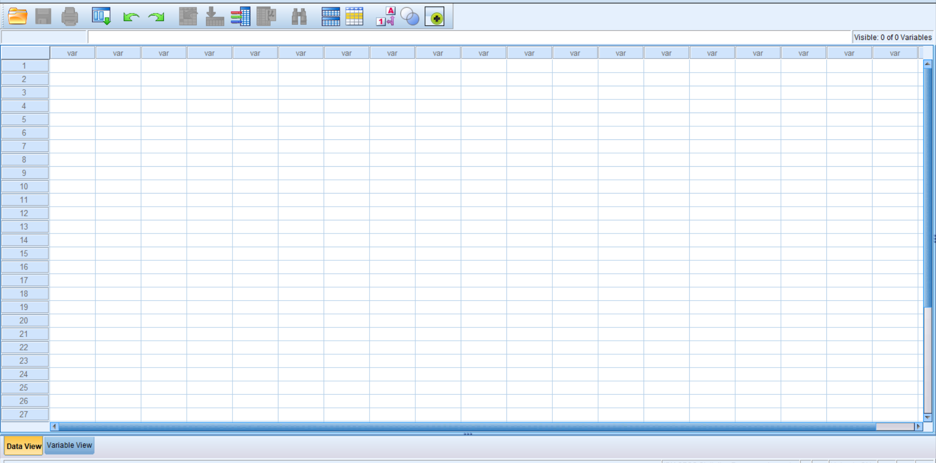To perform Task 2 of this project, the SPSS file was opened which will be used to perform the rest of the tasks with the given file. To perform task 2, an excel file called Students Score was provided which will be useful for the task 2.
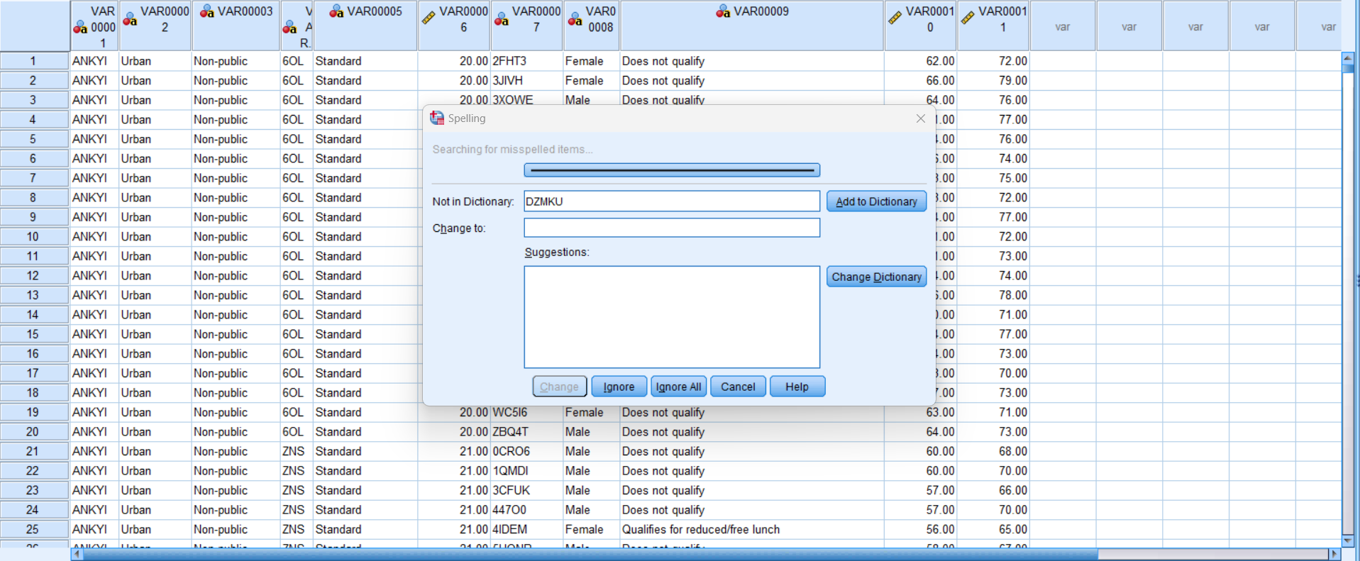
The data that are given in task 2 has been copied to the SPSS file, and then the SPSS automatically suggested some corrections on words which are not expected in this project, so all of those were ignored using the Ignore all button. Here the variable name which is the column name is provided as default, but to better understand, it will be helpful to name those according to the column name given in Excel so that is the first task.
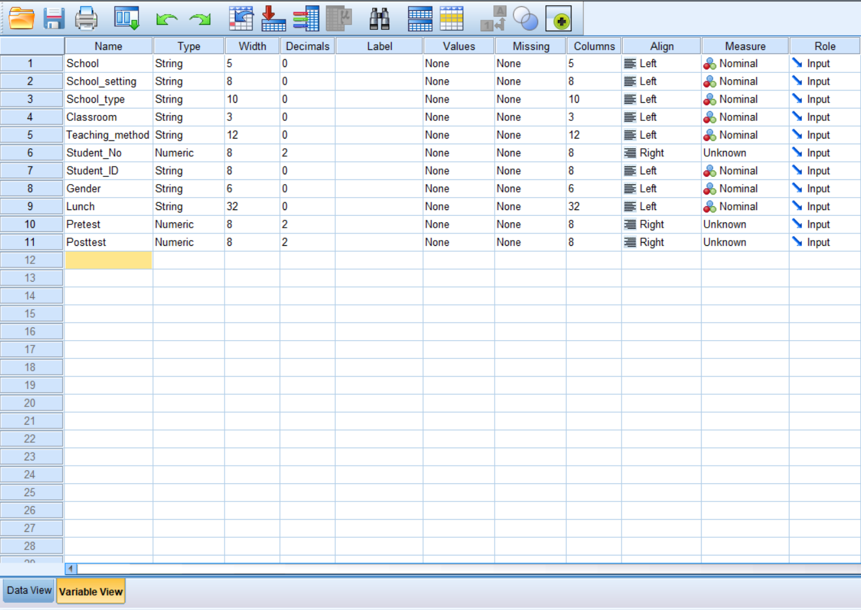
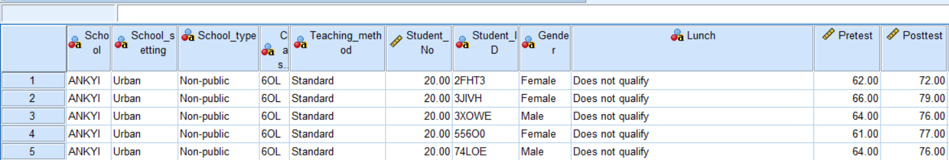
By going to the Variable View, the name of the variables can be changed, and each variable name was changed manually which can be seen in the other tab called Data view shown in the other picture.
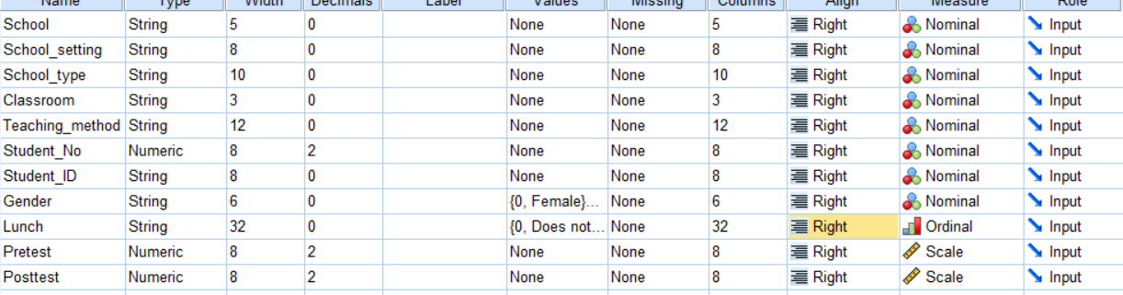
The variable has been set as needed for this project based on the data as well as the results that are needed. Here, all the variables except student_no, Prestest, Posttest are String as they contain words or letters in them, and these three variables are numeric as they do not have any word or letter instead only contains number (Field, 2013). So, these three variables called student_no, Prestest, Posttest were set as Numeric type. Later, the width, decimals, and label columns did not require any changes for this project, so these were left as it is. The value column requires inputs in two rows which are Gender and Lunch as these variables will be analysed and they can have only one or the other answer (Field, 2013). For example, Gender can only have either male or female, and Lunch can only be qualified or disqualified so these two variables were inputted under the values column. Based on the input on the Data View of these two columns, values were inputted in the Values column such as:
0 = “Does not qualify”
1 = “Qualifies for reduced/free lunch”
And in case of Gender:
0 = Female
1 = Male
The next two columns were not useful for this project so those were left as it is but the next column called Align was changed to the right alignment for each variable (Field, 2013).
The useful column is the measure where each of the variables is set based on their type and three different types are available which are Nominal, Ordinal, Scale. Among these three, Nominal basically are those where it does not need to be measured or compared to someone else, the ordinal is basically suitable to show whether something is greater than the other, and finally, scale indicates the value of each input to find out the chronology of the numbers (Field, 2013). In this project, most strings do not need to be compared to find out who has greater value, so they are assigned as nominal. The option Gender and Lunch both have only two answers either yes, no or yet, being a female or male is not greater than one another so they are assigned as nominal (Field, 2013). However, having free lunch is greater than not being qualified to have free lunch, so the Lunch is set as Ordinal in this case. Finally, the Pretest and Posttest are basically numbers that need to be compared and analysed so they are set as Scale to make the calculation easy.
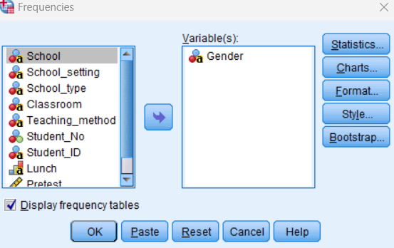
Using Transform option that is available in SPSS, the descriptive analysis has been chosen which provided the frequencies option which was chosen for this project which provided the tab shown above.
From this new tab, Gender was chosen and selected the arrow sign shifted the variable on the right side so that the SPSS knows to analyse and provide results for this variable (Field, 2013).
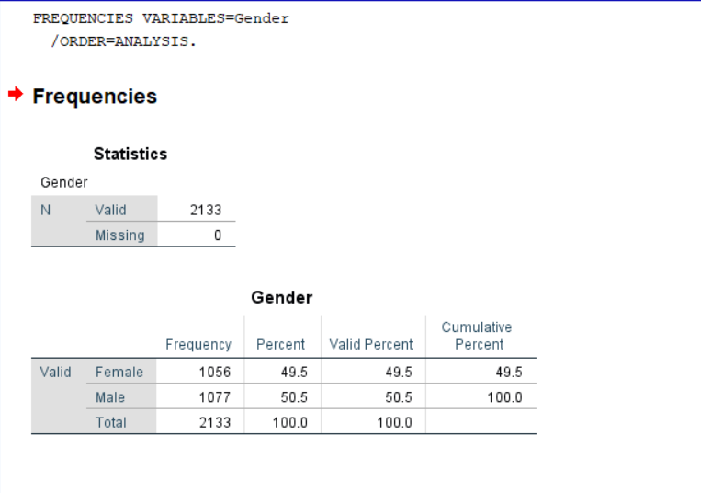
By analysing the Gender variable for the first task, the values found through analysing through SPSS are shown in the above picture. The SPSS calculation shows that the frequency of females in the class is 1056, and the frequency of males is 1077 (Field, 2013).
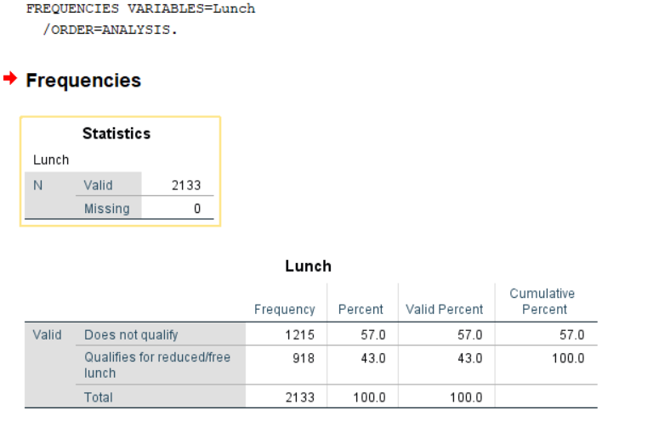
The second task is to find the number of people who qualify or do not qualify for free lunch which can be found by using the SPSS software. Using Transform option that is available in SPSS, the descriptive analysis has been chosen which provided the frequencies option which was chosen for this project. The frequency tab was used similarly as before, and to do so, the Gender tab was shifted back to the left side as it is not required anymore, instead the Lunch tab was shifted to the right side to order SPSS software to run the analysis using the data available for Lunch tab. The result is shown above as the frequency data found for people who do not qualify is 1215 whereas the frequency of students who qualify is 918.
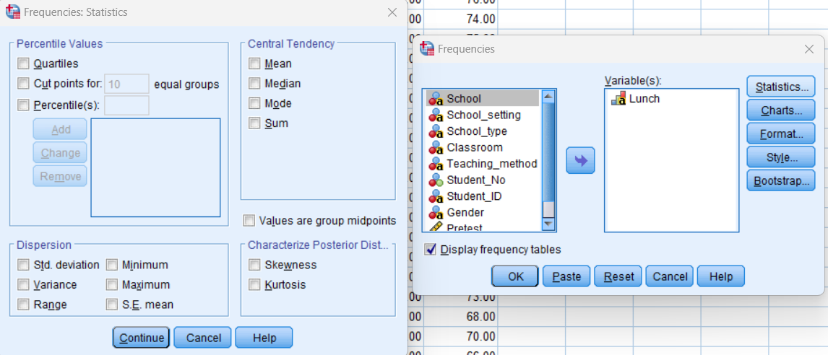
The same frequency tab is needed to perform the third task where the Lunch is needed on the right side but some additional steps need to be performed to get the required result. In the frequency tab, a statistics option is available which is used to get the mean, and median data from the SPSS. So, the new tab shown on the left of the frequency tab came up when the statistics option was pressed and in the new tab, mean and median options were ticked so that SPSS knows to analyse the data to find these two values.
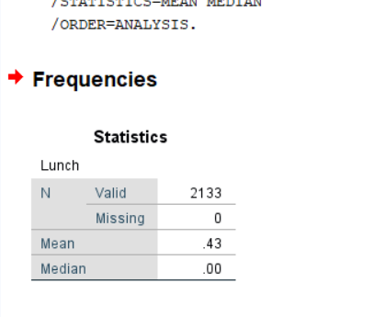
The mean and median values were needed but the values were not being analysed as the type of Lunch tab was chosen as a string, so in the variables tab, the type of variable for lunch was changed to numeric and all the values were replaced with 0 and 1 in the Lunch column. Where 0= does not qualify, and 1 = Qualifies for reduced/free lunch. By turning on the value labels option, all the data that are actually written such as does not qualify can be seen in the lunch column and turning off the value labels shows only numeric 0 and 1. By doing so, the file was ready to be analysed and turning the mean and median options on, clicking ok provided the mean and median values. As shown in the above picture, the mean value that SPSS found for this dataset of students is .43, but SPSS could not find any median for this dataset.
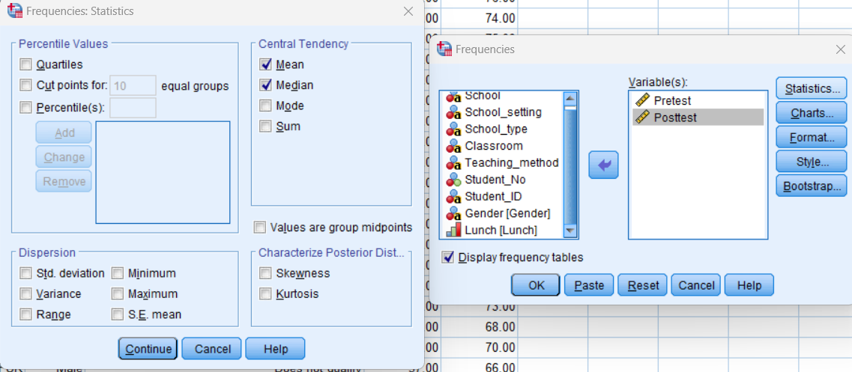By going to the frequencies tab again and shifting only Pretest and Posttest on the right, SPSS was instructed that specifically, these two variables need to be analysed by SPSS (Witte and Witte, 2017). To find the differences between mean and median, it is important that the Mean and Median of each of these are found first. So, the mean and median options were ticked so that SPSS perform the calculation and ok was pressed.
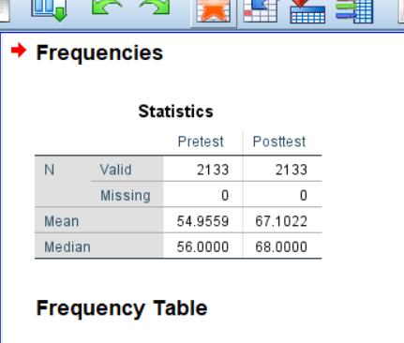
In terms of Pretest,
Mean = 54.9559
Median = 56.0000
In terms of Posttest,
Mean = 67.1022
Median = 68.0000
From these data, the difference between mean is = 12.1463
From these data, the difference between median is = 12
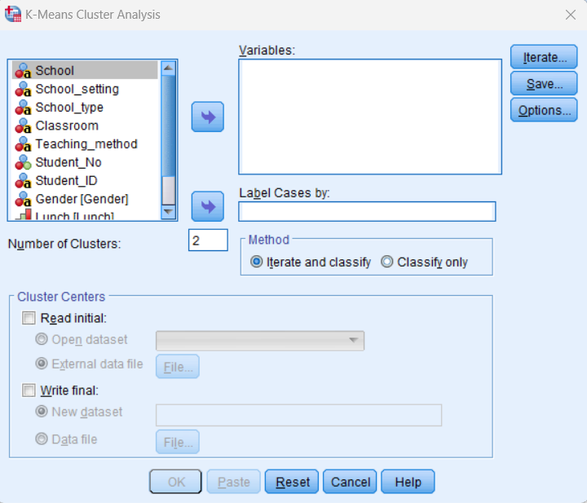
From Analyze, by selecting Classify, choosing K-means Cluster, the above option was found where the instruction will be provided to SPSS regarding the analysis needed (Ibm.com, 2021). Here 10 iteration was chosen so that multiple iteration can be done before getting the final answer and 2 clusters were chosen (Ibm.com, 2021)
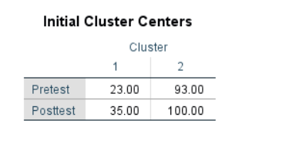
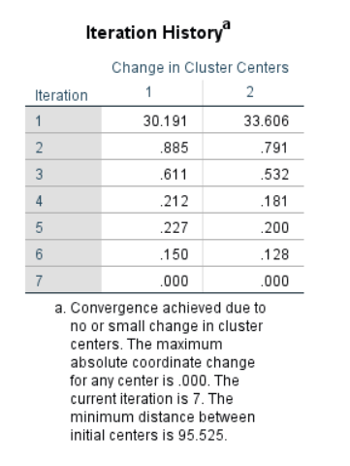
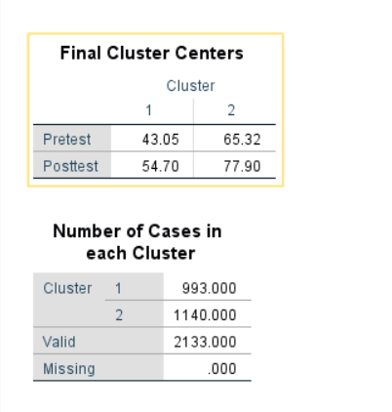
After the iteration was completed, the result that was found through K cluster is shown in the pictures above.

Five Data Mining:
Classification data mining can be used for customer segmentation or sentiment analysis which can be taken advantage of by e-commerce websites to analyse their customers (Adriaans, 1996).

Clustering is grouping similar data points which is being used by telecommunication companies to identify calling patterns of the people using their service (Adriaans, 1996).

Association rule mining is being used by mobile companies to identify people who are buying phones to suggest phone covers due to the method being able to discover patterns.

Regression is basically prediction which is used by companies to predict the number of customers they may get based on the historical data they recorded (Adriaans, 1996).

Anomaly detection is used by credit card companies to identify fraud attempts as it helps to identify rare instances.

Five Text Mining:
Sentiment analysis is used by social media to identify a page based on reviews (Gaikwad et al., 2014).

Text classification is used by AI ticket routing it can send tickets based on written request.

News agencies take advantage of named entity recognition to find information regarding a specific place (Gaikwad et al., 2014).

Topic modelling helps online media platforms to classify and make a group based on topics.

Text summarization helps to market research companies to turn long written essays to summarize.

SPSS | Excel
Advanced data analysis like advanced statistical test and regression model that might be useful for research (Gupta, 1999). | The advanced statistical tests are not available (Harvey, 2007).
Data manipulation, cleaning, etc. features are advanced in SPSS which can be used by marketing team to reduce variable of the customer data | Only basic data manipulation tools are available (Paceinstitute.lk, 2013).
SPSS can be costly for many as it requires a license (Gupta, 1999) | Excel is available with various other software which makes it cost effective (Harvey, 2007).
The SPSS learning curve is steeper as any beginner can easily learn the SPSS (Gupta, 1999) | Excel learning curve is usually low as statistical knowledge needs to be used in Excel to get the job done (Paceinstitute.lk, 2013).

Word count: 3,162

References
- Adriaans, P., 1996. Data mining. Pearson Education India.
- Advantageslist. (2022). List of Top 15 Advantages of Ms excel. [online] Available at: https://advantageslist.com/list-of-top-15-advantages-of-ms-excel/ [Accessed 18 Jul. 2023].
- Bluttman, K., 2013. Excel formulas and functions for dummies. John Wiley & Sons.
- Dierenfeld, H. and Merceron, A., 2012. Learning analytics with excel pivot tables.
- Field, A., 2013. Discovering statistics using IBM SPSS statistics. sage.
- Gaikwad, S.V., Chaugule, A. and Patil, P., 2014. Text mining methods and techniques. International Journal of Computer Applications, 85(17).
- Gupta, V., 1999. SPSS for Beginners. VJBooks Inc.
- Harvey, G., 2007. Excel 2007 workbook for dummies. John Wiley & Sons.
- Ibm.com. (2021). IBM Documentation. [online] Available at: https://www.ibm.com/docs/en/spss-statistics/beta?topic=features-k-means-cluster-analysis [Accessed 18 Jul. 2023].
- Leahy, J., 2004. Using Excel for analyzing survey questionnaires. University of.
- Paceinstitute.lk. (2013). The benefits of learning Microsoft Excel skills. [online] Available at: https://www.paceinstitute.lk/blog/ms-excel-training.html [Accessed 18 Jul. 2023].
- Witte, R.S. and Witte, J.S., 2017. Statistics. John Wiley & Sons.

‌

