Component 2: Project Management & Innovation.

Module: Changemakers: Creativity and Value Creation
Module Code: ACCA5033
Student Name: Sara Baiai
Student ID: 2437772
Lecturer Name: Dr. Osman Elgawi

Contents
Introduction 3
Task 1- Project managment 3
1.1 Project scope 3
1.2 Proposed Solution 4
1.3 Technologies and Resources 4
1.4 project Timeline and Schedule 5
1.5 Project constraints 5
1.6 Development Methodology 5
1.7 Project Design 6
Task 2 – Innovation 7
2.1 Introduction 7
2.2 PEST Analysis 7
2.3 SWOT Analysis 8
2.4 Legal and Ethical Considerations 9
2.5 Development within a Large Organisation. 9
Task 3 – Reflection 10
3.1 Skills Development 10
3.2 Contribution to Society 10
3.3 Risks and Challenges 11
References 12

Introduction
This Assignment builds on Component 1, in which PeerPoint was introduced. PeerPoint , a secure digital platform designed to support University students studying in the UK. The project was developed to address serval challenges faced by students, including the rising cost of study materials, limited access to academic support, transport difficulties and the lack of a single platform that brings the services together in one place. PeerPoint aims to provide a trusted environment where verified students can share academic resources, access campus services and collaborate through one easy-to-use platform.
The purpose of this Assignment is to demonstrate how the proposed project could be planned, managed and developed if it were taken forward. It explores the project management processes needed to support the making of PeerPoint. This also includes the project scope, proposed solution, technologies, project schedule, development mythology and design work. The Assignment also covers innovation through the use of PEST and SWOT analysis, together with the legal and ethical considerations that influence the implementation of the digital platform. Lastly, this reflects on the skills developed during the project, its potential contribution to society and the possible risks and challenges that may occur during the development process. This Assignment therefor extends the work of the completed component 1 by focusing on the practical planning and management needed to transform the project idea into a realistic solution.

Task 1- Project managment

1.1 Project scope
Project aim
The aim of this project is to design and develop PeerPoint, a secure digital platform that enbales verified university students to access academic resources, campus support services and collaborate within one trusted online community. Building on the research completed in component 1, the project focuses on creating a practical solution that improves the student experience and education by bringing together services that are currently spread across multiple websites, social media groups and applications that not everyone would have access to. The overall objevtive is to produce a functional prototype that demonstrates how PeerPoint could support collaboration, reduce costs and improve access to academic support.

Project scope
The scope of the project includes designing and developing a web-based prototype of PeerPoint with features that address the needs that were identified during the research stage. These features include secure user authentication using university email verification, textbook and academic resource sharing, parking information, peer tutoring and student event listings. The project will also include user interface design, database design, system testing and project documentation to demonstrate how the platform can be developed.

Out of Scope
The project will not include the development of a fully deployed commercial platform or a mobile application. Features such as payment processing, integration with university information system, real time GPS tracking and artificial intelligence services are outside the scope of this project. These features could be considered for future development.

1.2 Proposed Solution
PeerPoint provides a centralised digital platform that brings together a range of student services within one secure and verified environment. Rather than relying on multiple websites, social media platforms and third-party applications, students can access academic resources, peer tutoring, study space recommendations, ride sharing, parking information and student events through a single platform. Users' verifications through university email addresses helps create a trusted community where students can safely collaborate and share resources. By combining these services into one easy-to-use platform, PeerPoint aims to reduce costs, improve access to academic support and enhance the overall university experience.

1.3 Technologies and Resources
The development of PeerPoint requires a number of technologies and resources to support the design and implementation of the platform. The front-end will be developed using HTML, CSS and JavaScript to create a responsive and user-friendly interface [1]. The back end will use PHP to manage user authentication, Business logic and communication between the interface and database. A MySQL database will securely store user accounts, resources listings and platform data. Development will be supported using Visual Studio Code, XAMPP and Git for coding, testing and version control [2]. The project resources include a project manager, software developer. UI/UX designer and tester to ensure the platform is developed and evaluated successfully.

1.4 project Timeline and Schedule
The PeerPoint project was planned over a 12-week period, starting from project planning and research to system design and the completion of the final project proposal. Each stage was scheduled to ensure the project progresses in a structured and managable way while meeting its objectives. The Gantt chart below shows the planned development activities, key steps and overall project schedule.

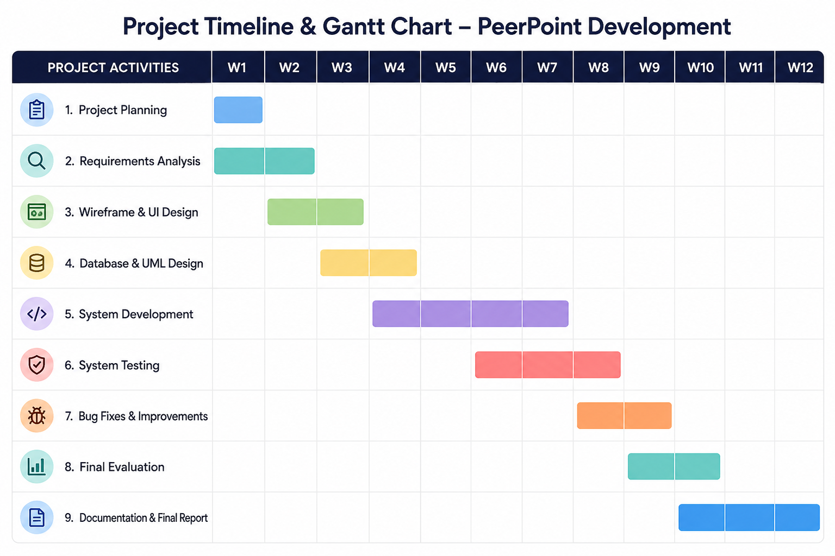Figure 1: Gantt Chart

1.5 Project constraints
The development of PeerPoint may face several constraints during the project. Time is limited, so each stage must be completed according to the project schedule. The available budget may restrict the software, tools and resources that can be used during the development stage. Technical constrains, such as limited experience with some technologies, may affect the implementation of some features. In addition, the platform must comply with GDPR and include security measures to protect users' personal information.

1.6 Development Methodology
The development methodology selected for PeerPoint is Agile Scrum. Aigle is best because it allows the development of the project in small stages rather than completing the whole project at once [3]. The project will be divided into sprints, with each sprint focusing on developing and testing specific features such as user login, resource sharing and peer tutoring. Testing will take place throughout every sprint to identify and fic any problems before moving to the next stage. Regular feedback and improvments will help ensure the platform meet users requirements and can be updated as the project develops.

1.7 Project Design
The following designs demonstrate how PeerPoint has been planned before development begins. The designs provide visual representation of the platform and help ensure that the system meets the projects requirements. The homepage wireframe shows the proposed layout and user interface, while the UML use case diagram illustrates how users interact with the main features of the system.

Design 1 – Homepage wireframe
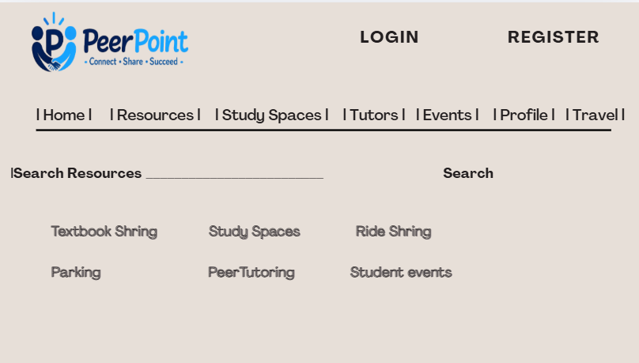
Figure 2: Homepage Wireframe

The homepage wireframe shows the proposed layout of the PeerPoint platform. It includes the main navigation menue, search function, featured services and user login area. The wireframe provides a clear structure for the user interface and helps ensure the platform is easy to navigate.

Design 2 – UML Use Case Diagram

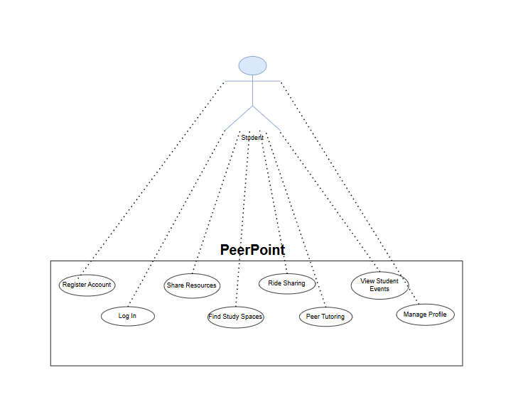
Figure 3: UML Use Case Diagram

The UML Use Case Diagram shows how the user interacts with the main functions of PeerPoint, including creating an account, logging in, sharing resources, accessing stidu support and viewing student events. It gives an overview of the system requirements and the interactions between users and the platform.

Task 2 – Innovation

2.1 Introduction
Innovation plays an important role in the development of PeerPoint by providing students with a modern platform to access academic support and academical services. This section uses PEST analysis to examine the external factors that may influence the development of the project.

2.2 PEST Analysis
A PEST analysis helps to identify the external factors that could affect the development and success of PeerPoint [4].

Political: PeerPoint must complay with the UK laws and university policies. The platform should also follow GDPR regulations to ensure that student's personal information is stored securly and used responsibly [5].

Economic: The cost of developing and maintaining the platform may affect the project. Students are also facing increased living costs [6], so providing free access to study resources, ride sharing and spaces and peer support could help reduce expenses.

Social: University students increasingly rely on digital platforms for communication and collaboration. PeerPoint supports this by allowing students to share resources, find study spaces, connect with peer tutors and discover campust events in one place forming a online and real-world community.

Technological: Advances in web technologies makes it possible to develop a secure and reliable platform. However, regular updates, security improvements and system testing will be required to ensure the platform stays effective and protects user data.

2.3 SWOT Analysis
A SWOT analysis identifies the strengths, weaknesses, opportunities and threats [7] that may be affect the development of PeerPoint.

Strengths: PeerPoint brings many student services togther in one platform. It allows students to share resources, find study spaces, access peer tutoring and stay updated with campust events, making university life more convenient.

Weaknesses: As a new platform, PeerPoint might have a limited number of users durinf the early stages. The project also requires regular maintenance and updates to ensure it continues to operate effectively.

Opportunities: The platform could be expanded by working with universities to provide more services and reach more students, Future versions could also include a mobile application and additional features based on user feedback.

Threats: Other platforms and social media groups already provide similar services, creating competition. There is also a risk of cyber security threats and data breaches, making strong security measures and GDPR compliance essential.

2.4 Legal and Ethical Considerations
GDPR: PeerPoint must comply with GDPR by collecting, storing and using students personal data responsibly. Users should also be informed about how their information is and will be used [8].

Data Protection: The platform should include measures to protect user data from unauthorised access. Personal data should only be available to authorised users, stored securely and never shared with third parties [9].

Cyber Security: Strong security measures, such as secure login and encrypted data, should be used to protect the platform from cyber threats, hacking and malware.

Accessibility: PeerPoint should provide a simple and easy-to-use interface that is accessible to all students, including those with disabilities. This will ensure the platform can be used by as many students as possible.

Student Safety: The platform should provide a safe enviroment by encouraging respectful behaviour, allowing users to report inappropriate content, bullying and hacked accounts. This protects students when using features such as peer tutoring and ride sharing.

2.5 Development within a Large Organisation.
Planning: The project should begin with clear planning to identify the project requirements, budget and timescale before development.

Deployment: Once development and testing are complete, PeerPoint can be deployed for students to access across the university.

Maintenance: Regular maintenance is needed to fix bugs, improve preformance and ensure that platform continues to function correctly.

Future Improvement: New features can be added over time based on changes of student needs and university requirements.

Cloud Hosting: Cloud hosting can improve reliability, increase storage and support a large number of users.

Software Updates: Regular software updates should be carried out to improve security, fix issues, and maintain compatibility with new technologies.

User Feedback: Student feedback should be collected regularly to identify improvements and ensure the platform continues to meet users need.

Task 3 – Reflection

3.1 Skills Development
Throughout the development of PeerPoint, i developed a range of technical and professional skills. Technical skills were improved by learning how to plan an online platform, create wireframes, produce a UML user case diagram and understand the technologies needed to develop the system.

Research: I improved my research skills by gathering information from books, journals and online sources. I also used surveys and questionnaires. This helped me understand project management, innovation and the requirements needed to support the development of PeerPoint.

Project Management: I developed my project management skills by creating a project plan, managing the project schedule and organising tasks using Gantt chart. This helped me understand the importance of planning and completing each stage on time.

Communication: My communication skills improved through presenting ideas clearly in the report and organising information in a logical way. These skills will be valuable in the future acadamic work and professional projects.

3.2 Contribution to Society
Academic Value: PeerPoiny supports students by providing access to shared learning resources, peer tutoring and study space. This can improve collaboration and help students achieve better academic outcomes.

Financial Value: The platform can help students reduce costs by sharing textbooks, using ride sharing and accessing free academic support instead of paying for external services.

Enviromental Value: Sharing textbooks reduces paper waste, while ride sharing can reduce the number of vehicles travelling to compus. This can help lower carbon emissions and support a more sustainable environment.

Student Wellbeing: PeerPoint encourages students to connect with others, attend university events and access academic support. This can reduce feelings of isolation and help students feel more supported during their studies giving them a sense of belonging.

3.3 Risks and Challenges
Security: PeerPoint may face cyber security threats such as hacking, malware and unautherised access. Strong password, secure login, encruption and regular security updates can help reduce these risks. The platform should also be monitered regularly to identify any security issues before they effect users. This will help protect student accounts and maintain trust in the digital platform.

Lower User Adoption: The platform may not be successful if students do not use it. The risk can be reduced by promoting PeerPoint through the university social media and student societies. Encouraging students to provide feedback and regularly introducing useful features can also increase user engagements and encourage more students to use the platform.

Funding: Limited funding may affect the development and maintenance of the platform. Careful budgeting and support from universities or external funding could help to manage this challenge. Additionally funding could also br used to improve the platform, intorduce new features and ensure that regualar maintenance and security updates continue in the future.

Scalability: As more students join the platform, the system must be able to handle increased demand. Cloud hosting and regular performance testing can help improve scalability. Planning for future growth will ensure that the platform continues to perform well even if the number of useres increases. Significantly across multiple universities.

Data Privacy: Student data must be protected by following GDPR and using secure methods to store personal information. Users should be informed about how their data is collected and used. Only autherised users should have access to sensitive information, helping to maintain privacy and build confidence in the platform.

Risk Management: Regular testing, softeware updates, user feedback and security monitoring can help to identify problems early and reduce the impact of potential risks. Reviewing risks throughout the project will allow improvments to be made before they become serious issues. This will help to ensure that PeerPoint remains secure. Reliable and suitable for university students.

References
[1] J. Kavanagh, “Creating Interactive User Interfaces with HTML, CSS, and JavaScript,” John Kavanagh, Jan. 21, 2019. https://johnkavanagh.co.uk/articles/creating-interactive-user-interfaces-with-html-css-and-js/ (accessed July 23, 2026).
[2] Maram Bhavya, “Setting Up the Development Environment,” LinkedIn, Apr. 15, 2025. https://www.linkedin.com/posts/maram-bhavya-15283229b_apexplanet-activity-7317970541443698688-whxc (accessed July 23, 2026).
[3] john, “What is Agile Methodology? Complete Beginner’s Guide,” Institute Project Management, Jan. 2022. Accessed: July 23, 2026. [Online]. Available: https://instituteprojectmanagement.com/blog/agile-methodology/
[4] S. Laoyan, “Adapt to changing environments with a PEST analysis,” Dec. 2022. Accessed: July 23, 2026. [Online]. Available: https://asana.com/resources/pest-analysis
[5] “Microsoft - Search,” 2022. Accessed: July 23, 2026. [Online]. Available: https://www.bing.com/ck/a?
[6] Office for Students, “Studying during rises in the cost of living - Office for Students,” Mar. 2023. Accessed: July 23, 2026. [Online]. Available: https://www.officeforstudents.org.uk/publications/studying-during-rises-in-the-cost-of-living/
[7] “a swot analysis identifies the strengths, weaknesses, opportunities and threats - Bing,” Bing, 2025. https://www.bing.com/search?q=a%20swot%20analysis%20identifies%20the%20strengths%2c%20weaknesses%2c%20opportunities%20and%20threats&qs=n&form=qbre&sp=-1&lq=0&pq=a%20swot%20analysis%20identifies%20the%20strengths%2c%20weaknesses%2c%20opportunities%20and%20threats&sc=0-79&sk=&cvid=9ed497df62824871bf8c7f99b594aab9 (accessed July 23, 2026).
[8] Department for Education, “Data protection in schools,” 2023. Accessed: July 23, 2026. [Online]. Available: https://www.gov.uk/guidance/data-protection-in-schools
[9] UK Government, “Data Protection Act,” www.gov.uk, 2025. Accessed: July 23, 2026. [Online]. Available: https://www.gov.uk/data-protection

