

LEVEL 4

SEMESTER 2

MODULE CODE: SHSS4078
Adventure: A Risk worth Taking

aSSESSMENT TYPE: aSSIGNMENT
Assessment/Component: 1 (Part A)
COMPONENT WEIGHTING: 55 %
WORD COUNT: 2000 WORDS
MODULE TUTOR: Denise leonard

Assignment:

With reference to a critical incident case study that we have examined, identify one key contributing hazard. In relation to this hazard, evaluate your own personal logged experiences from the module.

As appendices to this submission you should include a logbook recording every activity session you complete during this module and a synopsis of the critical incident case study you have referred to in your essay.

SUBMISSION DETAILS:

Deadline:
Date: 1st May 2020
Time: 3.00pm
Portal: Turnitin

School of Sport, Health & Outdoor Education

Assessment Feedback Sheet

Student No./Name: Daniel Hardy / 1900408
Module: SHSS4078
Module Code: Adventure: A Risk Worth Taking

Personal Evaluation – to support your academic progress please complete the section below BEFORE submitting your work.
What do you consider to be the best aspects of this work? |  |  | I believe that the logbook and Risk assessments are well detailed, a fairly clear image of each experience can be shown throughout
Which aspects do you consider could have been improved in this piece of work? |  |  | To be honest, I feel that this assignment has probably been my worst piece of work to date. This is something I am quite gutted about. I feel that due to recent circumstances with the covid 19 crisis, I have found it extremely hard to stay motivated, as I have not been in the university environment with access to the library and other resources. Towards the end of the assignment I found that I was rushing a lot of my work and this can probably be shown clearly throughout. I think that the chosen hazard was probably a bit too specific and I can admit I struggled to create a piece of work that is as good as the other assignments I have completed.
What have you found most satisfying whilst undertaking this submission? |  |  | I found the creation of the logbooks interesting as It was something I haven’t really done in the past apart from on the Making safety personal module. The activity days in particular were extremely exciting and interesting.
ASSESSMENT CRITERIA | Learning  Outcomes |  | GRADE
ASSESSMENT CRITERIA |  |  | Poor  0 – 25% | Unsatisfactory  26-39% |  | Satisfactory  40 – 49% | Good  50 – 59% | Very Good  60 – 69% | Excellent  70 – 85% |  | Exceptional  86– 100% | %
Complete logbook for each session | All |  |  |  |  |  |  |  |  |  |  | 15%
Provide a synopsis of a critical incident case study | All |  |  |  |  |  |  |  |  |  |  | 15%
Identify a specific significant hazard and the risk it poses to undertaking adventurous outdoor activities | 1,2,3,5 |  |  |  |  |  |  |  |  |  |  | 30%
Discuss a range of appropriate measures that might effectively control the identified hazard and consequent risks. | 1,2,3,5 |  |  |  |  |  |  |  |  |  |  | 30%
Appropriate references used and correctly formatted | All |  |  |  |  |  |  |  |  |  |  | 10%
It is expected that students will present work that is proof read, correctly referenced and adheres to the Assessment Checklist. Therefore a range of 0 – 10 marks will be deducted for non-completion of any of the points on the checklist below.
TUTOR COMMENTS:

Submission date:  via Turnitin |  | Return date:  (at least within 4 weeks) |  |  | Tutor: Denise Leonard |  |  |  |  | Mark:

Essay
More times than not, an incident will occur when multiple factors start to go wrong. Henrich (1936) explains that a chain of events can lead to an accident through the concept of the domino effect, for example when an act is not performed correctly or a control measure has not been put into place properly, the likelihood of an incident occurring becomes greater and greater as the problem can likely be the cause of another. In this body of work, I will look to identify communication as one of the many specific hazards that contributed towards the 2008 Mangatepopo disaster and how with appropriate control measures put into place the avoidance of this incident could have been achieved. Reflection on internal communication through personal experiences of climbing and river activities at specific locations such as the Teifi River and the Gower Peninsular shall also be discussed in detail.

When taking part in adventurous activities whether that is part of an educational experience or a recreational pursuit, we can often find ourselves in extremely positive or negative situations. More times than not this can be the result of an effective or poor use of communication. Attarian (2012) notes that it should be common practice for activity providers to conduct frequent safety briefings to members of staff and participants to relay important information prior, during and after activities take place. This can be for a number of reasons such as discussing weather forecasts, water levels, medical information, group objectives and equipment use to name a few.

Providers will need to demonstrate that they have procedures to ensure that staff and participants are given, in a comprehensible and relevant form, the information they need about the provider’s safety measures and arrangements (AALA, 2004)

Barton (2007) explains that a hazard is anything with the potential to cause harm loss or injury, however distinguishing a particular hazard will not exactly give us an idea of how severe the hazard could be to the individual. To most people, the use of communication sounds harmless, however, I personally believe that if misused or misunderstood it can prove to be extremely dangerous. For example, if an instructor was not informed about a participant’s asthma condition in a briefing prior to the activity and that participant forgot to bring the asthma pump to the session, both the instructor and individual could be left helpless in the case of an asthma attack. The risk of a catastrophic incident would be extremely high ‘Risk is a measure of the likelihood that a particular hazard will cause harm’ (Barton, 2007, p.12), however, if informed about this condition the instructor would be able to minimise this risk immensely by implementing a control measure through double checking the participant has the pump or even packing a spare pump in a first aid kit prior to the session ‘[control measures are] actions that can be taken to reduce the potential of exposure to the hazard’ (Health & Safety Authority, no date).

In my opinion, it was the result of multiple aspects of poor communication from an outdoor activity center, its field manager and the individual instructor that inevitably led to a tragic incident on an adventurous activity at Mangatepopo gorge. On the 18th of April 2008, an instructor named Jodie Sullivan unfortunately led six school children and a school teacher to their deaths as they were caught in an unexpected flash flood due to heavy rain fall and thunderstorms. According to the Coroner’s Report (2010) the field manager had failed to note in the morning briefing that thunderstorms and heavy rain was forecasted throughout the day. It is hard to understand that a professional outdoor pursuit center cannot relay a weather forecast that was issued to the center at 06:45am or even a Severe Convection/Thunderstorm Outlook that is available online by the met service when the activity that was planned to take place was scheduled for a mid afternoon start. It should be standard practice in all Outdoor Activity Centers or even any form of occupation that operates in an outdoor environment to implement a control measure that requires a weather forecast briefing for that specific day and how it could potentially effect the work that Is due to take place. When I compare my experiences of taking part in adventurous activities as part of an Outdoor Adventure degree, one of the most reoccurring forms of communication between the university staff and its pupils is the demand to turn up to the morning briefing with an up to date weather forecast for that day’s activity and its location “Please also come with an appropriate weather forecast and knowledge of the current river level” (Moore, 2019). By instructing pupils to turn up to practical sessions with relevant weather information, specific kit or even small pieces of homework that are related to the practical that is due to take place, students can understand that preparation and planning before an adventure is as equally important to the delivery of quality practise than the physical activity itself. Boyes (2018) explains how an on-going check on weather forecasts, the ability level of students and logistical information helped massively during the preparation of chosen routes, timings, equipment and risk levels before a backpacking expedition in the Southern Alps of New Zealand. Consistent checks on mountain weather forecasts and communication between other expedition leaders and students who would be taking part before the expeditions took place was extremely important to determine the success, potential dangers and struggles that each expedition could face. Similar preparation for activities on the university module is extremely important to gain the most out of the experience, before heading to the Gower to take part in our first climbing session at a venue called ‘Boiler Slab’ our tutor went around the group asking for our previous experiences climbing on either natural rock faces or man made structures. When I was asked I felt that honesty was the best answer so I explained that I had never climbed on a crag before. I feel that this provided the tutor with a good understanding about the group and the levels of difficulty he would challenge us to.

According to the Coroner’s report (2010) the field manager had spoken to Mrs Jodie Sullivan prior to the gorge walking trip asking if she was still up for running the activity due to a potential rise in the river. At this point you would question as to why either the instructor or field manager did not decide to dynamically assess the river levels before the session took place. An example of the correct way in which this type of situation was handled in the report was when another instructor explained how he inspected the river before his session and noticed slight rises in the water but also a change in colour giving off a spooky unattractive feel.

“It just did not feel right to be there today. That is what my gut feeling told me. At this stage I made my final decision not to go ahead with the upstream gorge trip planned for the afternoon.”

Simple control measures such as dynamically assessing river levels or an activity base at an outdoor center should be common practice and it is extremely concerning how this was not done by either the field manager or Mrs Jodie Sullivan before entering the gorge. In past experiences working at PGL as an instructor or even during the module activities, it has been mandatory that the inspection of the area in which we would be operating was to be done prior to running the session or taking part in the activity. On an experience at the Teifi River, the group was instructed to take a walk along the riverbank to assess, identify and note down any potential hazards or reasons for not potentially paddling on the river that day. This was our second time at Llandysul paddlers club and the plan was to spend the day mostly on the river, focusing on safety techniques in a white water environment. We had noticed that as well as the river levels looking slightly higher than what it had been before, there were a few hazards to be aware of such as the long green string just past the bridge on river left and the fairly small tree poking out of the water just after the first bend from the entry point. Both of these hazards could be seen as entrapments to a paddler and in the worst case scenario could end up causing a fatality, it was on immediate identification of these two hazards that we communicated with our tutor to double check if it was still safe to paddle. Comparing this experience to the Mangatepopo incident, Jodie Sullivan failed to comply with two of the outdoor pursuit center’s policy’s one of which was to ‘assess before entry into the gorge whether there was a significant chance of water levels rising above a safe level during the gorge trip’ (Coroner’s Report, 2010, p.33) it was not mentioned if this happened or not but the activity may not have taken place if Mrs Sullivan obeyed another policy under the communications policies stating “Instructors are to brief and identify known hazards to their students and put in place strategies to ensure their students safety” (Coroner’s report, 2010, p.4) . It is in these situations that communication is important hence why it should be common practice that communicating these hazards is vital during internal meetings within activity centers or morning briefings during the module course ‘[Safety briefings should] Explain the dangers. Describe the risks inherent in the activity (E.g.. Strainers, hydraulics, hypothermia, foot entrapment, white water swimmers positioning, lightning)’ (Attarian, 2012, p.28).

Personally, I believe that in all outdoor adventure settings whether that is as part of a university programme, activity center or a leisurely outdoor pursuit, communication with staff members, students, friends and family should be one of the first things to remember to add to the checklist. Through effective communication, simple control measures that minimise the risk of extreme dangers can be put in place. For example, when preparing for activities on the university programme, it was demanded from the staff that all pupils were to turn up with the correct kit, forecasts and relevant information regarding the activities we were undertaking. Failure to do so resulted in being sent home unable to take part, harsh this may sound but the safety of clients and students is the priority in these situations. I believe that with the evidence I have provided from the Coroner’s report and other sources such as the AALA regulations can clearly provide clear examples of control measures and actions that could have been used and put into place to prevent the incident that occurred on the 15th April 2008.

References

AALA (2004) ‘Guidance from the Licensing Authority on the Adventure Activities Licensing Regulations 2004’ Surrey: Health and Safety Executive. Available at: https://www.hse.gov.uk/pubns/priced/l77.pdf (Accessed: 15 April 2020)

Attarian, A. (2012) ‘Risk Management in Outdoor and Adventure Programs’ Illinois: Human Kinetics Publishers.

Barton, B. (2007) ‘Safety, Risk And Adventure in Outdoor Activities’ London: Paul Chapman Publishing.

Boyes, M. (2018) ‘The Role of Planning in Outdoor Adventure Decision-Making’ Journal of Adventure Education and Outdoor Learning. 19:4, 343-357, DOI: 10.1080/14729679.2018.1548364

Coroner (2010) ‘Mangatepopo Coroner’s Report’ Coroner CJ Devenport.

Health & Safety Authority (No Date) ‘Hazard and Risk’ Available at: https://www.hsa.ie/eng/Topics/Hazards/ (Accessed: 14 March 2020)

Henrich, H.W. (1936) Industrial Accident Prevention. New York: McGraw-Hill.

Moore, T. (2019) Email to Outdoor Adventure Education level 4 class, 18 November 2019.

Appendices

Mangatepop Synopsis

On the 18th of April 2008, a shocking event that should never have to happen in any walk of life occurred at the Mangatepopo Gorge in New Zealand. As part of a residential school adventure trip to the Sir Edmund Hilary Outdoor Pursuits Center, six students and a school teacher from the Elim Christian College tragically lost their lives whilst taking place in a gorge walking activity.

In the preceding days leading up to the incident, weather had been foul and it did not look like it would change any time soon. The center manager had just returned from annual leave and as part of the standard procedures on a day at an outdoor pursuits center, it was his duty to brief the instructor team with important information such as the forecasted weather in the morning before activities were to take place. Unfortunately, the manager had failed to check for an up to date forecast from the met service and although the gorge walking activity was to take place in the afternoon he didn’t even check for a second time.

It was an instructor called Jodie Sullivan who would be leading the gorge walking activity that afternoon. Fairly new to the role as an activity instructor and inexperienced in gorge walking after not fully completing the activity training, it was apparent that Mrs Sullivan should have never been walking into that gorge alone with a group in the first place. As the activity took place, the group made their way deep into the gorge and the expected horrible weather started to get worse and worse. It was when the levels of the river started to unexpectedly rise at an alarming rate that Mrs Sullivan decided it was important that the group turned round to make an escape for safety. The group had made it to a small ledge as the rising water levels turned into a flash flood, at this point it was clear that the group were stranded with no real means of escape. At the location of the ledge, radio signal was non-existent and Mrs Sullivan had no way of contacting the center for help, it was up to her to manage the situation accordingly. Mrs Sullivan decided that the best solution was to make their way out of the gorge by pairing up strong swimmers to weak swimmers and to perform a throw line river rescue technique pulling each pair to safely. This didn’t go to plan and resulted in eight students and the teacher being swept downstream and into a spillway resulting in multiple fatalities.

Logbook

Activity Day 1 – Climbing at Boiler slab 04/02/20

Date: 04/02/20 | Activity: Climbing / Tope Rope  Location: Gower / Boiler Slab |  | Module: A Risk Worth Taking.  Module Code: SHSS4078 |  |  | Staff:  Tom Moore  Denise Leonard
The Activity |  | Outcomes |  | Reflections |  | Notes
As part of the ‘A Risk Worth Taking’ module, I was part of the group that would be climbing for the first two practical sessions. The venue for today was a smooth limestone crag called Boiler Slab located on the southern area of the Gower Peninsular overlooking the Bristol Channel. The crag itself is situated in a fortunate south facing position causing any prevailing weather to push climbers into the crag instead of off the crag. In terms of grading, the crag is suitable for most beginner and intermediate climbers with routes mainly at an E2 level.  Weather  Weather was in our favour as there was no chance of precipitation forecasted, however north westerly gusts of wind ranging up to 40mph made for a fairly chilly day with temperatures forecasted at around 8 degrees but feeling like 2/3 degrees. |  | Objectives  On arrival to the car park, the objectives of the practical session were to identify hazards, assess the potential risks and to understand the steps that would be taken to minimise the danger these posed to the group. This was followed by a session of climbing on the crag in which we would climb then belay the next climber up whilst the tutor (Tom) sent another student down the crag on an abseil.  Hazard Identification  On arrival at the car park it was obvious that the strong winds would play a big part throughout the day, and we weren’t wrong. During the session heavy gusts started to become a real problem, as the hanging rope from the top of the crag would continuously get blown out of arms reach of the group stood at the bottom. We were able to climb a short distance to retrieve the rope, however this could have been seen as bad practice as the individual was not attached to a rope and could have easily slipped and hurt himself. Fortunately, a helmet was worn so any case of injury from falling rocks could have been avoided, however, I still wouldn’t risk it.  On arrival to the crag, we were made aware that we were not the only educational group present at the venue, a small class of young children were in the middle of an activity as we were arriving, this meant that we had to be careful as to how we approached the bottom of the crag as we passed the group on a steep slope. It also didn’t help that the northwesterly wind was pushing behind us on this descent of the slope. |  | Group Cohesion  In my opinion, I feel like the group I was placed in had a strong bond from the start. We all knew our strengths and weaknesses and were in full support of each other throughout the activity.  Personal Performance  For a first time climber on a crag in a coastal environment, I feel like I handled the climbing very well. I was fairly slow, however, I don’t think that can be seen as a problem as I was focused on the placement of my hands, feet and body position.  One Climb Each  Unfortunately due to the late start, we were only able to make one climb each on this crag. This was fairly unsettling to the group however, we were in understanding that the climbing itself was not the main purpose for turning up to the venue. This did however teach us a lesson that effective preparation and the providing of specific information such as weather forecasts and tide times can create a faster start to the practical day. | Personal equipment taken on the day  - First Aid Kit  -Waterproofs  - Approach shoes  - Spare warm clothing  - Notepad/ Pen  - Hot Coffee  - Water  - Food (couscous salad, protein bar, crisps, banana x2)  Equipment Hired from Cynefin  - Helmet  - Harness  Timing  - Late start due to extended morning meeting.  - Arrived at venue for midday.  - One climb attempt completed.

Date: 04/02/2020 | Activity: Climbing  Location: Gower / Boiler Slab |  | Module: A Risk Worth Taking  Module Code: SHSS4078 |  |  |  |  |  |  |  | Staff: Denise Leonard  Tom Moore
Site Specific RA
Hazard | Risk | Who is at Risk? |  |  | Unmanaged Risk |  | Control Measures |  |  |  |  |  | Control Led Risk
Steep footpath to base of crag | - Slipping/Falling down footpath.  - Injury | - Staff  - Students  - Public |  |  | MEDIUM |  | - Staff members to pre warn students of the steep footpath.  - Individuals to walk slowly and carefully down footpath.  -Space in between each individual whilst walking down footpath.  - Hands used to support individual if necessary. |  |  |  |  |  | LOW
Sheer drop at top of crag | - Falling from height.  - Injury (Broken bones, Concussion)  - Death | - Staff  - Students  - Public |  |  | HIGH |  | - Staff members to pre-warn students about the steep drop prior to arriving at crag.  - Individuals to keep distance from ledge when not taking part in activity.  - When operating near the ledge, all participants must wear appropriate PPE and must be attached to a rope system to avoid falling. |  |  |  |  |  | LOW
Loose rock and stones on footpath and top of crag | - Slipping and falling.  - Causing rocks to fall from top of crag.  - Injury / concussion  - Damage to local environment  - Death | - Staff  - Students  - Public |  |  | MEDIUM |  | - Individuals to avoid kicking or pushing any stones that are visible.  - Individuals to avoid loose stones as much as possible. If spotted, let the next person know. |  |  |  |  |  | LOW
Base of crag sloping down towards the sea. | - Falling into the sea  - Drowning  - Separation from land  - Falling from height  - Injury  - Death | - Staff  - Students  - Public |  |  |  | HIGH | - Staff to create awareness of slope and the sea below it.  - Safe distance between crag and sea to be kept.  - Individuals to communicate if plans to go near the sea.  - Individuals to stay with group, no one to go off alone. |  |  |  |  |  | LOW
Uneven ground in places | - Slips, trips, falls  - Twisted ankle | - Staff  - Students  - Public |  |  |  | MEDIUM |  | - Staff and students to make each other aware of any unfriendly looking ground.  - Caution taken when operating in the area. |  |  |  |  | LOW
Dynamic RA
Hazard | Risk | Who is at risk? |  | Unmanaged Risk |  |  |  |  | Control Measures |  |  | Control led risk
Strong NW Wind | - Wind could push individuals over/into people on uneven ground or steep surfaces.  - Injury  - Loss of Equipment  - Potential litter from possessions. | - Staff  -Students  -Public |  | MEDIUM |  |  |  |  |  | - Staff and students to use caution when moving during heavy gusts of wind.  - All possessions to be kept in bags to prevent loss.  - Appropriate PPE to be worn when climbing and in operating area.  - All loose food wrapper to be kept securely in pockets of bags. |  | LOW
School Group in area | - Interrupting the groups learning.  - Collision  - Injury. | - Staff  - Students - Public |  | MEDIUM |  |  |  |  |  | - Staff members to advise students to avoid and keep safe distance from group when passing.  -Individuals to keep noise at minimum to avoid distraction.  - When passing on the steep slope to the bottom of crag, individuals must walk on one side of the path to avoid collision. |  | LOW
High Tides | - Drowning  - Seperation from land  - Injury  -Hypothermia | - Staff  -Students  -Public |  | HIGH |  |  |  |  |  | - Staff to create awareness of coastal environment and dangerous sea conditions.  - Safe distance to be kept away from the sea.  - First aid kit and spare warm clothing to be carried in bags. |  | LOW

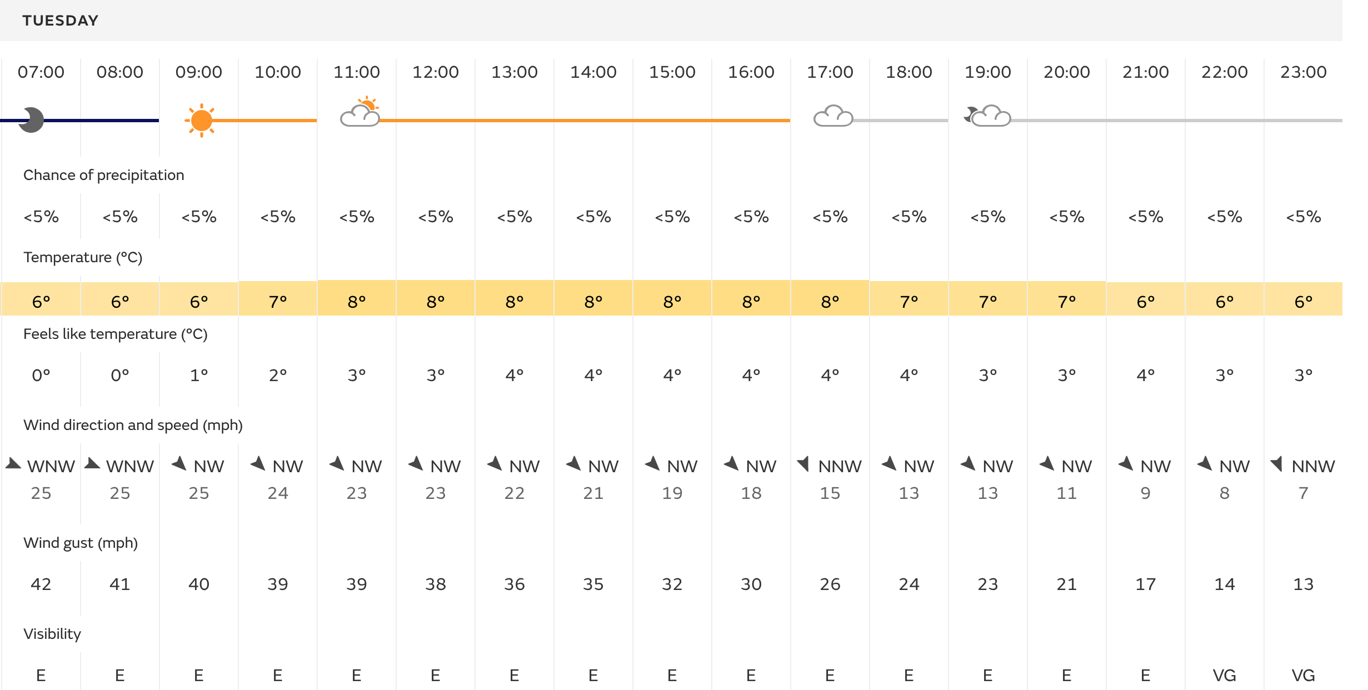
Gower Peninsular / Port Eynon Weather Forecast 04/02/20 – Taken from Met Office.

Activity Day 2 – Three Cliffs Bay / Gower

Date: 11/02/20 | Activity: Climbing.  Location: Three Cliffs Bay/ Gower |  | Module: A Risk Worth Taking.  Module Code: SHSS4078 |  |  | Staff:  Tom Moore  Graham Harvey
The Activity |  | Outcomes |  | Reflections |  | Notes
As part of the second practical day of climbing, the group I was part of was headed down to Three Cliffs Bay on the south coast of the Gower Peninsular. The crag itself sits on the beach and offers a variety of climbs suited to beginners with a couple of harder climbs included too.  Weather  On arrival at the car park it was clear again that the wind was going to be a problem, if not more of a problem than the week before. Wind gusts were ranging up 50-60 mph and there was a slight bit of precipitation coming from the northwest. On |  | Objectives  Again, the objectives for the day were to focus on hazard identification and the control measures that would be needed to put into place. This week, we were told that there may be a chance that the practical session itself could be called off due to the bad weather so we planned to focus more on the learning aspect but also what back up plans we could use in these situations and how we could keep groups engaged when the main practical session gets called off.  Hazard Identification  The most obvious hazard that the group was exposed to throughout the day was the ever-strong winds attacking us from the northwest. As the approach from the car park involves walking along the top of some cliffs it was apparent that a fair distance was to be kept between the edge and us. If we were working with young children or students we would have most probably entered Three Cliffs Bay via a different route.  The incoming tide was another obvious hazard, as adults we were all sensible enough to not go near the sea but when working with a group it would be important to advise individuals to not go near.  The beach was also in a nasty state upon entry from the land, it was easy to spot litter amongst the rocks and sand and it wouldn’t have surprised me if any needles were amongst it all aswell. We also strangely saw a dead cow rotting on the rocks. |  | Group Cohesion  Personally I feel that the group I have been placed in is very sporty and very keen to take part in the practical sessions, when we found out we would be unable to climb I feel that everyone was rather gutted about the situation, however, I cannot blame my group as its no surprise the practical is what everyone looks forward to.  Nonetheless we had a good experience, identifying hazards, listening to Graham’s stories and Tom’s banter.  Learning  It’s surprising how much one can learn from a single experience, after finding out we could not climb and that a back up plan would need to be used in a professional environment, I was surprised with the amount of options there could have been. Litter picking, traversing across the cliffs at the top of the beach (Bouldering), rock pooling and team games on the sand. I have said it before but I often find that the knowledge provided on activity sessions and tutorials are often more satisfying to receive than the actual participation in the activities. | Personal equipment taken on the day  - First Aid Kit  -Waterproofs  - Approach shoes  - Spare warm clothing  - Notepad/ Pen  - Hot Coffee  - Water  - Food (Stir Fry, protein bar, crisps, banana x2)  Equipment Hired from Cynefin  - Helmet  - Harness  Timing  - Group arrived on time.  - Roughly 2 hours spent approaching and spending time on the beach discussing module objectives etc.  - Session finished early due to no practical.

Date: 11/02/20 | Activity: Climbing  Location: Three Cliffs Bay / Gower |  |  |  |  | Module: A Risk Worth Taking  Module Code: SHSS4078 |  |  |  |  |  | Staff: Tom Moore  Graham Harvey
Site Specific RA
Hazard | Risk |  |  |  | Who is at Risk? |  | Unmanaged Risk |  |  |  | Control Measures |  |  | Control Led Risk
Steep Cliffs on approach to venue | - Falling from height.  - Edge of cliff could fall through.  - Death  - Injury |  |  |  | - Staff  - Students  - Public |  | HIGH |  |  |  | - Staff members to stand on cliff side of the students to act as barrier.  - Safe distance to be kept between path and cliff edge.  - Staff members to create awareness of hazard.  - Alternate route to be taken if needs be. |  |  | LOW
Sharp Rock | - Cuts  - Injury  - Damage to kit |  |  |  | - Staff  - Students  - Public |  | MEDIUM |  |  |  | - Appropriate PPE to be worn at all times.  - Chalk to be used on hands when climbing if necessary (Chalk must be cleaned after to show minimal impact on environment).  - Individuals to show caution on contact with sharp rock. |  |  | LOW
Sea | - Drowning  - Separation from land.  - Hypothermia  - Death |  |  |  | - Staff  - Students  - Public |  |  | HIGH |  |  | - Staff to raise awareness on dangers of the sea.  - Safe distance to be kept between venue and sea.  - Warm clothing and first aid kit to be packed by all members of the group.  - First aiders to be present at all times.  - Tide times to be checked prior to activity. |  |  | LOW
Overhanging drop | - Falling from height.  - Broken bones  - Concussion  - Death |  |  |  | - Staff  - Students  - Public |  |  | HIGH |  |  | - When climbing on crag, all participants must be wearing appropriate PPE.  - All members must be attached to secure rope device.  - First aiders present.  - Working staff must hold relative climbing qualifications.  - Awareness to be made of participants working above. |  |  | LOW
Vertical rock face | - Falling from height  - Injury  - Death |  |  |  | - Staff  - Students  - Public |  |  | HIGH |  |  | - Safe distance to be kept between rock face and footpath/operating area.  - Staff to create awareness of vertical rock face.  - Appropriate PPE to be worn at all times.  - Staff to hold relevant climbing qualifications. |  |  | LOW
Dynamic RA
Hazard |  | Risk | Who is at risk? |  |  |  |  |  | Unmanaged risk | Control Measures |  |  | Control led risk
Strong NW wind |  | - Wind can push individuals off of cliff ledge.  - Wind could push individuals off of crag.  - Sand swept into eyes.  - Poor visibility. | - Staff  - Students  - Public |  |  |  |  |  | HIGH | - Staff to stand between students and cliff edge.  - Alternative route to be taken to venue from car park.  - When talking to group, staff to stand against wind to benefit group.  - Group members to take a low position to defend from wind. |  |  | LOW
Public |  | - Collision  - Interruption of activity.  - Injury. | - Staff  - Students  - Public |  |  |  |  |  | MEDIUM | - Group members to keep distance from public.  - Group members to acknowledge public and show appropriate behavior representing university. |  |  | LOW
Litter on entry to beach. |  | - Damage to venue and wildlife.  - Potential injury.  - Infection | - Staff  - Students  - Public |  |  |  |  |  | MEDIUM | - Group to avoid litter and dangerous materials whilst operating in area.  - Litter picks to be done after session finishes.  - Appropriate PPE to be worn if handling litter (Protective gloves). |  |  | LOW
Water surrounding crag. |  | - Hypothermia  - Damage to kit  - Poor visibility of rocks resulting in potential slips and injurys. |  | - Staff  - Students  - Public |  |  |  |  | MEDIUM | - Group to keep safe distance from crag and water.  - Activity to be called off if no clear entry to crag can be found. |  |  | LOW

Activity day 3. Llandysul Paddlers Club Lake

Date: 03/03/20 | Activity: Paddling  Location: Llandysul Paddlers Club (Lake) |  | Module: A Risk Worth Taking.  Module Code: SHSS4078 |  |  | Staff:  Jon Haylock
The Activity |  | Outcomes |  | Reflections |  | Notes
The third activity day would consist of paddling at Llandysul paddlers club on the man made lake. As well as focusing on specific hazards and the control measures that would be put into place we were also focusing on rescue and safety skills as part of the FSRT course we had previously started earlier in the academic year.  Weather  As we would be in and out of the water, it wouldn’t bother the group too much if the forecasted weather included a lot of precipitation, however when operating in water environment the wind can often create a huge effect for multiple reasons such as the wind chill it has on your body and also the effect it can have on paddling into or with the prevailing wind.  Unfortunately for us, we had to deal with all these aspects, however we did not let this affect our performance. |  | Objectives  On arrival, the objectives were to assess and identify specific hazards in and around the lake at Llandysul paddlers club. We would then focus on rescue and safety techniques for the FSRT course such as towing, rescuing a capsized paddler, saving a swamped boat etc.  Hazard Identification  On arrival at the venue, it was clear that one of the main hazards during the session would be the prevailing winds on the lake. Although this wouldn’t put us in any real danger in as sheltered environment, the wind would cause an annoyance by manipulating the movements of crafts on the water making it difficult to paddle against.  Other clear hazards at the venue included the slippery banks of the lake due to the bad weather, slalom poles and wire across the lake, electricity poles on either side of the lake, moving vehicles in and out of the car park and wood pile a few meters away from the lake. |  | Group Cohesion  Spirits within the group were high at all times, and a solid rapport was built between our tutor and ourselves. We were all up for getting into the water to practice rescue techniques and the standards were all very high.  Learning  Out of all the activities we have taken part in so far on this module, I would say that paddling would have to be a favourite. For someone who has previously completed a FSRT course, It was very beneficial to practice these rescue techniques again to brush up on specific rescues and safety techniques that had not been practiced in a long time. The day on the lake really helped me to appreciate and become aware of hazards that you would not usually think of in a working environment. I feel that the day itself was successful. | Personal equipment taken on the day  - First Aid Kit  -Waterproofs  - Wet shoes  - Spare warm clothing  - Rash Vest  - Swimming shorts  - Neoprene Socks  - Towel  - River Knife  - River Bag  - Notepad/ Pen  - Hot Coffee  - Water  - Food (Sandwiches, protein bar, crisps, banana x2)  Equipment Hired from Cynefin  - Helmet  - Buoyancy Aid  - Throw Bag  - Safety Belt  - Wetsuit  -Dry Cag  Timing  - Group arrived on time.  - The whole day was spent working in and out of the lake.  - Group finished all objectives on time and made it back to Cynefin in good time.

Date: 03/03/20 | Activity: Paddling  Location: Llandysul Paddlers Club (Lake) |  | Module: A Risk Worth Taking  Module Code: SHSS4078 |  |  |  |  |  | Staff: Jon Haylock
Site Specific RA
Hazard | Risk | Who is at Risk? |  |  | Unmanaged Risk |  |  | Control Measures |  |  | Control Led Risk
Car Park / Moving Vehicles | - Collision  - Injury  - Death | - Staff  - Students  - Pupils |  |  | HIGH |  |  | - Staff to advise students to walk on pavement.  - High vis clothing to be worn at all times.  - Group members to identify any moving cars to group. |  |  | LOW
Slippery Floor (Banks of lake) | - Slips, trips, Falls  - Injury  - Hypothermia from falling in lake.  - Damage to lake bank | - Staff  - Students  - Pupils |  |  | MEDIUM |  |  | - Group members to use caution when walking on slippery surface.  - Appropriate footwear to be worn at all times (Grippy soles).  - Warm clothing to be packed in bags.  - First aid kit to be packed. |  |  | LOW
Slalom Poles | - Collision  - Concussion  - Injury | - Staff  - Students  - Pupils |  |  |  | MEDIUM |  | - Staff members to point out slalom poles and raise awareness.  - Slalom poles to be removed if necessary.  - First aid kit to be in possession by a member of staff.  - Staff to instruct group to stay away from poles. |  |  | LOW
Steep Banks | - Slipping into lake  - Injury  - Hypothermia | - Staff  - Students  - Pupils |  |  |  | MEDIUM |  | - Staff members to raise awareness of steep banks.  - Group members to keep distance away from steep banks.  - Warm clothing to be packed.  - First aid kit to be packed. |  |  | LOW
Light Electriciy Outputs | - Electrocution | - Staff  - Students  - Pupils |  |  |  | HIGH |  | - Staff members to raise awareness of electricity outputs.  - All group members to keep distance from outputs.  - Nobody who is wet to approach outputs. |  |  | LOW
Slalom Wire above Lake | - Potential of getting caught in wire.  - Entrapment | - Staff  - Students  - Pupils |  |  |  | HIGH |  | - Staff or group members to tighten and raise wire so it is out of reach.  - Wire to be removed if necessary.  - Staff members to raise awareness of wire. |  |  | LOW
Wood Pile | - Injury | - Staff  - Students  - Pupils |  |  |  | MEDIUM |  | - Staff member to raise awareness of woodpile.  - Group members to keep safe distance from woodpile at all times. |  |  | LOW
Dynamic RA
Hazard | Risk | Who is at risk? |  | Unmanaged risk |  |  | Control Measures |  |  | Control led risk
Other users of the lake | - Collision  - Injury  - Interruption of each session.  - Lack of learning | - Staff  - Students  - Public |  | MEDIUM |  |  | - Staff to raise awareness of other users of the lake.  - Distance to be kept between both groups.  - Group to stick to one area of the lake. |  |  | LOW
Prevailing wind and rain. | - Swamped Crafts  - Windchill  - Hypothermia  - Potential debris flying onto lake. | - Staff  - Students  - Public |  | MEDIUM |  |  | - Group members to use spray decks to avoid water entering craft.  - Group members to wear dry cags and neoprene gloves, socks.  - Group members to keep aware of surrounding environment.  - If weather gets too bad, group to exit lake immediately. |  |  | LOW
Low Slalom pole wires. | - Entrapment  - Collision  - Injury | - Staff  - Students |  | MEDIUM |  |  | - Staff member to tighten and raise wires.  - Awareness to be made of wires.  - Group to avoid wires. |  |  | LOW

Screenshot taken from BBC Weather
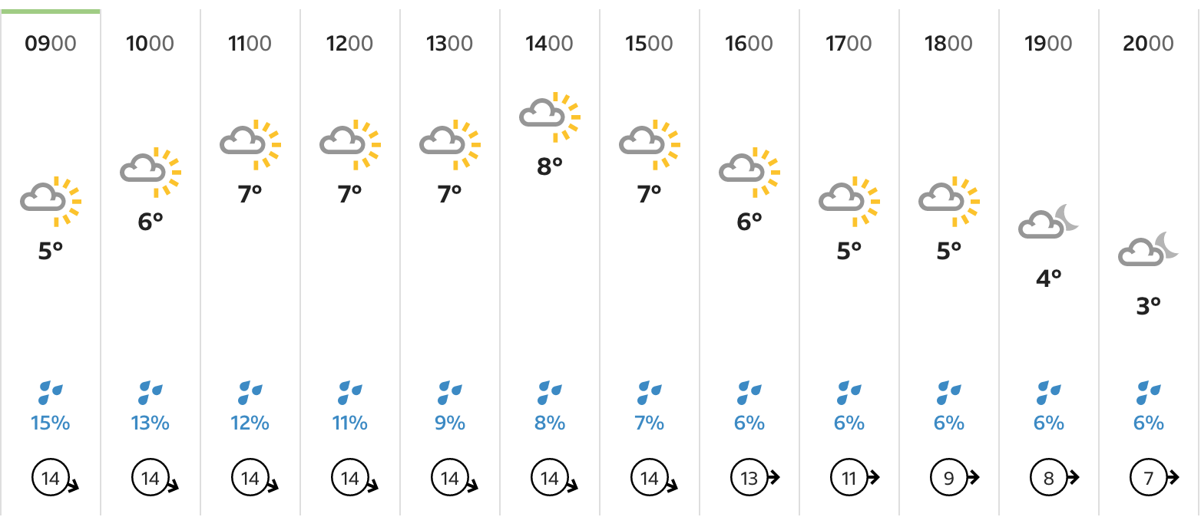

Screenshot taken from Met office.
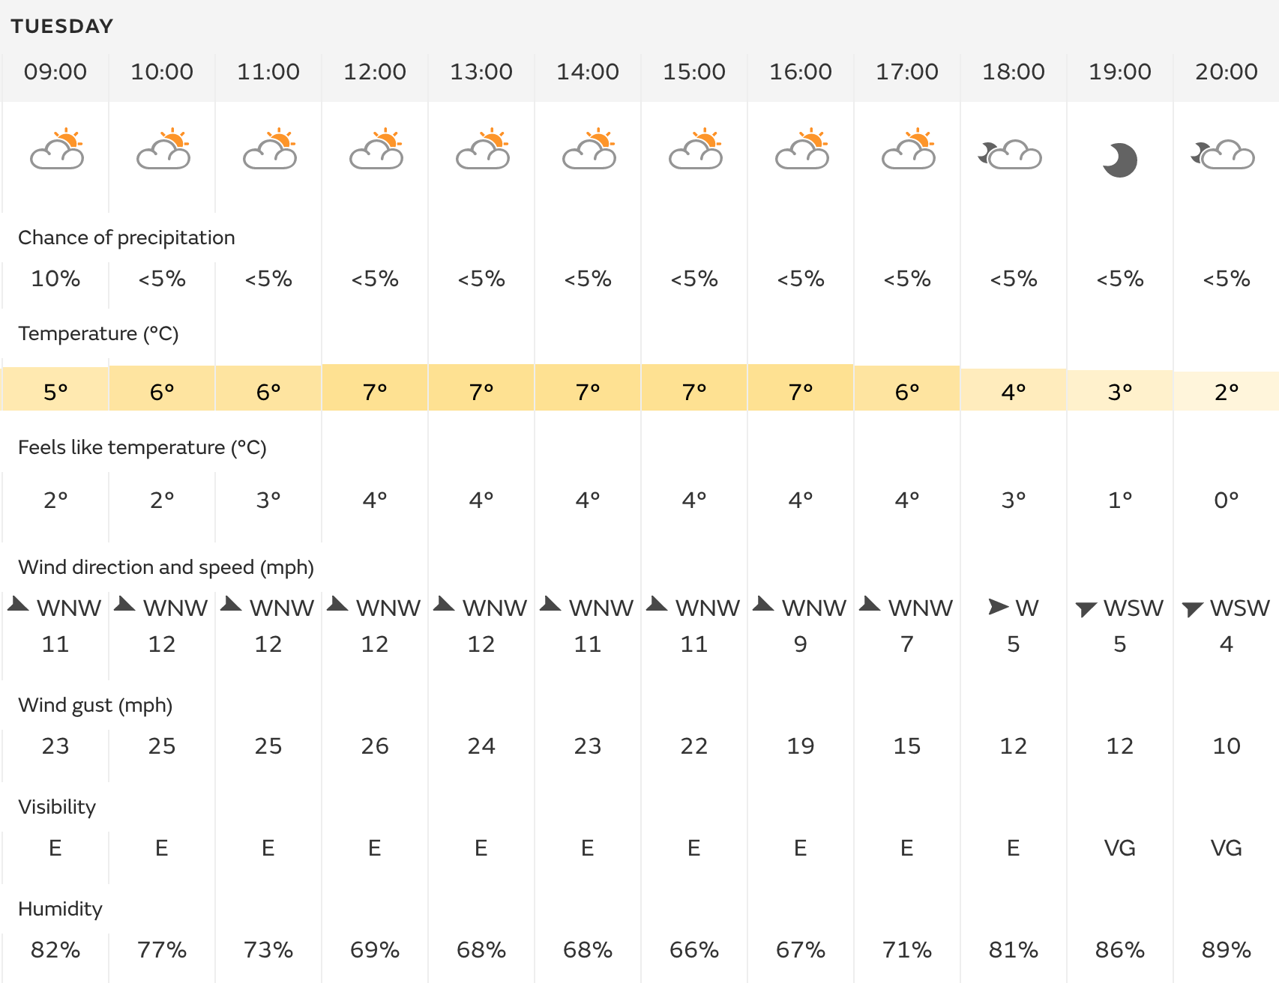

As you can see, there is a big difference in the predicted weather from both the BBC and Met Office. It is extremely important to check a variety of sources when looking for weather forecasts.
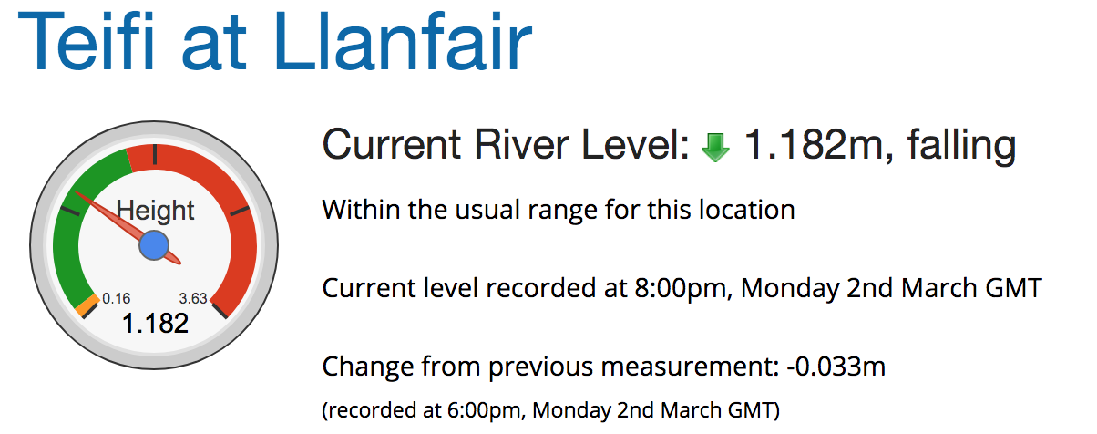

Activity Day 4. Llandysul Paddlers Club / Teifi River

Date: 10/03/20 | Activity: Paddling  Location: Llandysul / Teifi River |  | Module: A Risk Worth Taking.  Module Code: SHSS4078 |  |  | Staff:  Jon Haylock
The Activity |  | Outcomes |  | Reflections |  | Notes
The Fourth activity day was based on the river Teifi at Llandysul Paddlers Club. All levels of paddlers assuming there is qualified and competent staff present can use the river itself. The river is seen as a grade 2 river but at times can be higher dependent on river levels and the weather.  Weather  The weather on the day was fortunately not too bad, it was expected to rain however this was not a problem due to the high chance of getting wet during the activity anyway. Wind gusts were to reach up to around 35mph however this didn’t seem to affect the paddling as we were working on moving water and fairly low down out of reach from the wind. |  | Objectives  The plan was to initially take a walk up and down the river to identify potential hazards, assess the risks and the control measures that could be put into place. We would then use this information when paddling on the river to avoid specific spots previously pointed out. As a group we planned to make 2 successful descents of the river. For this activity day I chose to paddle in a canoe as my craft. Out of the group I was the only one in this form of craft, which could have potentially meant that I could have been a hazard to others.  Hazard Identification  As the group took a walk down the banks of the river it was extremely easy to identify multiple hazards. Obvious hazards that would be noticeable in all paddling environments included other paddlers on the water, this was something that could be easily managed through effective communication and timing on the river. We noticed that there were small hazards such as the green string floating around just after the bridge on the river left as well as a few trees just before the bridge that could act as potential strainers to any paddler. As the river levels were slightly higher than usual we noticed that some rocks were barley noticeable as they were only just sticking out of the river, this could act as a potential danger as these rocks can easily be collided with and could cause a paddler to capsize. As it was a windy day we had to be aware of the trees on the banks of the river and the potential instance of branches falling from above, we also noticed storm drains on river left just after the bridge. Although they were not too threatening, it was handy to notice these for future reference. |  | Group Cohesion  As a group we managed the river environment extremely well. As most of the members of the group were comfortable on a moving river environment we didn’t really experience any major problems apart from a couple of entertaining situations in which a couple of members capsized. Luckily we were all on hand to help out and get these individuals back into their crafts. We managed to make 2 successful descents of the river and spirits were extremely high throughout.  Personal Performance  I would personally say that this session was probably one of my favourite activity sessions I have had whilst on the university course. The fact that I was allowed to use a canoe was extremely satisfying. I felt that my paddling was at a sufficient standard throughout, I did not capsize during both descents however, I feel that my control of the canoe could be slightly better at times as I occasionally would crash into the river banks when attempting to paddle into the eddy’s. | Personal equipment taken on the day  - First Aid Kit  -Waterproofs  - Wet shoes  - Spare warm clothing  - Rash Vest  - Swimming shorts  - Neoprene Socks  - Towel  - River Knife  - River Bag  - Helmet  - Notepad/ Pen  - Hot Coffee  - Water  - Food (Sandwiches, protein bar, crisps, banana x2)  Equipment Hired from Cynefin  - Buoyancy Aid  - Throw Bag  - Safety Belt  - Wetsuit  -Dry Cag  Equipment hired from Llandysul  - Canoe  - Paddle x2  Timing  - Group arrived on time.  - 30 – 45 minutes spent walking up and down the river to identify hazards and assess risks.  - Roughly 3-4 hours spent in and out of water.  - Group arrived back at Cynefin on time.

Date: 10/03/20 | Activity: Paddling  Location: Teifi River / Llandysul Paddlers Club |  |  | Module: A Risk Worth Taking  Module Code: SHSS4078 |  |  |  |  |  | Staff: Jon Haylock
Site Specific RA
Hazard | Risk | Who is at Risk? |  |  |  | Unmanaged Risk |  | Control Measures |  |  |  | Control Led Risk
Carpark, cars and other moving vehicles | - Collision  - Injury  - Death | - Staff  - Students  - Public |  |  |  | HIGH |  | - Staff to advise students to walk on pavement.  - High vis clothing to be worn at all times.  - Group members to identify any moving cars to group. |  |  |  | MEDIUM
Slalom Poles and wire | - Collision  - Concussion  - Entrapment | - Staff  - Students  - Public |  |  |  | MEDIUM |  | - Staff members to point out slalom poles and raise awareness.  - Slalom poles to be removed if necessary.  - Staff member to tighten and raise wires.  - Awareness to be made of wires.  - Group to avoid wires. |  |  |  | LOW
Undercuts after bridge on river left | - Entrapment  - Drowning  - Death | - Staff  - Students  - Public |  |  |  |  | HIGH | - Staff members to raise awareness of undercuts prior to descent of river section.  - Staff member to be positioned near undercut for any potential rescues.  - Safety equipment (Throw bag, first aid kit etc) to be carried at all times. |  |  |  | LOW
Boulders | - Collision  - Injury  - Loss of craft | - Staff  - Students  - Public |  |  |  |  | MEDIUM | - Identification of boulders prior to descent of river to be made.  - Staff members to be positioned near to boulders to point out for incoming paddlers.  - Awareness prior to descent to be made. |  |  |  | LOW
Canoe trailer down stream | - Collision  - Injury  - Entrapment  - Death | - Staff  - Students  - Public |  |  | HIGH |  |  | - Staff members to raise awareness of canoe trailer prior to getting on river.  - River descent to stop before canoe trailer location.  - Staff members to position themselves in front of trailer to stop any incoming paddlers from collision. |  |  | LOW
Road / Bridge Crossing | - Collision  - Injury  - Death | - Staff  - Students  - Public |  |  | HIGH |  |  | - Staff to raise awareness of road and incoming traffic.  - High vis clothing to be worn at all times crossing road. |  |  | LOW
Dynamic RA
Hazard | Risk | Who is at Risk? |  |  | Unmanaged Risk |  |  |  | Control Measures |  | Control Led Risk
Slalom Wire / Poles | - Collision  - Concussion  - Entrapment | - Staff  - Students  - Public |  |  | MEDIUM |  |  |  | - Staff members to point out slalom poles and raise awareness.  - Slalom poles to be removed if necessary.  - Staff member to tighten and raise wires.  - Awareness to be made of wires.  - Group to avoid wires. |  | LOW
Green String past bridge on river left | - Entrapment  - Drowning  - Injury  - Pollution | - Staff  - Students  - Public |  |  | HIGH |  |  |  | - Staff members to create awareness of hazard prior to activity.  - If possible, staff or students to remove hazard safely from water.  - Staff member to position near to hazard to point out for incoming paddlers. |  | LOW
Fallen trees before bridge on river right | - Entrapment  - Drowning  - Death | - Staff  - Students  - Public |  |  | HIGH |  |  |  | - Staff members to create awareness and point trees out prior to session.  - Staff members to position themselves near to trees to direct paddlers away.  - Paddlers to paddle on river left. |  | MEDIUM
Other Paddlers | - Collision  - Injury | - Staff  - Students  - Public |  |  | HIGH |  |  |  | - Staff to raise awareness of other users of the river.  - Distance to be kept between both groups.  - Effective communication to be used between group and public. |  | LOW
Boulders | - Collision  - Injury  - Loss of craft |  | - Staff  - Students  - Public |  |  | MEDIUM |  | - Identification of boulders prior to descent of river to be made.  - Staff members to be positioned near to boulders to point out for incoming paddlers.  - Awareness prior to descent to be made. |  |  | LOW
High wind levels. | - Swamped Crafts  - Windchill  - Hypothermia  - Potential debris flying onto river. |  | - Staff  - Students  - Public |  |  | MEDIUM |  | - Group members to use spray decks to avoid water entering craft.  - Group members to wear dry cags and neoprene gloves, socks.  - Group members to keep aware of surrounding environment.  - If weather gets too bad, group to exit river immediately. |  |  | LOW
Sewage Outflows | - Pollution |  | - Staff  - Students  - Public |  |  | MEDIUM |  | - Group members to avoid area in which sewage is entering river. |  |  | LOW

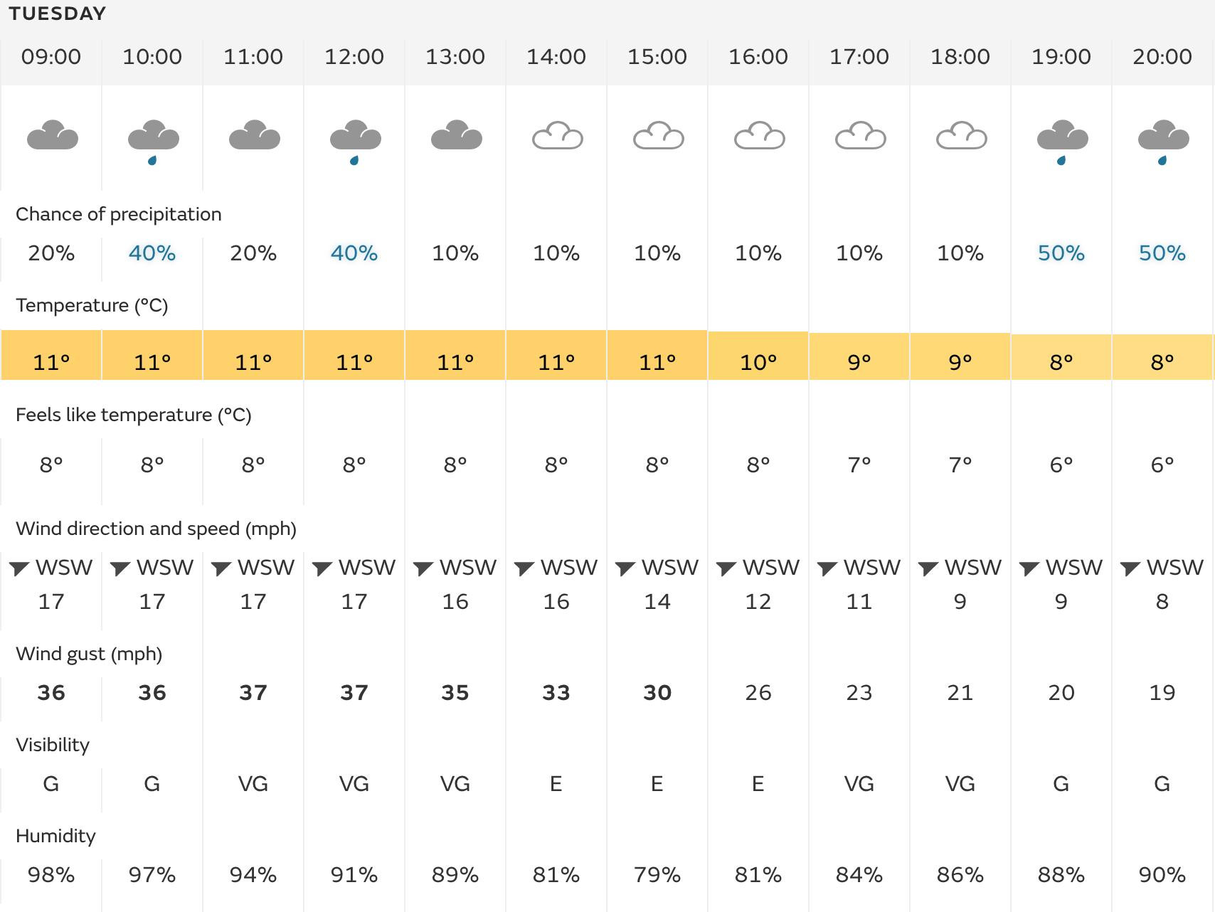
Forecast taken from Met Office

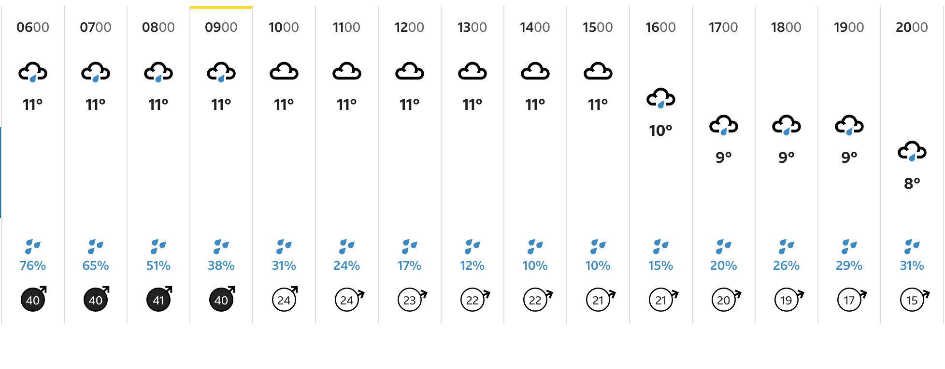
Forecast taken from BBC weather

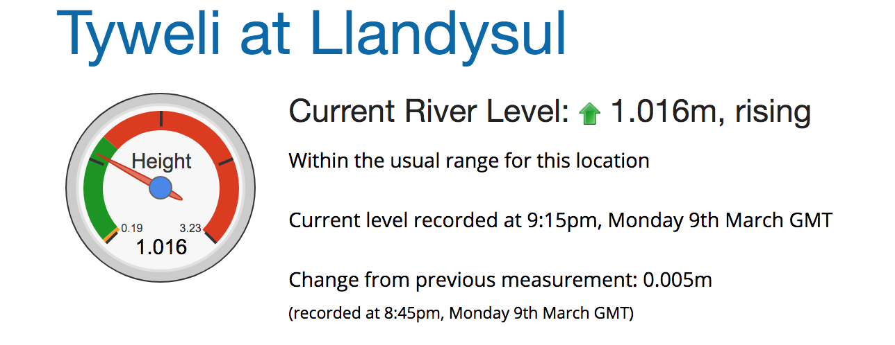
River levels



