Contents Page

Element 1 5-minute presentation. 10th June

Element 2 Reflective log. page 2 – 5

Element 3 Briefing paper. page 6 – 7

Element 4 Personal Development page 8 – 13
Plan.

Reference list page 14 - 16
Element 2 Reflective log
Disgrifiad byr o’r gweithgaredd (dim mwy na 50 o eiriau
Brief description of the activity (no more than 50 words)
This reflective log considers a stage 3 activity of Attention Autism otherwise known as ‘Bucket’. This entails a child between the age of 18 months-4yrs old from a semi-circle of 8 children, on invitation by the bucket lead, to come forward, scoop some ice cream on to a cone and take the ice cream back to their seat to eat (Davies, 2013).

Nod/Amcan y gweithgaredd Aim/Objective of the activity
Attention Autism (Bucket) has been designed to help parents and professionals give their child with autism an opportunity to learn whilst also having a fun experience. It can build a bridge to communication for many children, not just those with Autism. The four stages of bucket help children to develop attention and communication at different levels. The object of stage 3 is to develop turn taking skills and to be able to shift attention. This activity was included into bucket for the Summer term as a treat for the children and because members of staff had suggested when asked, that foods could be included into Attention Autism, myself included.

Eich rôl chi Your role
My role as a participant in the semi-circle, is to model to the child I am working one to one with, how to sit and to look at the bucket as if it is the most exciting thing I have ever seen. No unnecessary talking is allowed, and participants must not leave their seat unless invited to do so by the bucket lead. I can, however, use the same words as the bucket lead as they use their key words for that activity. I can use words of aw and wonder to reinforce my amazement but must not say ‘look’ or use eye gaze with the children to drawer their attention to the bucket activity, that is the job of the bucket lead. If my child on a particular day has a physical disability, then I could be asked by the bucket lead to help support that child at stage 3.

Agweddau cadarnhaol – pam? Positive aspects – why?
Once a child grasps the idea that bucket is fun and exciting. It is fascinating to see that once the bell rings for tidy up time, children with some of the most challenging behaviours will tidy up and sit on a chair for nearly twenty minutes with their peers, sometimes in complete silence or squealing with excitement. When a child is invited up, with or without support, to bend down, pick up the scoop, get some ice cream, put it on a cone and take it back to their chair, these actions can be of great developmental importance. In one session it may be the only time that a child is engaged. The children are very proud of themselves and what they have achieved. It is thoroughly rewarding, through modelling positive behaviour, to participate with a child who otherwise may not even realise that you are there. A child may also, through disability or a medical condition, be otherwise unable to participate unless I was there to support them.

Agweddau heriol – pam? Challenging aspects – why?
I found this activity with foods particularly challenging. I was not aware that only 2 or 3 children would be invited to scoop themselves an ice cream. Some had to wait until the end of the week to get an ice cream, with a view that it is part of a learning process to wait and take turns.
Some of our children come from difficult environmental backgrounds where their family experience can be very challenging. It made me feel very uncomfortable to see a child with their hand out to go up at stage 3, be ignored and another child invited. I felt that it was not appropriate in this instance for it to appear that some children were chosen over others when they may not experience treats in their home life.
Additionally, there are children who are Nasogastric tube fed or Enteral fed through their stomach. One of these children chooses not to eat orally for psychological reasons and another is nil by mouth due to their anatomy. These children are unable to participate in food activity’s and bucket is something which is repeated the same every day, therefore this becomes a very difficult activity when considering inclusivity.

Pa wybodaeth arddangoswyd? What knowledge was demonstrated?
There are 3 people who have had Attention Autism training and this knowledge has been imparted to other members of staff so that we can all participate in the correct way. I have also been taught how to lead and do so on a regular basis every week. I must be knowledgeable about the needs of the children involved on that day whether it be visual impairment, physical disability or whether the child needs to leave the room due to distress. When I am with the child who is tube fed, their feed may end during bucket, I then turn the machine off, disconnect the feeding tube and flush. I can do this through the knowledge of specialist training.
Pa sgiliau arddangoswyd? What skills were demonstrated?
Throughout Bucket, I demonstrate the skills that I have learnt through applying the knowledge that I have been taught through specific training from the community nurse to support a child which is fed gastro enterally. I have the skills to know what to do if the alarm sounds and gives a code on the reader, I can then act accordingly to resolve the issue. Having over 20 years’ experience of working with young children has enabled me to become skilled at modelling positive behaviour for children.

Pa werthoedd arddangoswyd? Which values were demonstrated?
When considering reflectively values which I have acquired through the experience of this activity I can acknowledge that I have used empathy for the child I am supporting, respect, equality and confidence. The children that I work with can be nonverbal. I am the voice of that child so sometimes it is for me to interpret what they want or do not want sometimes with the smallest of cues.

Beth allai cael ei wneud yn wahanol? Pam?
What could have been done differently? Why?
Once a term we have a chance to reflect upon Attention Autism, what worked well and the things we felt did not. We can fill in a slip if we choose which then goes to the bucket programme coordinator to re assess. On reflection I felt that my previous suggestion for adding foods into the bucket activities was misguided and had not been thought through thoroughly by myself and the team. However, as other people had also made this suggestion, I found it difficult to put it on a slip of paper. I sent an email to my Manager explaining my thoughts as above as to why I felt on reflection, the use of treats of food for bucket were inappropriate, due to different family challenges, varying ages, abilities and disabilities of our children.
For our team to be inclusive to all children, I felt it would be more beneficial in the Summer if the experience of having an ice cream was shared altogether at snack time on the days that the children who cannot eat foods orally are not present. Also, there will be no feelings of disappointment and this could then be a positive shared experience for all the children regardless of background.
I am pleased to say that my thoughts have been taken into consideration and as a team it has now been decided that foods as treats should no longer be included in Bucket.

Element 3 The Importance of Reflection for Early Years Practitioner
Continued Professional Development (CPD)
CPD is a personal commitment to updating knowledge and skills for the purpose of achieving professionalism in everything a practitioner does. Areas for continued development include;
- Knowledge – Updating knowledge in practice.
- Skills – Application of knowledge and use of skills in workplace situations.
- Behaviours – Use of appropriate values, conduct and relationship skills.
- Self-Assessment and Reflection – continually reviewing and reflecting on learning and development. (Care Council for Wales, 2016).

Reflective practice and continued professional development are key to high quality provision in early years education and care settings (Bleach, 2014). Reflection involves helping those most closely involved to think about what they already know and how this can be refined in order to enhance or change an activity, policy or method of learning (Read and Canning, 2010)
Reflective practice is an outlook of continued professional development and learning for the enhancement of best practice within early years settings and professions (Lindon and Trodd, 2016).

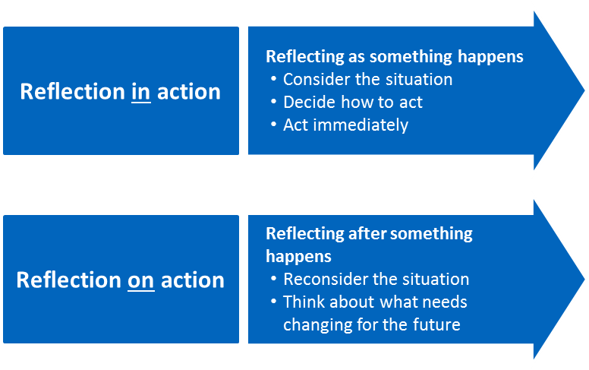source: Cambridge Assessment International Education
Donald Schon (1983) two strands of reflective practice (Lindon and Trodd, 2016).
Reflection in Action = thinking on your feet, making adjustments, acting with immediate insight, professional thoughtfulness.
Reflection on Action = can be undertaken alone or with colleagues, shared recall of other practitioners on past events, sharing and comparing perspectives to develop best practice (Lindon, 2012) (Paige-Smith and Craft, 2008).

Argyris and Schon (1978) developed a reflective process called single and double loop learning compatible with Schon’s ‘In and on’ strands of practice.
- The emphasis of Single loop learning allows a practitioner to change the activity rather than the governing principle.
- Double loop learning requires a practitioner to reflect more deeply on policies, values, principle assumptions and prejudices (Reed and Canning, 2010).
When working with young children and families, colleagues and multi-agency professionals it is crucial that we understand ourselves and our own professional development in order to further understand those we are working with (Kay, 2012).

Source: Stephen Ong (No Date).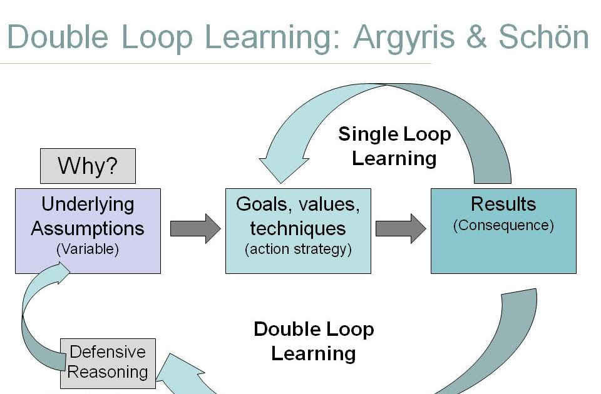
Ask reflective questions: What went well? What didn’t? how will I evaluate my provision? How will I improve it?

Have the support of a mentor.

be able to stand back from a situation and to observe the activities of the day in an objective manner.

have regular individual review and appraisal meetings.

To Reflect, practitioners need to be able to: (Hallet,2008, p.49)

talk with work colleagues and other multi agency professionals in order to share experiences and exchange ideas.

Have time and space to think.

access professional development.

The Benefits of Reflection for Best Practice in Early Years Provision.
- Develops a team culture within a community of learners.
- Leaders who reflect on their own practice encourage reflection in their staff by a collaborative reflective process through mentoring and supervision.
- Recognition of staffs current and potential strengths with an expectation of ongoing training and personal development.
- Builds a shared value base, promotes collective knowledge and a common purpose (Siraj-Blatchford and Manni, 2012).
- Leads to the question, am I all I can be or is growth and development possible for improved change in provision? (Wlodarsky, 2018).
- Reflection aids professional accountability.
- Enables deeper understanding of our own and other’s practices.
- Supports greater links between theories, research and practice.
- Leads to some form of action either mental or physical (Moyles, 2010).
Source: University of Sheffield (2019).
Gibbs Reflective learning cycle is an example of Reflection on Action, placing theory and practice in an iterative process (Potter, 2015).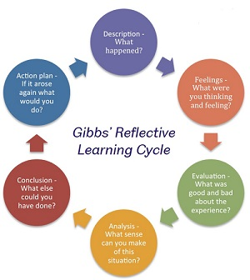
Source: University of Sheffield (2019
Reflective Practitioners are:
- Open minded.
Willing to accept that their views and practice can be developed through other viewpoints.
- Responsible.
Considering factors beyond practice of any change to provision and impact upon children’s learning outcomes.
- Wholehearted.
Ability to be genuinely reflective for the purpose of the benefit to best practice (Hallet, 2013).

Element 4 Personal Development Plan

Area for further development (provide further details) | Why? | How? | Who/Where? | When?
1.Knowledge  Picture Exchange Communication System (PECS) | Some of the children I work with are pre or post diagnosis for Autism and are nonverbal. Pecs allows these children to communicate by exchanging pictures for the motivator. This is a very complex, specific, structured process of learning. I would like to be trained in PECs to expand my knowledge so that I can support all children requiring PECS within our setting. | The course is sometimes offered to members of staff, 2 at a time. 2 names are chosen at random from a list of those who wish to attend. 2 people attended at the end of 2018. When the next opportunity is offered by our Manager, I shall put my name forward. | Pyramid Educational Consultants, Cardiff, £600 per person. | The next time the course is offered by my employers.
2. Knowledge  Incredible Beginnings Programme designed by Carolyn Webster-Stratton. PhD | This is a programme provided by Pembrokeshire County Council. There has been a marked increase recently within my profession of children referred for support at Snap Assessment Playgroup who come from various difficult challenging family environments. Sometimes families are not equipped for their child’s challenging behaviour and require support for an improved  family environment. The Incredible Beginnings programme is designed for childcare providers with children between the age of 1-5years. Social and emotional coaching is promoted as too is nurturing child directed play interactions and consistent positive behaviour management strategies. | When this programme is offered to my manager by PCC, she will ask who would like to attend? It is a 6-week twighlight  course which will be attended in my own time without pay. | Pembrokeshire County Council | None offered at the moment. Although an alternative is being discussed, Positive  Behaviour Strategies with Pembrokeshire County Council.
3.Skills  Signalong | I did my first Signalong training in 2013. Although I am skilled at using it, it is evident that if you don’t use it frequently the skill is lost. Signalong is used as an aid to communication for children who have speech and language developmental delay, children who are hearing impaired or as a general tool of communication for young children. It is used in primary schools and early years provisions throughout Wales. | The initial course with Signalong Book costs £25, after which any refresher courses are free of charge. Pembrokeshire Speech and Language Therapists provide the course which is 1 day. There are further stages, but these are not normally offered to practitioners as once the basics are learnt further books with an array of signs relevant to a variety of situations can be purchased. I can personally further develop my skill by using Signalong regularly with all children, as well as my peers, and if there is a sign I do not know, look it up in our Signalong dictionary. | Pembrokeshire County Council, either at the Withybush Hospital or Pembroke Dock Health Centre. | My manager normally ask’s if any members of staff require refresher courses in Signalong at the end of each term.
4.Skills  Enterel tube feeding | I have worked with 3 children who are Enterel tube fed. Each child I have worked with has a different Healthcare plan and has different nuances with their personal feeding regime. Some staff are unable to deal with aspirating a child’s stomach content through a mickey peg. Also checking ph value to make sure the tube is still securely in the stomach.  Working closely with young children who are Enterel fed is a skill I have acquired over time and with specific training. This a skill I am forever learning as each child’s feeding regime is unique to them and requires update training of my skills with every child. I need to have training to be able to vent the child I am with immediately when she retches to prevent inhalation of fluids into her lungs. | Training is arranged with the community nurse who works with the child and her family. This is arranged by her parents in conjunction with my manager. | Snap Assessment playgroup, Withybush Hospital. | Hopefully on the next session the child comes in, as it is required urgently.
5.Values  Respect | I have a lot respect for all children within our setting. Every child is unique and even when diagnosed with the same condition, the traits of these can be very different dependant on the child. | I try to show respect by treating every child as an individual. Coming down to the same eye level to the child. Reassuring in a new activity, modelling if they are uncomfortable. If a medical need arises such as checking micky peg insertions, the respect for that child’s dignity is crucial in developing a trusting relationship.  Developing respect is a continuing cycle of development and learning. Sometimes a new child’s need can make me feel uncomfortable if it is something which I have not experienced before, but I see this as a challenge in developing professionally and broadening my experience. | We have new children arriving at our setting in January, April and September. They can be with us for 2 or 3 terms. For some of our children it can take a whole term for them to settle. Before any of my new children start, it is important that I find out as much as I can about their particular need. Through reading and asking questions. My manager is a very adept at placing a child with the correct Play specialist support worker to enable a positive transition. | This is a constantly developing process of learning throughout life not just professionally but personally too.
6.Values  Compassion | I like to think that I am a compassionate person, that I am understanding, caring and sensitive. Through my own personal experiences throughout life, I try to make a point of walking towards someone in a difficult situation or under emotional duress, opposed to avoiding or looking the other way. I believe therefore, that I have been given difficult situations to deal with in the past so that I can empathise and give support to others without coming across as self-righteous or arrogant. | Our setting can be very busy at times, and sometimes we may not have a spare member of staff to help support other members. I try to help as much as I can, pre- empting situations before they arise. If I see something which goes against my set of values or is unethical, I will say. I try to use the appropriate procedures and will talk to my manager. | Within my work setting, at University. | Throughout my life constantly.
7.Other?  Self-righteous  /arrogance | I have never been an academic person and I did not achieve O level English or Maths when I left school due to other factors. However, I wanted to see if I could do a Degree. I have discovered in the last 9 months that I have a lot of questions both during lectures and in my own time. I read a lot and want to discuss this and share what I have read. I am aware that during lectures, my passion, enthusiasm could come across as arrogant or self-righteous. | When a question is asked to students by our lecturers, I could speak every time. I am aware of this and have been trying to hold back and give other people the chance to speak and discuss, even if I have a whole conversation going on in my head. If the class is silent and no one says anything I wait to see if someone will speak, if they don’t, then I will, mainly because I will have something to offer which I have read and because I don’t want that time to be wasted if I have a question. | I have very good work colleagues who are also doing the Degree. I am not shy in asking them for their opinions on whether what I have to say in lectures is relevant or comes across as arrogant or self-righteous. I trust their views on my actions both professionally and personally as I have worked very closely with them for the last 3 years. I am comfortable involving them in peer reflection and value their opinion as my personality evolves through my 50’s. | University, Work and personally.

Reference List
Abtahi, Y. (2018) Reflections on the Combination of the Theoretical Ideas of Piaget and Vygotsky with an Emphasis on the Role of Others, Available at:
file:///C:/Users/Owner/Downloads/AbtahiReflectionsontheCombinationoftheTheoretical1.pdf (Accessed: 2nd June 2019).
Attention Autism (no date) Available at:
http://www.drumbeatasd.org/attachments/download.asp?file=102&type=pdf (Accessed: 4th June 2019).
Bergsteiner, H. and Avery, G.C. (2014) ‘The twin-cycle experiential learning model: reconceptualizing Kolb’s theory’, Studies in Continuing Education, 36(3), pp. 257-274.
Bergsteiner, H. Avery, G. C. and Neumann, R. (2010) ‘Kolb’s experiential learning model: critique from a modelling perspective’, Studies in Continuing Education, 32(1), pp. 29-46.
Bleach, J. (2014) ‘Developing professionalism through reflective practice and ongoing professional development’, European Early Childhood Education Research Journal, 22(2), pp 185-187.
Cambridge Assessment International Education. (No date) Available at:
https://www.cambridge-community.org.uk/professional-development/gswrp/index.html (Accessed: 8th June 2019).
Cannon, H. Feinstein, A. and Friesen, D. (2010) ‘Managing Complexity: Applying the Conscious Competence Model to Experiential Learning Vol 37’, Proceedings of the annual ABSEL conference, Developments in business simulation and experiential learning. Available at:
https://absel-ojs-ttu.tdl.org/absel/index.php/absel/article/view/306/272 (Accessed: 2nd June 2019).
Care Council for Wales. (2016) Continuing Professional Development Principles for the early years and childcare workforce in Wales, Cardiff: Welsh Government. Available at:
https://socialcare.wales/cms_assets/file-uploads/Early-years-CPD-principles.pdf (Accessed: 13th June 2019).
Davies, G. (2013) Gina Davies Autism Centre, Available at: http://ginadavies.co.uk/
(Accessed: 4th June 2019).
Department for Education and Skills (2015) Reflective practice, Cardiff: Welsh Government. Available at:
https://learning.gov.wales/docs/learningwales/publications/150611-reflective-practice-booklet-en.pdf (Accessed: 2nd June 2019).
D’Souza, J. and Gurin, M. (2016) ‘The universal significance of Maslow’s concept of self-actualisation', The Humanist Psychologist, 44(2), pp. 210-214. Available at:
https://www.researchgate.net/publication/303889840_The_universal_significance_of_Maslow's_concept_of_self-actualization (Accessed: 2nd June 2019).
Hallet, E. (2013) The Reflective Early Years Practitioner, London: Sage.
Hallet, E. (2008) ‘The concept of reflective practice’, in Macleod-Brudenell, I. and Kay, J. (ed.) Advanced Early Years for Foundation Degrees & Levels 4/5, 2nd edn, Harlow: Heinemann.
Kay, J. (2012) Good Practice in the Early Years, 3rd edn, London: Continuum.
Lindon, J. (2012) Linking Theory and Practice, Reflective Practice and Early Years Professionalism, 2nd edn, London: Hodder Education
Lindon, J. and Trodd, L. (2016) Linking Theory and Practice, Reflective practice and Early Years Professionalism, 3rd edn, London: Hodder Education.
McLeod, S. (2013) Kolb - learning styles. Available at:
http://cei.ust.hk/files/public/simplypsychology_kolb_learning_styles.pdf (Accessed: 4th June 2019).
MindTools. (No, date) The Conscious Competence Ladder, Keep going when learning gets tough. Available at:
https://www.mindtools.com/pages/article/newISS_96.htm (Accessed: 2nd June 2019).
Moyles, J. (2010) Thinking about Play, Developing a Reflective Approach, Maidenhead: Open University Press.
Ong, S. (no date) My Journal, Available at:
http://stephenongjournal.blogspot.com/p/dace-c1-rp.html (Accessed: 9th June 2019).
Paige-Smith, A. and Craft, A. (2008) Developing Reflective Practice in the Early Years, Glasgow: McGRaw Hill, Open University Press.
Pearson, Talentlens. (no date) Honey and Mumford Learning Style Questionnaire. Available at: https://www.talentlens.co.uk/product/learning-style-questionnaire/ (Accessed: 1st June 2019).
Potter, C. (2015) ‘Leadership Development, an applied comparison of Gibb’s Reflective Cycle and Scharmer’s Theory U’, Industrial and Commercial Training, 47(6), pp. 336 – 342. DOI:10.1108/ICT-03-2015-0024
Reed, M. and Canning, N. (2010) Reflective Practice in the Early Years, London: Sage.
Siraj-Blatchford, I. and Manni, L. (2012) ‘Effective leadership in the early years sector: the ELEYS study’, in Miller, L. Drury, R. and Cable, C (ed) Extending professional practice in the early years, London: Sage.
University of Sheffield (2019) Academic Skills Centre, Reflective Practice. Available at: https://www.sheffield.ac.uk/ssid/301/study-skills/university-study/reflective-practice (Accessed: 15th June 2019)
Wilkinson, T. Boohan, M. and Stevenson, M. (2013) ‘Does learning style influence academic performance in different forms of assessment?’, Journal of Anatomy, Available at: https://onlinelibrary.wiley.com/doi/full/10.1111/joa.12126 (Accessed 1st June 2019).
Wlodarsky, R. (2018) ‘The benefits of reflection on improving teaching through change: a reflective model for professional development’, National Teacher Education Journal, 11(1), p. 33 - 40.

