Role & extent of Knowledge & Information Management in Google

Module: Knowledge and Information Management Skills for the Workplace
Module code: BMSW 5106
Student name: Gabriela Grad
Student number: 2027447
Lecturer: Akinseye Aluko

Executive Summary
Management skill is very essential for organizational development, people process, mapping, and team development to deal with changes. The report has demonstrated that Google has recognizable Knowledge management aims to accomplish sustainable goals. It has highlighted the stakeholder participation and contribution of knowledge to accomplish the set objective. The report has highlighted the distinct KM system approaches that contribute to overall development. It has illustrated the incentive of active participants in the KM system and investment in knowledge projects. It evaluates the major challenges and opportunities of knowledge management to maximize the overall performance of the firm. The report has discussed the new sources of knowledge that are essential for distribution to partners, clients, and other stakeholders. It has examined the best plan to promote the KM system and manage the stakeholder for effective utilization of the system.

Table of Contents
Introduction 4
Company overview (Google) and its KMS 5
Participants, Both in Contribution and Collection of Knowledge 8
Knowledge Management Approaches 9
The Incentives to Participants on KM Activities and their Importance 11
Potential Challenges and Opportunites associated with Knowledge Management system 12
Identify New Source of Knowledge 13
Operating Costs and Legal Requirements will be Managed 15
Promote KM System and Beware of this System 16
Conclusion 17
Reference List 18

Introduction
Knowledge management is a systematic procedure of capturing, storing, and sharing information as well as gaining the experience of employees to increase workplace knowledge (Valeri, 2023). The report has explained the historical background of Google with its existing knowledge management system. It has discussed the contribution and collection of knowledge to accomplish the career objective. The report has described the KM approaches that help Google to contribute toward overall development. It has illustrated the challenges and opportunities of the KM system to maximize the overall performance of the firm. The report has highlighted the new source of knowledge management systems to manage the products or services effectively. Google mainly focuses on the preparation of budgets, and legal requirement managed to gain a competitive edge. The report has demonstrated the plans of the Knowledge Management system contribute toward stakeholder awareness that best for organizational effectiveness.

Company overview (Google) and its KMS
Google LLC is an alliance of Alphabet Inc and is a giver of advertising and search services over the internet throughout the world. The organization frequently concentrates on a variety of trade sections like search, operating processes, advertising, hardware, and enterprise commodities. The company is currently the first position that pops into people's minds when they bring into the digital world (Jarrahi et al., 2023). Nowadays, nearly everyone who via the internet is recognizable this term and via it in different manners, nevertheless some individuals are not able to recognize what Google is. It is a multinational technology firm that offers goods and free services concerning the Internet. Google makes its offerings nearly all over the world. Further mentioning it, some popular services of the company are referred to as cloud computing, hardware, online ad techniques, software, cloud computing for search, and so much more (Chen et al., 2022).

Source: (Valeri, 2023)
Concerning the organizational or corporate structure of Google, the superior administration team of the company generally utilizes a purposeful organization (Tiwari, 2022). Further, the firm usually concentrates on value-chain activity determination. Additionally, the administration group at Google has combined their trade practices into 5 divisions to perform their actions effectually and more straightforwardly.
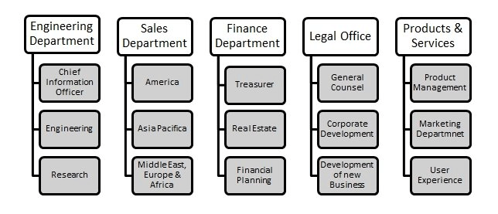
Source: (Jarrahi et al., 2023)
Meanwhile, the executive administration group of the firm reports to the BOD and accepts direct reports from every department head of Google (Nupap, 2022). Consequently, the smaller business sections are enabled to foster and develop new items within the massive organization. The multidivisional corporate structure of an enormous corporation namely, Google, simplifies its centralized planning. Nonetheless, the company was incorporated with the main aim of organizing and enabling the world with helpful and easily accessible information as well (Rashid et al., 2021). Therefore, the company has developed its corporate culture of value for its people to meet its pre-determined objective. Further mentioned before, the revenue or earning of Goggle generates from several sources that only market on YouTube and different alternative advertisements. Further, the company also catches its huge earnings through several other websites such as Google Maps, Gmail, and so on. On the contrary, Google is to be considered the world's greatest search engine. Its primary sources of earnings are licensing, ads, hardware sales, etc. More addition to this, the primary source of income of the company also consists of its advertising sector (Valeri, 2023). Likewise, Google has AdSense, DoubleClick, AdExchange, etc, which give greater allowance to marketers to effectually manage their digital marketing campaigns.
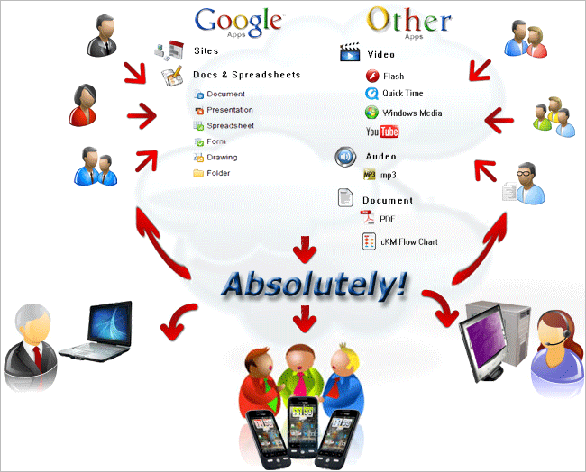
Source: (Chen et al., 2022)
KM (Knowledge management) methods enable businesses to effectually accomplish their competitive advantages with the help of organizing the immense range of data currently accessible (Jarrahi et al., 2023). About Google's KM system, the company makes its offerings in more than 91 languages in more than 47 countries, regions, and territories throughout the globe. The firm assimilates a range of characteristics or features in advertising and search services as well. Additionally, the company also enables aid users with dedicated search services. It further gives good-listing ads, which considered reasonable product information, such as merchant information, price, product image, etc without considering any extra keywords. More adding before, Google initiated Search plus Your World in the year 2012 and afterward launched different products. These are referred to as Google Now, Google's Knowledge Graph, and so on (Rashid et al., 2021). Further introduced before, an additional major component of the company's administration approach is its enhancing reputational capital. As one of the well-known and leading technological organizations, the company has refined its reputation for commercial as well as technological competence, by fostering persistent innovation of its products and services. As a result, the reputation of Google exercises a potent impact on the community’s preferences and expectations for upcoming services of the organization (Barnes, 2020).

Participants, Both in Contribution and Collection of Knowledge
In the KM system, Google mainly focuses on identifying candidates who take active participants in the contribution and collection of information (Valeri, 2023). The Company may bring the project or its completion with the support and resources of the firm. To become successful, Google mainly focuses on identifying which KM system helps to attain the project's success. Google focus on stakeholder who takes active participation in knowledge management for underlying growth. Some major participants in Knowledge management are:
- Customer: It focuses on knowledge of products or services to fulfill the demand effectively. The Company focuses on understanding the distinct types of attitudes, behavior, and expectation of a firm (Jarrahi et al., 2023). Google also conduct a live session with the client to understand their contribution toward organizational enlargement. Additionally, the firm focus on the recipient of the customer who is an internal participant, and the potential barrier to reaching the outcome.
- Employees: Google mainly focuses on the collection of information for employee satisfaction surveys and its usefulness for organizational enhancement (Nupap, 2022). The Company focuses on knowledge flows within the premises and conducts a workshop to polish their knowledge for better growth in personal as well as professional life. Google offer group-based work that helps to avoid barrier after the successful implementation of the KM system (Dwivedi et al., 2020).
- Senior Manager: Group members of Google focus on a strategic perspective that direct overcomes challenges (Tiwari, 2022). The Company mainly focus on the knowledge of manager to make the right decision and also compete in the marketplace. Google conducts motivational activities that help with the implementation and change management aspects of the KM system.
- Functional Support Manager: Nowadays, Google functional units require essential knowledge for smooth operation activities (Rashid et al., 2021). The Company mainly focuses on inputs has a key influence on the KM program for a better outcome. Google's functional department includes HR, IT, and training from finance to support another department for KM projects.

Knowledge Management Approaches
In the development of technology, the Manager of Google focuses on designing the platform to share essential information for organizational enlargement (Valeri, 2023). The Company mainly focus on effectively organizing the information and share with other to take the right decision. Knowledge management approaches help to manage the immense amount of information available within the firm. Google's business focused on vital areas such as promotion, search, operating activities, and systems for the distribution of products or services (Nupap, 2022). In changing situations, Google offers services and products in distinct languages to modify the search to gain a competitive edge. The Company mainly focuses on discussing two main KM approaches for the management of available information are:
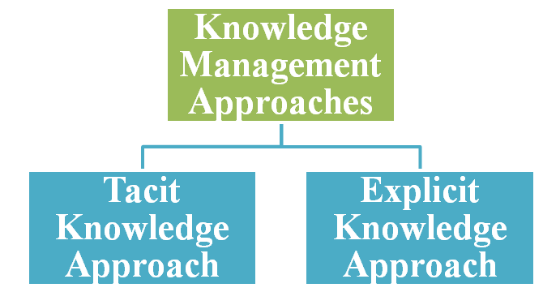
Source: (Jarrahi et al., 2023)
- Tacit Knowledge Approach: This approach has some outstanding features regarding personal knowledge creation, and is unmanageable to deduce from the use of a single person (Martins et al., 2019). In a competitive environment, Google mainly focuses on functioning from the site of knowledge inherent and a large amount of tacit. This approach includes public exposure attained by the transfer of people as knowledge carriers (Dwivedi et al., 2020). Within the firm, the manager of Google mainly focuses on knowledge processed with multiple people to manage the activities smoothly. Google focuses on communication channels to transfer their knowledge to another branch and generate new information to fulfill organizational needs. In this approach, Google focus on enhancing knowlegde who knows to fulfill the requirement of the firm. For instance, the tacit knowledge of Google is mainly spread within the organization for the completion of tasks. In this method, Google focuses on the preparation of production reports with large amounts of data in new factories for organizational effectiveness.
- Explicit Knowledge Approach: It is something used by a single person and helps to effort to express their opinion for organizational welfare (Tiwari, 2022). This approach helps an individual to express their opinion, feeling, attitude, and view that process the knowledge assets. With the use of an explicit knowledge system, Google help to prepare manuals, document, standard procedure, and drawing information to reach the outcome. This approach helps Google to experiment with and structured learning process to solve the inadequacies of the firm (Ahmad and Karim , 2019). The Company mainly focuses on planned partnering to observe the special knowledge and growth by effective knowledge assets. For instance, Google focus on designing new manuals developed by experts at the managing level and completing the project within the estimated timeframe.

The Incentives to Participants on KM Activities and its Importance
Through sharing of knowledge, the KM system of Google offer incentive to participants and contributors to manage the activities effectively (Nupap, 2022). The Company pays attention toward maintained a bond with the employer when they give something in return. Google motivates its employees to share their knowledge and experience with the team for organizational success. Google offers an awesome package and directs their offering for employees' contributions and participation in KM activities. Google aims to create the happiest working environment for employees including unique office premises, rules, and a wide array for organizational enhancement (Martins et al., 2019). The Company looking toward talent well-being, and positive work culture to enhance job satisfaction. Some incentives offered to participants in KM activities with its essential is discussed as under:
- Healthcare Benefits: The Company offers its employee medical facilities to those who participate in the KM system and customers comprehensive medical coverage (Jarrahi et al., 2023). Google focuses on health insurance, basic vision, dental care, and other facilities to improve the attention of participants in KM activities. This onsite facility of medical for the participant is important for those working within the premises (Antunes and Pinheiro, 2020).
- Work-life Balance: Google mainly focuses on offering a variety of learning and development program that helps to attain a good work-life balance (Singh et al., 2023). The Company encourages employees through benefits to taking active participation in KM activities to complete the project within time. Google always welcomes renowned professionals for seminars and conferences continuingly for future success.
- Retirement Benefits: For the financial well-being of employees, the Manager of Google focuses on financial incentives and retirement benefits to keep them happy while engaging in knowledge management activities (Tiwari, 2022). The Company always decide to keep their participant happy and offer the best compensation package for employee enhancement.
- Fitness Facility: The Company focuses on the development of a fitness center nearby every office to improve participation in knowledge management (Nupap, 2022). Google has developed a great way to encourage people while working out as proven and relieve stress within the firm. The Company offers gym membership to their participant in KM activities for organizational growth.

Potential Challenges and Opportunities associated with Knowledge Management system
Opportunities
Well-established knowledge management can give the greater edge to improve their overall performance and efficiency as well as significant information is easier to access, enhanced knowledge sharing, better collaboration, derive cultural and financial opportunities, and so on. Furthermore, one of the popular benefits of well-established KMS is fewer instances spent to again document existing knowledge (Sahoo et al., 2023). It allows people in companies to redirect their performance towards more meaningful and useful work. With greater access to expertise and knowledge as well, employees of the organization can able to share crucial information effectually and drive better outcomes. Well-established KMS also helps team individuals of the company to commit fewer grievances as well as successfully share critical information in their workplace and across the enterprise. Further mentioning it, this can lead to several further benefits to the firm towards improving its overall progress and accelerated cycles of innovation over every department (Martins et al., 2019). Additionally, an effectual KM system can further assist the company to enhance the greatest standards of its trade practices and functioning. Such as superior-level decision-making progress when the superiors of the organization are less wasting of their time and properly seeking accessible information over every department of the company.
Challenges of Knowledge Management
- Lack of employee motivation- Personnel or the workforce of the company can feel overwhelmed with the systems and procedures they are persistently forced to via just to maximize their efficiency and work (Ode and Ayavoo, 2020). It may lessen their morale to maximize their efforts and efficiency in their work surrounding and they are de-motivated as well.
- Technology overkill- Another potential drawback that may associate with KMS is it can be very difficult for companies’ personnel to focus on their core roles or duties when they need to make an update in a system on a persistent basis (Singh et al., 2023). They begin to experience the inception of technology fatigue in their workplace.
- Making sure knowledge contributions are accurately measured- Some knowledge that can derive through KMS is helpful or useful, nonetheless, all information is not created equal (Tiwari, 2022). Considering this, it is to be referred to as one of the major drawbacks of using the KM system. It is not easy for businesses to easily quantify all relevant knowledge as it originates from varying human experiences as well as from varied data.

Identify New Sources of Knowledge

Google mainly focuses on the development of a knowledge panel with information boxes for entities to fulfill the knowledge gap (Sahoo et al., 2023). The Company finds out new sources of knowledge to get quick snapshots for a better understanding of available content on the web. In changing situations, the Manager of Google always focuses on the generation of content and information with a knowledge panel to meet the requirement of the firm. The Company maintains a strong connection with data partner who provides authoritative data based on specific topics to understand the content available on site. Moreover, Google is mainly dependent on a variety of sources to compile factual information to meet the demand.
In addition, the firm focuses on public sources with license data to provide information like sports scores, and weather forecasts to fulfill the requirement of information on the premises. Google offers factual infromation direct collected from the owner and makes a suggestive change to fulfill the participant's requirement (Ode and Ayavoo, 2020). The Company focuses on the process of searches per day and automation to handle the searches. With automation, Google mainly focuses on enhancing the automated system, and search algorithms. Google always try to search a large amount of system for reporting to a higher authority. The Company mainly focus on finding out new sources of knowledge for effective management are:
- Insight from Google: In the digital era, Google also focuses on accessing information with AI and machine learning. In the world, the Company offers essential data that help to manage the everyday life of people and businesses as well. It is the Popular Times feature of Google to access information from crowded places and visit the local grocery stores to complete the task. In changing situation, the Manager of Google focused on technology development during the pandemic to improve organizational enhancement. Google insight helps people to crowdedness into account and better customer experience. In a simple way, the firm focus on a wide range of information that helps to understand its relevance and actual use it. AI helps to estimate flood forecasting and another disaster that help people to stay safe and also helps the participant in knowledge management systems.
- Partnership with Authoritive Information: The Company mainly focuses on the collection of information in form of words, phrases, and web pages (Singh et al., 2023). Google focus on an automated system with lots of easier for the system, organize and present for organizational growth. In changing situations, Google maintains partnerships with authorities who access confidential information with permission. The Company must license data to deliver quality information to candidates within and outside the firm. Google always tries to access reliable, authentic, and relevant information that helps to take the right decision for organizational enlargement (Tiwari, 2022). Every one focus on Google to search for relevant information and access it in the right manner.

Operating Costs and Legal Requirements will be managed
Google mainly focuses on an estimated $3000 to $18000 depending on the service provider and level of service for organizational effectiveness (Abdulmuhsin et al., 2021). The Company mainly focuses on knowledge management for quality service to accomplish the desired outcome. Google always focuses on the fastest, cheap, and easy to spam for organizational enhancement. Google Knowledge Panel's main aim is to educate people to do and target the attention of the audience. The Company focuses on maintenance work to keep up with evolving digital ecosystem and Google changes update. Google focuses on knowledge panels free to charge automatically and are quite accurate for organizational development (Singh et al., 2023). The Knowledge Panel to make sure facts and figures with clear understanding and confidence for better growth in the enhancement for better success.
Google spammers are hard with long-term memory and forgive memory for organizational enhancement. The Company trigger and manage the educating people and audience to fulfill the demand of customer (Sahoo et al., 2023). Google Cloud Compliance needs to validate with documentation, and certification, and control the activities to meet the client demand. To deal with the changing environment, Google focuses on share mapping and compliance control standards from around the world (Antunes and Pinheiro, 2020). The Company mainly focus on the legal requirement of privacy legislation to manage the information discussed as under:
- General Data Protection Regulation: GDPR is a privacy legislative that is replaced to manage organizational enhancement. The Company focus on the specific requirement of business and establish to manage the information collected at sources (Tiwari, 2022). Google follows GDPR to collect, use and store personal information to manage the information effectively. The Company focuses on current documentation, and reporting needs to increase accountability.
- Data Processing Agreement: The Company mainly focuses on Google workshop and cloud to commit to potential clients. Google involved feedback from the customer and regulations to fulfill organizational needs (Chen et al., 2022). The Company focuses on facilitating our customer complaint assessment and readiness to improve the experience. Google offers confidential passwords to employees to complete the mandatory work and respect the attitude who know better growth.

Promote KM System and Beware of this System
Google mainly focuses on the knowledge management system process from one person to another. The Company focuses on sharing knowledge to increase organizational productivity and empower employees to reach the outcome (Ode and Ayavoo, 2020). Google's focus on strategies to promote and awareness of the KM system are:
- Encourage Knowledge Sharing: Google employees feel happier and help others to enhance their overall development (Abdulmuhsin et al., 2021). The Company finds it hard to share information across distinct teams. It leads employees only to share knowledge with their closest colleagues. Google has developed sharing culture to fulfill the requirement of the employees.
- Sharing Activities: To encourage people, Google mainly focuses on knowledge management systems to boost employee engagement (Chen et al., 2022). The Company always shares the outcome for better satisfaction results. Google focuses on finding out multiple ways to share information right decision.
- Formalize the management Process: The Company mainly focuses on formalizing the management process to increase awareness and contribute toward development. Manager of the KM system helps to reduce the risk and keep innovating (Antunes and Pinheiro, 2020). Managers of Google focus on intelligence and create a process for firm enhancement. Google always select the best platform and location to fulfill the requirement of professionals.

Conclusion
In conclusion, the report has analyzed the knowledge management system with its essentials toward Google. The report has evaluated the contribution of participants toward the management of the knowledge system. It has examined the KM approaches to identify the candidate's potential for future success. The report has analyzed the operating cost and legal requirements to manage the activities to reach the outcome. It has discussed the challenges and opportunities to maximize the KM system and support of stakeholders to become successful. The report has identified the incentives offered by Google to improve the Knowledge project.

Reference List
Abdulmuhsin, A.A., Zaker, R.A. and Asad, M.M., 2021. How exploitative leadership influences on knowledge management processes: the moderating role of organisational citizenship behaviour. International journal of organizational analysis, 29(3), pp.529-561.
Ahmad, F. and Karim, M., 2019. Impacts of knowledge sharing: a review and directions for future research. Journal of Workplace Learning.
Antunes, H.D.J.G. and Pinheiro, P.G., 2020. Linking knowledge management, organizational learning and memory. Journal of Innovation & Knowledge, 5(2), pp.140-149.
Barnes, S.J., 2020. Information management research and practice in the post-COVID-19 world. International Journal of Information Management, 55, p.102175.
Chen, Y., Luo, H., Chen, J. and Guo, Y., 2022. Building data-driven dynamic capabilities to arrest knowledge hiding: A knowledge management perspective. Journal of Business Research, 139, pp.1138-1154.
Dwivedi, Y.K., Hughes, D.L., Coombs, C., Constantiou, I., Duan, Y., Edwards, J.S., Gupta, B., Lal, B., Misra, S., Prashant, P. and Raman, R., 2020. Impact of COVID-19 pandemic on information management research and practice: Transforming education, work and life. International journal of information management, 55, p.102211.
Jarrahi, M.H., Askay, D., Eshraghi, A. and Smith, P., 2023. Artificial intelligence and knowledge management: A partnership between human and AI. Business Horizons, 66(1), pp.87-99.
Martins, V.W.B., Rampasso, I.S., Anholon, R., Quelhas, O.L.G. and Leal Filho, W., 2019. Knowledge management in the context of sustainability: Literature review and opportunities for future research. Journal of cleaner production, 229, pp.489-500.
Nupap, S., 2022, January. Knowledge management system by applying knowledge creating company: transforming tacit to explicit knowledge. In 2022 Joint International Conference on Digital Arts, Media and Technology with ECTI Northern Section Conference on Electrical, Electronics, Computer and Telecommunications Engineering (ECTI DAMT & NCON) (pp. 439-444). IEEE.
Ode, E. and Ayavoo, R., 2020. The mediating role of knowledge application in the relationship between knowledge management practices and firm innovation. Journal of Innovation & Knowledge, 5(3), pp.210-218.
Rashid, A.S., Tout, K. and Yakan, A., 2021. The critical human behavior factors and their impact on knowledge management system–cycles. Business Process Management Journal, 27(6), pp.1677-1702.
Sahoo, S., Kumar, A. and Upadhyay, A., 2023. How do green knowledge management and green technology innovation impact corporate environmental performance? Understanding the role of green knowledge acquisition. Business Strategy and the Environment, 32(1), pp.551-569.
Singh, A., Kukreja, V. and Kumar, M., 2023. An empirical study to design an effective agile knowledge management framework. Multimedia Tools and Applications, 82(8), pp.12191-12209.
Tiwari, S.P., 2022. Knowledge Management Strategies and Emerging Technologies--An Overview Of the Underpinning Concepts. arXiv preprint arXiv:2205.01100.
Valeri, M., 2023. Trends in knowledge management research in small businesses. European Business Review, (ahead-of-print).

