

LCMB7024
ASSIGNMENT-1
COURSE: MBA MARKETING MANAGEMENT
TITLE: PIONEER VS. FOLLOWER STRATEGIES: EVALUATING MARKET ENTRY APPROACHES AND PRODUCT LIFE CYCLE MANAGEMENT FOR BUSINESS SUCCESS [ASSIGNMENT 1]
STUDENT NAME: KHUSHI PATEL
STUDENT ID: 2416327
LECTURER NAME: JAYALAKSHMI GOPALKRISHNA
TERM: FEBRUARY 2025



Table of Contents

Introduction 3
1a. Advantages of being a pioneer and follower company 3
Definition of pioneer 3
Advantages of being a pioneer with examples 3
One detailed example of a successful pioneer company 5
Definition of follower 6
Advantages of being a follower with examples 6
One detailed example of a successful fast follower company 7
1b. Impact of product life cycle strategies to increase the growth of the pioneer and follower companies 8
Definition of product lifecycle model 8
Diagram of the model 8
Description and examples of PLC strategies in the growth stage of model 9
Description and examples of PLC strategies in the maturity stage of the model 12
Advantages and disadvantages of the model 13
Conclusion 14
References 15



Introduction
As per the definition of strategic marketing, the dynamics of market entry and product evolution are effective for business success. The strategic marketing process explores the opportunities of being a pioneer versus a follower in the market, highlighting how each strategy impacts brand recognition, market share, and profitability. Pioneers, such as Coca-Cola and Tesla, often establish appropriate brand leadership and create industry standards, while followers, such as Samsung and Google, leverage existing market demand and maintain the product's refinements. Moreover, the product life cycle (PLC) model, with its stages of introduction, growth, maturity, and decline, provides a framework for understanding and strategizing product development. This paper will examine PLC strategies, specifically defensive and attack strategies in the growth stage and extended use and increased penetration strategies in the maturity stage, using real-world examples to illustrate their effectiveness.

1a. Advantages of being a pioneer and follower company

Definition of pioneer
The pioneering concept in the business field is associated with renewing or creating new products, services, technologies, and ideas that rank an organisation among the most successful in the dynamic market (Deshmukh and Tare, 2024). Pioneers mostly look for gaps in the market where new opportunities exist to improve on current industry offerings.

Advantages of being a pioneer with examples
- Strong brand recognition and market leadership: Being first in the market allows pioneer companies to establish strong brand recognition that makes it synonymous with a product or service category (Bombiak, 2023). Consumers most frequently associate pioneer brands with innovation and trust. For example, Coca-Cola was the first soft drink brand in the market that secured a dominant market share and became one of the most reputed global brands. As of 2024, the firm has acquired 40% of the global non-alcoholic beverage market, which is higher than other brands like PepsiCo and Nestle (Slack, 2024). Moreover, in 2024, the net revenue of the firm increased 6% to $11.5 billion with an


operating margin of 23.5% in Q4, higher than the previous year (The Coca-Cola Company, 2025).
- Capability to set industry standards and pricing power: Pioneer companies have the core advantage of defining the product standard and influencing market expectations eventually. They also have the scope to set premium pricing due to the absence of any such direct competition. As an example, focus can be provided on Tesla as the firm was the early mover in the EV (Electric Vehicle) industry and set certain standards for charging infrastructure, and autonomous driving, along with a premium price. The Model Y of Tesla is a premium product that sells in the USA with a starting price of $61,630. Even with the high price range, in 2024, the Model Y was the best-selling EV in the USA with sales of 373,000 units (Forbes, 2025). However, the next closest competitor of the model was the “Ford Mustang Mach-E” with a total sales unit of 51,745. With the demanding product and high customer preference, Tesla has been able to secure a market share of 18% in 2024

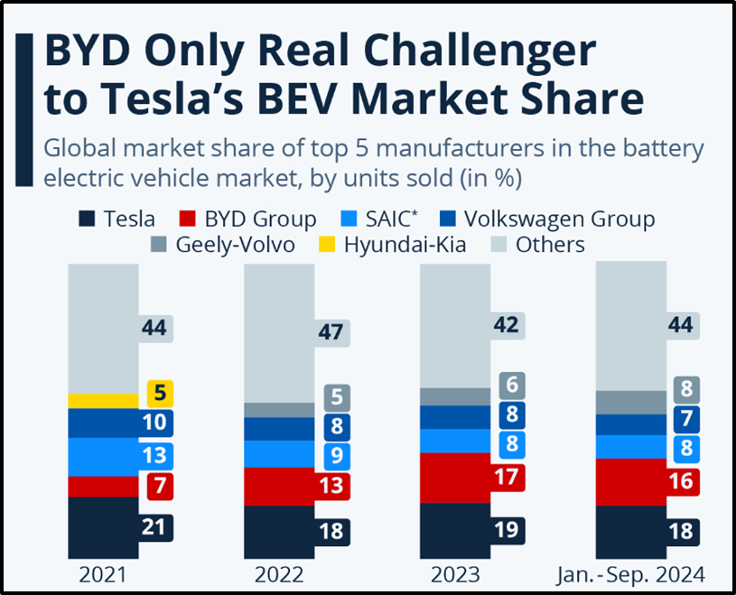

worldwide, although it has a direct competition, BYD Group, with a market share of 16% (Figure 1).
Figure 1: Global market share of the top 5 manufacturers in the battery EV market
(Source: Statista, 2025)
- Fast-mover advantage: Pioneers are also capable of gaining easy and early access to the market share along with consumer loyalty before the competitors enter the market.

One detailed example of a successful pioneer company
As a successful pioneer company, focus can be provided on Amazon as the firm initially was an online bookstore, whereas it disrupted traditional retail by leveraging the internet’s potential effectively. The brand pioneered e-commerce and transformed the way of consumer shopping. From the below figure, it has been observed that the total share of retail e-commerce sales for computer and consumer electronics was 49.6% in 2024 and for office equipment, it was 46.2%,

higher than the previous year (Statista, 2025). Moreover, for health and personal care, the share of sales was 34.7%, as well, which indicates that Amazon is capable of establishing itself as a dominant force in the e-commerce industry.
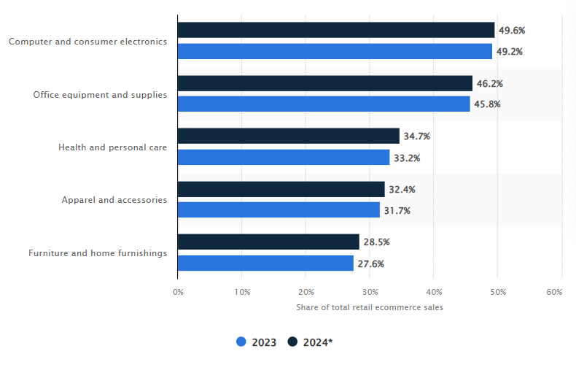
Figure 2: The share of total e-commerce sales of Amazon in the USA in 2023 and 2024 by product category
(Source: Statista, 2025)
The relentless focus of Amazon on consumer experience, aligned with continuous innovation, ensures to expansion its market in diverse sectors. The total research and development expenses for 2024 of Amazon have been identified as US$88.544 billion, which was a 3.4% increase from the previous year (Macrotrends, 2024). Hence, with a strong innovative mindset, Amazon is capable of managing its market position till now even after the presence of multiple competitors.

Definition of follower
A follower is not a leading company in a particular market, but it chooses to keep its position rather than competing in a forceful way for increasing the market share (Dreiling and Bican, 2022). A follower company can also be considered as a second market leader within a particular industry that wants to hold its market share without upsetting the status quo.

Advantages of being a follower with examples
- Lower risk and reduced cost structure: Follower companies get the scope to avoid high cost structure related to market education, R&D, and trial-and-error faced by pioneers (Maslach et al., 2024). For example, Samsung in the smartphone market is a prime example of a follower, where Apple pioneered the modern smartphone, and by developing certain features, Samsung is now quite popular. For example, in 2024, Samsung shipped more than 52 million smartphones, which is a little bit lower than the previous year, whereas it is able to place itself among the top 3 smartphone vendors throughout the world after Xiaomi and Apple (Statista, 2025). Moreover, as per the survey of American Customer Satisfaction Index, Samsung achieved #1 customer satisfaction and #1 overall service quality among 5G mobile devices, which indicates its high demand in the market (Samsung, 2024).
- Improved products and services: By keeping focus on pioneers, follower companies can refine their existing products by addressing consumer feedback, and are well aware of limitations (Maslach et al., 2024).
- Established market demand: Follower companies enter the market when the demand is proven and quite high, which helps to reduce uncertainty and the need to educate consumers. For example, Facebook studied the existing weaknesses of MySpace and introduced a more convenient and scalable social networking platform. It has been identified that Facebook took the highest position with 3065 million monthly active users worldwide, which denotes its rapid use among people even after the presence of several social networks (Figure 3).

Figure 3: Most popular social networks as of April 2024 worldwide
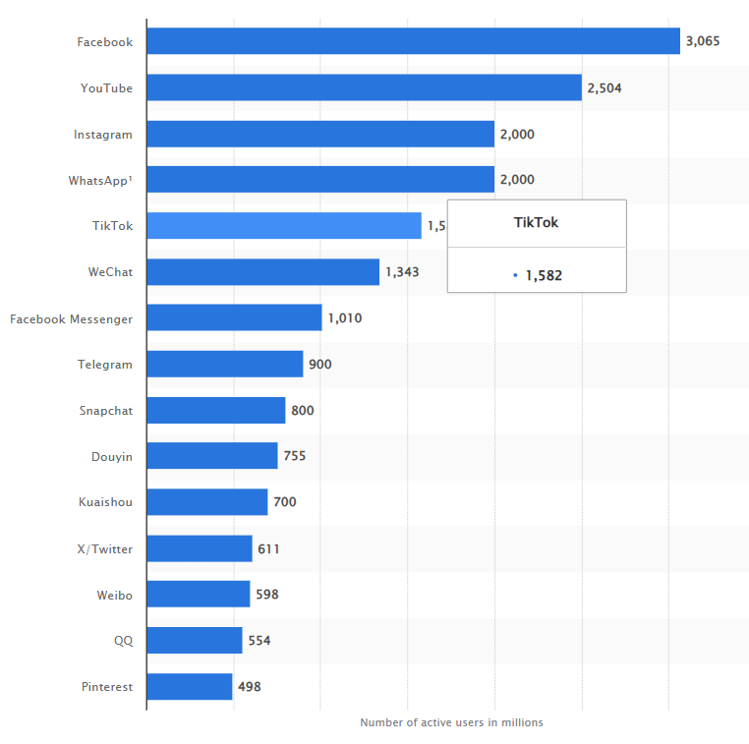
(Source: Statista, 2024)

One detailed example of a successful fast follower company
Google can be considered as a major example of a successful fast follower company, as when it entered the market, there were other search engines already like Yahoo. However, by using a

superior algorithm, PageRank and other advanced features, Google established itself as the main search engine in today’s world. It processes over 99,000 searches per second with more than 8.5 billion search queries each day (Pangarkar, 2025). Therefore, through advanced perceptions and effective follower strategy, Google outperformed the other search engines easily.

1b. Impact of product life cycle strategies to increase the growth of the pioneer and follower companies

Definition of product lifecycle model
The product lifecycle model defines a product's stages, from its initial introduction to the market until it is eventually withdrawn. As mentioned by Rusch et al. (2023), the main importance of the product life cycle model is maintaining organisation’s circular economic strategies. Another purpose of the product life cycle is to introduce the new products in the marketplace and, after that, develop the growth and maturity of the products.

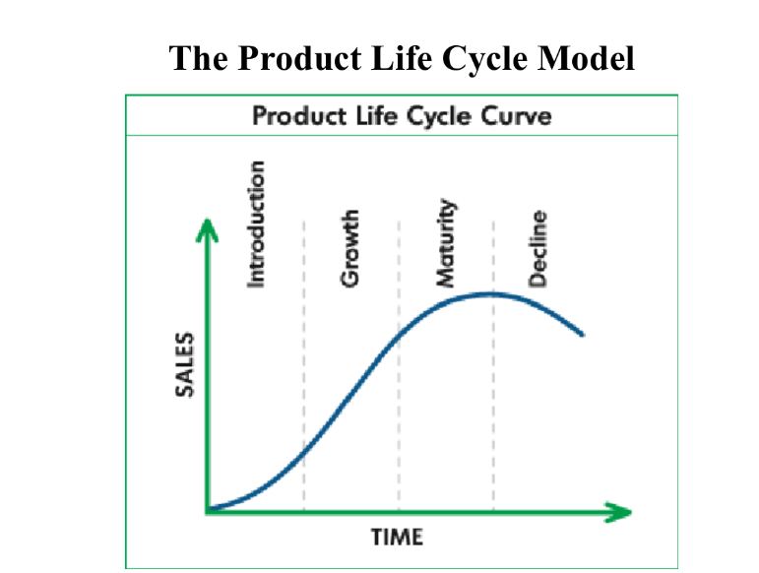

Diagram of the model
Figure 4: Diagram of product life cycle model
(Source: Lecture 6, slide 4)
In the context of the abovementioned image, the Product Life Cycle Model shows sales over time. The four main stages of the model are Introduction, Growth, Maturity, and Decline. These stages are illustrated by a curve rising and then falling, representing the product's lifespan. As opined by Chen et al., (2022), the key importance of the growth stage of the PLC strategy is to increase the production capacity rapidly. Apart from this, the key significance of the maturity stage is to maximise profitability and defend market share by innovation and diversification to extend the product's lifespan. It has been identified that the competition, promotion, distribution, pricing and market information of the products are changed and evaluated through the product life cycle model (Lecture 6, slide 3).

Description and examples of PLC strategies in the growth stage of the model
In the Product Life Cycle (PLC) model, the growth stage is crucial to improve rapid market acceptance and increase profits. The organisations employ different strategies during this phase to maximise market share and establish a strong competitive position. The growth strategies are described below:
Defensive strategies
- Flanker strategy: The Flanker Strategy is crucial to introduce a new product or brand into a market segment where the company does not currently have a strong presence, aiming to capture a different customer base and protect the main brand from competitors. As mentioned by Hudes (2024), the key effectiveness of the flanker strategy is to increase product quality and consumer satisfaction. This is why the market power is maintained properly. Apart from this, the second product is introduced through the strategy to protect the main product in the market. As per the example, Samsung has employed this particular strategy to introduce the Galaxy A series in the market. Through this strategy, the organisation has targeted the mid-range market segment, complementing its flagship Galaxy S series.

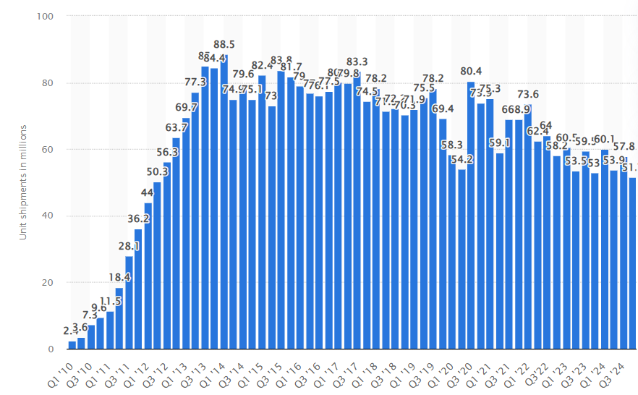
Figure 5: Sales rate of Samsung
(Source: Statista.com, 2025)
In 2022, the worldwide sales rate of Samsung was 58.2 million and the organisation sold more than 2 million Galaxy A series smartphones in India within 40 days, generating a revenue of $500 million (Tech.hindustantimes.com, 2025). After the application of this strategy, the Galaxy A series accounted for 58% of Samsung smartphone sales (Gizchina.com, 2025). Therefore, the success of the organisation is developed.
- Position defence strategy: Position defence strategy entails expanding a company's product line by adding new products or services that are closely related to existing ones, leveraging current expertise and resources. As opined by Wambui and Kavale (2022), this strategy is crucial as it helps to develop the business performance of the firms by 45.6%.

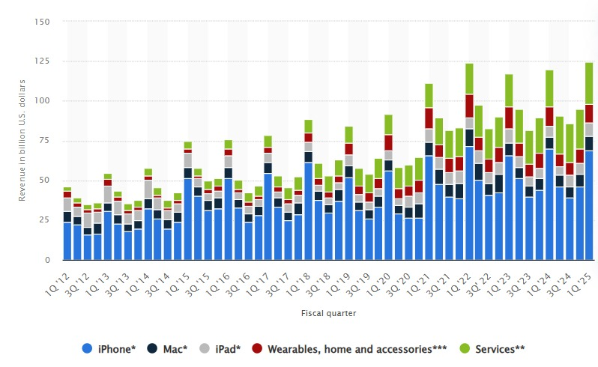

Figure 6: Revenue of Apple
(Source: Statista.com, 2025)
For instance, Apple diversified into consumer electronics through this strategy and introduced products such as the iPod, iPhone, and iPad. This position defence strategic move transformed Apple into a leading technology company with a revenue of $394 billion (Statista.com, 2025).
Attack strategies
- Frontal attack strategy: This particular strategy involves a challenger directly confronting the competitor by matching or surpassing their offerings in areas such as product quality, pricing, distribution, and marketing efforts. As opined by Olson et al., (2021), the key essentiality of this particular strategy is to identify the proper market trend, and this is why the product sales rate is maintained.

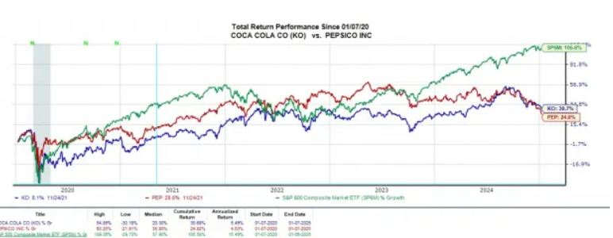

Figure 7: Total return performance of Coca-Cola and PepsiCo
(Source: Finance.yahoo.com, 2025)
As per the example, it has been identified that PepsiCo has engaged with the frontal attack strategy against Coca-Cola by offering similar products and investing in marketing campaigns to position itself as a direct alternative. In this context, the proper investment level of PepsiCo increases the sales rate by $94.8 billion, whereas the sales rate of Coca-Cola is $48.02 billion after investing heavily (Finance.yahoo.com, 2025). Therefore, these companies have competed head-to-head in various markets, continually innovating and adjusting strategies to capture consumer preference.
- Encirclement Attack Strategy: An encirclement attack is effective to involve a challenger targeting a competitor from multiple fronts. This strategy is offering a wide range of products or services to encroach upon the market share of competitors. The main effectiveness of the strategy is to identify superior resources of the challenger and aims to overwhelm the competitor by addressing various customer needs simultaneously (Irmak et al., 2023). For example, Seiko has engaged with the encirclement attack strategy, and after the implementation of the strategy, the organisation offered 400 models in most markets and a total of 2,300 models worldwide (Plus9time.com, 2025).

Description and examples of PLC strategies in the maturity stage of the model
In the maturity stage of the product life cycle model, the sales growth of organisations is slowed, and competition with other marketers is intensified. The two strategies of the maturity stage are described below:
Extended use strategy: The extended use strategy is crucial to encourage the existing customers to use the product more frequently or in new ways. The main aim of the strategy is to enhance the product value and utility for the present users. Through the implementation of the strategy, the sales rate of the organisations is boosted, which extends the lifespan of the products. For instance, Colgate-Palmolive has extended the use of toothpaste after the promotion of its use for whitening teeth in addition to its primary function of cleaning.
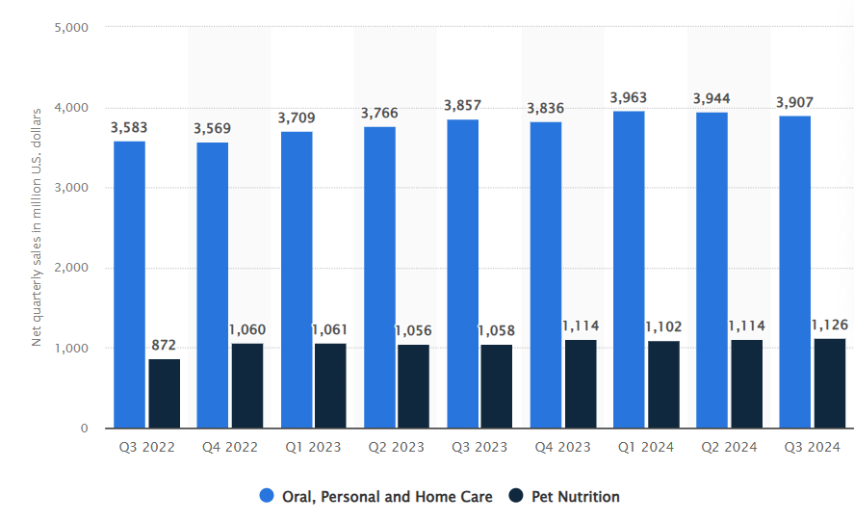
Figure 8: Net sales of Colgate-Palmolive
(Source: Statista.com, 2024)

This specific strategy helps to increase the market share rate of the company from 35.7% in 2014 to 42.1% in 2024. The sales rate of the organisation is developed by 3907 million in the year 2024 (Statista.com, 2024).
Increased penetration strategy: The increased penetration strategy is defined as a process that helps to expand the market share rate of products within the existing market. This strategy creates some tactics, including competitive pricing, enhanced promotions, and improved distribution channels. As per the example, Netflix applied aggressive market penetration strategies to develop the market domination process in the streaming industry. After the maintenance of competitive pricing, investing heavily in original content, and utilisation of data-driven personalized recommendations, Netflix expanded its subscriber base significantly. Through the implementation of the penetration strategy, the subscriber number of the company is developed by 301.63 million, and the revenue rate is increased by $39 billion in 2024 (Businessofapps.com, 2025).

Advantages and disadvantages of the model
The both advantages and disadvantages of the product are described below:
Advantages
- The PLC model helps organisations to improve the strategic planning to operate the marketing strategies properly. The pricing, production strategies and resource allocation optimisation are maintained through this particular advantage.
- Another advantage of this product life cycle model is to maintain the sales trend, demand and profitability for the betterment of the budgeting and inventory control (Okeke et al., 2024).
- In the context of this particular model, the innovation and rebranding process of the organisations are maintained after understanding the maturity or decline stage.
Disadvantages

- The main disadvantage of the model is related to the limited use of high-quality products. Products with extended lifespans, such as Coca-Cola, may not fit the linear progression of this model.
- The specific model product life cycle does not account for external influences such as financial shifts, regulatory changes and technological advancements (Triguero et al., 2022).
- Another disadvantage of the model is related tp the odentification of the difficult stages. It has been identified that the determination of the extract stage of the product is challenging, and this leads to the potential miscalculations in strategy.

Conclusion
In this study, it has been concluded that the entire discussion comprehensively explores pioneer and follower advantages, detailing strategies in the Product Life Cycle's growth and maturity stages. In the study, the proper examples with data and citations are also provided. Based on the discussion, the models are highlighted to identify the strategic importance and limitations in dynamic market conditions.

References
Bombiak, E., 2023. Effect of green intellectual capital practices on the competitive advantage of companies: evidence from polish companies. Sustainability, 15(5), p.4050.
Businessofapps.com, 2025. Netflix Key Statistics. Available at: https://www.businessofapps.com/data/netflix-statistics/ [Accessed on: 12.03.2025]
Chen, J., Wang, H. and Fu, Y., 2022. A multi-stage supply chain disruption mitigation strategy considering product life cycle during COVID-19. Environmental Science and Pollution Research, pp.1-15.
Deshmukh, P. and Tare, H., 2024. Green marketing and corporate social responsibility: A review of business practices. Multidisciplinary Reviews, 7(3), pp.2024059-2024059.
Dreiling, A. and Bican, P.M., 2022. Pioneer or follower: Which strategy to choose?. In The Routledge companion to technology management (pp. 100-115). Routledge.
Finance.yahoo.com, 2025. Coca-Cola Vs Pepsi Stock: Which is the Better Buy for 2025?. Available at: https://finance.yahoo.com/news/coca-cola-vs-pepsi-stock-235600173.html?guccounter=1&guce_referrer=aHR0cHM6Ly93d3cuZ29vZ2xlLmNvbS8&guce_referrer_sig=AQAAAKmbzJyFgAW42U9D5aDP6LwSenN45oI9qCmyzTGIZLzhJbKo_w85ds_ry3a6GPA1RSgw3q68aN3yN-SkLK6OmpjwkKWUyy7-_VR5_yuMbbXdBhCUt3EyKplIUbN-Guo8FeejhWy2Z9l4WfeVHOHgE15SDSpMA3ezMLTY61lGuG2l [Accessed on: 12.03.2025]
Forbes, 2025. Tesla Delivers First New Model Y ‘Juniper’ To Customers At Gigafactory. Available at: https://www.forbes.com/sites/brookecrothers/2025/03/08/tesla-delivers-first-new-model-y-juniper-to-customers-at-gigafactory/ [Accessed on 12/03/2025]
Gizchina.com, 2025. Samsung Galaxy A series accounts for 58% of Samsung smartphone sales in 2021. Available at: https://www.gizchina.com/2022/03/23/samsung-galaxy-a-series-accounts-for-58-of-samsung-smartphone-sales-in-2021/?utm_source=chatgpt.com [Accessed on: 12.03.2025]

Hudes, K., 2024. Exploring Market Dynamics: Canada’s Flanker Brands and American MVNOs. Available at SSRN 4913531.
Irmak, E., Kabalci, E. and Kabalci, Y., 2023. Digital transformation of microgrids: a review of design, operation, optimization, and cybersecurity. Energies, 16(12), p.4590.
Macrotrends, 2024. Amazon Research and Development Expenses 2010-2024 | AMZN. Available at: https://www.macrotrends.net/stocks/charts/AMZN/amazon/research-development-expenses#:~:text=Amazon%20annual%20research%20and%20development,a%2030.62%25%20increase%20from%202021/ [Accessed on 12/03/2025]
Maslach, D., Rousseau, H. and Lamont, B., 2024. Pioneer Learning From Failure: How Competitor Entry and Consumer Reports Improve Learning From Failure Repositories. Journal of Management, p.01492063241303059.
Okeke, N.I., Bakare, O.A. and Achumie, G.O., 2024. Forecasting financial stability in SMEs: A comprehensive analysis of strategic budgeting and revenue management. Open Access Research Journal of Multidisciplinary Studies, 8(1), pp.139-149.
Olson, E.M., Olson, K.M., Czaplewski, A.J. and Key, T.M., 2021. Business strategy and the management of digital marketing. Business horizons, 64(2), pp.285-293.
Pangarkar, T., 2025. Google Search Statistics 2025 By Algorithm, Results, Growth. Available at: https://scoop.market.us/google-search-statistics/ [Accessed on 12/03/2025]
Plus9time.com, 2025. Plus9Time. Available at: https://www.plus9time.com/ 2025/1/1/all-2024-grand-seiko-announcements [Accessed on: 12.03.2025]
Rusch, M., Schöggl, J.P. and Baumgartner, R.J., 2023. Application of digital technologies for sustainable product management in a circular economy: A review. Business strategy and the environment, 32(3), pp.1159-1174.
Samsung, 2024. Samsung Scores #1 in Customer Satisfaction and Overall Service Quality for 5G Mobile Devices. Available at: https://news.samsung.com/us/samsung-scores-1-customer-satisfaction-overall-service-quality-mobile-2024-acsi// [Accessed on 12/03/2025]

Slack, J.S., 2024. Coca Cola (Coke) Facts and Statistics (2024). Available at: https://www.investing.com/academy/statistics/coca-cola-statistics/#:~:text=Coca%2DCola%3A%20~40%25,non%2Dalcoholic%20beverage%20market%20share [Accessed on 12/03/2025]
Statista, 2024. Most popular social networks worldwide as of April 2024, by number of monthly active users (in millions). Available at: https://www.statista.com/statistics/272014/global-social-networks-ranked-by-number-of-users/ [Accessed on 12/03/2025]
Statista, 2025. Amazon's share of total retail e-commerce sales in the United States in 2023 and 2024, by product category. Available at: https://www.statista.com/statistics/1400772/amazon-share-us-e-commerce-category/ [Accessed on 12/03/2025]
Statista, 2025. Smartphone unit shipments of Samsung worldwide by quarter from 1st quarter 2010 to 4th quarter 2024. Available at: https://www.statista.com/statistics/299144/samsung-smartphone-shipments-worldwide/ [Accessed on 12/03/2025]
Statista, 2025. Tesla and BYD Claim a Third of the Global BEV Market. Available at: https://www.statista.com/chart/27733/battery-electric-vehicles-manufacturers/#:~:text=As%20of%20September%202024%2C%20Tesla,EV%20Volumes%20published%20on%20CleanTechnica [Accessed on 12/03/2025]
Statista.com, 2025. Quarterly net sales of Colgate-Palmolive worldwide from 2022 to 2024. Available at: https://www.statista.com/statistics/1449137/quarterly-sales-colgate-palmolive/ [Accessed on: 12.03.2025]
Statista.com, 2025. Revenue of Apple by operating segment from the first quarter of 2012 to 1st quarter 2025. Available at: https://www.statista.com/statistics/382136/quarterly-segments-revenue-of-apple/#:~:text=Apple%20registered%20its%20highest%20revenue,innovative%20products%2C%20updates%20and%20features. [Accessed on: 12.03.2025]

Statista.com, 2025. Samsung aims to double online smartphone sales in India. Available at: https://tech.hindustantimes.com/tech/news/samsung-aims-to-double-online-smartphone-sales-to-in-india-story-3tANKE8qbUTZ2gxV22tZzO.html [Accessed on: 12.03.2025]
Statista.com, 2025. Smartphone unit shipments of Samsung worldwide by quarter from 1st quarter 2010 to 4th quarter 2024. Available at: https://www.statista.com/statistics/299144/samsung-smartphone-shipments-worldwide/ [Accessed on: 12.03.2025]
The Coca-Cola Company, 2025. Coca-Cola Reports Fourth Quarter and Full Year 2024 Results. Available at: https://investors.coca-colacompany.com/news-events/press-releases/detail/1128/coca-cola-reports-fourth-quarter-and-full-year-2024-results [Accessed on 12/03/2025]
Triguero, Á., Cuerva, M.C. and Sáez‐Martínez, F.J., 2022. Closing the loop through eco‐innovation by European firms: Circular economy for sustainable development. Business Strategy and the Environment, 31(5), pp.2337-2350.
Wambui, M. and Kavale, S., 2022. Effect of corporate diversification strategies on performance of insurance firms in Kenya.

