

Visions for the Future – Theoretical Perspectives on Management

Student Number: 1809154
Module Leader: Dr Gladius David Kulothungan

Assignment Title

How technology advances (mainly e-Commerce and e-Business) have rendered traditional models of organizational structure and theories of management roles obsolete in the light of the changing nature of 21st century corporations

Executive summary
The current report is based on how the IT advances in 21st century business and how the IT influences in e-commerce as well as e-business activities. In addition, the study will also observe, due to the revolution of IT how the innovation impact on organizational structure and theories of management. In introduction, the report has been discussed about the elementary issues of the topic. Then in second part the report closely analyze the related literatures towards the topic. In third part of the report shows different organizational structures are available in organization and the origin of those organizational structures from the diverse management theories from 19th century till now. In analysis part, the report has tried to justify all the arguments and selected Standard Chartered Bank as a case to analyze the impact of IT revolution in SCB’s banking operations as well as its organizational structure. Finally the report ends the concluding remarks.

TABLE OF CONTENTS
Executive summary III
1. Introduction 5
2. Literature review 6
2.1. IT in 21st century’s business 6
2.2. E-commerce and e-business in new era 7
2.3. Technological advancement and its challenges in business for 21st century 8
3. Organizational changes and management theories 9
3.1. Different organizational structures 9
3.2. Management theories from 19th century till now 15
4. Analysis 20
4.1. Justification of the association between organizational structure and IT 20
4.2. Justification of the interaction between management theories and IT 23
4.3. Justification of the relationship among organizational structure, management theories and Information Technology (IT) for 21st century’s businesses. 25
4.4. Justification of the impact in IT revolution towards Standard Chartered Bank’s organizational structure 27
5. Conclusion 31
References 32

- Introduction
Information Technology (IT) and globalization have had great effect on the business firms. In the new business era for 21st business century, the organizational structure as well as management theories have a great impact on the revolutionary changes in IT sectors for the organization. So, the business firms are fully concerned on the new business challenges related to information technology. Information technology influences to the successes of the business the reason is, the IT straightly affects the market mechanisms by which businessmen can generate and grab new value to produce a profit. In this regard, IT is essential to the firms’ organizational structure, management theories, along with overall business-level strategy (Drnevich & Croson, 2013). Meanwhile the commercialization and the availability of the internet, many policymakers, scholars and associates related to the business media have proposed and revealed electronic commerce’s along with electronic business’s (widely known e-commerce’s and e-business’s) governing the transformations of business and creating the 19th century’s traditional business structures as well as models as obsolete for the 21st century (Tangpong, Islam, & Lertpittayapoom, 2009). The business transactions through e-commerce and e-business have matured expressively in the last few years (Grover & Teng, 2001) and the trend are anticipated to continue rising with a double-digit yearly growth rates (Daniels, Sehgal, & Vogel, 2008).

Technological expansion has possibly been the significant features of human progress over the previous 70,000 years, which is even more notable is the speed at which the innovation regarding the technologies has been quickening, mostly over the previous 12,000 years. For instance, about the ninety per cent of all the human innovations as well as inventions have seemed in less than five per cent of the period that contemporary humans, have existed on this globe (Palmer, 2006; Oppenheimer, 2004) and, nearly all of the recent innovations have seemed in exactly the preceding 200 years. In recent times, there are more creations along with revolutions in the 21st century only than in altogether of the earlier human history (Forster, 2006).

In this current report, the author tries to outlines the advancement of information technology and its impact on e-commerce and e-business. In addition, the report will also try to assess the different organizational structures created from management theories and role in 19th century and try to link up the organizational structures which is generated from management theories, and changes in IT revolution in 21st century’s business firms in UK and also across the globe. Finally, the report will justify the analysis and provide some recommendations to the policymakers and businessmen.

- Literature review
  - IT in 21st century’s business
Civilization has advanced from the agricultural upheaval to the recent industrial uprising and is currently stirring to the new era of information technology revolution. It is the tremendous computing ability at constantly falling the prices as well as the computers are being networked over the worldwide telecom pathways that is commanding to the usage of Information Technology (IT) in every single sector of humanoid action in 21st century; be it banking, communication, trading, teaching and learning, socializing, entertainment, government, librarying and management. Just as the machineries have prolonged human’s mechanical control and the human’s ease and convenience, Information Technology (IT) as frequently figurine by computers, is spreading people’s brain, or mind or intellectual ability. The concept of information technology in 21st century has fueled to embrace many features of computing along with technology, and the thought is more identifiable than ever (Pal, 2008).

Information Technology in 21st century is enormously imperative to the personal as well as business perspectives. Technology influences in many business and service sectors for the recent times such as in case of medical and healthcare service sector the revolution of IT has enhanced the service level to diagnosis the critical diseases and better treatment for the patients. The usage of artificial intelligence in medical surgery is another revolution for this sector. Besides the medical sector the IT has also created more opportunities and better service providing abilities in entertainment field, shopping, transportation facilities, online services etc. (Diggory, 2018). In addition, the new concept has been arisen after the revolution of IT in 21st century and the concept is Tech-Life Balance. The Tech-Life Balance can be achieved by utilizing the technologies those can make the life easier than the past, limiting time for communicating or contracting people, and limiting the TV and social media time (Diggory, 2018).

  - E-commerce and e-business in new era
E-Commerce which is well known as the elaborative from of “Electronic Commerce” refers the procedure of buying as well as selling which is generally done through the internet of the web. Contrasting the physical shop or store, in the concept of E-Commerce, there is not needed of existence of any seller and the buyer to physically meet to each other so as to do the entire buying and selling process. Most commonly e-commerce activities can be classified as follows. Business to Business (B2B), Consumer to Consumer (C2C), Business to Consumer (B2C), Consumer to Business (C2B), Consumer to Administration (C2A), and Business to Administration (B2A). On the other hand, E-Business which is widely known as Electronic Business denotes to the usage of, extranet, internet, intranet and web to operate businesses. E-Business is fairly analogous to E-Commerce, however it is beyond just a modest performance of buying as well as selling services and products through online. E-business can be classified into two types those are, (i) Pure play which means, to a business that emphases on single specific type of service or product, in place of numerous types at once. (ii) Brick and click is appropriate for a business that operates their firms in both the online along with offline way. That means, while the businesses have their website and propose their services or products through online, simultaneously the firms also have their own physical store or shop and trade their services and products there (Expert, 2017).

E-commerce and e-business are mounting at an explanatory rate. For instance, the credit card service providing company as well as Visa cards, narrates that its customers' internet acquisitions extended to the mark of $13 billion this current year, accounting for roughly 1% of its entire charge action. This digit is projected to extent the mark of $100 billion and 11% of the whole transactions by the year of 2003 and it is also estimated to be the most events of credit card businesses in the near future. Amongst the furthermost popular substances of E-commerce, as said by the Better Business Bureau (BBB) are CDs, books, and contributions to magazines. Since 1995, Amazon.com has played a key player in e-commerce market. Amazon.com also claims to trade millions of various CDs, book titles, and DVDs to over and above 6.2 million clients in over the 160 countries. A key factor persuading the fruitful explosion of E-commerce, recognized by chief corporations, the Better Business Bureau (BBB) and Federal Administration, is customer’s faith in internet sellers. As per the Better Business Bureau (BBB), there is a requirement of endorsing trust and assurance on the internet and internet based business. Truthfully, the Better Business Bureau demands that the key reason customers do not purchase online shop is their anxiety concerning the safety in online payments, consistency of companies, as well as the nonexistence of any privacy procedure (Gefen, 2000).

The United Kingdom (UK) is considered as one of the foremost countries in the Europe. Like one of the five fulltime members of the United Nations (UN) Security Council as well as an establishment associate of NATO, the UK is the persuasive country with an imperative economy. A report in 2019, from the E-commerce Foundation demonstrates that PayPal (popular online payment system) is, definitely, the greatest popular payment technique in the United Kingdom. Over the 40% of online buyers have practiced PayPal not less than once in 2018. Credit cards with having 23.7% of usage rate are also another popular payment system, next to the prepaid cards with having the rate of 17.2%. A study from the E-commerce Foundation also reveals that 7.94% of the UK’s gross domestic product (GDP) is produced through the e-commerce sales. A previous study in 2014, also revealed that e-commerce counted for 10.7% of entire retail sales. At the end of this year 2019, E-commerce practice in UK is projected to be the value of marginally over the 200 billion euros (Ecommerce News Europe, 2019).

  - Technological advancement and its challenges in business for 21st century
The mankind are living in historic times, where the civilians along with businessmen are facing new challenges as they are entering in 21st century challenges. As the challenges for 21st century are many however the most intense challenges are being considered by the civilian are the challenges from information technology (IT). Technology is truly not more than any methodical alteration of the business or general environment for social ends. This method might be a procedure or action that spreads or increases a human role. A telescope lengthens human’s visual insight. A tractor encompasses people’s physical aptitude. A computer spreads an individual’s skill to calculate. Information technology is neither decent nor malevolent. The civilian view behind the specific information technology regulates its value (Michalski, 2019).

As per (Anderson, 2000) there are three key principles regarding technological challenges should be considered by the businessmen or policymakers. Those are, firstly, information technology (IT) should be perceived as an instrument, not as the end in IT. There is not anything consecrated about information technology. Awkwardly, European or western culture inclines to trust on IT more than it is suitable. For instance, if a computer shows a certain point, individuals have a superior propensity to trust it instead of if the response was a well-augmented conclusion provided by a person. If an engine can fix the job, managers are having the tendency to mechanize, even though if the human labor can do a healthier or more inspired job. Frequently our civilization instinctively give places the machines over human being. Individuals are becoming the servants to machineries instead of the further way around. Secondly, information technology ought to be applied in various techniques, according to definite guidelines. Technological aptitude does not allow the moral permission. Thirdly, ethics, instead of technology, essentially regulate the way of our society (Michalski, 2019).

However, technological improvements in human societies deliver no inevitable conclusion as to the range and custom in which those will be consumed. With the aim of realize the possibilities of 21st century information technologies (ITs) in specific information technology for individuals, governments and businesses need to hold a culture of creativeness, investigation and candidness to transformation. Strategy and rules related to information technology at both the national as well as international levels have to warrant that the assistances are divided by the society or the entire world. It should similarly be seen to it that, anywhere possible, probable risks related with the new information technologies are monitored and unwanted side-effects restricted without unjustifiably prejudicing technological, social, and economic dynamism (Michalski, 2019).

- Organizational changes and management theories
  - Different organizational structures
Structure denotes to the associations between the mechanisms of a systematized whole. So, concept of structure can be applied for all (Ahmady et al., 2016). For instance, a building denotes a structure of the association among the skeleton, foundation, wall, and ceiling. The human body is also a structure contains of the associations among organs, bones, tissues, and blood (Jo. hatch, 2014). Organizational structure states the outline of the associations on systems, jobs, operating process, groups and people making exertions to attain the goals. The organizational structure remains a set of approaches isolating the task to govern responsibilities as well as coordinates them (Monavarian, Asgari, & Ashna, 2007). Organizational structure stands a mode by which administrative actions are distributed, systematized as well as coordinated. The organizations generate the constructions to organize the doings of work features and regulate the organizational members’ activities (Rezayian, 2005). As per the research of Schine (1988) related to the unifications of three distinctive organizational dimensions such as functional, hierarchy and inclusion. (Pearce et al., 2000) in their strategic management book, sorted out seven organizational structures for strategic formulation in business.

- Simple organizational structure. A simple organizational structure stands for those type of structure where in organization has an owner along with few employees under the owner or manager and where there the organization of responsibilities, tasks, and communication are extremely informal as well as completed through straight supervision (Pearce et al., 2000).

Figure-1. Simple organizational structure
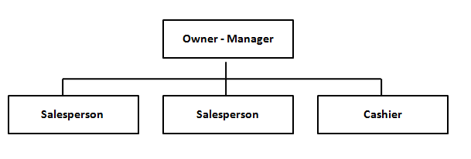
Source. Pearce, Robinson, and Subramanian, 2000

- Functional Organizational Structure. A functional organizational structure denotes the structure where the people, tasks, and technologies required to complete the tasks of the businesses are allocated into distinct “functional” clusters (for example, finance, marketing, operations, accounting, HRM etc.) with progressively formal ways for integrating as well as coordinating their actions to offer the business’s services and products (Pearce et al., 2000).

Figure-2. Functional organizational structure
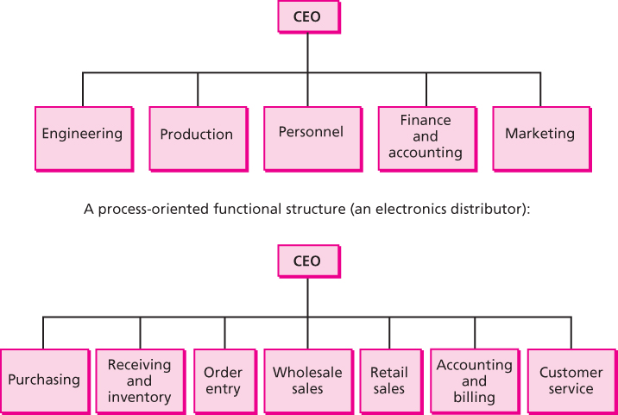
Source. Pearce, Robinson, and Subramanian, 2000

- Divisional structure. A divisional organizational structure denotes one wherein a kit of comparatively independent divisions or units, are administered by a central business corporate office on the other hand where every functioning division has its identifiable functional experts who deliver services or products diverse from those of the other units or divisions. This structure advances decision making in compare to the diverse competitive business environments. The unit or division habitually is given the responsibility to earn profit for the organization (Pearce et al., 2000).

Figure-3. Divitional organizational structure
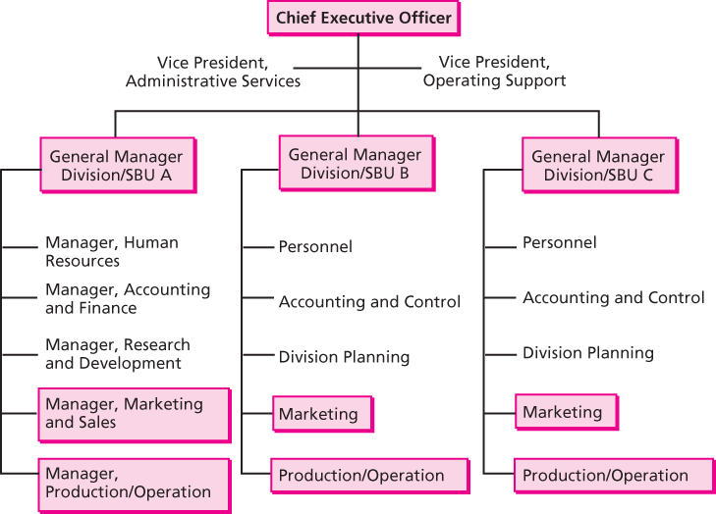
Source. Pearce, Robinson, and Subramanian, 2000
- Strategic Business Unit (SBU). The strategic business unit (SBU) stands for an adjustment of the divisional organizational structure whereby numerous divisions or units of divisions are clustered together constructed on certain mutual strategic foundations, usually connected to the distinct market or product variances The benefits and drawbacks of the strategic business unit (SBU) system are very alike to those recognized for the divisional organizational structures (Pearce et al., 2000).

Figure-4. Virtual SBU
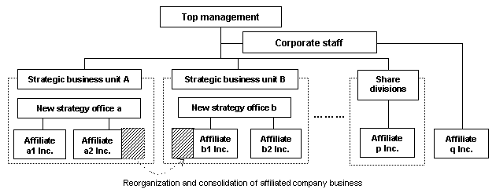
Source. Pearce, Robinson, and Subramanian, 2000

- Holding Company Structure. An ultimate arrangement of the units or divisional organization remains the holding company structure. In that structure, the corporate unit is an extensive gathering of habitually dissimilar divisions or businesses such that the structure (the corporate entity) performs as financial administrator “holding” the interest of ownership in the numerous portions of the company nonetheless the company has slight direct administrative engagement (Pearce et al., 2000).

Figure-5. Holding company structure of Johnson & Johnson
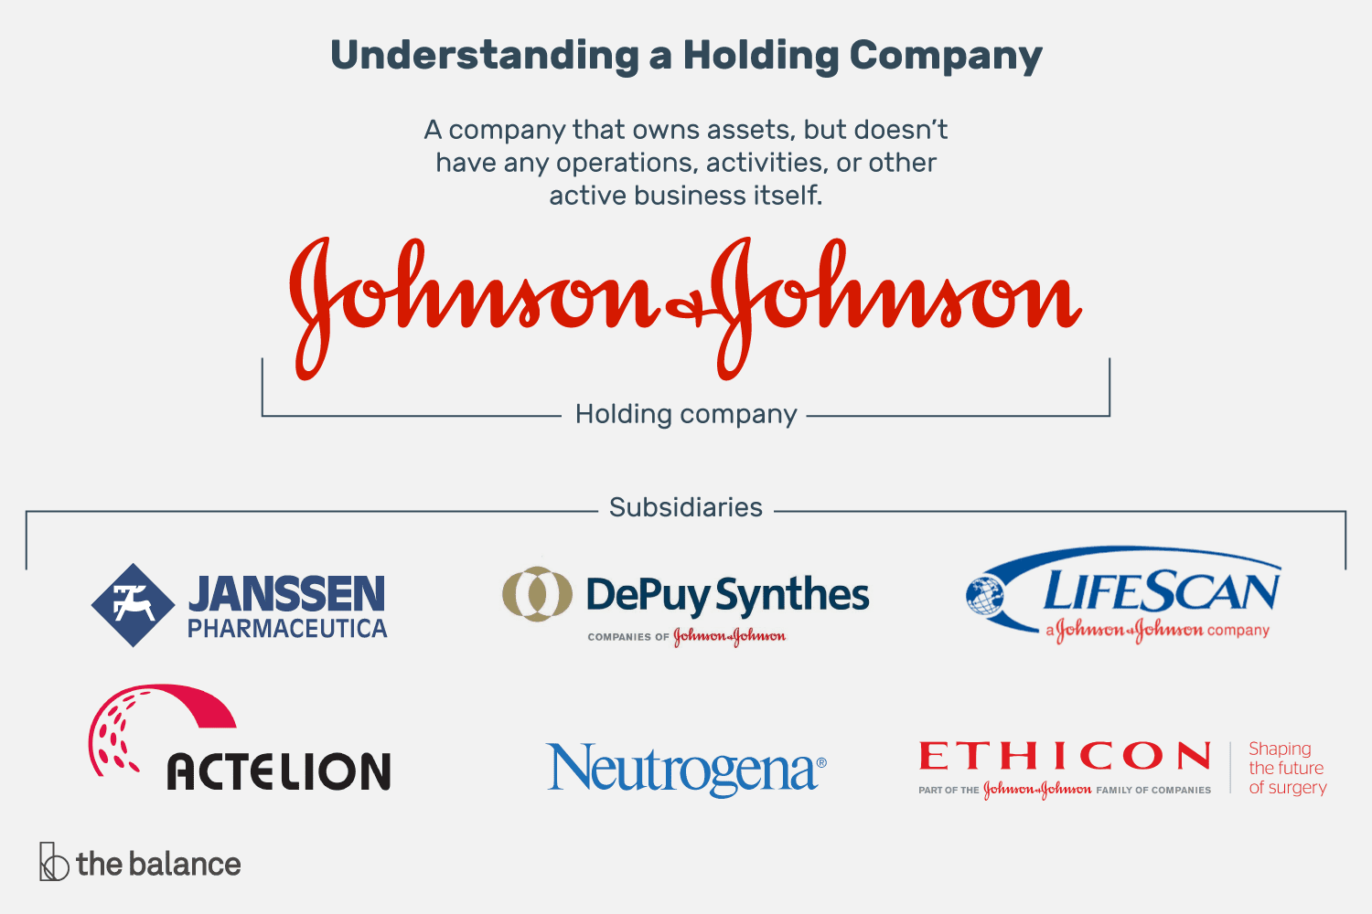
Source. The Balance, 2019

- Matrix Organizational Structure. The matrix organizational structure stands for that type of structure in which staff personnel and functional are allotted to mutually an elementary functional extent as well as to a product or project manager. The matrix system is projected to create the greatest usage of talented people inside the firm by joining the benefits of the functional specialism along with product-project concentration (Pearce et al., 2000).

Figure-6. Matrix organizational structure
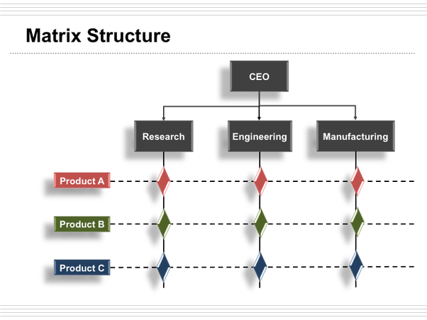
Source. Pearce, Robinson, and Subramanian, 2000
- Product-Team organizational Structure. The product-team organizational structure pursues to amplify and simplify the emphasis of resources and capitals on a slight but tactically vital product, market, project, innovation, or customer. The product-team organizational structure allocates functional experts and managers to an innovative process, product, or project team that is authorized to create foremost decisions nearly their products (Pearce et al., 2000).

Figure-7. Product-team structure

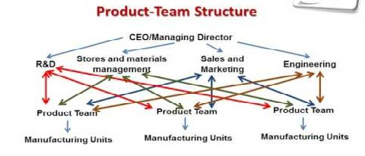
Source. Pearce, Robinson, and Subramanian, 2000

In addition, (Writing, 2019) denotes three foremost kinds of organizational structures in business. Those are, functional, divisional, and matrix organizational structure. In another classification of organizational structure, Pingboard (2019), classified six types of organizational structures for business. Those are, Hierarchical Organizational Structure, functional, matrix, customer organizational structure, product structure, geographic organizational structure. Where customer and geographic organizational structure are different from the classifications of Pearce et al, (2000).

Figure-8. Customer and geographic organizational structure
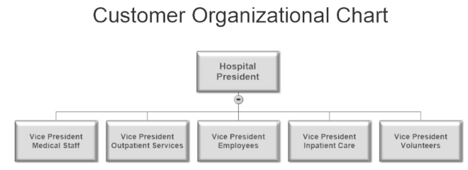

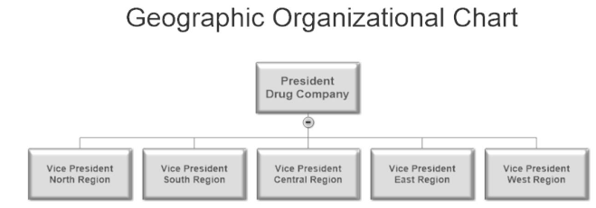
Source. Lotich, 2018

  - Management theories from 19th century till now
Management theories are established to support and help the businesses and organization to develop the different organizational structures. The theories of management are divided into different approaches based on the innovation of the theories and the time horizon of the innovation. The discussion has been stated as follows.

- Classical approaches in management theories. The modern management and theories of management have been developed through administrative approach which was proposed by Henri Fayol in 1916 (Robbins, Decenzo, & Coulter, 2001). As per the Fayol, he proposed 14th crucial principles for organization and management those are, Division of Work, Discipline, Unity of command, Authority, Unity of direction, Remuneration, Subordination of individual interests to the general interest, Scalar chain, Centralization, Equity, Order, Initiative, Stability of tenure of personnel, and Esprit de corps. Fayol also suggested the business for six important managerial activities those are technical, financial, commercial, safety, accounting and management activities. He also proposed six more functions for the management those are, forecasting, planning, organization, commanding, coordinating, and controlling (Griffin, 2006). In this classical approach F. W. Taylor also proposed the scientific theme of management in 1911 (Robbins, Decenzo, & Coulter, 2001). Taylor offered four important tasks and functions for the managers those are replace the old rule-of-thumb method, systematically choice and then teach, train, and develop the employee, enthusiastically collaborate with the employees in order to safeguard that all the managerial works are completed in accordance by the support of the science principles and distribute the responsibility and work nearly similarly between the employees and management (Griffin, 2006; Robbins, Decenzo, & Coulter, 2001). Under this classical approach, Max Weber also developed a philosophy of authority buildings and associations grounded on an idyllic sort of organization. Weber called that management theory as bureaucracy (Robbins, Decenzo, & Coulter, 2001).

- Behavioral approaches. Even though a quantity of individuals in the initial twentieth century identified the significance of individuals to the success of an organization, four be noticeable as early promoters of the Organizational Behavior approach. Those theorists are Chester I. Barnard, Robert Owen, Mary Parker Follett and Hugo Munsterberg. Those theorists’ contributions were diverse as well as distinct, however all of them believed that individuals are the utmost important strength of the business & organization and the people should properly be managed consequently. Their concepts or ideas delivered the basis for such behavioral management performs as employee recruitment & selection processes, motivation plans, along with work teams (Robbins, Decenzo, & Coulter, 2001).

Without a doubt, the greatest significant contribution to the Organizational Behavior (OB) field brought out of the investigation of Hawthorne Studies. Where a sequence of researches have been piloted at the Western Electric Company. These series of studies, which was started in the year of 1924, were primarily planned by Western Electric manufacturing engineers by way of a new scientific management research. The ultimate outcomes of the study specified that the motivation or incentive strategy had a smaller amount of effect on an employee’s work output than did the group tasks pressure, security, and acceptance. The investigators settled that group values or social were the vital elements of individual worker’s work behavior (Griffin, 2006). The behavioral tactic has essentially formed how present day’s administrations are being managed. From the method that managers can design the jobs to the mode that the managers can work with the employee or workers teams to the method that they can communicate. It is been seen the components of the managerial behavioral approach (Robbins, Decenzo, & Coulter, 2001).

- Quantitative approaches. After the establishment of behavioral approach the theorists feel an urge to develop the quantitative theme in management. The quantitative approach basically support the organization in case of business operations and productions management. Quantitative methods is used to improve the managerial decision making. This quantitative approach is also well known as the management science (Griffin, 2006). The quantitative managerial approach developed from the mathematical as well as statistical explanations settled for the military complications during the World War II. When the world war was finished, numerous of those quantitative methods practiced for military complications were implemented in organization and businesses. For example, in the mid of the year 1940, the Ford Motor Company immediately instigated using the quantitative models along with statistical methods to develop the company’s decision making. What accurately ensures the quantitative method do? Quantitative approach contains relating optimization models, statistics, computer simulations, information models, and other quantitative methods to the management accomplishments. For example, linear programming is a method that administrators or managers apply to progress the decisions related to the resource allocation. Work scheduling is another technique which can be applied as more efficient on account of the analysis for critical-path scheduling. Another approach named economic order quantity (EOQ) model aids the managers to determine the optimum levels of inventory (Robbins, Decenzo, & Coulter, 2001). So, the quantitative approach in management theories contributes straightly to the management choice and decision making under the extents of management planning as well as controlling. For example, when a company managers prepare budgeting, quality controlling, scheduling, queuing, and analogous decisions, in that case the managers usually depend on quantitative techniques. Specified software has been prepared for the usage of these quantitative techniques to fewer the threatening for the managers, though many of the managers till now feel worried about the using of those software (Robbins, Decenzo, & Coulter, 2001).

- Contemporary approaches. Starting from the early 1960s, management scholars instigated to observe that what was going on in the outside of the boundaries named as external environment of the business or organization. The system approach along with contingency approach are the main part of this contemporary perspectives of management. Systems theory or concept is the elementary approach under the physical disciplines, but the approach had not ever been practiced to planned human labors. In the year of 1938, Chester I Barnard, who was working as an executive in a telephone company, firstly inscribed in his book that a business or organization performed as a supportive system (Griffin, 20016). Nevertheless, the concept was not until the 1960s, where the management scholars started to observe more cautiously at systems concept and how the system theory related to the organizations. A system theory is a kit of interconnected and inter-reliant parts organized in a way that harvests a joined whole. The two elementary categories of the systems are the closed systems and open systems. Closed methods are not generally inclined by and usually do not cooperate with their buisness and management environment. In contrast to the open methods are stirred by and usually do interrelate with their business and management environment. How well the systems theory contribute to the general thoughtful of management? Scholars projected an organization or business as being pretended of groups, motives, attitudes, including individuals, interdependent factors, formal structure, status, interactions, goals, and authority. Which means that, as the managers coordinate their work events in the several measures of the business or organization, they also certify that all of these portions are functioning together thus the organizational goals or objectives can be accomplished. In conclusion, the systems theory identifies that the businesses or organizations are not selfcontrolled. They depend on their operating environment for vital inputs as well as outlets to imbibe their outputs. No business or organization can endure for long if the organization overlooks governmental regulations, relations with supplier, or the diverse external communities in where it depends. Under the contemporary approach of management, another approach is called the contingency theory of management (occasionally known as the situational method). The approach articulates that the organizations are diverse, face various contingencies or situations, and need different methods of managing. A decent way to define contingency approach is, organizations are not similar, face diverse situations, and need various techniques of managing. Nonetheless, obviously, it is one important thing to narrate that the approach to manage has depended on the condition and one more to narrate what the condition is. The key value of this contingency management approach refers that the approach pressures there are not any universal or simplistic rules for the managers to observe or follow (Robbins, Decenzo, & Coulter, 2001).

Figure-9. Major approaches of management history
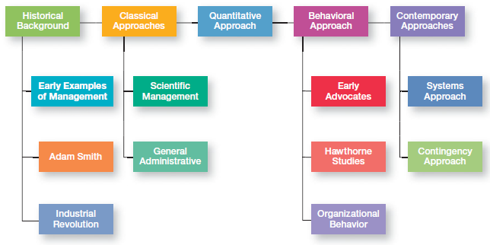
Source. Robbins, Decenzo, & Coulter, 2001

- Analysis
  - Justification of the association between organizational structure and IT
An organization along with its information technology (IT) require structure. Much similar to the information technology (IT) networks and structures have its own organizational architecture, therefore does a business or organization itself. Businesses shape themselves to the best attain their objectives or goals and undertake all of their essential tasks. To certify an organizational building or structure is accurately feasible, it has also to consider into the account that, the information technology related actions, functions and infrastructure and functions. Once the business owners or leaders carry out the procedure of revising or designing their business or organizational structures, the leaders should first consider a full list of the responsibilities and aims of their businesses. They observe to perceive which tasks and functions are not being completed and any existing disorganizations or redundancies. All the aspects, positions, and duties inside the organization should be taken into consideration, together with the information technology (IT). Truthfully, once the companies grasp a certain growth or size then they habitually elect no less than one individual, if not the group of individuals designate an organization’s IT department accountable for conducting entire technological features of a business or a company (Feigenbaum, 2019).

Figure-10. Direct Influence of Information Technology (IT) on Organizational Structure
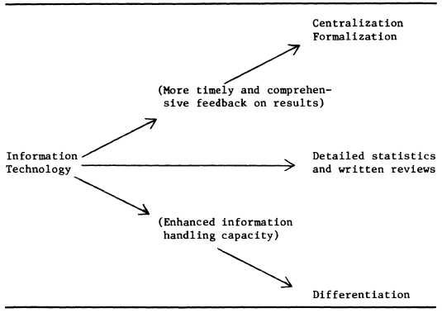
Source. Pfeffer & Leblebici, 1977
We are living in era of Information Technology (IT). It is developed so universal that the business and organization almost do not observe it. However what influence has entirely on this information technology has had on the organization? So, it can be inferred that information technology has transformed the surface of the workstation, comprising with an emphasis on two definite points of attention. One is automation and the other one is information technology (IT) (Pfeffer & Leblebici, 1977).

At first, the report can narrate about certain broad techniques that information technology has influenced the employees. Information Technology has numerous amount of different effects on the organizations and it can influence the organizational structure. Which means presenting new information technology to the staffs through time worthy training. Often this training involves that new experts who are engaged in information technology (IT) are need to appointed to the workplace. It is also mean that, the changes are required towards the organizational physical layout. For instance, transferring over to the new computers from finger filing means that the file assistants who are worked under that department is no longer required. This alterations the office layout and organizational structure. These types of technological modifications can similarly create the organizations better well-organized. While improving the information technology is most of the time might be primarily very expensive, it can also assist the organizations in the long run to save money (Frank, 2019).

Figure-11. The connection between Information Technology (IT) and the business value goes over the organizational structure
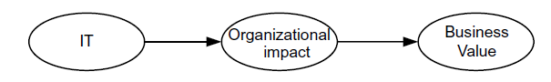
Source. Gustafsson, Franke, Höök, & Johnson, 2008

Information technology (IT) is so dominant to how well a company can operates. Computers along with its networks grasp the data on company secrets, finances, and individual information. Occasionally in the situation of insurance companies, hospitals, and banks where the data of those companies partake a lawful obligation to protection. Network managers and the computer experts who have exceptionally admittance to a firm's business data can exist a break of safety. As a consequence of this, many business companies design Information Technology positions so as to no individual has all the access or unexamined access to vital data and systems. Businesses that engage in numerous, sophisticated computer as well as technological organisms often discover it compulsory to construct and separate their IT team into domains. One arrangement may necessitate distinct programming and assist that only a few persons know (Feigenbaum, 2019).

For example, a company which is engaged in communications business switches and servers or the hospital networks might be required 24-hour observing by skilled and trained staffs. Organizational structures essentially should take an account of these above needs and outline how the business or organization is tracing them. As the companies produce and advance new business lines or obtain other companies and businesses, the managers frequently pick to shape or organize their various operations in distinct divisions. Naturally, organizational divisions operate somewhat unconventionally, each of the divisions with its specific structure, approaches, and leadership while all the divisions will be reporting to a shared and common top level management. Divisions typically have diverse needs and structures, which make assisting them all for more exciting as well as challenging to an integrated and centralized information technology (IT) department. Thus, rather than the specializing in unique pattern of hardware or software and delivering support and help across the business or company, companies sometimes may favor their IT team to be the generalists accustomed to a department’s or division's certain needs (Feigenbaum, 2019).

Information Technology (IT) largely denotes to the procedure from the input to the output inside the organization or business. The degree of inevitability on technical actions of the business or organization governs diverse management as well as coordination desires for the specific organizational structure. A great extent of inevitability can support the centralization and formalization of any organizational structure. In contrast, the organizational structure under this circumstance or condition requires to have superior flexibility. Information Technology is an alteration process of the mechanism to finish its tasks or works in a business or organization. A very crucial matter in information technology (IT) is assembling an organizational or structural clients’ demand for the output customization. The fastness of which products or goods must be altered is connected to this. When the requirement or demand for a product modify or production customization is large, a constant organizational building or structure is unsuitable for governing the entire production process. With the aim of efficiently accomplish the needs of change and customization, an adjusted organizational structure may work more advisable and effective way. For illustration, in case of Microsoft, the advancement of new information technology and innovation of product is a main mission or task in the aggressive market rivalry. To attain the organizational goal, staffs and departments require to focus more devotion to the market demand along with other close competitors. Thus, flexible organizational structure is crucial to take an effective actions in case of any environmental fluctuations (Goel, 2013).

  - Justification of the interaction between management theories and IT
Management theories have been advanced over the last century, defines how businesses or companies forecast, plan, staff, organize, lead as well as control or monitor their staffs. Effective and active managers hire individuals to achieve goals and consume materials intelligently to accomplish profitability and retain the best competitive advantage for the organization. Progresses in information technology (IT) have permitted the automation, standardization, along with globalization at the level that the initial management theorists perhaps never thought conceivable. The complicated information technology (IT) solutions, together with software and hardware allow the businesses and organizations to generate, store and recover data from places all through the globe. In businesses small and large, all the departments, containing sales, marketing, manufacturing, and finance, now naturally depend on the firm’s Information Technology (IT) infrastructure to handle the functions and operations essential to accomplish the business processes (Duggan, 2017).

- Effect on Scientific Theory towards Information Technology (IT). In the period of early 1900s, Frederick W. Taylor, who was an American origin mechanical engineer, defined by what means the scientific management theory could be employed to the managing employees. By optimizing and simplifying the approach tasks were accomplished, the managers might direct employees to done the tasks in one steady and consistent way. By refining industrial effectiveness, efficiency and dropping the human fault, managers increase the productivity and enhance profits. By applying the introduction of information technology (IT), for instance computer software along with hardware, tasks and responsibilities formerly completed by individuals are now accomplish by expert machines, decreasing monotony, security concerns as well as deviation (Duggan, 2017).

- Influence on Administrative Theory towards Information Technology (IT). Similarly in the initial period of 1900s, a French origin mining engineer named Henri Fayol, established a sequence of 14 management principles that defined how to manage and operate a company. Mr. Fayol hypothesized six managerial functions of management. The effect of information technology (IT) on his administrative management theories spreads to every department or unit in most of the companies, as the computer software as well as hardware applications have swapped by paper based structures of organizing and guiding organizational task (Duggan, 2017).

- Effect on Contingency Theory towards Information Technology (IT). In case of managerial contingency theory, the method narrates that there are not a single person best of handling and managing. Leadership approach that demonstrates effective in single condition may be unsuitable in the others. Victory often relies on a diversity of situational aspects, containing the abilities of the supervisor’s or manager’s assistants and the (IT) information technology. The manager or the supervisor has accessible to create a well-versed decision by applying the IT advancement. By the help of portable computing, cell phones and others related factors always present in information technology (IT), managers or the supervisors have supplementary information and data at their removal than forever before. Indeed, too much data and information may create it problematic to decision making. Managers or the supervisors need to screen the data, news, and other related content they accept in print, video, and audio formats with the aim of function successfully as well as effectively (Duggan, 2017).

- Impact on Systems Approach towards Information Technology (IT). Applying the managerial systems approach permits managers to assess their business or company as a complicated system containing of inter-reliant departments or units. By aligning worker performance objectives to the strategic goals of the firms, all the employees work to resolve the identical problems. Information Technology (IT) enables all the parts of a business or organization to communicate and connect easily. Applying the email, telecommunication, social networking approaches such as blogs, wikis, and forums, owners, managers and employees work together across the world to resolve the company problems and difficulties. Enterprise resource software and hardware systems tie the units or departments so the whole organization works as well as functions as consistent and cohesive whole (Duggan, 2017).

  - Justification of the relationship among organizational structure, management theories and Information Technology (IT) for 21st century’s businesses.
Based on the above discussions it can be presume that the organizational structure generally originated from the different management theories. For example, the classical approach of management (administrative approach by Henri Fayol, scientific management approach by F. W. Taylor, and bureaucracy theory by Max weber) helps the manager to create the foundation of organizational structure. Like the simple and functional organizational structure are generated from the classical approaches of management. However, in the early 21st century where the information technology have been emerged across the globe and completely influenced the businesses along with organizational structures (Robbins, Decenzo, & Coulter, 2001).

Figure-12. Bureaucracy theory supports organizational structure
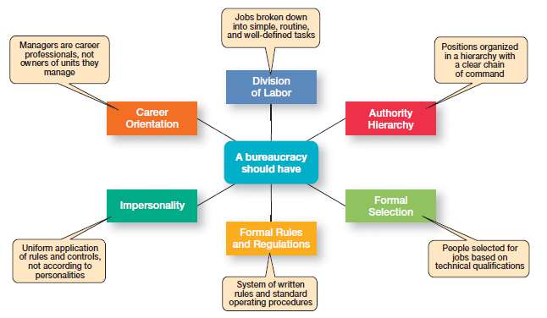
Source. Robbins, Decenzo, & Coulter, 2001
The figure-12 reflects the origin of organizational structure from management theories. Yet, the innovation of IT has great influence on that organizational divisions and structure. For instance, in case of division of labor the organization needs to divide its different tasks. IT related tasks should be added after the innovation of computing devices, internet, World Wide Web (www), telecommunication, as well as different transportation technologies. The issues are need to be considered by the organizational managers to divide and centralize or decentralize of their organization. Sometimes in case of functional organizational structure many of the companies have separate IT functional departments for smooth functioning of their business and organization (Hill, 2013).

Figure-13. Organization and organizational structures are now open system

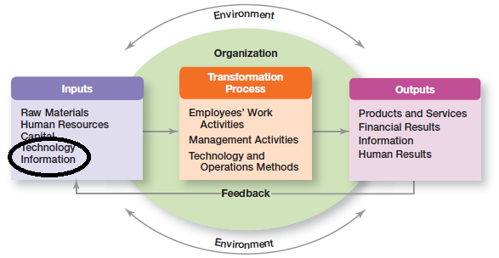

Source. Robbins, Decenzo, & Coulter, 2001

In addition, the behavioral, contingency, and system approaches, supports the divisional, strategic business units, matrix, product division and other related organizational structures. In all the cases the information technology has boosted up the operations and performances organization as well as organizational structure (Robbins, Decenzo, & Coulter, 2001). From the figure-13, it can be narrated that after the advancement of IT, organization are now open system and IT is used as an input of organizational structure; through the business environment the transformation process has been occurred and finally the better organizational performances have been found as output. This is how, the IT influences on 21st century’s organizational structures along with management theories.

  - Justification of the impact in IT revolution towards Standard Chartered Bank’s organizational structure
The banking sector in 21st century is facing countless exceptional challenges because of the growth of financial information technology companies. Industry top operators, along with the ambitious beginnings in the overall banking prospect, are facing lots of stress on the bank staffs or executives to discover the strategic improvement policies that would protect their banking business from these emerging IT revolution (Stani, 2019). Information Technology (IT) has been considered as one of the greatest imperative factors for the advancement of mankind. Information as well as communication technologies are the major initiation in the arena of information technology which is applied for process, access, dissemination, and storage of information automatically. Banking sector is fast the growing with the practice of IT in the system of Mobile banking, ATMs, on-line banking etc., plastic type of card is such a banking products that provide to the requirements of retail banking section has observed its progression in geometric rate in the recent years. This growth or progression has been powerfully maintained by the expansion of the Information Technology (IT) field, without that IT revolution this innovative and automated banking services have not been possible ever. Certainly the IT revolution in banking sectors will modify the mankind’s lifestyle in 21st century (Goel, 2019).

The management practice is much more challenging for the banking industry now. For example, if banking the services are consistent, long product life-cycles, and customer exceptions are limited, more mechanistic or bureaucratic structures in bank will be appropriate. But due the innovation of new technologies banks are facing with great stresses for the output customization or modification are paying higher consideration to effective hazards and problem solving, while the banks, who are comparatively steady transformation in information technologies should emphasis more on the well-organized performance. As the task in banks with routine information technologies is homogenous, staffs are required to be less training, development and education. On the other hand, Employees in the banks with non-routine information technologies should require specialized training, development and pertinent work experience (Goel, 2019).

Span of control in overall organizational structure is also diverse in banking sector with various types of information technology. The more complicated and complex the IT, the more requisite of a specific administrator or supervisor for the problem solving process. Nevertheless, it trusts on professional and experts bank executives with having non-routine information technologies. Professional banking staffs have skilled knowledge and individual experience that they can execute well without the close supervision of management, thus the extent of control in banking management can be bigger. The span of control in banks with non-routine or non-functional information technologies is lesser than that in those banks with having routine information technologies. Centralization in decision making also remains a feature of banks with routine information technologies. Furthermore, control as well as coordination are limited within those banks which have centralized structure in management. When the bank’s task is generally in the system of transactions, reports, memos, and procedures when the task is analyzable and also the frequent in communication. In contrast, if the bank’s task is not as much analyzable and information is transported by interactive communication, for example, telephone, online conversation as well as group conferences. The opportunity of the decision making from the authority is prolonged in banks those have non-routine information technologies, so as control and coordination activities. Grounded from the association between information technology and banks’ organizational structure, in can be guess that which types of organizational structures are suitable for which method of information technology. For illustration, machine based organizational structure should merely be used to the routine information technologies. Organic organizational structure is acceptable for other types of information technologies, despite the fact it might work the best for the banks with having non-routine information technologies (Goel, 2019).

The greatest negative effect of information technology in banks is loss of banking jobs as the automation has substituted a number of banking jobs. Through the information technology (IT) arises the danger of the Cyber Attack, an ambiguity in the structure, a huge amount data might be missing in no time. These information technologies takes less time and also sometimes creates individuals careless which may causes the loss of individual details as occurred the year in 2016, numerous debit cards particulars and details of large banks were negotiated (Tiwari, 2019).

- The case of Standard Chartered Bank (SCB). Standard Chartered Bank (SCB) is one of the leading international bank operated in 150 years, working 67 world markets with having around 84,000 employees. The rights issue of SCB to strengthen its balance sheet, the bank tries to align the banking operations to its strategy with constricted the risk tolerance, businesses target and the assets demonstrating nearly one-third of the group assets associated to the risk-weighted, simplified the organizational structure of SCB, and transfer on the banks’ conduct as well as risk programs associated with financial crime. SCB restructure its Institutional as well as Corporate Banking for greater returns, quickening the transformation of Retail Banking, renovation of the cost management along with Commercial Banking to create the capacity of investment. The SCB innovate and invest in Private Banking as well as Wealth Management, construct on a robust foundation and finance to raise carefully in Africa, also leverage in the inaugural of China, and compress of the improved Retail digital competences (Standard Chartered Bank, 2019).

Figure-14. How IT helps in banking operation for Standard Chartered Bank
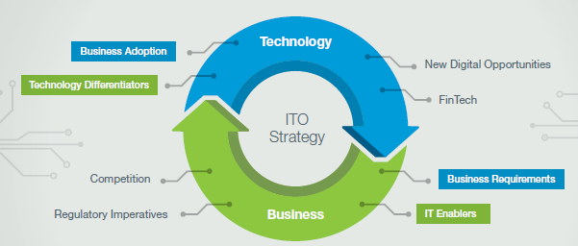
Source. Standard Chartered Bank, 2019

Two comments from the two key persons of SCB related to the IT revolution and SCB’s banking operations are as follows.

Michael Gorriz (Group Chief Information Officer of SCB) said, “We are embarking on a journey to shape the future of banking while creating a culture of innovation, efficiency and automation. We are introducing global platforms, machine learning and bringing forth intelligent technology. We want to lead this change and not be led by it.”

In another comment, Bill Winters (CEO of SCB) said, “Standard Chartered is a relationship bank with a deeply resonant brand. I’ve always been excited by the Asia, Africa and Middle East regions and the opportunity to get involved in a real banking business. We are building a technology platform that works seamlessly across borders.”

Figure-15. The Information Technology and Operations (ITO) world of SCB
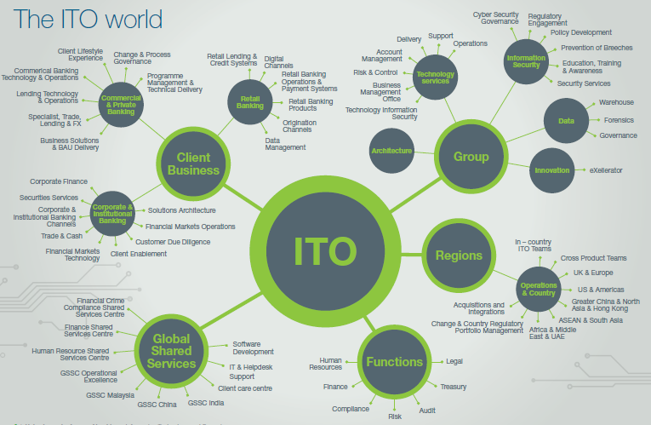
Source. Standard Chartered Bank, 2019

The above figure-15 reflects the overall strategy and plans related to ITO of SCB for international banking activities. ITO remains at the lead of delivering the core components of SCB’s Banking strategy. Which is supported by greatest investment and ITO will involve with the industry to advance and experiment new ideas and innovation in a responsive manner applying the rapid improvement and deployment to construct significant business resolutions. Innovation is required both in practice of information technology and then how well the bank can think and perform. SCB is determined to shape the bank and banking operations of the upcoming future through empowering their people to create an impact in banking sector. Few latest IT based services from SCB are Breeze the Mobile Banking App which has been successively awarded for five times as “World’s Best Consumer Internet Bank”. Another one is applying the block chain or distributed ledger technology to mitigate the fraud risk associated to the duplicate invoicing. The SCB also launched another app in Nigeria called Consumer Price Tracker app. By using the crowd sourced data, to deliver earlier unreachable consumer price inflation index (CPI). For smoothening of the above IT based services the SCB needs to take support or make partnership with some other related IT based firms and finally the bank needs to closely reengineering its organizational structure from country to country based on the extent to provide IT related services (Standard Chartered Bank, 2019).

- Conclusion
This report emphases on the significance of information technology (IT) in association of organizational structure and management theories. At present-day to cope up with the toughest competitive market, the organization should safeguard the practice of innovative information technology (IT) in their respective business. As a result of the innovation of information technology (IT) in business, organizations should modify their organizational structure consistent with the advancement of technology. Firms’ organizational structures need to be formed and changed in a progressive way. In addition to generate the effective organizational structure, understanding the significance of information technologies (IT) is very imperative to the business and organization. By applying the innovation of information technology (IT) any business and organization can easily be interacted and engaged to their stakeholders. The usage of information technology in an organization or business affected the individuals of that respective organization. In conclusion, the modifications in innovative information technologies such as e-commerce as well as e-businesses have significantly altered the firms’ organizational structure along with the management theories and roles in organization.

References
- Ahmady, G.A., Mehrpour, M. and Nikooravesh, A., 2016. Organizational structure. Procedia-Social and Behavioral Sciences, 230, pp.455-462.
- Anderson, K., 2000. Technological Challenges of the 21st Century. Retrieved from, https://probe.org/technological-challenges-of-the-21st-century/.
- Charles, W.L., 2013. International business: competing in the global marketplace: postscript 2002. Irwin/McGraw-Hill.
- Diggory, K., 2018. Technology in the 21st Century: Blessing or curse? Retrieved from, https://www.explore-life.com/en/articles/technology-in-the-21st-century.
- Drnevich, P.L. and Croson, D.C., 2013. Information technology and business-level strategy: toward an integrated theoretical perspective. Mis Quarterly, pp.483-509.
- Duggan, T., 2017. The Impact of Technology on Management Theories. Retrieved from, https://bizfluent.com/list-6159320-four-principles-management-human-services.html.
- Ecommerce News Europe., 2019. Retrieved from, https://ecommercenews.eu/ecommerce-in-europe/ecommerce-the-united-kingdom/.
- Expert, M., 2017. E-Business vs E-Commerce, Know The Differences. Retrieved from, https://medium.com/@Magento_expert/e-business-vs-e-commerce-know-the-differences-151ec9baf0fe.
- Feigenbaum, E., 2019. Technology and Organizational Structure. Retrieved from, https://smallbusiness.chron.com/technology-organizational-structure-3818.html.
- Forster, N., 2006. The impact of emerging technologies on business, industry, commerce and humanity during the 21st century. Vision, 10(4), pp.1-27.
- Frank, T., 2019. Impact of Technology on Structure & Design of Organizations. Retrieved from, https://study.com/academy/lesson/impact-of-technology-on-structure-design-of-organizations.html.
- Gefen, D., 2000. E-commerce: the role of familiarity and trust. Omega, 28(6), pp.725-737.
- Goel, M., 2013. Impact of Technology on Banking Sector in India. International Journal Of Scientific Research, 2(5).
- Griffin, R.W., 2006. Student achievement series: Principles of management. Cengage Learning.
- Gustafsson, P., Franke, U., Höök, D. and Johnson, P., 2008, November. Quantifying IT impacts on organizational structure and business value with Extended Influence Diagrams. In IFIP Working Conference on The Practice of Enterprise Modeling (pp. 138-152). Springer, Berlin, Heidelberg.
- Michalski, W., 2019. 21st century technologies: a future of promise. Retrieved from, https://oecdobserver.org/news/archivestory.php/aid/48/21st_A0century_technologies:_a_future_of_promise.html.
- Pal, S. K., 2008. 21ST CENTURY INFORMATION TECHNOLOGY REVOLUTION. Retrieved from, https://ubiquity.acm.org/article.cfm?id=1399619.
- Pearce, J.A., Robinson, R.B. and Subramanian, R., 2000. Strategic management: Formulation, implementation, and control. Columbus, OH: Irwin/McGraw-Hill.
- Pfeffer, J. and Leblebici, H., 1977. Information technology and organizational structure. Pacific Sociological Review, 20(2), pp.241-261.
- Robbins, S.P., Decenzo, D.A. and Coulter, M., 2001. Fundamentals of management. Tehran: Cultural reseach office.
- Standard Chartered Bank., 2019. Help shape the future of banking Information Technology and Operations. Retrieved from, https://www.sc.com/technology/assets/pdf/SC_ITO_Pitchbook_v12.pdf.
- Stani, R., 2019. The Impact of Technology on Banking: Revolution or Evolution? Retrieved from, https://bankinnovation.net/allposts/biz-lines/lending/the-impact-of-technology-on-banking-revolution-or-evolution/.
- Tangpong, C., Islam, M. and Lertpittayapoom, N., 2009. The emergence of business-to-consumer e-commerce: new niche formation, creative destruction, and contingency perspectives. Journal of leadership & organizational studies, 16(2), pp.131-140.
- Tiwari, B., 2019. Impact of Technology on Banking sector. Retrieved from, https://www.groupdiscussionideas.com/impact-of-technology-on-banking-sector/.

