University of Wales: Trinity Saint David
London campus

Global Business Environment
Assessment 2: Environmental Analysis of
An industry
Lecture: Dr Rexon Nting

Student: Galina Gancheva
2022711

Date 07/05/2021
Contents:

Introduction…………………………………………………………………………………3
Critical analyses of the changes that the fashion company have made upon the concerns raised by the different stakeholders…………………………………………………………4
Changes giving the company competitive advantage position……………………………...6
Conclusions and Recommendations………………………………………………………...8
Bibliography………………………………………………………………………………...9
Appendices………………………………………………………………………………….12

Introduction

Considering the fashion industry case study, the assessment will analyse critically the changes that the companies Primark, Burberry, ASOS have made in the last few years to their business model to self-regulate and adapt to some of the concerns raised by the different stakeholders. The main concerns revolve around two key issues and more broadly around matters of business sustainability: environmental pollution and labour exploitation. It will explain if these changes have given the company some form of competitive advantage position and provide any relevant recommendations to management. It will apply relevant business models (Porter’s Diamond, Value Network, Five Forces,) within the context of an international environmental analysis (PESTEL).
Primark may be a worldwide retailer that gives the foremost in vogue slant, greatness, and homeware at the leading worth on the tall street; set forward doubtlessly, Astounding Design at Astounding Costs. Primark opened its to begin with store in Dublin in 1969 beneath the title Penneys and nowadays works in more than 380 stores in thirteen countries over Europe and America. (Primark, about us)
ASOS plc is an online design and makeup retailer within the UK. The company was set up in London in 2000, primarily for youthful individuals. The site offers more than 850 brands, as well as its possess clothing and adornments collections, and ships them to all 196 nations / regions from centres within the UK, USA and Europe. ASOS conveyed a strong execution over the year as they investigated the extraordinary challenges that risen since the Covid-19 pandemic. Total sales grew by 19% to £3,263.5m and profit before tax increased to £142.1m, an increase of £109m on the previous year.
Burberry have already seen from the annual analyses, in the last year due to covid19 incomes decreased. The fashion industry is directly affected by the pandemic.

Critical analyses of the changes that the fashion company have made upon the concerns raised by the different stakeholders

Consistent with Bishop; (2014, p40-41) SWOT investigation is an essential in organizing technique used to evaluate the qualities, deficiency, openings, and Dangers related with an undertaking or in a commerce experience. It incorporates showing the target of the undertaking or wander moreover, recognizing the internal and exterior components that are great and unpleasant to achieve that impartial. A SWOT examination ought to at first start with characterizing an perfect conclusion state or objective.

It is generally acknowledged by Worthington (2006) that corporate execution is impacted by a blend interior and outer elements. This measure is then rehashed for the company's outside promising circumstances and dangers all together to feature those outer variables which are probably going to happen and which are expected to affect the association's future positions.

The motivation behind this work is the investigation of one of the overall driving retailers, the
Primark Stores Ltd. (Primark) concerning expected posting on the London stock trade. The
strategy applies the productivity and effectiveness, transient dissolvability and liquidity, long haul dissolvability and soundness just as investor and venture proportions. The PESTEL system is utilized to assess the political, financial, social, innovative, ecological, and lawful foundation of Primark's activities. The SWOT model exhibits the organizations monetary and business strength what is more, shortcomings alongside the chances and dangers of the retail business. With respect to public offering, the likely offer cost is determined by the net resources’ strategy and the profit valuation model. In view of the suggested share value, the hypothetical value/profit proportion and a market capitalisation of Primark are examined. A conjecture of future net benefits is endeavoured with the basic normal development model and the pattern line extrapolation technique. Corporate administration suggestions following the stock trade floatation are examined against the UK Corporate Governance Code furthermore, scholastic writing. The discoveries accommodate a solid business case grounded on an expense initiative technique, which would be respected by the financial exchange positioning in the upper 2nd Quartile of the FTSE area organizations. The outcomes might be dependent upon limits emerging from bookkeeping numbers on which the computations are based. (researchgate.net)

As defined by Worthington (2006) Porter 39’s Five Forces may be a show that recognizes and explores five powers that shape each industry and chooses an industry’s inadequacies and qualities. Five Strengths examination is regularly utilized to recognize an mechanical plan to choose corporate framework. Porter’s show can be connected to any area of the economy to comprehend the degree of contention interior the industry and move forward a company’s long-haul efficiency. The Five Forces model is named after Harvard Business School teacher, Michael E. Porter. Porter’s five powers are: Competition in the industry; Potential; Power of suppliers; Power of customers and Threat of substitute products.

Worthington (2014, p274) examines the live cycle model: a typical model of taking a gander at an item and the association that produces it is using the „live cycle model", where the situation of the item in its live cycle will have suggestions for such things as the showcasing of that item. Firms are probably going to have bigger portions of the overall industry and there will be lower costs because of economies of scale and the experience impacts. There is probably going to be cost cutting and the market can be scratched, conceivably looking to abroad business sectors.

Above all, in Worthington (2006) organizations that wish to apply for these issues should give evidence to natural execution from their providers. In this way items will be assessed utilizing live – cycle examination, a support to-grave appraisal of an item's effect upon the climate.
There are lots of new articles on the impact of textile production and waste on the environment. Garments, footwear, and family materials are answerable for water contamination, ozone depleting substance emanations and landfill. Quick design - the consistent arrangement of recent fads at extremely low costs - has prompted a major expansion in the number of garments. Water contamination - Material creation is assessed to be liable for about 20% of worldwide clean water contamination from colouring and completing items. Washing artificial materials delivers an expected 0.5 million tons of microfibers into the sea a year. Washing synthetic dress accounts for 35% of essential smaller scale plastics discharged into the environment.(www.europarl.europa.eu)

Since 1996, the measure of garments purchased in the EU per individual has expanded by 40% after a sharp fall in costs, which has diminished the life expectancy of apparel. Europeans utilize almost 26 kilos of materials and dispose of around 11 kilos of them consistently. Utilized garments can be sent out external the EU, yet are generally (87%) burned or landfilled. All around the world under 1% of garments are reused as apparel, mostly because of deficient innovation. Under the waste order affirmed by the Parliament in 2018, EU nations will be obliged to gather materials independently by 2025. The new Commission methodology additionally incorporates measures to help roundabout material and creation measures, tackle the presence of perilous synthetics and assist buyers with picking reasonable materials. The EU has an EU Ecolabel that producers regarding characteristic guidelines can apply to things, ensuring a limited use of harmful substances and diminished water and air defilement. (The Guardian, 07 Apr 2020)

Changes giving the company competitive advantage position

We live in a society where fashion is changing very fast. It is also used to change clothes in the wardrobe. The so-called "fast fashion" is entering more and more into people's lives. This is the reason why a lot of clothes are thrown away over the years. They in turn pollute the environment. This pollution is huge in all parts of the world. Another big problem is that as a result of the rapid change of clothes, people prefer to look for cheaper clothes that are such at the expense of quality. Cheap but low-quality materials are increasingly used in companies. They are difficult to degrade. Due to the increase in the consumption of clothes, shoes and accessories, the disposal of obsolete ones also becomes a problem. They remain in the ground or accumulate over a huge area in landfills. They do not decompose quickly, and society finds it difficult to accept their recycling.

Normally, individuals bought 60% more articles of clothing in 2014 than they did in 2000. Design generation makes up 10% of humanity’s carbon outflows, dries up water sources, and sullies streams and streams. What is more, 85% of all materials go to the dump each year. (business insider article 2019)
Fast design - the consistent arrangement of modern styles at exceptionally more costs - has driven to enormous increment within the amount of dress delivered and tossed away. To handle the effect on the environment, the EU needs to speed up the move towards a circular economy. In Walk 2020, the European Commission received an unused circular economy activity arrange, which incorporates an EU procedure for materials, pointed at invigorating development and boosting reuse inside the sector. In February 2021, the Parliament received a determination on the modern circular economy activity plan demanding extra measures to realize a carbon-neutral, ecologically feasible, toxic-free and completely circular economy by 2050, counting more tightly reusing rules and authoritative targets for materials utilize and utilization by 2030. As portion of the recommendations, MEPs inquired for modern measures against microfiber loss and stricter benchmarks on water use. Circularity standards ought to be executed all through all stages of an esteem chain to form the.
In this photo (see Appendix) we see a landfill in Bangladesh. It clearly reflects the current reality with pollution. It shows that the problem is big and immediate action must be taken. In the Guardian article (07.04.2020) a co-creator of the examination from Manchester University Dr Patsy Perry stated, "It is actually a worldwide issue," call attention to that the worldwide idea of the design business implies garments may have gone all throughout the planet a few times during fabricate, while it is assessed that if 3% of piece of clothing transportation moved from boat to air payload – an expanding pattern in the business – it could result in more than 100% more fossil fuel by-products than if all piece of clothing transportation was by transport.

Environmental Audit Committee (EAC) proposed different measures, recalling a 1p charge for each new thing of clothing to finance better reusing and arrangement. The design and materials industry are a significant polluter of water at all phases of the worth chain, from the rural overflow from cottonfields causing algal sprouts that gag streams, to the withering cycle delivering a mixed drink of harmful synthetic compounds and the washing of garments delivering micro plastics. (Forbes.com, 19/09/2020)

Charity shop is also an important factor in the fashion industry. There can be handed over clothes, shoes and accessories that are no longer worn by people and can be bought by other people who are looking for something different and cheap and necessary for them. This gives the goods a longer life, and reduces the amount of quickly discarded, less modern clothes.
Material colouring is the greatest guilty party in the style business and is the second-biggest polluter of water universally as per the UNEP. Colouring garments to get striking tones and completes that are regular in the quick design industry require a lot of water and synthetic compounds, which wind up being unloaded in close by waterways and lakes. (onegreenplanet.org)

In 2019, the UN dispatched the Alliance for Sustainable Fashion to facilitate worldwide endeavours to check the ecological effects of the design business. Exhaustive changes in the quick style industry can help end sweatshops and misuse work rehearses, recuperate the wellbeing and conditions of networks where articles of clothing are created, and furthermore help the worldwide battle in moderating environmental change. An illustration of an alleged quick style store is Primark. This is a store that offers merchandise at low costs. As we have considered the circumstance above, we track down that these lower costs are to the detriment of the nature of the materials utilized. Supplanting or bringing down the regular ones like cotton with counterfeit ones like polyester.
For instance, the utilization of reused materials in their items, just as upcycling strategies their product offerings, is basic. Stella McCartney, Mara Hoffman, and Marine Serra are only a portion of the enormous marks taking the word 'manageability' and following up on it. Likewise, these brands have improved their assembling strategies to lessen waste, harmfulness, and ecological effect. These names take disposed of fishing nets, plastic containers, and surprisingly grounded espresso and transformed them into astounding couture.

The competition of the companies in the fashion industry is great. Each of them realizes that the problem is big and strives to offer the most attractive and good on the market. More and more companies are realizing that they need to do more about global pollution, and each company offers a different approach. Primark pays attention to recycling. Burberry remake old models and make them different and interesting. Other companies emphasize making models from recyclable materials.
ASOS set tall moral measures and bolster our providers to assist them meet them, so we created a world-leading Moral Exchange Methodology in 2017 with needs counting straightforwardness; moving forward compensation; wellbeing and security; tending to and diminishing advanced subjugation dangers and distinguishing and ceasing child work.
Primark's competitive advantage is that it represents a large part of its market share over its competitors. The company strives to combat huge pollution and recycle much of the unnecessary materials.

Conclusions and Recommendations

Daily, Primark stores make huge profits. They are a large chain of stores, where they make big profits every day, which we can see to the financial statement. However, during the pandemic, they were closed for a long time and this brought them losses. However, after opening their doors again, they regained some of the lost capital.
Much of the land and water resources are polluted. This also leads to the death of many animal species. It also leads to many diseases of humanity. More and more factories and companies need to look to the future and increase the benefits and reduce the damage. In general, the pursuit of quick profits and the irresponsibility of the natural resource should be replaced by concern for environmental protection through the various ways described above.
In order to solve the problem of global pollution as a result of the fast fashion in the industry, attention must be paid to the quality of the materials used and their degradability. The use of natural materials, the quality of treatment and recycling are just some of the tools to reduce the amount of waste. Some companies rent clothes, others remake old models to be used again. More and more companies need to do what is necessary to deal with pollution. The pursuit of quick profits has its consequences. It is time for everyone to take responsibility for their actions and to protect the nature and health of workers

Bibliography
Bishop, Trinidad, (revised edition 2014) Principles of marketing management; Delhi, Orange Apple;
Porters, Michael (2016) Product Life Cycle, Value chain, etc and should focus on just ONE case study. Publisher: 50Minutes.com
Sloman, John; Garratt, Dean: Jones, Elisabeth (2019) Economic for business, eight editions, England Pearson,
Worthington, lan (2006) The business environment; fifth edition, England; Harlow
Product Life Cycle; By CAROL M. KOPP; Updated Dec 27, 2020 Available at:
https://www.investopedia.com/terms/p/product-life-cycle.asp
The fashion industry emits more carbon than international flights and maritime shipping combined. Here are the biggest ways it impacts the planet. McFall Morgan -Johnsen Oct 21, 2019, 5:22 PM Available at:
https://www.businessinsider.com/fast-fashion-environmental-impact-pollution-emissions-waste-water-2019-10?r=US&IR=T
The impact of textile production and waste on the environment (infographic); (Updated: 03-03-2021 - 13:25; Created: 29-12-2020 - 08:00) Available at:
https://www.europarl.europa.eu/news/en/headlines/society/20201208STO93327/the-impact-of-textile-production-and-waste-on-the-environment-infographic
HomeEconMarket FinanceFinancial EconomicsStock MarketsStock Exchange ArticlePDF Available
Financial Analysis of Primark Stores Ltd. with regard to a Stock Exchange Floatation (IPO) (January 2019) Paul Eisenberg University of Portsmouth
https://www.researchgate.net/profile/Paul-Eisenberg/publication/330676430_Financial_Analysis_of_Primark_Stores_Ltd_with_regard_to_a_Stock_Exchange_Floatation_IPO/links/5c4ef048299bf12be3e9424f/Financial-Analysis-of-Primark-Stores-Ltd-with-regard-to-a-Stock-Exchange-Floatation-IPO.pdf
5 ways to fix fashion’s biggest pollution problem, JESS COLE (3 JUNE 2019 ) available at:
https://www.vogue.com.au/fashion/news/5-ways-to-fix-fashions-biggest-pollution-problem/image-gallery/13a38d47bbf7c2f15a160ef0dc6a7611
Fashion Waste Is Rubbish – Yes, But This Is Not the Issue; by ELEWISA YOUNG
5 July 2020 Available at:
https://wtvox.com/fashion/fashion-waste/
Primark Ltd. Modern Slavery Statement 2020 Avilable at:
https://primark.a.bigcontent.io/v1/static/Primark-MSA-2020#_wt.cqs=WT34sl-UABe8Pa_kgq0RcaRpOMCcswgd4M_32RPHm84mLU_WGArxsURjdts2R_RAWM5MG_WHkS5DqME1oodIeWvjODmprY8909Ikj8YSQiFMRAqKJORheefBinBvWxmW5_bUWOA_e_38TXYxtFmqPsSqfrNlYCB9g6_JO1phDtv8vVXOBAmOY4pkWGGBiEtUw9Ee1ZBqt59BEx5koRPXmP2CtD11PM~
2021 © PRIMARK STORES LIMITED About Us
Adored by fashion fans and value seekers alike Primark is widely established as the destination store for keeping up with the latest looks without breaking the bank. Available at:
https://www.primark.com/en/aboutus
How the Fast Fashion Industry Destroys the Environment; 7 months ago; By Clingham-David Jaia Avilable at:
https://www.onegreenplanet.org/environment/how-the-fast-fashion-industry-destroys-the-environment/
Scott Mike Out Of Fashion - The Hidden Cost Of Clothing Is A Water Pollution Crisis;
Sep 19, 2020 10:00 am Available at: https://www.forbes.com/sites/mikescott/2020/09/19/out-of-fashionthe-hidden-cost-of-clothing-is-a-water-pollution-crisis/?sh=434838f2589c
Davis, Nikola Fast fashion speeding toward environmental disaster, report warns;; Tue 7 Apr 2020 4:00pm Available at
https://www.theguardian.com/fashion/2020/apr/07/fast-fashion-speeding-toward-environmental-disaster-report-warns
The impact of textile production and waste on the environment (infographic); Society Updated: 03-03-2021 - 13:25 Created: 29-12-2020 - 08:00 Available at:
https://www.europarl.europa.eu/news/en/headlines/society/20201208STO93327/the-impact-of-textile-production-and-waste-on-the-environment-infographic
The fashion industry emits more carbon than international flights and maritime shipping combined. Here are the biggest ways it impacts the planet.; McFall-Johnsen Morgan
Oct 21, 2019, 5:22 PM available at: https://www.businessinsider.com/fast-fashion-environmental-impact-pollution-emissions-waste-water-2019-10?r=US&IR=T
Product Life Cycle; By CAROL M. KOPP; Updated Dec 27, 2020 Available at: https://www.investopedia.com/terms/p/product-life-cycle.asp
https://www.asos.com/about/who-we-are/?ctaref=aboutus|whoweare
https://www.asosplc.com/investors/2020-year-in-review/year-in-review
https://www.burberryplc.com/en/investors/annual-report-19-20.html

Appendix:
https://www.theguardian.com/fashion/2020/apr/07/fast-fashion-speeding-toward-environmental-disaster-report-warns 1.17pm 02/05/2021
fig.1
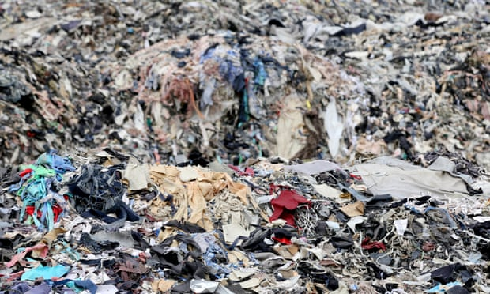
Textile offcuts in Bangladesh. The report highlights the innovative use of offcuts as one measure that could help reduce the fashion industry’s environmental footprint. Photograph: Mohammed Anwarul Kabir Choudhury/Alamy
Fig.2
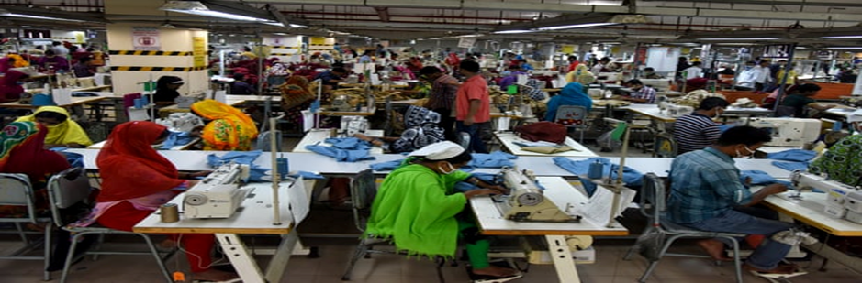
A garment factory in Dhaka, Bangladesh. The production of clothes for foreign designers is one of the issues highlighted in the report. Photograph: NurPhoto/ via Getty Images
Fig.3 fig4
https://www.abf.co.uk/documents/pdfs/2020/ar2020/ar2020.pdf (primark)
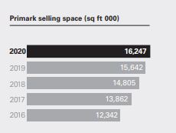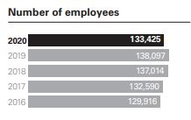
2. BUSINESS SITUATION OF PRIMARK STORES LTD.
Financial statement income:

Fig5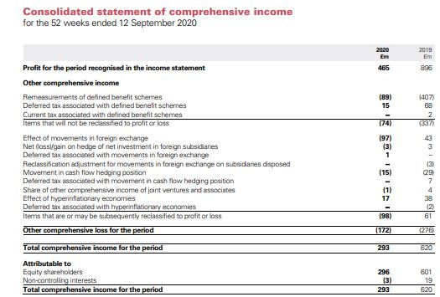
Fig6.Financial consolidated statement:
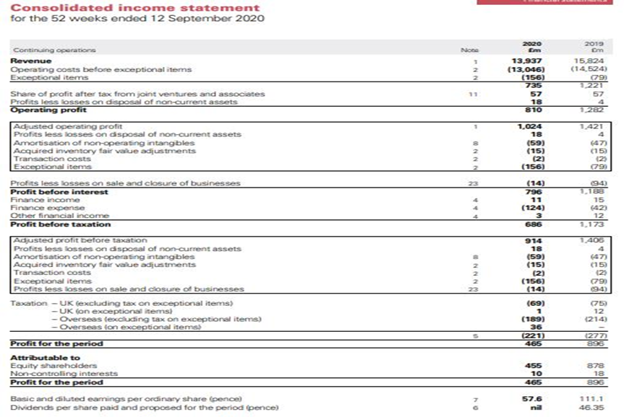
Fig7.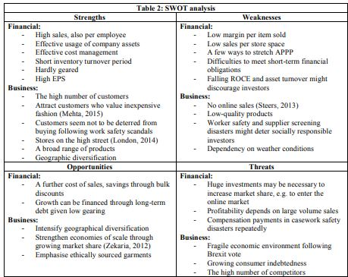
Fig.8. SWOT and PESTEL analysis Primark:


