Student Name: | Luke Connor Church
Student Number: | 2533137
Module No: | BMSK4015
Module Title: | Academic and Research Skills

Table of Contents
Introduction 1
Employee 2
Advantages for Employees 2
Disadvantages for Employees 2
Recommendations for Employees 3
The Manager 4
Advantages for Managers 4
Disadvantages for Managers 4
Recommendations for Managers 5
The Company 5
Advantages for Companies 5
Disadvantages for Companies 6
Recommendations for Companies 6
5.Conclusion 7
6.Reflection using a recognised model 8
Statistics graph 10

Introduction
Define remote management
Remote management is when a manager or IT staff control, support or supervise work from a different location using the internet and digital tools. It allows them to communicate with employees, assign tasks, check progress, and solve problems without being in the same place. Tools such as Microsoft teams and zoom help people stay connected and work together even when they are not in the same office.
Explain why analysing remote management from different perspectives (employee, employer, company) is important.
Analysing remote management from different perspectives, such as employee, employer and the company is important because each group is affected in different ways. Employees may care about things like flexibility, communication, and work-life balance, while employers focus on managing staff and making sure work is completed. The company looks at how remote working affects productivity, costs and overall performance. Looking at all perspectives helps businesses understand the advantages and disadvantages of remote working.

This report will look at the advantages and disadvantages of remote management in the workplace from three points of view: employees, employers, and the company. For employees, remote management can offer flexibility, the ability to work from home, and a better work–life balance. However, it can also make them feel isolated, reduce communication with managers, and sometimes make it harder to stay motivated. From the employer’s perspective, remote management helps supervise staff, assign tasks, and provide support without being in the office. At the same time, it can be harder to monitor productivity and maintain personal connections with the team. From the company’s point of view, remote management can reduce costs, improve efficiency, and allow access to talent from different locations. On the downside, it may require investing in technology and can create challenges in coordinating teams. Looking at all three perspectives helps understand the full impact of remote management in the workplace.
Qualitative
Is remote working means studying how people feel and work, like their happiness, teamwork, communication, and daily challenges.
Quantitative
Is remote working means looking at numbers to see how much work is done, how long people work, and how well tasks are completed.

Employee

Advantages for Employees
One major advantage of remote working is flexibility. Employees can often choose where they work and sometimes when they work. This allows them to plan their work around personal responsibilities, such as family or household tasks. Being able to decide their working hours and location can reduce stress and help employees manage both work and personal life better. This flexibility can make employees feel more satisfied and comfortable in their job. Another benefit of remote working is that it removes the need to travel to work every day. Commuting can take a lot of time and money, especially for those who live far from the office. By working from home, employees can save money on transport costs like fuel, bus, or train fares. They can also save the time normally spent travelling, which can be used for completing tasks or taking care of personal matters. Reducing travel can also make employees feel less tired and more ready to focus on their work. Remote working can help employees focus more on their work. A quiet home environment with fewer distractions allows them to concentrate better. Without office noise or constant interruptions from colleagues, employees can finish tasks more efficiently. This can improve their performance and make them feel more confident about the work they do. Overall, remote working encourages employees to become more responsible. They must manage their own time and ensure tasks are completed without supervision. This helps employees improve their time management skills and develop good work habits. Overall, remote working gives employees many advantages, including flexibility, less commuting, better focus, improved work–life balance, and more independence in managing their work. Office for national statistics. (2022)

Disadvantages for Employees
One main disadvantage of remote working is that employees can feel isolated. Working from home can make it harder to connect with colleagues. For example, employees may not have regular face-to-face contact with their team. This lack of connection can make teamwork and communication more difficult and reduce a sense of belonging. Feeling isolated may also lower motivation and make work less enjoyable. Another challenge is separating work and personal life. Being at home can make it hard to stop working after office hours. For example, employees might continue answering emails or finishing tasks late in the evening. This can increase stress and make it difficult to maintain a healthy balance between work and personal life. Remote working can also lead to distractions. Household chores, family responsibilities, or noise can interrupt employees while they work. For instance, employees may find it difficult to focus on tasks when there are constant interruptions at home. This can reduce productivity and make completing work more challenging. Remote working can limit career growth because employees may miss learning opportunities, mentorship, or networking that happens in the office. Technical problems, like slow internet, can also disrupt work. Misunderstandings can occur when relying on emails or messages instead of talking face-to-face, which can affect teamwork. Overall, while remote working provides flexibility and comfort, it can also cause isolation, distractions, communication difficulties, and trouble separating work and personal life. Companies should provide guidance and support to help employees work effectively and stay motivated. Chartered institute of personnel and development. (2022) (Anakpo et al., 2023)

Recommendations for Employees
To make remote working effective for employees, there are several important steps companies and employees can take. First, employees should set up a clear and comfortable workspace at home. This helps them focus, stay organised, and separate work from personal life. Having a dedicated space also reduces distractions and improves productivity. Employees should also plan their day and manage their time carefully. Creating a schedule with clear working hours, breaks, and deadlines helps maintain a healthy work–life balance and ensures tasks are completed on time. Using digital tools such as Microsoft Teams, Zoom, or shared documents can help employees stay organised, communicate effectively, and collaborate with their team. Regular communication with managers and colleagues is also essential. Employees should participate in meetings, give updates, and ask questions to stay connected and avoid misunderstandings. This helps reduce feelings of isolation and ensures everyone is on the same page. Employees should also focus on well-being by taking regular breaks, exercising, and maintaining personal routines. This reduces stress and keeps them motivated. Overall, employees should track their own performance and focus on results rather than just time spent working. Setting goals and monitoring progress helps build responsibility, confidence, and trust with managers. By following these steps, employees can work more efficiently, stay motivated, maintain a healthy work–life balance, and stay connected with their team while enjoying the benefits of remote working.

The Manager

Advantages for Managers
Remote working provides many advantages for managers and makes it easier to lead teams effectively. One of the main benefits is flexibility. Managers can oversee employees from different locations without needing to be in the office all the time. This allows them to manage teams in multiple locations and hire skilled workers from anywhere, giving access to a larger area. Another advantage is better use of technology. Tools like Microsoft Teams, Zoom, and project management platforms help managers track tasks, set deadlines, and give feedback quickly. This makes planning and supervising work easier and helps teams stay organised. Remote working also saves time. Managers spend less time on commuting or physically checking on employees and can focus more on important tasks such as planning, problem-solving, and supporting their team. It can also improve team communication when digital tools are used correctly. Regular online meetings, updates, and collaboration through shared documents keep everyone connected, even if employees are in different locations. Overall, remote working allows managers to supervise teams efficiently, support employees, and improve productivity while giving them the flexibility to adapt to changing business needs. It is a modern approach that helps managers work smarter and keep their teams effective. (Ferrara et al., 2022) Watermeyer et al. (2022)

Disadvantages for Managers
One major disadvantage of remote working for managers is that it can be hard to monitor employees. When staff work from home or other locations, managers cannot see them directly. For example, it can be difficult to track productivity, check if tasks are done on time, or spot problems quickly. This may lead to delays or uneven work quality. Managers need to find other ways to supervise work, which can take extra effort and time. Another challenge is communication. Without face-to-face interaction, managers may find it harder to explain instructions clearly or solve problems quickly. For instance, relying on emails, chat messages, or video calls can lead to misunderstandings. Miscommunication can cause employees to be unsure about their responsibilities, which can affect team performance. Remote working can also create feelings of isolation for both managers and staff. Managers may feel disconnected from the team, making it harder to maintain strong relationships or company culture. For example, they might miss casual interactions that help build trust and team spirit. Coordinating work across different locations or time zones is another challenge. Scheduling meetings and aligning deadlines can become more complicated. Managers may also spend extra time learning new software or solving technical problems, which can reduce the time available for core management tasks. Overall, while remote working gives managers flexibility and access to talent, it can make monitoring employees, communicating, and coordinating teams more difficult. Managers need careful planning and strong digital skills to keep their teams productive and connected. Chartered institute of personnel and development. (2025) (AI-Habaibeh et al., 2021)

Recommendations for Managers
To manage remote working effectively, managers need to take several important steps to ensure teams remain productive, engaged, and connected. First, it is essential to use reliable technology. Managers should ensure that all team members have access to tools such as Microsoft Teams, Zoom, project management software, and shared online documents. These tools help managers track tasks, provide updates, and communicate efficiently. Second, managers should maintain clear and regular communication. Holding scheduled video meetings, sending progress updates, and checking in with employees frequently ensures that everyone stays informed and understands their responsibilities. This also helps prevent misunderstandings and keeps the team connected. Providing training and support is another key step. Managers should guide employees on how to use remote working tools, organise their time, and stay productive. This reduces confusion and increases efficiency across the team. Managers should also encourage collaboration. Using shared documents, virtual projects, and online discussions helps maintain teamwork and ensures employees continue to share ideas, solve problems, and feel part of the group. Finally, managers should support employee well-being by setting clear work hours, encouraging breaks, and promoting a healthy work–life balance. Performance should be measured based on results, not just time spent online, which helps build trust and motivation. By following these steps, managers can ensure remote working is effective, organised, and beneficial for both the team and the company.

The Company

Advantages for Companies
One major advantage of remote working for companies is cost savings. When employees work remotely, businesses need less office space, which reduces expenses for rent, electricity, and office equipment. For example, companies can save money by having fewer desks, chairs, and computers in the office. Reducing these costs allows businesses to spend money on other important areas, such as technology or staff development. Another benefit is that remote working allows companies to hire employees from anywhere. For instance, businesses are not limited to people living nearby and can recruit skilled workers from different cities or countries. This gives companies access to a larger talent pool and helps them find the best employees for the job. Remote working can also increase productivity and employee satisfaction. Many employees work more efficiently at home because there are fewer office distractions. Flexible schedules make it easier for staff to balance work and personal life, which can reduce stress and improve overall happiness. This can also reduce employee turnover and increase loyalty, which benefits the company in the long term. Remote working supports business continuity during emergencies. For example, employees can continue working during severe weather, travel disruptions, or other unexpected events. This ensures that operations continue smoothly, even when the office cannot be used. Overall, remote working helps companies save money, access skilled employees, increase productivity, improve satisfaction, and maintain operations during emergencies. It is a flexible and cost-effective strategy that allows businesses to remain competitive in today’s fast-changing world. Johnson. (2023)

Disadvantages for Companies
One main disadvantage of remote working for companies is that it can be harder to monitor employees. When staff are not in the office, managers may find it difficult to track productivity, make sure tasks are done on time, or identify problems quickly. For example, missed deadlines or uneven work quality may happen because managers cannot see employees working directly. This can affect the overall performance of the company if issues are not noticed early. Another challenge is that communication and teamwork can be affected. Without face-to-face interaction, sharing ideas, solving problems, and collaborating on projects may take longer or be less effective. For instance, relying too much on emails or messages can lead to misunderstandings or missed information. Poor communication can slow down progress and reduce efficiency. Remote working can also increase costs for technology. Companies may need to buy laptops, software, secure networks, or communication tools to support employees working from home. These expenses can be high, especially for small businesses, and can add to the company’s overhead. Employees may feel isolated or disconnected from the team, which can lower morale and engagement. Coordinating work across different locations or time zones can also be difficult. Scheduling meetings and managing deadlines becomes more complex, and maintaining company culture can be harder when employees rarely meet in person. Overall, remote working gives flexibility and cost savings, but it requires careful planning, strong communication, and good management to avoid problems with productivity, teamwork, and company performance. Nestlé Professional. (2024) (Mutebi & Hobbs, 2022)

Recommendations for Companies
To make remote working successful, companies need to take several important steps. First, it is essential to invest in reliable technology. This includes providing employees with laptops, secure networks, and software tools such as Microsoft Teams or Zoom to ensure smooth communication and collaboration. Without proper technology, employees may struggle to complete tasks efficiently, and productivity could drop.
Second, companies should maintain clear and regular communication. This can be done through scheduled meetings, progress updates, and check-ins. Regular communication helps employees feel connected to the team and ensures everyone is aware of tasks, deadlines, and company goals.
Providing training and support is also important. Employees need guidance on how to use remote tools effectively, manage their workload, and maintain productivity while working from home.
Companies should encourage teamwork by promoting collaboration through shared documents, virtual projects, and online discussions. This helps maintain strong relationships between employees and supports problem-solving and creativity.
Supporting employee well-being is another key recommendation. Clear work hours, regular breaks, and guidance on balancing work and personal life can prevent burnout and improve morale.
Overall, companies should measure performance based on results, rather than just time spent online, to build trust and focus on outcomes. Following these steps ensures that remote working is productive, engaging, and beneficial for both employees and the company.

5.Conclusion
In conclusion, remote working affects employees, managers, and companies in both positive and negative ways. For employees, it offers flexibility, comfort, and better work–life balance. They save time by not commuting, can create a personalised workspace, and often work more efficiently. However, it can also cause isolation, distractions at home, communication problems, and difficulty separating work from personal life. Employees need to manage their time, use digital tools, and communicate regularly to stay productive and connected.
For managers, remote working allows for better supervision, use of digital tools, and flexible scheduling. Managers can oversee teams in different locations, track tasks, and spend less time on office supervision. At the same time, they face challenges like monitoring productivity, communication issues, and managing employees across locations or time zones. Clear communication, and support are essential for managers to keep teams motivated and effective.
For companies, remote working provides cost savings, access to more skilled employees, increased efficiency, and the ability to continue operations during emergencies. However, it can also bring technology costs, coordination challenges, and difficulties maintaining company culture. Companies need to invest in reliable technology, provide guidance, and support both employees and managers.

Overall, remote working can be very beneficial if managed carefully. By focusing on communication, teamwork, well-being, and results, employees, managers, and companies can enjoy its advantages while reducing the challenges.

6.Reflection using a recognised model
I’m using the model Gibb’s (1988)
1. Description:
In this assignment, I explored remote working from the perspectives of employees, managers, and companies. I looked at the advantages, disadvantages, and recommendations for each group, and then wrote a conclusion summarising the main points.
2. Feelings:
At the start, I felt a little overwhelmed because there was a lot of information to include for three different perspectives. I was unsure how to structure the report clearly. As I progressed, I felt more confident and found it interesting to understand how remote working affects different people in different ways.
3. Evaluation:
The strengths of my work are that I explained the points clearly, covered each perspective in detail, and included both advantages and disadvantages. I also gave recommendations to help each group improve their experience with remote working.
4. Analysis:
Writing this assignment helped me understand that remote working affects everyone differently. Employees gain flexibility and comfort but may feel isolated. Managers can supervise teams more efficiently but face challenges with communication. Companies save costs and hire from a wider area but may struggle with technology and team bond. This shows that remote working must be carefully planned and supported to work effectively.
5. Conclusion:
I learned that remote working has both advantages and challenges for all groups involved. Considering multiple perspectives helps provide a balanced understanding of its impact.
6. Action Plan:
In my action plan i will include statistics and consider using visuals such as tables or diagrams to make comparisons easier to understand and make the report more engaging.

Statistics graph
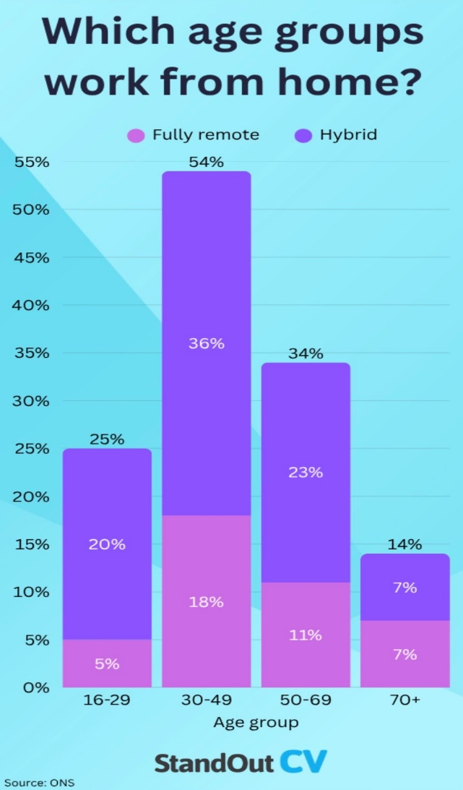
Sampling
The OPN analysis in this article is based on 6,670 working adults in Great Britain, from a pooled dataset comprising eight waves of data collection, covering the following periods:
14 to 25 September 2022
29 September to 9 October 2022
12 to 23 October 2022
26 October to 6 November 2022
8 to 20 November 2022
22 November to 4 December 2022
7 to 18 December 2022
21 December 2022 to 8 January 2023
Pooling eight waves of data together increases sample sizes allowing detailed analysis for different groups of the population. ONS (2022)
7.References
https://www.cipd.org/uk/knowledge/bitesize-research/remote-working-employee-wellbeing-work-behaviours
https://www.ons.gov.uk/employmentandlabourmarket/peopleinwork/employmentandemployeetypes/articles/characteristicsofhomeworkersgreatbritain/september2022tojanuary2023#characteristics-of-homeworkers
https://prospluscons.com/pros-and-cons-of-being-a-manager/
https://ifs.org.uk/articles/remote-working-probably-here-stay-and-these-are-reasons-why
Gibbs, G. (1988). Learning by doing: A guide to teaching and learning methods. Oxford Polytechnic.
https://post.parliament.uk/research-briefings/post-pb-0049/
https://pmc.ncbi.nlm.nih.gov/articles/PMC9690707/
https://www.proquest.com/docview/2785244541?sourcetype=Scholarly%20Journals
https://link.springer.com/article/10.1007/s10734-022-00892-y?utm_source=chatgpt.com

