case studies | Neil,Sharon swp3514  Domestic Abuse

Tania MOORE
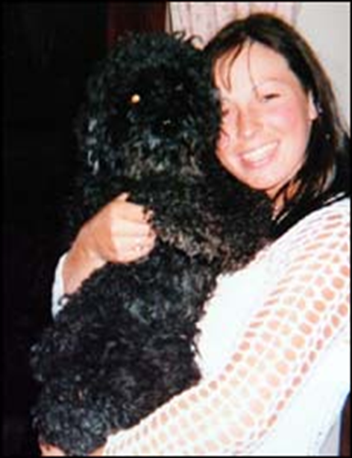
Engaged to Mark DYCHE 36 years.
Threatened to kill her if she ended the engagement.
Engagement ended.
Sent chilling messages and stalked her for 12 months – repeated threats to kill. Subjected her to a campaign of abuse and intimidation. DYCHE arranged for others to have her robbed, beaten (punched, kicked, struck her with a baseball bat) in her own home.
DYCHE and others rammed her vehicle off the road and DYCHE shot her in the face.
Derbyshire police
No dynamic risk assessment and treated as ‘low level’ domestic abuse.
Lack of information sharing with neighbouring police force.
Evidence gathering and investigative process poor (of the robbery 9 months before her murder).
Use of DASH criteria would have identified Tania MOORE as high risk.
One police officer was sacked, another demoted and four others including a Chief Inspector reprimanded for an, ‘abysmal’ failure to protect Moore after she had repeatedly told police about her fears following a robbery at her stables and home, stalking and threats to gouge out her eyes and break her legs.
The IPCC said that the response was “abysmal, no officer took control and no meaningful investigation took place.”

Claire BERNAL
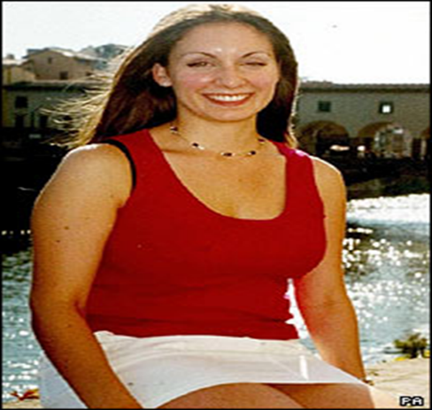
Claire Bernal (22yrs) had a brief relationship (3 “dates”) with Michael PECH (30yrs), whom she met at work at the Harvey Nichols Department Store in London.
PECH, a Czech national who had previously served in the Czech Army and as an armed guard at the American Embassy in London, was working at the Store as a Security Guard at the time. (Trainer note: The UK C Agency can check a person’s pre-cons with other EU countries).
Clare ended the relationship in March 2005 as she felt that PECH was getting very serious for such a casual relationship.
PECH then began a pattern of obsessive behaviour - turning up at Clare’s home, pestering her at work and texting her continually. He also threatened to kill himself.
PECH also watched Clare closely at work (physically moving “shoplifter mirrors” to focus on her counter, lurking near her counter) and persuaded a number of other employees to try to get Clare to start seeing him again.
On March 30th 2005 PECH followed Clare from the Store to London Bridge station he boarded the train with Clare who threatened to report him. PECH responded by putting his face close to hers and saying "IF YOU REPORT ME I’LL KILL YOU."
He tried to prevent her from leaving the train and at one point held her hand, smiled and said “IF I CAN’T HAVE YOU, NOBODY WILL.”
The next day Clare reported PECH’S behaviour to the Store Head of Security (a retired Police Officer) who adjusted CCTV cameras to monitor and record PECH and obtained statements from other employees. The Head of Security compiled this information into a file which he later offered to the OIC to assist the prosecution case. The OIC declined this offer.
Clare then contacted the Police and a statement was taken from her. No statements were taken from her flatmates or work colleagues and PECH was not arrested at this time but Harvey Nichols suspended PECH and he was escorted from the store by Police.
Within days the stalking resumed, with PECH lying in wait for Clare outside her new flat in Dulwich. He left before the Police attended.
On 4th April 2005 PECH followed Clare to a nearby café and sat staring at her until she fled.
He was arrested on 6th April 2005 and released on Bail.
On 10th April 2005, he attended at Clare’s flat again and was arrested. According to Clare, PECH "wasn't fazed at all," holding up his hands to show her the handcuffs and smiling directly at her.
Clare received no further contact from the Police.
PECH was charged with Harassment and Breach of Bail and remanded to Belmarsh prison.
On April 19th 2005 PECH appeared at Tower Bridge Magistrates. His case was adjourned until August 31st 2005 and PECH was released on Court Bail to appear 22nd September 2005.
No historical context/bad character evidence was given to the Court and no attempt made to confiscate his passport.
This situation was assessed as Low Risk (despite Threats to Kill, access to firearms, Mental Health issues, obsessive, controlling behaviour).
The Incident was dealt with in silo and no Joint Safety Planning took place. Clare was never told that PECH was out on bail…
PECH travelled to Slovakia on 25th April 2005 and bought a pistol.
On 20th July 2005 PECH returned to London with the pistol (he travelled by coach and was not searched at Customs).
Six weeks later he pleaded guilty to S.2 PHA (allegedly reduced from S.4 to protect Clare from having to give evidence in front of a man of whom she was still very afraid) and was bailed to 22nd September 2005 for pre-sentence reports.
At 7.45pm on September 13th 2005, shortly before the store was due to close, PECH walked into the store and shot Clare in the back of the head. He then fired three more bullets into her face before turning the gun on himself.
INQUEST - 18th JANUARY 2007
The Coroner (Dr. Paul Knapman) stated that he was satisfied Clare’s murder could not have been reasonably foreseen.
Knapman said that the police had made a series of errors in the run-up to the murder, the result of an "obsession" with paper trails and a culture of "ticking boxes".
Curiously this was not true in this case. Important forms, designed to feed vital information into police systems had been left untouched. Little additional paperwork had been completed beyond written statements taken at the time of Clare’s first complaint. Not every witness had been interviewed and no notice had been taken of Harvey Nichols’ own security file on PECH. Knapman declared several times that none of these oversights would have made any difference to the eventual outcome…
There was no written Risk Assessment at any stage of the investigation. The OIC in the PPU, an inexperienced PC who had received just 1 day’s training, assessed the situation as Low Risk. She later stated that she stood by her Risk Assessment.
Harvey Nichols:
Sacked PECH. Banned PECH from the store and handed out photographs of PECH to Security. Moved one of the CCTV cameras to focus on her counter.
If Harvey Nichols identified Clare Bernal as High Risk, why didn’t the Police?

Levi BELLFIELD
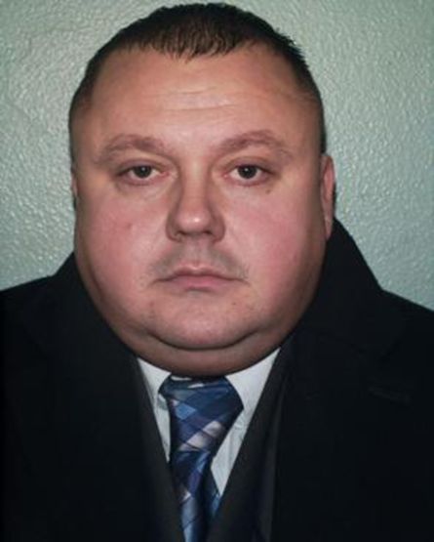
BELLFIELD was a doorman at a nightclub and a wheel clamper.
History of DA with partners including rape, choking, beatings with a hammer.
Controlling and possessive “I’m above the law.”
Convicted of 3 murders, (Marsha McDONNELL, Amelie DELAGRANGE and later Milly DOWLER), Attempted murder of Kate SHEEDY.
‘whole life tariff imposed.’
Had a particular liking for certain types of female.
Whilst working as a bouncer he would ID this type of person and get them into the VIP lounge and buy them champagne etc.
When relationship developed he would turn into controlling and sadistic. He would force partners to eat dog food off the floor naked. He would force them to sit in a chair naked all night and unable to move so they would wet themselves. He would carry out horrendous sexual acts against them. He would check the mileage on their car before and after they went out in the car. Although convicted of 2 murders, suspected of many more and being a serial rapist.
He would get his girlfriends to clean out the car after rape/murders and used this as a control strategy as that’s what he would do to them.

