

Master of Business Administration
Assessment component: Financial performance and management

Name:- Naimish Bhimjibhai Khunt
Student ID:- 2505506
Module cord:- LCMB7002
Module:- Financial Management
Lecturer:- Isaiah Oino

Table of Contents
1. Introduction 2
2. Financial Status Review 2
2.1 Evaluation of the Financial Statements of Firm 2
2.2 Financial Ratio Analysis 2
2.3 Analysis of Trends, Threats and Strengths 6
2.4 Prediction of Corporate Failure Utilizing Altman Z-Score Model 7
3. Evaluation of Working Capital Management 8
3.1 Analysis of Cash Operating Cycle 8
3.2 Recommended Approach 8
3.3 Analysing Short-Term and Long-Term Financing Options 9
4.Strategic Financial Reorganization 10
4.1 Financial Restructuring Recommendations 10
4.2 Effect on Debt Structure, Shareholder Value and Operational Adaptability 12
4.3 International and moral considerations 14
5. Capital Investment Analysis 15
5.1 Evaluation of Three Investment Proposals 15
5.2 Recommendation and Justification of Final Investment 19
6. Conclusion 19
7. References 21
8. Appendices 26

1. Introduction
Within a global enterprise entity such as General Electronics that has recently entered the financial problems arena and is in the consumer electronics industry, the main focus of the research is an analysis of the financial performance of the company in the past five years. In that sense, the research will focus on determining the main financial problems of the company and helping to develop a strategic financial restructuring plan that would resolve the problems and enhance the financial performance of General Electronics. This research will also evaluate three projects that have been proposed as an investment in the future and recommend the most suitable to the company.

2. Financial Status Review

2.1 Evaluation of the Financial Statements of Firm
The 2020 to 2024 financial reports reveal that the stability and performance reduced dramatically. ‘In 2024, operating losses went up to 15,297 million, largely due to high expenditures and impairments of assets, and net revenues decreased to 394,879 million (compared to 614,680 million in 2020). The net income in recent years decreased and decreased equity between the sums of £313,301 million and the sum of 153,105 million. Despite the fact that it was much lower than in the past years, cash flow was still positive in 2024 at £14,822 m. Liquidity declined with a decrease in cash as it moved down to £26,783 m’. Everything being said and done, the business is facing problems of profitability, efficiency, and liquidity that require strategic restructuring.

2.2 Financial Ratio Analysis
a. Profit Margin Ratio
The net profit margin is used to get the net income per unit of sales of a company after deducting costs and taxes (Corporatefinanceinstitute, 2025). ‘The margin has declined in 2020 to a relatively low 6.3% and then it has lost it in 2023 and 2024 by 23.6% and 23.6%, respectively, which is a symptom of poor profitability and low utilisation of costs. Such losses include high costs and poor performance in terms of income.
b. Operating Margin
Andoko and Angeline (2023) state that operating margin presents the percentage of the profit gained in the normal operation that is devoid of interest and taxes. It dropped to 6 percent in 2020, -20 percent in 2023, and -40 percent in 2024, which implies a significant drop in the efficiency of its operations. The decline was most probably caused by the higher selling and administrative expenses. The negative overall margins are showing less production and poor cost control.
c. Current Ratio
The current ratio measures a company in relation to its debt within the current period that it can fulfill using its current assets (Corporatefinanceinstitute, 2024). It decreased to 1.8 in 2020 and then 1.5 in 2024 as an indicator of reduced liquidity. The decreasing pattern implies deteriorating working capital, although a ratio of more than one can indicate sufficient working capital short-term solvency. This implies that the cash flow of the firm is not high. The liquidity may be limited by shorter payment periods and effective stock management.
d. Quick Ratio
The current ratio measures a company in relation to its debt within the current period that it can fulfill using its current assets (Corporatefinanceinstitute, 2024). It decreased to 1.8 in 2020 and then 1.5 in 2024 as an indicator of reduced liquidity. The decreasing pattern implies deteriorating working capital, although a ratio of more than one can indicate sufficient working capital short-term solvency. This implies that the cash flow of the firm is not high. The liquidity may be limited by shorter payment periods and effective stock management.
e. Inventory Turnover Ratio
Inventory turnover is the number of times inventory is being sold and replenished in the long run (BDC, 2025). It increased to 3.5 times in 2024, which is an indication of improved inventory management and demand recovery after a downturn in 2022. Nevertheless, the performance remains lower than it was to 2021. The sale and production cycles should be balanced in the business.
f. Receivables Turnover Ratio
The Receivables Turnover displays the pace at which the business collects receivables by its clients. It declined to 3.5 times in 2024, downward of 4.7 times in 2020 because of reduced collections and credit risk. This could be due to soft credit policy or a fall in consumer demand. The slow pace of collections is a decrease in cash inflows and liquidity. The business is also recommended to better its management of credit.
g. “Debt to Equity” Ratio
To indicate financial leverage, debt to equity ratio can be used to compare the total debt and shareholder equity of a company (Corporate Finance Institute, 2023). Its increase was 0.63 to 1.11 in 2020 and 2024 respectively which showed a higher dependence on borrowed funds. High leverage is a financial risk that is associated with a reduction in profitability. The growth also implies poor equity because of a sustained loss. The firm also needs to methods of re-balancing its sources of funding in a bid to restore investor confidence and financial balance.
h. “Interest Coverage” Ratio
Interest Coverage Ratio indicates the effort with which the company can use its operating income to cover interest on its debt. It fell to negative in 2023 and 2024, which is 26.1 times in 2020, suggesting that the company will not have sufficient funds to cover the interest expenses on profits. It is an indication of severe financial problems, even bankruptcy. Poor coverage would hike the interest rates and destroy the credibility of lenders. It is necessary to regain profitability and minimize the levels of debt (Jariah and Lukiana, 2023).
i. Return on Equity (ROE)
The return on equity (ROE) measures an organization and its ability to use shareholder capital to make profits (HBS, 2025). It declined between 12.3 per cent in 2020 to -54.9 per cent in 2023 and -15.7 per cent in 2024, which led to great losses and destruction of equity value. The negative ROE is very large which indicates that instead of the money going back to the shareholders, it is being drained away. To reverse this the business would have to improve operational efficiency in the business.
j. Earnings per Share (EPS)
EPS is the number of dollars given by the company to every share that is outstanding. It dropped significantly in 2020, down to 2.78, and -7.64, respectively, with very low profits. The deterioration reflects the overall loss of earnings and potential impairments of assets. The destruction of market value and shareholder trust takes place when the EPS is always lower than zero. The increase in revenue and the control of expenses should be ensured to get back to profitability.
k. Operating Cash Flow Margin
This ratio reflects the ratio of operating cash flow and the total sales (Corporatefinanceinstitute, 2025). It was 3.8 in 2024 (-11.9 in 2020), yet it remains positive, which means that, even in the situations of financial loss, the business is able to generate working cash. The decreasing margins however indicate that sales-to-cash conversion process is inefficient.
l. Free Cash Flow Margin
Free cash margin of flow is the percentage of sales which remains after deduction of the capital expenditure. It dropped to 2.6 in 2024 and 2.2 in 2022, which implies a decrease in financial flexibility. A positive FCF that decreases after investments is an indication that cash is becoming tight. The business should focus on the necessary capital expenditures and increase the rate of cash generated during operations in order to maintain the liquidity.

2.3 Analysis of Trends, Threats and Strengths
Area | Trend | Interpretation
Revenue | Sales dropped to £394,879 million in 2024 from £614,680 million in 2020. | A roughly 36% decline in sales suggests a potential loss of global market share and weakening of demand. Threat
Profitability | Between 2020 and 2024, net income decreased from £38,572 million in gains to £24,029 million in losses. | demonstrates declining earnings as a consequence of lower sales and higher COGS. Threat
Operating Margin | In 2024, it decreased from 6.06% in 2020 to -3.87%. | Decreased effectiveness in sales and a startling rise in expenses, Threat
Liquidity Ratios | As of 2024, the current ratio ranges from 1.82 to 1.53. | The short-term liquidity has been maintained, although it is gradually decreasing. Threat
Leverage | Between 2020 and 2024, the debt-to-equity ratio increased from 0.63 to 1.11. | Demonstrates the company's growing dependence on debt and declining equity. This indicates the firm's financial risk.Threat
Cash Flow | The operational cash flow decreased from 11.94% to 3.75% throughout these five years. | Ineffective cash conversion from sales. This indicates a decrease in sales efficiency. Threat. As of 2024, operational cash flow of £14,822 million demonstrates a steady performance of core businesses. Strength
Asset Efficiency | Between 2022 and 2024, inventory turnover increased somewhat from 2.79 to 3.54. | After suffering losses in 2022, the corporation has improved its inventory management. Strength
Shareholder Return | From 12%, return on equity dropped to -16%. | A steady drop in share value.Threat
Table: Trends identified from the above Financial Statement and Ratio Analysis
(Source: Self-developed)
When it comes to the strengths of the company, it was found that, despite the massive losses reported in the financial statement, the company was generally doing well in terms of its core business operations, which is observed by the operational cash flow of £14,822million as of 2024. Also, the consistent turnover of accounts receivable proves that client payment cycles are steady in recessions, and they are the main source of revenue. Furthermore, the drop in inventory in 2022 of between £140,181 million to 2024 of £79,355 million illustrates an increase in the working capital efficiency. General Electronics may reduce receivables and improve net finances available to conduct operations on day-to-day basis by adopting an aggressive working capital policy could result in an overall improvement in financial performance of the company. The increasing debt level as witnessed by the increasing debt-to-equity ratio, however, is a threat to the long term financial performance of General Electronics. Moreover, the company is increasing its costs at an alarming rate as the table provided with it indicates. This endangers the profitability of the company. Also, economic unsustainability manifests itself in the shareholder value, which dropped to -16% in 2024, which threatens the departure of key shareholders.

2.4 Prediction of Corporate Failure Utilizing Altman Z-Score Model
The Altman Z-Score model (Altman, 2017) is a quantitative method of using financial measures to forecast the probability of a company going into bankruptcy. It has five weighted measures, including Market value of Equity to Total Liabilities (X 4), Earnings before Interest and Taxes to Total Assets (X 3), Working Capital to Total Assets (X 1), Retained Earnings to Total Assets (X 2) and Net Sales to Total Assets (X 5). The formula can be presented in the following way:
Z = 1.2X₁ + 1.4X₂ + 3.3X₃ + 0.6X₄ + 1.0X₅.
The calculated values of this model based on the latest information of General Electronics in 2024 are:
- The ratio of total assets to working income is 0.26.
- The ratio of retained profits and total assets is -0.07.
- Total Assets/EBIT = -0.05
- Value of Equity/Total Liaisons = 0.90.
- Total Assets/Sales = 1.22
Hence, Z = (1.2×0.26) + (1.4×−0.07) + (3.3×−0.05) + (0.6×0.90) + (1.0×1.22) = 1.44.
The Z-score of less than 1.8 is regarded by Altman as a business being in the crisis zone that is highly likely to fail. General Electronics is therefore facing a serious financial crisis as indicated by its Z-score of 1.44 which is in line with previous results of decreasing profitability, negative ROE, and increasing debt’. To recover solvency and investor confidence, this foreseeable situation enhances the sense of urgency in the nature of restructuring plans, such as the sale of underperforming assets and efficiency of the working capital.

3. Evaluation of Working Capital Management

3.1 Analysis of Cash Operating Cycle
The cash operating cycle (COC) is referred to as the time required to turn inventories and receivables into cash and indicates the efficiency of the company to utilize working capital (Asman et al., 2022). ‘General Electronic experienced an increase in the inventory turnover rate which currently stands at 2.79 in 2022 and 3.54 in 2024 which shows that the current inventory clearance rate is faster. But the slower customer collection was indicated by the reduction of the collection turnover that dropped to 3.46 to 4.83. Because of this factor, the cash conversion cycle is increasing up to 10 times the stock handling has become better because of the tardiness of client payments. Also, the company is experiencing slower cash collections in its operations, thereby diminishing liquidity and putting pressure on finance. Also, more time in the COC translates to money that can be used in debt repayment or investment.

3.2 Recommended Approach
The increase in the debt to equity ratio in the case of General Electronics implies that it does not need external borrowing but should work on improving its working capital as a way of increasing liquidity. Some of the proposed tactics include the following:
Turnover of accounts receivables declined in 2022 (4.83) and 2024 (3.46), which means that the company is currently taking more time to collect the money due to previous sales. Bessonova, Bessonova, and Shevchenko (2024) state that the high level of receivables decreases the profitability of a company and restricts its liquidity. In this way, it could be implied that the company could raise the liquidity by accelerating the turnover of money collected based on the prior sales by tightening the credit requirements, offering incentives to pay on time, and outsourcing the collection. The businesses can maximize on liquidity and returns by good management of cash conversion cycles.
In spite of the fact that the General Electronics inventory declined to 79,355 million of 2024 compared with 140,181 million of 2022, the present inventory of the company still comprises approximately 33 percent of the current assets as of 2024. It means that the inventory optimisation still needs to be improved with minimising inventory and employing leaner methods such as Just-in-Time (JIT) approaches, demand forecasting systems, and simplification of stock holding units. Also this could boost the total liquid assets that get freed up by the firm thus triggering up the liquidity of the firm. To companies, an efficient inventory management is necessary as it results in less investment in inventory, availability of newer products and better liquidity. Furthermore, inventory management also plays a vital role in determining financial stability of a firm because it can either amplify financial liquidity of a firm in case of optimisation of inventory.

3.3 Analysing Short-Term and Long-Term Financing Options
Short-term and long-term funding are different in terms of their length, cost, and purpose. Short-term funding options include credit lines, trade payables, short-term loans that are usually paid in less than a year (Corporatefinanceinstitute, 2024). The long-term financing will be made up of bonds, debentures, and equity, which will be paid over a period of several years and are all financed on asset or expansion. According to the balance sheet, General Electronics increasingly depends on short-term borrowing, in 2020, the company was already dependent on it at 20,000 million, and in 2024, the level was already 36,960 million. That indicates the use of short-term borrowing to address liquidity requirements. Even though short-term financing is more adaptable and cheaper, there is a risk that it would create a liquidity problem in case of a low sale (Hempel and Tibay, 2024). The quick and current ratios are also decreasing in the company and this indicates that the company is becoming less efficient in satisfying its short-term obligations without being strained. Conversely, the long term debt has not changed, comprising of the deferred obligations and leases. This implies that the use of long term financing is becoming less frequent, which could be done to circumvent increased interest rates and more long term repayment obligations. Financial financing is however, very predictable and enables the business to invest in lucrative assets without necessarily making repayments immediately. The debt-to-equity ratio of the company has increased and by 2024 the company will have 1.11 which is higher compared to the 0.63 of 2020. The company should create a balance between the two sources of funding. Although high amounts of long-term debt can negatively affect financial flexibility and raise interest payments, high amounts of short-term debt could put ministership on their liquidity. In order to stabilize it, General Electronics must concentrate on the internal funding by enhancing management of working capital. The shorter time of invoice payment and increased optimisation of inventory would lead to reduced reliance on costly external resources’. The tightening of the belt in case of requiring outside capital can be helped by a combination of long-term loans and retained profits.

4.Strategic Financial Reorganization

4.1 Financial Restructuring Recommendations
Strategic Option 1: Divestment of underperforming assets
The value of a firm can be enhanced by selling its non-core assets which perform poorly as it has been reported by Rask and Hedegaard (2021). ‘In this respect, the return on assets (ROA) of the General Electronics has reduced considerably to -7.4% in 2024 against 7.6% in 2020 despite the asset base of the company remaining at 323,354 million. This again proves that, as at 2024, the company is keeping assets that do not give it sufficient returns but rather reduce the profitability of the company. On the other hand, the sale of the said assets will increase the liquid cash reserves of the company and will enable it to invest in the acquisition of assets that would yield more returns in the road. Consequently, the decision to sell non-core business that is not performing well is a very strategic decision in the case of General Electronics.

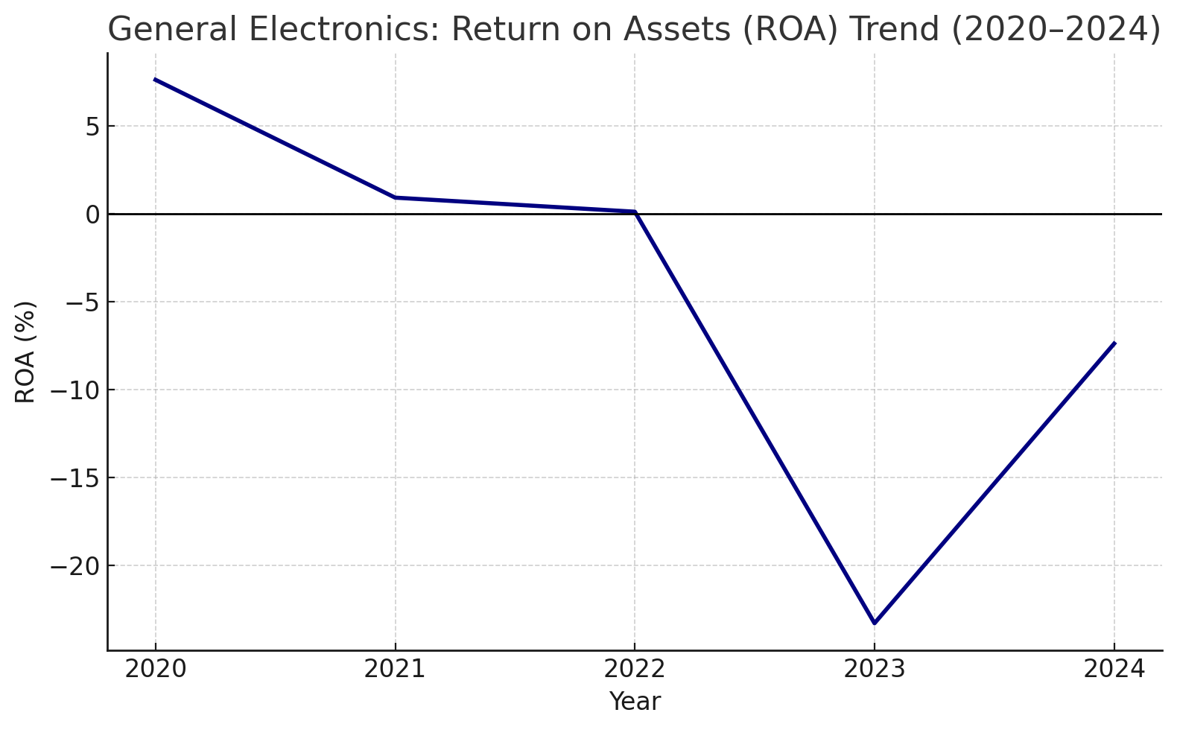
Figure: ROA Trends for General Electronics between 2020 and 2024
(Source: Self-Developed)
Strategic Option 2: Equity Injection via Rights Issue
Corporations that are making losses may at times choose to acquire equity by giving rights to the existing shareholders as they are usually much motivated to save the corporation. Thus, the General Electronics shareholders will have a greater chance of injecting equity into the company to boost ROE in exchange of a rights issue because the shareholder value of the company has gone down to -16% by 2024. that even companies tend to issue the rights to raise equity as a last resort to raise funds. Equity injection is an appropriate strategic option to General Electronics as a final solution, which is not superior to the previously described divestment option (Piprani et al., 2022). Therefore, the sale of General Electronics' underperforming non-core assets is the best course of action for the company's strategic financial reorganisation.
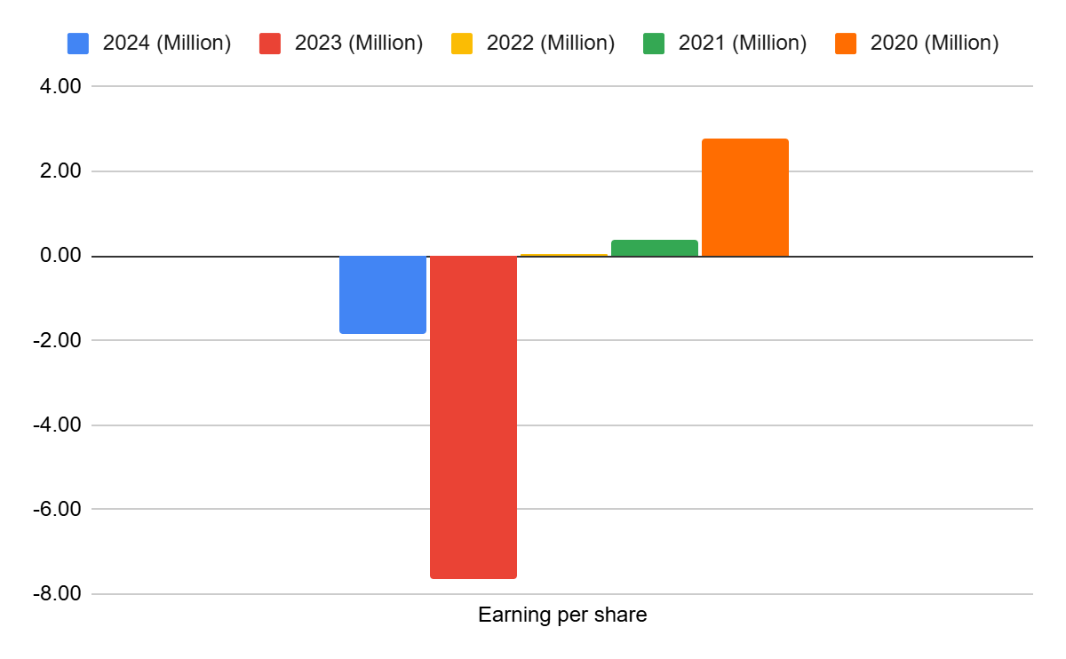
Figure: Earnings per share
(Source: Table to Appendix)

4.2 Effect on Debt Structure, Shareholder Value and Operational Adaptability
Debt Structure: Businesses exploit divestitures as a solution to internal issues which include poor performance of business units or companies. This is in line with the case of General Electronics. In this regard, the insurance of the company enables the company to compensate its debts, thereby decreasing the debt-to-equity ratio. Also, the sale of non-core assets which are not doing well can affect the debt structure of the company by dramatically improving the liquidity ratio which currently stands at 1.11 however in 2020 it was at 0.63. The interests on loans are considered as real spending of a business whereas the timely payment of the debts can increase the creditworthiness of the firm (Feng and Wu, 2023). In this regard, the divestment can help the company reduce its interest based costs on account of the increased liquidity and the repayment of the loans can help improve the credibility of the company to borrow funds at low costs in future. This shows that the debt structure of General Electronics can be affected in a major way by the application of non-core, non-performing divestiture (Ramadhan, 2024).
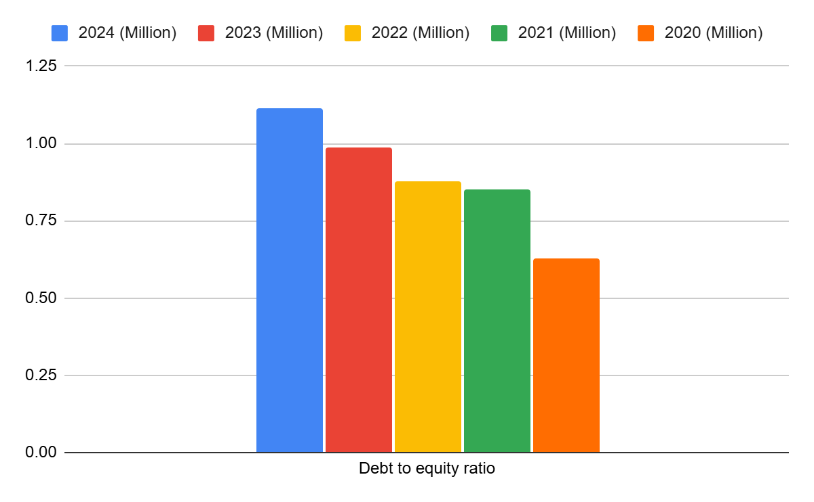
Figure: Debt-to-equity ratio
(Source: Refer to Appendix)
Shareholder Value: A study by Osiichuk and Wnuczak (2021) further revealed that non-operating assets of a company may greatly decrease its potential value in case they are not strictly controlled by the shareholders. This is because these assets and related activities deny businesses its ability to be agile and thus make the overall organisational structure unnecessarily opaque. The company is also experiencing the effect of the underperforming non-core assets owned by General Electronics as they are reducing the ROA and consequently, they are destroying the shareholder value. Consequently, liquidation of such assets can not only increase the liquid cash position of the company but also reduce debt-to-equity ratio which would reduce leverage, decrease cost of capital, and increase shareholder equity. Thus, the sale of non-core underperforming assets can greatly enhance the shareholder value of General Electronics.
Operational Flexibility:Regarding the operational flexibility of the General electronics, the business can streamline its main business operations by selling the non core assets. This provides the company with the option to shift its resources and experience towards improving its main operations. Moreover, this could assist General Electronics to make decisions more efficiently since it would simplify the organisational structure of the company. Non-operating assets might make the corporate structure of a company vague. In that regard, one can assume that the divestment of the non-core underperforming assets can considerably influence the operational flexibility of General Electronics. To this effect, the operational efficiency of the firm could also be enhanced through strategic disposal of non-performing assets, which would improve the financial returns of the firm.

4.3 International and moral considerations
The global and moral concerns that General Electronics should consider when the company divestiture of non-core businesses that are performing poorly as financial restructuring strategy is CSR, taxes, inflation and currency risks.
Tax Liabilities:As an example, the capital gains of selling the assets might follow different tax rates in the foreign markets. General Electronics should properly structure the asset transactions to avoid such issues as the possibility of double taxation and the failure to comply with the requirements of the OECD transfer pricing (Challoumis, 2023).
CSR: besides that, General Electronics should ethically handle the post-divestiture consequence in corporate social responsibility (CSR) terms through green investments, proper layoffs, and open communication and reporting throughout the entire process. The key to successfully incorporation of corporate social responsibility (CSR) into corporate restructuring efforts of businesses in asset divestment involves open and transparent updates of progress and proper layoff of staff in the company.
Inflationary Risk: Since the value of the assets to be sold can change rapidly in the countries with high inflation, therefore, General Electronics will have to carry out open reevaluations.
Currency Risk:Also, the buys of assets that General Electronics made in volatile foreign economies may also lead to reduced sales revenues after conversion into the reporting currency of the company. The company should develop forward contracts in order to prevent such losses due to depreciation of the currency’. Currency risk is one of the key threats to the equity capital depreciation of a company (Bhatia and Kumar, 2024).

5. Capital Investment Analysis

5.1 Evaluation of Three Investment Proposals
NPV
Definition
The difference between the investment and the current inflows of cash in the project is the net present value, or NPV. ‘It is applied to calculate the current-worth of the project to the company in general ( Net present value, 2024). The value of the net present value (NPV) when it is positive signifies that the project is profitable; a negative NPV implies the project is not worth taking (Le, 2021).
Project A
Project A will experience a positive cash flow within five years with the initial investment amounting to forty million pounds. The net present value (NPV) of the total inflows of 41.31 million at a discount rate of 10 percent is 1.31 million. This implies that the project is a cheap one and it will introduce a marginal value. The returns are low and the payback period is consistent. Project A will increase shareholder value since it has a profitability index that is more than 1; however, the profitability of Project A is lower than that of Project C and it is a bit limited by its capital efficiency.
Project B
Project B will generate an inflow of 6 million every year, but it will need an investment of 30 million. With the discount rate of 10 percent, the present value of 22.73 million NPV is negative and takes the form of 7.27 million. This implies that the business kills value and does not make its cost of capital. The low and low cash flows are not promising and do not have much potential of growth. It is not economically viable as it is indicated by the profitability index that is lower than 1. In general, Project B must not be accepted because it does not comply with the requirements of the company in terms of the investment performance and provides adequate returns (Youseuf et al., 2021).
Project C
Project C possesses an increasing and high inflow in a period of five years investment in the project, yet the capital expenditure of the project is huge of fifty million pounds. The total present value of inflows at 10 per cent will be equal to 54.2 million and the NPV will be equal to 4.2 million. Project C is the best of the three, based on this favourable NPV. In the first and fourth years, there is a high increase in the cash flows, implying a huge potential of profitability. The project will be worth more than giving a high starting cost and its profitability index will be also more than 1. It has been improving its financial performance and it utilizes its resources effectively thus it has to be given priority to be invested in.
IRR
Definition
The rate at which a project's net present value is regarded as zero is known as the discount rate. It is the project's projected rate of return. The project is economically viable and ought to be approved if the internal rate of return (IRR) exceeds the company's needed rate.
Project A
Project A would involve a financial inflow of a growing amount over the five year duration following a preliminary investment of £40 million with the high of these inflows coming in year three of 14million. The internal rate of return (IRR) stands at 6 and this is not high compared to the budgeted cost of capital which stands at 10. This implies that the project would not give the required rate of return to the company. Profitability is not sufficient in the initiative despite the steady inflows generated by the initiative. Project A is therefore poor in financial terms and should not be given the green light unless it has been selected to be not based on financial considerations, but due to its strategic importance. Its risk in investment is medium and value production is low.
Project B
Project B requires a capital amount of thirty million pounds, and the annual inflows are equivalent, that is, six million pounds annually, in five years. The project is undoubtedly not profitable and is not worth its initial investment as the forecasted IRR is -8 (Wu et al., 2022). The negative value of the return would indicate it is impossible to cover the original expenditure through the total inflows even without discounting. This implies that it has a low level of capital efficiency and high level of financial risk. Any reasonable cost of capital assumption requires the project to be abandoned immediately as it is value-destroying and there is no indication of any future growth (Xia, Baghaie, and Sajadi, 2024).
Project C
Project C This is a 50 million investment whose cash flows are increasing achieving a maximum of 25 million on year four but reducing slightly in the last year. Similar to Project A, the IRR of 6 represents poor profitability as the value is lower compared to 10 percent cost of capital. Nevertheless, the project provides a higher cash flow growth, cumulative returns, which are better in the long-term. Nevertheless, the quality of the investment is not yet as high as it should be. Yan and Zhang (2022) indicate that Project C is also not an appropriate investment undertaking and would have been pursued in case of strategic or non-financial advantages.
Index of Profitability
Definition
The profitability index ratio is the present value of the future cash inflows of the original investment. The Profitability Index (2024) indicates the value created on a pound of investment. A project which has PI less than 1 must be rejected though when it is bigger than 1, then it means that the project would be value adding.
Project A
According to Project A, the initial investment is required to be 40 million and the cash inflow within the period of five years is 8-14 million annually. When it is discounted at 10 percent the total present value of the inflows will be £41.31 million and the index of profitability (PI) will be approximately 1.03. This implies that the project is a marginal value source and has already crossed past the break-even level. The project appears to be very sound and the returns are average. There are no imbalances in cash flows and risk is managed. Consequently, Project A is a decent and not most profitable project comparing it to other ones.
Project B
Project B will incur an initial investment of £30 million within a period of five years that will be subject to recurring inflows of the same sum or 6 million pounds annually. To determine the profitability index where the present value of all these inflows at a discount rate of 22.73 = 10 percent will be less than 1 or about 0.76. This implies that in case the project is implemented, value will be killed and the investment capital would not be recovered (Wang, 2021). The homogenous flow of inputs implies low growth levels and poor use of capital. In accordance with the existing assumptions, Project B is not supposed to be accepted since it is not a financially appealing project (Jain et al., 2021).
Project C
Project C will offer higher inflows which will increase with time to reach 25 million pounds in the fourth year, but will require higher investment amount of 50 million pounds. The discounted value of the inflows or 54.2 million pounds is the present value of the inflows discounted at 10%. This can be translated to a profitability index of nearly one point eight. This implies that it is an investment with a high value creation rate and great returns as compared to the investment cost. The project is very profitable and uses resources well, even though its initial investment is high, it has a high value of cash flow characteristic (Charupat and Sarkar, 2025).

5.2 Recommendation and Justification of Final Investment
Based on the investment appraisal study, which is based on the NPV, IRR and Profitability Index, project C is the most cost effective project to consider investing in. Project C will have positive net present value of 4.2 million with a profitability index of 1.08 and a maximum total present value of 542 million. It is an indicator that it produces high ROI, and enhances shareholder value. The high capital need is still being offset by growing cash inflows and prospects of good development and the initial high capital requirements of $50 million are still justified (Shou, 2022). Project A is a little more profitable as compared to Project C and has PI of 1.03 and NPV of £1.31 million. Project B is not a profitable venture as the NPV is negative and PI is below 1. Project C is the best investment to be done because it returns the highest returns therefore in a capital-rationing environment where 60 million is the only amount that may be invested it should be prioritised. Project A can be considered in case it gets more funding, and Project B would not be accepted. Project C is the best option in terms of enhancing profitability and financial viability in the long term due to the outstanding performance and increased risk resistance as indicated by increasing cash flows.

6. Conclusion
As shown through the financial analysis of financial records of General Electronics, the business is currently losing money, it has falling shareholder values, and increasing debt-to-equity ratio. In this case it has been established that the company can maximise its liquidity through optimisation of its inventory, working capital reform and a faster conversion of the receivables into cash. Moreover, the company will be forced to reorganize its finances by disposing the non-core assets that are not performing well. This would improve the debt position, operating capacity, and share values of the company and the overall financial performance of General Electronics’. Moreover, Project C is chosen as the one suitable to General Electronics among three strategic investment projects provided because of its high profitability potential.

7. References
Altman, E.I., Iwanicz‐Drozdowska, M., Laitinen, E.K. and Suvas, A., 2017. Financial distress prediction in an international context: A review and empirical analysis of Altman's Z‐score model. Journal of international financial management & accounting, 28(2), pp.131-171.https://onlinelibrary.wiley.com/doi/abs/10.1111/jifm.12053
Asman, F.N., Fernandez, D., Jamaludin, N.A., Omar Zaki, H. and Ghazali, A.W., 2022. Cash conversion cycle and firm’s performance. International Journal of Academic Research in Business and Social Sciences, 12(11), pp.2682-2692. https://www.academia.edu/download/66068090/WORKING_CAPITAL_MANAGEMENT_AND_BUSINESS_PERFORMANCE.pdf
BDC. (2025) BDC.ca. Available at: https://www.bdc.ca/en/articles-tools/entrepreneur-toolkit/financial-tools/inventory-turnover-benchmarking-tool (Accessed: 12 November 2025).
Bessonova, A., Bessonova, S. and Shevchenko, A., 2024. Optimization of Receivables of an Enterprise as a Tool for Strengthening Financial Efficiency. Економіка розвитку систем, 6(2), pp.146-150. https://esd-journal.sumy.ua/index.php/journal/article/download/75/68
Bhatia, P. and Kumar, R., 2024. Do debt, and operating efficiency contributes to corporate performance?. International Journal of System Assurance Engineering and Management, 15(3), pp.1203-1209.https://link.springer.com/article/10.1007/s13198-023-02206-6
Challoumis, C., 2023. Impact factor of liability of tax system according to the theory of cycle of money. Social and Economic Studies within the Framework of Emerging Global Developments Volume 3, V. Kaya, 3, pp.31-42.https://www.researchgate.net/profile/Mohammed-Alfoul/publication/374056617_Unlocking_the_Potential_of_ChatGPT_in_Economic_and_Finance_Studies_A_Game-Changing_Case_Study/links/650b6f7882f01628f0345f6a/Unlocking-the-Potential-of-ChatGPT-in-Economic-and-Finance-Studies-A-Game-Changing-Case-Study.pdf#page=32
Charupat, N. and Sarkar, S., 2025. Operating flexibility and optimal capital structure. Accounting & Finance.https://onlinelibrary.wiley.com/doi/abs/10.1111/acfi.13391
Corporate Finance Institute. (2023). Corporate Finance Institute. Available at: https://corporatefinanceinstitute.com/resources/commercial-lending/debt-to-equity-ratio-formula/ (Accessed: 12 November 2025).
Corporatefinanceinstitute. (2024). Corporate Finance Institute. Available at: https://corporatefinanceinstitute.com/resources/accounting/current-ratio-formula/ (Accessed: 12 November 2025).
Corporatefinanceinstitute. (2024) Corporate Finance Institute. Available at: https://corporatefinanceinstitute.com/resources/accounting/short-term-loan/ (Accessed: 12 November 2025).
Corporatefinanceinstitute. (2025). Corporate Finance Institute. Available at: https://corporatefinanceinstitute.com/resources/accounting/net-profit-margin-formula/ (Accessed: 12 November 2025).
Corporatefinanceinstitute. (2025). Corporate Finance Institute. Available at: https://corporatefinanceinstitute.com/resources/accounting/operating-cash-flow/ (Accessed: 12 November 2025).
Feng, Z. and Wu, Z., 2023. ESG disclosure, REIT debt financing and firm value. The Journal of Real Estate Finance and Economics, 67(3), pp.388-422. https://pmc.ncbi.nlm.nih.gov/articles/PMC8390044/pdf/11146_2021_Article_9857.pdf
HBS. (2025) How & why to calculate return on equity (ROE) - HBS online. Available at: https://online.hbs.edu/blog/post/return-on-equity-formula (Accessed: 12 November 2025).
Hempel, S., Li, Y. and Tibay, S., 2024. Firms' financing choice between short-term and long-term debts: Are they substitutes?.https://www.federalreserve.gov/econres/notes/feds-notes/firms-financing-choice-between-short-term-and-long-term-debts-are-they-substitutes-20240503.html
Jain, V., Malviya, B.I.N.D.O.O. and Arya, S.A.T.Y.E.N.D.R.A., 2021. An overview of electronic commerce (e-Commerce). Journal of Contemporary Issues in Business and Government, 27(3), p.666.https://www.researchgate.net/profile/Vipin-Jain-13/publication/351775073_An_Overview_of_Electronic_Commerce_e-Commerce/links/60a8d9af45851522bc0aed79/An-Overview-of-Electronic-Commerce-e-Commerce.pdf
Jariah, A. and Lukiana, N., 2023. Management of Financial Performance Based on Capital Structure, Liquidity Ratio, Coverage and Activity. Assets: Jurnal Ilmiah Ilmu Akuntansi, Keuangan Dan Pajak, 7(2), pp.1-7.http://178.128.120.64/index.php/asset/article/view/1030
Le, S., 2021, December. The applications of NPV in different types of markets. In 2021 3rd International Conference on Economic Management and Cultural Industry (ICEMCI 2021) (pp. 1054-1059). Atlantis Press.https://www.atlantis-press.com/proceedings/icemci-21/125966042
Net present value. (2024). Corporate Finance Institute. Available at: https://corporatefinanceinstitute.com/resources/valuation/net-present-value-npv/ (Accessed: 12 November 2025).
Osiichuk, D. and Wnuczak, P., 2021. The Impact of Minority Shareholder Protection and Atomization of Shareholder Base on the Nonoperating Activities of Firms. Available at SSRN 3872957. https://papers.ssrn.com/sol3/Delivery.cfm?abstractid=3872957
Piprani, A.Z., Jaafar, N.I., Ali, S.M., Mubarik, M.S. and Shahbaz, M., 2022. Multi-dimensional supply chain flexibility and supply chain resilience: The role of supply chain risks exposure. Operations Management Research, 15(1), pp.307-325.https://link.springer.com/article/10.1007/s12063-021-00232-w
Profitability index. (2024). Corporate Finance Institute. Available at: https://corporatefinanceinstitute.com/resources/accounting/profitability-index/ (Accessed: 12 November 2025).
Ramadhan, S.A., 2024. Exploration of the Impact of Profitability and Debt Policy on Company Value. KINERJA: Jurnal Manajemen Organisasi dan Industri, 3(2), pp.212-220.https://jurnalpustek.id/index.php/kjmb/article/view/148
Rask, S.S. and Hedegaard, K.G., 2021. Value creation in corporate divestments. https://research.cbs.dk/files/68334314/1155567_Master_Thesis_S.Rask_K.Hedegaard.pdf
Shou, T., 2022, July. A literature review on the net present value (NPV) valuation method. In 2022 2nd International Conference on Enterprise Management and Economic Development (ICEMED 2022) (pp. 826-830). Atlantis Press.https://www.atlantis-press.com/proceedings/icemed-22/125975449
Wang, Y., 2021, December. The development and usage of NPV and IRR and their comparison. In 2021 3rd International Conference on Economic Management and Cultural Industry (ICEMCI 2021) (pp. 2044-2048). Atlantis Press.https://www.atlantis-press.com/proceedings/icemci-21/125966320
Wu, C.K., Cheng, C.T., Uwate, Y., Chen, G., Mumtaz, S. and Tsang, K.F., 2022. State-of-the-art and research opportunities for next-generation consumer electronics. IEEE Transactions on Consumer Electronics, 69(4), pp.937-948.https://ieeexplore.ieee.org/abstract/document/9999553/
Xia, L., Baghaie, S. and Sajadi, S.M., 2024. The digital economy: Challenges and opportunities in the new era of technology and electronic communications. Ain Shams Engineering Journal, 15(2), p.102411.https://www.sciencedirect.com/science/article/pii/S2090447923003003
Yan, R. and Zhang, Y., 2022, March. The Introduction of NPV and IRR. In 2022 7th International Conference on Financial Innovation and Economic Development (ICFIED 2022) (pp. 1472-1476). Atlantis Press.https://www.atlantis-press.com/proceedings/icfied-22/125971692
Yousuf, A., Lorestani Zeynvand, V., Felföldi, J., Zatonatska, T., Kozlovskyi, S. and Dluhopolskyi, O., 2021. Companies performance management: the role of operational flexibility.https://essuir.sumdu.edu.ua/handle/123456789/83571

8. Appendices
Ratio analysis:
Table:
Profitability ratio
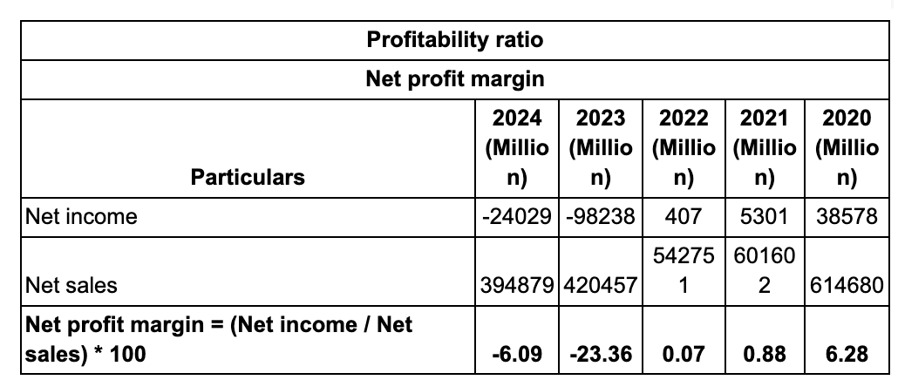
Table 1: Net profit margin
(Source: self-report, 2025)
Operating profit margin
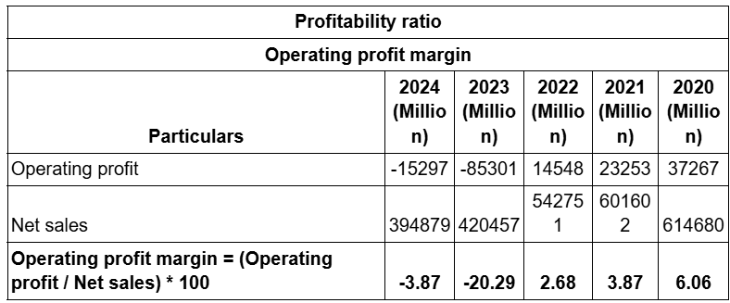
Table 2: Operating profit margin
(Source: self-report, 2025)
Liquidity ratio
Current ratio
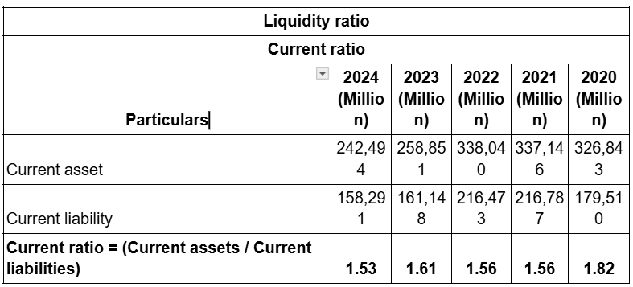
Table 3: Current ratio
(Source: self-report, 2025)
Quick ratio

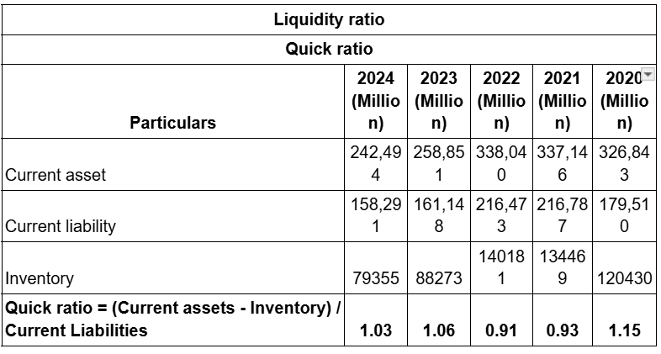
Table 4: Quick ratio
(Source: self-report, 2025)
Efficiency ratio
Inventory turnover ratio

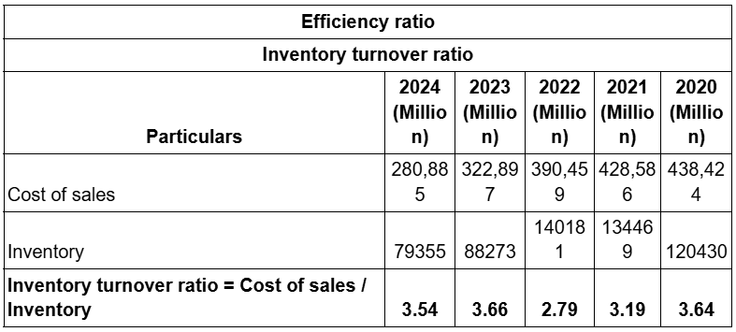
Table 5: Inventory turnover ratio
(Source: self-report, 2025)
Receivable turnover ratio

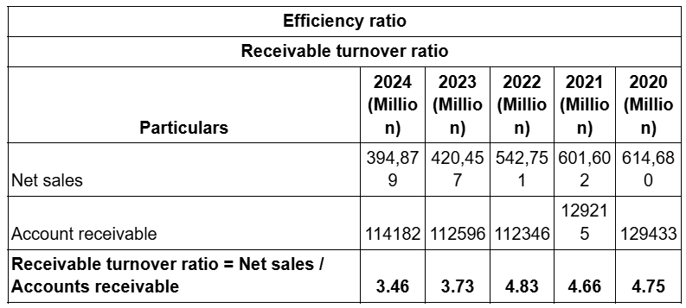
Table 6: Receivable turnover ratio
(Source: self-report, 2025)
Gearing ratio
Debt to equity ratio

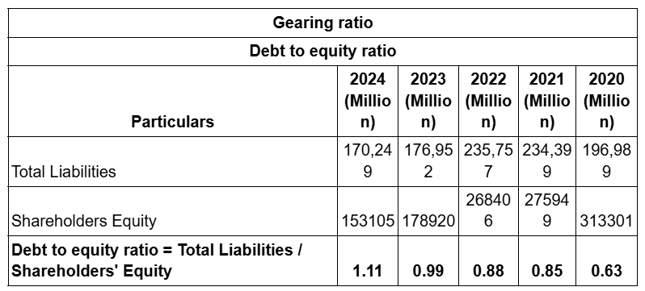
Table 7: Debt-to-equity ratio
(Source: self-report, 2025)
Interest coverage ratio

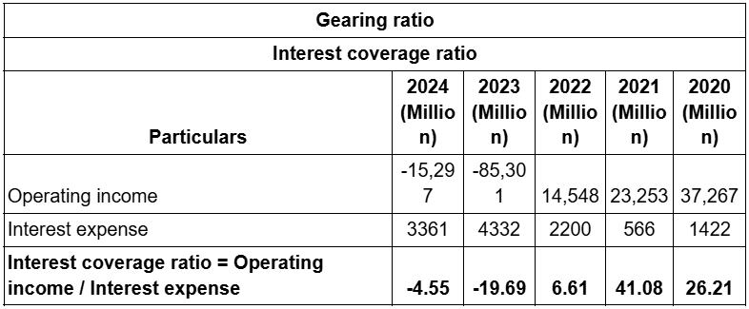
Table 8: Interest coverage ratio
(Source: self-report, 2025)
Investment ratio
Return on Equity
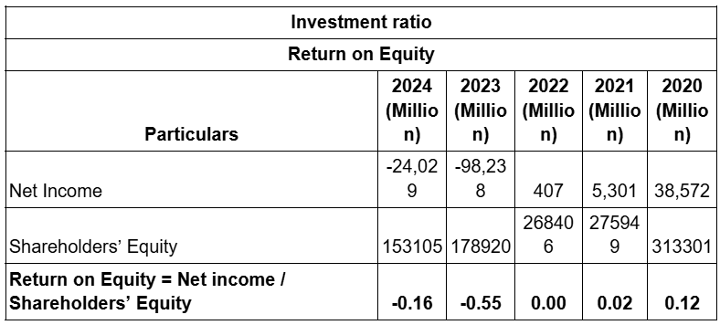
Table 9: Return on Equity
(Source: self-report, 2025)
Earnings per share

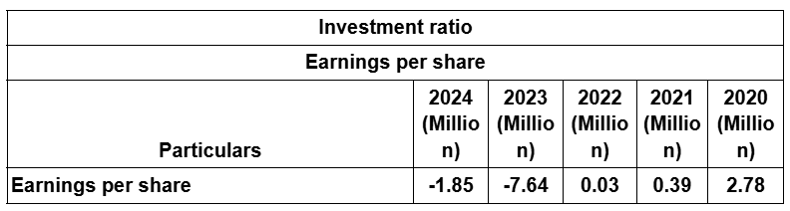
Table 10: Earnings per share
(Source: self-report, 2025)
Cash flow ratio
Operating Cash Flow Margin

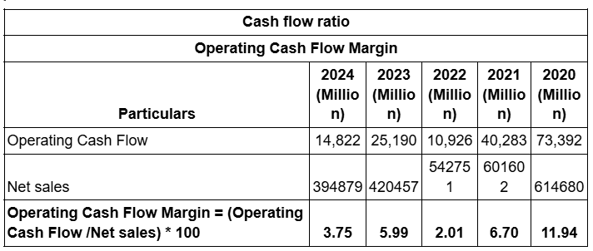
Table 11: Operating Cash Flow Margin
(Source: self-report, 2025)
Free Cash Flow Margin

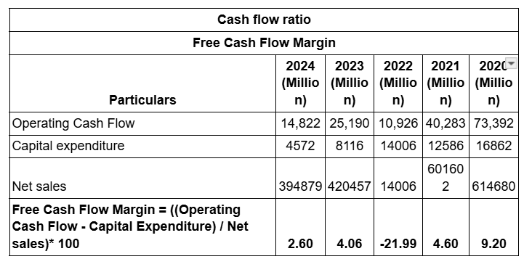
Table 12: Free Cash Flow Margin
(Source: self-report, 2025)
Graph
Profitability ratio
Net profit margin
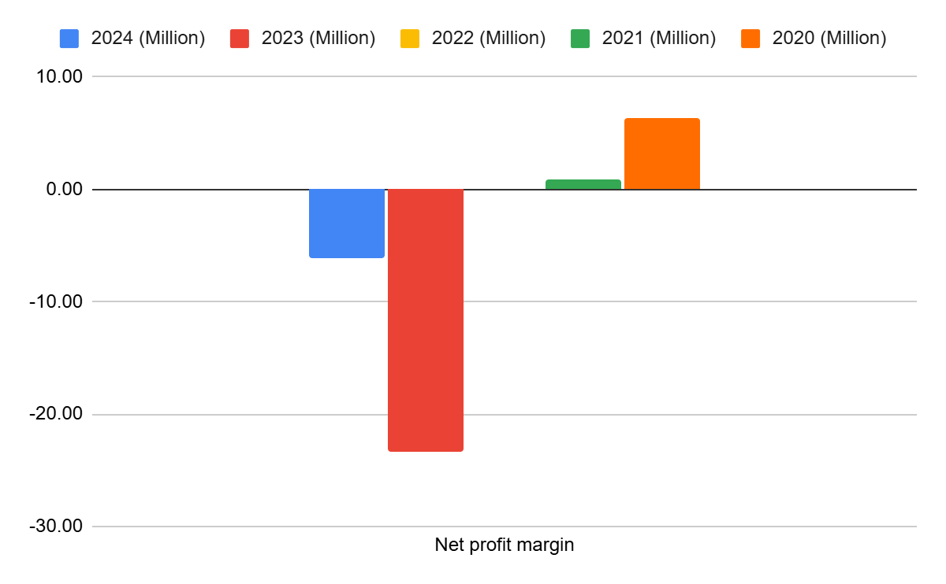
Figure 1: Net profit margin
(Source: self-report, 2025)
Operating profit margin
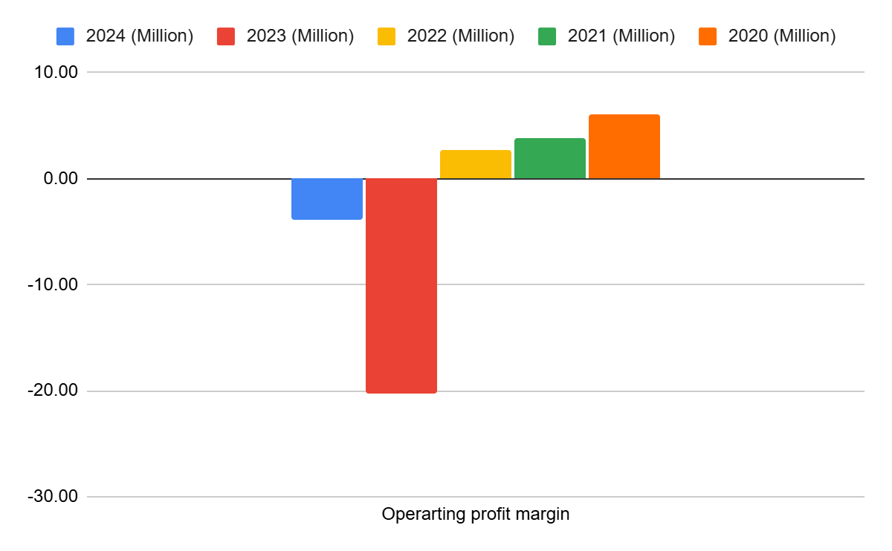
Figure 2: Operating profit margin
(Source: self-report, 2025)
Liquidity ratio
Current ratio
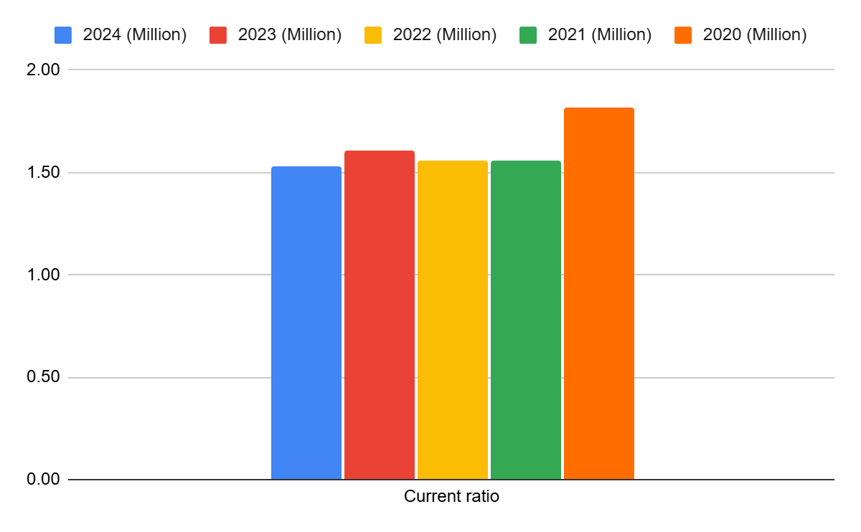
Figure 3: Current ratio
(Source: self-report, 2025)
Quick ratio
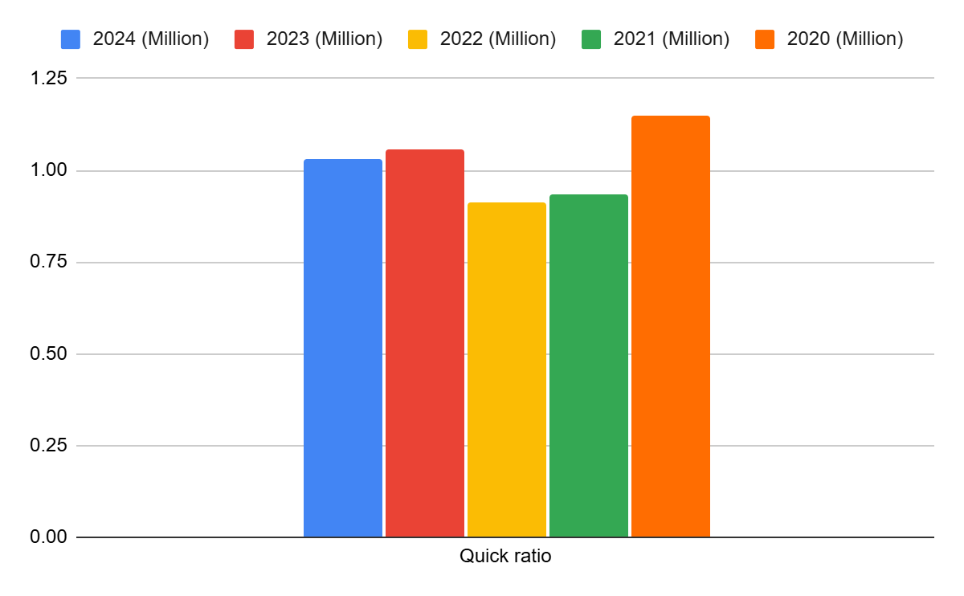
Figure 4: Quick ratio
(Source: self-report, 2025)
Efficiency ratio
Inventory turnover ratio
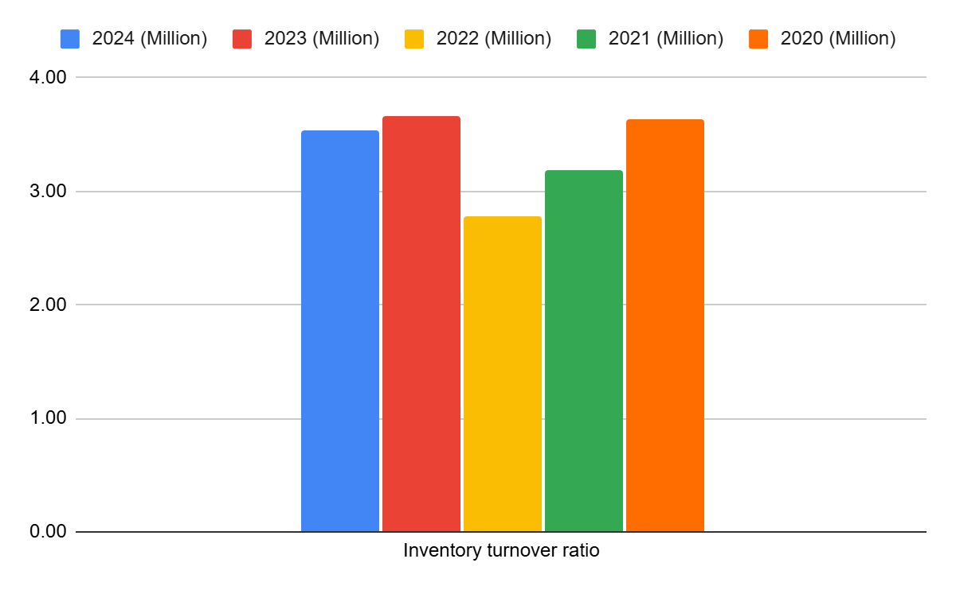
Figure 5: Inventory turnover ratio
(Source: self-report, 2025)
Receivable turnover ratio
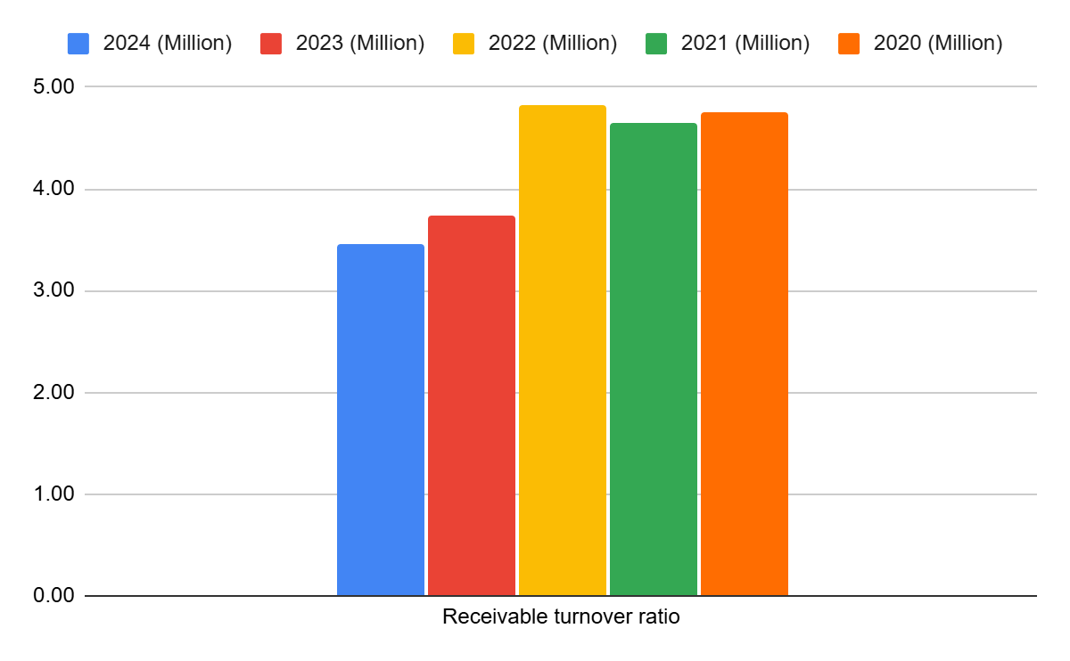
Figure 6: Receivable turnover ratio
(Source: self-report, 2025)
Gearing ratio
Debt to equity ratio
Figure 7: Debt-to-equity ratio
(Source: self-report, 2025)
Interest coverage ratio
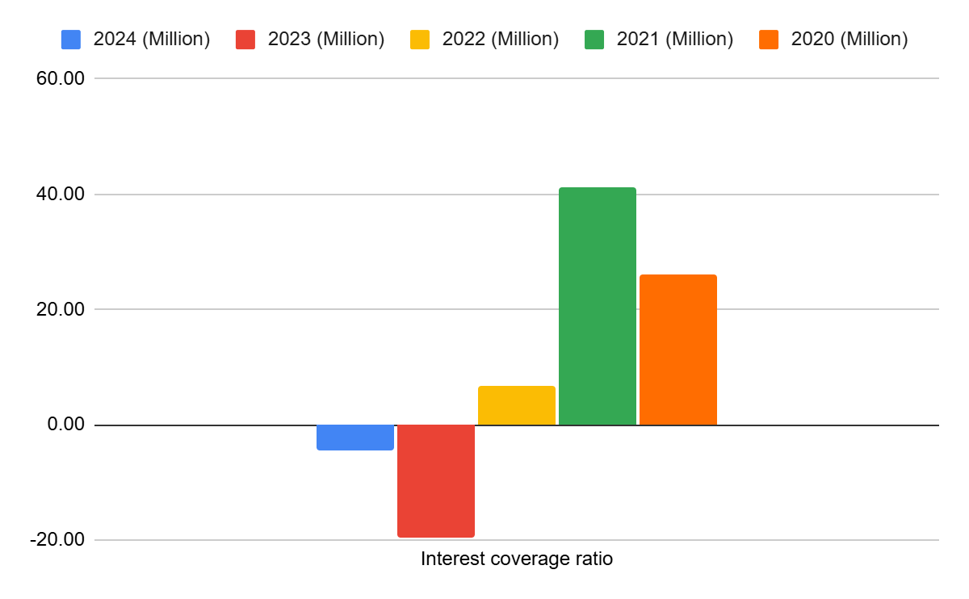
Figure 8: Interest coverage ratio
(Source: self-report, 2025)
Investment ratio
Return on Equity
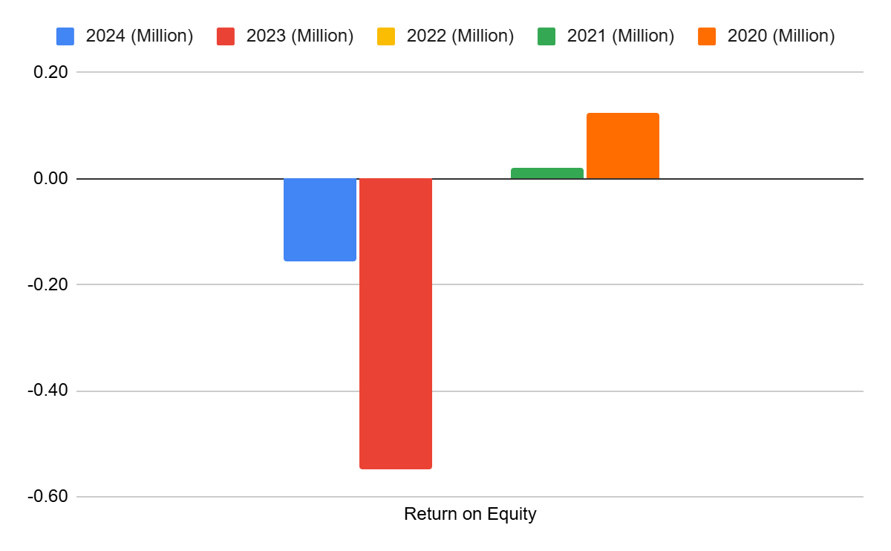
Figure 9: Return on Equity
(Source: self-report, 2025)
Earnings per share
Figure 10: Earnings per share
(Source: self-report, 2025)
Cash flow ratio
Operating Cash Flow Margin
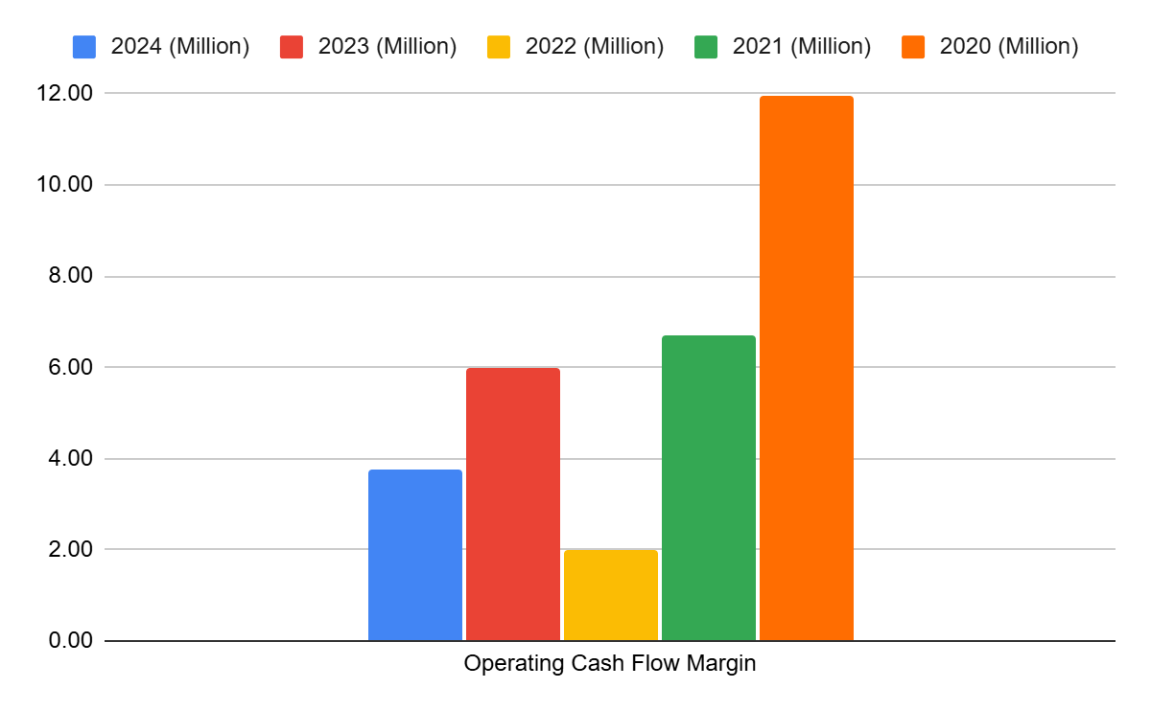
Figure 11: Operating Cash Flow Margin
(Source: self-report, 2025)
Free Cash Flow Margin
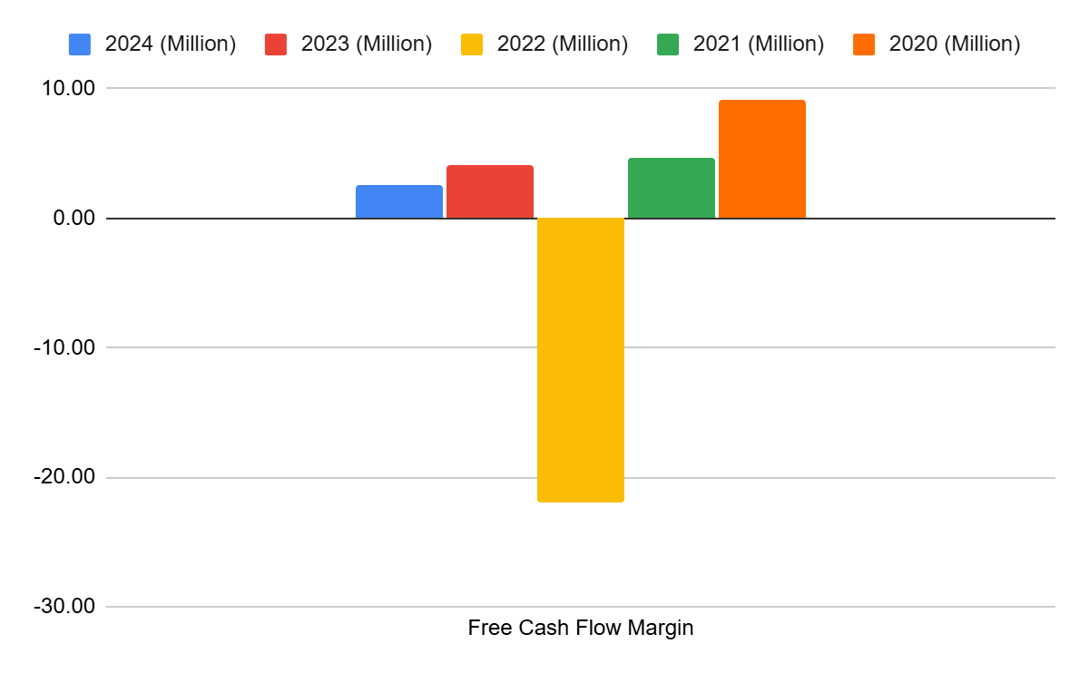
Figure 12: Free Cash Flow Margin
(Source: self-report, 2025)
Investment analysis
Net Present Value
Project A

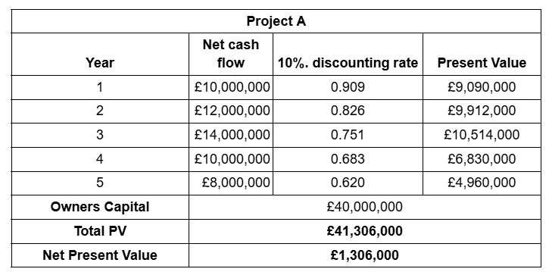
Table 14: NPV for Project A
(Source: self-report, 2025)
Project B
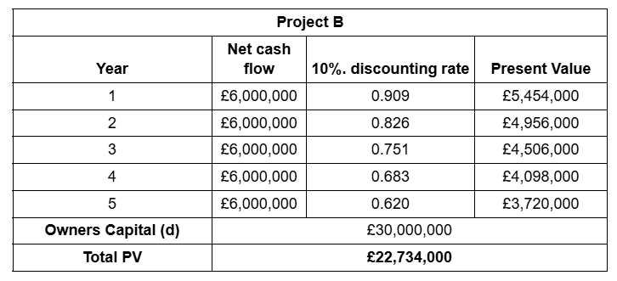
Table 15: NPV for Project B
(Source: self-report, 2025)
Project C

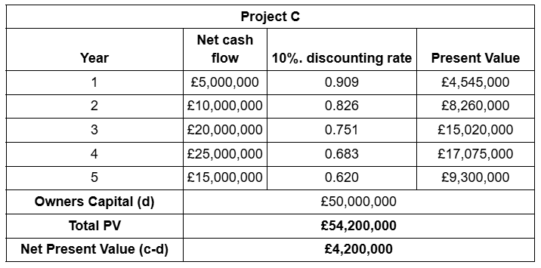
Table 16: NPV for Project C
(Source: self-report, 2025)
Internal Rate of Return
Project A
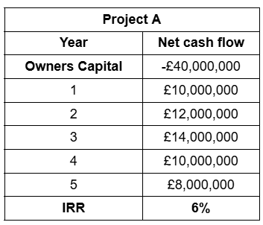
Table 17: IRR for Project A
(Source: self-report, 2025)
Project B
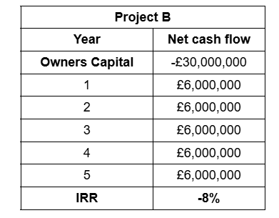
Table 18: IRR for Project B
(Source: self-report, 2025)
Project C
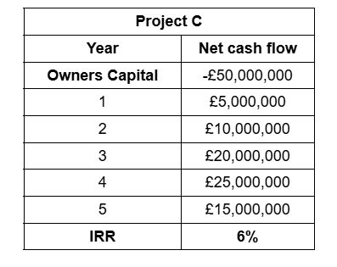
Table 19: IRR for Project C
(Source: self-report, 2025)
Profitability Index
Project A

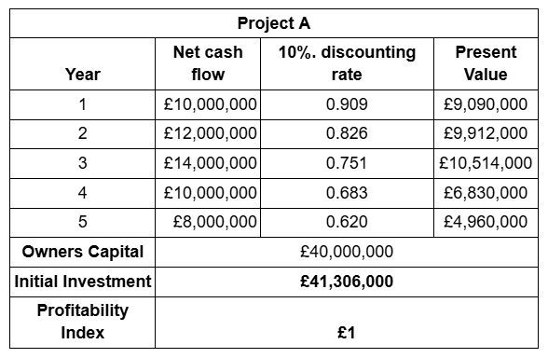
Table 20: Profitability Index for Project A
(Source: self-report, 2025)
Project B

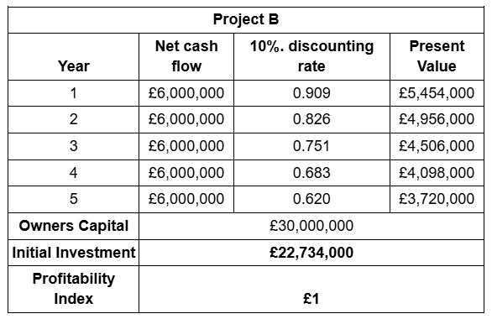
Table 21: Profitability Index for Project B
(Source: self-report, 2025)
Project C
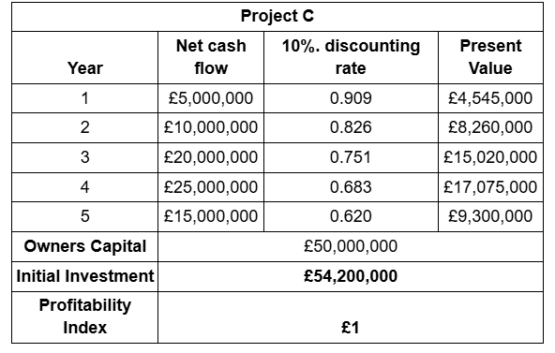
Table 22: Profitability Index for Project C
(Source: self-report, 2025)
Payback period
Project A
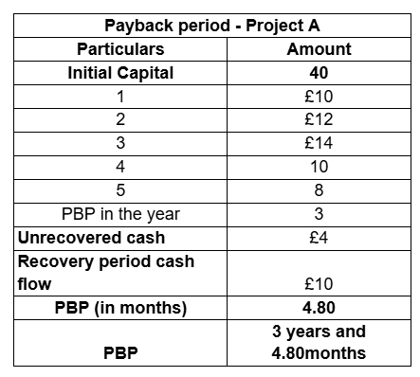
ZTable 23: Payback period for Project C
(Source: self-report, 2025)
Project B
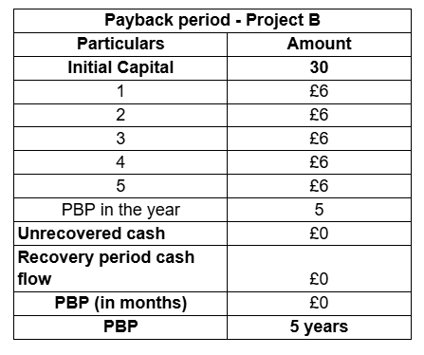
Table 24: Payback period for Project C
(Source: self-report, 2025)
Project C
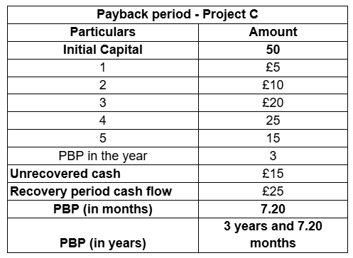
Table 25: Payback period for Project C
(Source: self-report, 2025)
ARR
Project A
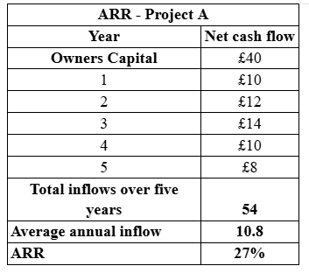
Table 25: ARR for Project A
(Source: self-report, 2025)
Project B

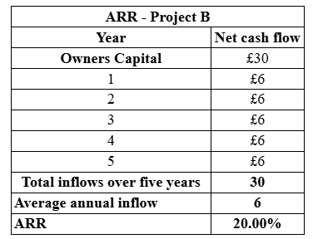
Table 26: ARR for Project B
(Source: self-report, 2025)
Project C
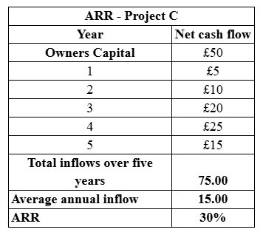
Table 27: ARR for Project C
(Source: self-report, 2025)

Formula that is followed in the report


