
technology vs traditional
Is the printed word dying out?

December 19, 2017
katrina taylor
P145567 - M6X01791

Table of Contents
Introduction 2
Figure of images. 4
Chapter One: points and figures 7
Chapter two: history of books. 15
Chapter Three: recycling and creating art. 22
Conclusion 26
Bibliography 29

Introduction
T
he e-reader has brought a battle between traditional and new technology and has seemed to split the love of reading towards e-readers vs printed books, but to what content? Is the printed book soon to die out and become something that we look back on throughout our history lessons, or is the e-book just a phase and will printed books always be available to purchase and in our dusty libraries?
This dissertation will endeavor to research, critically analyses and conclude the decline of physical books in comparison to the sales of the digital electronic book. Statistics relating to the sales of e-books vs printed books and preferences to them in the public eye will also be looked at.
This dissertation will also highlight the key facts found to help ascertain whether the digital age is making the printed book redundant, and will research into the public’s opinions as to whether they would prefer books or e-books.
The results of a poll will also be revealed that questioned what the preferences of the population are on using: printed books or e-books and why? The results will reveal an average.
Chapter 1 will focus on books/ e-books. This chapter will discuss the facts and figures that have been found and researched to find out what the public prefer, e-book or printed book. It will give detailed information regarding for and against, and try and prove figuratively what is selling and what the public seems to want more.

Chapter 2 will discuss the simple facts of both e-book and printed book, and how they came to be. What they may be leading to, also key knowledge that is important to know before deciding if the printed book falling into the dust of history.

Finally, the dissertation will conclude with books through art history and the way books could survive. Giving artiest that create different ways of recycling and creating art from books. This provides inspiration to people to recreate eco-friendly art with hardly any money spent.

Figure of images.
Table 1 - showing growth of book sales within the market.
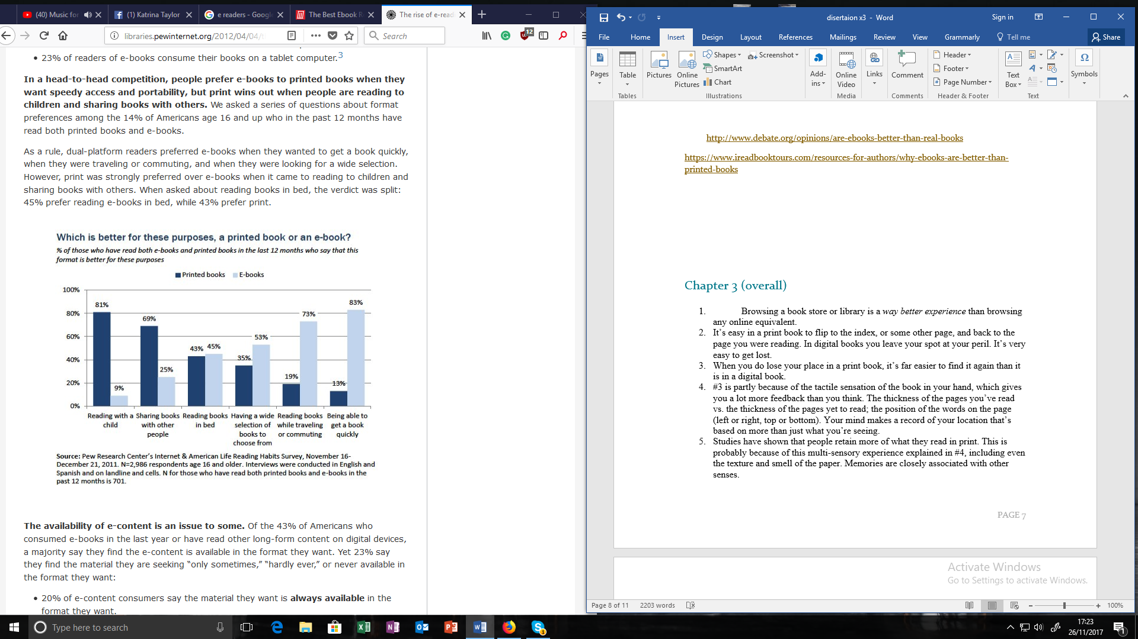
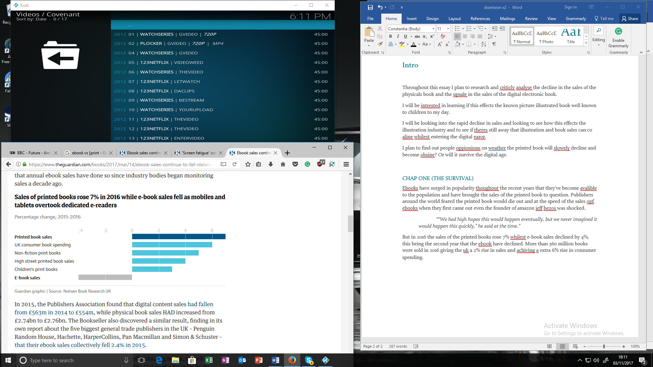
Table 2 - pew research center

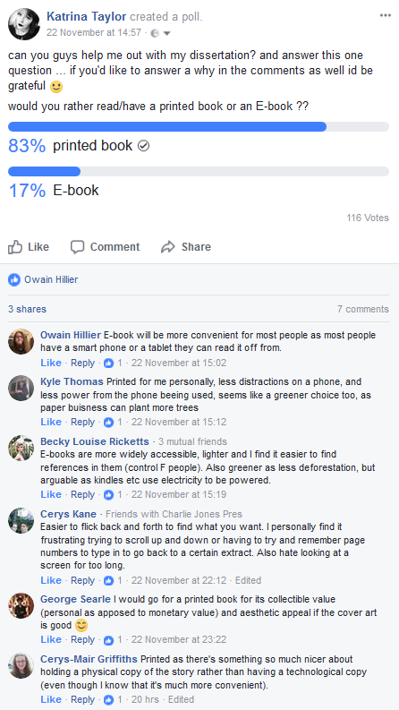
Facebook poll taken by Katrina Taylor. Asking whether the public preferred reading printed or digital books

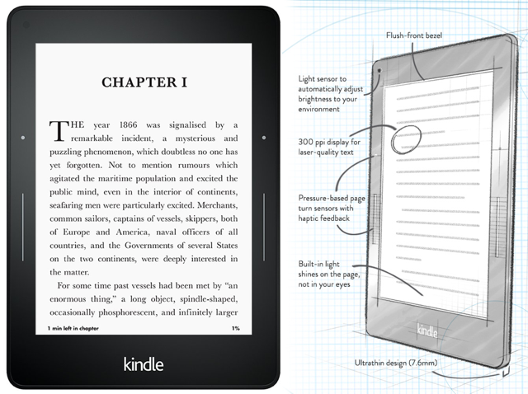
Figure 1 - kindal and design http://www.makeuseof.com/tag/best-ebook-reader-7-models-compared/
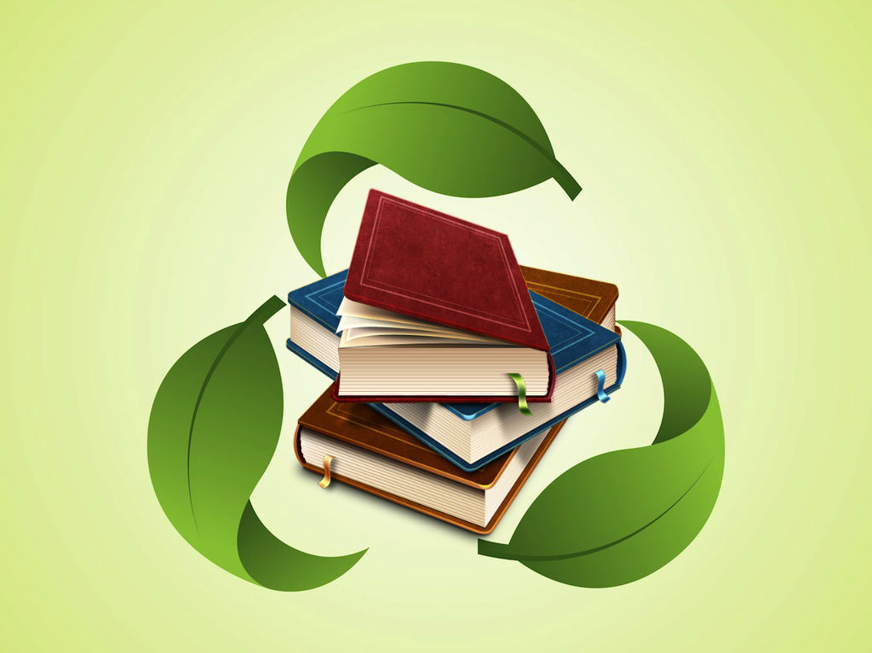
recycling books image.
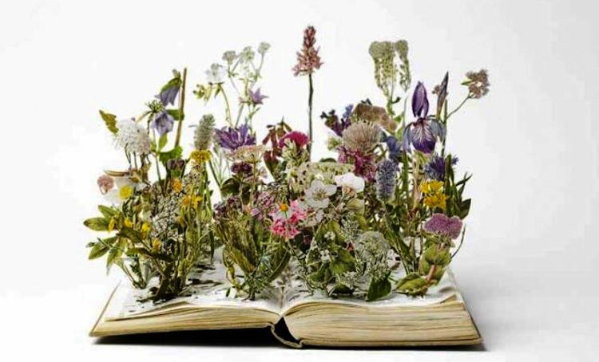

Su Blackwell’s art piece.

Chapter One: points and figures
E
books have surged in popularity throughout the recent years that they have become available to the population, and have brought the sales level of the printed book to question. Publishers around the world feared the printed book would die out, and at the speed of the popularity and sales of e-books when they were first introduced the founder of amazon Ieff Bezos was pleasantly surprised.
“We had high hopes this would happen eventually, but we never imagined it would happen this quickly,” he said at the time.”
(Cain, 2017)
However, in 2016, the sales of the printed books rose 7% whilst e-book sales declined by 4%, this being the second year that the e-book sales have declined. More than 360 million books were sold in 2016, giving the UK a 2% rise in sales and achieving an extra 6% rise in consumer spending.
Table 1 - showing growth of book sales within the market.
(Cain, 2017)
The increase it seems is being led by adults’ new found love of colouring books, bringing the first slump of the e-book in sales in 2015 by 1.6%, “Meanwhile, sales of printed books grew by 0.4% to £2.76bn.” (Sweney, Printed book sales rise for first time in four years as ebooks decline , 2016)
This was also helped by a year of high profit in fictional books- proofed loved fictional books like “The Girl on the Train” by Paula Hawkins, and “Go Set a Watchman” by Harper Lee.
Through a recent survey conducted by Nielsen’s, it revealed that the younger generation now prefer a physical book to the electronic e-book, as the survey asked 16-24 year olds which they preferred most, and it concluded that 62% preferred traditional books to their digital equals. They found “printed books jump out as the media most desired in material form, ahead of movies (48%), newspapers and magazines (47%), CDs (32%), and video games (31%).” (Bury, 2013) The Guardian (date) also states:
"It is surprising because we think of 16-24s as being attached to their smartphones and digital devices, so it does shout out," said Luke Mitchell”
(Bury, 2013)
The research found that people preferred the value to money with a printed book, and the emotional connection they had with physical books, compared to e-books. They found that 20% liked not being restricted to a single device, 51% of people liked to feel the book in their hands instead of on a an electronic device, 9% liked the packaging; holding hopes for illustrators and photographers around the world, who hope in remaining within the book jacket industry. And furthermore, 6% liked the fact that they could sell it when finished with it.
This can be assumed that young people are using books as a break from their devices or social media and possibly creating a way to relax:
“We are seeing that books are a respite, particularly for young people who are so busy digitally,” Steve Bohme, research director at Nielsen Book Research UK, said. ““Over the last few years we have seen a return to favouring print, partly from what is really successful, this year being non-fiction and children’s books,” he said. While adult colouring books were popular in 2015, last year saw books about healthy cooking and the latest Harry Potter sell well – which Bohme noted are “books that tend to translate better in the print form”. (Cain, 2017)

Throughout the research of this essay an online poll was created, see figure, to see what the population thought about e-books, and weather they preferred the e-book or traditional printed books, this allowed them to share their views on the subject and give key facts to why they thought there choice was better.
On average 83 % of people out of 116 people preferred printed books compared to the 17% of e-books.
People seem to prefer printed books to e-books because of many reasons some being because they like the adventure and visiting a book store. They find it easier to navigate from index or another page back to the reader’s original page, and it is easier to highlight specific areas of text and make notes on what they find interesting or read. Preowned books are much easier to come across and a lot cheaper than e-books and freshly printed books. The reader doesn’t have to wait for the book to charge or load, it is ready and waiting to be read. Finally, the reader feels they can showcase printed books more easily in their homes and therefore they can be admired or become a conversation piece in themselves.
Research sources found that 90% of people read printed books and that 46% of people will only ever read a printed book. “In response to the fading eBook market, publishers are trying to offer deals such as including a free eBook version with the purchase of a hardback book. Or, include a backlist eBook title with the current hardback title” (Source: George Lossius, CEO at Publishing Technology). (Knight, 2016)
“Reading an eBook is similar to running on a treadmill rather than running outside.” ~ Jeff Staiger, UO Librarian (Knight, 2016)
This is to say that the reader isn’t really getting the real experience when reading from an e-reader and that to actually get the true experience, the reader should buy and read a real book. Weather it is brand new, or second hand brought from charity shops or online.
(Knight, 2016)
Figure 1 - kindle and design http://www.makeuseof.com/tag/best-ebook-reader-7-models-compared/
The e-readers became popular due to their ability to carry a large amount of information in a small amount of space, enabling the reader to carry all their favorite books in their pocket. They gave readers access to books around the clock, this means anyone could get any book at any time. It being cheaper in the long hall than most printed book they allowed the reader to save money. The reader can travel with more books at their fingertips and read in any light due to the onboard lighting. Also, with access to the internet and a dictionary at all times, no word or part of the story is going to confuse the reader and let them miss out of the impact of the story there involved in. With e-books being more environmentally friendly, the readers tend to love the idea of reading while helping save the planet at the same time.
The research shows that 21% of the American population provided information saying that they had or had been given e-readers – that is 1/5 of the population. The research and surveys of Pew Research Center and its multiple research into the rise of e-reading, also shows that on average, the average e-book reader is able to read 24 books a year (the mean number), compared to the 15 on average that the printed book reader is able to read. This enables the e-book reader to enjoy more books throughout the year, and when the e-reader came in 2007, the population on average now say they have more opportunities to read and have been reading more; 41% of readers who have both e-books and printed books overall in fact.
Table 2 - pew research center
The graph shows key points that where brought up in this section at the beginning relating to the preference of e-books against printed books. The results are highlighted and backed as 83% compared to its 13% on average of people stated that they could get a book quicker and more efficiently than having to wait for a store to open, or for it to be delivered. The results also show that 73% of people on average compared to its 19%, thought the e-reader was much easier to travel with and allowed more reading while traveling.
(poll., n/a) (Ferraresi, 2016)

Chapter two: history of books.
W
ithin the 1990’s beliefs of advancing technologies and new skills that would bring about the death of the book however, the book shows the symbol of culture (Castleman 1994 78); and with today’s further advances into technology taking over, making it much more simpler to find information, read stories, look into history, we find that books continue to be wanted.
The book originated from the dusty manuscripts and ancient scrolls of history and are seen in nearly everyone’s life at times. But is it possible that it is the artists that are pushing the boundaries into keeping people reading them and interested in them in giving them a fresh new look, therefore, bridging the gap between the digital world and traditional world?
“Whenever a new tool or new technology allows us to put contents into a new format or medium it frees the establishment from the banal practical uses of the form”
This written by an anonymous reader in response to the New York Times article with kindle, can you still tell it is prouse. By Joanna Kaufman.
As humans are we devoted to books, do we need them within our lives as history or a way to escape or can we escape and leave them behind in dust to rot away. Is the most important thing about a book its contents? Allowing us to take technology freely into our lives leaving tradition behind.
“The most important thing to be opened when reading is the persons mind, not two slabs of cardboard” (Gomez 2008: 168).
“Reading is a visual medium” the Guardian. (Sweney, Printed book sales rise for first time in four years as ebooks decline , 2016)
With the digital age and readers now having access to the internet allowing them to access possibly anything why would we enclose ourselves between four walls and rationalizing the need for a large collection of encyclopedia when the internet has all the same information and more time than non-more up to date and relevant information right at your fingerprints where ever you are in the world. (Anonymous, artic at Chris Meade imagination and digitalization.
Or are computers as traditionalists might say ‘cold and impersonal’ do they as Amanda Ross, the creator of the Richard and Judy book club once said “they lack the vital imaginative spark that unequally binds the reader to the unique sensory experience that is scanning the printage page. E-books are nice devices, but they are not books” could we need the feeling of the pages between our figures and our mind alert scanning through the letters of the paper to really connect with a story. Or would a battery operated equivalent do?
Are we contempt enough not to fall for an e-books tricks as long as the battery doesn’t run out and the object doesn’t crash? As we have the security of knowing that would never happen with a printed book. Some may even feel a sense of privacy feeling there within a privet conversation or reading a personal letter that only the reader knows about.
Sadly with technology advancing much quicker than evolution would or ever could, the human body has yet to be able to gain the ability to use the monitors and screens without damage or fatigue, this meaning the longer a reader stears at an e-book, the more damage they could be doing to themselves, where the printed book cant damage the human body more than a paper cut without force.

Before the 15th century revolution in publishing created the Gutenberg printing press, mass produced work was carved by hand into wood, stone, and metal. Then after a layer of ink was rolled over the final finished carving it was hard pressed onto material. This would all be done by hand with the help of weighted machines to help put pressure on the roller once printing.
Books such as the bible where hand printed, mostly by people of faith and religion, but with the creation of the Gutenberg printing press, ideas could be communicated and passed on freely and easily. Which meant commotion broke out amongst religious traditional communities and many were appalled, the church even went as far as condemning the translation of the bible.
By the 1830’s the next big development was aimed at the working-class community as a way of entertainment. They were inexpensive books that contained short stories and illustrations that where later on nicknamed ‘ penny dreadfulls’. Printed on cheap pulp paper what working man could complain when compared to the comics around previously.
Penguin publishing house first became known in the 1930’s, when they introduced there first paper back novel to the mass market. Selling extremely well and cheaper than your average book at the time. But it was hard to imagine that liberies and publishing series seriously rejected the book format for a long period of time.
The first e-book was first created or founded by a man called Mitchal Heart once he realized
“The greatest value of computers would not be computing, but would be storage, retreaving, and searching for what was stored in our local libraries” (www.ebookweek.com)
This began the ‘Gutenberg project’ in 1971 to create and distribute e-books. Volunteers worked to archive and digitalis many work. Over time heart created and converted over 30,000 free text and 100,000 books into digitalized versions to be placed onto the internet. However, it wasn’t until 2001 that publishing houses started to take notice of e-books and documents in which creating later on e-publishing houses. All thanks to the internet the e-books gain global distribution and now have gained entry into over 76% of the populations lives and homes.
(Rainie, 2014)
Children are always play with technology and are always seen as curious and open to learning, sometimes to open. With new technology, computers and electronic devises children’s books can add layer upon layer of interactive knowledge and help them understand more. Using sound, interactive tags, gifs, videos, movement and much more a children’s book can now become its own little world of knowledge and play.
On the other hand Disney have refused to follow on with this way of advancement in technology as they believe books are in danger of being replaced says Yves Saada president of the New York times. Disney recognizes that kids are spending more time pre-occupied playing video games, watching videos and DVDs/TV, than reading. So just like other publishing houses they are trying to combat the problem in as many ways as they can.
Technologist argue that pages are trapping words within their boundaries (Gomez 2008: 14) and with new technology advancing, writers can now publish their work online on their website, or through e-book websites. Writing, publishing and selling is much easier and simpler through the powers of the internet. This may be frightening the common bibliophiles into thinking that their beloved printed book may be dying out.
Figure 2
As the world strives to become greener, clean technology has become a must but are books bad for the environment? Giving of four times more greenhouse gasses than their digital opponent, shown in a study by the CleanTech Group, books create a lot of pollution in their creation. Not to mention their mass in deforestation are we harming the environment and the ozone if we continue creating books by printing them? The environment.” (www.cleantech.com) furthermore according to the guardian publishing is one of the world’s most polluting sectors, if readers picked up and took to e-books it could have a long-lasting effect on the environment.
To save the environment instruments like Eco-libris were created, there goal “planting trees for every book you read…” (www.eco-libris-net). They believe that it shouldn’t be a matter of one or the other, it is save the environment and save the book form. “Eventually … books will be made up of recycled paper and eco-friendly materials.”
Eco libris offers readers to go to their websites and donate to plant a tree for each book perches, balancing the impacted out on the environment and helping deforestation and pollution. They send stickers to represent and showcase to the community about the readers environmental help: with the hope that it will inspire more people to help and do the same.
The appeal of an e-reader helps save the environment from deforestation, chemical pollution and air pollution all of which are made and let out into our ecosystem destroying our ozone when books are created.
Although with the problem of not all books being suitable for recycling there is a question many environmentalists may have of ‘what can they do with old books they don’t want any more?’ To answer that question many websites have been created to help people around the world in to finding new and exciting ways of creating and recycling their old, perhaps unwanted books.
“Let's talk numbers. According to the environmental consulting firm Cleantech, which aggregated a series of studies, a single book generates about 7.5 kg of carbon dioxide equivalents—the value of all its greenhouse gas emissions expressed in terms of the impact of carbon dioxide. That includes production, transport, and either recycling or disposal.”
(Palmer, 2010)
“Apple's iPad generates 130 kg of carbon dioxide equivalents during its lifetime, according to company estimates. Amazon has not released numbers for the Kindle, but independent analysts put it at 168 kg. Those analyses do not indicate how much additional carbon is generated per book read (as a result of the energy required to host the e-bookstore's servers and power the screen while you read), but they do include the full cost of manufacture, which likely accounts for the lion's share of emissions. (The iPad uses just three watts of electricity while you're reading, far less than most light bulbs.) If we can trust those numbers, then, the iPad pays for its CO2 emissions about one third-of the way through your 18th book. You'd need to get halfway into your 23rd book on Kindle to get out of the environmental red.”
(Palmer, 2010)

This gives tge prof that to make a book will in the end make more damage to the planets environment and eco –system, than the eco-friendlier e-book. Readers with worries about the environment and greenhouse gasses will want to stick to the e-reader.

Chapter Three: recycling and creating art.
B
ooks are found everywhere but when we have finished with them do we really want to put them on a shelf, never to be opened again?
Or could we as humans use our creativity and recycle books to recreate art, and other objects that would help inspire or recreate our life in new ways.
Websites like Big DIY Ideas (Beal, 2015) and saved by love creation (Collier, n/a) are designed to help out the average person to recycle their old books and recreating them into something new and exciting. Something that would be well loved and a one off that the recyclable would be able to show off.
It was once said “artiest enjoy the tactical satisfaction of holding a book” (ducker 2007:15) but can we see this as an artist no only loves a book for what it is condense is but for its form and the beauty and emotion it brings? Possibly even its history. Could artiest want to use these emotions and feel drawn to them so much that they need to recreate art with books? Deconstructing and reconstruction books to create work of art. Or is it just that the end result is visually stimulating?
“There is a distinct Patten we can follow in human information technologies as they have evolved and developed over time: the new technology has become the old technology into an art form”
(rees 1998:24)
Floating book shelves, lamps, hiding spaces, bags, art and much more has been created with old recycled books. Moreover, with more people looking for cheap and easy/ simple ways of decorating their home in delightful ways that are appealing to the eye. People are more willing to turn to do it yourself than going out and buying something that could look that same and make their house feel just as homely but for more cash. Why wouldn’t they? With simple step by step instructions and most of the ingreadance they need lying about the everyday home, they are simple and take little money to do. So in a way each book ‘do it yourself’ the average person douse it not only saves money and looks nice, saves pollution and is ecofriendly, but is making them into their own artist.
The term artist’s book was first used in franc in the 20th century. There ‘Livre D’artiste format published to create a combination of famous artiest combined with contemporize writers at the time. With limited number of the art pieces and selling them at high prices, they sold quickly. Over time though the worlds ‘artiest books’ have evolved and adapted.
Today’s artiest books are created in a more three dimensional way and grab the attention of the everyday public’s attention. Take for example Su Blackwell, she creates one off book sculptures that impicture the images of the books with the books themselves, carefully selecting books with the unique wording, stories and illustrations, size and style to then create her work. This “allows the viewer to visually enter the book in new ways.” Blackwell (prickett 2008 : 46 ) furthermore like most book art, you could and would struggle to recreate anything close to Blackwell’s three dimensional imagery and what she’s portraying.
Another artiest who creates three-dimensional work but in a complete different way with books is Guy Laramee who creates his work by carving into thick books and creating historic landscapes and mystical scenes that you can see from the adventure books that allow you to travel around the world. Using layers of layers of books, he doesn’t stay bound by one book, and carves each final piece with wood carving tools. They are beautiful creative pieces that show the beauty in the landscape.
Another would be American artist Brain Dettmer, who uses a collection of old used dictionaries, encyclopedias, textbooks, art books, history books, comic books and much more to create one final image. Layered upon one another to make one three-dimensional image. Again, each of these artists are very different from one another and they show a different way of working compared to each other. You can see neither one is the same nor yet each one has created beautiful three-dimensional work that showcases books and imagination to the extreme. But is it that being an artist make us drawn to the destruction of books? Or would someone call it the prolonging of books? Making sure that the book stays with humanity as long as possible in as many ways as possible. Can the destruction of an object to create a new object still bring its history through and stay with us? Or are books bound to leave the printed world, and be used only for reconstruction? Leaving us only glimpse of what use to be?
These pieces of art are once again the way of making books stay in our lives. Weather it Is just for it to be art or to still be a readable book they show we’ll still have printed black and white lettering in our lives one way or another.

Conclusion
I
n conclusion, this dissertation provides the information needed to prove that humans need books in their lives whether being printed or digital.
Although that the human race are starting to care about the carbon footprint, ozone layer, pollution and global warming, there are there are many reasons why digital books have been proven to be better for the environment. Provided within the second chapter, 168 kg of carbon dioxide is created when creating the kindle and uses on average 3 watts of power using its light, this compensates its co2 gasses, meaning the reader would have to be into his/her 23rd book before the wattage is used, compared to its competitor the book, given the lighting in the readers house varies from 20 watts – 100 watts or bigger.
E-readers are also loved by many because of their availability, in which they allowed the reader to carry so many books whilst traveling anywhere in the world. This allows the reader light weight, portable compact travel with hundreds of books to read at any time they want.
Projects over the years began, making huge impacts in the industry, one being the ‘Gutenberg project’ in 1971. This was created by Mitchal Heart to create and distribute e-books. Volunteers worked to archive and digitalise many works. Over time, Heart created and converted over 30,000 free text and 100,000 books into digitalized versions to be placed onto the internet. It wasn’t until 2001 that publishing houses started to take note, and the public started seeing a mass publication of e-books and e-publishing houses.
But will the ‘cold and impersonal’ technology that has advanced throughout the years, did this stop people wanting printed books?
The answer being no, statistically proven, and shown in chapter one, people want printed books more than the advanced technology way of reading.
Also shown in chapter one, the printed books rose 7% whilst e-book sales declined by 4%, this being the second year that the e-book sales have declined. More than 360 million books were sold in 2016, giving the UK a 2% rise in sales and achieving an extra 6% rise in consumer spending. The rise in sales are provided by fictional books like: “The Girl on the Train” by Paula Hawkins, and “Go Set a Watchman” by Harper Lee. Giving the publishing houses proof that readers adore fictional books that leave them wanting more and looking forward to the next sequel.
Through my own personal poll, the results revealed on average 83 % of people out of 116 people preferred printed books compared to the 17% of e-books. This also provides the information that helps prove that people today will love printed book and its tradition.
Tradition will always be within our lives, even as technology advances into the future. Humans continue to want to bring through old traditions and make them last.
With computer technology advancing and the printed word doing so as well in the form of reading material, there are now multiple ways of communicating in the literary world. Writing and illustrating have advanced from quills and charcoal to mechanical pencils and computer. Technologies have advanced so much that three dimensional images can now be created on the computer using hand controlled devices, creating art forms that can move with the times.
However, due to the advances in technology, this does not mean that previous skills have not been moved into our present. For example, North Carolina artist Peter Deligdisch shows that we can carry through the past into the present with his ink drawings. With a glass quill, he creates beautiful pieces of winding art that mesmerizes the onlooker.
Another example is Sir Arthur Conan Doyle’s Sherlock Holmes books. They have inspired countless movies, advanced our technology and helped bring hours of joys reading them. But no matter what technology that has applied to the reading source, whether traditional or electronic, the reader constantly experiences the love of his writing. The reader always sees his writing in an enjoyable light.
Despite the ever changing advances in technology and the likelihood of new forms of digital reading equipment, publishing houses will continue to be concerned about the popularity and sales of printed books.
In chapter three, this essay developed on by showing how we as humans have learned to take the old and create something new, all by recycling. Showing artiest like Brain Dettmer, Guy Laramee and Su Blackwell, all three artiest have created three dimensional art in beautiful ways, carving into the book pages, and showing the books in new way. Using layers of pages and books to create the art inspired by the books themselves.
Therefore in conclusion, books whether being provided within a technologically advanced field, or an ‘old fashioned’ way, we as humans will devour to seek out and find the best stories and the best way each individual feels comfortable to read them.
We will continually have printed books in our lives, only they may advance within themselves to beautiful pieces of art, or constantly be recycled to help keep our planet eco-friendly.

Bibliography
Beal, A. (2015, May 1st). 35 Unique DIY Project Ideas to Repurpose Old Books . Retrieved from BIG DIY: http://www.bigdiyideas.com/35-unique-and-creative-vintage-book-crafts/
Bury, L. (2013, November Monday 25th). Young adult readers 'prefer printed to ebooks' . Retrieved from The Guarden : https://www.theguardian.com/books/2013/nov/25/young-adult-readers-prefer-printed-ebooks
Cain, S. (2017, March Tuesday 14th). Ebook sales continue to fall as younger generations drive appetite for print . Retrieved from The Guarden : https://www.theguardian.com/books/2017/mar/14/ebook-sales-continue-to-fall-nielsen-survey-uk-book-sales
Collier, J. (n/a, n/a n/a). 50+ Things to Make From Old Books. Retrieved from saved by loves creation: http://savedbylovecreations.com/2012/04/50-things-to-make-from-old-books.html
Ferraresi, A. (2016, November 20th). Why eBooks Are Better than Printed Books. Retrieved from iRead Book Tour: https://www.ireadbooktours.com/resources-for-authors/why-ebooks-are-better-than-printed-books
Flood, A. (2016, Febuary Wednesday 3rd ). Ebook sales falling for the first time, finds new report . Retrieved from The Guarden: https://www.theguardian.com/books/2016/feb/03/ebook-sales-falling-for-the-first-time-finds-new-report
Knight, R. (2016, January 18th). 16 Facts About eBooks & Print Books. Retrieved from UPAUTHORS: http://www.upauthors.com/16-facts-about-ebooks-print-books/
Kraft, A. (2015, December 14th 6am). Books vs. e-books: The science behind the best way to read. Retrieved from CBS NEWS : https://www.cbsnews.com/news/kindle-nook-e-reader-books-the-best-way-to-read/
Mitchel, N. (2015, Apri 15th). E-Readers vs. Book Books: A Book Lover Weighs the Pros and Cons. Retrieved from Apartment Therapy : https://www.apartmenttherapy.com/e-readers-pros-cons-218010
Palmer, B. (2010, August 24th). Should You Ditch Your Books for an E-Reader? Retrieved from Slate : http://www.slate.com/articles/health_and_science/the_green_lantern/2010/08/should_you_ditch_your_books_for_an_ereader.html
poll., p. (n/a, n/a n/a). Are eBooks better than real books? Retrieved from Debate.org: http://www.debate.org/opinions/are-ebooks-better-than-real-books
Rainie, K. Z. (2014). E-Reading Rises as Device Ownership Jumps. USA: Pew Research Center.
Sweney, M. (2016, May Friday 13th ). Printed book sales rise for first time in four years as ebooks decline . Retrieved from The Guarden : https://www.theguardian.com/media/2016/may/13/printed-book-sales-ebooks-decline
Sweney, M. (2017, April Thursday 27th ). 'Screen fatigue' sees UK ebook sales plunge 17% as readers return to print . Retrieved from The Guarden : https://www.theguardian.com/books/2017/apr/27/screen-fatigue-sees-uk-ebook-sales-plunge-17-as-readers-return-to-print
books, papers and journals.
- The Future of the Book in the Digital Age
1st Edition Editors: Bill Cope Angus Phillips eBook ISBN: 9781780632124 Imprint: Chandos Publishing Published Date: 31st December 2006 Page Count: 248
- Bound to end?
Is the digital revolution responsible for the current, thriving and inspiring use of books as an art form? : Lucy Bird: March 2010
- Castleman, R. (1994) a century of artist books, New York: museum of modern art.
- Gomez, j. (2008) print is dead; books in our digital age, new York: Macmillan
- Davis m. (1994) the Gutenberg bible, London: the British library board.
- Pricket, r. (2008) between the sheets, illustration, issue 16, pages 46-48

