A Reflective and Evaluative Management Report



Module Name: Academic Skills
Project Name: Matthews House
Name: Ella Williams
Student ID Number: 1707424

Table of Contents

- Introduction………………………………………………………………………………..……………………….5
1.1 Report Remit……………………………………………………………………….…………………….....5
2. Background on My Project…………………………………………………………………………………….5
3. Models of Reflection……………………………………………………………………………………………..6-9
4. Masterclass Sessions……………………………………………………………………………………………..10
5. Influence of Masterclasses on the Project………………………………………………………….....11-14
6. Influence of the Masterclasses on Personal Learning and Development……………..…15
7. Conclusion………………………………………………………………………………………………….............16
8. References………………………………………………………………………………………………………..…..17

List of Figures

Figure 3.1 Experiential Learning Cycle Diagram…………………………………………………………….6
Figure 3.2: Gibbs (1988) Model of Reflection Diagram………………………………………………….8
Figure 5.3 Strategic Planning Diagram………………………………………………………………………….11
Figure 5.4: Blog for Project…………………………………………………………………………………………..12
Figure 5.5: Ruby and I fundraising for Matthews House……………………………………………….13

Appendices

Appendix A: Andy Rogers Masterclass Notes……………………………………………………………..18
Appendix B: Networking Masterclass Notes……………………………………………………………….19
Appendix C: My Skills Audit Diagram 1……………………………………………………………………….20
Appendix D: My Skills Audit Diagram 2……………………………………………………………………….21
Appendix E: My Action Plan………………………………………………………………………………………..22

Executive Summary
This report provides a reflective and evaluative discussion throughout, explaining the skills and techniques I have developed across the Academic Skills Module. The purpose of the report is to show the reader what I have experienced and how I want to develop my skills for the future, with the influence of the Masterclass Sessions.
I had to undertake a project and work with a not for profit organisation called Matthew House. The organisation is set up to give hope to vulnerable people in Swansea. There is one employee who works for Matthews House called Thom who we had to communicate with throughout this process. Within the project I worked with 4 other team members to complete the aims the organisation set us, which were to spread awareness and raise money to refurbish their showers, costing £1,500. Throughout the project we raised money by packing bags in Tesco, holding a bake sale, collecting money through charity pots placed in different locations and more.
Within this report used two different models of reflection to reflect and evaluate the experiences I had during my project. The two models are Kolb (1984) and Gibbs (1988).
I also attended Masterclasses which had a huge impact on the process of my project and my personal learning and development. There were three people that influenced me the most called, Kate Jenkins, Stifyn Parri and Andy Rogers. Jenkins showed me how having a positive attitude, a lot of motivation and if you undertake a lot of marketing you are able to start up your own successful business. Parri also influenced me to become more motivated and strive for every opportunity I can, in order to become successful. Lastly, Rogers influenced me a lot because he was a very shy person when he was young. However, he become a very confident person when he started networking as he had to communicate with a lot of people and speak in front of a huge crowd.
Throughout this experience my skills have enhanced a lot. I am now able to use those skills I have gained and this experience in the future.

1 - Introduction

1.1 - Report Remit
This report will address the knowledge and skills developed during the Masterclass sessions and how they impacted both the project implementation and personal skills development. I will reflect and evaluate the masterclass sessions I attended, which had a huge impact on my project.
Kolb (1984) and Gibbs (1988) Reflection Modules will be used to structure the discussion in this report.

2 - Background on My Project
Matthews House is a not-for-profit organisation that exists today to help vulnerable homeless people in Swansea (Lynch, 2018). The organisation offer food and hope to the local community. Matthew’s House was established in 2015 and founded by a group of 30 friends who all had the same ambition to give something back to their local community (Lynch, 2017). The organisation is located in The Hill Church in the heart of Swansea and have set up a café for homeless people to be able to eat a warm meal. The café does not expect people to pay a certain price, people can give what they can. However, it only costs 70p to feed a person.
For my project I was in a team of 5 and the leader chose an organisation we had to help, called Matthews House. As a group we had to communicate to the employee called Thom who then set two aims for us to complete; to spread awareness and raise money to refurbish their showers. The showers costed £1500 which meant we had a lot of fundraising to do. Throughout this experience my group and I held a bake sale, collected money through charity boxes and bag packed in Tesco Supermarket. We would have liked to walk up Pen Y Fan however due to the weather we were unable to.

3 - Models of reflection
There are four major models of reflection, which are:
- Driscoll (1994) Three Staged Model
- Gibbs (1988) Reflective Cycle
- Cottrell (2010) Core Prompt Model
- Kolb (1984) Experimental Learning Model
There is no model correct model. Each model is a framework to help you reflect and learn from your experience (Clark, 2009).
For the purpose of this report I will be using Kolb and Gibbs Model of Reflection diagrams to relate to the experiences I had during my project.
Throughout my project I went through an experiential learning cycle.
Kolb published a book called Experiential Learning in 1984. This made people aware that they can learn through their experience (Mobbs).
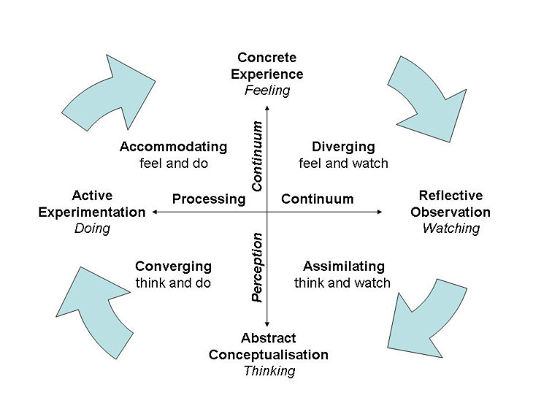
Figure 3.1: Experiential Learning Cycle Diagram.

In the first stage of the cycle it begins with the task that has been set to an individual, group or organisation. Kolb believes the main key to learning is being involved in an activity as you cannot learn by just reading or watching (Kolb, 2011).
For my project this situation occurred as we had to get into a group after only being in university together for a few weeks, we did not know each other well enough. Activities which broke the awkwardness were used and we discussed whether we all liked the choice of organisation. As a group we then had to work together to complete our set aims. Usually I am very shy and watch and listen to others but I knew I had to involve myself a lot as it was a group project.
The second stage was the reflective observation which means actually observing the task and what has already been experienced. Throughout this stage questions must be asked and communication is key (Kolb, 2011).
As a group we always had to discuss every situation, either in person or via text messages so we knew what was happening, what we had done already and what we could do next. This was vital as if we did not do this then we may not have known what we were doing or what we need to do next. Especially when we needed to contact Thom to arrange fundraising events and ask for fundraising boxes. However, we did not always have to talk to reflect, having a break or thinking when we were by ourselves meant we were reflecting on the project. This helped a lot as we could see what we were doing and whether it was benefiting our project or not.
The third stage is the Abstract Conceptualisation. This is where the individual or group reflect on what they have done and what they already know. This could be by giving theories or facts on what they have done, then explain exactly what they have done and acknowledging the developments they have made.
As a group we did this a lot as we spoke to Thom about what we have done to raise money and also our lectures to see if we were on track with our project.
Lastly, the fourth stage is the active experimentation. This is the final stage of the learning cycle in which the learner has to think about how they are going to put what they have learnt into practice successfully (Mobbs). This could take a while as the learner needs to plan it perfectly. The learner should hopefully realise that without learning they will find it very difficult (Kolb, 2011).
Throughout the whole project as a group we planned everything we were going to do and documented it. This was so we could always look back and see if we could improve. This occurred when we planned our fundraising events as we planned to hold a bake sale in university, however we held a bake sale during our show case event. This was so we could manage our time better as we would have had to undertake too many fundraising events around the same time.

Gibbs (1988) was another model of reflection I could relate too during my experiences of my project. It can be seen as Gibbs’ reflective cycle encourages people to think about their experiences thoroughly to see what they did well and what could have been improved on (Brookes, 2018).

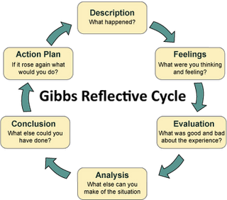
Figure 3.2: Gibbs (1988) Model of Reflection Diagram

Within the first stage of the cycle it is very important to review what has happened and describe the process you have been involved in fully. This includes what you did, who else was there, as well as what they did (Gaynor, 2013).
For my project, I would have reflected on what my team and I did, which was spreading awareness through social media and fundraising.
The second stage of the cycle was what I was thinking and feeling. At first, I was very nervous as I had only just met my team members a couple of weeks ago and I had to undertake different tasks to complete the project with them and was not sure how it was going to go. However, during the project it was very stressful as we fud out we were unable to do our sponsored walk up Pen Y Fan, so we did a bake sale instead. This was very frustrating as we were excited and did a lot of promotion for this walk, and raised money for it.
The third stage is the evaluation. This is where you explore what was good and what was not, so it could be improved in the future. Within the project, my group and I did a lot of planning, communicated well with the organisation and completed the aims they set us. However, some of the planning did not go well as we could have been more realistic with money we wanted to raise as £1500 is a lot of money to raise in a couple of months.
The next step is the biggest section to reflect on. In the analysis, you need to reflect on all of the issues you faced and understand why they occurred (Gaynor, 2013). During my project I did face a lot of issues such as being shy and not voicing all of my opinions. This had a huge impact on the outcome on all of the decisions made as I had to go with what was set.
The conclusion stage is where you conclude what you examined and see what you can overcome in this area. The action plan would also be included in this and you have to examine what you would do again if you had the chance (Gaynor, 2013). If I were to do this project again I would voice more of my opinions and be more realistic with my goals. This is so I would be happier with the decisions made.

4 - Masterclass sessions:
The Masterclass sessions had a huge impact on the project performance, as well as my personal learning and development. Each entrepreneur was different and some had more of an impact on myself compared to others. Overall, there were 6 guest speakers who had an impact on my project performance and personal development.
Out of the 11 masterclass sessions, the ones that had the greatest impact on the project were:
- Stifyn Parri
- Kate Jenkins
- Andy Roger
They all had an impact on my marketing, networking and motivation. They had a huge impact on my development personally, which helped throughout the project. The proceeding section will discuss this in detail.
The first guest speaker was Stifyn Parri who is an entrepreneur, entertainer and the manager of MR PRODUCER, with 35 years’ experience in the creative industry. The organisation was set up in 2001 offering developing concepts, creative consultancy, media training, and mentoring on presentation skills and confidence (Parri, 2016). Parri produced the “Opening Weekend of Wales Millennium Centre for BBC Wales and the ‘Welcome 2 Wales Ryder Cup Opening Concert’ at the Millennium Statium for Sky 1 and Sky Arts” (Parri, 2016). Not only did Parri produce amazing live events but Parri holds workshops to develop confidence in interviews and performance techniques for all abilities and ages, in both the English and Welsh language (Parri, 2016). Parri helps to motivate people which is inspiring.
The second guest speaker who had an impact on me was Kate Jenkins. In 2007, Jenkins started selling her homemade brownies in her local village shop. Locals and tourists loved the brownies and now Jenkins Brownies are multi award winning. Thousands have been sold across the UK. Jenkins also featured on ITV1’s Countrywise Kitchen Team to show the nation how to bake something simple yet delicious (Jenkins, 2016).
The third person who influenced me throughout the masterclass sessions was a Man called Andy Rogers. I took a lot of notes during Rogers’s session which I have displayed in the Appendix for the reader to see. Rogers creates networking strategies for introverts. This is inspiring as he has helped hundreds of people.

5 - Influence of masterclasses on the project:
Every masterclass session was interesting. However, Stifyn Parri, Kate Jenkins, and Andy Roger were the three main masterclass sessions that has a huge impact on the project that I was involved in.
- Kate Jenkins
Jenkins states how “anyone can become self-employed” (Dickins, 2017). Jenkins also stated how word of mouth and social media were key promotional tools and skills she used to help her promote her brownie business (Jenkins, 2017).
During the masterclass session Jenkins spoke about how she had to do a lot of promotion during the first few stages of starting her business up as not a lot of consumers and other business knew of her. I found it extremely interesting that Jenkins did not have a business before baking brownies but her hard work and dedication helped her get to where she is today.
For organisations to be successful they need to have great a marketing strategy. This is so the organisation have a set plan for a long-run survival plan and know what they are aiming for (Kotler, 2014).
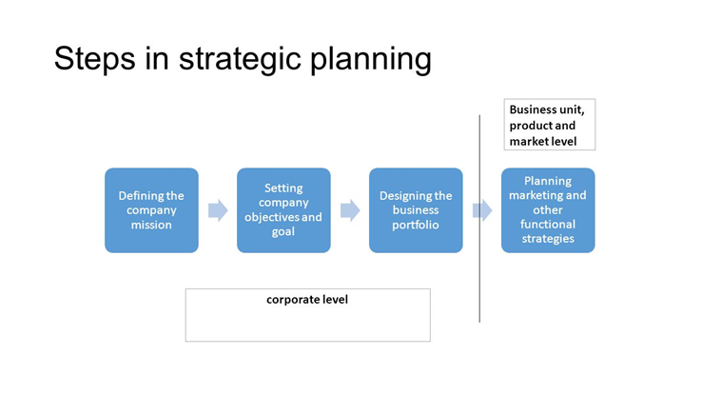
Figure 5.3 Strategic Planning Diagram
For organisations like Jenkins Gower Brownies and Matthews House, they all have to define their mission, set aims, objectives and goals and design a portfolio, as well as other strategies to start their business. This is to help the organisation know exactly where they need to go, so they do not fall off track. However, the only difference is Jenkins business is a micro business. Micro businesses are businesses that are owned and operated by one person. Studies show that 76% of businesses in the UK are microbusinesses and it has increased in the last 10 years due to more people becoming self-employed (Peter, 2015).
This had an impact on my project as I had to do a lot of marketing to promote Matthews House. The organisations employee set my group and I aims to achieve which were to raise money for showers and to spread awareness. To spread awareness we needed to promote the organisation, and we did this by:
- Creating posters
- Starting a blog on WordPress
- Word of mouth whilst bag packing in Tesco.
- Sharing the official Matthew’s House Facebook Page.
Although this was very time consuming, we still managed to promote the organisation and achieve goals that were set.
Whatever we achieved we liked to show the public and our family and friends on social media and our blog for our project what we were doing and what we had achieved. This was another way for people to see how much we were achieving for this organisation and to promote the organisations name even more.
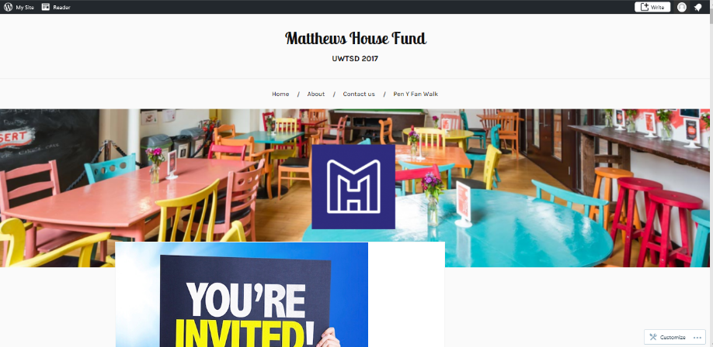

Figure 5.4: Blog for Project

This was the first time I had blogged before, so I was unaware of how to use it properly. However, one of the group members had her own blog so she already had the skills on how to blog properly, which helped a lot. Although blogging can be time consuming, it is then a quick way of spreading information. We shared our blog through social media and got over 50 views. This showed the information that my group and I displayed in our blog was shared and seen by a lot of people.
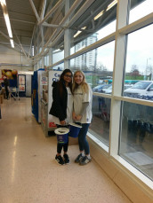
Figure 5.5: Ruby and I fundraising for Matthews House

Whatever we achieved we liked to show the public and our family and friends on social media and our blog for our project what we were doing and what we had achieved. This was another way for people to see how much we were achieving for this organisation and to promote the organisations name even more.
- Stifyn Parri
Stifyn Parri also had a huge impact on my project as he is a hard worker, who motivates people to do their best. Throughout the project my team and I had to motivate each other to complete each task together successfully. This meant we had meet up on time and always make sure we all knew what we were doing in order to achieve each goal.
Viteles (1953) compared motivation in a group of employees’ performance and morale through a survey. The survey showed that “the employee who is highly productive is a worker who has positive attitudes towards the job” (Viteles, 1953, p. 30) . This shows that people who are positive and want to undertake the task they have been set and motivated are people who want to achieve their goals and be successful.
Parri has shown me how to be motivated you need to have self-esteem, as you need to believe in yourself. Without being positive you won’t feel like you are able to complete the task. Korman’s self-consistency theory states that “employees who have high self-esteem have higher job performance compared to those who have a low self-esteem” (Korman, 1970, p. 132).

This has been proven to be true as I am a very shy person and there are people in the group I was in who have more self-esteem and tend to try and take over some tasks. However, we all knew we had to complete the tasks together and I gained confidence throughout the journey through this project as I had to communicate to external people such as Tesco employees whilst bag-packing, volunteers in Matthews House and more.

- Andy Rogers
Within the Masterclass Rogers spoke about networking skills, which I took notes on as you can see in Appendix B.
Not everyone is the same, as some people may be shy, but more productive and others may prefer to work in groups, but then risk more opportunities. However, some people may get scared and hide away from any opportunities they get. This is the difference between the introvert, extrovert and the panic zone.
Rogers states how “speaking in front of people is something I would not do” (Rogers, 2017). However, now he Networks for Introverts and has the confidence to speak in front of people. This had a huge impact on me as I am a very shy person, who hates to speak in front of people.
However, during my project I had to communicate with a lot of people and at the end of this project each group, including my own had to stand up in front of a crowd full of people to explain what we had to do throughout our project for a showcase. The masterclass sessions definitely influenced my confidence and motivation to strive for success. Bandura states how working in a team can change the situation and influence each other to achieve a goal (Bandura, 2001).
My group and I had to undertake a lot of networking as we had to get in touch with a lot of people. This occurred when we had to communicate to Thom who was the employee for Matthews House about what we were going to do to fundraise and spread awareness. We also had to communicate with each other to know what was happening. When we wanted to bag-pack for Tesco my group and I got in touch with Tesco and they told us there was no room for us to bag-pack. However, due to Tesco helping the organisation by giving Matt’s Café food they cannot sell anymore so they can feed the homeless, Thom got in touch with Tesco employees and we were then able to pack-bags in Tesco to raise money for the organisation.
Networking is becoming more powerful every day and more people are using social networking sites to communicate to each other. Everyone does it. People use networking sites to contact people from the other side of the world, whether that’s for general communication or to promote their services (Hiremath, 2016).

6 – Influence of the masterclass on personal learning and development
Not only did the masterclasses influence the project but they also influenced my personal learning and development. I completed a Skills Audit, which is displayed in the Appendices, to show all of my current strengths and weakness.
It is clear to see in Appendix C and D I have not completed everything and I need to improve on some skills and I have been influenced to do this to improve my future. I also created an action plan displayed in Appendix E, on how I can improve on the skills I was unable to complete in my skills audit as I have no experience in.
Kate Jenkins influenced me a lot as she was very motivated and started her own business up from nothing. This goes to show how with the positivity and motivation Jenkins had anyone is able to start their own business up. Personally, this has influenced me to start my own business in the future. I have always considered it but now I know I want too and I think it would be a good career path to take.
Stifyn Parri has also influenced me to be more motivated with everything I do. I have learned the harder I work for something the more successful I will become. Although I am a very shy person I am going to become more motivated to achieve things I never thought I could.
Pink states how scientific studies show evidence on motivation that if a task is straightforward and the reward is basic then people will not want be motivated to work. This shows how money is a key motivator at work and people are more motivated to work when a fairly paid job is involved (Pink, 2009).
However, this was not the case during the project as I did not get paid, I was rewarded with completing my assignment. Although, in the future I will be motivated to get a career with a highly paid job.
Andy Rogers also influenced my personal learning and development as I have learnt that he was a very shy person but he has got through being shy and overcome his fear of speaking in front of people. I feel like I am able to overcome this as I know other people have just like him.
Amy Cuddy explains how “powerful people make themselves bigger and are more assertive”. Studies show how your body language shows if you are confident or not. This can effect a lot of people when going for a job interview as the organisation tend to go for people who have more confidence (Cuddy, 2016). From learning this I now feel more confident as a person.

7 - Conclusion
To conclude, the masterclass sessions definitely had an impact on the implementation of my project, as well as having an influence on my personal learning and development.
I learnt throughout this process that even if you do not have skills you wish you did you are still able to adapt and enhance them to help you in the future. I would like to become more confident in the future and be more motivated to reach higher aspirations.

References

Bandura. (2001). Influence and Power. In A. Gilchrist, The Well-Connected Community (p. 16).
Brookes. (2018). About Gibbs reflective cycle. Retrieved from Oxford Brookes University: https://www.brookes.ac.uk/students/upgrade/study-skills/reflective-writing-gibbs/
Clark, S. E. (2009, November 9). Critical Reflection. Models (or Frameworks) of Reflection. Nottingham.
Cuddy, A. (2016, February 25). Amy Cuddy - More confidence in 2 minutes (Condensed Talk).
Dickins, S. (2017, October 23). Self-employed workers in Wales 'need more support'. Retrieved from BBC News: www.bbc.co.uk/news/av/uk-wales-41725705/gower-cottage-brownies-anyone-can-become-self-employed
Gaynor, A. (2013). Retrieved from HHS: https://hhs.hud.ac.uk/lqsu/Sessionsforall/supp/Gibbs%201988%20reflective%20cycle.pdf
Hiremath, B. K. (2016, February). Social Networking Site in Academic Libraries: A Review of the Literature. Retrieved from Research Gate: https://www.researchgate.net/publication/292906760_SOCIAL_NETWORKING_SITES_IN_ACADEMIC_LIBRARIES_A_REVIEW_OF_THE_LITERATURE
Jenkins, K. (2016). About us . Retrieved from Gower Cottage Brownies : www.gowercottagebrownies.co.uk/
Jenkins, K. (2017). Kate Jenkins Masterclass Session. Swansea.
Kolb, D. A. (2011). The Experiential Learning Theory of Career Development.
Korman. (1970). Self-Esteem Theory. In G. P. Latham, Work Motivation (p. 132).
Kotler, A. (2014). Strategic Planning. In Principles of Marketing (p. 63).
Lynch, T. (2017, October). First meeting with Thom about Matthews House. (R. J. Ella, Interviewer)
Lynch, T. (2018). About us. Retrieved from Matthews House: matthewshouse.org.uk/about/
Mobbs, D. R. (n.d.). David Kolb. Retrieved from Learning theories: https://www2.le.ac.uk/departments/doctoralcollege/training/eresources/teaching/theories/kolb
Parri, S. (2016). About. Retrieved from Mr Producer: https://mrproducer.co.uk/homepage/
Peter. (2015, October 19). What is a micro business? Retrieved from The Company Warehouse: https://www.thecompanywarehouse.co.uk/blog/what-is-a-micro-business
Pink, D. (2009). Motivation - Pink (Three Elements of Intrinsic Motivation). Retrieved from Tutor2u: https://www.tutor2u.net/business/reference/motivation-pink-three-elements-of-intrinsic-motivation
Rogers, A. (2017). Andy Rogers Masterclass Session. Swansea.
Viteles. (1953). Job Satisfaction and Job Performance. In G. P. Latham, Work Motivation (p. 30).

Appendix A

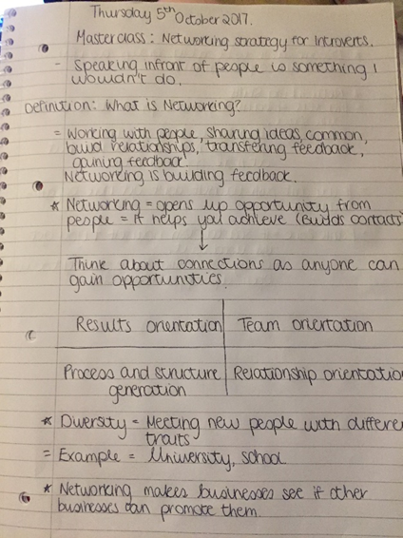
Appendix A: Andy Rogers Masterclass Notes.

Appendix B

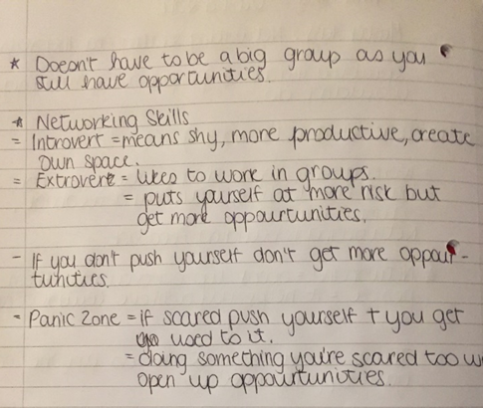
Appendix B: Networking Masterclass Notes.

Appendix C

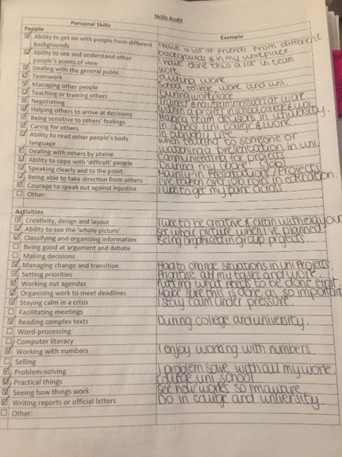

Appendix C: My Skills Audit Diagram 1

Appendix D

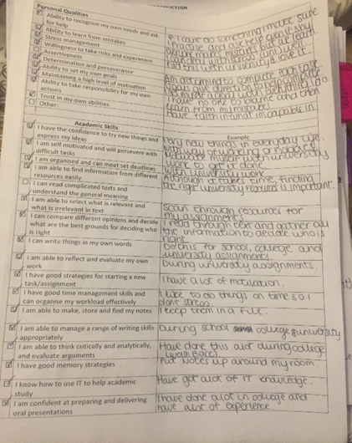
Appendix D: My Skills Audit Diagram 2

Appendix E

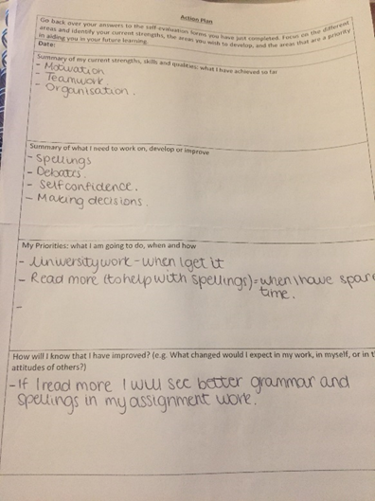

Appendix E: My Action Plan

