Name: jermaine gamble

Student ID: 2504604

Lecture : DR Besty Joe

Module: Professional Development within Health and Social Care

Module Code : LCHS4009

Assessment Title: Personal Development Portfolio

Contents Page
Section | Page Number
Cover Page | 1
Contents Page | 2
Task 1: Job Advertisement | 3
Figure 1: Indeed, Job Advertisement | 3
Introduction | 4
Task 2: Professional CV | 7
Task 3: Personal Statement | 8
Task 4a: SWOT Analysis | 10
Figure 2: Personal SWOT Development Plan | 12
Task 4b: Personal Development Plan (PDP) | 13
Task 5: Gibbs’ Reflective Cycle | 14
Figure 3: Gibbs Reflective Cycle Model | 15
References | 17

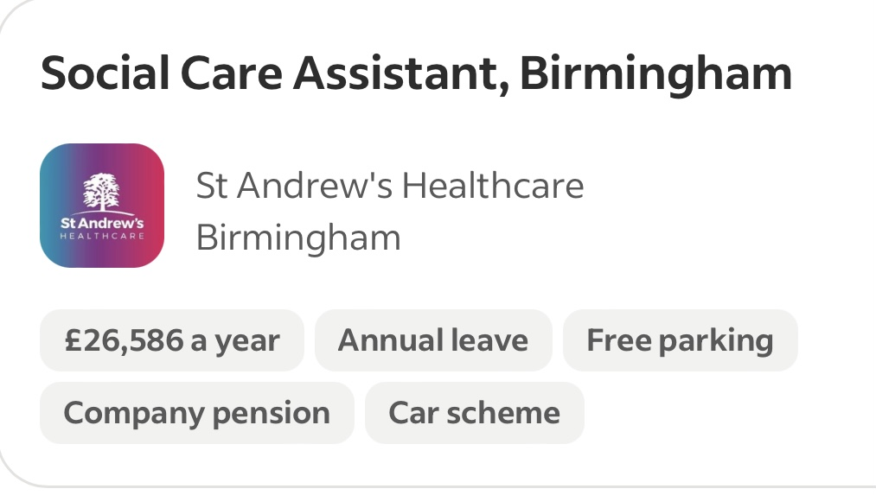
Task 1 – Job Advertisement

Figure 1: indeed, UK job search website(indeed,2026).

Job Title: Social Care Assistant
Employer: St Andrew’s Healthcare
Location: Birmingham, West Midlands
Salary: £26,586 per annum
Contract: Full-time (37.5 hours)
Job Category: Social Work
Date Posted: 24 June 2026
Job Reference: REQ000166

Main Duties and Essential Requirements
The successful candidate will provide high-quality, person-centred support to individuals, promoting dignity, independence, choice, and wellbeing. The role involves assisting service users with daily living activities, including personal care, mobility, nutrition, emotional support and maintaining social relationships. Person-centred practice ensures that care is tailored to individual needs, preferences, and goals rather than focusing solely on health conditions (NICE, 2023).
The post holder will encourage independence by supporting individuals to make informed decisions about their care and daily routines, enhancing confidence and quality of life (Care Act, 2014). They will work collaboratively with healthcare professionals and multidisciplinary teams to provide safe, effective, and coordinated support (NHS England, 2024; HCPC, 2024).
Accurate record keeping, confidentiality and professional documentation are essential responsibilities to ensure safe and accountable practice (NMC, 2018). The candidate must follow safeguarding procedures to protect vulnerable individuals from abuse, neglect, and harm (Care Act, 2014; CQC, 2024).
Applicants should demonstrate excellent communication skills, compassion, reliability, and the ability to develop respectful relationships with service users, families, and colleagues. A commitment to equality, diversity, person-centred care, and continuous professional development is essential for keeping professional competence and improving the quality of care provided (Equality Act, 2010; Skills for Care, 2024; Social Work England, 2024).

Task 2 – Professional CV
Your Address
Phone Number: 07310153772
Email Address: jaygamz374@gmail.com
Your Name: Jermaine gamble
SUMMARY
A compassionate, dependable, and hardworking Health and Social Care student with a strong interest in becoming a Social Worker. Enthusiastic about supporting vulnerable individuals, promoting equality, and improving people's wellbeing. Skilled in communication, teamwork, safeguarding awareness, and person-centred care. Eager to contribute positively within a professional health and social care environment.
EDUCATION
University of Wales Trinity Saint David (UWTSD), Birmingham Campus
Level 4 Health and Social Care (Expected September 2026).
Level 5 Health and Social Care (Starts September 2026).

EXPERIENCE
• Supported service users with daily activities.
• Maintained confidentiality and professional standards.
• Communicated effectively with colleagues and service users.
• Recorded information accurately.
• Promoted independence and wellbeing.
• Followed safeguarding procedures.
Volunteer – Community Centre/Food Bank
• Helped vulnerable members of the community.
• Worked effectively within a team.
• Developed communication and people skills. • Supported community activities.
• Safeguarding
• Communication
• Person-Centred Care
• Equality & Diversity
• Problem Solving
SKILLS
• Teamwork
• Active Listening
• Record Keeping
• Confidentiality
• Time Management
ACHIEVEMENTS & INTERESTS
Successfully completed Health and Social Care coursework, delivered university presentations, and developed knowledge of safeguarding, social care legislation, and professional responsibilities. Enjoy community volunteering, reading about mental health, walking, and supporting a healthy lifestyle.

Task 3 – Personal Statement
Choosing to study Health and Social Care reflects my ambition to make a positive difference in people’s lives. I am passionate about supporting individuals, promoting wellbeing, and helping vulnerable people achieve the best possible quality of life. I am interested in understanding how healthcare systems support individuals and communities, particularly those who may experience vulnerability or disadvantage. Health and social care professionals play an essential role in promoting independence, dignity, and wellbeing, which has encouraged me to develop the knowledge and skills needed for a career in this sector (Skills for Care, 2024). My passion for helping others and advocating for those in need continues to motivate me to pursue a career within the health and social care field.

My studies have helped me understand the importance of person-centred care and the need to consider everyone's personal circumstances, values, and preferences. According to Rogers (1961), effective support requires respect, empathy and understanding of the individual. These principles have influenced my approach to communication and my belief that every person should receive compassionate and respectful care.
Throughout my academic journey, I have developed important transferable skills including teamwork, communication, and critical thinking. Working with others during group activities has improved my ability to listen to different perspectives and contribute effectively towards shared goals. Teamwork is particularly important in healthcare because professionals from different disciplines must collaborate to provide safe and effective support (NHS England, 2023).
I recognise that working within health and social care requires strong ethical awareness and responsibility. The principles of confidentiality, safeguarding and equality are central to professional practice. The Care Quality Commission (2023) highlights that safe and effective care depends on services protecting people’s rights and ensuring ambitious standards. Developing my understanding of these principles has strengthened my commitment to professional behaviour.
My future goal is to build experience within healthcare and progress into a role where I can support individuals and contribute to improving service quality. I aim to continue developing my knowledge through further training, reflective practice, and practical experience. Schön (1983) explains that reflection allows professionals to learn from experiences and improve future practice, which is a skill I intend to support throughout my career.
My strengths include compassion, willingness to learn and commitment to helping others. However, I also recognise areas for improvement, including developing greater confidence in professional situations and expanding my practical experience. Through continuous professional development, I will work towards becoming a skilled and responsible health and social care professional.
Overall, studying Health and Social Care has provided me with valuable knowledge about healthcare practice, professional values, and the importance of supporting individuals. I am committed to personal growth and developing the qualities required to contribute positively to the health and social care sector.

Task 4a – SWOT Analysis

SWOT Analysis Explanation and Importance

A SWOT analysis is a tool used to identify Strengths, Weaknesses, Opportunities and Threats that influence personal and professional development. It helps improve self-awareness, identify areas for growth, plan career goals and prepare for future challenges.

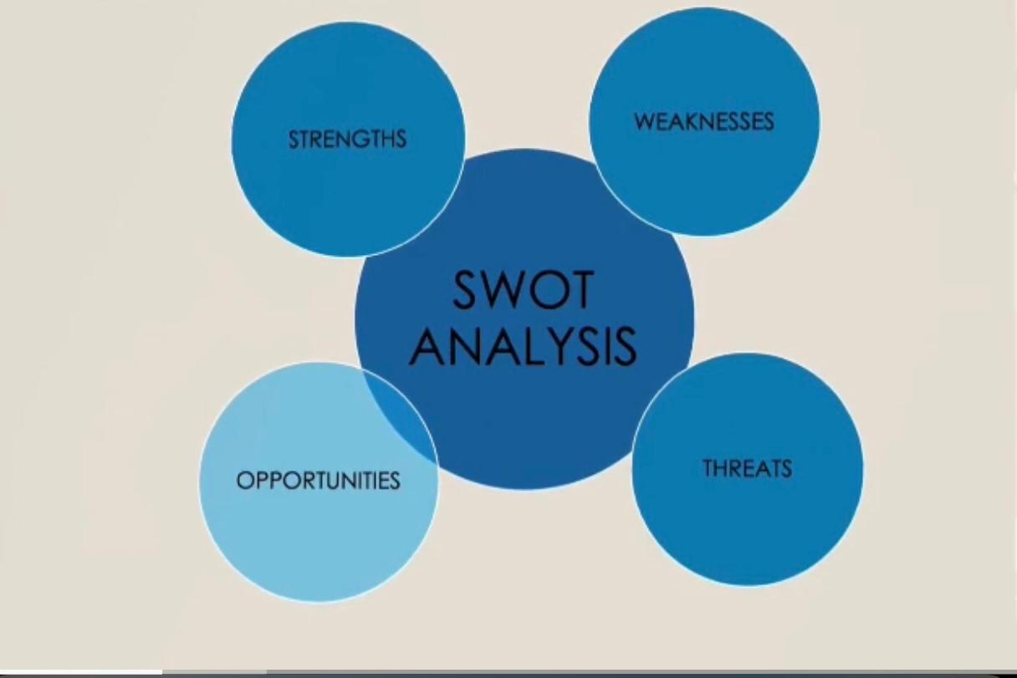

Figure 2: According to (Emiliyaa, Nataliab and Oleg, 2016), I used a SWOT development plan to identify my strengths, weaknesses, opportunities, and threats, reflecting on my learning, knowledge, and experiences.

SWOT Analysis – Personal and Professional Development for Social Work
My SWOT analysis identifies the key factors that influence my personal and professional development towards a career in social work.
My strengths include effective communication skills, empathy, active listening, and the ability to work well with others. These qualities help me build positive relationships with service users, families, and professionals. I am organised, motivated, committed to person-centred care and have developed knowledge of safeguarding principles and professional responsibilities. My volunteering experience has also helped me develop professionalism, patience, confidence, and critical thinking skills when supporting others. These strengths are important for developing positive relationships and effective professional practice within social care (Social Work England, 2021).
My weaknesses include the need to improve my time management skills to balance academic, personal, and professional responsibilities. I also need to gain more practical social work experience, develop confidence in decision-making, improve my application of social care legislation in practice, and become more confident when presenting to larger groups.
The opportunities available to me include university placements, Continuing Professional Development (CPD) activities and working alongside experienced social care professionals. These opportunities will allow me to develop practical skills, improve my knowledge, and prepare for a future career in social work. Further training in areas such as safeguarding, child protection and communication will also enhance my employability and professional development (BASW, 2021).
The threats: I may face include the high workload, emotional challenges and stress associated with social work practice. Managing pressure and preventing burnout will be important in maintaining my wellbeing. Competition for social work roles and changes in social care policies and legislation may also require continuous learning and development. Developing resilience, practising self-care, and maintaining a healthy work-life balance will be essential for long-term success in social care (Trevithick, 2012).

Task 4b – Personal Development Plan (PDP)

Personal Development Plan (PDP) Explanation and Importance
A Personal Development Plan (PDP) is a structured approach that helps individuals identify goals, develop skills, and monitor progress. It supports self-reflection, continuous professional development, and career progression by encouraging individuals to evaluate their strengths and areas for improvement (BASW, 2021).
Goal | Actions | Timescale | How I Will Monitor Progress
Improve my time management skills to complete university assignments and professional responsibilities effectively. | Develop a personal time management plan by using a weekly planner, prioritising important tasks, setting realistic goals, creating a study schedule, and avoiding last-minute work. | Within 6 months | Review planner weekly and monitor whether assignments are submitted on time.
Gain practical experience in social care to develop my professional confidence and skills. | Complete placements and volunteer within community or social care services. | Within 2 years | Record experiences in a reflective journal and seek feedback from supervisors.
Develop confidence in professional communication and presentations. | Attend communication workshops, practise presentations, and ask for feedback from tutors. | Within 1 year | Reflect on presentation feedback and evaluate improvements after each presentation.

Task 5 – Gibbs’ Reflective Cycle

Gibbs’ Reflective Cycle and Explanation
Reflection is the critical evaluation of experiences to identify learning, strengths, and areas for improvement. It is important in Health and Social Care as it promotes self-awareness, professional development, and improved practice (Schön, 1983). Gibbs’ Reflective Cycle (1988, as cited in Jasper, 2013) provides a structured framework for reflection through six stages: Description, Feelings, Evaluation, Analysis, Conclusion and Action Plan. It helps professionals understand experiences, apply learning, and develop strategies to improve future practice.



Figure 1: Gibbs Reflective Cycle (1988, AS CITED IN JASPER, 2013) is a six-stage model that helps individuals learn from experience by reflecting on what happened and planning improvements for future situations.

Gibbs’ Reflective Cycle
1. Description | 2. Feelings
As part of the LCHS4009 module, I completed a presentation based on my research and understanding of the topic. The assessment helped me develop my communication and presentation skills. My lecturer provided feedback and identified time management as an area for improvement. Reflection helps individuals learn from experiences and improve future practice (Schön, 1983). | Before the presentation, I felt nervous because I wanted to perform well and communicate my ideas clearly. I felt prepared because I had researched my topic and practised. After the presentation, I felt relieved and appreciated the feedback because it helped me identify areas for improvement (Jasper, 2013).

3. Evaluation | 4. Analysis
Overall, my presentation was successful because I explained my ideas clearly and showed good knowledge of the topic. I answered questions confidently. However, my lecturer recommended that I improve my time management because I spent too long on some sections and rushed my conclusion. | I understand that time management is important in social work because professionals must manage assessments, meetings, and records effectively. Social Work England (2021) highlights the importance of professional organisation and responsibility. I learned that practising with a timer and planning each section would improve my future presentations (Kolb, 1984).

5. Conclusion | 6. Action Plan
This presentation helped me develop confidence and recognise areas for improvement. Although I showed good knowledge and communication skills, I need to continue improving my time management. This will support my academic progress and future career as a Social Worker. | I will improve my time management by using a planner, setting deadlines, and practising presentations with a timer. I will also ask for feedback from lecturers and continue developing my communication skills to become a more confident Social Worker (Social Work England, 2021).

6- References

Bandura, A. (1977) Social Learning Theory. New Jersey: Prentice Hall.
British Association of Social Workers (BASW) (2021) The BASW Code of Ethics for Social Work. Birmingham: British Association of Social Workers. Available at: https://www.basw.co.uk (Accessed: 8 July 2026).
Care Act (2014) Care Act 2014. London: The Stationery Office. Available at: https://www.legislation.gov.uk/ukpga/2014/23/contents (Accessed: 8 July 2026).
Care Quality Commission (CQC) (2023) The State of Health Care and Adult Social Care in England. London: CQC.
Care Quality Commission (CQC) (2024) The Fundamental Standards. London: Care Quality Commission. Available at: https://www.cqc.org.uk (Accessed: 8 July 2026).
Department of Health and Social Care (2022) Health and Social Care Integration and Professional Standards. London: DHSC.
Equality Act (2010) Equality Act 2010. London: The Stationery Office. Available at: https://www.legislation.gov.uk/ukpga/2010/15/contents (Accessed: 8 July 2026).
Health and Care Professions Council (HCPC) (2024) Standards of Conduct, Performance and Ethics. London: HCPC. Available at: https://www.hcpc-uk.org/standards/standards-of-conduct-performance-and-ethics/ (Accessed: 8 July 2026).
Jasper, M. (2013) Beginning Reflective Practice. 2nd edn. Andover: Cengage Learning.
Kolb, D.A. (1984) Experiential Learning: Experience as the Source of Learning and Development. New Jersey: Prentice Hall.
Maslow, A.H. (1943) ‘A theory of human motivation’, Psychological Review, 50(4), pp.370–396.
National Institute for Health and Care Excellence (NICE) (2023) People’s experience in adult social care services: improving the experience of care and support. London: NICE. Available at: https://www.nice.org.uk (Accessed: 8 July 2026).
NHS England (2023) The NHS Long Term Workforce Plan. London: NHS England.
NHS England (2024) NHS England: Delivering high quality care and support. London: NHS England. Available at: https://www.england.nhs.uk (Accessed: 8 July 2026).
Nursing and Midwifery Council (NMC) (2018) The Code: Professional Standards of Practice and Behaviour for Nurses, Midwives and Nursing Associates. London: NMC. Available at: https://www.nmc.org.uk/code/ (Accessed: 8 July 2026).
Pluchevckaya, E.V., Varlacheva, N.V. and Andrienko, O.V. (2017) ‘SWOT-Analysis as a Tool to Achieve a State of Personal Well-Being’, The European Proceedings of Social & Behavioural Sciences (EpSBS), Vol. 19: Lifelong Wellbeing in the World (WELLSO 2016). Nicosia: WELLSO.
Rogers, C. (1961) On Becoming a Person. Boston: Houghton Mifflin.
Schön, D. (1983) The Reflective Practitioner: How Professionals Think in Action. New York: Basic Books.
Skills for Care (2024) The State of the Adult Social Care Sector and Workforce in England. Leeds: Skills for Care. Available at: https://www.skillsforcare.org.uk (Accessed: 8 July 2026).
Social Work England (2021) Professional Standards. Sheffield: Social Work England. Available at: https://www.socialworkengland.org.uk/standards/professional-standards/ (Accessed: 8 July 2026).
Social Work England (2024) Professional Standards. Sheffield: Social Work England. Available at: https://www.socialworkengland.org.uk/standards/professional-standards/ (Accessed: 8 July 2026).
Trevithick, P. (2012) Social Work Skills and Knowledge: A Practice Handbook. 3rd edn. Maidenhead: Open University Press.
Tuchman, B.W. (1965) ‘Developmental sequence in small groups’, Psychological Bulletin, 63(6), pp.384–399.
World Health Organisation (2021) Health Promotion Glossary of Terms 2021. Geneva: WHO.

