LCBM 7001

MARKETING MANAGEMENT

ASSESSMENT 1

LINA BIRMANTE

STUDENT NUMBER 2010698

MODULE LEADER TUSHARA BALENDRAN

SAMSUNG MARKETING MANAGEMENT

04/05/2021

Table of Contents

Introduction​3
Communication process and its application​3
Challenges of the crowded and competitive market place​4
Integrated marketing communication strategies​5
Current promotional strategies​8
Discussion and recommendation for the promotional strategies​9
Brand and brand equity​10
Customer journey and customer touchpoint​11
Summary and conclusion​12
References​13

Introduction
The concept of marketing management is based on the philosophy through which every organization needs to identify and examine the requirements of the targeted customers in the market. This marketing management then proceeds with the decision of providing the market with satisfactory products and services to serve the customers' needs as well as enhance the competitive level of the organization. The initial concept of the marketing management and marketing strategy of Samsung was First developed with promotional and competitive Strategies (Tien, 2020). Samsung health initiated new competitive strategies to develop superior products for marketing and create high-quality brands at a premium price. This study aims to analyze the marketing management and the marketing strategy of the company Samsung.
Communication process and its application
Communication is an important process in the organization to make connections with its target customers and stakeholders. Also, communication helps to develop a bridge between an organization and its consumers that help to develop an effective relationship in the market. Clear communication and the right use of communication channels are necessary for the organization to avoid any kind of miscommunication. Developing an understanding of the organizational activities to create brand awareness in the market is an essential part of communication. Communication can be different types such as verbal, non-verbal, written, listening, and visual. The organization Samsung needs to identify what kind of communication is effective for them to attract the attention of the market consumer. The concept of communication impacts all aspects of life in technology and human interrelation as well. According to the Shannon and Weaver model of communication, the process of communication and channel has various concepts like information source, message channel, noise, sender, recovers, encode, decode, and destination of the information. The sender is the originator of the message. The message of the sender transmits into the weave or binary data (Gillespie, and Schiffman, 2018). Decoders are the place of the reception of messages that transfer the signal into messages. It makes the signal into understandable messages. The receiver is the destination message of the receiver. Based on the decoded message the feedback is provided to the sender. In the wholesale process, the message can be affected by physical noise like horn, crown noise that may affect the flow of communication. The model helps to identify the berries ineffective communication so that the barriers can be removed from the process. However, the application of the model in interpersonal human communications is more difficult rather than it is useful for telecommunication.
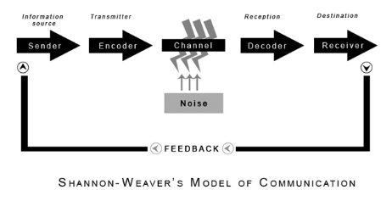
Figure 1 Shannon Weaver’s model of Communication
(Source: Gillespie, and Schiffman, 2018)
Challenges of the crowded and competitive market place
In terms of operating the business process of Samsung company, this requires focusing on the possible challenges such as changing business environment and p[rovide stress on the digitalization of the business process. The management of Samsung needs to focus on the changing business environment regarding technological development as well as the matter of focusing on the price-related issues. Through the use of an effective promotional strategy and keeping the price rate low, the competitors of the said company start the matter of providing the business threats (Getaruelas, 2019). The globalized world also provides a business threat by increasing the rate of customer demand as well. About that, the capacity of the mobile phones' memory and software-related issues also provide effective competition based on which the practice of switching to the other companies product by the customers can occur. On the other hand, the matter of tax-related issues and also the other problems with the company's product such as sudden heat of the body can also reduce the brand reputation of the organization.
On the other hand, information management-related issues can also occur which can affect the business-related process of the organization. Here in the application of social media can create complications based on the use of making negative feedback on the different platforms. Thereby, the problems can affect the functional work process and the revenue generation process of the company can also be hampered. Problems of the tax-related issues and the enhancement of the price of the raw materials cannot be avoided. In addition to that, the managerial problems of the organization can make problems that can hamper the organizational feasibility and also the business reputation (Murtiningsih et al. 2017). Sometimes the after-selling service of the organization can create issues that reduce the company's reputation and brand name as well.
Integrated marketing communication strategies
Integrated marketing communication is a strategic, collaborative, and functional marketing promotional strategy where integrated customers consistently receive brand awareness with effective channels that influence buyers' process of decision making. The strategy to develop integrated marketing communication is as follows;
Identify different methods of marketing communications: As per the target audience, Samsung needs to identify different ways to communicate with their target customers and what is the best channel of communication. For example, content marketing, email marketing, social media marketing, are the best ways to develop connections with the audience. Among them, social media is an easy and eye-catching way to attract the young generation customers by using WhatsApp, Facebook, Linkedin, and others.
Develop a plan for marketing communication: After determining the channel of communications is necessary to determine what needs to be provided as content to the audience, for that it is necessary to analyze the perception of buyers in the market and make note of their demand and change in their market preference. Adore needs to define the content most efficiently to speak to the target audience (Duralia, 2018).
Understands the decision-making process of customers: It is a vital stage of integrated marketing communication to understand the decision-making process of the target audience. The organization needs to recognize the problem and then search for information. Also, after that, the organization needs to identify which product and service can solve the problem of their customers. This provides the customers an alternative to buy. Then it is necessary to access the after-sale experience of customers.
Implement the IMC plan: After developing as an aspect it is time to implement the communication polanin market. For that, develop a timeline. If possible use automotive softwares in the organization and align that with CRM in the organization. Keep analyzing the progress and it will provide success to the organization on time.
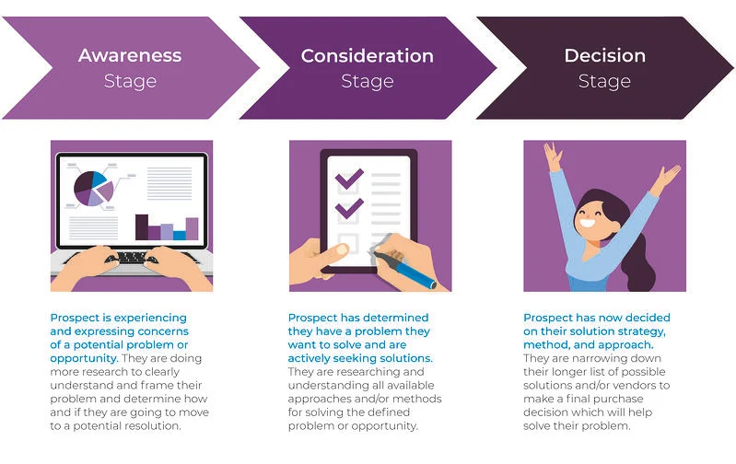
Figure 2: Decision-making process of customers
(Source: Duralia, 2018)

Current promotional strategies of Samsung products
a) Print and media advertisement
The process of making application of the strong promotional activities for the sake of the organization can help to keep undertaking the betterment of the business regarding feasibility. The advantages of the system can provide the business-related mileage by informing the large mass which through the projected business revenue margin can be reached in favor of the company. The management of the company can make contacts with the large print media and make applications of the advertisement which can help to reach the business demand of the customers (Sah and Karki, 2020). About that the management of the company can make use of the advertisement which can help to spread the business process of the company in the remote area as well. This enhances the possibility of informing the people about the production process of the company. In this context, this can be noted that the functional approach of the company can provide feasible business applications as well based on which the decision-making process of the employees can be taken based on the benchmark of the competitive advantages.
Apart from that the media presentation of the company can help to keep accelerating the business process and focusing on the matter of incurring the possible business growth. In this regard, the management of the company can decide on the media coverage by introducing the new mobile set in the market with heavyweight media coverage. In addition to that, the statement and interview of the CEO can be interrelated to the process which is why the promotional activities of the organization can also be incurred (Ganesan and George, 2019). Through the statement of the core competency of the products, this can be possible by enabling functional development and the matter of the better version of the products. This creates the brand recalling process among the intended customers. About that the celebrities in the different industries can also link to the procedure which through the attention can be developed for the business process of Samsung as well.
b) Sales Promotion
For the matter of operating the business process, the marketing approach such as sales promotion can be effective for the favour of Samsung. The objective of this process can be marked as launching new products, attractive new clients, stay business competitive and run clearance campaigns. The management of Samsung can generate the possible business goals which can generate the business growth effectively. Apart from that the types of sales promotion can also be linked with the business process such as price deal, coupons, mobile couponing and sampling approaches as well. The sales promotions types can help the organisation to generate the feasible business output using which the generation of business revenue can be ascertained. Through the use of popular techniques, the positive output regarding the business deliverables can be incurred. This can help to make enhancement of the business based operation and sustainability as well. For the matter of getting more competitive advantages and informing the customers about the work process of Samsung, this type of marketing approach can be useful.
c) Direct marketing
The management of Samsung can make use of the direct marketing strategies which through the possibility of getting the customer's attention can be confirmed. In this regard, the use of different communication channels can be interrelated with the approach such as the development of the business regarding feasibility and the practice of betterment of making connections with the requirement of the customers. Through the direct marketing approach, the product-related specification and the matter of developing the specific idea considering the products can be generated. In addition to that, the betterment of the configuration of the products can also be inculcated which through the matter of developing the buyer's decision can be easy to take. About that the direct marketing approach can be occurred by focusing on the different technological activities and media-based planning can be implemented here which through the development of the knowledge of the customers can be developed. On the other hand, the marketing team of the organization can also apply the effective emailing process to make connections with the customers by providing information and discount-related support to the customers. The disadvantage of direct marketing is linked to the matter of not reaching the ass through the communication process in a short period.
Discussion and recommendation for the promotional strategies
a) Online promotion
Samsung has different promotional strategies based on its size of the market in different countries. The company focuses on selecting celebrities as its brand ambassador to promote its products. It also provides free content on mobile in collaboration with the copyright of Bollywood movies. They have also started Samsung Fun Club to establish a sustainable customer relationship (Putri, 2020). They allow customers from all around the world to post their reviews and feedback on the portal and viewed by people worldwide. This helps the company to grow loyalty among customers. It promotes the reviews along with their latest models. The strategy that makes Samsung stand out from others is its online software updates and tutorials. It assists customers thoroughly when they confront any difficulty operating the device. The brand also uses attractive advertisements on televisions and different social media platforms to promote its products. They make sure to highlight the latest features in the advertisements shown. The online promotional strategies are regarded as pull strategies and involve making announcements about new devices or updates on Facebook, Youtube, Twitter (Anorue et al.,2020). Also, to facilitate online marketing, it has started launching the latest devices on online platforms before making them available in stores.
b) Traditional marketing techniques
The promotional Strategies for Samsung are enhanced with their tradition for targeted marketing techniques. The organization depends on advertising Strategies and has already resulted in successful outcomes from these marketing techniques. Moreover, the organization considers advertisement techniques as a traditional process for involving the heavy promotion of their business by using full and full strategies (Baghsheykhi and Arabiyeh, 2019). Moreover, Samsung also places their products through advertising Strategies and sales for traditional approaches with marketing strategies and making placement of their major product events full and unique. It can be recommended in the context of Samsung marketing techniques and promotional strategies that Samsung can make an approach in reaching their targeted customers and persuade them to purchase services and products that are effective for their advertising strategies. Moreover, through this marketing strategy, the organization Also enhances their advertisement plans and insurance the effectiveness of their products information to be carried forward to their customers to emphasize benefits of the products to the customers that week had their drive successful sale for the company.
Brand and brand equity
The brand is considered to be an intangible asset for an organization, the case is the same with Samsung as well. Constructing brand value requires a huge amount of rigorous effort, investment as well as productive time. The concept of brand equity can be referred to as the premium value that a company can generate from the identification of a product Wait recognizable name when it is compared to an equivalent generic value. Samsung provides effective marketing strategies as well as advertising strategies to position the brand image into the consumer's thoughts. These consumers create an effective brand image and identity to recognize the value of the product and its features easily. The concept of brand equity can be demonstrated with different dimensions. These dimensions can be constructed as a negative dimension or a positive dimension of brand equity. In case some consumers relate the brand equity with feelings and some people among the customer group relate it with the performance of the products. Moreover, this concept of brand equity can also be segmented under brand intimacy, brand commitment, brand reliability as well as brand performance, and brand cyclic to highlight various dimensions of the product brand (Kim, and Chao, 2018).
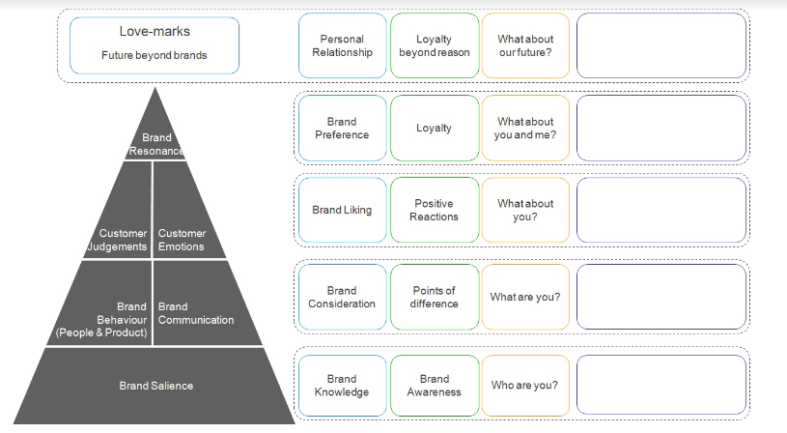
Figure 3: this figure denotes the concept of brand equity of Samsung
(Source: Kim, and Chao, 2018)
The organization can construct brand equity for its products by making them easily identified and recognizable as well as memorable and superior with the features of reliability and enhanced quality. The brand value of the organization can be identified with the demand of the products of the organization by the consumers in the global market. The consumers of Samsung have expressed In affection and respect for the organization’s products of telecommunication devices whose brand wear found to be loyal. The loyalty of a brand was found to be having an effective impact on the brand equity that was influenced positively by the financial value of the brand. In addition to this, brand equity and brand loyalty were highly influenced by the positive perception of quality and brand image (Hendro and Syah, 2020).
It has also been analyzed from the company’s context that about 56% of Samsung mobile phones were found to be having a positive influence for perceiving brand quality and equity which was further explained with monetary value, an image of the brand, and Awareness of the brand. Although, it can be stated that the brand equity of the organization can easily be generated through the true promotion of new and updated generations in the global market. The advantages of the Keller brand equity model can be specified by focussing on the skills by presenting the positive idea which through the positional development of the work process can be ensured. On the contrary, this could be marked as the threat regarding the brand equity based perspective by keeping continuation of the threat relating issues.
Customer journey and customer touchpoint
The customer’s touchpoint can be defined as the customer’s contact at brand points from starting till the finishing of the trash point. On the other hand, the touchpoint of the customers is defined as a potential customer contact with the product brand after, before, and during purchasing the product from the company (Westerman, 2017). To describe the customer's touchpoint of the brand Samsung, it can be widely described that Samsung collects customer feedback with a small All event of touchpoints survey that is located in the store while purchasing Samsung products. The electronic products of Samsung are one of the world's largest technical applications that the company provides with distributing their stores in more than 80 countries with approximately 320000 employees all around the world.
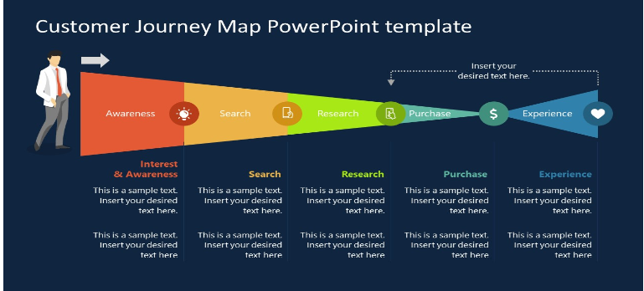
Figure 4: This figure denotes the customer journey map concept
(Source: Harris et al 2020)
The customers all around the world are different groups and are always emphasized with getting transparency applications from the brand stores. Therefore, expect the brand to provide them sufficient knowledge and ideas about their product so that it becomes easy for them to identify and decide what they will purchase and what they will not purchase. In most cases, it is very common that retailers find the opportunity of engaging the consumers and surprise them with Peer reviews and competitive pricing with open messages. retailers can also bring the experience detail of the product and explain the risk of the purchase in the product to initiate the customer to buy the product with a high pricing rate.
The customer touchpoint-related functions can be interrelated to the process which through the requirements of the customers can be documented and about that the related marketing activities can be done which can be helpful to reach the requirements. In this regard, the after selling service and providing the machine-related guarantee can be marked as the integrated part which can be beneficial for the matter of developing operational efficiency.
Through the specification of the strength of the journey map of the Samsung, the possible remedies regarding the after selling services and the other requirements of the customers can be sorted out. On the other hand, the weakness of the journey map can also be specified by considering the approach which through the particular section of the particulars products related concern can be found out. The medium involvement purchases of SAmsung provided with simplistic customer journey which is not relatively long. On the other hand,the pre purchasing activities include multiple sequences for the customer. In order to avail the products of Samsung, the customer gathers information through making a detailed review of marketing communications through searching on internet and visiting offline stores. The reviews are also gone through along with making comparison with the competitor products to make a finalized decision about the purchase.

Summary and conclusion
This study derives information regarding the development of the marketing-related potentials which through the betterment of the business process of Samsung can occur. In this concern, the feasibility of the business-based work process and the marketing-related parameters have been analyzed here by introducing the digital and traditional mode of the business process (Yu, 2020). This can help to keep generating the feasible development and productivity-based outcome which can generate force for the revenue generation. About that, the application of the marketing communication process and the promotional applications have been analyzed here which through business-based sustainability can be ensured.
This can be recommended that the marketing communication process can also be developed by focusing on the matter of more use of the digital communication strategy developing policy and operation. This helps to incur the strategy which can be beneficial for the matter of making the collection of the feedback related information for the organisational betterment. On the other hand, another recommendation that can be provided to Samsung is to identify the needs and aspirations of the customers in order to procure a cohesive digital communication strategy. This strategy can help in communicating feasible brand message to target customers to persuade them to avail the services of Samsung.

References
Anorue, I.L., Ugboaja, S.U. and Okonkwo, C.P., 2020. Influence of online advertising in the promotion of Nigeria Professional Football League (NPFL). International Journal of New Economics and Social Sciences, 11, pp.231-246.
Asdi, A. and Putra, A.H.P.K., 2020. The Effect of Marketing Mix (4P) on Buying Decision: Empirical Study on Brand of Samsung Smartphone Product. Point Of View Research Management, 1(4), pp.121-130.
Baghsheykhi, H. and Arabiyeh, F., 2019. INVESTIGATING AND EVALUATING THE EFFECT OF NEURO MARKETING ON CONSUMER BEHAVIOR WITH EMPHASIS ON CONSUMER LOYALTY (CASE STUDY OF SAMSUNG PRODUCTS. Humanidades & Inovação, 6(2), pp.224-234.
Duralia, O., 2018. Integrated marketing communication and its impact on consumer behavior. Studies in Business and Economics, 13(2), pp.92-102.
Ganesan, M. and George, E.P., 2019. A study on the effectiveness of aesthetically appealing print recruitment advertisement. Management Research Review.
Getaruelas, R., 2019. IMPACT OF SOCIAL MEDIA ADVERTISEMENT TO THE CUSTOMER PRODUCT BRAND AWARENESS OF SELECTED INTERNATIONAL COFFEE SHOPS IN MUSCAT, OMAN: AN INQUIRY TO THE CUSTOMER. Asian journal of management sciences & education, 8(1), pp.11-19.
Gillespie, D.J. and Schiffman, R., 2018. A critique of the Shannon-Weaver theory of communication and its implications for nursing. Research and theory for nursing practice, 32(2), pp.216-225.
Hendro, H. and Syah, T.Y.R., 2020. The Intention of Origin Influence Image Country to Buy Smartphone in Indonesia: Case Study on Samsung Brand. Journal of Multidisciplinary Academic, 4(2), pp.102-104.
Kim, R.B. and Chao, Y., 2018. The effect of country of origin on consumer-based brand equity (CBBE) of Colombian consumers: An empirical investigation of Samsung vs. Huawei brands. Journal of International Studies, 11(3).
Murtiningsih, B.S.E., Advenita, G.M. and Ikom, S., 2017. Representation of Patriarchal Culture in New Media: A case study of News and Advertisement on Tribunnews. com. Mediterranean Journal of Social Sciences, 8(3), p.143.
Putri, A.V., 2020. MARKETING AND ADVERTISING STRATEGY IN ACHIEVING THE TOP OF MIND (SAMSUNG BRAND CASE STUDY). Profetik: JurnalKomunikasi, 13(2), pp.290-309.
Sah, G.K. and Karki, S., 2020. The Impact of Media Advertisement on Consumers Purchasing Behaviour. PatanPragya, 7(1), pp.268-278.
Tien, N.H., 2020. International distribution policy comparative analysis between samsung and apple. International Journal of Research in Marketing Management and Sales 2019, 1(2), pp.24-27.
Tien, N.H., Dat, N.V. and Chi, D.T.P., 2019. Product Policy in International Marketing. Comparative Analysis between Samsung and Apple.“. International Journal of Research in Marketing Management and Sales, 1(2), pp.129-133.
Tien, N.H., Long, N.T. and Chi, D.T.P., 2019. Price Policy in International Marketing. Comparative Analysis between Samsung and Apple.“. International Journal of Research in Marketing Management and Sales, 1(2), pp.144-147.
Westerman, R.A., 2017. Development of a measurement instrument for smartphone behavior during the customer journey in different product categories (Master's thesis, University of Twente).
Yu, Y., 2020. Social Media Usage in Crisis Communication: aCase Study of Samsung (Doctoral dissertation, Syracuse University).
Harris, P., Pol, H. and van der Veen, G., 2020. 5 Customer Journey. The Routledge Companion to Strategic Marketing, p.67.

