TINAMARIE PENA-SMITH
1816447
YOHAN MENDIS
REFLECTIVE PORTFOLIO
BMSW 4005

CONTENTS PAGE
1 cover page
2 contents page
3 this is me
6 interview
9 SMART
13 references

THIS IS ME
My name is Tinamarie Pena-Smith I prefer to be known as Tina Smith, as I have reverted to my maiden name. The past 2 years have seen my life change tremendously, caring for mu terminally ill mother until she passed away in October 2018, I have been the sole proprietor of a catering business for 5 years and am a single parent to a 13 year old, with additional needs. I had always planned that the catering and self-employment was the decision to take this career path was bringing a dream and passion for cooking to life to keep me occupied whilst I cared for my mother and got my son through his education.
My previous work had predominantly been in the child protection, childcare and occupational therapy fields. My plan on commencing a university degree course was to gain a recognised qualification that encompassed these fields, I had identified that the field I am most interesting in developing is working with children and adolescents in a mental health or therapy capacity, and so my journey to achieving employment in this field commences. I have various qualifications that I have achieved both formal education undertaking GCSE’s and vocational qualifications BTECH National Certificate in Nursery Nursing, these qualifications were what enabled me to begin my career within nursery settings, where I was able to work up from a nursery officer to nursery manager. I am the type of person who enjoys learning and takes a great sense of achievement when I reach my targets or goals. Following on from working within nurseries for several years I decided to work within a residential child care setting and commenced a supervisory role in a Local Authority children’s home, working primarily with children with disabilities and their families, I really enjoyed the diversity of the children that were in our care and the things which I learnt whilst here. Fallowing on from this I began working with young people leaving local authority care, and child protection.
I undertook a short skills self-assessment, this was to enable me to understand more about myself, where I was at the beginning of this journey of returning to education and returning to a workplace as an employee. (Morgan, P. page19)

There are numerous theories and tools which I was able to utilise which helped me to learn more about myself, I will focus on 2 of these which I explored in depth, and to help learn about (how communication works impacts and influencescommunicationtheory.org) The first tool and theory I explored was the Johari window. (Communication Theory,
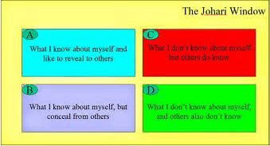
By working through the 4 areas of the Johari Window and discussing with peers with in my cohort and also friends and family away from study I was able to learn many of my strengths which I could use to evidence the skills which I possess and am aware of and also those which others had observed. This was a valuable tool as it gave me some validation in some areas which I felt I needed to improve or acquire but others had observed.
When working within a team or group identifying my own skills ensures I can find my role within the team, it enables others to utilise that to build their own strengths and also share the skills they could share. The benefits of teamwork are the self-discovery, the expansion of communication, the exchange between individuals which is built on trust.

I also researched how the Kolb Model could also assist in gaining advantage when seeking employment. I found that this was more beneficial when I was writing my CV in ensuring I wrote statements that were evidence based and I was able to prove and demonstrate the skills which I was claiming to have. Through writing experiences, I have had.
According to (McLeod S) Kolb's experiential learning theory works on two levels: a four-stage cycle of learning and four separate learning styles. Much of Kolb’s theory is concerned with the learners.
Kolb’s theory encouraged me to look at the things I perhaps do daily, and why I do them. It helped me explore how these things could influence my learning as a student my practise as an employee, alongside what I do as a parent, friend, carer and other roles. I could discuss how I could improve or change and develop these practices. An example of this could be explained by perhaps looking at a job description. On reading the job description I can identify what skills knowledge and attributes I already possess that are relevant to the role, and ensuring I can meet the essential criteria, this could be demonstrated through past skills and experience and qualifications. I could look at the desirable attributes for the job and identify which I already possess and suggestions or enthusiasm to learn could be identified, this could be thru further research about the job and company or identifying tasks goals to set myself, or by undertaking further training. Thus, using Kolb’s theories as the diagram below shows.

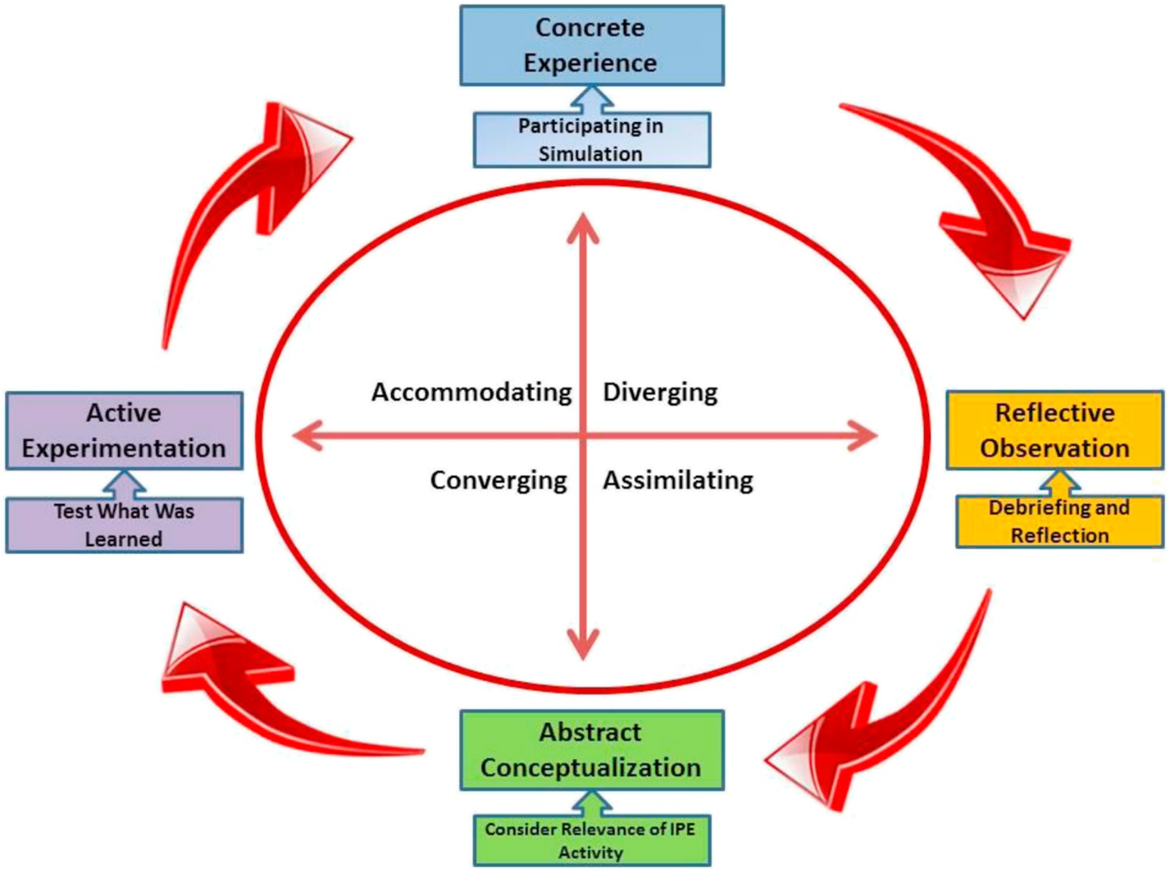
I discovered that my learning style according to Kolb is diverging and I agree this description best described my problem-solving methods and interactions within a group and general lifestyle and solutions when I must resolve or make decisions.

Diverging (feeling and watching - CE/RO)
These people are able to look at things from different perspectives. They are sensitive. They prefer to watch rather than do, tending to gather information and use imagination to solve problems. They are best at viewing concrete situations from several different viewpoints.
Kolb called this style 'diverging' because these people perform better in situations that require ideas-generation, for example, brainstorming. People with a diverging learning style have broad cultural interests and like to gather information.

INTERVIEW
It has been several years since I had last had a formal interview as I had been in my previous position for approximately 7 years. Followed by nearly 5 years of been self-employed. I had been on interview panels and been the interviewer. Alongside not having had recent interviewee experience I had not applied for a job or updated my CV in as many years ((Certificate in Higher Education: Skills for the Workplace Student Yearbook, 2020, chapter 12)
I didn’t feel confident in re writing my CV but I had not lost confidence in my abilities to put my experiences across., it was also a time to draw all of my experiences both through paid employment, life experiences and other experiences which could be used to impress any future employers. In the past the positions I have held had required thar I complete an application form, so I felt it was important to get the CV correct. I researched what was important to include, the importance of writing and attaching a cover letter, that could demonstrate further skills, showing research into the company. (Strengths & Weaknesses of the Curriculum Vitae Format, 2020)
SEARCHING FOR A POSITION
I had already developed a professional Linked in profile (Tina Pena-Smith) and kept this updated with any new courses and information re further education and my business. (7 benefits of using Linked in,2020) I have had some interests shown from the updated and relevant information shared on here. I intended to add my linked in profile to my CV so my intention was to ensure I was utilising this platform to the best of my ability.
Next, I made a list of the skills and qualifications I possessed and enter these into WMJOBS this Is a job search page I have previously browsed, mainly to see what positions are available that match my skills. I whittled down to suitable jobs which I had a good skills match. I was able to further select the criteria based on hours full or part time, location and how far I was willing and realistically able to travel given other responsibilities I already had. There were also the options to look at what time of employer I preferred such as Local Authority, private sector, voluntary sector and charities, all of these covered employment which my qualifications would cover.

The interview
Prior to the interview I did research into the company, I studied the job description and person specification to practice how when different questions were asked I would be prepared to give answers which would demonstrate I was prepared. I ensured I chose clothes which were smart in appearance which came across in a professional way, and which I was comfortable to wear. I had already planned the route to drive and prepared a folder which included all materials to the position.
I arrived punctually with at least 10 minutes to spare, so that on entry I was as relaxed as possible. I wanted my entrance to be confident but to also show the interviewers that I was a little nervous, amd hoped that as the interview commenced, I would gain confidence and nerves would subside.
On entry I greeted one of the interviewers with a handshake however I did not to this with the other interviewer and only greeted with a smile and to say hello. From the feedback which I received I was able to give a good impression, the different styles in which the interviewers had was demonstrated in their feedback, but both had felt I was punctual, dressed appropriately, maintained good eye contact and had greeted them both well.
Within the main interview the feedback points were in the main positive. Where again the information which the interviewers were looking for was interpreted differently. This has equipped me with information I need to bear in mind for future interviews examples of this I have identified are;
Give extra points of detail when asked questions which perhaps start…What do you think? To not be hesitant in sharing things about myself that will further support and back up whet I say about my skills and experiences.
When given the opportunity to perhaps ask a question which would demonstrate that I have done some research but still wanted to know more.
When answering questions posed in the interview to know when I need to pause to compose myself to then answer in a more clear and concise manner, using the words erm, ahh and and less frequently.what I demonstrated well within the interview were my past work experiences showing the need to be flexible in my approach, my abilities to work within a team ans to possess good communication skills, and why they are important. I demonstrated a good understanding of the job description and requirements of the position, and that I answered questions in detail.
After receiving feedback I also identified I needed to research and familiarise myself with the STAR approach, this was not an approach I was familiar with and had not been included in any in class lectures of literature, however having researched it , it is something I can ensure I include in future interviews, and also apply to my own personal goals. (How to Use the STAR Interview Method to Get the Job, 2020)

SMART
My SMART objectives for the really help me to identify how I hope to see my future, It helps me to identify how to put the wheels in practice to make them achievable and to set a time scale which gives me a duration and an endpoint. (SMART Goals: – How to Make Your Goals Achievable, 2020)

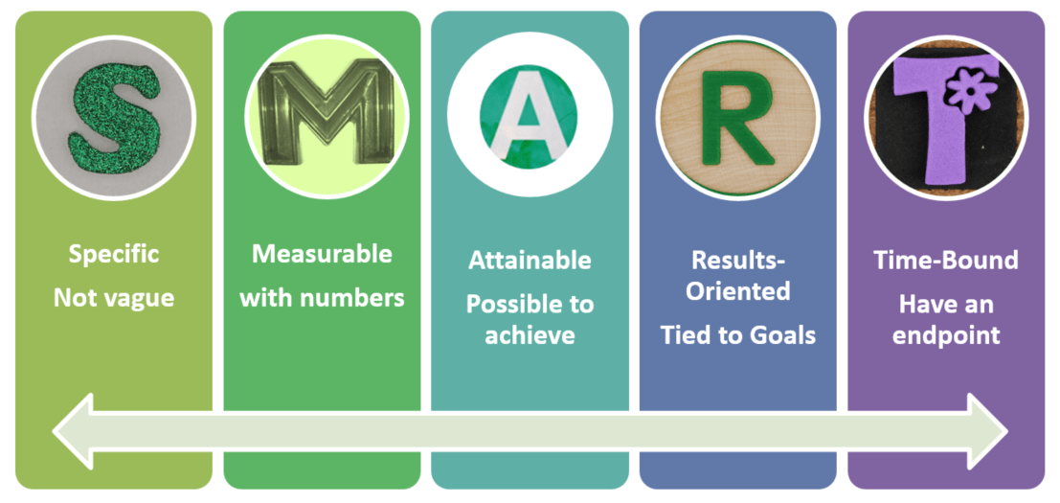

SMART target number 1 is to complete the current course which I am undertaking and go on to gain a BSC in Health and Social Care.
SMART target number 2 Improve my interview skills
Smart target number 3 is to ensure a healthy balance between study, work and family life
SMART target number 4 is to apply for student finance in time for the beginning of next term.
SMART target number 5 is to maintain a healthy mind.
SPECIFIC
When planning my SMART goals, I firstly have to clearly identify what it is I want, with each goal I have to question myself as to what I want, when I want it, who is involved, where it will take place and which resources will be needed
Number 1
As I near the completion of the first year the when comes in to play. In the next two years is how I would manage this as it is a 3-year journey and I have almost finished the first year. My plan to make this attainable is to apply to UWTSD to complete levels 5 and 6, there is now a possibility of a delay with this as the University and all others in the country have to await Government announcement of how long the social distancing, and prohibition of meetings and gatherings in groups and public places remains in place. This is at this moment in time the unknown and as yet no one is sure when the next term will commence that said I have completed the application form required of this and am awaiting acknowledgement of this. It is primarily me involved in this but I also recognise that for this to be achievable the staff, my family and friends are important in supporting me to achieve this. To ensure that I can also continue on my journey it is necessary to apply to Student Finance England, so that the funding needed to maintain our home, and cover the cost of the course is in place, and financial worries are not a reason I cannot continue.
Number 2
To improve my interview technique, I would need to attend more interviews. To do this I would need to identify positions which interest me and which I think I am capable of doing, or I could do some work experience or voluntary work, during the time in which I am studying again looking at the field of work I would like to enter. The interview techniques could be measurable by feedback and result, it may only take 1 interview. (Five ways to improve your interview technique, 2020) The voluntary work experience may be useful prior to applying for positions so I can demonstrate experience within the remaining 2 years of the course. I feel this is achievable in working towards my 5-year plan, as it sits easily within the time frame I have set myself, and could be completed over a period of time rather than immediately.
Number 3
It is imperative that I maintain the management of any current health conditions I am diagnosed with. To achieve this, I must continue to attend regular appointments and continue with my medication regime. As some of my health needs are affected by stress and can affect my energy levels it is important to set aside time away from study to relax and spend time with family and friends. Find activities which I enjoy and help to calm my body and mind, this is achievable on a daily basis and has no end date to achieve, as it needs to become a routine. If there are times which I find myself feeling unwell, overwhelmed or that I am struggling emotionally its important to address them, through various channels. The achieving of this goal is relevant as in maintaining these important things will make reaching my end goal of completing the course more achievable, in my first year of study I evidenced that by managing my health attending appointments , taking time out for family commitments and down time, I was able to balance all of the commitments I had made, including taking family holidays and setting time aside during these to complete my studies. (rana, 2016)
Number 4
As mentioned above applying for student finance is an important action to enable number 1 to be a [possibility. Having now completed the first year and experienced the lengthy process of applying for finance I recognise the importance of applying early and gathering all the information required. My experience had demonstrated that it only takes one thing to go wrong or be delayed for the whole process to grind to a halt. This is achievable by applying as early as is possible, by gathering all the information needed, and by chasing up outstanding tasks which maybe reliant on other people completing or contributing to. It is measurable by ensuring the time needed is allowed, for example by applying earlier than my previous year. It is also important that all information is fully completed and up to date. Failure to do these could result in application been declined and this would then impact on the opportunity to continue on the course or delay and affect my long-term chances of success and ability to achieve my goals in set times.
Number 5
Having experienced a bereavement prior to starting the course, it is essential that managing my emotional wellbeing and been aware when I am emotionally struggling to access help. In the first year of this course before establishing a good routine and homework and family balance I had found it overwhelming and questioned the timing and importance of continuing. I sought out what services that University could offer and found the counselling service. After contacting them and arranging to meet the benefit in making this decision was evident. I had a regular time slot which fitted in with my other commitments and did not affect the study work family balance. It was a safe outlet it was time sensitive as there were a predetermined amount of sessions. My goals were met in that it stopped my emotional health from spiralling to a point it could impact on my study.

GOAL | 1 | 2 | 3 | 4
SPECIFIC | ENROL ON FURTHER COURSE | IMPROVE INTERVIEW TECHNIQUE | ENSURE WORK, STUDY AND FAMILY  BALANCE | APPLY FOR STUDENT FINANCE | MANAGE EMOTIONAL HEALTH
MEASURABLE | MEET DEALINE FOR ENROLEMEN T | CONSIDER WORK EXPERIENCE OR APPLY FOR JOBS | MANAGE HEALTH ALLOCATE TIME | MAKE APPLICATION IN GOOD TIME | FAMILIARISE SELF AT BEGINNING OF COURSE WITH SERVICES
ACHIEVABLE | THROUGH ENROLEMENT | APPLYING FOR JOBS OR VOLUNTARY WORK | KEEP APPOINTMENTS AND MAINTAIN ROUTINES | ALL INFORMATION GATHERED CHASE ANYTHING OUTSTANTING | ACTING ON FEELINGS
RELEVANT | ONLY WAY TO COMPLETE AND ACHIEVE GOALS | WILL GIVE GOOD FOOTING TO IMPROVE TECHNIQUE | YES TO CONTINUE COURSE AND NOT RISK RELAPSE | PAYS FOR THE COURSE AND EMTITLES ME TO ATTEND | ADDRESSES NEEDS AS THEY ARISE
TIMEBOUND | 2 YEARS TO COMPLETE TO LEVEL 6 | 2 YEARS | ONGOING | 3 MONTHS | ON GOING PARTICULARLY DURING TERM TIME

References

Kolb's Learning Styles and Experiential Learning Cycle | Simply Psychology
https://www.simplypsychology.org/learning-kolb.html
The Business students guide to study and employability Peter Morgan. Sage. 2017
https://study.sagepub.com/morgan/student-resources/chapter-1/interactive-tests

The Johari Window Model

https://www.communicationtheory.org/the-johari-window-model/

https://www.bing.com/videos/search?q=wmjobs&docid=608043553403374086&mid=DF20FB0B7DC16DFBB87EDF20FB0B7DC16DFBB87E&view=detail&FORM=VIRE
https://www.linkedin.com/pulse/7-benefits-using-linkedin-sarah-rycraft
https://careertrend.com/strengths-weaknesses-curriculum-vitae-format-26341.html> [Accessed 1 April 2020].
//careertrend.com/strengths-weaknesses-curriculum-vitae-format-26341.html> [Accessed 1 April 2 SAGE Publications Ltd. 2020. Certificate In Higher Education: Skills For The Workplace Student Yearbook. [online] Available at: <https://uk.sagepub.com/en-gb/eur/certificate-in-higher-education-skills-for-the-workplace-student-yearbook/book260960> [Accessed 3 April 2020]. 020].

Mindtools.com. 2020. SMART Goals: – How To Make Your Goals Achievable. [online] Available at: <https://www.mindtools.com/pages/article/smart-goals.htm> [Accessed 2 April 2020].
the Guardian. 2020. Five Ways To Improve Your Interview Technique. [online] Available at: https://www.theguardian.com/careers/careers-blog/five-ways-to-improve-your-interview-t rana, v., 2016. 7 Tips To Balance Study, Work, And Personal Life - Elearning Industry. [online] eLearning Industry. Available at: <https://elearningindustry.com/7-tips-balance-study-work-and-personal-life> [Accessed 3 April 2020]. echnique> [Accessed 3 April 2020].

