

Exploring how social media influencers impact consumers purchasing behaviour: the case of Superdrug in UK

Dissertation
LCMB7020
Name : Simranjit kaur
Student Id : 2216400
Module Name : Dissertation
Lecturer name : Amare Desta

Abstract
This study investigates the role and extent of social media influencers on customers buying behaviour about the cosmetics sector and more specifically on the Superdrug brand. Therefore, through primary and secondary data analysis, the study discusses specific areas such as social media impact on the buying decision, influencers’ reliability, visual content, in social media marketing.
There is a evidence suggest that social media is effective in creating consumer interest and sales, dependent on recommendations. The factors that define influencers’ effectiveness involve credibility and authenticity, with visuals having a significant impact on customer perceptions and purchase intentions. Influencers on social media are those who have built a significant following on platforms like Instagram, YouTube, and TikTok. They promote their popularity to promote products and brands have perceived as more relatable and trustworthy than traditional celebrities do.
Thus, the key recommendations for Superdrug are to build better relationships with influencers, to focus on hiring professionals who will create appropriate pictures and videos for promotion, and to leverage data as the marketing weapon. The future studies should involve more longitudinal research, more platform-related research, and studies of effects of new technologies showing how and in what ways the role of social media is developing.

Table of Contents
Chapter 1: Introduction 6
1.1 Introduction 6
1.2 Research Background 6
1.3 Rationale 8
1.4 Problem Statement 9
1.5 Purpose of the study 9
1.6 Research aims and objectives 10
1.7 Research questions 10
1.8 Research Significance 10
1.9 Summary 10
1.10 Dissertation Structure 11
Chapter 2: Literature Review 12
2.1 Introduction 12
2.2 Factors Influencing Consumer Buying Patterns in the context of purchasing cosmetics-related products 12
2.3 Impact of Social Media campaigns, Influencer Collaborations, and user-generated content on Brand Awareness and engagement 15
2.4 Influencer-Customer Relationship 17
2.7 Theoretical Overview 25
2.8 Literature Gap 26
2.9 Summary 27
Chapter 3: Methodology 28
3.1 Introduction 28
3.2 Research philosophy 28
3.3 Research Approach 28
3.4 Research Design 29
3.5 Data Collection 29
3.6 Data Analysis 30
3.7 Ethical Consideration 31
3.8 Summary 31
Chapter 4: Data Analysis and Findings 33
4.1 Introduction 33
4.2 Findings on Primary Data 33
4.3 Findings on secondary data 40
4.4 Discussion and analysis 45
4.5 Summary 48
Chapter 5: Conclusion 49
5.1 Conclusion 49
5.2 Limitations 50
5.3 Future scope 51
Chapter 6:Recommendations 52
References 56

List of Figures
Figure 1.1: Revenue of Superdrug Company 7
Figure 1.2: Market growth of the global cosmetic market 8
Figure 1.3: Dissertation Structure 11
Figure 2.1: Green Consumer Behaviour in the Cosmetics Market 13
Figure 2.2: Social media marketing strategy 16
Figure 2.3: Influencer-Customer Relationship 18
Figure 2.4: Ethical, Legal and Social Issues 22
Figure 2.5: The Economic and Social Impact of Influencer Marketing 24

Chapter 1: Introduction

1.1 Introduction
Social media influencers' impact on customer purchasing behaviour with their exploding popularity correlating with their cosmetics brand Superdrug is an vast challenge. As opined by Gregor and Olejniczak (2023), influencers in the beauty industry are eager to utilize platforms of social media to share their content with many types of beauty products. Targeted at the level of research, given inequality, the purpose of this research is to find out the extent to which influencers affect consumer choice and brand engagement, providing the current picture of the dynamics of the marketing system in the digital age.

1.2 Research Background
Social media has experienced robust growth in recent years especially with the rise of social media. This has generally transformed the brand and consumer behaviour. Platforms, Instagram, and TikTok have become the most valuable media advertising studios, where social media influencers have achieved the ultimate power of exposure (Haenlein et al., 2020). Research on influencer marketing shows that the involvement of such influencers contributes to developing consumer-friendly brands, creating awareness, and boosting sales (Agustian et al., 2023). influencers, in all the endorsements it gives, give brands an air of authenticity, trustability, and, consequently consumer engagement and trust (Audrezet, de Kerviler, and Guidry Moulard, 2020). However, the cult of personality building between influencers and followers is the other reason behind the inclination of the fans of these influencers towards the brands and services they advocate (Venciute et al., 2023). In the UK retail arena, Superdrug’s holds one of the major positions as it offers an extended variety of beauty, health, and skin care products to its consumers that constitute, in turn, a very diverse market.
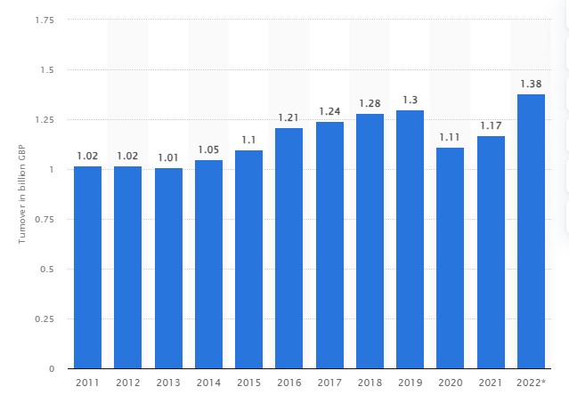

Figure 1.1: Revenue of Superdrug Company
(Source: Statista.com, 2023)
In 2021 Superdrug company generated over 1.17 billion pounds compared to 1.38 billion pounds in 2022 (Statista.com, 2023). With consumers today increasingly seeking products and services that are recommended over social media and influencers' effect, in this case, comes under the spotlight for marketers in the Digital Realm (Belanche et al., 2021). Along with that recognizing the operational mechanisms of influencers in marketing does not exclude the lack of in-depth knowledge of how this occurs in the case of Superdrug. It states that still in question does Superdrug’s target audience, the extent to which influencer artifacts affect consumers’ engagement level, and the completion degree of purchasing behaviour driven by influencer endorsements, predominantly choose the kinds of influencers.
The company has used social media to its advantage to reach a larger audience, particularly millennials and Gen Z consumers who value authenticity and peer recommendations. The study will then focus on the character of the influencers, the content type employed, and the influence of the content on consumer perception and buying behaviour. In this way, it would provide the much-needed findings for Superdrug's marketing strategies. Furthermore, by shedding light on some core features of influencer marketing in the retail area, as well as by offering some suggestions for brand growth and developing connections with consumers, this study provides implications for marketers who are interested in applying influencer marketing techniques toward the advantage of their organisations in the complex world of e-commerce.

1.3 Rationale
Social media influencers have been a revolutionary approach in marketing and consumer engagement for the Superdrug business in the UK, which warrants more investigation into their impact on consumer behaviour.
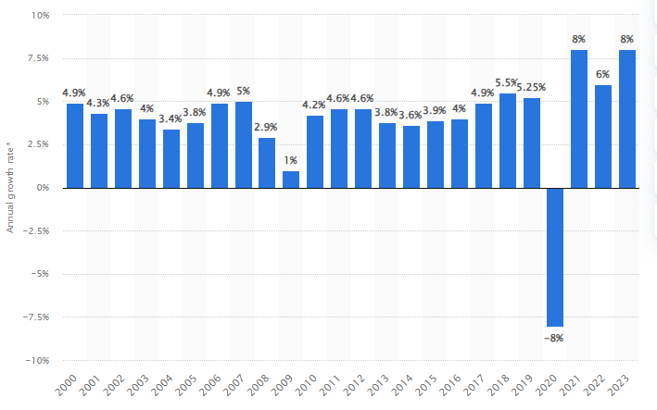

Figure 1.2: Market growth of the global cosmetic market
(Source: Statista.com, 2024)
Global cosmetics market growth has reached 8% in 2023 compared to 6% in 2022 (Statista.com, 2024). Social media platforms have occupied a significant portion of the brand-consumer space where influencers have become important opinion leaders and therefore possess tremendous power to influence consumer-buying behaviour (Gupta and Chopra, 2020). The new breed of consumers is demanding authentic content, influencer marketing provides a way in which trust with the help of originality, quality, and humour that can be established and brand reputation can be enhanced. This study focuses on identifying the strategic ways in which influencer-generated content could be incorporated into the Superdrug ecosystem.
Hence the foundations of this study will help in understanding the type of influencers, content strategies, and engagement tactics that can incite the positive reaction of Superdrug's target audience (Barta et al., 2023). Furthermore, this study suggests there are many hidden facets of collaborations and Superdrug which this research aims to furnish marketers with actionable information for optimizing influencer partnerships, growing brand involvement, and increasing sales. Further, the study provides the ground for a deeper examination of influencer factors in retail and thereby enriches academic discourse and advances future research on the issue.

1.4 Problem Statement
As stated by Wang and Lee (2021), influencers directly or indirectly help to promote new products that help to develop the appeal of the brand directly on social media with the help of sponsorship tags. Consumers often rely on influencers' opinions to discover new products and decide on their purchases. This trend is particularly evident among younger audiences who use social media extensively. Nevertheless, influencers' effects on consumers' behaviour cannot be underestimated. Hence, there is a gap in the knowledge on the extent to which their recommendations and content are affecting brand engagement and buying behaviour of customers of Superdrug. The investigation of these issues yields actionable information for Superdrug's marketing team and all who share the industry effort. It helps to employ respected social media influencers to achieve business growth. It tightens the cord between consumers and the retail area in a competitive market.

1.5 Purpose of the study
This research seeks to explore the significance of social influencers for the Superdrug concerning their effect on consumer behaviour. The conducted investigation highlights the importance of having influencer-generated content and determines its effectiveness in purchasing decisions and brand engagement. Thus, the research provides practical recommendations that can be used in Superdrug's further marketing activities. Also, the study seeks to add to the existing knowledge about ways of influence marketing in the retail sector providing useful practical recommendations to marketers in their effort to employ social media influencers more successfully in increasing sales and customer loyalty.

1.6 Research aims and objectives
- To understand major factors that influence consumer buying patterns
- To understand the impact of social media to influence consumer in their decision to purchase
- To understand how different types of social media used by influencers affect consumers' perceptions and intentions to purchase
- To investigate major lessons learned from the role and extent of social media investment and activities

1.7 Research questions
- What are the factors that influence consumer buying patterns?
- How are social media used to influence consumer in their decision to purchase?
- How do different types of social media used by influencers affect consumers' perceptions and intentions to purchase?
- What are the lessons learned from the role and extent of social media investment and activities?

1.8 Research Significance
The inferences from this research have important implications for the brand marketing department of Superdrug by moving its marketing efforts towards an influencer marketing trend trailing the industry. It also advances the overall comprehension of influencer marketing effectiveness in an operational retail sector and B2B marketing theory (Mero, Vanninen, and Keränen, 2023). Along with that, in turn, informs best practices and strategic steps to adopt influencers extensively across varied product categories and consumer segments (Mero, Vanninen and Keränen, 2023). Furthermore, the paper adds to scholarly discourse by extending the scope of theory used in literature within Influencer marketing and Consumer behaviour areas. On that account, grasping the factor of influencers brings benefit to consumers as the latter are enabled to make informed purchasing choices online that intensifies the wellness and delight of the consumers.

1.9 Summary
This study investigates the impact of social influencers on consumers' behaviour in the average Superdrug, UK store. It intends to identify the type of influencer now in influence, assess the extent of the impact of influencer-generated content on individuals, and understand the degree of influencer effect. The research gives economical performances of these aspects and contributes to the understanding of both influencer dynamics in the retail industry and consumers' behaviour, which will be useful for marketers.

1.10 Dissertation Structure

Chapter 1

Chapter 2

Chapter 3

Chapter 4

Chapter 5

Chapter 6

Introduction

Literature review

Methodology

Data Analysis and Findings

Conclusions

Recommendations

Figure 1.3: Dissertation Structure

Chapter 2: Literature Review

2.1 Introduction
In the new digital marketing world, social media influencers have become the key players in the process of consumer behaviour formation. This literature review is going to focus on the hundreds of studies that have been conducted to investigate the effect of social media influencers on the consumer purchasing decisions, especially in the cosmetics industry. Instagram, TikTok, and YouTube have revolutionised previous marketing methods and how brands interact with their audiences. This paper will in detail be discuss how the influencers affect the consumers' views of cosmetics products and the behaviour of the shoppers, particularly the case of the Superdrug, which is one of the leading retailers of the UK.

2.2 Factors Influencing Consumer Buying Patterns in the context of purchasing cosmetics-related products
The buying behaviour of consumers in the cosmetics industry is a complex product of psychological, social, and economic factors which are added to the cultural and technological changes that are current today (Limbu and Ahamed, 2023). Psychological drivers are the key factors that psychologically influence people, for example, self-esteem and personal gratification are the main reasons people turn to cosmetic products to boost their self-esteem and confidence. This behaviour has been described as the “lipstick effect,” which states that even during the recession, customers will still buy luxury cosmetics. Thus, it can be stated that these products have a strong emotional and psychological meaning (Limbu and Ahamed, 2023).
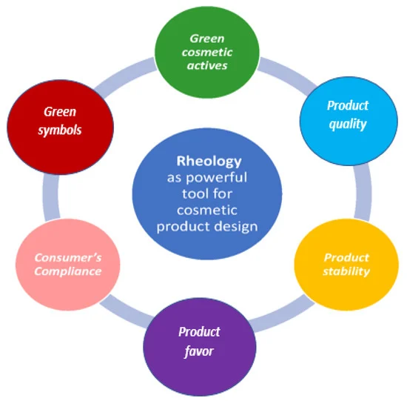

Figure 2.1: Green Consumer Behaviour in the Cosmetics Market
(Source: Amberg and Fogarassy, 2019)
Social influences are also crucial as the endorsement of influencers and the recommendations of peers are why consumer preferences are being changed (Chopra, Avhad and Jaju, 2020). The relationship of the products with the acknowledged influencers who represent the consumer needs outweighs the product's real benefit. It shows the strong effect of social symbolism in the cosmetics buying process. Moreover, cultural backgrounds are the factors that form beauty standards and hence affect product preferences (Zhang and Dong, 2020). The worldwide adoption of these standards through social media has been the main factor in the similarity of consumer tastes. Thus, the market for international cosmetics brands has been enlarged.
Economically, the fact that cosmetics prices are changed and the attractiveness of promotions are the causes of the changes in the buying patterns (Onwezen et al., 2020). Customers are usually attracted to seasonal sales and discounts, seen as having more value, thus promoting impulsive shopping behaviours. The progress of the technology that is virtual reality and virtual try-on has also changed the way consumers deal with cosmetics. The technologies improve online shopping by reducing the risks of the inability to try the products in person, making the consumers more confident in their decisions, and having a good impression on online shopping (Grewal et al., 2020).
Marketing mix elements such as product quality, brand reputation, pricing, advertising strategies, product availability, prior purchase experiences, and packaging are the leading cause of the cosmetic buying decisions of the buyers (Hanaysha, Al Shaikh and Alzoubi, 2021). Students from upper-middle-class backgrounds usually buy luxury cosmetic items. In contrast, students from middle to lower-income brackets tend to spend their money on items necessary for their daily use. The research has stated that personal factors are the main basis of the cosmetic decisions of the students (Hanaysha, Al Shaikh and Alzoubi, 2021). It is for this reason that Superdrug can employ these factors to improve on its marketing plans and products have been sold.
For instance, it can be discovered from research that social media influencers have a great influence on the buying decision and therefore, the stores can enhance its associations with most used beauty influencers. Through such an approach, they can announce new products and services or suggest a separate bonus through the pages of influence marketing content. Moreover, using the example of Superdrug, it can highlight that this company can promote on its policy of offering quality products and services combined with affordable prices and responsible attitude to various concerns among clients, including gender, race, age, and disability. The buying process usually begins with the realisation of a need or desire, followed by the search for the products or services that can serve these requirements (Candra Wahyu Hidayat, 2021).
The impact of marketing and advertising on consumer behaviour are powerful and direct (Rosário and Raimundo, 2021). Nevertheless, the fashion trends of today's consumers are very different from the past, and, thus, they are influenced by other factors that shape their buying patterns. Marketers spend a lot of time on market research every year to enhance these changing behaviours (Rosário and Raimundo, 2021). In terms of this, in a marketplace dominated by many choices, price competition and fast trend changes, marketers encounter difficulties in accurately identifying and targeting consumer behaviour.
In their research, Kotler and Armstrong explain price as the sum of money that the buyers exchange for the perceived value of a product or service (Anjana, 2018). It is identified that customers who are loyal to a brand are ready to pay extra for products due to their attachment to the brand. Companies foster these loyal customers, and their care and attention are given to them to enhance their business, as they are more profitable in the end. On the other hand, it has been discovered that product features, which consist of brand and price, are the main factors determining consumer behaviour (Sharma, 2021).
The study by Sharma, (2021) demonstrates the strong connection between price and customer satisfaction, which shows that price is an essential factor in the buying process and influences how the customer feels about his or her purchase. Advertising is an important part of the marketing mix: place, promotion, and product (Toha and Supriyanto, 2023). It is the main strategy used to sell a product. Advertising is essential in creating product awareness among possible customers and deciding whether to buy the product (Sharma, 2021). The authors stated that advertising is the means to create a very emotional bond with customers, which in the end causes people to remember brands more, leading to loyalty towards the brand.

2.3 Impact of Social Media campaigns, Influencer Collaborations, and user-generated content on Brand Awareness and engagement
Social media is now a commonly used platform for marketing communications as many people across different age groups now adopt it. Corporations can now launch and execute marketing strategies quickly on social media platforms, thus, breaking the bonds related to time and geography that were prevalent in the past. Traits such as live chats and comment sections allow consumers to interact directly with the brands, influencers, and other users, by expressing their views through likes, dislikes, or comments on posts.
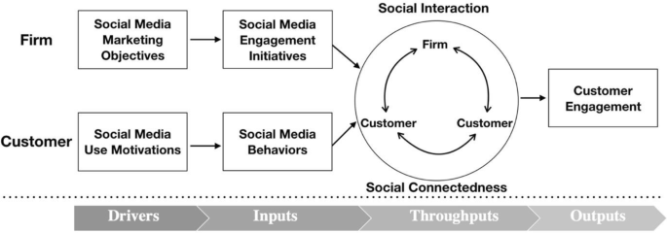

Figure 2.2: Social media marketing strategy
(Source: Li, Larimo and Leonidou, 2020)
The effect of influencer marketing has been tremendous; thus, the $1 market has shown a great expansion. 7 billion in 2016 to $9 in 2020, the world's population is anticipated to reach 9 billion. (Chowdhury and Chakraborty, 2021). This pattern continued, and eventually, the market peaked at $13. 2021 it is projected to have 8 billion inhabitants, and the 100 most powerful cities will cost $16 billion. The influence of the celebs on social media is undeniable, so it is no wonder the brands are now on an outbreak to get them on board to market to their demographics more effectively (Chowdhury and Chakraborty, 2021). All marketers use influencer marketing in their campaigns, which shows that this is the main promotional strategy.
An influencer on social media is a person who is a recognised online personality on platforms like Facebook, YouTube, Twitter, and Instagram, having a big active audience without broader publicity (Chowdhury and Chakraborty, 2021). These influencers are generally experts in specific areas like food, travel, fitness, or fashion, with the content they post on their social media pages which makes their audience always interested and updated on the new trends. By creating distinctive content and sharing unique stories, individuals get the chance to achieve a following and thus gain fame online, which is the cause of the growth of social media influencers (Vuong, 2022).
Social media campaigns are marketing policies that aim to promote a product , service or brand through one or more social media platforms (Bhandari and Bimo, 2022). The tactics used in these campaigns efficiently reach a large crowd quickly and can be customised to target groups. Social media is supportive and interactive platform, gives immediate feedback and interaction from the consumers to the brand, making the brand more visible and appealing (Aydin, Uray and Silahtaroglu, 2021). Campaigns that use trending topics or viral content can make a brand's name highly visible and put the brand in the digital space.
The partnerships with the influencers are based on their credibility and followers, who already have a relationship that can be used to promote the brands more naturally and realistically. Influencers usually know their audience's likes and dislikes very well and can come up with just perfect content for them (Aljukhadar, Bériault Poirier and Senecal, 2020). Such adequateness is essential as it boosts the trust and loyalty of customers are focusing to buy. Influencers can successfully lead the brands to new audiences, raise engagement using likes, shares, and comments, and foster direct sales from affiliate marketing and product endorsements (Aljukhadar, Bériault Poirier and Senecal, 2020).
User-generated content is the name given to any kind of content such as videos, pictures, reviews, and testimonials produced by product or service users and then shared on different platforms. UGC is a strong testimonial for a brand (Bozkurt, Gligor and Babin, 2021). Hence, it makes the brand authentic and credible. Brands that enable their customers to share their experiences with them can gain stronger loyalty and a better feeling of community. Moreover, UGC is full of actual content that the brands can use for marketing purposes. Thus, they can make their messages more relatable and appealing to the users. In terms of this, these strategies form a complicated approach to digital marketing that can enormously improve brand visibility and interaction. Brands can increase the number and length of social media campaigns, influencer partnerships, and user-generated content to get a more diverse and sustained engagement strategy (Bozkurt, Gligor and Babin, 2021).
In average, one out of every four adults have admitted being affected by influencer recommendations, a figure that increases to over 50 percent among Generation Z (Moran, Muzellec and Johnson, 2020). In 2023, a third of the UK businesses planned to increase their budgets for influencer marketing, while 45 percent intended to keep their spending the same as before. From 2019 to 2023, spending on influencer advertising has increased by over thrice, reaching 791 million British pounds, which exceeds the entire amount spent on magazine, radio, and movie advertising in the UK., and It is anticipated to be more than one billion pounds by 2025. The funds are now being channelled from traditional media outlets, experiencing a reduction in print, outdoor advertising, and radio (Limbu and Ahamed, 2023).
Influencer marketing is now one of the most popular means of connecting with the audience, which is more efficient than the conventional digital marketing channels such as Meta and TikTok (Limbu and Ahamed, 2023). This method is based on the idea of teaming up with the influencers who have a particular follower base that is in direct correlation with the target market of the brand. Successful influencers keep an active and reliable following, which makes it highly probable that their endorsements will result in consumer action. The effectiveness of this strategy is based on the selection of influencers whose audience is not only large but also engaged and interested in the brand's products.

2.4 Influencer-Customer Relationship
The influencer-customer relationship is rooted mainly based on trust and authenticity. Influencers' fans usually feel like they have a personal relationship with them; therefore, they treat them as their friends or as the persons whom they admire rather than as the advertisers (Saputro, Wahyudi and Yuningsih, 2023). On the other hand, influencers who stay true to their identity and openly admit their collaborations with brands are more to keep and involve their followers better. The influencer's honest experiences or views about a product can create a stronger connection with the audience and increase their trust.
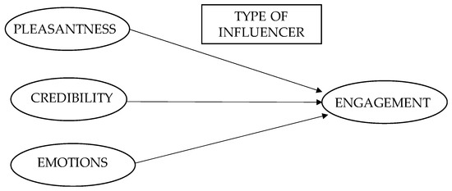

Figure 2.3: Influencer-Customer Relationship
(Source: Berne-Manero and Marzo-Navarro, 2020)
The prominence of the influencer-customer relationship does not only lie in the persuasion but also the level of engagement and interaction (Berne-Manero and Marzo-Navarro, 2020). Unlike old-fashioned advertising, which is primarily impersonal, influencer marketing is based on two-way communication. The constant discussion between the two parties helps to solidify the relationship and to keep the audience engaged (Berne-Manero and Marzo-Navarro, 2020). Thus, for brands, this implies that the audience that is already engaging with their content, which can thus significantly increase the effect of marketing messages, will see all the endorsements by the influencer. Main competitors would most probably be the hotel chains that are already well known and have large brand recognition (Bhandari and Sin, 2023).
For instance, Marriott, Hilton, and Hyatt have several properties all over the city. These big stores usually have all kinds of facilities, rewards programs, and competitive prices that can be attractive for both the owners and the tourists. Influencers have been focusing on the stating stories of their personal lives, day-to-day experiences, and matter-of-fact aspects into their lives, which is why they establish stronger emotional bonds with their audience. This connection is the main reason, as it goes beyond a normal customer-brand relationship to form a community feeling among the followers. Such communities are those that share the same interests and values (Anderson, 2024). Thus, they create an ideal environment for brands to insert their messages that align with the community's beliefs and preferences.
The feeling of trust, engagement, and emotional connection among influencers and their followers greatly influences the customers to choose a specific product or service (Ki et al., 2020). Customers are ready to purchase products promoted by an influencer if they think the influencer is trustworthy and has similar tastes and values. In addition, influencers usually use or demonstrate products in real-life situations. Hence, some of their recommendations are useful to their potential customers as they can understand the product and its relevance to their daily lives, thus decreasing the uncertainty that generally occurs during online shopping.
Influencer marketing is a new strategy in marketing which is the process of finding and putting into action the key people who can influence a particular target audience or community, ultimately boosting the brand's reach output sales and engagement (Ki et al., 2020). This method is a type of marketing through word-of-mouth on a higher level but within a social context. This is also a way for companies to expand their customer base with the final aim of turning them into faithful customers by establishing trust and credibility. This is the reason why influencers maintain strong connections with their audience, which are based on content that is interesting and engaging. Hence, they can establish trust in the influencers’ viewpoints that they can share with their audience.
Scientific research has proven that influencer marketing can give a better return on investment than the usual advertising methods. The fashion industry is one of the areas where this generation Y and Z are the most responsive to influencer endorsements (Chen and Yang, 2023). Influencer marketing is necessary for inventing and distributing new products and the associated information, which is an essential element of marketing communications. The effect of an influencer on the consumer attitude mostly depends on how they present the advertising messages and the type of visual and verbal information they use when promoting a product. Consumers tend to like advertisements that show memorable, credible, engaging, and charismatic people.
In the world of fashion purchasing, where the decision-making process involves a lot of attention to detail, social media influencers can boost consumers' self-esteem, especially when they buy the items they recommend (Gentele and Persson, 2022). Make Over has intelligently used Instagram's interesting features like stories, story highlights, IGTV, live video, hashtags, and checkout tags to push its marketing campaigns (O’Sullivan, 2021). These characteristics make it possible for them to present the prices directly connected to their online shop, thus improving the shopping experience. Rather than leaning on the usual big stars, Make Over has opted to work with beauty influencers to forward their brand. As Lucia from Make Over's public relations says, the brand is seen as a high-quality competitor to international brands, even though it is cheap (O’Sullivan, 2021).
The notion of para-social interaction (PSI) explains the kind of connection between media users and performers (McLaughlin and Wohn, 2021). It indicates that people usually feel a one-sided relationship with celebrities; they feel a sense of friendship, understanding, and identification from their interactions. This sort of relationship can result in a para-social interaction, where the followers feel they are friends with the influencer or celebrity. This so-called friendship has feelings of closeness and liking that later develop into a more significant bond, usually described as the regular interaction with the influencer's content (McLaughlin and Wohn, 2021). The person-to-person contact between the influencer and the people can lead to a friendship that is as true as a real friendship.
When followers like an influencer's thoughts and style, they usually go for more content from that influencer, and with that, the bond between the two gets deeper (Bi, Yin and Kim, 2021). Besides, the support from celebrities or influencers significantly affects the consumers' views about the products. They usually check and confirm the advantages of the products and sometimes act as long-term spokespersons. The trustworthiness and reputation of a celebrity can be transferred to a product, thus, improving the perception of the brand among the consumers. This linkage can boost the customers' desire to buy the products endorsed by these influencers, making them think that these products are related to the lifestyle or qualities of their preferred personalities.
Influencers act as the bridge between the companies and their target customers, thus, providing the companies with new ways of connecting with the people (Moreira et al., 2021). This article deals with the different ways that influencers use the media and platforms to attract followers and the kinds of generational segments of Gen Y and Gen Z. The research had as its aim to find out the social network preferences in different age groups, the differences between these groups in their choice of platforms and influencers as well as the link between age and consumer behaviour in influencer marketing (Moreira et al., 2021). The research emphasises the importance of influencer marketing and discusses virtual influencers, like those created by brands, such as NYX Cosmetics, designed to fit and control the brand's messages. By the end of the paragraph, the author presents the survey results, which show the different preferences of Gen Y and Gen Z; Gen Y likes Facebook, while Gen Z shows a stronger preference for Instagram.
2.5 Challenges and ethical considerations associated with social media marketing, including issues related to transparency
Social media marketing is the perfect tool for businesses to reach out to their clients but it has a range of challenges and ethical issues that they must deal with to keep their credibility and to build trust with the consumers (White and Boatwright, 2020). One of the main ethical issues in social media marketing is the disclosure of endorsements and partnerships. Institutions such as the Federal Trade Commission (FTC) in the U.S. and other organisations worldwide are the ones who make it a requirement for influencers and brands to reveal any of the partnerships that have an impact on their endorsements (White and Boatwright, 2020). The phrase refers to using clear and conspicuous disclosures on social media posts. Thus, the consumers get to question the authenticity of the endorsement and the honesty of the influencer or the brand.
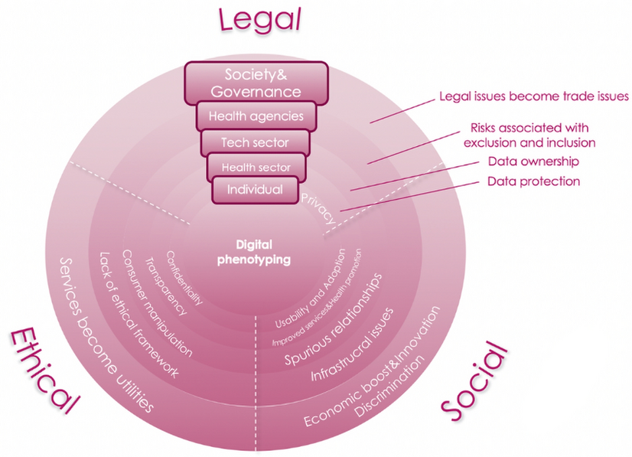

Figure 2.4: Ethical, Legal and Social Issues
(Source: Tomičić, Malešević and Čartolovni, 2021)
The spread of digital marketing has led to increased consumer privacy and data protection issues, which are being challenged (Wang et al., 2023). Social media sites gather vast information from people, which is later used to make ads more successful. The ethical treatment of this data is a primary issue for consumers and regulators (Wang et al., 2023). The drive for high engagement rates on social media can sometimes lead to practices that harm authenticity, such as buying followers or using bots to increase engagement metrics. Such methods can cause the erosion of the consumers' trust not only in the influencer or brand which used them but also in the platform to which the consumer is subordinated.
Social media marketers are to oversee checking the accuracy of the content they publish (Modi and Zhao, 2020). The false information can be spread all over social media, and the brands linked with it can be poorly damaged in their reputation. The quality of the content is really significant in building the consumer's trust and credibility. The tactics employed in social media marketing, especially for those groups that are not capable of protecting themselves, like children or those with low digital literacy, are ethically ambiguous (Modi and Zhao, 2020). The fact that aggressive advertising methods have a negative effect on the user's psychological well-being and that this is a growing problem is why marketing companies are now called to do more respectful advertising.
Brands must go through a hard time in doing the background check of influencers to verify if the influencers have the same values and behaviour as the brand’s principles and beliefs (Samuel and Buchanan, 2020). An influencer’s misbehaviour or the controversy they are involved in can negatively affect the brand they represent, which in turn causes an immediate and often a great deal of backlash from the public. Social media marketing is a new way of communication, and it brings many advantages, but it also has some difficulties that need to be thought out and handled in an ethical way. Brands should be transparent, respect the regulations, protect consumers' personal data, ensure the content is accurate, maintain authenticity, and care for the influencer's relations to gain and keep the trust of their audience (Samuel and Buchanan, 2020).
2.6 The Economic and Social Impact of Influencer Marketing
Influencer marketing is now a revolutionary trend in the advertising field, and it's affecting the world both economically and socially (Chopra, Avhad and Jaju, 2020). This new method has not only changed a big part of the advertising budgets that were used for the traditional advertising to the influencer collaborations but also has re-defined the way the products are marketed and consumed in our digital age.
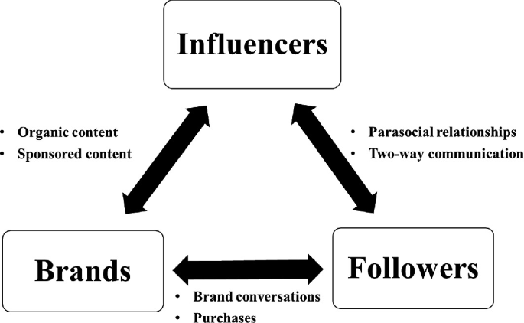

Figure 2.5: The Economic and Social Impact of Influencer Marketing
(Source: Anjana, 2018)
Economic Impact
Influencer marketing has quickly turned into a multi-billion-dollar industry, therefore, its high return on investment is a proof of the fact that it is more effective than traditional marketing channels (Chopra, Avhad and Jaju, 2020). This expansion has been the centre of attention of investors and this has changed the way the companies spend their marketing budgets, specifically targeting the millennial and Gen Z demographics. Besides, the emergence of influencers as significant elements in the advertising world has stimulated entrepreneurship in the digital content sphere, thus, the creation of new business opportunities and thus, the support of such industries as influencer agencies and content creation services (Chen and Yang, 2023). This has been the main reason why economic activity and marketing strategies have been the areas of innovation in the market. The companies have stated that the sales and the brand growth have been boosted directly when they got to work with the influencers. These influencers, with their big and usually loyal following, can introduce products to a huge audience and thus have higher conversion rates because of their own personal and direct engagement with their audience.
Social Impact
On the other hand, social media influencer marketing has greatly changed the way consumers behave (Martínez-López et al., 2020). Most consumers now prefer to consider influencers for their recommendations and insights on products rather than traditional advertising. The confidence given by the consumers to the influencers over the traditional advertising channels has changed the purchasing procedure and now social media is a major place for the buying decisions to be made. The foundation of influencer marketing is constructed on the sincerity and reliability between influencers and their followers (Chopra, Avhad and Jaju, 2020). The relationship between influencers and brands is a bit of a tricky thing because they must mix their personal feelings with the sponsorship deal. The influence of influencers has a lot to do with cultural trends and societal values, for example, the youth is the one who is mostly affected by this, where influencers usually bring or speed up lifestyle changes, fashion, and societal norms changes (Campbell and Farrell, 2020).
On the contrary, the increase in this kind of marketing has also strengthened the arguments about the ethical issues in this field(Chen and Yang, 2023). The problems that arise due to the lack of transparency in advertising, the psychological effects on followers, and the authenticity of influencers' endorsements have made it necessary for the industry to have strict regulations and standards. These undertakings are meant to safeguard consumers and guarantee the integrity of the marketing practices, which shows the increasing requirement for supervision in an industry that is based on the personal influence that directly determines the consumption decisions of the consumers.

2.7 Theoretical Overview
In terms of the analysis of influencer marketing and its consequences, there are several theoretical frameworks that can be used to elaborate the analysis and as a result, the interpretation of consumer behaviour, social media dynamics and marketing strategies(Chen and Yang, 2023). The theoretical examination is mainly concentrated on the major theories that are the key to the comprehension of the influencer marketing phenomena.
Among the basic theories that are closely related to influencer marketing is the Social Proof Theory, which, according to it, people try to find relevant behaviours for different situations from others (Chopra, Avhad and Jaju, 2020). Influencers, in their character, act as social proof for their followers. An influencer endorsing a product is like telling his audience that it is a must-have and desirable thing, and this can greatly affect the followers' attitude and purchasing decisions. In influencer marketing, the success of an influencer's message largely depends on their perceived expertise, trustworthiness, and attractiveness. Brands usually team up with influencers who are seen as trustworthy experts in particular areas to make the message of their marketing stand out.
The TPB point out that behaviour is determined by behavioural intentions, which are affected by attitudes towards the behaviour, subjective norms and perceived behavioural control (La Barbera and Ajzen, 2020). This theory is the instrument that explains the reasons, how, and the pace of the new ideas and the technology that are spreading. Influencers are usually vital persons in the dissemination of new products as they can easily introduce the innovations to a big and active audience.
The central route and the peripheral route are the two, correspondingly, most significant ways of being persuaded by which more of the person to which the information was given would believe in the argument that was being proposed to him through these two routes respectively. Influencer marketing can be both the central route and the peripheral route; the central one through the detailing, logic, and facts about a product, and the peripheral one through the attractiveness or likability of the influencer (La Barbera and Ajzen, 2020). The chosen path is usually influenced by the extent of the viewer's participation and interest in the content.

2.8 Literature Gap
Most of the research that was done has been focused on mainstream influencers while disregarding the role and impact of influencers from different backgrounds or those that are catering to niche markets. The requirement for more studies that investigate influencer marketing's performance on different cultures, genders, and age groups and how these factors impact consumer engagement and brand loyalty is there. Further, most of the studies primarily concentrate on the initial outcome of influencer marketing campaigns, like the immediate sales jumps or the social media frenzy. Although, some studies are present on the short-term effects of these campaigns on consumer loyalty and brand reputation, but there is no one that studies the long-term effects of these campaigns on brand reputation and customer loyalty (Grewal et al., 2020). The knowledge of these long-term consequences can enable brands to create more durable marketing plans. Although some studies have examined the ethical issues that are related to influencer marketing, such as transparency and authenticity, the research that shows how these and other factors affect consumer trust over time is still lacking. Besides, the industry needs more controls on ethical practices, and by studying their impact, we could get a lot of useful information.

2.9 Summary
The part of the literature review under consideration has delved into the many facets of influencer marketing; thus, emphasizing the great influence it has on buyer behavior, brand strategy and the overall marketing scene. The exploration commenced with a discussion of the theoretical frameworks that are the basis of influencer marketing, such as the social proof theory, the source credibility theory and others, which will enable us to understand the reason and the way influencer marketing can be so effective.
It has focused on the economic and social influences of influencer marketing, which is the factor that boosts market growth, affects consumer purchases, and changes cultural trends. The economic advantage is obvious, as influencer, marketing not only raises sales but also originates new markets and job opportunities in the digital and creative industries.

Chapter 3: Methodology

3.1 Introduction
The chapter presents the procedure used to explore the effect of influencer marketing on consumers and brand dynamics in this research. The selected methodology is of the most importance as it is the foundation of the entire research therefore, the whole research is based on it by offering a systematic approach to the collection and analysis of the data, as well as making the findings be reliable and valid. The central goal of this research methodology is to investigate how influencer marketing affects consumer buying behaviour and brand sticking and to find the most effective tactics in different demographic segments.

3.2 Research philosophy
The research philosophy selected for this study is interpretivism. This approach permits for a deeper exploration of the subjective reasons behind consumer behaviour. Interpretivism is a philosophical theory that is mainly concerned with the human context in the interpretation and understanding of the social environment (Grewal et al., 2020). It can be stated that interpretivism philosophy has been focusing on the interpretations of research works of other researchers (Junjie and Yingxin, 2022). In terms of this, this study has been adopting interpretivism, so it has been focusing on the aspects related to interpret different factors including product quality, brand reputation, and social media influences. As positivism is founded on the objective truths and the generalizing predictions that can be obtained by using quantitative methods, on the contrary, interpretivism is a study of the subjective meanings that people attach to the world that they have created from their experiences and interactions (Junjie and Yingxin, 2022).

3.3 Research Approach
The study has adopted the inductive method as it has been helping to enhance flexibility and openness in research. Furthermore, development of new concepts can also be possible through this approach. In terms of this, this research has been discovering the aspects related to unexpected factor that has been influencing consumer-buying aspects.
The inductive research is the one that comes from the observation of the concrete data and, therefore, it creates new theories and hypotheses instead of starting with the hypothesis and testing it against the data (Kyngäs, 2019). In contrast, the deductive approach has been useful for the testing of hypothesis under proven theories and existing literature. These are formed deductively on a variety of principles including consumers, marketing and social psychology knowledge (Naeem et al., 2023). It uses the low-level approach in reviews through testing hypotheses by using the quantitative data and high-level approach in problems opening of other new things through them using the qualitative analysis. However, the inductive approach has been useful for the thematic analysis, in which the data will be reviewed for new patterns and themes (Kyngäs, 2019). Through inductive research, this study has contributed to the existing knowledge by presenting the grounded and empirical views of the effective strategies of influencing and the psychological and social mechanisms that work as the driving force of its success.

3.4 Research Design
The study design for this research is the mixture of qualitative and quantitative design and it has been helping to review of the effect of influencer marketing on consumer behaviour. It has also been helping in the enhancement of flexibility and adaptability under this research. The gathered data will be interpreted with both quantitative and qualitative approaches, which will offer comprehensive aspects of the phenomenon being investigated.
A case study methodology has been employed to do a detailed examination of some specific incidents of influencer marketing. This method permits a thorough analysis of the context and the conditions in which influencer marketing influences consumer decisions. Through the concentration on some brands or campaigns, the research can find the ways the strategies that were used and their effectiveness, thus, the examples will be the evidence to be the general trends in the field (Mezmir, 2020). This research design was chosen to match the interpretivism philosophy and the inductive approach that was discussed previously, thus, the study will be able to generate significant and practical insights into the so-called influencer marketing. In designing the research which covers the impact of social media influencers over consumer behaviour in the old Boots surroundings (Superdrug), a mix of positivism and deductive approach will be employed to guarantee a systematic and rigorous process of investigation (Peel, 2020).

3.5 Data Collection
This research has been adopting the secondary qualitative data as it has been conducting the desk-based research. Furthermore, secondary qualitative data collection is beneficial as it is less time consuming and it is cost effective. Enhancement of the quality of research can be possible through adopting this data and the data will be collected through Google scholar, Science direct and other industry reports. Furthermore, the grey literatures, peer reviewed, as well as non-peer reviewed articles have also been used to collect the data (Rosário and Raimundo, 2021). In terms of this, qualitative data that are rich in nature are also used to answer the questions of research adequately. Furthermore, the data collection method focuses on the collection of latest and adequate data that are published after the 2018 which ensures current purchasing behaviour of consumers can be identified adequately.
Collection of primary data from the participants of 63 for the research project could be described in the following way. In the first place, the enquiry blocked out will be set up with the use of a platform like Google Forms. Such survey will be composed of both closed-ended questions for cohort analysis and open-ended ones for open interpretations. Ethical issues will be fully taken care of during the process so that individual privacy is observed and locked. In this research, 63 participants were called to participate in the study. The participants were recruited following convenience sampling technique mainly reaching out to social media users who best represent prospective consumers in the Superdrug market. Then the link to the survey was provided on social media sites, email, and relevant forums a decision that was taken because the item deals with health and beauty products. The survey was both closed and open-ended to obtain numerical and anecdotal information and divided into sections to deal with the objectives and purposes of the research.
Primary research covers a structured and methodical way for collecting data that is quantitative, through Superdrug customers, which in the end is focused at influencer marketing issues as well as the buying evaluation (Busetto, Wick and Gumbinger, 2020). The questionnaire will be designed minding the study aims and hypotheses, using both the closed-ended questions to tally responses and the open-ended question to understand meanings.

3.6 Data Analysis
The thematic analysis has been chosen as the main method for the data analysis in this study. This method is particularly useful for the analysis of complex data sets where the researchers are looking for the similarities and patterns that can be used to describe human behaviour and social phenomena, such as those in influencer marketing.
The thematic analysis is the whole and systematic process of data collection and analysis that makes the coder codes the data in detail and come up with themes that show the hidden core meanings in the data (Peel, 2020). It has been used the secondary qualitative data that is collected from various sources like peer-reviewed journal articles, industry reports, and case studies. As stated by Peel (2020) by means of thematic analysis, the research tries to compress the large data into comprehensible and useful insights that can be the mirror of the small deviations in the impact of influencer marketing on shopping behaviour.
In examining the data acquired of the supermarket customers in UK through the survey that was conducted, the utilization of graphs and charts using systematically approach can greatly help uncover the impact of social media influencers on consumer behaviour. Furthermore, the descriptive feature will present the major demographic traits and behaviours of the sample, and they could be grouped together in the graphical form, where the bar graphs or pie chart provides the visualization.

3.7 Ethical Consideration
Ethical principles are the most essential in any social science research, especially one that is based on the study of consumer behaviour and marketing strategies (Bhandari, 2023). In this research, on influencer marketing, various important ethical principles are to be followed to make sure the whole process is ethical and the research is of the sound aspect. The owner's data is confidential and private, particularly when the data comes from case studies or industry reports that may hold sensitive business information. Although the data are secondary, it is still necessary to go through all data sources and ask for any data privacy issues that could arise and make sure that the data is stored in a way that is respectful to the privacy rights of the people or entities concerned (Bhandari, 2023).
Participants should be free to terminate their participation at any time with no penalty or any repercussion. This indicates that privacy of the participants and their confidentiality is critical, this is in cases whereby there is collection of sensitive data such as the consumers’ behaviour towards influencer marketing and their buying habits. Gathering primary data by using survey questionnaires while conducting research, researchers must focus on informed consent, making sure that the respondents clearly understand the intention of the study and volunteering on their own will. Privacy of a participant is the most important thing and needs to be protected by anonymization and secure storing which will destroy personal data if it is not needed anymore.

3.8 Summary
This chapter has described the methodological framework of the study, showing the research philosophy, approach, design, data collection, and analysis methods. The qualitative research works together with the case study methods to provide a comprehensive overview and in-depth analysis of the interaction of the influencers and their impact on consumers. Therefore, the research design for appraising the effect of the influencers' social media activity with respect to the consumer behaviour among consumers of Superdrug brand is specified very carefully. Research design that is underpinned by the mix method of positivism and deductive principles, the investigation starts with the well-defined purpose and hypotheses that are developed to respond to existing theories. With the processing of the primary data, through surveys and the secondary data of the analysis, they both have been focusing to the ethical factors such as the informed consent, participant confidentiality, and data privacy.

Chapter 4: Data Analysis and Findings

4.1 Introduction
This chapter aims to discuss the findings of the research conducted during the study to understand the influence of social media influencers on the purchasing behaviour of consumers, especially in the cosmetics industry. The findings will be relevant to the research questions and objectives provided in the previous chapters to explain the factors affecting consumers’ buying behaviour, the part of social media in consumers’ decision-making, and the effects of the various social media platforms on customers’ perceptions and buying intentions at Superdrug. In this chapter, the author has taken it upon himself/herself to explain the lessons that can be drawn from social media investment and activities in the cosmetics industry. For these reasons, the analysis of the data is presented in accordance with the research questions set at the beginning of the study and each of the following sections relates to one of the themes identified in the data.

4.2 Findings on Primary Data
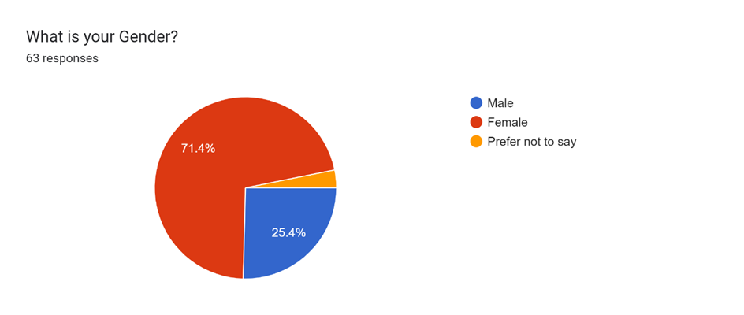
The data collected from the survey reveal that gender bias is apparent in the respondents, where 71.4% of the total respondents are female, 25.4 per cent male and 3.2% of the respondents declined to state their gender. This is important since it highlights the main target market for cosmetics products hence the findings help explain the behaviour of the female consumer. The presence of more female respondents also supports the proposition that social media influencers play a crucial role in consumers’ buying decisions in this specific segment. The subsequent analysis will examine how these gender relations affect buying decisions and the efficacy of various social media platforms in the cosmetics industry.
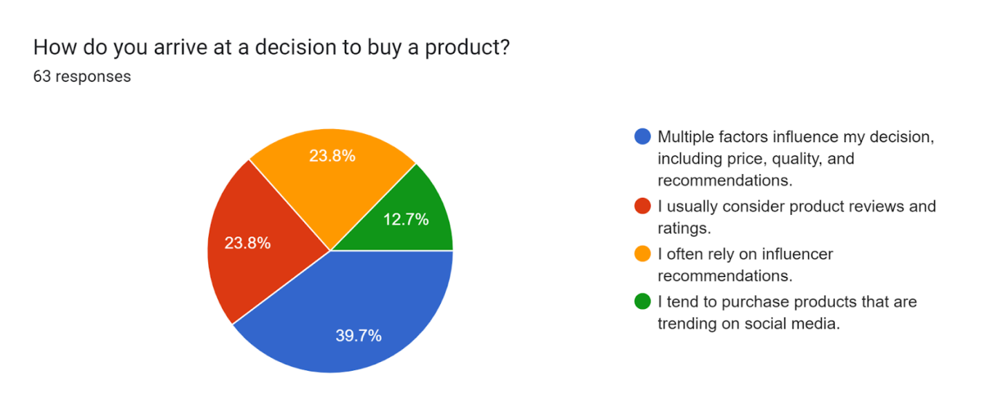
The largest portion of the participants (39. 7%) stated that they make their purchases based on several considerations such as price, quality, and recommendations. This implies that the consumers are not limited to a single factor when assessing the value of a given product. When it comes to the product reviews and ratings, 23.8% of respondents usually take into account which means that the feedback of the peers influences the decision significantly. The findings revealed that 23.8% of participants rely on the opinion of influencers most of the time, thus showing how influential influencers are in shaping consumer decisions. Furthermore, 12.7% of the respondents use the social media trends when buying products and this shows the extent to which social media trends affect the consumer. These results underscore the complex nature of the purchase decision and the importance of social media and influencer marketing in driving consumer behavior. For marketers at Superdrug, these insights are useful in creating marketing strategies that conform to the factors that impact its target market.
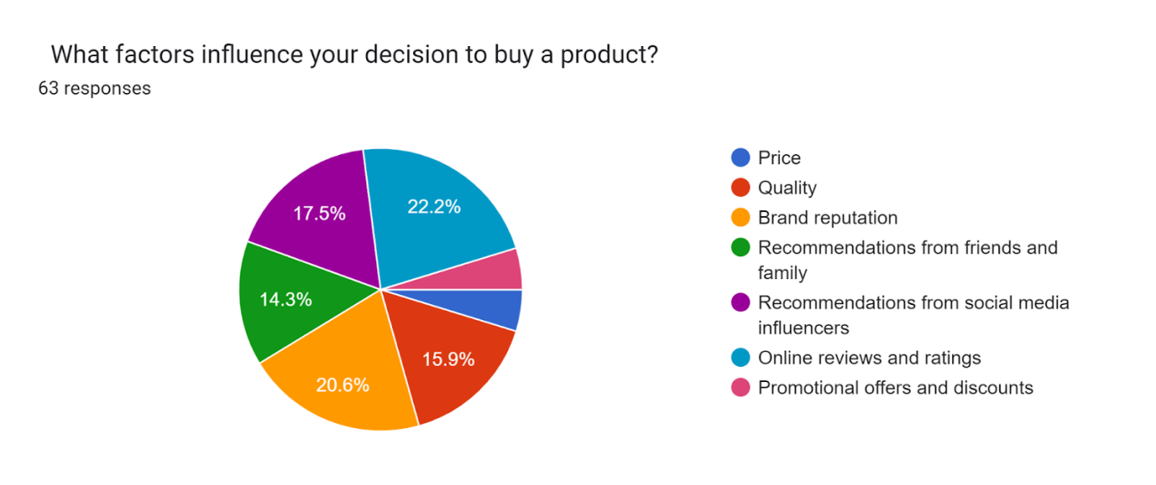

The survey responses to the question "What factors influence your decision to buy a product?" provide a clear overview of the key elements that shape consumer purchasing behavior. According to the results, 22.2% of participants identified price as the most significant factor, indicating that cost is a primary consideration for many consumers. Quality follows closely, with 20.6% of respondents highlighting it as a crucial influence, emphasizing the importance of the product's performance and durability. Only 17.5% of the respondents said they were influenced by the experts, which demonstrates the importance of word of mouth in the decision making process. The conclusions drawn from this research show that even though the conventional factors such as price and quality are essential, social factors and online reviews are equally important in shaping the consumers’ decisions. Such information can be helpful to marketers to align their approaches in a way that would respond to the various aspects that consumers consider when making purchase decisions.

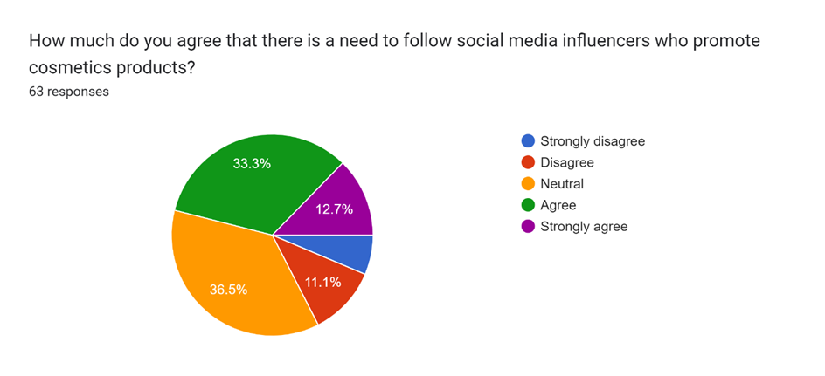
The survey findings show that the people have different perceptions of the need to follow social media influencers who advertise cosmetics products While 46% of respondents agree or strongly agree on the importance of following these influencers, a significant 36.5% remain neutral, and 17.4% either disagree or strongly disagree. This shows that although many consumers appreciate the role of influencers, they either do not consider them necessary or do not care about them. To this end, brands need to consider this range of possibilities and ensure that any influencer marketing strategies align with the needs and wants of the influenced and the uninterested consumers.
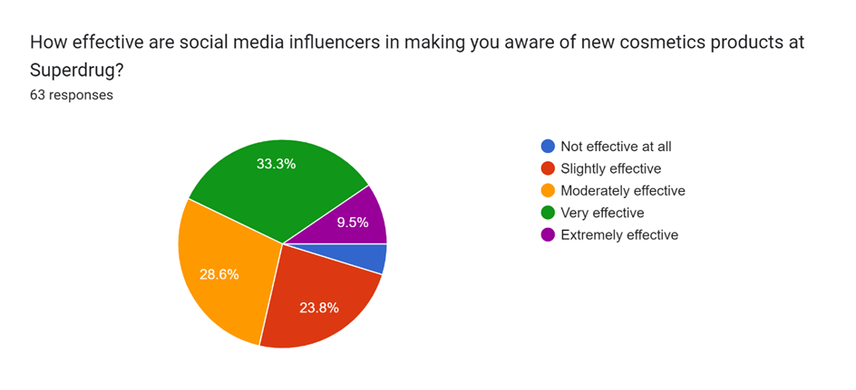
The survey results also revealed that, in general, the social media influencers successfully create awareness among the respondents about new cosmetics products at Superdrug. Specifically, 33.3% of respondents find influencers very effective, and 9.5% find them extremely effective. Additionally, 28.6% rate them as moderately effective. Only 23.8% of the respondents see influencers as somewhat effective, while as few as 4.8 percent believe they are not effective at all. The data depicted above shows that the influencers are very effective in creating awareness of new products. Therefore, they can be seen as valuable assets for brands such as Superdrug in their marketing strategies.
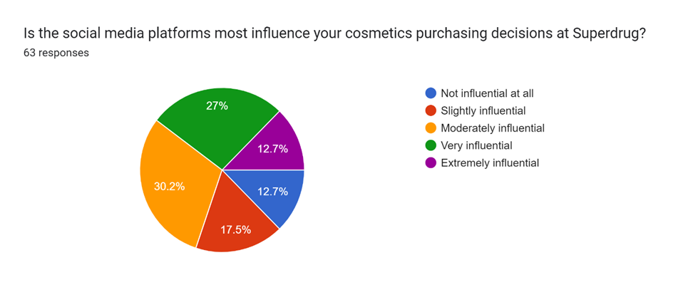
From the survey, the findings suggest that the various social media platforms have an impact on the respondents’ cosmetics buying behaviour at Superdrug in different ways. Specifically, 27% of respondents find social media platforms very influential, while 12.7% consider them extremely influential. Additionally, 30.2% rate them as moderately influential. On the other hand, 17.5% view them as slightly influential, and 12.7% believe they are not influential at all. This spread further emphasises the potential of social media in influencing consumers’ behaviour especially as most of the respondents pointed out that these platforms to some extent affect their buying behaviour. This shows that Superdrug must ensure that they have an active social media account to be able to create the necessary conversation and influence their customers.
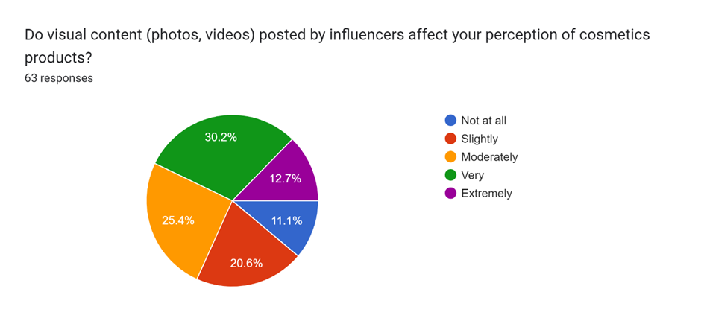
The results of the survey present the effect of visual content (photos and videos) shared by influencers on the perception of the respondents towards the cosmetics products. A significant portion, 30.2%, finds visual content very influential, while 12.7% consider it extremely influential. Additionally, 25.4% rate it as moderately influential. On the lower end, 20.6% view visual content as slightly influential, and 11.1% believe it does not influence them at all. These findings imply that visual content is highly effective in influencing the perception of consumers and, therefore, underscores the influence of photos and videos that influencers use in marketing cosmetics brands such as Superdrug.
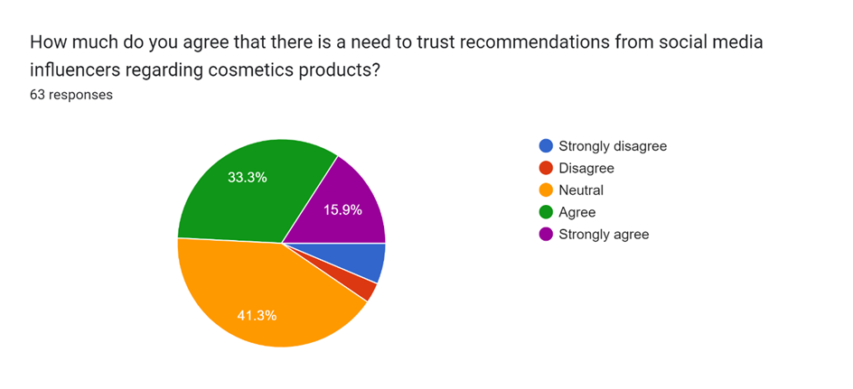
The findings on the aspect of trusting the recommendations of social media influencers on cosmetics products indicate a high level of agreeability. A significant 33.3% of respondents agree that there is a need to trust these recommendations, while 15.9% strongly agree. Meanwhile, 41.3% remain neutral, indicating some reservations or uncertainty. A small percentage, 3.2%, disagree, and 6.3% strongly disagree. These findings imply that many consumers are likely to have confidence in an influencer’s recommendation, therefore pointing to the fact that influencers play an important role in influencing consumer behaviour within the cosmetics industry. Marketers should bear this in mind when using influencers to advertise their brands in a bid to gain the trust of consumers.
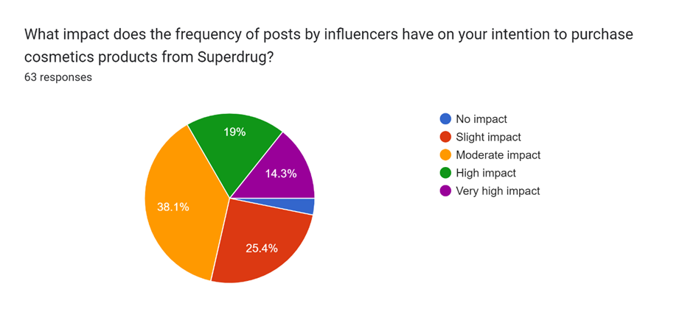
The analysis of the survey data shows the relationship between the frequency of posts by the influencers and the respondents’ willingness to buy cosmetics products from Superdrug. A notable 38.1% of respondents report that frequent posts have a moderate impact on their purchasing decisions, while 19% experience a high impact. Additionally, 14.3% of respondents feel a very high impact from frequent influencer posts. Conversely, 25.4% report only a slight impact, and a minimal 3.2% indicate no impact at all. Based on these results, the frequency of posts from influencers can greatly impact consumers’ purchase intentions, thus, reinforcing the need for brands such as Superdrug to engage in collaborations with influencers more often to create interest and sales.
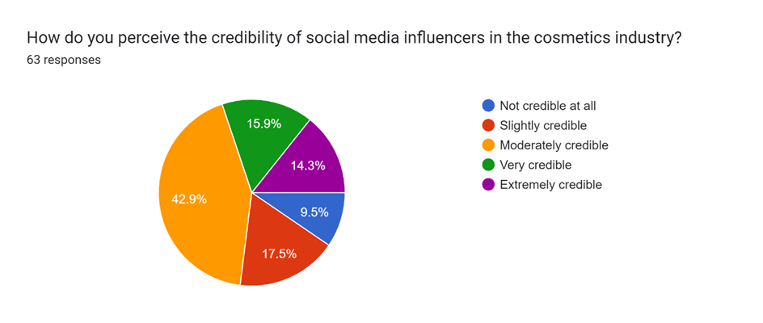
The data derived from the survey also reveal that there is a difference in the level of trust given to the social media influencers in the cosmetics market. A significant 42.9% of respondents find influencers moderately credible, while 17.5% consider them slightly credible. Additionally, 15.9% view influencers as very credible, and 14.3% perceive them as extremely credible. However, 9.5% of respondents believe that influencers are not credible at all. Therefore, it can be concluded that even though most consumers have moderate trust in influencers, there is a significant variation in the level of confidence in their authenticity. This shows that brands dealing with cosmetics must be very keen in the selection of their influencers and make sure that they align well with their brand to avoid the negative reflection of their brand among their target audience.
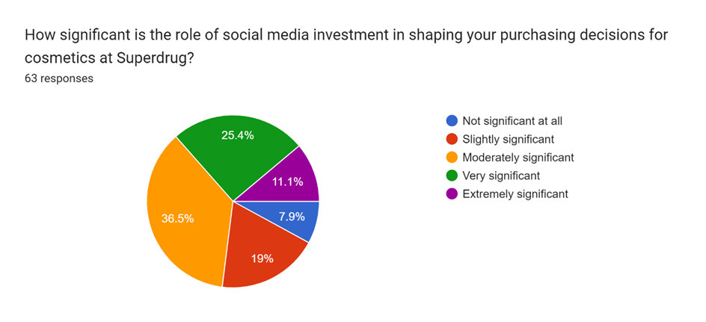
From the survey, the authors aimed at understanding the importance of social media investment in the purchase decision process of cosmetics in Superdrug. A considerable portion of respondents, 36.5%, finds social media investment moderately significant, while 25.4% view it as very significant. Additionally, 11.1% believe it is extremely significant. On the lower end, 19% consider it slightly significant, and only 7.9% think it is not significant at all. These findings provide the significance of social media investment in adjusting consumer behaviour which could be a directional model to guide Superdrug in making proper strategic investments in social media marketing to boost cosmetics sales among the target customers.
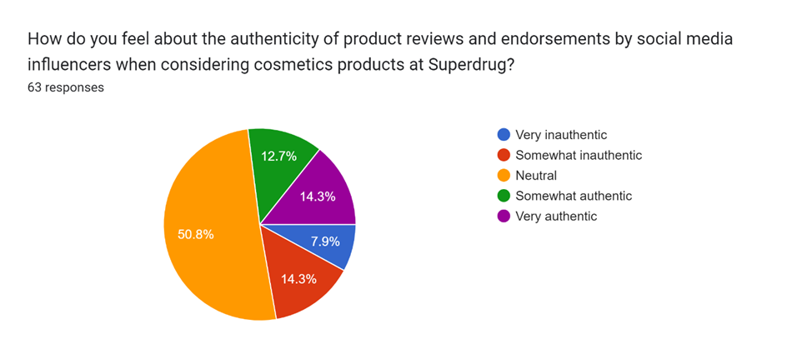
The survey results reveal that the respondents had different opinions regarding the legitimacy of the product reviews and endorsements by social media influencers when buying cosmetics products at Superdrug. Most respondents, 50.8%, remain neutral about the authenticity of these reviews. Additionally, 14.3% of respondents feel somewhat inauthentic, while 7.9% perceive them as very inauthentic. On the other hand, 12.7% find these reviews somewhat authentic, and 14.3%consider them very authentic. From these findings, it can be stated that there are varying levels of understanding of influencer authenticity and a considerable level of doubt among consumers. Brands should aim to work with legitimate influencers and establish clear communication with them to create believable sponsored content.

4.3 Findings on secondary data
Theme 1: Influence of Social Media on Consumer Buying Behaviour
It is identified that social media has a significant impact on the consumer buying behaviour especially in beauty and cosmetic products. According to Voramontri and Klieb (2019), 74% of the consumers use social media to make decisions on the products that they intend to purchase. The above implies that user content, reviews, and recommendations are useful in creating trust and authenticity among consumers which cannot be achieved by the classical advertising media.
Thus, according to the study, 54% of social media consumers interact with beauty influencers, as they inform the public about new products and trends. This clearly shows the power that influencers hold within the society and the ability that they must draw consumers to new products (Varghese and Agrawal, 2021). Instagram, TikTok, and YouTube have become social media platforms that allow influencers to visually and interactively display the products through videos and live product usage presentation which includes tutorials, unboxing, and reviews that can alter consumer purchase decisions.
This is because 81 percent of consumers say that they are influenced by social media and beauty and personal care are some of the industries that have been most impacted. This is so because the information available on social media is easily comprehendible and presents a clear image of products to the consumer making it very easy for the consumer to make an impulsive buying decision (Rachapudi, Lakshmanna and Kumar, 2023). Hence these findings create a strong argument on how social media is not only a passive influence on consumer buying behaviour but an active one. To this effect, brands in the cosmetics industry, including Superdrug, can harness this influence by collaborating with genuine influencers. By using this strategy, brands can effectively leverage the influence of social media in influencing consumers and increase sales while strengthening brand identification.
Theme 2: Credibility and Trustworthiness of Influencers
A key factor that consumers usually do is to believe the influencers when they showcase actual use and understanding of the products they promote. It can be seen through sharing real-life experiences, showing backstage, and giving candid feedback which make the audience to consider the influencer as their friend (Coutinho, Dias and Pereira, 2023). This is because the followers appreciate it when influencers relay information on products’ advantages, disadvantages and their own experiences. This knowledge enables the consumers to make a sound decision and have faith in the influencer because of the knowledge they have on the subject (Lou and Yuan, 2019). Timeliness in posting and clear disclosure of sponsorship is vital in the development of credibility. People who actively post and are very much open about sponsored content are honest and credible. Disclosing information on partnerships and sponsored content decreases the audience’s cynicism and fosters a trustful long-term relationship. People like when the influencers declare that they have a partnership with the brands, this helps to avoid the appearance of the bias.
Another factor that leads to high credibility is when an influencer engages and interacts with his/her followers frequently. Such influencers are more friendly and thus, credible since people feel like they can interact with them. This bidirectional exchange enhances the perception of followers and makes them feel as if their input is being acknowledged by the influencer thus increasing the credibility of the influencer (Balaban, Mucundorfeanu and Naderer, 2021). The quality of the information given in the visual format and the professional appearance of the content can also affect the credibility of the influencer. Having clear and high-resolution images, videos, and very selective content indicate professionalism and dedication of the influencer to share useful information with the followers. This means that professionalism in content creation of products reflects positively in the eyes of the influencer’s followers as well as shows the influencer’s commitment.
Nonetheless, the same influencers can experience certain limitations which make them less credible. This therefore means that over commercialization and posting of too many sponsored posts makes the audience feel that the influencer is not genuine and thus the credibility of the influencer is affected. People can doubt the influencer’s intention if they think the influencer is posting with the aim of earning money from the product instead of supporting the product due to its quality (Ashaq Hussain Najar et al., 2024). Also, controversies and ethical misconducts can lead to a loss of repute and credibility for an influencer. Trustworthy influencers can indeed influence the consumers’ buying decisions. The view of consumers towards the influencer must be positive so that they can be influenced to consider and buy the products being promoted. This trust also covers the recommendations and endorsements that the influencer gives, meaning that the opinion of the influencer plays an influential role in marketing. Influencers with whom brands enter partnerships already have credible and trustworthy audiences and, therefore, increase the likelihood of generating better engagement and conversion rates.
Theme 3: Effectiveness of Visual Content
Studies have shown that visual content such as photos, videos and live videos always receive higher engagement than the text-based posts. The visual content has become one of the main focuses of social networks like Instagram and TikTok, this is why cosmetics brands and influencers rely on these platforms. A visually appealing content is more engaging, more likely to be Liked, Shared, or Commented on, and more likely to reach more people than the immediate followers (Karpenka et al., 2021). Because of the algorithmic tendencies of social media platforms, visual posts tend to receive more attention and are shared more frequently than other types of content. Videos and images are useful as influencers can showcase the application of cosmetics products in real life and provide their followers with tangible examples of how things work. The information that is presented in a more realistic and easily identifiable manner is likely to be shared more often (Sunarso, Tusriyanto and Mustafa, 2023). In this case, followers of influencers who take photos and videos of their daily lives, sudden moments, and other aspects of their life feel close to the influencers. Sponsored content can look more natural this way, as it is posted alongside the regular content of the influencer.
Visual content is particularly the most effective way of capturing the attention of the target audience and stirring an emotional response from them. Colours, emotions and picture can express emotions in a way that cannot be portrayed in words (Chan, Chen and Leung, 2023). This is important in the cosmetics industry because the success of many products depends on consumers’ ability to relate to the idea of beauty and confidence. As such, with the use of appealing imagery and visuals, both influencers and brands may be able to build a closer relationship with consumers, as well as encourage customers’ recurring purchases of products and services (Agung Artha Kusuma et al., 2024). As a result of following a consistent and visually relevant theme, brand recognition and recall increase. Thus, consumers who are exposed to high-quality images and videos with a specific brand logo and message become familiar with the brand, and the brand becomes familiar to them. Those who adhere to the adopted visual themes and posting frequency contribute to the formation of a specific brand identity, which makes consumers easily recognize the brand and connect it with the certain set of features. This is especially beneficial in industries and markets that are filled with numerous brands promoting for the consumers’ attention.
It is important to note that visual content does not only work in engaging the target audience but also in converting them (Chan, Chen and Leung, 2023). Among the secondary data, it has been found that posts which have some visually appealing elements are more likely to generate clicks, visits to the website, and even sales. Elements like the ability to buy a product directly from a post, using links in stories that only swipe up, and tagging products in posts help in the convenience of consumers to transition from browsing to purchasing. Becoming proficient in the use of these features would be advantageous to cosmetics brands in the use of influencers.
Theme 4: Strategic Investment in Social Media Marketing
Social media advertising makes it easy for brands to get to their desired audiences and deliver their messages to them. Social media advertising features an extensive number of targeting options, which are based on user information, such as age, gender, geographic location, interests, and behaviour. This precision allows brands to target their messages to specific groups of consumers, which increases the chances of reaching the right ones and generating interest (Cao and Weerawardena, 2023). Influencer partnerships are among the key strategies that can help to achieve successful social media marketing. This is where brands can leverage on the help of influencers, who have similar brand values as the brand and have many followers within the target audience. Long term relationships with influencers could be more productive than short lived projects since audiences will be familiar with the influencer and can develop trust in them (Rosário and Dias, 2023). Influencers can share content that is genuine and appealing to their audience, thus increasing the brand’s visibility and sales. This paper aims to assess the quality of content development for capturing and keeping audience engagement on social media platforms. The use of professional photography, videography, and graphics can greatly improve the appearance of social media content (Li, Larimo and Leonidou, 2020). Besides, it is recommended to post different types of content, including tutorials, behind-the-scenes, and user generated content, to ensure the audience remains interested. For cosmetics brands, it could be beneficial to share how the product is used as well as make-up tips or real-life transformations to illustrate the product value and create consumer desire.
Maintaining an engaged community on social media means actively posting and responding to the follower’s social media brands should consider spending in social media management tools to ensure that they reply to comments, messages, and mentions as soon as possible (Sofiane Laradi et al., 2023). It is recommended to interact with the audience on a frequent basis, as this creates the feeling of being a part of the community, which leads to loyalty towards the page/work. Other features such as live sessions, Q&A, and polls can also help increase audience engagement and make the brand more engaging.
It is important to invest in analytics tools and the measurement of performance as it is vital for the analysis of social media marketing strategies. Some of these include the engagement rates, the reach, the conversion rates, and the ROI; by monitoring these metrics, brands can identify between the successful and the unsuccessful elements (LI, LARIMO and LEONIDOU, 2022). This paper has pinpointed the benefits of the data-driven approach, whereby modifications to social media marketing strategies may be made to improve their effectiveness. It is also important to note that the regular analysis of the market situation also means that brands can be more versatile in their approaches and are ready to meet the challenges of new trends and consumers’ behaviour. It can therefore be argued that adopting the use of multiple platforms in the social media marketing strategy is therefore beneficial in enhancing the overall outcome. For this reason, brands need to concentrate on developing seamless strategies that work in harmony with the various platforms’ strengths, such as visual content on Instagram, or the possibility of creating viral content on TikTok or extended videos on YouTube.

4.4 Discussion and analysis
The findings provided in this study suggest that social media can be considered as an influential factor that defines consumer behaviour. Most consumers seek product information and recommendations through social media, which traditional advertising cannot provide in the same manner. The high engagement levels on social media platforms such as Instagram and TikTok are testament to the benefits of using these platforms to target consumers. For Superdrug, by using these platforms in the right way and providing regular and relevant content, the company can increase the awareness of the customers and sell more products.
Thus, it is crucial to determine the authority of the influencers as they can have the audiences follow their recommendations. As indicated in the data, the consumers are likely to trust and engage with influencers who are perceived to be real and knowledgeable about the product (M. Radhika, Kumar and Kandi, 2023). This trust is related to higher consumer engagement levels and the probability of the consumer purchasing the product. From this research, it can be argued that influencers who post often and those who disclose sponsors have a higher chance of obtaining the trust of followers. In that regard, Superdrug should ensure that they are collaborating with influencers who possess a good image and in the same way, are active with their audience. This will help in making sure that the endorsement is a credible one and this will in return help to enhance the image of the brand and consumer loyalty.
Visual content is especially useful in the cosmetics industry since the aesthetic of the products is crucial. Effective photographs and videos portraying the use of the product and the results that can be expected are crucial in altering consumer expectations and buying behaviours (Ashley and Tuten, 2015). The data reveal that the consumers are sensitive towards the visual content that helps in generating an emotional response and a direct engagement. For Superdrug, paying for high-quality visual content and incorporating features like tutorials or live demonstrations can help to increase user interaction and sales (Dubbelink, Soria and Constantinides, 2021). Moreover, the use of user-generated content can provide more credibility and realism into the content.
It is of paramount importance to allocate funds to social media marketing in order to increase the effectiveness of collaborations with influencers and the use of visual content. Reaching the audience, monitoring the results, and synchronizing the activities across different social networks are essential for a successful social media presence (Appel et al., 2020). Thus, by using data to make adjustments to the campaigns on a regular basis, Superdrug can be sure that its marketing is efficient and productive. Superdrug should aim at ensuring that there is consistency in the campaigns being posted across social media platforms.
The social proof theory states that individuals tend to follow the behaviours of others in different situations as that determines the best course of action (Chopra et al. 2020). In influencer marketing, influencers serve as referrals wherein their followers seek to emulate their decisions and actions. They give the impression to their readers that the thing is valuable and worth buying if it is use by influencers. This is very much a reason why followers have their attitude and purchasing behaviour affected.
Theory of Planned Behavior (TPB) provides knowledge on the fact that behavioural intentions control the behaviour which is again controlled by attitude towards the particular behaviour, subjective norms, and perceived behavioural control (La Barbera & Ajzen, 2020). Further, influencers impact these attitudes of acceptability and desirability, hence normative acceptability of new products. This theory enables one to understand why Laureate is effective in its marketing strategies; the association of the cosmetics with social media personalities develops both a positive attitude towards the products and acceptable norms of the society. The survey findings which reveal that majority of the consumers are in effect, guided by what they see on the social media platforms while making consumption choices further support the proposition of TPB model suggesting that influencers have the capability to control the intentions and behaviours of consumers.
Understanding the primary and secondary data collected is vital in identifying the influence of social media in the cosmetics industry. According to the consumer data, the consumers concur that social media influencers are particularly influential on the consumers’ purchasing decisions since credibility and visual appeal are the main determinants that shape consumers’ perception of a product (Li et al., 2022). Secondary data also supports these findings because the latter also supports the arguments about the importance of having targeted advertising, right investment in quality content, and right partnership with influencers. Hence, the following can be the social media strategy for Superdrug based on the above findings that include using influencers, visual content, and targeted advertising.
Among all the consumers, 38% responded that they hardly ever recall seeing CAB following its introduction into the market. This evidence indicates that influencers are helpful from a consumer engagement and conversion perspective, which implies that brands should pour more resources into influencer collaborations to further augment their advertising objectives. This means that there is a great value of influencers especially to brands that are looking to enter the market with new products. The social media influencers, Overall, there are somewhat ambiguous attitudes towards the importance of following social media influencers, As much as 46% of them agreed that the practice was necessary, while 36% of the respondents disagreed. The 5% that displayed a neutral sentiment implies that even though a large number of consumers may use influencers, there are others who do not care about them. Brands need to come up with a variety of plans that address both types of consumers and while doing this they should not solely rely on influencer marketing tactics, but also use others.
Visual content shared by influencers has a great impact, with 30 percent of them stating that they were affected by the posts and comments made by influencers (Argyris et al., 2020). Very influential-cite, 2% of the respondents said that the source was very influential in their decision-making while 12. 7% extremely influential. This goes to show how effective the use of improved quality in visuals is in the overall business marketing plans. It is essential for brands to create great visually appealing content that will be more effective in gaining he attention of the consumer and how they perceive the product.
Another essential aspect, 41% of customers relied on the recommendations of social media influencers. It is vital for brands to ascertain that the influencer they are planning to target has similar values set as the brand and the influencer should be very open about his/her association with brands (Belanche et al., 2021).
This means that the frequency of post influencer also affects the purchasing bargain of consumers, in 38.18% of respondents admitting to a minor loss. From this, the probability may be deduced that frequent posting on the part of the brand owner in turn increases the likelihood of the brand being seen and bought by the consumers. Hence, there is a need for brands to employ the services of influencers regularly to ensure there is always content that is up and running (Campbell & Farrell, 2020).
The secondary data further supports these findings, suggesting overwhelmingly that social media plays a critical role in altering consumer buying behavior, even in Beauty and Cosmetics. Social media influence again proves essential here, given that visuals and high engagement are the improvement’s primary characteristics (Siddiqui et al., 2021).

4.5 Summary
This chapter reviewed the literature and the research findings on the effects of the social media influencers on purchasing behaviors with a particular focus on cosmetics industry and the Superdrug brand. It has been possible to establish the discussed problems through the use of primary and secondary data, including the share of social media in advertising, credibility and trust in influencers, effectiveness of visuals, and need to put more resources into social advertising.

Chapter 5: Conclusion

5.1 Conclusion
Hence, this research has given evidence that social media influencers are an effective force in determining consumers’ buying behaviour within the cosmetics industry, specifically for Superdrug. The survey and literature review show that the consumer tends to use the social media for decision making with regard to consumption, whereby the larger percentage of the consumers uses the same as a source of information and reviews on the product. This means that consumers can be captured and persuaded to make a purchase through visual platforms such as Instagram, TikTok, or YouTube.
Perceived credibility and authenticity influence consumer behaviour and the presence of the influencers in the process. Customers are more likely to make those purchases from influencers who are seen as real and knowledgeable about the products they are promoting (TÜMEN AKYILDIZ, 2021). Consequently, brands need to select influencers who are trustworthy and can help to convey brand messages to the intended consumers. Another significant factor is the quality of visual content since aesthetics and demonstrations are vital in the cosmetics industry where the look and feel of the product determine consumers’ perceptions and buying behaviours. Paying for professional visuals and taking advantage of interactive elements like tutorials and live videos may greatly improve the audience’s engagement and encourage them to make purchases. Social media marketing, which entails specific advertising, analysis of performance, and the integration of different platforms, is crucial in enhancing the effectiveness of marketing strategies.
The purpose of this research is to identify the role and influence of social influencers in relation to consumer behaviour in Superdrug. The study objectives, therefore, are to determine the variety of influencers permeating social media now, to evaluate the effectiveness of a notion presented by such influencers, and to gauge the level of control enjoyed by these personalities. Thus, the aspects discussed in this respect in the course of the study enable to comprehend the ways and the extent of how social influencers influence the decision-making of customers in the context of the cosmetics industry and, in particular, in the framework of the Superdrug stores.
This has brought attention to the economic impact of influencer marketing and how such personalities commendably aid in creating awareness about various brands and increasing actual sales for retailers. Empirical analysis of the given research proposes the primary systematic parameters of consumer behaviour by the consideration of the psychological, social and economical factors. Examining social media giants such as Instagram, TikTok, and YouTube as prime examples, the study raises the question of how these novel platforms force a shift from the conventional understanding of marketing strategies and foster rich brand-consumer relationships.
The study applies a comprehensive literature review to examine the subject concerning the impact of influencers pertaining to the cosmetic products’ perceptions and shopping behaviours. While the former tackles the motivation to buy through psychological factors including self-esteem and personal satisfaction, the latter explores the influence of social pressures, cultural and regional orientations, and consumerisms on people’s buying behaviour. It also discusses the difficulties of social media marketing, such as ethical concerns and purposes of using the platform: open-mindedness and handling of consumers’ rights to privacy.
Influencer marketing is defined in terms of trust and credibility to determine its efficiency. This implies that consumers are in a position to be influenced by influencers who display authenticity and more especially being very transparent. Thus, the brands have to be more cautious while identifying influencers and it is essential that they should be completely transparent about sponsorships so that the trust clientele has placed in them remains unshaken.
The frequency of an influencer's posts also plays a role in shaping consumer behaviour. Interacting with the consumer over social media platforms and at frequent intervals can promote brand recognition and subsequent decision-making to make a purchase. This probably means that brands need to partner with influencers, establish long-term collaborations to ensure their position stays active on social media platforms. The study also examines the rationales of consumers in the cosmetics industry regarding the use of social media. Therefore, based on research analysis, it can be stated that choosing social media influencers is a strategy guaranteeing the desired shift in behaviours of cosmetics products consumers. Superdrug, for instance, can benefit from a well-planned influencer collaboration, using eye-catching visuals, and activity on a regular basis to improve its marketing advantage and profits. It is to be stated that, trust is one of the essential elements that regulars as well as newer brands need to ensure to create and retain trust amongst customers.

5.2 Limitations
The primary data was collected through a relatively limited and focused number of consumers, which may not give a comprehensive picture of the consumer population. The first source of common method bias may stem from the fact that the surveyed users are younger and use social media more often than the other customers. The following limitations should also be recognized: the main data was collected using surveys; hence, the study may be prone to common method biases such as social desirability and recall bias (Miller, 2020). This can be since the respondents may have given answers that are likely to be socially desirable or because they may not have been able to recall what they did or thought.
It is worth to note that this research design that is cross-sectional in nature focuses on capturing the consumers’ behaviour at a certain period and hence may not be comprehensive to capture changes in behaviour over time (Ben Hassen et al., 2021). Studies would be more suitable for determining how the effects of social media and influencers change over time. The study did not distinguish between the effects of specific social media platforms (for instance, Instagram, TikTok, YouTube). It is also important to note that each platform has its own characteristics and the users of the platform, which affects consumer behaviour in a different manner. Further work may be useful if the analysis were more focused on the platform level.

5.3 Future scope
Based on the results of this study, future research can focus on a number of areas, some of which are covered below. To have a better perspective of consumer behaviour as influenced by social media, longitudinal studies should be conducted to ascertain changes in consumer behaviour over time. Therefore, increasing the number of participants and including participants from different backgrounds can improve the transferability of the results. Furthermore, analysing the effectiveness of various social media platforms and expanding the study to other industries apart from cosmetics can provide comparative results and industry specific patterns. It is possible to use more comprehensive and detailed data collection techniques, including interviews and focus groups, to gain deeper insight into consumer behaviour (Lobe and Morgan, 2020). As to future trends, analysing the effects of the new technologies such as augmented reality and artificial intelligence on social media marketing may provide beneficial insights. In addition, defining the specific metrics that can be used to assess the effectiveness of the given marketing campaigns, as well as discussing the ethical concerns that may arise and consumer trust, can be helpful in developing sustainable and successful social media strategies.

Chapter 6: Recommendations
- Strategic Influencer Partnerships
Develop enhanced influencer relationships through forming collaborative partnerships with notable influencers who embody Superdrug’s values and possess a large following within the beauty market (Richert and Carter, 2024). This creates a sense of reliability and predictability to their viewership. Furthermore, micro-influencers can also be incorporated into the strategy, as they are usually followed by a more dedicated audience and can potentially provide more credible and realistic content, thus increasing the ROI. In addition, to make the advertising reach even more people, the Superdrug should establish its influencer marketing campaigns with people who are different (Zhan et al., 2020). This involves the following; the use of micro influencer who are influencers with small audience but highly active and the macro influencer who have large audience coverage.
Micro-influencers have the opportunity to have better compatibility with the followers, which in turn contributes to the better engagement rate and fan base (Trziszka, 2021). Members of those groups rely on their recommendations because they are experts within their specific industries (Trziszka, 2021). While the micro-influencers work towards converting their followers into potential buyers, the macro-influencers can popularize the brand among a larger population, which, in its turn, will increase brand recognition (Zhan et al., 2020b). Using both macro and micro influencers for their marketing can also ensure that Superdrug gets the best out of its advertising across the different consumer demographics.
- Investment in High-Quality Visual Content
Publishing high-quality images and or videos can be done by hiring professional photographers and videographers to ensure the products are well presented on the website (Thomson, 2024). In addition, the use of user-generated content could increase authenticity and identifiability and, therefore, attract higher engagement rates. The use of videos, tutorials, unboxings, and before-and-after transformations is especially potent as they visually showcase the value of a product and impact the consumer’s perception (Nidoli, 2024). Make use of the targeted advertising technique to get a specific population of interest or consumers. The key advantage of social media advertising is the ability to target the audience based on the collected data such as age, gender, location, preferences, and actions (Arrigo, Liberati and Mariani, 2021). Furthermore, these options help to segment the audience and deliver targeted messages that can lead to engagement and conversions.
To increase the level of active participation and foster a sense of community, it is recommended to communicate with the followers more often (Oltra González, Camarero and San José Cabezudo, 2021). Interactions like answering comments and messages, going live, and doing polls can also make the users feel that they are part of a family. This bidirectional communication lets followers know that a brand cares for their input and therefore increases their regard for the brand. Optimise on tools of analytics and performance evaluations in identifying the successes and failures of social media marketing (Chidera Victoria Ibeh et al., 2024). Since engagement rates, reach, conversion rates, and return on investment can be measured, Superdrug will be able to determine which strategies work and which ones do not. This data-driven approach brings a lot of benefits for the optimization of the social media marketing campaigns as well as for the overall effectiveness and efficiency of the marketing process.
It continues these efforts through targeted social media advertising. Through features such as audience definition on the social media platforms, the company is able to get to the specific target group or segment through the use of demographic data, interests, or some behaviours of the people. This will enhance targeting thereby improving the efficiency of communication through marketing related campaigns. Measuring the engagement rates on the posts, the reach, the conversion rates, and the return on investment are crucial in assessing the effectiveness of social media marketing and how the future promotions will be handled.
Lastly, developing a content spectrum that consists of not only product-focused posts but also photos and videos of customers, short vlogs about daily life with the current brand’s products, and educational content on beauty and skin care keeps the audience interested and offers more than just buying products. Promoting cultural sensitivity is another way of making sure that the contents produced to reflect the culture of the targeted customers and clients through the supply of culturally relevant content. This makes more people pick the products since everyone wants to feel that they are a part of something big thereby creating brand loyalty.
- Consistent and Frequent Engagement
It is in this regard that Superdrug should ensure that while it is posting on its social media platforms for the benefit of creating awareness of new products, promotions, and brand updates, it should ensure that it is consistent in its posting so that the audience does not lose interest (Naslund et al., 2020). It also enables a constant bombardment of the consumer’s mind to get used to the particular brand or logo to gain a better understanding of the product. Sharing of consumer inquiries and opinions through live Q&A sessions, the use of polls, and contests enhances the two-way communication with them. This makes people feel that they are part of a community and increases the bond with the brand, the end consumers.
- Promotion of Trust and Integrity
The sponsored only for collaborations which are obviously involving advertising and sponsorships (Cornwell & Kwon, 2019). Sometimes the brand sponsorship itself is doubtful while posting sponsored materials, which should be rigorously labelled, to be honest about the partnership. Promote Superdrug and its products with the help of real-life stories from the influencer and their critique (Cornwell & Kwon, 2019). Holding back solutions is genuine, genuine storytelling of consumers is gained attention more and helps to establish an emotional connect with the brand.
- Targeted Social Media Advertising
Take advantage of the targeting options available on social media accounts to contact specific populations with specific interests and behaviours that correspond to the Superdrug store's target consumer group (Swart, 2021). It improves relevance by minimising the number of irrelevant messages and effectiveness by strengthening the connection with the audience. To determine the impact and success of marketing efforts, regular analysis of social media engagement rates, reach, conversion, and ROI is required (Swart, 2021). Apply these levels of knowledge to effectively fine-tune campaign efforts and make better informed decisions about where future funds should be spent.
- Broadened Content Strategy
To reach the target audience more often and create a diverse post schedule, the content strategy should be developed with different types of content, with posts of users, interesting looks at behind-the-scenes, and posts of educational nature about beauty and skincare (Jain et al., 2021). It literally makes the audience’s eyes dilate and there is much more added value than mere advertisements. Make sure that the length and everything that is displayed grants respect and understanding to the cultural differences as displayed by audiences. The benefits of inclusive marketing are that there will be an appeal for the target market and make those who have not had a particular product feel that they have a place in the company.

References
Agung Artha Kusuma, Adi Zakaria Afiff, Gayatri, G. and Sri Rahayu Hijrah Hati (2024). Is visual content modality a limiting factor for social capital? Examining user engagement within Instagram-based brand communities. Humanities and Social Sciences Communications, 11(1). doi:https://doi.org/10.1057/s41599-023-02529-6.
Agustian, K., Hidayat, R., Zen, A., Sekarini, R.A. and Malik, A.J. (2023). The Influence of Influencer Marketing in Increasing Brand Awareness and Sales for SMEs. Technology and Society Perspectives (TACIT), [online] 1(2), pp.68–78. doi:https://doi.org/10.61100/tacit.v1i2.54.
Aljukhadar, M., Bériault Poirier, A. and Senecal, S. (2020). Imagery makes social media captivating! Aesthetic value in a consumer-as-value-maximizer framework. Journal of Research in Interactive Marketing, 14(3), pp.285–303. doi:https://doi.org/10.1108/jrim-10-2018-0136.
Amberg, N. and Fogarassy, C. (2019). Green Consumer Behavior in the Cosmetics Market. Resources, [online] 8(3), p.137. doi:https://doi.org/10.3390/resources8030137.
Anderson, S. (2024). Zeitgeist of the 2010s and Impact on Fashion Trends. Senior Theses, [online] 33(4), pp.1–96. Available at: https://scholarcommons.sc.edu/senior_theses/672/ [Accessed 6 May 2024].
Anjana, S. (2018). A study on factors influencing cosmetic buying behavior of consumers. [online] Available at: https://www.acadpubl.eu/jsi/2018-118-7-9/articles/9/40.pdf.
Appel, G., Grewal, L., Hadi, R. and Stephen, A.T. (2020). The Future of Social Media in Marketing. Journal of the Academy of Marketing Science, 48(1), pp.79–95. doi:https://doi.org/10.1007/s11747-019-00695-1.
Argyris, Y. A., Wang, Z., Kim, Y., & Yin, Z. (2020). The effects of visual congruence on increasing consumers’ brand engagement: An empirical investigation of influencer marketing on instagram using deep-learning algorithms for automatic image classification. Computers in Human Behavior, 112(4), 106443. https://doi.org/10.1016/j.chb.2020.106443
Arrigo, E., Liberati, C. and Mariani, P. (2021). Social Media Data and Users’ Preferences: A Statistical Analysis to Support Marketing Communication. Big Data Research, 24(4), p.100189. doi:https://doi.org/10.1016/j.bdr.2021.100189.
Ashaq Hussain Najar, Iram Sadia Wani and Ab Hamid Rather (2024). Impact of Social Media Influencers Credibility on Destination Brand Trust and Destination Purchase Intention: Extending Meaning Transfer Model? Global Business Review. doi:https://doi.org/10.1177/09721509241225354.
Ashley, C. and Tuten, T. (2015). Creative Strategies in Social Media Marketing: an Exploratory Study of Branded Social Content and Consumer Engagement. Psychology & Marketing, 32(1), pp.15–27. doi:https://doi.org/10.1002/mar.20761.
Audrezet, A., de Kerviler, G. and Guidry Moulard, J. (2020). Authenticity under threat: When Social Media Influencers Need to Go beyond self-presentation. Journal of Business Research, [online] 117(1), pp.557–569. doi:https://doi.org/10.1016/j.jbusres.2018.07.008.
Aydin, G., Uray, N. and Silahtaroglu, G. (2021). How to Engage Consumers through Effective Social Media Use—Guidelines for Consumer Goods Companies from an Emerging Market. Journal of Theoretical and Applied Electronic Commerce Research, [online] 16(4), pp.768–790. doi:https://doi.org/10.3390/jtaer16040044.
Balaban, D.C., Mucundorfeanu, M. and Naderer, B. (2021). The role of trustworthiness in social media influencer advertising: Investigating users’ appreciation of advertising transparency and its effects. Communications, 0(0). doi:https://doi.org/10.1515/commun-2020-0053.
Barta, S., Belanche, D., Fernández, A. and Flavián, M. (2023). Influencer marketing on TikTok: The effectiveness of humor and followers’ hedonic experience. Journal of Retailing and Consumer Services, [online] 70(103149), p.103149. doi:https://doi.org/10.1016/j.jretconser.2022.103149.
Belanche, D., Casaló, L.V., Flavián, M. and Sánchez, S.I. (2021). Understanding influencer marketing: The role of congruence between influencers, products and consumers. Journal of Business Research, [online] 132, pp.186–195. doi:https://doi.org/10.1016/j.jbusres.2021.03.067.
Ben Hassen, T., El Bilali, H., Allahyari, M.S., Berjan, S. and Fotina, O. (2021). Food purchase and eating behavior during the COVID-19 pandemic: A cross-sectional survey of Russian Adults. Appetite, 165(4), p.105309. doi:https://doi.org/10.1016/j.appet.2021.105309.
Berne-Manero, C. and Marzo-Navarro, M. (2020). Exploring How Influencer and Relationship Marketing Serve Corporate Sustainability. Sustainability, [online] 12(11), p.4392. doi:https://doi.org/10.3390/su12114392.
Bhandari, A. and Bimo, S. (2022). Why’s Everyone on TikTok Now? The Algorithmized Self and The Future of Self-Making on Social Media. Social Media + Society, [online] 8(1), pp.1–11. doi:https://doi.org/10.1177/20563051221086241.
Bhandari, M.P. (2023). The Fundamental Principles of Social Sciences. Business Ethics and Leadership, [online] 7(2), pp.73–86. doi:https://doi.org/10.21272/bel.7(2).73-86.2023.
Bi, Y., Yin, J. and Kim, I. (2021). Fostering a young audience’s media-induced travel intentions: The role of parasocial interactions. Journal of Hospitality and Tourism Management, 47(4), pp.398–407. doi:https://doi.org/10.1016/j.jhtm.2021.04.011.
Bozkurt, S., Gligor, D.M. and Babin, B.J. (2021). The role of perceived firm social media interactivity in facilitating customer engagement behaviors. European Journal of Marketing, 55(4), pp.995–1022. doi:https://doi.org/10.1108/ejm-07-2019-0613.
Busetto, L., Wick, W. and Gumbinger, C. (2020). How to use and assess qualitative research methods. Neurological Research and Practice, [online] 2(1), pp.1–10. doi:https://doi.org/10.1186/s42466-020-00059-z.
Campbell, C. and Farrell, J.R. (2020). More than meets the eye: The functional components underlying influencer marketing. Business Horizons, 63(4), pp.469–479. doi:https://doi.org/10.1016/j.bushor.2020.03.003.
Candra Wahyu Hidayat (2021). The Influence Of Mix Marketing On Decisions For Use Of Online Transportation Towards Global Competition. International Journal of Science, Technology & Management, 2(4), pp.1154–1163. doi:https://doi.org/10.46729/ijstm.v2i4.253.
Cao, G. and Weerawardena, J. (2023). Strategic use of social media in marketing and financial performance: The B2B SME context. Industrial Marketing Management, 111, pp.41–54. doi:https://doi.org/10.1016/j.indmarman.2023.03.007.
Chan, I.C.C., Chen, Z. and Leung, D. (2023). The more the better? Strategizing visual elements in social media marketing. Journal of Hospitality and Tourism Management, 54, pp.268–289. doi:https://doi.org/10.1016/j.jhtm.2022.11.007.
Chen, N. and Yang, Y. (2023). The Role of Influencers in Live Streaming E-Commerce: Influencer Trust, Attachment, and Consumer Purchase Intention. Journal of Theoretical and Applied Electronic Commerce Research, 18(3), pp.1601–1618. doi:https://doi.org/10.3390/jtaer18030081.
Chidera Victoria Ibeh, Onyeka Franca Asuzu, Temidayo Olorunsogo, Oluwafunmi Adijat Elufioye, Ndubuisi Leonard Nduubuisi and Andrew Ifesinachi Daraojimba (2024). Business analytics and decision science: A review of techniques in strategic business decision making. World Journal of Advanced Research and Reviews, [online] 21(2), pp.1761–1769. doi:https://doi.org/10.30574/wjarr.2024.21.2.0247.
Chopra, A., Avhad, V. and Jaju, S. (2020). Influencer Marketing: an Exploratory Study to Identify Antecedents of Consumer Behavior of Millennial. Business Perspectives and Research, [online] 9(1), pp.77–91. Available at: https://journals.sagepub.com/doi/full/10.1177/2278533720923486.
Chowdhury, M.B. and Chakraborty, M. (2021). The Impact of COVID-19 on the Migrant Workers and Remittances Flow to Bangladesh. South Asian Survey, 28(1), pp.38–56. doi:https://doi.org/10.1177/0971523121995365.
Cornwell, T. B., & Kwon, Y. (2019). Sponsorship-linked marketing: Research Surpluses and Shortages. Journal of the Academy of Marketing Science, 48(4), 607–629. https://doi.org/10.1007/s11747-019-00654-w
Coutinho, F., Dias, Á. and Pereira, L. (2023). Credibility of social media influencers: Impact on purchase intention. Human technology, 19(2), pp.220–237. doi:https://doi.org/10.14254/1795-6889.2023.19-2.5.
Dubbelink, S.I., Soria, C.H. and Constantinides, E. (2021). Social Media Marketing as a Branding Strategy in Extraordinary Times: Lessons from the COVID-19 Pandemic. Sustainability, [online] 13(18), p.10310. doi:https://doi.org/10.3390/su131810310.
Gentele, L. and Persson, M. (2022). How is the consumer influenced by social media influencers? : A qualitative exploratory study of how the consumers’ buyer decision process is influenced by social media influencers. [online] www.diva-portal.org. diva-portal.org. Available at: https://www.diva-portal.org/smash/record.jsf?pid=diva2:1683618.
Gregor, B. and Olejniczak, A. (2023). Consumer Preferences Towards Influencer Marketing in the Beauty Industry on Instagram and Youtube Platforms (Comparative Analysis). Marketing of Scientific and Research Organisations, [online] 49(3), pp.47–64. doi:https://doi.org/10.2478/minib-2023-0015.
Grewal, D., Hulland, J., Kopalle, P.K. and Karahanna, E. (2020). The future of technology and marketing: A multidisciplinary perspective. Journal of the Academy of Marketing Science, [online] 48(1), pp.1–8. doi:https://doi.org/10.1007/s11747-019-00711-4.
Gupta, S. and Chopra, C. (2020). Impact Of Social Media On Consumer Behaviour. [online] ResearchGate. Available at: https://www.researchgate.net/publication/342638389_Impact_Of_Social_Media_On_Consumer_Behaviour [Accessed 4 May 2024].
Haenlein, M., Anadol, E., Farnsworth, T., Hugo, H., Hunichen, J. and Welte, D. (2020). Navigating the New Era of Influencer marketing: How to Be Successful on Instagram, TikTok, & co. California Management Review, [online] 63(1), pp.5–25. doi:https://doi.org/10.1177/0008125620958166.
Hanaysha, J.R., Al Shaikh, M.E. and Alzoubi, H.M. (2021). Importance of Marketing Mix Elements in Determining Consumer Purchase Decision in the Retail Market. International Journal of Service Science, Management, Engineering, and Technology, 12(6), pp.56–72. doi:https://doi.org/10.4018/ijssmet.2021110104.
IJSREM JOURNAL (2023). Influence of Social Media on Consumer Buying Behavior. Indian Scientific Journal Of Research In Engineering And Management, 07(08). doi:https://doi.org/10.55041/ijsrem25382.
Jain, A. K., Sahoo, S. R., & Kaubiyal, J. (2021). Online social networks security and privacy: comprehensive review and analysis. Complex & Intelligent Systems, 7(5). springer. https://doi.org/10.1007/s40747-021-00409-7

Junjie, M. and Yingxin, M. (2022). The Discussions of Positivism and Interpretivism. Global Academic Journal of Humanities and Social Sciences, 4(1), pp.10–14.
Karpenka, L., Rudienė, E., Morkunas, M. and Volkov, A. (2021). The Influence of a Brand’s Visual Content on Consumer Trust in Social Media Community Groups. Journal of Theoretical and Applied Electronic Commerce Research, [online] 16(6), pp.2424–2441. doi:https://doi.org/10.3390/jtaer16060133.
Ki, C.-W., Cuevas, L.M., Chong, S.M. and Lim, H. (2020). Influencer marketing: Social media influencers as human brands attaching to followers and yielding positive marketing results by fulfilling needs. Journal of Retailing and Consumer Services, 55(102133), p.102133. doi:https://doi.org/10.1016/j.jretconser.2020.102133.
Kyngäs, H. (2019). Inductive Content Analysis. The Application of Content Analysis in Nursing Science Research, [online] 2(4), pp.13–21. doi:https://doi.org/10.1007/978-3-030-30199-6_2.
La Barbera, F. and Ajzen, I. (2020). Control interactions in the theory of planned behavior: Rethinking the role of subjective norm. Europe’s Journal of Psychology, [online] 16(3), pp.401–417. doi:https://doi.org/10.5964/ejop.v16i3.2056.
Li, C.H., Chan, O.L.K., Chow, Y.T., Zhang, X., Tong, P.S., Li, S.P., Ng, H.Y. and Keung, K.L. (2022). Evaluating the Effectiveness of Digital Content Marketing Under Mixed Reality Training Platform on the Online Purchase Intention. Frontiers in Psychology, [online] 13(881019). doi:https://doi.org/10.3389/fpsyg.2022.881019.
Li, F., Larimo, J. and Leonidou, L.C. (2020). Social Media Marketing strategy: definition, conceptualization, taxonomy, validation, and Future Agenda. Journal of the Academy of Marketing Science, [online] 49(1), pp.51–70. doi:https://doi.org/10.1007/s11747-020-00733-3.
LI, F., LARIMO, J. and LEONIDOU, L.C. (2022). Social Media in Marketing research: Theoretical bases, Methodological aspects, and Thematic Focus. Psychology & Marketing, [online] 40(1), pp.124–145. doi:https://doi.org/10.1002/mar.21746.
Limbu, Y.B. and Ahamed, A. (2023). What Influences Green Cosmetics Purchase Intention and Behavior? A Systematic Review and Future Research Agenda. Sustainability, 15(15), pp.11881–11881. doi:https://doi.org/10.3390/su151511881.
Lobe, B. and Morgan, D.L. (2020). Assessing the effectiveness of video-based interviewing: a systematic comparison of video-conferencing based dyadic interviews and focus groups. International Journal of Social Research Methodology, 24(3), pp.1–13. doi:https://doi.org/10.1080/13645579.2020.1785763.
Lou, C. and Yuan, S. (2019). Influencer Marketing: How Message Value and Credibility Affect Consumer Trust of Branded Content on Social Media. Journal of Interactive Advertising, 19(1), pp.58–73. doi:https://doi.org/10.1080/15252019.2018.1533501.
M. Radhika, Kumar, M. and Kandi (2023). A Perspective of Investment Relationship on Effects of Social Media Investment Outcomes. Global Business Review. doi:https://doi.org/10.1177/09721509231187496.
Martínez-López, F.J., Anaya-Sánchez, R., Fernández Giordano, M. and Lopez-Lopez, D. (2020). Behind influencer marketing: key marketing decisions and their effects on followers’ responses. Journal of Marketing Management, [online] 36(7-8), pp.579–607. doi:https://doi.org/10.1080/0267257X.2020.1738525.
McLaughlin, C. and Wohn, D.Y. (2021). Predictors of parasocial interaction and relationships in live streaming. Convergence: The International Journal of Research into New Media Technologies, 27(6), p.135485652110278. doi:https://doi.org/10.1177/13548565211027807.
Mero, J., Vanninen, H. and Keränen, J. (2023). B2B influencer marketing: Conceptualization and four managerial strategies. Industrial Marketing Management, [online] 108, pp.79–93. doi:https://doi.org/10.1016/j.indmarman.2022.10.017.
Mezmir, E.A. (2020). Qualitative Data Analysis: An Overview of Data Reduction, Data Display and Interpretation. Research on Humanities and Social Sciences, [online] 10(21), pp.15–27. Available at: https://core.ac.uk/download/pdf/356684456.pdf.
Miller, B.K. (2020). Impact of Social Desirability and Common Method Variance on Two Measures of Entitlement. Psychological Reports, 33(2), p.003329412093743. doi:https://doi.org/10.1177/0033294120937439.
Modi, D. and Zhao, L. (2020). Social media analysis of consumer opinion on apparel supply chain transparency. Journal of Fashion Marketing and Management: An International Journal, ahead-of-print(ahead-of-print). doi:https://doi.org/10.1108/jfmm-09-2019-0220.
Moran, G., Muzellec, L. and Johnson, D. (2020). Message content features and social media engagement: evidence from the media industry. Journal of Product & Brand Management, [online] 29(5), pp.533–545. doi:https://doi.org/10.1108/jpbm-09-2018-2014.
Moreira, I., Stenzel, P., Lopes, J. and Oliveira, J. (2021). Do digital influencers successfully contribute to reducing the gap between customers and companies? Brazilian Business Review, [online] 18(6), pp.662–678. doi:https://doi.org/10.15728/bbr.2021.18.6.4.
Naeem, M., Ozuem, W., Howell, K.E. and Ranfagni, S. (2023). A Step-by-Step Process of Thematic Analysis to Develop a Conceptual Model in Qualitative Research. International Journal of Qualitative Methods, 22(1), pp.1–18. doi:https://doi.org/10.1177/16094069231205789.
Naslund, J. A., Bondre, A., Torous, J., & Aschbrenner, K. A. (2020). Social Media and Mental Health: Benefits, Risks, and Opportunities for Research and Practice. Journal of Technology in Behavioral Science, 5(3), 245–257. https://link.springer.com/article/10.1007/s41347-020-00134-x
Nidoli, D. (2024). Chinese cosmetics companies and social commerce: Florasis and Perfect Diary cases. dspace.unive.it, [online] 33(4). Available at: http://dspace.unive.it/handle/10579/26332 [Accessed 13 May 2024].
O’Sullivan, M. (2021). The impact of exposure to luxury brands on social media on self-esteem, conformity, and the counterfeit market. [online] norma.ncirl.ie. Available at: https://norma.ncirl.ie/5477/ [Accessed 25 Mar. 2024].
Oltra González, I., Camarero, C. and San José Cabezudo, R. (2021). SOS to my followers! The role of marketing communications in reinforcing online travel community value during times of crisis. Tourism Management Perspectives, 39(4), p.100843. doi:https://doi.org/10.1016/j.tmp.2021.100843.
Onwezen, M.C., Bouwman, E.P., Reinders, M.J. and Dagevos, H. (2020). A Systematic Review on Consumer Acceptance of Alternative Proteins: Pulses, Algae, Insects, Plant-based Meat Alternatives, and Cultured Meat. Appetite, [online] 159(4), p.105058. doi:https://doi.org/10.1016/j.appet.2020.105058.
Peel, K. (2020). A Beginner’s Guide to Applied Educational Research Using Thematic Analysis. Practical Assessment, Research, and Evaluation, [online] 25(1), pp.1–15. doi:https://doi.org/10.7275/ryr5-k983.
Rachapudi, R., Lakshmanna, D.B.C. and Kumar, D.M.L.S.D. (2023). IMPACT OF SOCIAL MEDIA MARKETING ON CONSUMER BUYING BEHAVIOR. INTERNATIONAL JOURNAL OF MARKETING AND HUMAN RESOURCE MANAGEMENT (IJMHRM), [online] 14(2), pp.16–22. Available at: https://iaeme.com/Home/article_id/IJMHRM_14_02_002 [Accessed 30 May 2024].
Richert, L. and Carter, G.L. (2024). ‘Conscientious Guardian’ vs. ‘Commercialized Jungle’: Pharmacists and Pharmacy Design in the Postwar United States. Journal of the History of Medicine and Allied Sciences, [online] 79(1), pp.39–64. Available at: https://muse.jhu.edu/pub/8/article/918327/summary [Accessed 30 May 2024].
Rosário, A. and Raimundo, R. (2021). Consumer Marketing Strategy and E-Commerce in the Last Decade: a Literature Review. Journal of Theoretical and Applied Electronic Commerce Research, [online] 16(7), pp.3003–3024. doi:https://doi.org/10.3390/jtaer16070164.
Rosário, A.T. and Dias, J.C. (2023). Marketing Strategies on Social Media Platforms. International Journal of E-Business Research, [online] 19(1), pp.1–25. Available at: https://www.researchgate.net/publication/367485227_Marketing_Strategies_on_Social_Media_Platforms [Accessed 30 May 2024].
Samuel, G. and Buchanan, E. (2020). Guest Editorial: Ethical Issues in Social Media Research. Journal of Empirical Research on Human Research Ethics, 15(1-2), pp.3–11. doi:https://doi.org/10.1177/1556264619901215.
Saputro, K.A., Wahyudi, T.N. and Yuningsih, Y. (2023). Influencer Marketing Strategies in Increasing Customer Engagement (Tiktok Minke Case Study). Conference Proceedings International Conference on Education Innovation and Social Science, [online] 33(4), pp.9–21. Available at: https://proceedings.ums.ac.id/index.php/iceiss/article/view/3152.
Sharma, A.P. (2021). Consumers’ purchase behaviour and green marketing: A synthesis, review and agenda. International Journal of Consumer Studies, 45(6), pp.1217–1238. doi:https://doi.org/10.1111/ijcs.12722.
Siddiqui, M. S., Siddiqui, U. A., Khan, M. A., Alkandi, I. G., Saxena, A. K., & Siddiqui, J. H. (2021). Creating Electronic Word of Mouth Credibility through Social Networking Sites and Determining Its Impact on Brand Image and Online Purchase Intentions in India. Journal of Theoretical and Applied Electronic Commerce Research, 16(4), 1008–1024. https://doi.org/10.3390/jtaer16040057
Sofiane Laradi, Berber, N., Hafiz Mudassir Rehman, Md Billal Hossain, Lee-Chea Hiew and Csaba Bálint Illés (2023). Unlocking the power of social media marketing: Investigating the role of posting, interaction, and monitoring capabilities in building brand equity. Cogent Business & Management, 10(3). doi:https://doi.org/10.1080/23311975.2023.2273601.
Statista.com (2023). Revenue of Superdrug 2011-2022. [online] Statista. Available at: https://www.statista.com/statistics/999093/superdrug-stores-turnover-united-kingdom-uk/#:~:text=Superdrug%20generated%20a%20turnover%20of [Accessed 4 May 2024].
Statista.com (2024). Annual growth rate of the cosmetics market worldwide, 2018 | Statistic. [online] Statista. Available at: https://www.statista.com/statistics/297070/growth-rate-of-the-global-cosmetics-market/ [Accessed 4 May 2024].
Sunarso, B., Tusriyanto and Mustafa, F. (2023). Analysing the Role of Visual Content in Increasing Attraction and Conversion in MSME Digital Marketing. Journal of Contemporary Administration and Management (ADMAN), 1(3), pp.193–200. doi:https://doi.org/10.61100/adman.v1i3.79.
Swart, J. (2021). Experiencing algorithms: How young people understand, feel about, and engage with algorithmic news selection on social media. Social Media + Society, 7(2), 1–11. https://doi.org/10.1177/20563051211008828
Thomson, T. (2024). Picturing a quality local news visual: Perspectives from non-specialist journalists. Journalism, 5(4). doi:https://doi.org/10.1177/14648849241253136.
Toha, M. and Supriyanto (2023). Factors Influencing The Consumer Research Process: Market Target, Purchasing Behavior and Market Demand (Literature Review Of Consumer Behavior). Danadyaksa: Post Modern Economy Journal, [online] 1(1), pp.1–17. Available at: https://e-journal.bustanul-ulum.id/index.php/danadyaksa/article/view/5.
Tomičić, A., Malešević, A. and Čartolovni, A. (2021). Ethical, Legal and Social Issues of Digital Phenotyping as a Future Solution for Present-Day Challenges: A Scoping Review. Science and Engineering Ethics, 28(1). doi:https://doi.org/10.1007/s11948-021-00354-1.
Trziszka, M. (2021). Micro-influencers as an Effective Channel to Reach Customers Using Social Media in the Time of the COVID-19 Pandemic. Advances in Manufacturing, Production Management and Process Control, 13(4), 395–400. https://doi.org/10.1007/978-3-030-80462-6_48
TÜMEN AKYILDIZ, S. (2021). An Overview of Qualitative Research and Focus Group Discussion. International Journal of Academic Research in Education, [online] 7(1). Available at: https://dergipark.org.tr/en/pub/ijare/article/866762.
Varghese, S. and Agrawal, M. (2021). Impact of Social Media on Consumer Buying Behavior. Saudi Journal of Business and Management Studies, [online] 6(3). doi:https://doi.org/10.36348/sjbms.2021.v06i03.001.
Venciute, D., Mackeviciene, I., Kuslys, M. and Correia, R.F. (2023). The role of influencer–follower congruence in the relationship between influencer marketing and purchase behaviour. Journal of Retailing and Consumer Services, [online] 75(0969-6989), p.103506. doi:https://doi.org/10.1016/j.jretconser.2023.103506.
Voramontri, D. and Klieb, L. (2019). Impact of Social Media on Consumer Behaviour. International Journal of Information and Decision Sciences, [online] 11(3), pp.209–233. Available at: https://www.inderscienceonline.com/doi/epdf/10.1504/IJIDS.2019.101994 [Accessed 30 May 2024].
Vuong, Q.-H. (2022). A New Theory of Serendipity: Nature, Emergence and Mechanism. [online] Google Books. Walter De Gruyter GmbH. Available at: https://books.google.com/books?hl=en&lr=&id=2wdsEAAAQBAJ&oi=fnd&pg=PR1&dq=creating+distinctive+content+and+sharing+unique+stories [Accessed 13 May 2024].
Wang, L. and Lee, J.H. (2021). The Impact of K-beauty Social Media influencers, sponsorship, and Product Exposure on Consumer Acceptance of New Products. Fashion and Textiles, [online] 8(1). doi:https://doi.org/10.1186/s40691-020-00239-0.
Wang, R., Bush-Evans, R., Arden-Close, E., Bolat, E., McAlaney, J., Hodge, S., Thomas, S. and Phalp, K. (2023). Transparency in persuasive technology, immersive technology, and online marketing: Facilitating users’ informed decision making and practical implications. Computers in Human Behavior, [online] 139(2), p.107545. doi:https://doi.org/10.1016/j.chb.2022.107545.
White, C.L. and Boatwright, B. (2020). Social media ethics in the data economy: Issues of social responsibility for using Facebook for public relations. Public Relations Review, 46(5), p.101980. doi:https://doi.org/10.1016/j.pubrev.2020.101980.
Zhang, X. and Dong, F. (2020). Why Do Consumers Make Green Purchase Decisions? Insights from a Systematic Review. International Journal of Environmental Research and Public Health, 17(18), p.6607. doi:https://doi.org/10.3390/ijerph17186607.
Zhan, Y., Han, R., Tse, M., Ali, M. H., & Hu, J. (2020b). A social media analytic framework for improving operations and service management: A study of the retail pharmacy industry. Technological Forecasting and Social Change, 163(4), 120504. https://doi.org/10.1016/j.techfore.2020.120504

