

Problem solving and decision-making Assignment task 2 Report
Muhammad Arifeen Khan 2113068| Effective Teamwork and communication BMSW4004 | 29/08/2022
Lecturer: Saqib Shamim

Table of Contents
Problem solving and Decision making 2
What is problem? 2
Problem solving Approaches One 3
Problems solving approaches two 3
Decision Making 4
Types of Decision Making 5
Decision Making Tool 5
Cause and Effect (Fishbone diagram) 5
Porter’s Five Force Analysis 7
Porter’s Five Force Analysis 7
References 8

Problem solving and Decision making

What is problem?
Problem can be defined as something that needs a solution, in some cases. Problem can also be defined as a pleasant unsatisfactory state that needs to be changed to a desired state as soon as possible.
You could face a lot of different problems at work. There could be work conflict between the colleagues. There are methods and techniques that could be used to find solution for the problems you’re facing during your work or between your colleagues. With he helps the techniques and methods you be able to find the main cause of the problem and then figure out a plan to solve the problems.
You could also face problems due to human institutions and human being. This is one of the most common problems people have around the word and these problems are the same everywhere. Examples of these types of problems are the following communication problems, attitude problems, ethical problems and many more reasons like that. (Kenton, 2013)
You could face problems because of the job you’re doing. Problems could be created because of organizations policies, they the organizations process, there could be different services provided to the stakeholders. This could cause problem because their way of working could be unique to you. There could also be problems caused because some people may not be following the process of certain procedures properly. Which then causes problems for everyone. Stakeholders could cause you problems because the organizations provide different services in which you may not have specialty in and could cause you a serious problems of the stakeholder selling your stake and you could potentially loss a very valuable clint and that could have a huge effect on your business or the organization you work for.
All problems have solutions and in this following report I will be telling you of the approaches you could use to solve a problem. There are two main different types of approaches we could uses. This will allow you to keep certain mind to seal with a problem.

Problem solving Approaches One
To solve a problem is always important to keep in mind the following:
- Problems are manageable when they are conceived in large global terms. This just means that something that effects the global market, there is nothing you could do about it. One key example could be when covid pandemic came it effaced a lot of business and got a lot of multinational companies to go bankrupt. These problems main occur because of economical cruise or political cruises.
- Problems should not be allowed to linger. This suggests that don’t leave to deal with problems later. It is much better and more effect when dealt with the problem at the right time. Delaying problem till late could lead to you missing out key details and the decision would not be fair because there could be key detail that could be messing out.
- Practice fairness in solving problems. When ever dealing with problems you must look at both side of the story. You also must be bias; you must withdraw yourself out if you know one od the offenders who is causing the problem or is a victim of the problem to get a fair solution.

Problems solving approaches two
Like I mentioned before there are a lot of different type of approaches towards problems. It depends on the situation and the problem you’re facing. Here are some effect methods and techniques that could be used towards problem solving.:
- Trial and error methods
Trial and error are a problem-solving method which helps you solve the problem by seeing how many times you have tried to solve the problem. It is a very common learning and basic method which is almost used by every organization to learn a new behavior.
E.g.: You have tired to take a wardrobe down the stairs you tired using different angels to take the wardrobe down the stairs and it didn’t work, you then tried to use a different angel by lifting the wardrobe straight up that also didn’t work lastly you open the wardrobe, and you were able to take it downstairs. You are trying different ways to taking the wardrobe downstairs is you using trial and error methods. (AlleyDog, 2022)

- Affinity map
Affinity diagrams, which were developed in the 1960s by the Japanese anthropologist Jiro Kawakita, are also known as affinity charts, affinity maps, or the KJ technique. (Team, 2022)
Affinity Map is a visual tool used to aggregate loose, unstructured ideas created during brainstorming or problem solve sessions. It collects a lot of language data (ideas, options, and issues) and arranges it into groups depending on how naturally they relate to one another. (Improvement, October 2011)
- Fishbone Analysis
An organized team method called root cause analysis helps in determining the primary causes of an unfavorable occurrence or near-miss. Actions that maintain the correction can be developed with the aid of an understanding of the contributing factors or causes of a system failure.
A cause-and-effect diagram, sometimes known as a "fishbone" diagram, can be helpful for categorizing thoughts and brainstorming potential causes of a problem. An effective visual representation of cause and consequence is a fishbone diagram. It is a more organized method than some other problem-solving programs on the market (e.g., the Five Whys tool). The issue or result is seen at the fish's mouth or head.
On the smaller "bones," numerous cause categories are indicated along with potential contributory causes. By instructing the team to look at the categories and examine alternate causes, a fishbone diagram can be useful in identifying potential explanations for an issue that might not otherwise be considered. Include team members who have firsthand experience with the systems and processes related to the problem or incident under investigation. (API, 2022)

Decision Making
Decision Making is chosen between two or more options. Decision making mainly effect the feature of the organization. However, decision making must be creative, directional, and done at senior level, but you could be making some decision in lower level and tactical level of an organization.

Types of Decision Making
There are three main three main type of decision making that management can be forced with:
- Routine Decision: Theses decision are normally based on well detailed evidence for the decision to be made quickly depending on the situation.
- Adaptive Decision: This type of decision is based upon the problems and alternative solutions are not very clear or better understood.
- Innovative Decision: This decision is used in a case where the problem is unclear and unusual, which will need to be investigated more and a creative solution are necessary.
Making decisions is a step in the process of solving problems. A company may have numerous issues, all of which require time and resources. Choosing which topic to address as a priority is an important task for those in management and leadership roles. (team, 2019)
Deciding in three steps:
- Utilize issue solving to find viable answers. This may require making decisions, such as choosing to meet with stakeholders or allocating team members to work on certain problem areas.
- Choose the approach that best addresses the issue at hand.
- Decide what actions to do after selecting the best answer.

Decision Making Tool

Cause and Effect (Fishbone diagram)
Cause and effect analysis is a method for determining all potential causes (inputs) connected to a certain problem or effect (output) before focusing on the few primaries, underlying causes that require attention.
Step 1- Decide what the issue is and think about it in detail, including who is affected, when, and where. A box with the problem written inside it and an arrow pointing in its direction.
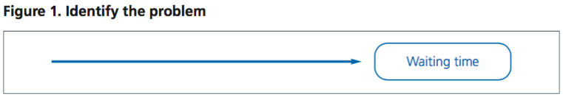
Step2- Draw four or more branches off the large arrow to symbolize the key categories of potential causes, label each branch with the important components, and then list the primary causes. Equipment, the environment, procedures, and people are possible categories. Make sure the categories apply to your specific issue. As an alternative, you might employ group headings and the affinity diagram technique.
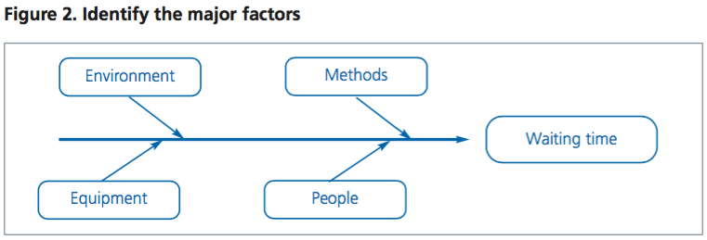
Step three- Think of potential causes for the issue under each of the major categories. Investigate each one to find more precise "causes of causes," adding and labelling more lines off the spine.
Once every potential cause has been found, keep branching off. Consider dividing intricate causes into smaller ones. Put them on lines that branch off of each cause line.
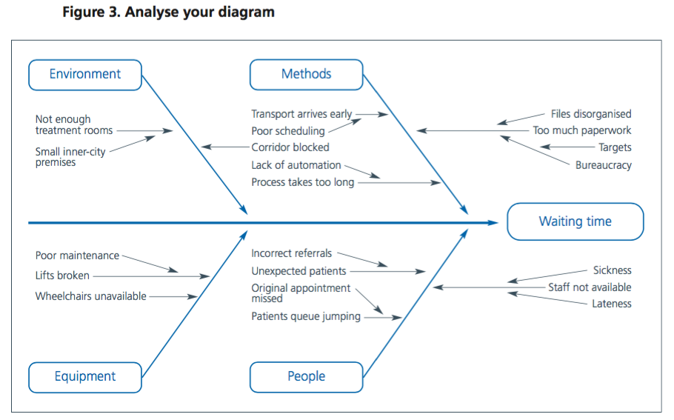
Step Four- Investigate your diagram. By this point, you ought to have a diagram that details every potential root of your issue. You can now look at the most likely causes in greater detail, depending on their complexity and significance.
This could entail using additional methods for identification, such as data check sheets, scheduling interviews (see patient accounts), creating process maps, or conducting surveys to determine whether the reasons identified are real and accurate.
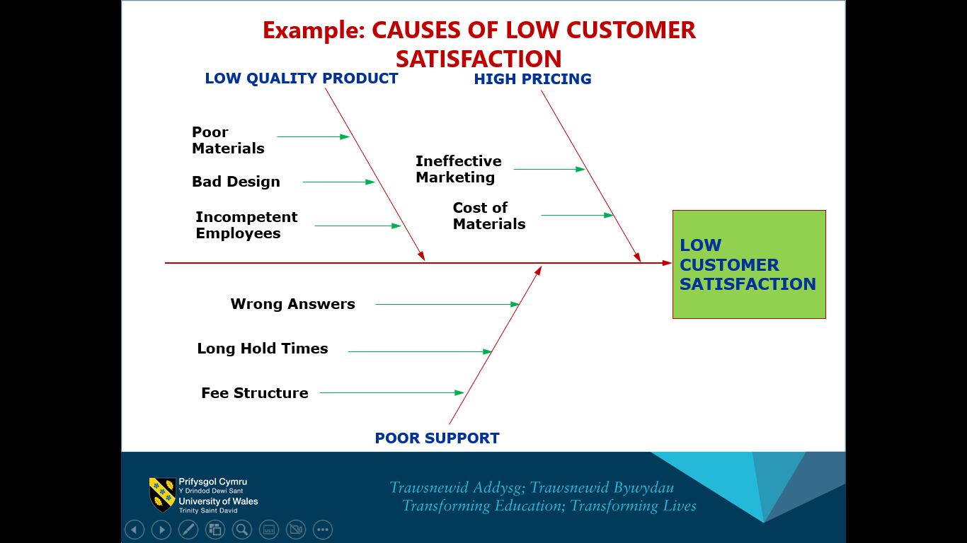

Above you can see how to use fishbone diagram to identify cause of a problem. With the help of fish bone diagram, you can assess the cause of the problem and use a method which you may think would be best fit to use in that current situation.

Porter’s Five Force Analysis
- A framework called Porter's Five Force Analysis attempts to assess the degree of competition in a market and the formulation of corporate strategies.
- It uses Industrial Organization (IO) economics to identify five factors that affect how competitively intense an industry is and how appealing that industry is as a result.
- In this sense, attractiveness refers to the overall profitability of the sector. An industry is considered "unattractive" if all five of these factors combine to reduce overall profitability.
- An industry that is close to "pure competition," in which possible earnings for all firms are driven by normal profit, would be exceedingly undesirable.
Components of Porter’s Five Forces Model
- Threat of new entrants
- Threat of substitutes
- Bargaining power of buyers
- Bargaining power of suppliers
- Rivalry inside the industry

Porter’s Five Force Analysis
- Threat of new entrants: There is fierce competition in the market. The business is challenged not only by competing companies, but also by the entry of new players. In the ideal situation, the market is constantly accessible for entry and exit, resulting in profits that are comparable for all businesses. In actuality, all sectors have some characteristics that help them safeguard their high profits and keep out potential competitors by creating barriers.
- Threat of substitutes: The goods produced by other industries that can meet comparable needs can be referred to as replacements. For instance, coffee can be substituted in place of tea since it contains caffeine and can be consumed in the morning. The demand for a related product is likewise impacted when the price of a substitute product fluctuates, because customers have more options to choose from when there are more substitute products available, competition also grows. This compels businesses to increase or decrease pricing.
- Bargaining power of buyers: This significantly impacts the manufacturing sector.
The term "monopsony" refers to the circumstance in which there are many producers and only one consumer in the market. These markets, buyers have a very powerful position and have the power to determine prices. There are very few monopsony markets. Customers' leverage in negotiations forces businesses to lower their prices and sometimes demands a higher-quality good or service at a lower cost.
- Bargaining power of Suppliers: Producing requires raw resources, thus the company's producers must establish ties with its suppliers. When suppliers are in a position of power, they can sway producing companies by offering them raw materials at higher costs.
an illustration, Wal-business Mart's success is based on its ties with its suppliers.
- Rivalry inside the industry: The main factor affecting an industry's competitiveness in most sectors is the level of rivalry between firms.
Potential Factors:
- Sustainable competitive advantage through innovation
- Competition between online and offline companies
- Level of advertising expense
- Powerful competitive strategy
- Firm concentration ratio
- Degree of transparency

References
AlleyDog. (2022). Trial And Error. Retrieved from AlleyDog : https://www.alleydog.com/glossary/definition.php?term=Trial+And+Error
API. (2022). How to Use the Fishbone Tool for Root Cause Analysis. https://www.cms.gov/medicare/provider-enrollment-and-certification/qapi/downloads/fishbonerevised.pdf.
Improvement, N. (October 2011). Guidance - How to create an. Leicester: https://www.england.nhs.uk/improvement-hub/wp-content/uploads/sites/44/2017/11/Creating-an-Affinity-Diagram.pdf.
Kenton, B. (2013). sociologydictionary. Retrieved from sociologydictionary: https://sociologydictionary.org/institution/
team, C. (2019, july 30). Problem solving vs decision making – what is the difference? Retrieved from Chnage Bored : https://www.changeboard.com/article-details/16960/problem-solving-vs-decision-making-what-is-the-difference-/
Team, L. C. (2022). Affinity Diagrams: Your Key to More Creative Problem Solving. Retrieved from Lucid Chart: https://www.lucidchart.com/blog/affinity-diagrams-your-key-to-more-creative-problem-solving

