Intercultural Competence Report

Module Title: Foreign Languages & Cultural Awareness
Module Code: BMIH5003
Lecturer: Lisa Bassler
Date: 16th February 2024

Student Name: Nisipeanu Denisa Elena
Student ID: 2234127

Executive Summary

This report examines the cultural differences between England and Portugal and their impact on intercultural leadership within the Inclusivity Hotel & Spa. Utilizing the GLOBE Project’s cultural dimensions, it identifies key disparities in Uncertainty Avoidance, Power Distance, and Individualism/Collectivism that present challenges in managing a culturally diverse team. The English workforce, characterized by lower Power Distance, favours an egalitarian approach, whereas Portuguese staff may prefer a more hierarchical structure. Additionally, the English team's comfort with uncertainty contrasts with the Portuguese preference for clear guidelines. These differences necessitate a leadership approach that is adaptable and culturally aware. The report concludes with practical recommendations to address these challenges, including cross-cultural training, inclusive team-building activities, and a leadership style that is sensitive to the cultural nuances of both English and Portuguese employees.

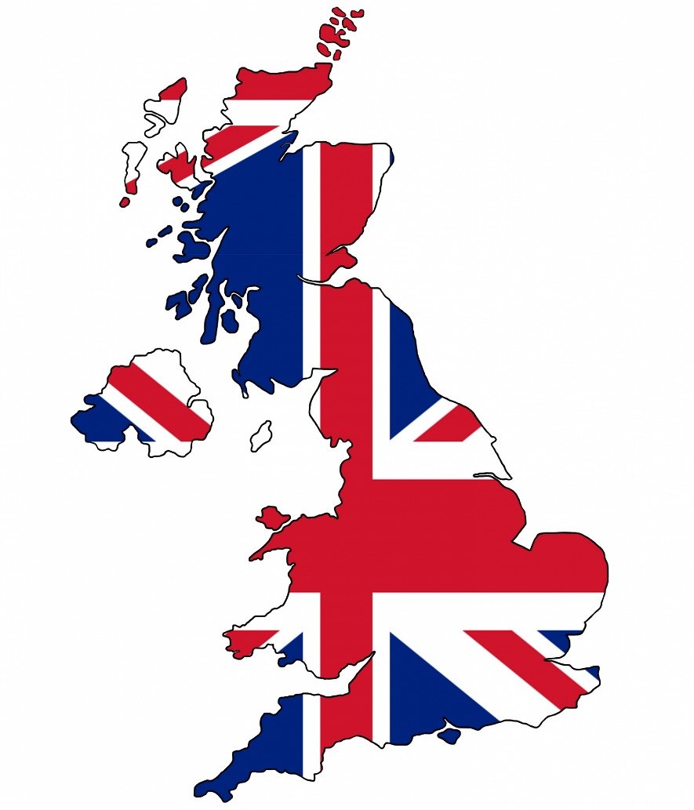
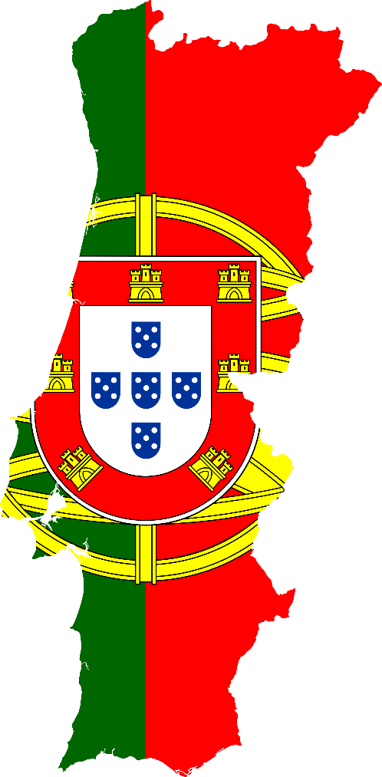

Content Table

- Introduction
- Main Body
  - Culture Overview
  - GLOBE Project/Country Analysis
  - Intercultural Leadership Challenges
- Conclusion
- Recommendations
- References

Introduction
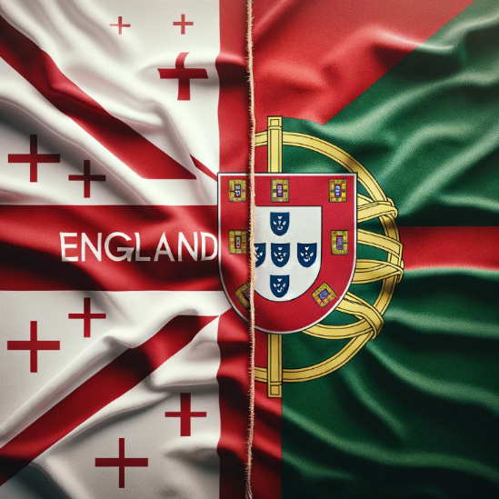
This report was prepared to inform the management of the Inclusivity Hotel & Spa in London of the critical cultural considerations when leading a diverse team of English and Portuguese employees. Appreciating cultural differences is more than just a theoretical concept in the hospitality industry; it is essential to ensure smooth operations and provide exceptional guest experiences. The GLOBE Project provides a solid foundation for understanding how cultural factors affect leadership and workplace dynamics. This report will compare the cultural dimensions of England and Portugal as outlined by the GLOBE Project, providing actionable insights for intercultural leadership strategies. These strategies can improve collaboration and increase guest satisfaction in our multicultural environment.

Culture Overview
England vs. Portugal

1Hofstede Insights. (2024)
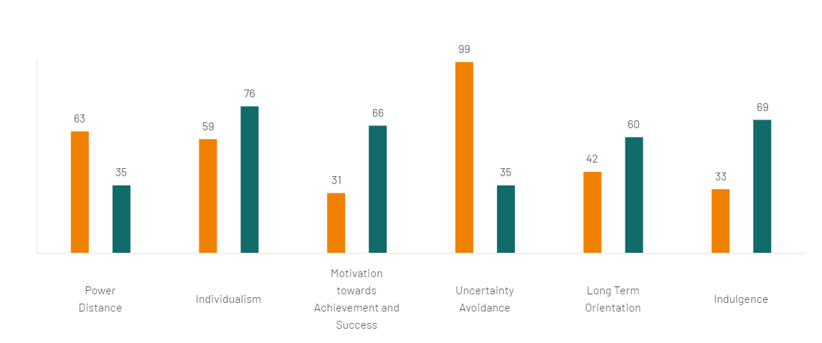When comparing English and Portuguese cultural dimensions, several distinctions become critical for understanding how they manifest in the hospitality industry. England, a member of the Anglo Cluster, values individualism. This means that in English society, personal goals and achievements are frequently prioritised (Hofstede, Hofstede, & Minkov, 2010). Portugal, on the other hand, is a member of the Latin Europe Cluster, which is known for emphasising collectivism and placing a high value on close family ties and group loyalty.
England has a lower Power Distance, which means that its organisational structures favour flatter hierarchies. This may lead to English team members expecting greater participation in decision-making (Deresky, 2000). Portugal, on the other hand, frequently exhibits greater acceptance of hierarchy, which may influence Portuguese employees' preferences for clearer direction from management (Minkov and Hofstede, 2011).
Another difference is how each culture approaches uncertainty. Portugal has a higher tendency to avoid uncertainty, preferring routines and the need for clarity to reduce risk (Hampden-Turner & Trompenaars, 2020). England has lower uncertainty avoidance, indicating greater comfort with change, new experiences, and adaptability in workplace practices (Hampden-Turner & Trompenaars, 2020).
In hospitality, cultural nuances have a significant impact on guest interactions and service expectations. It is critical to remember that while models such as Hofstede's provide useful insights, they generalise cultural tendencies. Individual differences still exist, and these findings should be applied with caution (Maheshkar and Sharma, 2018).

GLOBE Project
Country Analysis

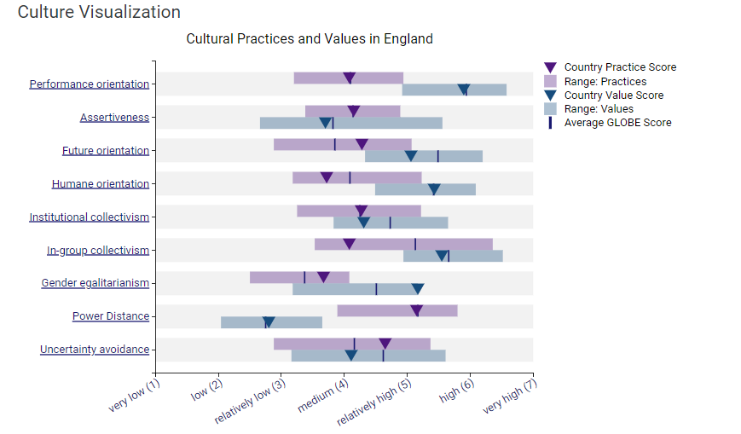
The GLOBE Project gives us valuable insights into cultural practices and expectations around leadership in both England and Portugal. For instance, Portugal scores higher in in-group collectivism. This means they typically put a stronger emphasis on building close, lasting relationships and loyalty within groups – something that could shape team dynamics at the hotel (Nedelko and Brzozowski, 2019). England, on the other hand, generally prioritizes individual achievement, potentially impacting how teamwork is viewed.
2The Globe Project, (2024)
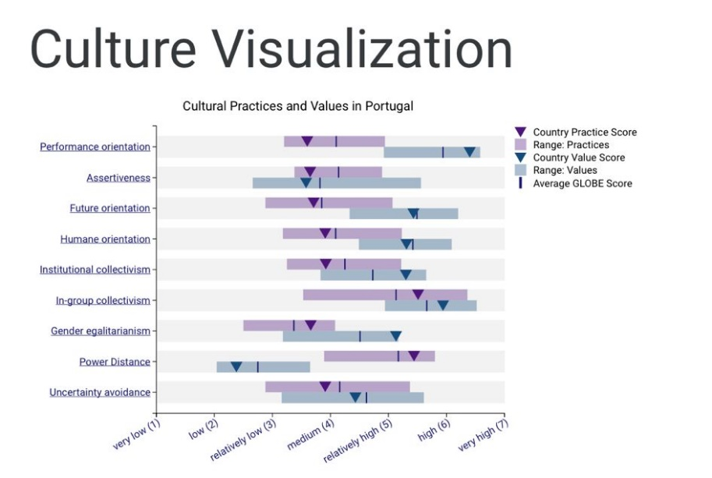
England also scores higher in assertiveness. This suggests a cultural preference for competitiveness and direct communication, which can influence how managers lead and how staff interact (Christiansen, Branch, & Karmowska, 2020). In contrast, Portuguese culture leans towards modesty and a gentler approach, meaning there may be different expectations around how to handle conflict or negotiate within the hotel's management team (Nedelko and Brzozowski, 2019).
3The Globe Project, (2024)
Another difference lies in how each culture handles uncertainty. Portugal's higher uncertainty avoidance favours structure and clear guidelines, crucial for maintaining consistent standards across our hotel (Deresky, 2000). England's lower uncertainty avoidance could mean their employees are more comfortable with change, allowing for greater flexibility when a guest needs a shift.
Lastly, Portugal scores higher in Power Distance, suggesting respect for hierarchy and centralized decision-making. This could affect how responsibilities are assigned and how decisions are reached within the hotel's structure (Minkov & Hofstede, 2011).
It's key to remember that the GLOBE Project helps us see broader cultural trends, not to predict individual behavior. Still, these insights provide a framework for understanding potential differences in the workplace (Maheshkar & Sharma, 2018).

Challenges of Intercultural Leadership

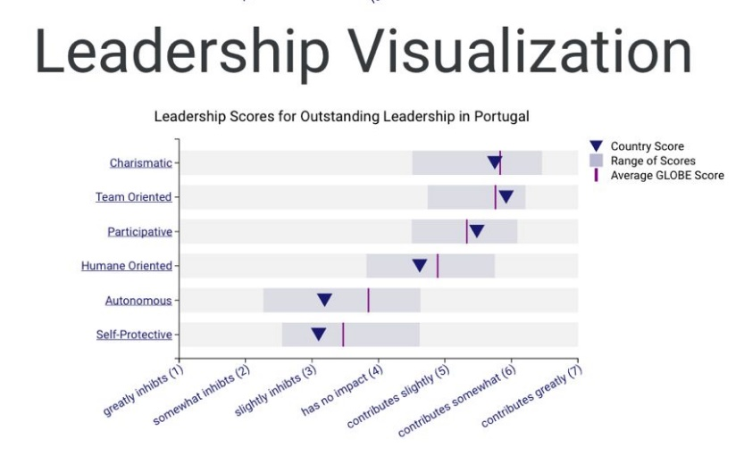
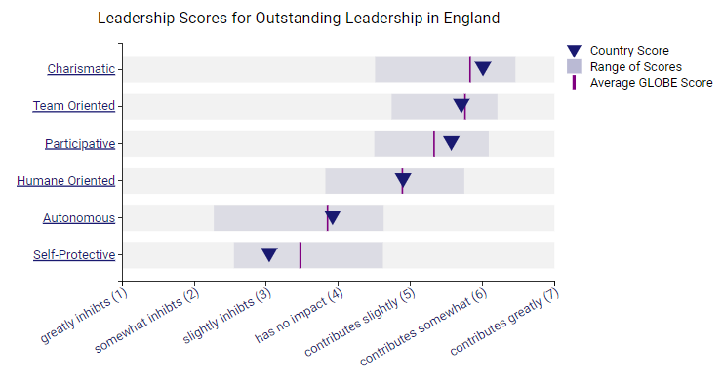
Leading teams in the hospitality industry require navigating complex cultural differences and communication styles. A perfect example is a Japanese guest having a subpar dining experience because the server is unfamiliar with Japanese customs. This highlights the real-world consequences of misinterpreting cultural norms and behaviours (Liu et al., 2022).
In a busy hotel, leaders must manage teams that serve guests from all over. According to the GLOBE Project, value differences such as assertiveness or group loyalty can result in mismatched work styles and even team friction. A Portuguese employee's sense of modesty, for example, may clash with a British colleague's directness, resulting in miscommunication and confusion.
Furthermore, guest satisfaction is central to the hospitality industry. Teams require more than just language skills; they must also understand cultural nuances, such as how food is presented and how to interact with guests (Thoungphut & Kaur, 2023). Mistakes here harm the guest experience and the hotel's reputation.
4The Globe Project, (2024)
5The Globe Project, (2024)
The way forward? Hotel management must cultivate a culture that truly values diversity. It is not enough to simply recognise differences; we must also use them to improve innovation, performance, and guest engagement (Manoharan et al., 2021). This demonstrates the ongoing importance of cultural sensitivity training and language learning as keys to professional development in the hospitality industry.

Conclusion


This analysis shows that to lead effectively at Inclusivity Hotel & Spa, we need to be keenly aware of the cultural differences between our English and Portuguese staff. This is especially true when it comes to communication styles, what employees expect from leadership, and how team dynamics work. The GLOBE Project's findings point to the need for a flexible leadership approach that can bridge the gaps between different levels of assertiveness, and individualism, and how comfortable people are with uncertainty. Putting these kinds of nuanced leadership strategies into practice will be essential for building a strong, productive team and upholding Inclusivity Hotel & Spa's reputation for excellent service.

Recommendations

Invest in detailed cross-cultural training. Go beyond broad concepts and concentrate on the unique values and communication styles of both English and Portuguese employees. This improves understanding and collaboration within the team.
Do team-building a cultural exchange. Plan regular activities that allow employees to share their perspectives and learn from one another. This creates a truly inclusive workplace in which everyone's contributions feel valued.
Prepare leaders to be culturally adaptable. Management requires tools to navigate the complexities of a multicultural workplace. Teach them how to tailor their approach to the diverse needs of their team members.

References

- Christiansen, B., Branch, J.D. and Karmowska, J. eds., 2020. Cultural Factors and Performance in 21st Century Businesses. IGI Global.
- Deresky, H., 2000. International management: Managing across borders and cultures. Pearson Education India.
- GLOBE Project. The Global Leadership and Organizational Behavior Effectiveness Research Program. Retrieved from https://globeproject.com/
- Hampden-Turner, C., Trompenaars, F. and Hampden-Turner, C., 2020. Riding the waves of culture: Understanding diversity in global business. Hachette UK.
- Hofstede Insights. Country Comparison Tool. Retrieved from https://www.hofstede-insights.com/country-comparison-tool
- Hofstede, G., Hofstede, G.J. and Minkov, M., 2010. Cultures and organizations, software of the mind. Intercultural cooperation and its importance for survival.
- Hofstede, G., Hofstede, G.J. and Minkov, M., 2010. Cultures and organizations, software of the mind. Intercultural cooperation and its importance for survival.
- Images from Freepik website: Freepik | Create great designs, faster
- Liu, Y., Liu, J. and King, B., 2022. Intercultural communicative competence: Hospitality industry and education perspectives. Journal of Hospitality, Leisure, Sport & Tourism Education, 30, p.100371.
- Maheshkar, C. and Sharma, V. eds., 2018. Handbook of research on cross-cultural business education. IGI Global.
- Manoharan, A., Madera, J.M. and Singal, M., 2021. Walking the talk in diversity management: Exploring links between strategic statements, management practices, and external recognition. International Journal of Hospitality Management, 94, p.102864.
- Nedelko, Z. and Brzozowski, M. eds., 2019. Recent Advances in the Roles of Cultural and Personal Values in Organizational Behavior.
- Thongphut, A. and Kaur, J., 2023. “Doing Explicit” in hospitality and tourism service encounters in English as a lingua franca. English for Specific Purposes, 70, pp.224-236.

