The Winter Travel Fair

International Meetings Management For The Hotel Industry
Katryn Flynn
Dana Bagy
2208667

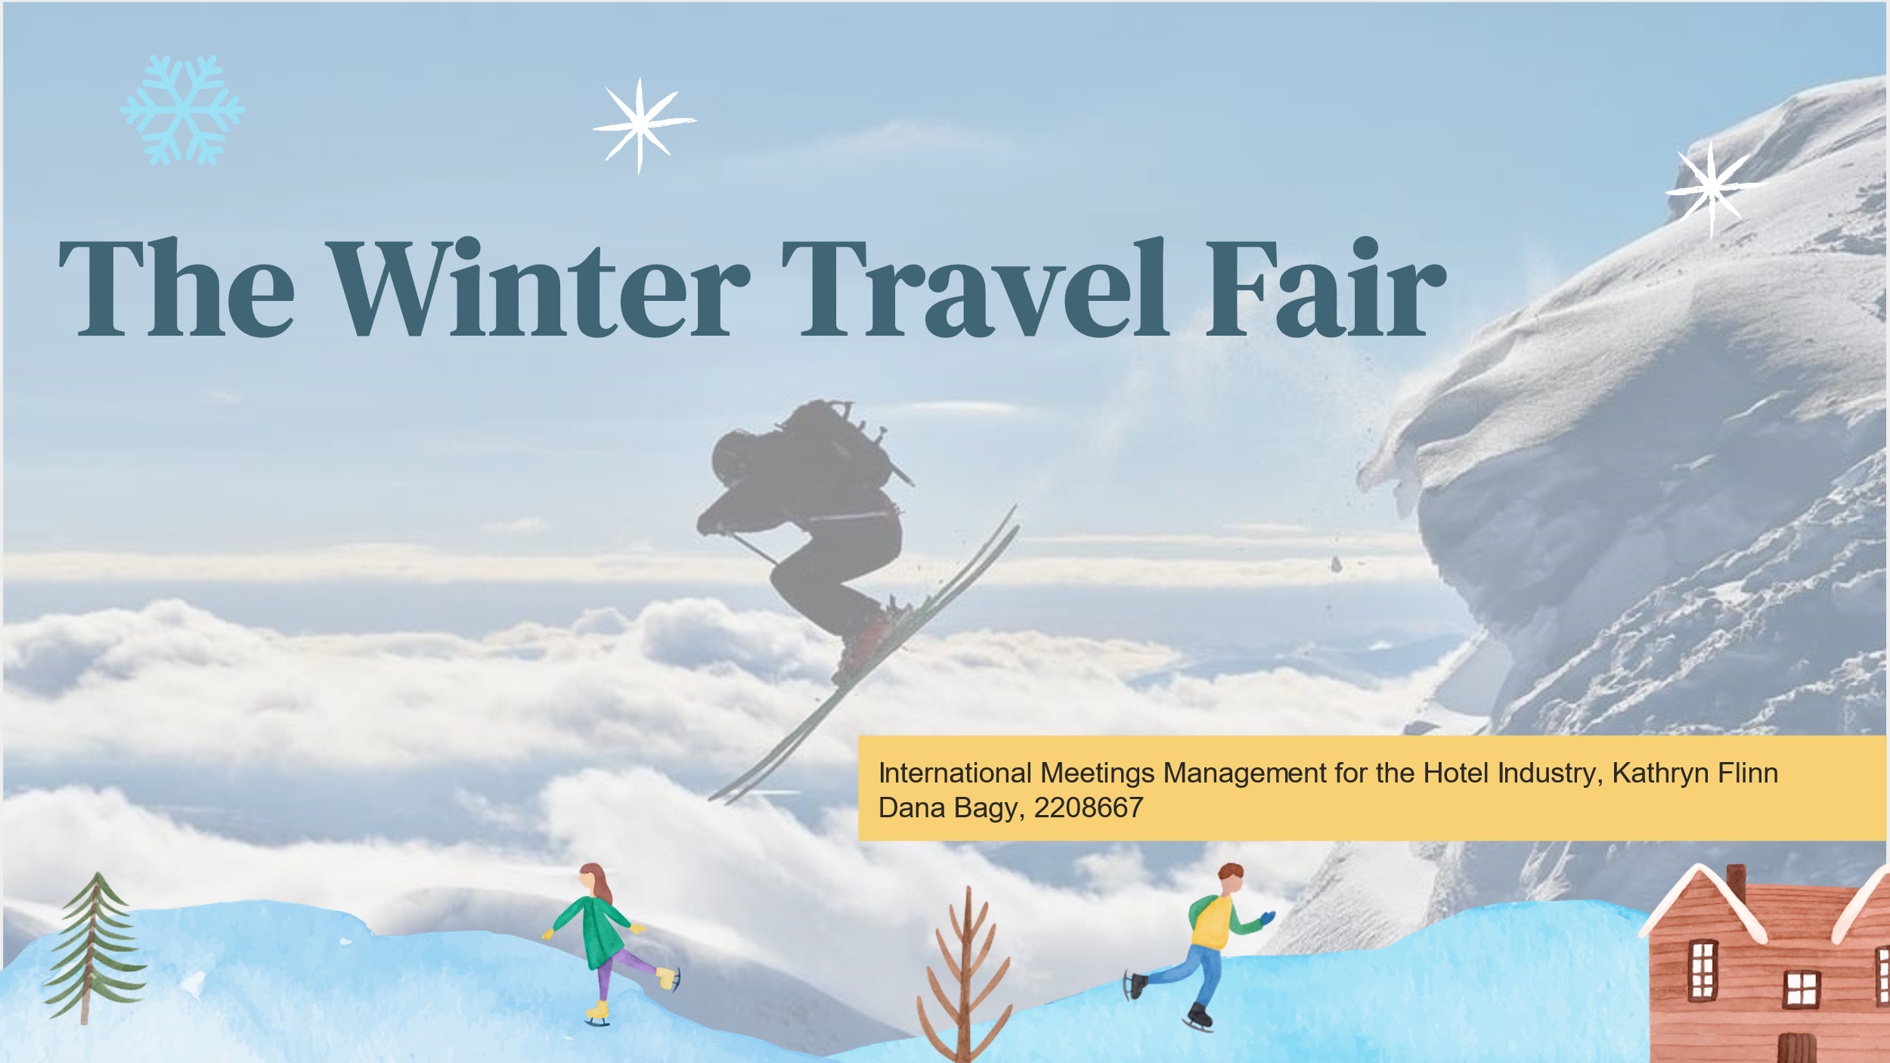
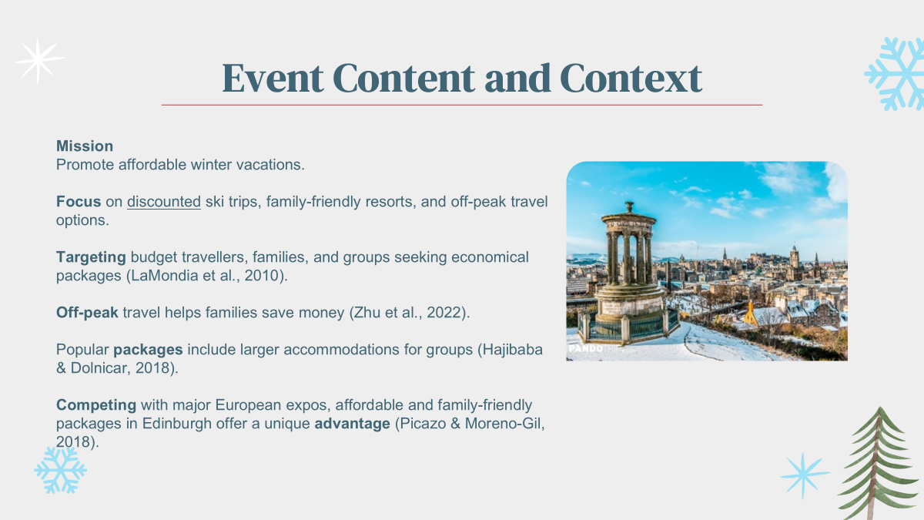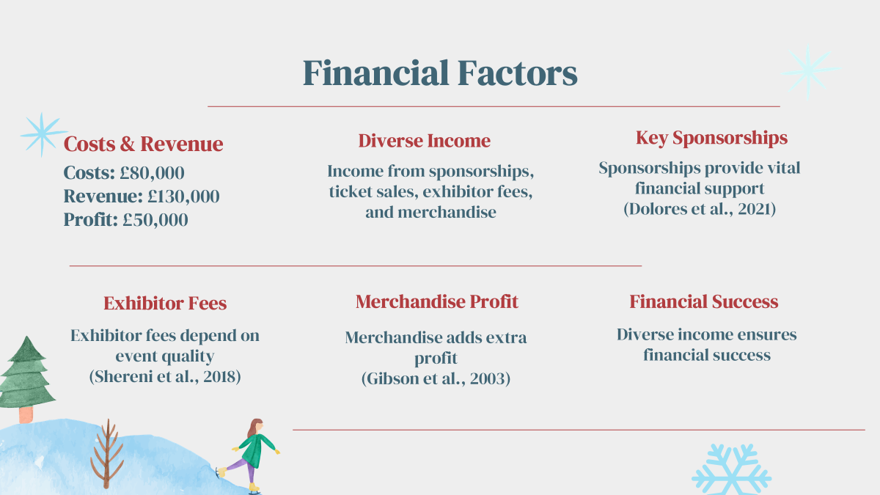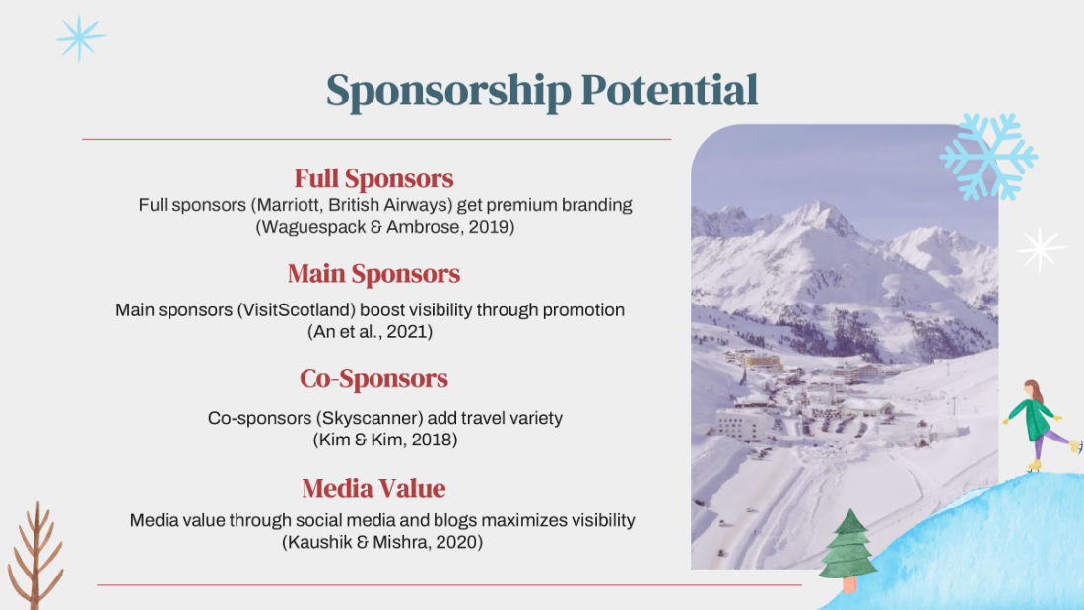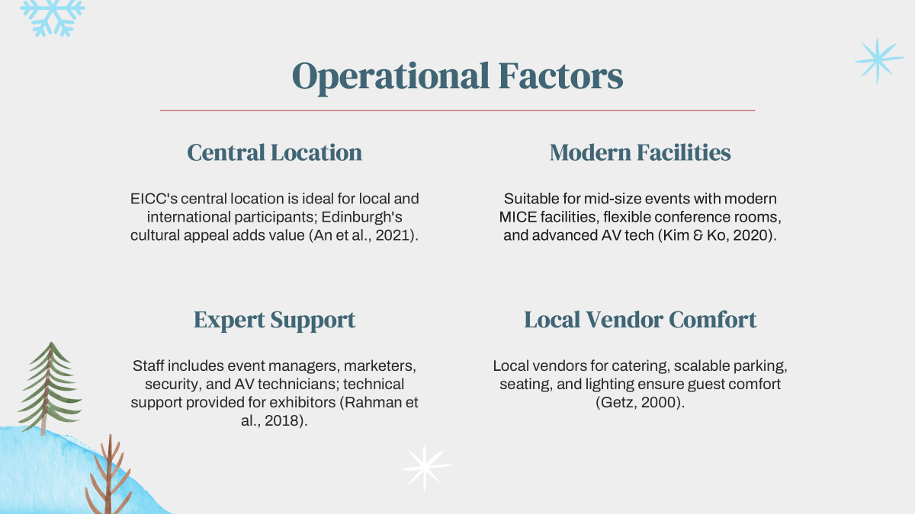
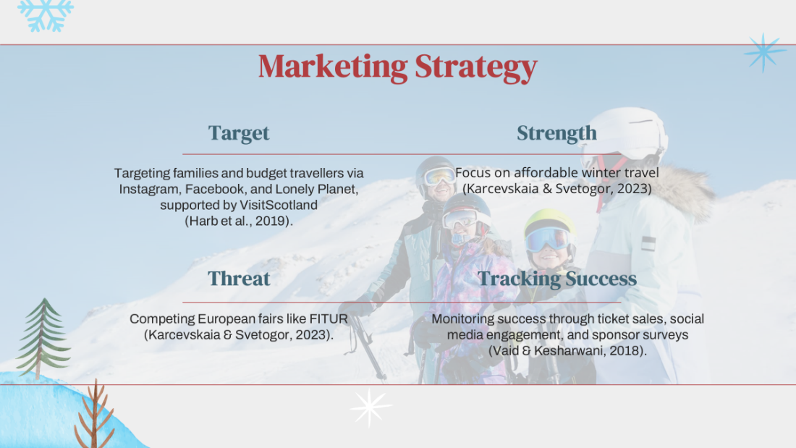
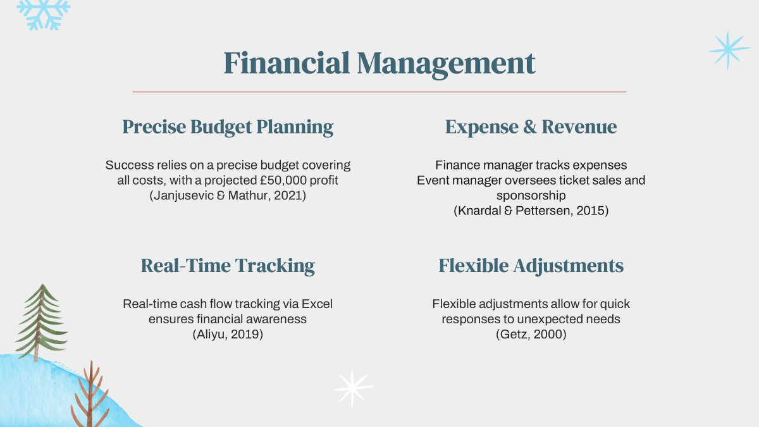
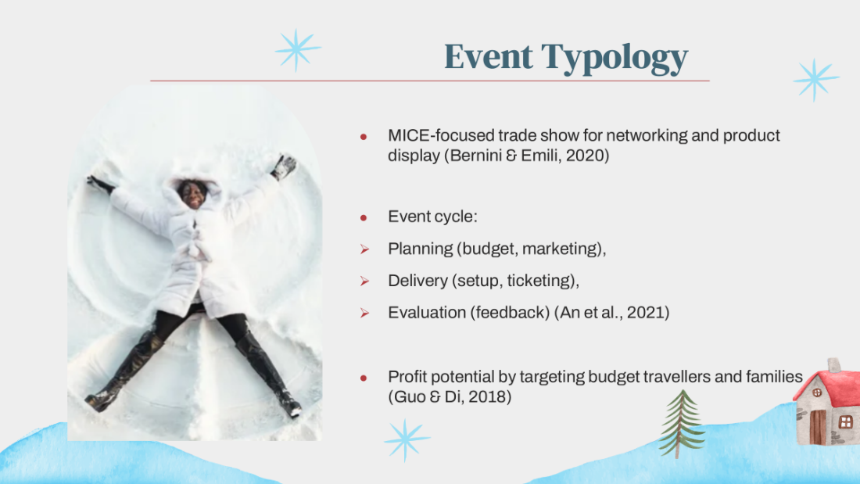
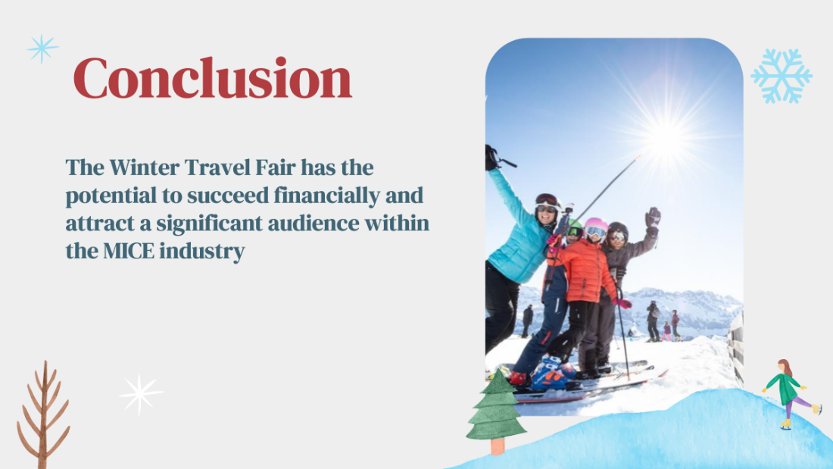

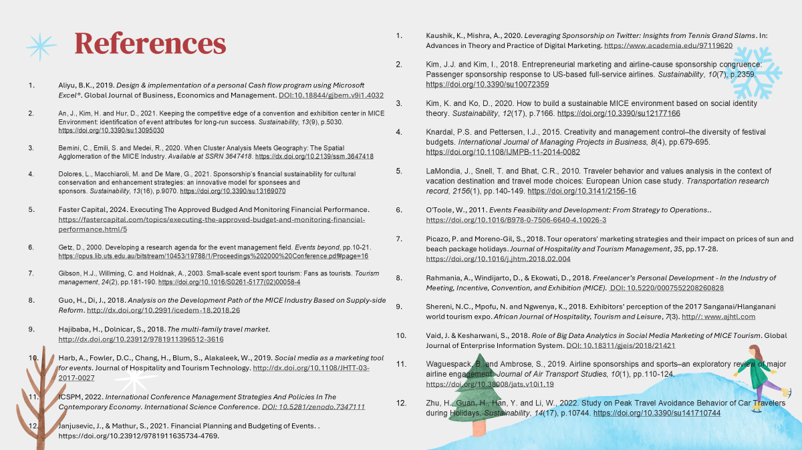

- Aliyu, B.K., Aliyu, B.K., 2019. Design & implementation of a personal Cash flow program using Microsoft Excel®. Global Journal of Business, Economics and Management. DOI:10.18844/gjbem.v9i1.4032
- An, J., Kim, H. and Hur, D., 2021. Keeping the competitive edge of a convention and exhibition center in MICE Environment: identification of event attributes for long-run success. Sustainability, 13(9), p.5030. https://doi.org/10.3390/su13095030
- Bernini, C., Emili, S. and Medei, R., 2020. When Cluster Analysis Meets Geography: The Spatial Agglomeration of the MICE Industry. Available at SSRN 3647418. https://dx.doi.org/10.2139/ssrn.3647418
- Dolores, L., Macchiaroli, M. and De Mare, G., 2021. Sponsorship’s financial sustainability for cultural conservation and enhancement strategies: an innovative model for sponsees and sponsors. Sustainability, 13(16), p.9070. https://doi.org/10.3390/su13169070
- Faster Capital, 2024. Executing The Approved Budged And Monitoring Financial Performance. https://fastercapital.com/topics/executing-the-approved-budget-and-monitoring-financial-performance.html/5
- Getz, D., 2000. Developing a research agenda for the event management field. Events beyond, pp.10-21. https://opus.lib.uts.edu.au/bitstream/10453/19788/1/Proceedings%202000%20Conference.pdf#page=16
- Gibson, H.J., Willming, C. and Holdnak, A., 2003. Small-scale event sport tourism: Fans as tourists. Tourism management, 24(2), pp.181-190. https://doi.org/10.1016/S0261-5177(02)00058-4
- Guo, H., Di, J., 2018. Analysis on the Development Path of the MICE Industry Based on Supply-side Reform. http://dx.doi.org/10.2991/icedem-18.2018.26
- Hajibaba, H., Dolnicar, S., 2018. The multi-family travel market. http://dx.doi.org/10.23912/9781911396512-3616
- Harb, A., Fowler, D.C., Chang, H., Blum, S., Alakaleek, W., 2019. Social media as a marketing tool for events. Journal of Hospitality and Tourism Technology. http://dx.doi.org/10.1108/JHTT-03-2017-0027
- ICSPM, 2022. International Conference Management Strategies And Policies In The Contemporary Economy. International Science Conference. DOI: 10.5281/zenodo.7347111
- Janjusevic, J., & Mathur, S., 2021. Financial Planning and Budgeting of Events. . https://doi.org/10.23912/9781911635734-4769.
- Kaushik, K., Mishra, A., 2020. Leveraging Sponsorship on Twitter: Insights from Tennis Grand Slams. In: Advances in Theory and Practice of Digital Marketing. https://www.academia.edu/97119620
- Kim, J.J. and Kim, I., 2018. Entrepreneurial marketing and airline-cause sponsorship congruence: Passenger sponsorship response to US-based full-service airlines. Sustainability, 10(7), p.2359. https://doi.org/10.3390/su10072359
- Kim, K. and Ko, D., 2020. How to build a sustainable MICE environment based on social identity theory. Sustainability, 12(17), p.7166. https://doi.org/10.3390/su12177166
- Knardal, P.S. and Pettersen, I.J., 2015. Creativity and management control–the diversity of festival budgets. International Journal of Managing Projects in Business, 8(4), pp.679-695. https://doi.org/10.1108/IJMPB-11-2014-0082
- LaMondia, J., Snell, T. and Bhat, C.R., 2010. Traveler behavior and values analysis in the context of vacation destination and travel mode choices: European Union case study. Transportation research record, 2156(1), pp.140-149. https://doi.org/10.3141/2156-16
- O'Toole, W., 2011. Events Feasibility and Development: From Strategy to Operations.. https://doi.org/10.1016/B978-0-7506-6640-4.10026-3
- Picazo, P. and Moreno-Gil, S., 2018. Tour operators' marketing strategies and their impact on prices of sun and beach package holidays. Journal of Hospitality and Tourism Management, 35, pp.17-28. https://doi.org/10.1016/j.jhtm.2018.02.004
- Rahmania, A., Windijarto, D., & Ekowati, D., 2018. Freelancer’s Personal Development - In the Industry of Meeting, Incentive, Convention, and Exhibition (MICE). DOI: 10.5220/0007552208260828
- Shereni, N.C., Mpofu, N. and Ngwenya, K., 2018. Exhibitors’ perception of the 2017 Sanganai/Hlanganani world tourism expo. African Journal of Hospitality, Tourism and Leisure, 7(3). http//: www.ajhtl.com
- Vaid, J. & Kesharwani, S., 2018. Role of Big Data Analytics in Social Media Marketing of MICE Tourism. Global Journal of Enterprise Information System. DOI: 10.18311/gjeis/2018/21421
- Waguespack, B. and Ambrose, S., 2019. Airline sponsorships and sports–an exploratory review of major airline engagement. Journal of Air Transport Studies, 10(1), pp.110-124. https://doi.org/10.38008/jats.v10i1.19
- Zhu, H., Guan, H., Han, Y. and Li, W., 2022. Study on Peak Travel Avoidance Behavior of Car Travelers during Holidays. Sustainability, 14(17), p.10744. https://doi.org/10.3390/su141710744

