
Transitions:

A Practitioners guide to Supporting Wellbeing during the Transition to Nursery.

Contents

Page 3 Purpose of the Handbook
What are transitions and why are they so important?
Page 4 Supporting Children during transitions
Page 5 The practitioner’s role
Staff Responsibilities
Communication
Working Together
Page 6 Creating a holistically nurturing environment.
Understanding Attachment
Page 7 Practical ideas to support Transitions
A gradual approach
The Zone of Proximal Development
Page 8 Interventions to encourage positive outcomes
Page 11 What does a Successful transition look like?
Page 12 References

Purpose of the handbook.
This handbook has been created as a guide to support Early Years staff as they welcome new children and their caregivers into the nursery and assist in planning for a smooth and positive transition that best supports the needs of the children.
Practitioners must be aware that the transition to school is a massive upheaval in a child’s life and your approach could have life altering effects, so practitioners must endeavour to make sure those effects are positive as research tells us that failure to create secure attachments can create stress, which experienced at a vulnerable age can lead to behavioural issues poor physical and mental health and decreased academic success (national scientific council on the developing child)

What are transitions and why are they so important?
Transitions are simply periods of change, which according to Brooker (2008) occur naturally throughout the lives of individuals. Early Years Matters (2022) instructs us to view transitions as a continuous process that children will experience, rather than an event that happens to them, if we as practitioners take this view, we will remember that even though most transitions are inevitable, we can play a role in making them a smooth and positive experience. Brooker (2008) goes on to say that these transitions are recognised by families and the wider community, who attach rituals to these events in order to prepare and support the individual during these transitional periods. For instance, a child losing their baby teeth is a natural transition which can be a confusing and painful experience, however, many children look forward to losing a tooth due to the socially constructed celebration of this event by leaving it under a pillow in exchange for a gift from the tooth fairy.
These childhood myths can be taken for granted by adults as a whimsical fun, but if we connect it to the thoughts of Brooker and Early Years Matters, we recognise this myth as a useful aid in facilitating transitions in the Early Years.



The needs of the child
Supporting Children during transitions
In order to support children and meet their needs during transitions, Early Years workers will need to apply a holistic approach to allow children and their caregivers to adjust over time.
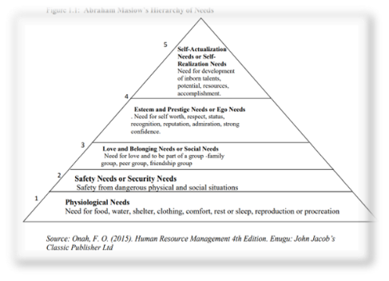
This means considering the whole child when it comes to education, recognising how their physical, emotional, social and spiritual needs are intrinsically linked and are only able to progress if their needs in each area are being met.
Maslow’s Hierarchy of needs supports this approach, if we look at the table detailing the order of needs a person needs to fulfil to move up the hierarchy - which are as follows;
1. Physiological needs
2. Safety needs or security needs
3. Love and belonging needs or social needs
4. Esteem and prestige needs, or ego needs
5. Self-actualization needs (International Journal of Development and Economic Sustainability, 2017)
(Source: International Journal of Development and Economic Sustainability, 2017)
we see that a child must feel safe and secure physically before they are able to make emotional and social connections to fulfil their need for love and belonging, failure to meet these needs mean they are at a disadvantage when it comes to attaining self-worth and developing their abilities, which are part of the next stages. We can see how this theory has informed the New Curriculum for Wales, educators must enable children to become ‘’Healthy, confident individuals who are ready to lead fulfilling lives as valued members of society.’’(Welsh Parliament, 2022) If practitioners do not meet the needs of the child , not only are we failing them, we are failing to follow government guidelines.
Lindon (2017) provides a scientific explanation for why children need to advance through the hierarchy of needs in order to make developmental progress - when children experience positive emotions, the brain produces chemical secretions that help messages cross the synapses, therefore learning is easiest for a child who is rested, nourished and free from anxiety, whereas a child who feels under threat, will only be able to focus on meeting their more basic needs for safety.
Prolonged states of stress activation can become trauma inducing and impact a child’s holistic wellbeing, research from Harvard University refers to this as ‘Toxic Stress’ and presents skilled and responsive practitioners as a way to counteract adverse childhood experiences and allow them to thrive. (National scientific council on the developing child)

The practitioner’s role
Staff Responsibilities
To facilitate smooth transitions, Early Years workers must be welcoming, patient and responsive in addition to providing a high standard of education delivered through the physical environment and following a robust safeguarding strategy. An intake of new starters may be stressful for the adults as well as the children, so prioritising and planning for transitions and creating a predictable routine can help us prepare and manage stress and look forward to seeing positive results.
Communication.
Relationships with the Parents and caregivers is just as significant to ensuring the transition process runs smoothly. Early Years workers who are able to create pathways to communicate with the people who know the children attending the setting best, will have greater success in ensuring the children feel safe and happy when separated from the primary caregiver. Knowledgeable and confident practitioners can discuss each child’s needs, preferences, and any specific requirements with the primary caregiver, and together, develop a holistic idea of the children and tailor the nursery to reflect and represent them, and the culture they are a part of.
Examples of this may be if they have a faith, dietary requirements or if they have a favourite song or story. With this information, planning to incorporate elements of the child’s existing knowledge and understanding of the world from their perspective can be acknowledged, in turn allowing the child to feel acknowledged as an individual, fostering a sense of acceptance and inclusivity that forms a strong foundation for secure attachment.
This practice is shown to be effective, even where communication could be classed as challenging due to language barriers, or involve people on the autism spectrum, by The Continuity and Transition Project in Wandsworth whose main goal to build a collaborative network has supported transitions by listening, reflecting and responding appropriately (Department for Education and Skills 2006) This, in turn, will create trust and a sense of community between staff and parents, and hopefully create and maintain a dialogue where all involved can share information that can support the wellbeing of the child.
Working Together.
Furthermore, extending communication to other agencies, such as pre-school childcare, Health Visitors and Speech and Language Teams, we can develop a much more in depth understanding of the children transitioning to nursery and use the experience of other professionals to create a quality learning environment that is able to support a wide range of specific needs in the setting. This approach is known as working as part of a multi-Agency Team and will be crucial when planning a transition for a child with more complex needs who may require a Statement of special needs. This is a legal document that establishes the specific needs of the child, and the provisions that will be put in place to overcome any barriers to learning and development. (Contact, 2022) Early years workers will need to listen to the views of the child and their family as well as other professional organisations to provide the appropriate provisions to support the child as they transition and beyond. This could mean additional training for staff to support a physical need, such as administering medication, or allocation of a 1:1 staff member to support a child with may exhibit challenging behaviour. These measures ensure we are adhering to Articles 28 and 6 of the UNCRC, a child’s right to education, and rights to life and development.
Creating a holistically nurturing environment.
According to Dunlop and Fabian (2007), the transition into school can be a culture shock for the child who has not had time to process the change. Practitioners must be aware of this and plan well in advance to create an environment that is welcoming and inspires curiosity, so children will think of their new setting as a place they feel safe, happy and confident to explore.
Nutbrown, Clough and Selbie, (2012) discuss one element of the theory of Susan Issacs, as understanding the importance of the nursery environment being an extension of the child's home and the nursery teachers needing caring and supportive qualities, similar to those of the child's parents or caregivers in order to support intellectual and social development in the children who attended her school The Malting House, where she developed a progressive approach to education that used psychoanalytical ideas to design a child centred framework that provides routine and autonomy to the children.
Understanding attachment.
If we consider Bowlby’s Theory of attachment when looking at Issacs Framework, we can see how it supports the idea of positive attachment, Linden (2012) defines attachment as an affectionate bond that provides an internal feeling of security which is necessary in forming the foundation for healthy development, The Nursery teachers in Issacs school become figures of attachment for the children and by developing these relationships, the children are able to feel secure in this environment and learning and growth can take place.
Bowlby noted that children seek proximity to a caregiver, even if they are not physically dependant. (healthresearchfunding.org) Children attending nursery may be leaving their primary caregiver for the first time which, as Bowlby’s research suggests, can be stressful for the child. If measures are taken to prepare that child for nursery, and efforts are made to form a trusting relationship with them, that stress can be avoided during the transition, and it can be a happy experience.

Practical ideas to support Transitions
A gradual approach.
The Department for Education and Skills (2006) maintains that a gradual approach to transitions supported by responsive Early Years professionals, will allow the children to understand what to expect, and learn that their nursery is a safe place for them. A staggered start creates the possibility for a calm and relaxing entry into the setting, where parents can take time to separate gently from their children who can be soothed and settled before more arrive. (Nurseryworld)
Reggio Emilia Schools particularly value a gradual approach and dedicate an indeterminate amount of time for caregivers and their child to acclimatise to the school,(e, g) the comfort of the child and their immediate family is prioritised over any educational schedule as teachers following the Reggio method follow a truly child centred approach to learning and want to do develop a trusting partnership with the family. Reggio Emilia schools have shown positive result for decades and the method has inspired early years pedagogy in Wales, who also have a child centred curriculum where learners should be feel empowered to use their voice to shape their own learning through enabling environments.(Welsh Government, 2022)
The Zone of Proximal Development
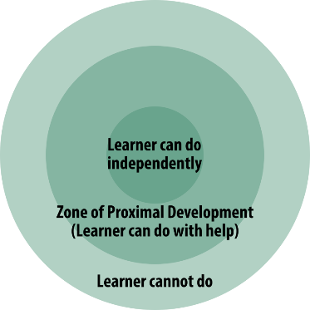
Using Vygotsky’s theory of The Zone of Proximal development we can plan for transitions with a deeper understanding of child development that can help the process take place with fewer issues.

Early Years Workers can organise visits to the nursery so children their carers can become familiar with the staff and the setting, which will eventually morph into a staggered start. The child can observe the new routines and activities with the comfort of their primary caregiver and form connections with their new caregivers and peers.
Staff can also work with the children and their caregivers to produce a written profile of the child, detailing their interests, abilities and what is important to them. From the information provided prior to children’s arrival, early Years staff can plan continuous provision that stimulates children’s curiosity and encourages them to explore their new environment. According to Vygotsky’s theory, this will become what the child already knows/can do independently.
Practitioners can build on this foundation when a child is settling in by guiding them to their areas of interest, helping them to adjust to the new routine and utilising the connections made during settling in sessions to develop caring attachments and responding to the child when they express their needs, Vygotsky identified the practice of scaffolding – modelling, providing cues and suggestions on how to complete a given task (McLeod, S. A. 2019) as a strategy to enable children to develop autonomy to do these things for themselves, for instance, putting on their coat to go outside or washing their hands after messy play, This is the Zone of Proximal development, which Bresler, Cooper and Palmer(2001) summarise as the distance between the child’s existing skills, and the new skills they are working towards. Eventually, the child will master these skills and their confidence and self-esteem will grow alongside their knowledge and positive associations with education are created.
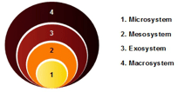
Bronfenbrenner expands combines the theories of Vygotsky and Maslow with his Nested systems
model, it depicts the ecological systems that each individual will interact with.

(source: firstdiscoverers.co.uk)
The centre of the diagram, the microsystem, is the layer that encompasses a child’s immediate surroundings and human interactions, i.e., the home and their family, the Nursery environment will become the Mesosystem, and if transitions are implemented properly, will include interactions new surrounding and interactions with the microsystem – this could refer to the settling in sessions and written profiles.
Bronfenbrenner, U., & Morris, P. A. (2006), go on to say in order for a child to develop holistically they require activities that reciprocal between a child and more knowledgeable other that becomes progressively more complex to be truly effective these activities need to occur regularly overtime, this research supports Vygotsky’s theory on the Zone of proximal development and reinforces the necessity of a familiar routine.
Interventions to encourage positive outcomes.
Routines are a good transitional intervention, they support theory in practice by alleviating anxiety, letting children predict what will happen next and provide a sense of security we know is essential to their learning and development.
Nutbrown and Clough (2014) discuss Winnicott’s object relations theory and the use of a transitional object, also known as a comfort blanket as a transitional intervention, the object can provide a sense of security and belonging and be used to comfort a distressed child by helping them to feel secure as they move from being dependant on their primary caregiver to being independent at nursery.
Nurseries may adopt the Keyperson approach; this means a particular member of staff will be the one to greet the child and ease them into the setting each day to reinforce the feeling of familiarity and allow for the child to transition seamlessly from their primary caregiver to the setting. This person can observe the child, learn their emotional cues and being close by to respond to them. If intimate care is needed, having a key person to attend to those needs can help a child feel safe in an especially vulnerable situation. The Keyperson can also be the point of contact for families and can feedback information at the end of each session to reassure the parents and reinforce the reciprocal nature of Early years setting, noted as important by Bronfenbrenner (2006)
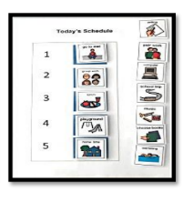
Visual timetables can create a sense of predictability by providing a way for children to understand the structure of their day in a series of recognisable symbols, this intervention is particularly useful when language is a barrier and helping children on the autism spectrum adjust to their routine. Bilson, Roberts and Shanks (no date) Having a visual timetable can help children manage their anxieties by being able to see what they will do next, support independence and decision making which can help prevent negative emotions and challenging behaviour.
(Source: NHS Wales)
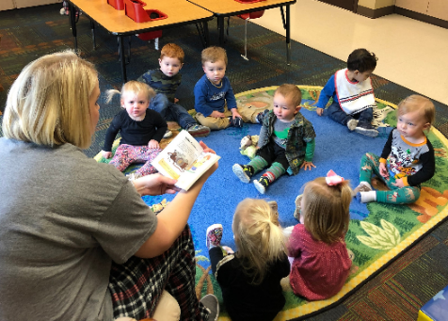
Fabian and Dunlop suggest sharing stories with issues children can relate to, to help them develop coping strategies and make sense of strange, new situations, Jerome Bruner would consider this an effective intervention to aid transition as it encapsulates his Modes of representation theory and allows children to construct their own learning so they can better understand what they are experiencing. The act of leaving parents to attend school is the action based Enactive representation, the pictures in the book (and other visual cues available around the nursery) become the image based, Iconic representation and the Early years worker reading the story provides the language based Symbolic representation. (Source: Preschool & Nursery | Frisco First)

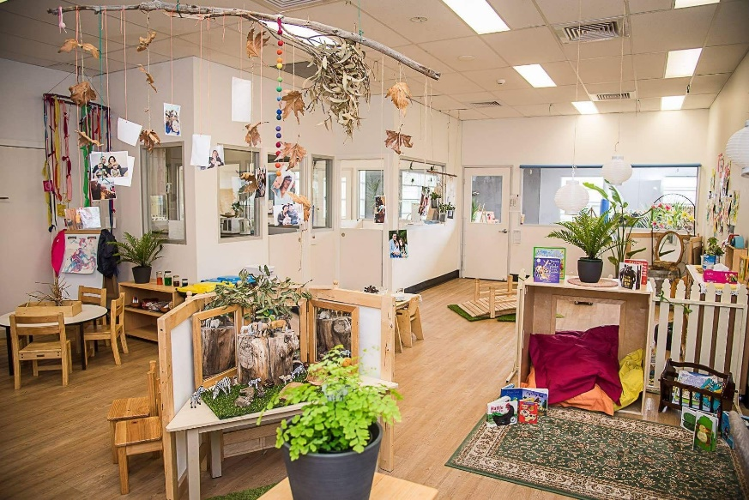
(Source: Pinterest)
The Reggio Emelia approach considers the learning environments as a ‘the third teacher’ (Edwards, Forman and Gandini) this means that a child will gain learning experiences from their surroundings. Nurturing environments, noted in the handbook previously, as being essential to meeting the needs of the children who use them. Therefore, creating opportunities to engage with the outdoors can be used as an intervention to a transition as the learning environment is so rich and full of natural resources to spark a child’s curiosity. Outdoor play is a vital element of the Early Years Foundation Phase in Wales and is shown to benefit children across all areas of development (Welsh Assembly Government, 2009) Being out in the open can also provide respite to a child feeling overwhelmed or overstimulated by the new routine. Outdoor play is also beneficial as we understand the effect of quality outdoor experiences on a child’s wellbeing, Children who engage with the outdoors develop higher levels of self-regulation cognitive development and deep levels of understanding both emotionally and academically (Janet Moyles, 2013)

What does a Successful transition look like?
Nutbrown and Clough reviewed the work of Bronfenbrenner and concluded that educational programmes involving the parents, had improved, and longer lasting success than child only approaches, therefore, Practitioners reflecting on periods of transition who are able to recall continuous, quality communication with the children and families can feel assured that they are working effectively.
Children who have transitioned successfully should be making progress through the curriculum and on their way to becoming ambitious, capable learners, enterprising, creative contributors, ethical, informed citizens of Wales and the world and healthy, confident individuals, in accordance with the new curriculum. (Welsh Government, 2022) Practitioners can assume that if progress is occurring, then positive attachments have been formed and children feel secure and enabled in the setting, their needs are being met and the transition has been facilitated successfully.

(Source:Earlyyears.wales)

