Soyful Khan 1704983
Group name: Aisha’s Wisdom Ltd.
Other Participants: Farzana Hussen, Sufia Khan, Shamsur Rahman and Samad Uddin.
Google account for group: samaduddin1710009@gmail.com
Password for account: Nazifa123.

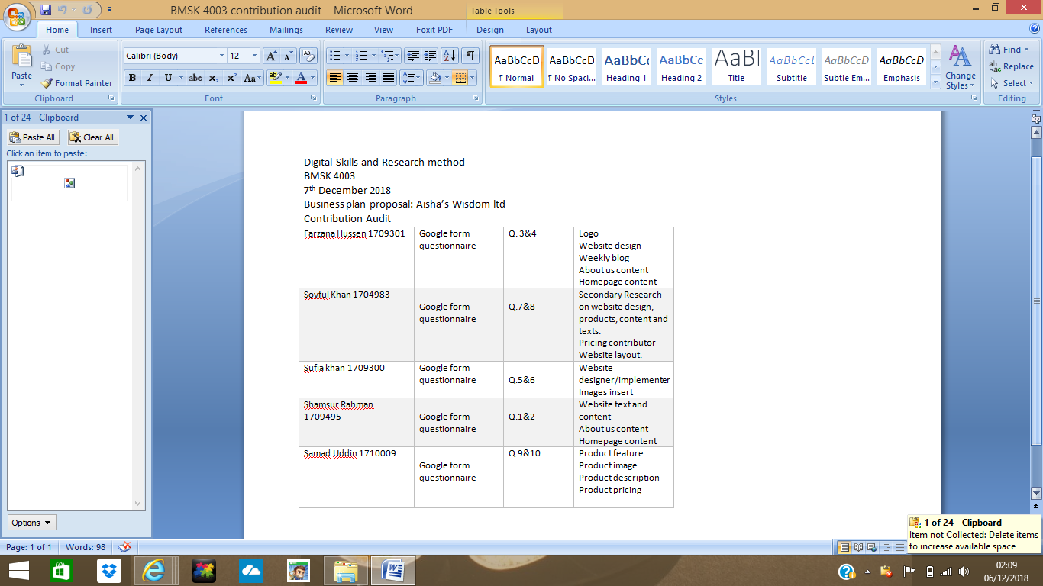

Website Contribution

My contribution to our website Aisha’s Wisdom Ltd was mostly my research, because I did all the secondary research regarding the website. I gave suggestions and ideas on what similar online bookstores have used on their websites, such as the layouts, website design, images, contents, product pricing and narration. The group decided on which layout, images and what the design, products, contents, pricing and narration should be.
This is a list of most of the websites I have used for my research:

http://www.kalamullah.com/books.html (Images, design and narration)
https://www.al-hidaayah.co.uk/ (Electronic products, E books and special offers)
http://kitaabun.com/shopping3 (Advertising ideas best sellers and delivery options)
http://www.islamicbookstore.com/ (Free delivery on bulk buys products on sale)
https://www.minhajbooks.com/english/index.html (Free downloads for customers and special offers}
https://minhajpublications.com/ (Membership for customers, Special offers and other products)
https://darussalam.com/?SID=t6fci7kvo36trhkmmmdhtio283 (Advertising new arrivals, images, other products on sale)
http://www.muslimchildrensbooks.co.uk/ (The narration, Inspiration for reading, popular books and images)
https://www.islamicbookstore.com.au/Zam%20Zam%20Water (Design, images and other Islamic products on sale)
https://www.islamicimpressions.co.uk/books ( Website design, Offers on popular books, browsing categories)
https://www.theworks.co.uk/page/books?gclid=EAIaIQobChMIm6-t9cWr3gIVxeR3Ch04ygkfEAMYASAAEgKcTPD_BwE (Book bundles, special offers)
https://www.ibraheemtoyhouse.com/us/product/hadith-for-kids/ (Related products on display, images)
https://www.buatsimanja.com/ (Books by age groups, popular books)
https://www.amazon.co.uk/s/?ie=UTF8&keywords=the+bookstore&index=aps&tag=googhydr-21&ref=pd_sl_9gsni0biaj_b&adgrpid=56835658207&hvpone=&hvptwo=&hvadid=259061294760&hvpos=2t2&hvnetw=g&hvrand=2599372039376692406&hvqmt=b (Best selling Islamic books)

Questionnaire Contribution

My contribution to the questionnaire was making notes on how to create it, as I was the only person in the group that took notes and my questions on the questionnaire is questions 7 and 8.

.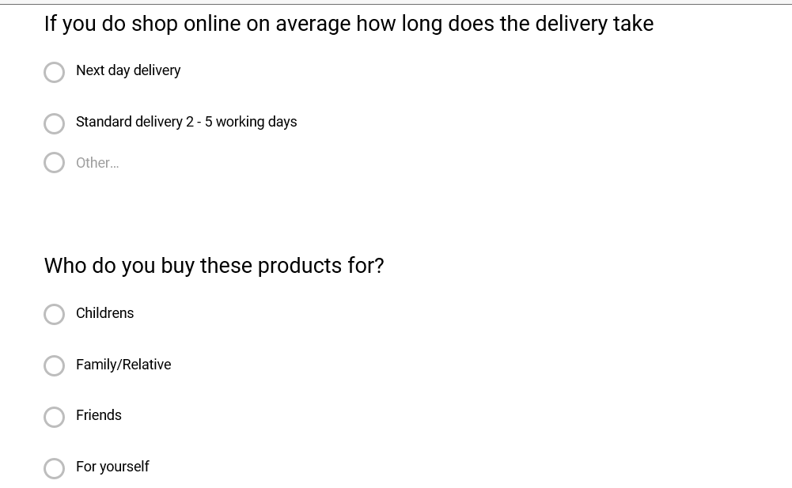

These are the graphs showing the response to my questions;


