Title: Coercive control: How has the 2015 legislation changed police response in Gwent?
Research Methodology and Planning

3.1 Research Strategy

This research aims to examine how the 2015 legislation has changed police response in Gwent. A self-report, online, anonymised survey will be used, and data analysis will be conducted to examine how serving police officers feel about the legislation in their everyday service. The sample study included serving police officers from the researchers’ ‘shift’ within the Gwent police force who undertook a self-report, online, anonymised survey generating quantitative data. The study employed the use of convenience, non-probability sampling, whereby the participants are recruited due to social ties, in this case, being part of the same shift pattern (Vehovar et al, 2016). This method is sampling was chosen as it is inexpensive, can be used to help to overcome many of the limitations associated with research. For example, using colleagues as part of sample is easier than targeting unknown individuals (Taherdoost, 2016). The researcher considered Myhill’s (2018) ‘A normative framework and key questions for considering police response to domestic violence’ and used this framework to devise a list of survey questions. To measure attitudes, Likert type questions were used to ask participants to give either a positive, negative or neutral response to a given statement, on a five-point scale (Online Surveys, N.D.). The 15 statements did not seek to question participants about their own conduct in relation to coercive control response, and therefore were not intrusive, however it did need to be considered that harm could be caused due to the context of the research. The researcher considered that the research could potentially cause harm as participants recall traumatic personal experiences or behaviours they themselves were ashamed of, meaning that distress or re-traumatization could occur (Campbell et al, 2019). To ensure that all participants were aware of support and how to access this, details were included on the information sheet and debriefing section of the survey.

Using a self-report online anonymised survey, collecting quantitative data, ensured that no personal data was stored or shared directly with any agency or individual. This was important as the research was conducted in the police force within which the researcher worked, which could have potentially led to participants feeling as though they had been coerced into taking part in the research (Cameron, 2021). Myhill (2018) in his study on police response to domestic violence questioned whether his position as college researcher might be ethically questionable, as officers might have felt obligated to participate in the research if they were requested to by someone within their force. To minimize any perceived coercion in the present study, the researcher ensured, via the information sheet, that potential participants were aware that whether they participated or not, this would have no bearing on their employment.

The research design was completed with ethics being a major consideration of the process, due to the sensitive nature of the topic. When questioning anyone about coercive control and domestic abuse it was clear that the survey and the questions posed must be carefully considered in order to protect all participants from harm (Women’s Aid, 2020). Fully informed consent was required, meaning that all participants were fully aware of both the subject matter and the ability to refrain from answering questions if they so wished. The information sheet was displayed on the first page of the survey and detailed information on the anonymity of their responses, support services, their right not to participate and withdraw and contact details for the researcher (BERA, 2018).

3.2 Data Collection
Considering practical issues, the use of an online survey has numerous strengths for the participants and the researcher. For example, one strength of using an online survey can allow participants to feel more secure in their anonymity, meaning that social desirability forces might be lowered and lead to the possibility of increased validity in terms of responses (Weisband and Kiesler, 1996). For example, Touvier et al’s (2010) study around comparisons between paper based and online surveys found that participants preferred the online version in comparison to the paper-based version. However, more recent research such as Dodou and de Winter’s (2014) meta-analysis of studies published in the preceding 45 years found that social desirability in computer surveys (Internet/offline) and paper surveys is the same. Another strength of the use of this method can be that it allows for increased autonomy, in that participants can take part when and where they wish to do so and can dictate the length of their participation (Willis, 2011). Validity can also be said to be enhanced via the use of an online survey because participants will not be influenced by any visual cues from the researcher as the researcher will not be present. This can be said to lead participants to feel less inhibited in their responses due to the perception that judgment from the researcher or others is unlikely (Bowker and Tuffin, 2004). Using this type of survey is also convenient, as participants can answer questions at their own pace. It is also not limited in terms of geography, is cost-effective and is gathering quantitative data, meaning data will be produced quickly (Nayak and Narayan, 2019).

3.3. Data Analysis
The quantitative data gathered will be analysed with Microsoft Excel. This will allow the researcher to conduct data analysis in response to the statements posed. Excel has been chosen as the data is being collected via Online Surveys, and this allows for the exportation of responses to Excel with ease.

3.4 Limitations & Potential problems
One limitation identified is issues with representativeness and generalizability. To have confidence in the representativeness of survey results each person in the target population must be given a chance to participate, however non-probability sampling was used in the study due to time and access restrictions, meaning that this study will be unable to assess how representative the sample in relation to the target population. Subsequently, generalisations that are made from such sampling techniques are simply educated guesses about the nature of a given population (Best et al, 2001). Another limitation of using an online self-report survey is that participants may not understand the questions, (Lobe et al, 2008) particularly as the researcher is not present at the time of data collection (Weigold et al, 2013). As the validity depends on the assumption that all participants have understood the questions in the way in which the researcher intended, considering this limitation means that the validity of results gained can be questioned (Lobe et al, 2008). This issue must be carefully considered as whilst participant information sheets were included, it may be that some participants misinterpret question meanings.

References:

Best, SJ; Krueger, B; Hubbard, C; and Smith, A (2001) ‘An Assessment of the Generalizability of Internet Surveys’, Social Science Computer Review, Vol 19(2), 131–145

Bowker, N and Tuffin, K (2004) ‘Using the online medium for discursive research about people with disabilities’, Social Science Computer Review, Vol 22(2), 228-241.

British Educational Research Association [BERA] (2018) ‘Ethical Guidelines for Educational Research’, fourth edition, London. Available at: https://www.bera.ac.uk/researchers-resources/publications/ethicalguidelines-for-educational-research-2018 [Accessed on: 15/02/2023]

Cameron, B (2021) ‘Qualitative Insider Research in a Government Institution: Reflections on a Study of Policy Capacity’, The Qualitative Report, Vol 26(11), 3519-3533.

Campbell, R; Goodman-Williams, R and Javorka, M (2019) ‘A Trauma-Informed Approach to Sexual Violence Research Ethics and Open Science’, Journal of Interpersonal Violence, Vol 34(23-24), 4765-4793
Dodou, D and de Winter, JCF (2014) ‘Social desirability is the same in offline, online, and paper surveys: A meta-analysis’, Computers in Human Behavior, Vol 36, 487-495,

Lobe, B; Livingstone, S; Olafsson, K and Simões, JA (2008) ‘Best Practice Research Guide: How to research children and online technologies in comparative perspective’, London: EU Kids Online. Available at: http://eprints.lse.ac.uk/21658/1/Best%20practice%20research%20guide%28lsero%29.pdf [Accessed on 10/02/2023]

Myhill, A (2018) ‘The police response to domestic violence: Risk, discretion, and the context of coercive control’, PhD Thesis, City, University of London. Available at: https://openaccess.city.ac.uk/id/eprint/19905/1/Myhill,%20Andy_Redacted.pdf [Accessed on 12/02/2023]

Nayak M and Narayan, KA (2019) ‘Strengths and weaknesses of online surveys’, IOSR Journal of Humanities and Social Sciences, Vol 24(5), 31-38.

Online Surveys (N.D.) ‘Scale/rank questions’, Available at: https://www.onlinesurveys.ac.uk/help-support/scalerank-questions/ [Accessed on: 10/02/2023]

Taherdoost H (2016) ‘Sampling Methods in Research Methodology; How to Choose a Sampling Technique for Research’, International Journal of Academic Research in Management, Vol 5(2), 18-27

Touvier, M; Mejean, C; Kesse-Guyot, E; Pollet, C; Malon, A; Castetbon, K and Hercberg, S (2010) ‘Comparison between web-based and paper versions of a self-administered anthropometric questionnaire’, European Journal of Epidemiology, Vol 25, 287–296.

Vehovar, V; Toepoel, V and Steinmetz, S (2016) ‘Non-probability Sampling’, Available at: https://www.researchgate.net/profile/Vasja-Vehovar/publication/307546330_Non-probability_sampling/links/5bb1978d45851574f7f39af6/Non-probability-sampling.pdf [Accessed on 20/02/2023]

Weigold, A; Weigold, IK and Russell, EJ (2013) ‘Examination of the equivalence of self-report survey-based paper-and-pencil and internet data collection methods’, Psychological methods, Vol 18(1), 53-70.

Weisband, S and Kiesler, S (1996) ‘Self disclosure on computer forms: meta-analysis and implications. In Proceedings of the SIGCHI Conference on Human Factors in Computing Systems (CHI '96)’. Association for Computing Machinery, New York, NY, USA, 3–10. https://doi.org/10.1145/238386.238387

Willis, P (2011) ‘Tackling sexuality online – technical, methodological and ethical considerations of online research with sexual minority youth’, Qualitative Social Work, Vol 11(2), 141-155.

Women’s Aid (2020) ‘Research Integrity Framework (RIF) on Domestic Violence and Abuse (DVA)’. Available at: https://welshwomensaid.org.uk/wp-content/uploads/2021/11/Research-Integrity-Framework-RIF-on-Domestic-Violence-Abuse-NOV-2020.pdf [Accessed on: 15/02/2023]

Appendix 1: A normative framework and key questions for considering police response to domestic violence (Myhill, 2018).

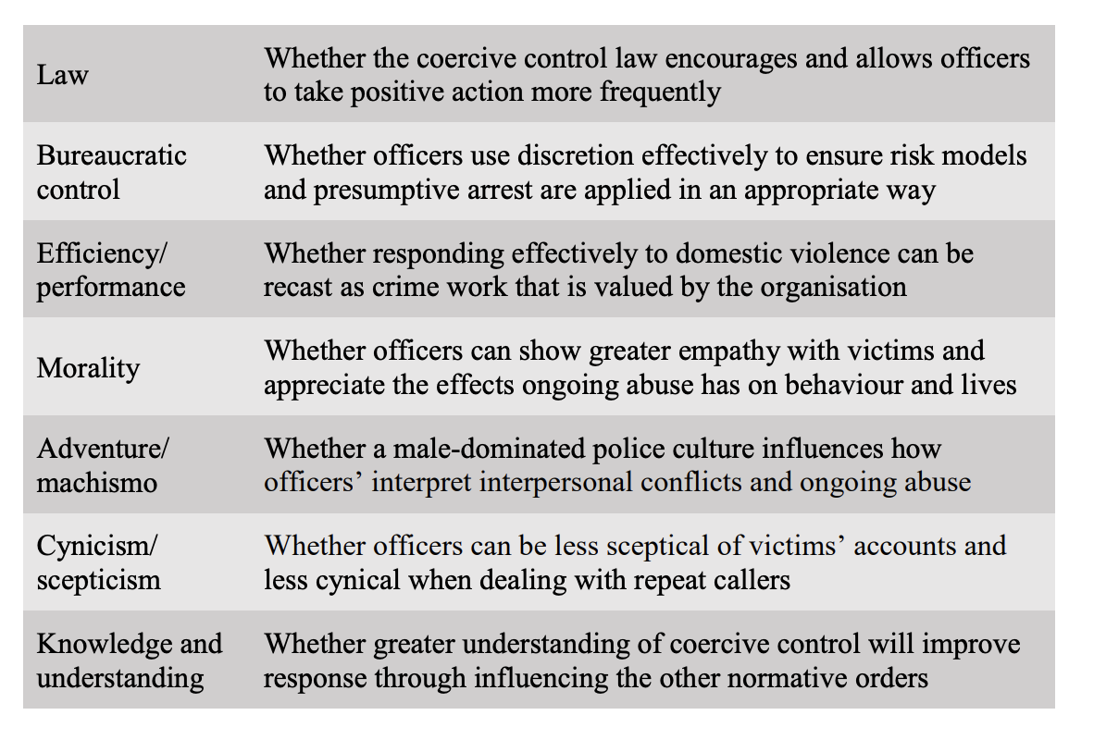
Appendix 2:

Survey:

Please indicate your gender:
Male
Female
Non-binary
Other
Prefer not to disclose

Please indicate your age group:
18-25
26-35
36-45
46-55
56+

Please indicate your length of service in Gwent police:

Less than 12 months
1-5 years
6-10 years
11-19 years
20+

Instructions
The following are different statements which describe attitudes toward a variety of police responses to coercive control which different people have. There are no right or wrong answers, only opinions. Therefore, it is very important that you answer each question honestly.
Please express your feelings about each statement by indicating whether you:
(1) Strongly Disagree
(2) Mildly Disagree
(3) Neither Disagree nor Agree
(4) Mildly Agree
(5) Strongly Agree.
1 Coercive control is easy to identify

2 The coercive control law encourages and allows officers to take positive action more frequently

3 The coercive control law allows officers to respond effectively to domestic violence

4 Greater understanding of coercive control has improved response to incidents

5 The coercive control law helps me to show greater empathy with victims

6 The coercive control law helps me to understand and appreciate the effects ongoing abuse has on behaviour and lives

7 Training on coercive control has informed my response to coercive control incidents

8 A male-dominated police culture influences how officers interpret interpersonal conflict and ongoing abuse

9 The coercive control law supports officers in being less sceptical of victims’ accounts

10 The coercive control law supports officers being less cynical when dealing with repeat callers

11 Gathering evidence of coercive control is difficult

12 Officers are able to use discretion effectively to ensure risk models are applied in an appropriate way in coercive control incidents

13 Covid 19 had a negative impact on police ability to respond effectively to coercive control

14 Raised public awareness of coercive control has resulted in increased incident reporting

15 Male victims of coercive control are easy to identify

