

Problem Solving
and

Decision Making
Report

Name: Daniela Ambros
Student ID: 2115350
Module code: BMSW4004_LON
Lecturer’s name: Hossein Shokri

Table of content:
- Introduction…………………………………………………………………………….3
- Workplace problem – Unhelpful management……….…………..........................4
  - Identify the problem…………………………………………………….………4 – 7
  - Generating alternatives…………………………………………………………….7
  - Evaluating alternatives……………………………………………………………..7
  - Choosing an alternative……………………………………………………………8
  - Implementing the decision…………………………………………………………8
  - Evaluating decision effectiveness…………………………………………………8
- Feedback from presentation…………………………….……………………..…8 - 9
- Gibbs’ reflective cycle………………………………………………………….…9 - 10
- PDP…………………………………………………………………………………….11
- Conclusion…………………………………………………………………………….12
- References…………………………………………………………………………….13
- Appendix…………………………………………………………………...……..14 - 20

1. Introduction
A problem is an unsatisfactory state that causes human dissatisfaction. Rather than meeting standards, the problem is a nonconformity that hinders achieving objectives. It is common for people to face challenging problems in their daily lives, but they encounter them primarily at work. The most frequently reported problems at work related to working hours, working environment conditions, relations with superiors and subordinates, effective communication, conflict and disagreement resolution, job stress, mental health issues, and sexual harassment (Natarajan, 2021). Therefore, employees must eliminate the problem to complete their responsibilities. The process of eliminating a problem at the workplace is named problem-solving. To be able to solve problems effectively and efficiently without any impediments is required to possess critical thinking skills. This process involves the ability to identify and define a problem, generate alternatives, evaluate, and select the most suitable solution, and implement the selected alternative. The purpose of this report is to explain the importance of a six-step decision-making process while highlighting the skills, and techniques needed for solving workplace problems.

2. Workplace problem ‘Unhelpful management’
The following paragraphs will analyse and describe a decision-making process. Furthermore, according to the rational model, decision-making involves six steps (Schoenfeld, 2011).
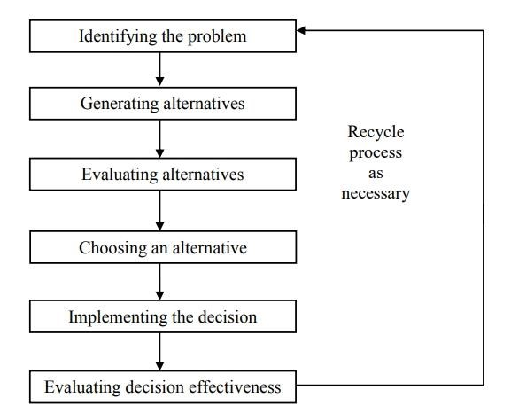

2.1 Identify the problem
In the UK, unhelpful management is one of the most common workplace problems that employees must deal with. It is necessary to provide a definition of management to make the concept easier to understand. According to Wellington, management is the process of achieving results using other people. (Wellington, 2011) However, unhelpful management refers to leaders who do not communicate with, support or value their employees. Such management will lead to a lack of productivity and stress among co-workers.
Case study scenario: An individual works at the Premier Inn Hotel in Brighton as a supervisor. Due to the unhelpful manager and poor communication skills, he is disengaged at workplace. There is no sense of value or support from the company leadership. The employee tried several times to speak with his manager without success. He always found excuses to walk away from the conversation. To identify the root of the problem, a Fishbone analysis will be used. It was Professor Ishikawa of Tokyo University who recommended the fishbone diagram (Majaro, 1991). This diagram represents all potential causes of a problem and their sub-causes.

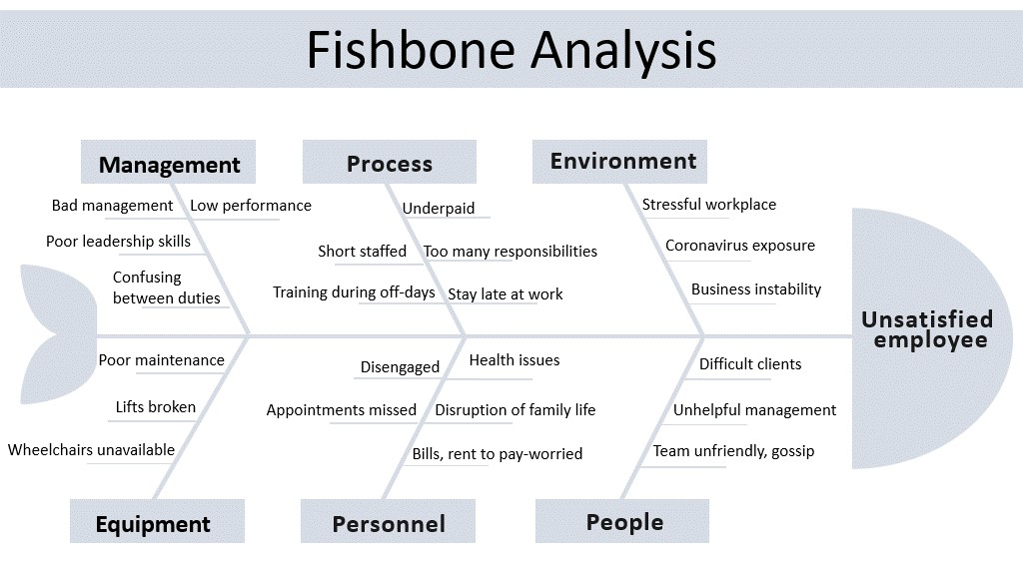
Figure 2: Fishbone Analysis

Pestle analysis is a strategic management tool that helps to identify all potential reasons for changes affecting company operations. Before the legal and environmental perspectives were added, the original evaluation factors were political, economic, social, and technological (PEST), (Zahari & Romli, 2019). Applied to the case study, this technique will be used to identify all external factors that could affect the hospitality industry.

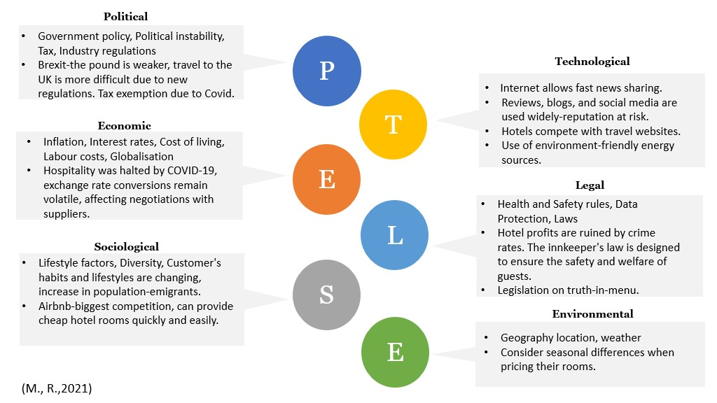
Figure 3: Pestle Analysis

Using SWOT analysis, an organisation can identify the most effective strategy for its business. The objective of this process is to identify externally the strengths and weaknesses of the organisation in relation to internal opportunities and threats (Proctor, 2018).
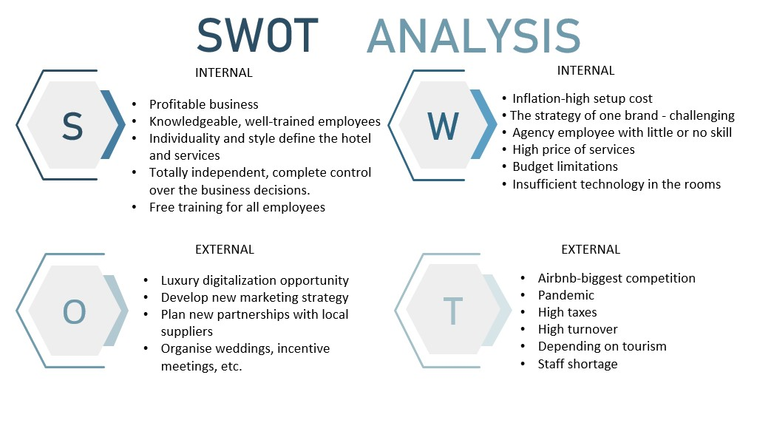
Figure 4: Swot Analysis

Using a variety of techniques and applying them to our case study, we were able to identify the reasons why an unsatisfied employee may be unsatisfied. It can be because of external factors that cannot be changed by a company, as well as the company's internal and external circumstances.

2.2 Generating alternatives

In some cases, decisions can be made with little consideration. Nevertheless, decisions that are challenging or difficult require more consideration.
- Uncertainty – there is a prominent level of uncertainty.
- Complexity - many factors need to be considered.
- Substantial risk consequences - the decision may have a significant impact after implementation.
- Alternatives - there may be several options.
- Interpersonal issues - what will other people think or how they will react.

The Lotus Blossom technique will assist in identifying potential solutions. First, a central theme or issue is identified, followed by the development of innovative ideas by expanding the circles or petals (Proctor, 2018). Company management is the root of the employee's problems. To find appropriate solutions, all ideas will be directed to the management.
Ideas:
- Supportive leadership
- Appraisal and recognition
- Role clarity
- Goal alignment

2.3 Evaluating alternatives
It is crucial to choose the right path for achieving goals to make a successful decision.
'Plus/Minus/Interesting' is what PMI stands for. The system was developed by Edward de Bono as a development of the 'pros and cons' strategy that has been used for centuries to choose the right idea (Proctor, 2018). There is also a technique for valuing ideas that uses tables to compare the advantages and disadvantages of different concepts. Firstly, we list the criteria against which the ideas are being compared and evaluated. Each option is rated against the same criteria, and space is left to indicate whether the idea was rated primarily as advantageous or disadvantageous (Proctor, 2018)

2.4 Choosing an alternative
When a leader assigns a task to an employee, he waits for it to be done. When a supportive leader assigns a task to an employee, he monitors his progress by supporting the employee until the task is completed. Employees can count on mentorship from their managers until they are able to work independently. A supportive leader:
- Positivity - having a cheerful outlook at work.
- Considerate - to consider employees' ideas.
- Empathetic - able to understand employees' feelings and circumstances.
- Resourceful - able to provide tools.
- Knowledgeable - possess a solid foundation of knowledge.
- Patient - keeping calm in different situations.

2.5 Implementing the decision
Before moving forward with actions, it is beneficial to consider suggestions when implementing a decision (Ahmed, 2011). To ensure stakeholder’s understanding, it is important to communicate clearly. It is also essential that company management encourages acceptance of the alternatives. It is vital to identify the responsibilities clearly, setting realistic deadlines, and ensuring adequate resources are available for the implementation. Also, Adkar model must be used when change in management is needed (Hiatt, 2006).

2.6 Evaluating decision effectiveness
It is necessary to control and monitor closely the implementation to be able to see the progress. The Gantt chart will highlight the main tasks, employees who are expected to complete them and deadline.

3. Feedback from Power Point Presentation

During week teen, I presented a PowerPoint presentation. As part of the assessment, I had to assume the role of a consultant in a company that solves workplace problems. Most of my colleagues congratulated me on my work. However, I also received constructive feedback from my lecturer. Sir Hossein told me that I had to work on my time management because I did not finish my presentation in time. In addition, he commented on emotions I conveyed through my presentation. However, he said that the content of the presentation was good, even though I provided more information than was required. He used the Lotus Blossom and Gantt chart as examples.

4. Gibb’s reflective cycle
Using Gibb's (1988) model of reflection, I will analyse and reflect on my experience delivering a presentation. Gibb's reflection model is divided into six stages: Description, Feelings, Evaluation, Analysis, Conclusion, and Action Plan. (Adeani, et al., 2020) To use the model effectively, it is imperative to follow all the stages closely and answer all questions honestly.
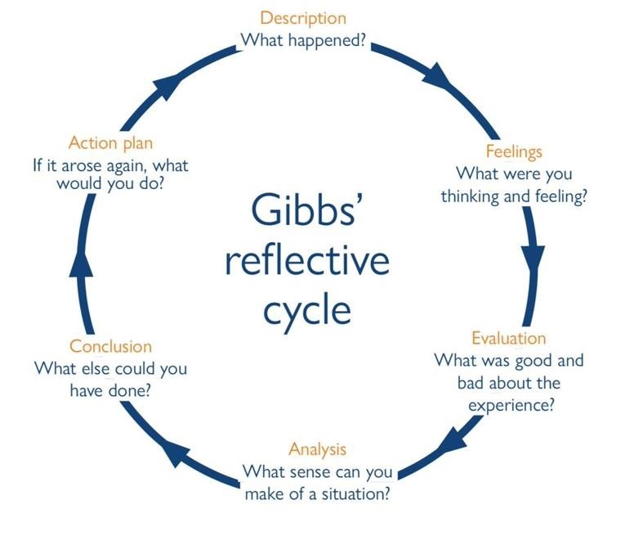
Figure 5: Gibbs’ reflective cycle
Description - A few days ago, I gave a presentation in front of the class. The presentation was supported by PowerPoint slides. I had the privilege of presenting first that
morning. While most students attended online, others were in class with the lecturer and me.
Feelings - My breathing was difficult during the speech as I experienced feelings of worry. In reaction to my lecturer informing me of the time, I began to rush through my presentation, making myself feel incompetent in the process. Despite this, I felt relaxed and happy at the end of the presentation.
Evaluation - As I think about this experience, I try to determine what was good and what was bad. Thus, I believe that presenting in front of the class and taking the lead is a positive experience. I had some negative points: most of the students were online, which made my presentation superficial; there was a bad network connection, and I had trouble hearing my colleague at the beginning of the role play.

Analysis – Based on my analysis, the presentation was successful. In week four, I began working on it, sometimes early in the morning and sometimes late at night. While preparing the draft, I read a lot of information, which provided me with a wide vocabulary. Also, it was extremely helpful to receive feedback from my lecturer on my work. Because I was in front of others for the first time and I left my comfort zone, I experienced some emotion during the presentation.

Conclusion – From this experience, I learned that I must be organised and keep an eye on the clock. This means that I need to improve my time management. Instead of worrying too much about the outcome, I need to have more trust in my abilities. In terms of my presentation, I can say that I am satisfied with it. Despite some issues, it was a positive experience.

Action plan – My action plan is to summarise the speech and to chronometer myself in advance to ensure it will not take me too long. Moreover, I can ask my family members to play the role of my colleagues and lecturer to assist me with my speech. Therefore, I will be able to manage future situations with confidence and calm.

5. Personal Development Plan
An initial qualification such as a first degree or professional qualification is not enough, and this is at the heart of the concept of continuous professional development (Smale & Fowlie, 2009). A personal development plan is essential in today's fast-changing world, where knowledge and skills are constantly being updated.

Personal Development Plan
Aims | Actions | Resources | Measurement | Review and timescale
Improving time management  skills | I will divide the tasks into smaller parts and give each one a different amount of time. By doing so, I can estimate how much time  I will need to complete a task. | Practice wide range of work. Reading books and using time management  tools can help me gain more knowledge about the topic. | When I will complete all the tasks and assignments on  time, then I will achieve the proposed goal. | Tasks can last from 1 week to 4 weeks, depending on  their importance. Revision will take place every month.
Acquiring more practical knowledge | My new job starts on 5 September, so I will try to participate in conversations with a variety of people. I will be able to use all the skills I have learned in this module. | To build professional development, it is helpful to discuss your ideas with co-workers. Attend brainstorm sessions. | To achieve the criteria, I must be confident in my abilities to work independently. | It is not possible to determine a timeline.

6. Conclusion
As a summary, this report described a workplace problem and decision - making process to solve it. It reveals the six key steps that are needed to successfully solve a complex workplace problem. Also, using Gibb's cycle, I made sense of my experience by reflecting on presentation. Furthermore, I developed a personal development plan using the knowledge that I gained from the module.

References

Adeani, I. S., Febriani, R. B. & Syafryadin, S., 2020. USING GIBBS REFLECTIVE CYCLE IN MAKING REFLECTIONS OF LITERARY ANALYSIS. Indonesian EFL Journal [Online], 6(2), p. P. 144. Available at: https://doi.org/10.25134/ieflj.v6i2.3382 [Accessed 23 08 2022].
Ahmed, P. K. (2011). Innovative management: Context, strategies, systems, and processes. Upper Saddle River, NJ: Prentice Hall.
Gibbs, G. (1988). Learning by doing: A guide to teaching and learning methods. Oxford: Oxford Further Education Unit.
Majaro, S., (1991), The Creative Marketeer, London: Butterworth Heinemann.
Natarajan, P., 2021. Problems and Issues at the Workplace of the Employees. International Journal of Trend in Scientific Research and Development, 6(1), p. 1186.
Proctor, T., (2018). Creative Problem Solving for Managers: Developing Skills for Decision Making and Innovation (Fifth edition.). Routledge. Available at: https://bibliu.com/app/#/view/books/9780429857171/epub/OEBPS/xhtml/contents.html#page_va [Accessed 11 07 2022].
Schoenfeld, A. H. (2011). How we think: A theory of goal-oriented decision making and its educational applications. New York, NY: Routledge
Smale, B., & Fowlie, J., 2009. How to succeed at university: an essential guide to academic skills and personal development. s.l.:SAGE PUBLICATIONS, P.27- 43. Available at: https://sk.sagepub.com/books/how-to-succeed-at-university#:~:text=How%20to%20Succeed%20at%20University%20is%20a%20uniquely%20comprehensive%20study,framework%20of%20personal%20development%20planning [Accessed 3 07 2022].
Hiatt, J. M. (2006). ADKAR: a model for change in business, government and our community. Prosci Learning Center.

Wellington, P., 2011. Effective people management. s.l.:Kogan Page. Available at: https://www-vlebooks-com.ezproxy.uwtsd.ac.uk/Product/Index/52062?page=0 [Accessed 5 08 2022].
Zahari, A. R. & Romli, F. I., (2019). Analysis of suborbital flight operation using PESTLE. Journal of Atmospheric and Solar-Terrestrial Physics, 192, 104901–.
https://doi.org/10.1016/j.jastp.2018.08.006 Available at: https://www-sciencedirect-com.ezproxy.uwtsd.ac.uk/science/article/pii/S1364682617303309 [Accessed 3 07 2022].

8. Appendix:

