
Student Name | Darshan Nareshbhai Sheliya
Student Number | 2530070
Subject Name | Research Methods and Professional Development
Module Code | ACFA7004
Lecturer | Dr. Dipo Dunsin

Machine Learning For Cybersecurity Threat Detection

Table Of Content
Abstract
1. Research Introduction
1.1 Research Context and Background
1.2 Problem Statement
1.3 Research Aim and Objectives
1.4 Research Significance
2. Review of Related Literature
2.1 Introduction
2.2 Evolution from Traditional to ML-Based Cybersecurity
2.3 Machine Learning Techniques and Architectures for Threat Detection
2.4 Adversarial Machine Learning
2.5 Data Challenges and Concept Drift
2.6 Explainable Artificial Intelligence (XAI) in Cybersecurity
2.7 Research Gaps and Positioning
2.8 Summary of Literature
3. Research Methodology and Design
3.1 Research Approach and Design
3.2 Methods and Research Materials
3.2.1 Research Method
3.2.2 Materials and Resources
4. Expected Research Outcomes
4.1 Expected Results
4.2 Research Implications and Limitations
5. Project Timeline
5.1 Project Phases and Key Milestones
6. Overall Presentation
7. References
Abstract
The ever-increasing digitization of today's society has increased the attack surface on which organizations operate, making the threat from cyber-attacks ever more complex. Signatures are effective to find known security threats but they are not effective against new attacks, machine learning (ML) is likely to be effective in many aspects but it also has serious issues when it comes to be used in practice such as adversarial attack, concept drift and lack of interpretability. This research proposal will describe a research study for creating and assessing a strong, versatile and explanatory framework that can be used to tackle cybersecurity threats using ML. A Design Science Research approach will be adopted for the study in order to arrive at a hybrid model of the ML model, combining anti-adversarial defense methods with the concept drift adaptation and XAI techniques. The proposed framework will be tested based on benchmark cybersecurity datasets by thorough performance measures. The deliverables to be expected are a novel paradigm in threat detection, working prototype system and experimental results that will prove the superiority of this system in terms of performance, robustness and interpretability of the results, when compared with the current paradigms.
1. Research Introduction
1.1 Research Context and Background
Businesses, critical infrastructure—even personal communication—are becoming all digital source by source: there are unprecedented opportunities for efficiency, for growth. It has created, however, far larger global cyber-attack surface area, and the individuals and organizations are vulnerable to a wide spectrum of cyber-attacks all of which are increasing in number and complexity over the years. These threats can emerge from financial motivated ransomware and data breaches, advanced Persistent Threats (APT), state-sponsored espionage, and everywhere in between. The world is plagued with cybercrime – the size of which is estimated in trillions of dollars worldwide annually [2].
On the other hand, the typical way of dealing with security has been the traditional way and both signatures based anti-virus products and rule-based Intrusion Detection Systems (IDS's) have been such. Below are some of these techniques that rely on an analysis of the network traffic and/or the hash codes of the files against a file of signature patterns for known attacks. They are good at known threats but are merely reactive and cannot find new attacks, zero-day attacks or changing attack methods [6]. The other manual activities to update these systems on newly identified threat intelligence information are time consuming and could be error prone causing gaps in threat intelligence information and implementation of these in the systems [14].
These issues have presented a challenge to the cybersecurity industry, with AI and ML increasingly becoming mired in cybersecurity addressing these issues. The paradigm shift in machine learning is about going from reactive (defensive) to proactive (predicting) defense techniques and in doing so, the system learns from data, can recognize the situation, and can learn to predict without being programmed explicitly. This effect is important when huge volumes of data are analyzed within today's networks but also for revealing irregularity that could indicate a compromise in the network [17]. In recent years ML has proven its potential in boosting cybersecurity in various areas, such as network security, endpoint security, application security and user behavior analytics [3] [4] [12].

1.2 Problem Statement
While ML has the potential to transform the cybersecurity arena, there are some challenges that hinder its widespread use and implementation in real-world scenarios. An important hurdle we expect to address with this research is mapping the "good performance" of an ML model (tested under lab environment) to the one that works well in the operational, dynamic and complex field. Some of the problems identified in the literature are significant to this problem. One is by adversarial models (that is, new attack surfaces introduced as part of the ML models). Adversarial techniques in such security systems include: Data poisoning attack and Evasion attack, which can potentially cause severe problematic situations to AI-based security systems [8][9].
Second, real-world network environments will yield a lot of false positives and the performance of ML models might not be consistent across different environments. The network behavior can also change as time goes on, an issue referred to as concept drift, which can further lower detection performance. The third thing is that it can be challenging for security analysts to comprehend why a model is marking an instance as suspicious. This can have an impact on their investigation capabilities and level of trust in the system. The performance of machine learning (ML) is heavily reliant on the data they have been trained on, and many of the data sets do not have an up-to-date coverage of the current cloud and edge landscape, lack balanced class distribution, or cover older attack scenarios [5].

1.3 Research Aim and Objectives
Aim: To build and test a comprehensive, flexible and interpretable toolkit for adversarial training and strengthening machine learning based threat detection in today's cyber landscapes, which feature disparate and dynamic datasets and a challenging nature of vulnerabilities.
To achieve this, the following point objectives or measurable objectives of the research will be followed: Engage with and rationally discuss; current state of the art cybersecurity threat detection techniques using ML, vulnerabilities, challenges and effective mitigation strategies.
Develop a resilient threat detection system with approaches to deal with adversarial attacks and concept drift adaptation techniques.
Build a hybrid ML system combining the high-level accuracy of deep learning and interpretability of explainable AI (XAI) methods to achieve high accuracy and interpretability for the purposes of increasing trust and security analysis.
Validate the proposed framework and model using model challenging sets of cybersecurity data and to compare the model with the state-of-the-art solutions and the traditional systems.

1.4 Research Significance
Significance of research is that it has a potential end route towards making the gap between theoretical ML research and practical, reliable cyber security application. For the research community, it will offer an organized scheme of synthesizing more robust and explainable ML-based security solutions to fulfill the identified research gaps and will act as a yardstick that will aid in future research. Technical implications include but are not limited to the improvement and greater trustworthiness of a prototype threat detection system as well as its ability to provide input for next generation security tools. Practical applications will benefit cybersecurity practitioners by offering tools which can better detect threats and provide explanations on their thought process, resulting in quicker threat responses and lowering alert fatigue. At the societal level, improving the reliability of the cyber defense would help to increase the security of the digital scenario by critical infrastructure, businesses and individuals, reducing the socio-economic damages of cybercrime.

2. Literature Review
2.1 Introduction to the Literature Review
This has consequently raised the intelligence and adaptability of cyber threats, presenting the demand for smarter, more adaptive defence mechanisms. Utilising Machine Learning (ML) is one of the great solutions that has come to the forefront due to it being able to process large amounts of security data, discover underlying patterns and recognise never before seen attacks. Nevertheless, despite tremendous progress, there are still existing issues of importance such as the problem of adversarial attacks that pose a threat to ML models, the concept drift problem, low data quality and lack of explainability within ML models.
The chapter in this book critically examines recent studies on the cybersecurity threat detection using ML. The conventional methods of security are discussed and a brief introduction is given to the contemporary ML algorithms, deep learning techniques and adversarial ML, the challenges that come along with the data, explainable AI (XAI) and the existing research gaps. Not only does this review sum up the literature that has already been reviewed; it presents an overview of the different methods of research, along with their respective pros and cons, and potential opportunities for future research.
2.2 Evolution from Traditional to ML-Based Cybersecurity
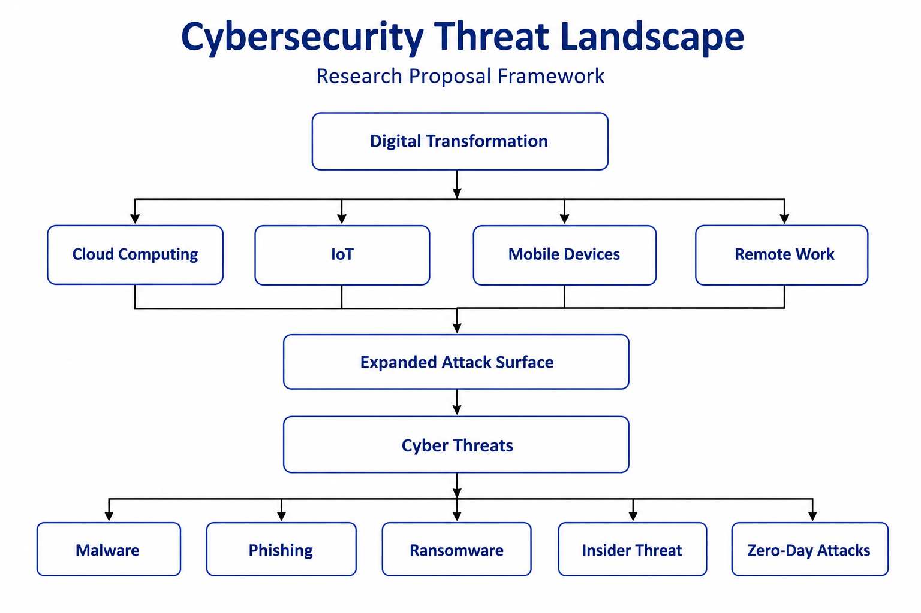
Figure 1. Cybersecurity Threat Landscape
Signature-based Anti-Virus products, Firewalls and Rule-based Intra-Detected Systems (IDS) have been the first measures in traditional cyber security. Through these methods, one has to look for known attack patterns or for manually set rules to detect malicious activity [6]. They work well for known attacks; but are reactive, lack ability to find zero-day attacks, polymorphic attacks and new techniques in attacks. [2]
The attackers are more sophisticated when attacking and due to that, more ML techniques are integrated inside of cybersecurity. The reason why using ML systems in the analysis of anomalous behavior is more advantageous with respect to the traditional way is because they are signature-free: the patterns are abstracted from the time series of historical information. Recently, the usage and success of ML can be found in the context of intrusion detection, malware analysis, phishing detection, botnet detection, insider threat detection and user behavior analysis [12,14].
2.3 Machine Learning Techniques and Architectures for Threat Detection
The preliminary studies were mainly on computational methods like Support Vector Machine (SVM), Decision Tree (DT), Random Forest (RF), Naïve Bayes and K-Nearest Neighbor (KNN). The primary reason for this reminisce is that these algorithms are relatively easy to compute and sometimes they provide processes for human interpretation when making decisions [11].
Thus with the evolution of deep learning and hierarchical feature representations, automated cyber threat detection has progressed a great deal. CNNs have achieved very good performance especially in malwares image classification [4] and feature extraction of packets [2]. Since network traffic is also temporal dependent, these networks that have modeled sequential data in almost every field, such as Recurrent Neural Networks (RNNs) and Long Short-Term Memory (LSTM) networks [7] are suitable.
In recent years, Transformer-based architectures with self-attention networks have emerged, basing themselves on different limitations found in recurrent networks, which gave good results in the analysis of long network sequences. In our case, among these the Random Forest method, due to the property of using ensemble learning which significantly reduces the risk of overfitting and helps to improve the generalization results for the classification task, always shows a good classification result. SVMs are good for high dimensional binary classification problems, whereas decision trees provide readily understandable decision rules that can aid in security investigations.
Although it's true that deep learning models tend to be more effective in terms of accuracy concerning detection, they still require huge amounts of computation, a great quantity of labelled information and, in a number of cases, are “black boxes” that don't provide insight or interpretability to analysts. But traditional ML algorithms largely depend on the manual approach of featurization and are not suitable for nonlinear relationships existing in complex network traffic [11].

2.4 Adversarial Machine Learning
One of the key concerns is that ML models themselves can be manipulated adversarial. Adversarial Machine Learning (AML) is a important research area that addresses vulnerabilities that ML systems introduce in the cyber security architecture [8][9]. Data poisoning attacks involve when bad guys add bad samples to training sets [9]. Evasion attacks consist of creating inputs which will lead to misclassification [8]. Adversarial training, in which the models are presented with the adversarial examples while training [13]. But adversarial research and solid defense development are still at its infancy [8].

2.5 Data Challenges and Concept Drift
Data quality and representativeness are key factors contributing to the effectiveness of ML models [5][15]. There is a plethora of available public datasets, for many of which there are drawbacks such as class imbalance, lack of timeliness, and orientation to network rather than system-level data [5]. One of the main concerns is change in the statistical properties over time (a.k.a. concept drift), which is especially critical in cyber security [11]. At the moment new applications arise, and new techniques are introduced to the attackers, network traffic patterns change. History-based models can become useless resulting in higher rate of false positive and false negative alarms [11].

2.6 Explainable AI in Cybersecurity
Advanced ML models are often perceived as "black boxes," which can lead to challenges in security deployment [10]. CAWs should be aware of the reasons for suspicious events being called out. Combining explainable methods with network intrusion detection systems helps security analysts get the reasoning behind the alerts, thereby enhancing the efficiency in responding to them [10]. A lightweight ensemble framework with XAI features is proposed to be effective and able to construct trust to provide the security analysis [16]. Indeed, XAI applications to cybersecurity are difficult as explanations should be accurate as well as helpful to alleviate the pressure on humans’ cybersecurity analysts. There are multiple approaches used for explanations, such as feature based, counterfactual and rule based [10],[20].

2.7 Research Gaps and Positioning
A few major areas of research need have been identified from the literature. First, although, adversarial ML and concept drift are investigated independently, there are only very few studies of frameworks that solve both challenges together [8][11]. Second, proposed solutions optimize for accuracy, robustness or interpretability, rarely optimizing for all three, which are hard to find [10][16]. Third, a lot of research is obsolete with data on polar conditions that do not reflect current enterprise conditions [5][15]. Fourth, existing XAI research lacks a focus on impact of using robustness techniques on interpretability. The proposed research is designed to tackle these challenges by creating an adversarial training framework with drift adaptation and XAI.
2.8 Summary of Literature
Literature shows that there are benefits of using ML in cybersecurity threat detection analysis for better than traditional detection methods. So the big themes involve moving from legacy to ML-native approaches, the variety of ML techniques for threat detection, the problems of adversarial ML and concept drift, data quality issues and the increased need for explainability. There are still to be considered major important issues in the integrated consideration of adversarial robustness, concept drift adaptation and interpretability. In order to fill these gaps, the proposed research is to develop a resilient framework and an explainable threat detection framework.
3. Research Design and Methodology
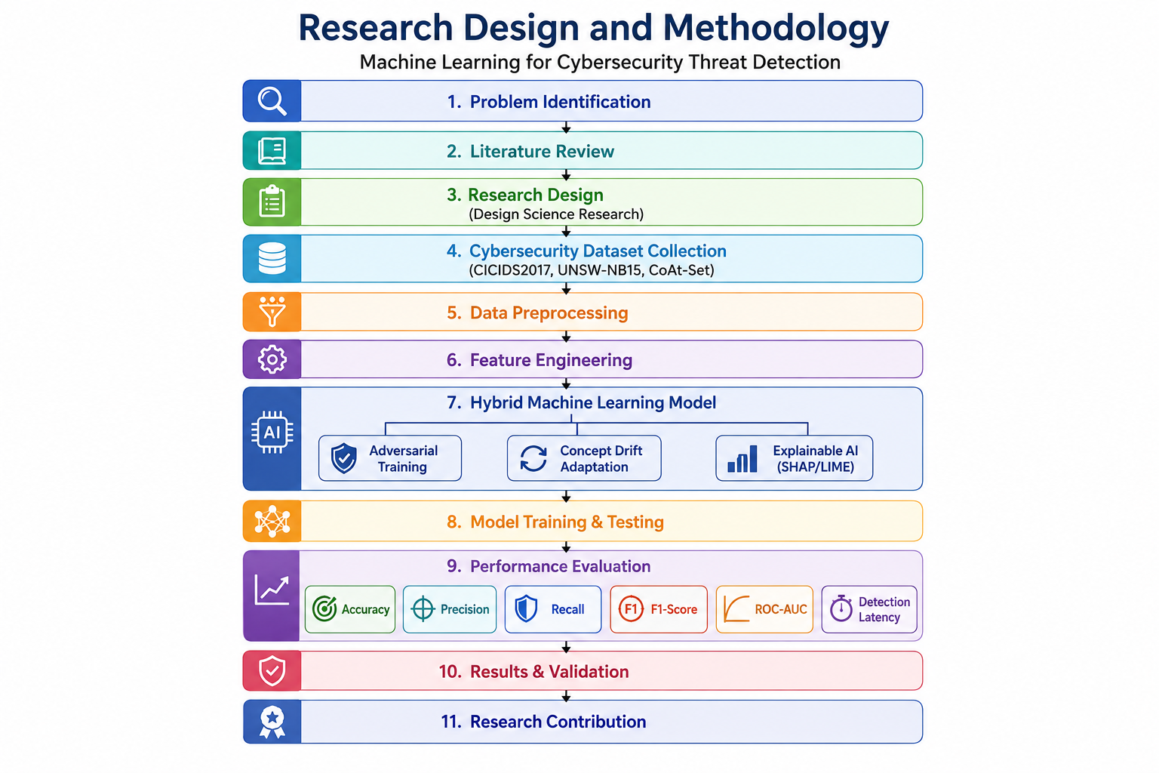
Figure 2. Proposed Research Design and Methodology
3.1 Research Approach and Design
The research will use Design Science Research (DSR) method and experiment test. The DSR paradigm is a problem-solving approach which aims to design and test unique artefacts to solve recognized organizational issues [18]. Such would be an appropriate approach as it would produce a new framework and prototype (based on ML algorithms) for detecting threats. DRSR, on the other hand, have been very practical in their marketing efforts to provide relevance for the research, especially when it comes to the research goal of “developer to deployed” ML for real-world cybersecurity situations. An iterative DSR process enables the refinement and validation of the real world problems [19].
Although there are six activities associated with the DSR methodology [19]. It is elaborately explained how the objectives for a solution are defined. Development and design are development phases where the proposed framework and prototype system design are developed based on an iterative agile methodology and made adversarial-robust, concept drift–adaptive and integrated with XAI. Demonstration – prepare the artefact for certain danger scenarios by a set of benchmark data and demonstrate it. Evaluation is systematic measured performance (quantitative) and measured usefulness (qualitative) of the artefact according to criteria.
Communicating the findings is how you inform about the research either through academic papers or writing documentation – much more practical.

3.2 Methods and Research Materials
3.2.1 Research Methods
The method of the study will be a majority quantitative method but with qualitative ingredients. A comprehensive performance assessment of the ML model is done through the use of prescribed metrics and is compared to the performance of the baseline model, and the statistical analysis to ensure that the model is performing a significant better, is included in the quantitative section. The qualitative component analyzes the quality and the usefulness of the explanations generated using XAI and their usefulness from the security analysts' perspective, from a practical standpoint.
This research approach is mostly experimental in nature that has a controlled experiment to analyses the proposed research framework. The experimental method is one that has the merit of systematic variation of variables, permits comparison of treatments that can be controlled, and facilitates scientific assessment that can be later repeated. Experiments span from modeling on cybersecurity data sets, testing model robustness against adversarial attacks, checking for concept drift, to checking of interpretability of the data set to reporting.
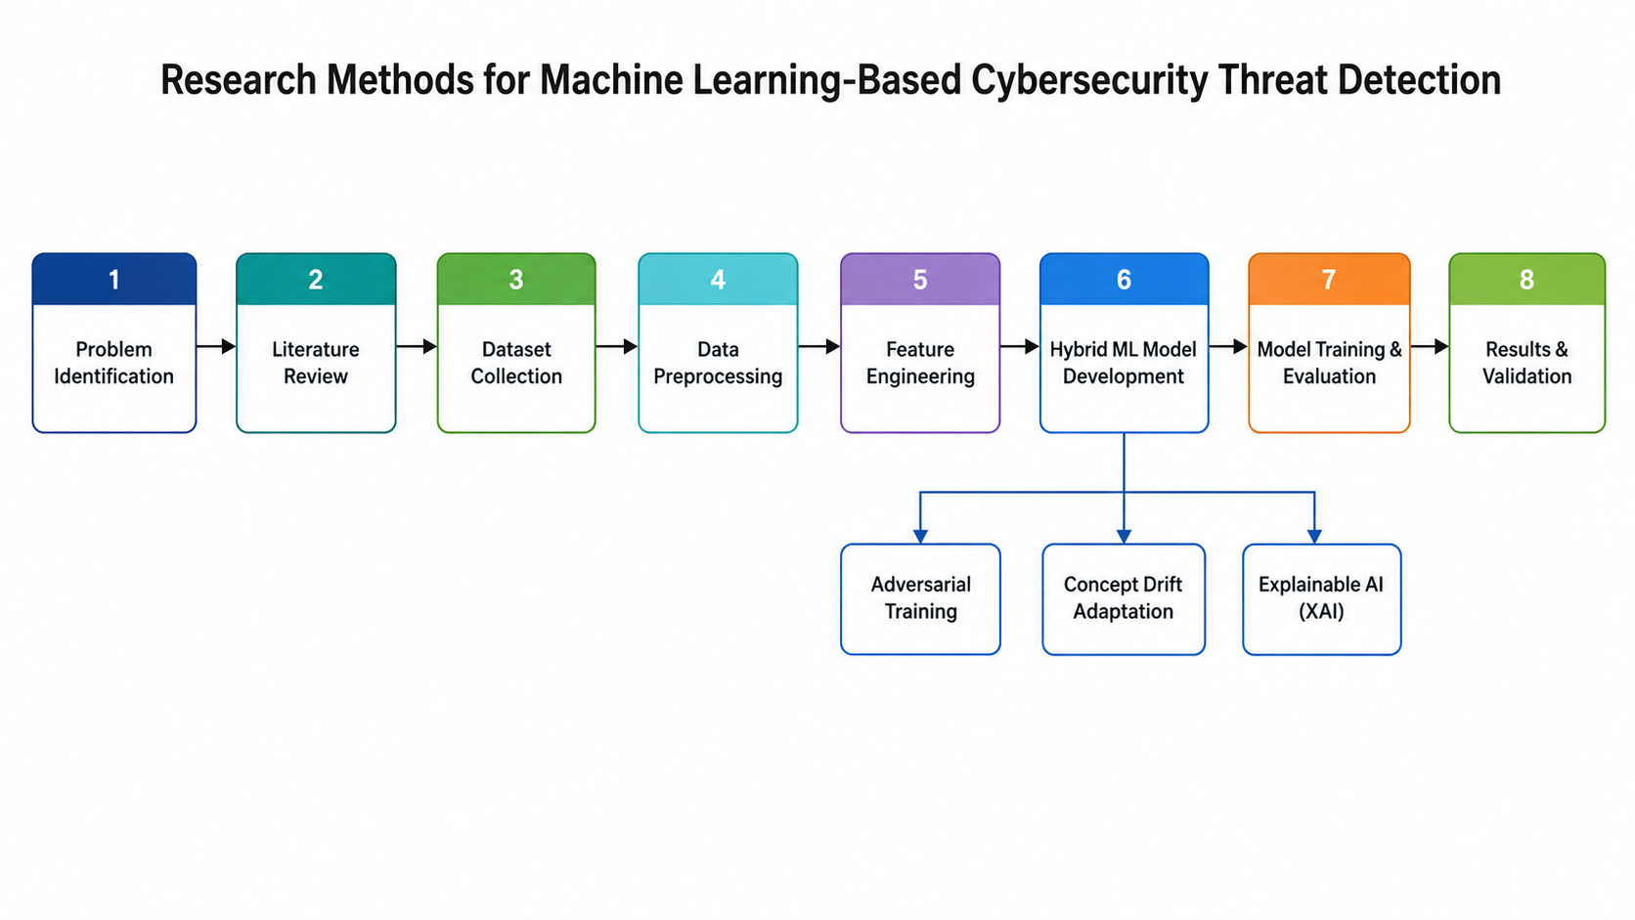
Figure 3. Proposed Machine Learning Threat Detection Framework
This new threat detection system will comprise of four modules: Data Ingestion and Preprocessing Module which will receive network traffic logs and extract features from them; Feature Engineering and Selection Module which will select relevant features and apply dimension reduction technique; ML Model and Detection Module which will use the proposed hybrid model with adversarial training and drift detection; and XAI and Reporting Module which will generate explanations and alert for security analysts.
Data will be analyzed through various accuracy, precision, recall, F1-Score, AUC-ROC, Robustness Score and Detection Latency. Some statistical analyses used are: Statistical comparison of performance using paired t test or wilcoxon signed rank test, K-fold cross validation (k=fold value of ten), Bootstrapping for statistical confidence intervals. Explanations are being evaluated during a qualitative evaluation and a comparative analysis of interpretability is being made as well.

3.2.2 Materials and Resources
Data Sources: Several cybersecurity data sources will be utilized in the research, among them CIC-IDS2017 with various attack scenarios [1] where realistic attack nowadays patterns will be specified, CoAt-Set which has coordinated attacks in heterogeneous networks [5] and public data of malware which can be used for the classification of different types of malware.
Uses: They cover a variety of types of attacks, network conditions, are created for the cyber security research and widely used in the literature and meaningful comparisons are possible.
Ethical Considerations: This is publicly available anonymized data with NO personally identifiable data. For any vulnerabilities uncovered the "Responsible Disclosure" policy will be followed. The report of correct results will be an aid to laboratory ethics.
Languages: Python is used specifically to achieve the following: Python Coding (Version 3.9+), Python ML/DL Libraries (TensorFlow, PyTorch, Scikit learn, Seaborn and Matplotlib for visualization and SHAP and LIME for XAI), and version control with Git.
Development: 16GB or more RAM, cloud computing option to scale up, 8 or more CPU cores (with or with NVIDIA RTX 3060 or higher for training deep learning, as required).

4. Expected Research Outcomes
4.1 Expected Results
The entire apparatus of building peak-performing robust and easily explainable threat detection systems will be developed for ML; powered by adversarial defense mechanisms [13] and the concept drift adaptation methods [11] and integrated with XAI – Explainable model decisions [10][16]. The effectiveness of detection will be significantly improved than existing detection system, the robustness against adversarial attack, the accuracy when concept drift happens, and reasonable explanations in terms of XAI. The authors should reasonably expect that the results will show that the hybrid ML model will be superior to the traditional models, that adversarial training will have a positive benefit on the robustness of the model, and that introducing XAI in the model will not negatively affect its performance, but will add value in terms of understanding.
4.2 Research Implications and Limitations
Theoretically, the work could be extended to the analysis of integrated adversarial robustness, concept drift adaptation and interpretability in threat detection problems. The practical applications include being used in Security Operations Centers, Incident Response, Regulatory Compliance, and Automated Security Systems. Societal implications: Enhance the process of cyber-security of critical infrastructure and individuals.
Some difficulties include representativeness of datasets (may lack the diversity of attacks from the wild); attacks may not evaluate under controlled lab conditions, reflecting real world diversity; accuracy conflicts with explanation; sometimes attack set scope is limited to non-network-based attack types; integration with on-the-fly security product infrastructure.

5. Timeline
5.1 Project Phases and Milestones
Activity | W1 | W2 | W3 | W4 | W5 | W6 | W7 | W8 | W9 | W10
Topic Selection and Research Planning | 
Review of Existing Literature
Research Design and Method Selection
Dataset Gathering and Data Preparation
Feature Preparation and Model Development
Model Training and Validation
Model Performance Assessment and Data Analysis
Results Analysis and Discussion
Report Preparation and Editing
Final Checking and Submission

6. Overall Presentation
The research proposal will be presented in straight forward and simple academic writing. This proposal will include the following: Cover sheet, Abstract, Table of Contents, Introduction, Literature Review, Research Methodology, Results Literature, Expected Project, Time Schedule, Reference List. Writing will be clear, factual, objective and third person will be used as necessary. IEEE (Institute of Electrical and Electronics Engineers) style for referencing sources will be used. Tables, figures and/or diagrams will be used where they are relevant in order to explain the information provided and support the discussion.

7. References
[1] I. Sharafaldin, A. H. Lashkari, and A. A. Ghorbani, "Toward Generating a New Intrusion Detection Dataset and Intrusion Traffic Characterization," Proc. ICISSP, pp. 108–116, 2018.

[2] M. A. Almaiah et al., "Advancing Cybersecurity: A Comprehensive Review of AI-Driven Detection Techniques," Journal of Big Data, vol. 11, no. 105, 2024.

[3] A. S. Momand, S. U. Jan, and N. Ramzan, "A Systematic and Comprehensive Survey of Recent Advances in Intrusion Detection Systems Using Machine Learning: Deep Learning, Datasets, and Attack Taxonomy," Journal of Sensors, vol. 2023, Art. no. 6048087, 2023.

[4] R. Sommer and V. Paxson, "Outside the Closed World: On Using Machine Learning for Network Intrusion Detection," IEEE Symposium on Security and Privacy, pp. 305–316, 2010.

[5] R. Vinayakumar, M. Alazab, K. P. Soman, P. Poornachandran, and S. Venkatraman, "Deep Learning Approach for Intelligent Intrusion Detection System," IEEE Access, vol. 7, pp. 41525–41550, 2019.

[6] M. A. Ferrag, L. Maglaras, S. Moschoyiannis, and H. Janicke, "Deep Learning for Cyber Security Intrusion Detection," Journal of Information Security and Applications, vol. 50, 2020.

[7] M. A. Ferrag, L. Maglaras, S. Moschoyiannis, and H. Janicke, "Deep Learning for Cyber Security Intrusion Detection: Approaches, Datasets, and Comparative Study," Journal of Information Security and Applications, vol. 50, Art. no. 102419, Feb. 2020.

[8] F. Ceschin et al., "Machine Learning (In)Security: A Stream of Problems," Digital Threats: Research and Practice, vol. 5, no. 1, 2024.

[9] K. He, D. D. Kim, and M. R. Asghar, "Adversarial Machine Learning for Network Intrusion Detection Systems: A Comprehensive Survey," IEEE Communications Surveys & Tutorials, vol. 25, no. 1, pp. 538–566, 2023.

[10] A. Madry et al., "Towards Deep Learning Models Resistant to Adversarial Attacks," ICLR, 2018.

[11] J. Gama, I. Žliobaitė, A. Bifet, M. Pechenizkiy, and A. Bouchachia, "A Survey on Concept Drift Adaptation," ACM Computing Surveys, vol. 46, no. 4, pp. 1–37, 2014.

[12] A. K. Dasari, S. K. Biswas, and B. Purkayastha, "Enhanced Network Intrusion Detection Systems with Explainable Artificial Intelligence," International Journal of Network Management, vol. 35, no. 1, 2025.

[13] S. Gupta and B. Singh, "Lightweight Ensemble Learning Based Intrusion Detection Framework with Explainable Artificial Intelligence," Engineering Applications of Artificial Intelligence, vol. 139, 2026.

[14] R. Guidotti et al., "A Survey of Methods for Explaining Black Box Models," ACM Computing Surveys, vol. 51, no. 5, 2018.

[15] N. Moustafa and J. Slay, "UNSW-NB15: A Comprehensive Data Set for Network Intrusion Detection Systems," Military Communications and Information Systems Conference, 2015.

[16] A. A. Wardana, "CoAt-Set (Coordinated Attack Dataset) on Heterogeneous Computer Network," Mendeley Data, 2024.

[17] A. R. Hevner, S. T. March, J. Park, and S. Ram, "Design Science in Information Systems Research," MIS Quarterly, vol. 28, no. 1, pp. 75–105, 2004.

[18] K. Peffers, T. Tuunanen, M. A. Rothenberger, and S. Chatterjee, "A Design Science Research Methodology for Information Systems Research," Journal of Management Information Systems, vol. 24, no. 3, pp. 45–77, 2007.

[19] R. Kumar et al., "Leveraging Machine Learning for Cybersecurity Resilience in Industry 4.0," IEEE Access, vol. 12, pp. 159579–159596, 2024.

[20] M. Al-Hawawreh, N. Moustafa, and E. Sitnikova, "Identification of Malicious Activities in Industrial Internet of Things Based on Deep Learning Models," IEEE Internet of Things Journal, vol. 6, no. 5, pp. 8487–8497, 2019.

Appendix A – Research Ethics Form
Submitted

