Question 4: From this semester’s lectures, choose a theme or selection of illustrators that relate to your practice or interests. Critically assess primary themes, key writers, and relevant practitioners.

Student number: 2204581
Course Title: BA Illustration
Word Count: 2422
Lecturer: Alice Samuel

What it means to be feminine: how four female artists and illustrators from the past 100 years have expressed their femininity through their self-portraits

Introduction:

‘It has become difficult to name one’s feminism by a single adjective’ (Haraway, 1991, p. 16). Femininity cannot be defined by a set of fixed, establishing qualities. It is the state of being a woman as much as it is not being a man (Butler, 1990). Having a sense of gender identity is a key part of what makes someone a person. It is a complex concept as gender identity is mixed up in a vicious cycle with gender expression: both determine the other (Butler, 1990). Femininity is what you decide it is and it is different for everyone. The only unifying concept of femininity is that is it not masculinity. This, however, doesn’t necessarily mean they are opposing identities. Femininity and masculinity are two concepts that must exist together; you cannot have one without the other.

There are different aspects to femininity: appearance, motherhood, companionship, romance, and work, which are all expressed differently throughout every individual. In this essay, I will explore how four female artists, from Frida Kahlo in the late 1930s, to Caroline Wong in 2021, explore their femininity in self-portraits.

Frida Kahlo:

Kahlo is a woman portrayed as confident in her identity. She always embraced her bold eyebrows and facial hair in her paintings despite these being commonly perceived as not feminine qualities. Frida Kahlo’s femininity lies within the true self.

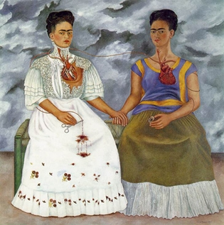
Fig.1: The Two Fridas (1939)

In this 1939 double self-portrait, the two Fridas are pictured seated on a wicker bench against a stormy grey sky and holding hands while holding an object in the other. Both Fridas have her defining features: her steely gaze at the viewer, bold eyebrows, facial hair, and braided hairstyle.

Kahlo’s paintings depict femininity through her use of thick black eyebrows and moustache. In portraits, artists would correct any imperfections in the subject, so the person’s appearance was more reflective of societal norms and trends of the time. Women’s body hair was considered a taboo, something not to be seen or mentioned and surrounded by “shame, disgust and censure” (Lesnik-Oberstein, 2006, p.2). Kahlo’s facial hair was a key part of what she looked like and an essential component to her paintings. Kahlo’s moustache and eyebrows were and still are considered masculine in trait and this was a deliberate choice. She uses the juxtaposition of traditional masculinity and femininity to form her own definition of femininity. If she had excluded these powerful, attention-grabbing features from her paintings, she would have diluted her character into a more palatable presentation of femininity. This unapologetic embrace of her natural appearance is part of why she is seen as a feminist icon today.

Companionship has long been considered an essential element of femininity. Female sewing groups and church groups used to be some of the ways women could participate in society and these friendships played a huge part in controlling societal narratives (Ray, 2020). In The Two Fridas (1931), despite each Frida showing contrasting parts of her identity, they are a unified being, connected via their hearts and blood, and by holding hands they clearly show support of each other.

The maternal, nurturing element of Kahlo’s femininity is shown through blood in The Two Fridas. Kahlo was unable to have children due to injuries sustained in a tram crash when she was 18 (Espinoza, 2007). This devastated Kahlo as she wished to have “a little Dieguito” (Espinoza, 2007). With no children to nurture, the suggestion within this painting is that she put her maternal love into Rivera. A blood vessel leads from the heart of the right-hand Frida into a portrait of Rivera as a child, showing this flow of love. In the left-hand Frida, the Frida Rivera rejected, the reflection of this vessel is severed and clamped, however blood still flows out of it. Arguably without Rivera to nurture, her unyielding maternal love has nowhere to go.

The stormy, grey sky could be Kahlo’s way of representing the turbulence of being a woman. Femininity consists of many opposing characteristics: mother versus worker; looking feminine but not too feminine; being independent whilst requiring a man and it is up to the woman to ensure she lives within these juxtaposing constraints. The narrative of femininity has historically been created and controlled by men based on the need to have an opposition to masculinity (Butler, 1990). The turbulence within the stormy sky represents the battle between maintaining feminine norms of the past whilst moving forward with women’s rights/ autonomy, into a new chapter of femininity, created within contemporary society. Rivera’s rejection of Kahlo could arguably be creating the storm which has separated her into her two selves; the one Rivera loved and the one he hated (Bryson, 2023). At the time of the painting Rivera was getting divorced from Kahlo and this is evident within the representation of her different identities. This allows Kahlo to reflect on herself and unify these different identities to become a whole person; an amalgamation of feminine and masculine traits this picture arguably depicts Kahlo embracing her true self.

Francesca Woodman:

Francesca Woodman revolutionised how photography was used to explore identity. Her photos provide an intimate view into teenage life and the issues related to growing up as a woman.

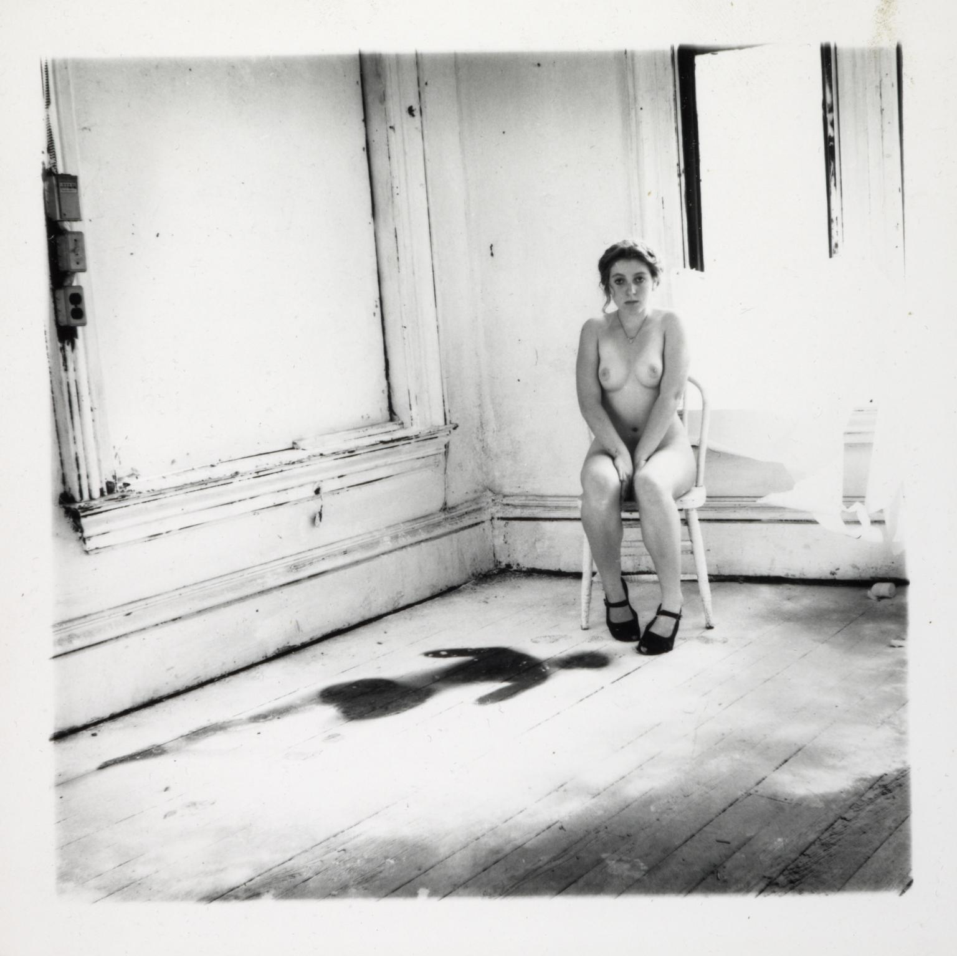
Fig.2: Untitled, Providence, Rhode Island (1976)

In this 143x144mm photo, 18-year-old Woodman is sitting in a decaying interior space. She is seated on a wooden chair next to a window, wearing nothing but a pair of Mary Jane shoes and a necklace. Her hair is tied back with a loose strand falling by her face. A dark, incomplete female silhouette lies on the floor with its head at Woodman’s feet.

The small scale of this photo creates an intimate relationship between the viewer and its contents (Tate a., 2023). The viewer must look closely and carefully to notice all the details within the image and understand the fragility of Woodman’s identity at this turning point of her life from childhood into adulthood.

In some of her other photographs, Woodman is unapologetically nude and invites the viewer to see her sexually (Tate b. 2023). However, in this photo, nudity has been used to reflect how her identity has been stripped to its core as she balances between being a child and an adult. Her shoes and necklace offer a sense of timeless femininity, suggesting that despite everything, being a woman will always be part of her identity.

The bareness of her body is reflected in the emptiness of the room. This should be a place of comfort but the only thing separating her from the decaying interior is a wooden chair. Woodman is clearly not comfortable, her position indicating that she is closing in on herself; her arms are closed around her with her hands between her legs perhaps protecting her intimate area, her legs a little apart come together at the feet and she appears hunched over as if protecting herself. She emits a feeling of childlike vulnerability whereby despite being naked she is insular. She is very vulnerable here and appears to be trying to shrink into herself, perhaps she is trying to revert to a more child-like state away from the complexity of adulthood.

Jenny Saville:

Saville is exceptional at capturing female beauty, especially that of larger women. By partaking in the male tradition of painting nude women, Saville created an “entirely new artistic convention” (Sotheby’s, 2023). While painting oneself is often a matter of convenience, there is great significance in a female painter, like Saville, creating a space for herself in such a male dominated field (Sotheby’s, 2023).

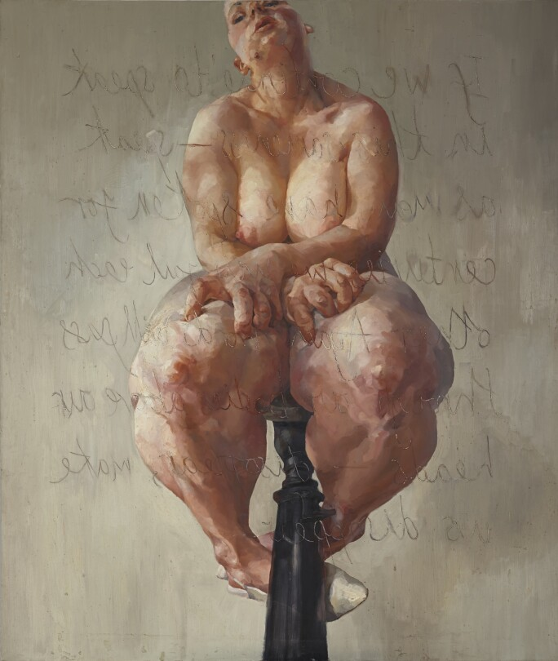
Fig.3: Propped (1992)

In this self-portrait, Saville is seated on a small stool facing towards a clouded mirror. Across the portrait is a paraphrased quote from the French feminist, Luce Irigaray - “If we continue to speak in this sameness – speak as men have spoken for centuries, we will fail each other. Again, words will pass through our bodies, above our heads – disappear, make us disappear” (Sotheby’s, 2023). By using this quote, Saville is sharing with herself and the viewer that the way women and femininity is spoken about needs to change; without this change women will cease to exist. Judith Butler describes a similar concept, suggesting that men create women as the “Other”, and within these definitions, women are nothing (Butler, 1990).

The small, uncomfortable stool which Saville is sitting on arguably represents the pedestal society puts women on. It is an impossibly small space with an unmeetable set of demands which sorely punishes anyone (and therefore everyone) that cannot fit in this limiting area of existence. This pedestal is so unattainable that it makes women into a theory because no woman can live up to its image.

The mirror frames the portrait providing irrefutable boundaries, reminiscent of society’s confines and restrictions. The viewer is inside the mirror, looking out at the incredibly intimate experience of interrogating yourself in a mirror. This arguably also means that the viewer is reflected in the painting. When originally exhibited, there was a mirror hung directly opposite the painting so the viewer could be an observer or the subject of the artwork depending on whether they faced the painting or the mirror (Sotheby’s, 2023). The roles of the viewer, in context with the quote from Irigaray, “take on a gendered significance” (Sotheby’s, 2023). Irigaray proposes that “men use women as mirrors, forcing them to fill an impotent reflective role in order to satisfy male narcissism” (Sotheby’s, 2023). In this painting, Saville has reversed this idea that women are a reflection of men and gives strength to women to be their own whole beings.

By painting what are typically unattractive traits of women’s bodies, Saville challenges small-minded concepts of female beauty. However, while this painting celebrates the female form, it also shows the deep discomfort that can come with embracing a form of femininity that isn’t societally accepted. Saville’s thighs are unrealistically large, and her hands grip them as if trying to manipulate the tissue. Alternatively, she may be trying to rip chunks of her flesh away in an attempt to conform to society. In the painting, Saville is looking away from herself. She almost appears to be feeling relief, perhaps from taking a moment away from the visuals of her body that receive unrelenting pressures from society.

The vulnerability of Saville’s body and expression is contrasted by the scale of the painting (Sotheby’s, 2023). Propped is over two metres tall and her whole body isn’t included within the frame. Saville created a massive figure of femininity showing that a woman can be as ‘big’ as a man. This huge visual is intimidating to the viewer and demonstrates the power large women hold within themselves and arguably the power women throughout society hold without knowing.

Caroline Wong:

Caroline Wong has used the shyness and insecurities she experiences as a result of her upbringing to create ‘messy’, vibrant works of art (Wilson, 2022). Wong expresses her femininity through self-indulgence.

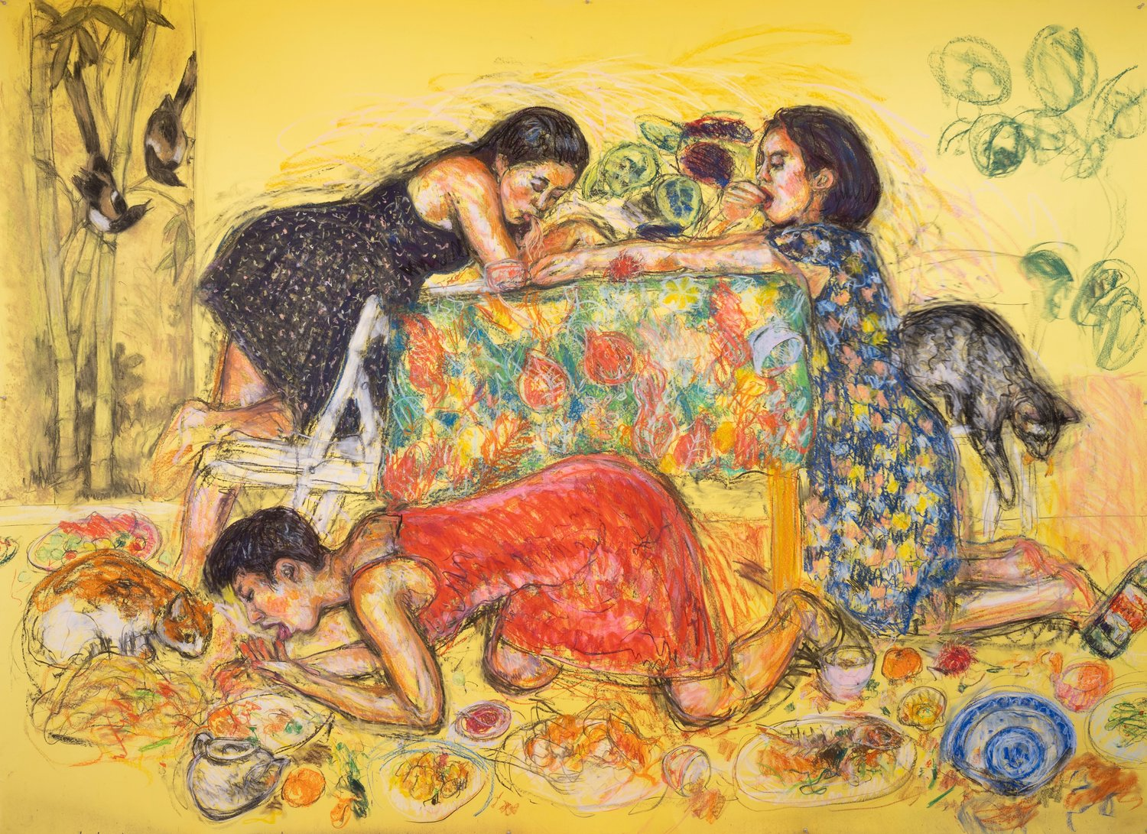
Fig.4: New Year’s Eve Dinner (2022)

In this colourful pastel drawing, three women sit sprawled around a table, alongside cats, and gorge themselves on the food around them.

Through her series Cats and Girls, Wong wanted to explore the “limiting expectations of gender and historical ties between the feline and the feminine” (Hingley, 2023). Here, she has turned her “girls” into cats, taking many of her animalistic poses from Chinese scroll paintings (Wilson, 2022). These women are “amoral, untameable and purely focused on their own pleasure, just like cats” (Hingley, 2023). In Chinese culture, cats are part of a creation myth: the gods put cats in charge of the world, but instead of following the role given to them by the gods, they just wanted to enjoy the world rather than rule it (Vijay Bodas, 2023). In this scene by Wong, the women, like the cats to the gods, are just trying to enjoy the world and are mirroring their actions. They are stepping back from the roles and restrictions imposed on them by men and society to live their lives in their own way.

Other than a few slightly darker outlines, there is very little tonal depth within this piece. Wong may be suggesting that women, or the concept of a woman, is one dimensional. There are so many, often conflicting, notions of what it means to be a woman and to be feminine, that the idea of a woman cannot occur in reality and the perfect woman can only be achieved on paper as a theory.

The sketchy lines Wong has used in this piece, and throughout this series of drawings, may be symbolic of freedom from society’s expectations. The women in this drawing are existing for themselves outside of the rules of society. This way of drawing creates a very dynamic atmosphere. Along with the mess of food everywhere, this high-energy technique suggests these women have become frenzied since being released from their restraints. They can finally be free of the boundaries that have dictated their life and they have to use every second of this freedom because they have a background fear of being shut away again.

By using the medium of pastels and coloured paper, Wong brings the idea of childhood into this work (Hingley, 2023). Both of these are typical to the materials a child would have access to. Wong stated that using cheaper paper in this way allows her to be free from the need for perfection that comes with more expensive materials – here she can experiment and play like a child would (Hingley, 2023).

Conclusion:

Femininity is what an individual makes it. Frida Kahlo used a combination of feminine and masculine traits to explore the closeness of these identities and how they can unite within the same person. Francesca Woodman showed us the vulnerable state of transitioning from childhood to adulthood. Jenny Saville focused on body image and the perception of women who do not live within societies ideals. Finally, Caroline Wong imagined what true feminine freedom looks like and exist solely for your own enjoyment.

Of the artwork in this essay, Wong’s is the only self-portrait where the subject is not seated still and poised. The other three artists remain within society’s lens, whereas Wong belongs to her own world, separate to the other’s. Here, this essay ends with the notion that femininity needs to be set free; women should be allowed to exist for themselves.

Bibliography:

Bryson, M. (2023) The Two Fridas [Website]. Available at:
https://www.britannica.com/topic/The-Two-Fridas (Accessed: 10th November).

Butler, J. (1990) Gender Trouble. 2nd edn. London: Routledge.

Conway, S. (1998) ‘Fashion: The history of... The Mary Jane shoe: Called to the bar’, Independent, 16 August. Available at:
https://www.independent.co.uk/life-style/fashion-the-history-of-the-mary-jane-shoe-called-to-the-bar-1172022.html (Accessed: 20th November).

De Beauvoir, S. (1956) The Second Sex. London: Johnathan Cape.

Espinoza, J. (2007) ‘Frida Kahlo’s Last Secret Finally Revealed’, The Observer. 12th August. Available at:
https://www.theguardian.com/world/2007/aug/12/artnews.art (Accessed: 23rd November).

Haraway, D. (1991) A Cyborg Manifesto. New York: Routledge

Hingley, O. (2023) Caroline Wong’s drawings of women eating like cats challenge expectations of “restraint and decorum”. Available at: https://www.itsnicethat.com/articles/caroline-wong-cats-and-girls-project-art-290323 (Accessed: 7th November).

Plessis, A. (2022) “The Two Fridas” by Frida Kahlo – Double Self-Portrait Analysis. Available at: https://artincontext.org/the-two-fridas-by-frida-kahlo/ (Accessed: 15th November 2023).

Ray, R. (2020) Women’s Friendships and Feminism. Research Paper. Brandeis University. Available at: https://www.brandeis.edu/writing-program/write-now/2020-2021/ray/index.html (Accessed: 18th November)

Reyburn, S. (2018) A Landmark Achievement for a Painting by a Woman, Upstaged by a Man. Available at: https://www.nytimes.com/2018/10/12/arts/-jenny-saville-banksy-sothebys.html (Accessed: 16th November).

Sotheby’s. (2018) The Groundbreaking Self-Portrait That Launched Jenny Saville's Career. Available at: https://www.sothebys.com/en/articles/the-groundbreaking-self-portrait-that-launched-jenny-savilles-career (Accessed: 12th November).

Sotheby’s (2023) Propped by Jenny Saville [website]. Available at: https://www.sothebys.com/en/auctions/ecatalogue/2018/history-of-now-collection-david-teiger-l18623/lot.6.html (Accessed: 17th November).

Tate a.(2023) Francesca Woodman: Untitled, Providence, Rhode Island [website]. Available at: https://www.tate.org.uk/art/artworks/woodman-untitled-providence-rhode-island-ar00352 (Accessed: 13th November).

Tate b. (2023) Francesca Woodman: Untitled, Providence, Rhode Island [website]. Available at:
https://www.tate.org.uk/art/artworks/woodman-untitled-providence-rhode-island-ar00347 (Accessed: 16th November).

Tate c. (2023) Finding Francesca. Available at: https://www.tate.org.uk/art/artists/francesca-woodman-10512/finding-francesca (Accessed: 13th November).

Vijay Bodas, R. (2023) Cats in Chinese Art. Available at: https://www.dailyartmagazine.com/cats-in-chinese-art/#:~:text=In%20ancient%20China%2C%20the%20rich,a%20cat%20deity%2C%20Li%20Shou. (Accessed: 21st November).

Wilcox, C. (2023) Making her self up – Frida Kahlo's cosmetics. Available at: https://www.vam.ac.uk/articles/making-her-self-up (Accessed: 15th November).

Wilson. A. (2022) Caroline Wong • Cats and Girls. Available at:
https://static1.squarespace.com/static/631be2f3d6972e6dc58bce79/t/631d05d246840937a6dc3c72/1662846418252/soy-capitan-caroline-wong-cats-and-girls-68954%281%29.pdf (Accessed: 19th November).

List of Illustrations:

Figure 1: Kahlo, F. (1939) The Two Frida’s [painting]. Available at: https://en.wikipedia.org/wiki/The_Two_Fridas (Accessed: 10th November)

Figure 2: Woodman, F. (1976) Untitled, Providence, Rhode Island [photograph]. Available at: https://www.tate.org.uk/art/artworks/woodman-untitled-providence-rhode-island-ar00352 (Accessed: 13th November)

Figure 3: Saville, J. (1992) Propped [painting]. Available at: https://www.sothebys.com/en/articles/the-groundbreaking-self-portrait-that-launched-jenny-savilles-career (Accessed: 12th November)

Figure 4: Wong, C. (2022) New Year’s Eve Dinner [pastel and charcoal on paper]. Available at: https://www.carolinewongart.com/work/catsandgirls (Accessed: 19th November)

