3/24/2025
University of Wales Trinity Saint David
London campus

E-Portfolio Link: https://www.canva.com/design/DAG5PFt-yKM/WHzy6yl9hcRtTlLoo5IOgA/view?utm_content=DAG5PFt-yKM&utm_campaign=designshare&utm_medium=link2&utm_source=uniquelinks&utlId=h0b1cec7c8e
Module Name: Learning In the Digital Era
Module Code: ACCA 4025

Student Name:Daud Jama
Student ID:2442748
Group: 1

Lecturer’s Name: Koushik Modak

LDE Assignment 1
E-Portfolio
Table of Contents
Introduction 2
Main Body 2
Task 1: Essential Academic and Employment Skills for the future career Path 2
Task 1 (a): Report on Essential Academic and Employment Skills 2
Task 1 (b): Evaluation of Task 1 (a) based on Similarity report 2
Task 2: Collaborative Mind Map and Individual Poster 2
Mind Map (Collaborative) 2
Poster (Individual) 2
Task 3: Virtual Collaboration and RefWorks 2
Report on Virtual Collaboration 2
Step-by-step process of using RefWorks with visuals 2
Task 4: E-Portfolio Creation and Evaluation 2
Task 4 (a): E-Portfolio Creation 2
Task 4 (b): Illustrative Review of E-Portfolio tool Selection 2
Conclusion 2
References 2
Task 1 References: 2
Task 3 References: 2

Introduction

Main Body

Task 1: Essential Academic and Employment Skills for the future career Path

Task 1 (a): Report on Essential Academic and Employment Skills
1a-Essential skills for study and employment:
To excel in both school and work, you need to have both study skills and job skills. Study skills such as management of time, efficient thinking, and researching allow you to learn better and get good grades. The book Essential Study Skills elaborates that learning these skills earlier on allows you to keep learning throughout life.


When hiring, employers look for skills such as good communication, working well with others, solving problems, and being flexible . A report from Coursera says these skills are crucial for getting hired and having success in your career
For example, in business jobs, communicating and solving problems allows you to deal customers and handle projects more efficiently handle projects . If you continue to practice these skills while studying, it’s easier to move into your career and grow over time. Teamwork plays an important role in expanding employees’ knowledge a nd skills. Research has shown that people that are more open towards teamworking are more inclined to have a positive impact on skill levels. (1)
Having good work habits and study skills helps you prepare to compete in today's society job market and helps you able to adapt to adapting to changes at the workplace. Having these skills is essential for school success and your future career. Problem-solving and decision-making capabilities allow workers to be able to manage issues and employ effective solutions and extend to actual complexities. Flexibility and adaptability are two parameters that are also vital in present day societies quickly changing work environment, as workers have to be ready to adapt to new technologies and familiarize themselves with new situations.
Initiative and leadership describe ability to lead and take initiative, while digital competence assures technology workability in technology-oriented workplaces/enviroments. In 1990, the enterprise in higher education was introduced to British Universities, as a means of developing enterprise skills in an attempt to make graduates better suited to life in the workplace.(2). In addition to enterprise skills, technology skills are just as important.To have baseline Technology skills is to be able to operate a computer for word processing, utilize a spreadsheet and send an email, or be able to operate office equipment such as a photocopier.(3)

- Bacon, N. and Blyton, P. (2003). ‘The impact of teamwork on skills: employee perceptions of who gains and who loses. Human Resource Management Journal, 13: 2, 13–29.
- Harwood, J., Harwood, D. and Lamble, K. (1999) The Learning Society: Perceptions of the Importance of Skills for Employment. 1st ed. London: Routledge, p. 9.
- Youth Central (2024). Employability skills | Job skills | Youth Central. [online] Youth central.

Task 1 (b): Evaluation of Task 1 (a) based on Similarity report
My similarity report tells me i have 0 % similarity score(aside from references), which indicates my work is of my own work and has been constructed in my own words. This score of 0 % showcases that I can understand how to stay away from plagiarism and that i am able to express ideas independently without copying from other sources. It also allows me to demonstrate my ability to be able to think critically and paraphrase effectively. On the other hand , while achieving 0% similarity is positive, I still need to make sure that my work has proper citations and references when using other people’s academic ideas or research. Academic writing should have balance between originality with evidence from reliable sources. In the future, I will make sure to continue to develop my writing skills by ensuring i am paraphrasing correctly while also maintaining academic integrity. In conclusion , this result shows that I have good research habits and can produce original work that meets academic standards.

Task 2: Collaborative Mind Map and Individual Poster

Mind Map (Collaborative)
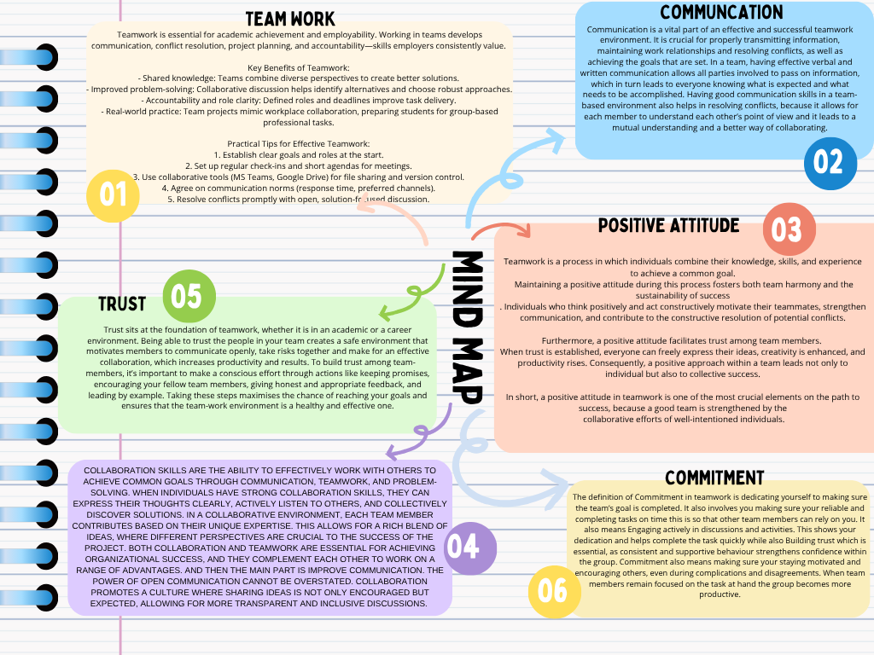
01 Poster (Individual)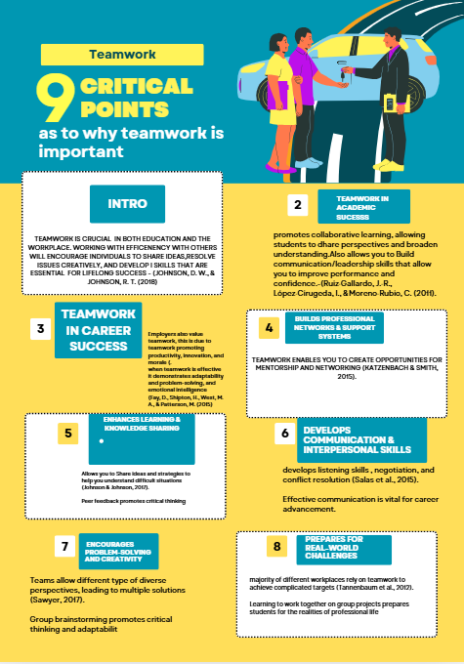
(References are included in the poster!)

Task 3: Virtual Collaboration and RefWorks

Report on Virtual Collaboration

Forming a Virtual Team
Forming a virtual team takes planning and understanding the strengths and weaknesses of each member of that tea, . A efficient team starts with shared goals, which provide direction for all members [1] Identifying the skills required for the team and selecting individuals who relate and possess those skills, is essential for ensuring the team functions effectively [2]
Once the team members are chosen, leaders of those teams should make the expectations clear regarding responsibilities, communication methods, and decision-making [3]:. If you Set these standards early it helps prevent misunderstanding and ensures accountability, and within the team[ 4 ].This Encourages communication, and mutual respect while also strengthening collaboration and trust among members (5) .
Building trust is also a key component of forming a strong virtual team. The reasoning being that Trust allows members to be able to rely on each other, share ideas openly, and be able to work through conflicts strategically [6].Structured onboarding activities, such as team-building activites is great for a teams development this is due to the fact that it can help establish initial trust and cooperation, creating a positive team environment from the start therefore improving efficieny in a team (7).


It is also very important to be able to plan workflows and processes that support effective teamwork. Making sure you Clearly define roles, responsibilities, deadlines, and collaborative processes makes sure that the team will operate efficiently (8). Using different methods to track progress, and facilitate group discussions can further improve coordination and productivity Within a team whch is crucial (9)
In Addition to this making sure you understand individual differences ,diverse skills and perspectives of team members can enhances problem-solving and decision-making which is
extremely crucial. A good team will also recognise the unique contributions of each member and making sure there is shared responsibility and accountability.

Overall, forming a team means making sure there is deliberate planning, good communication and trust-building, When these standards are set from the beginning teams are more likely to collaborate successfully, achieve their objectives, and maintain strong working relationships. This s due to the fact that a good structure allows teams to work efficiently ensuring a teams success.

Step-by-step process of using RefWorks with visuals
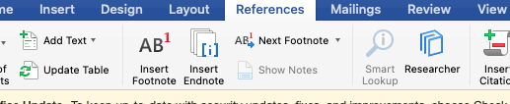

the first step was to open Microsoft Word and go to the References tab, which has everything I need to managing citations and bibliographies. I made sure to take a screenshot at this stage to show that I am able to select the correct tab before beginning the citation process

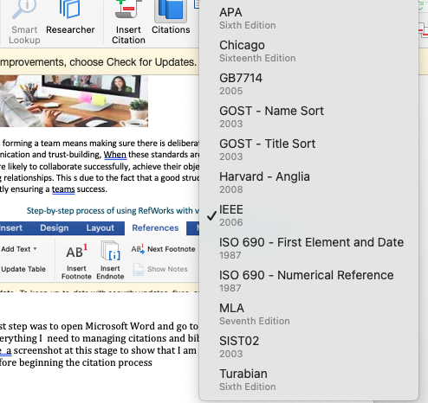

the second step is to make sure you are choosing the correct referencing style for your work. After opening the References tab, I made sure clicked on the Style dropdown menu to view the different citation formats. From this list, I selected IEEE, which is the required referencing style for my current assignment.

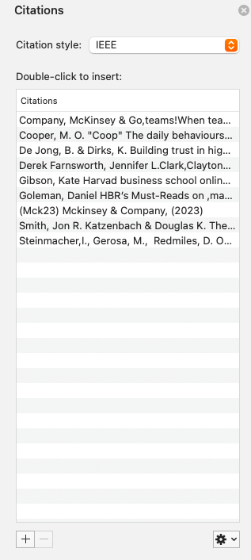

The third step is to click the Insert Citation button that’s in the References tab. After you do This should open the citation management window, where all of my saved sources are. If starting brand new , the list should be empty. If so you then make sure you tap the +.

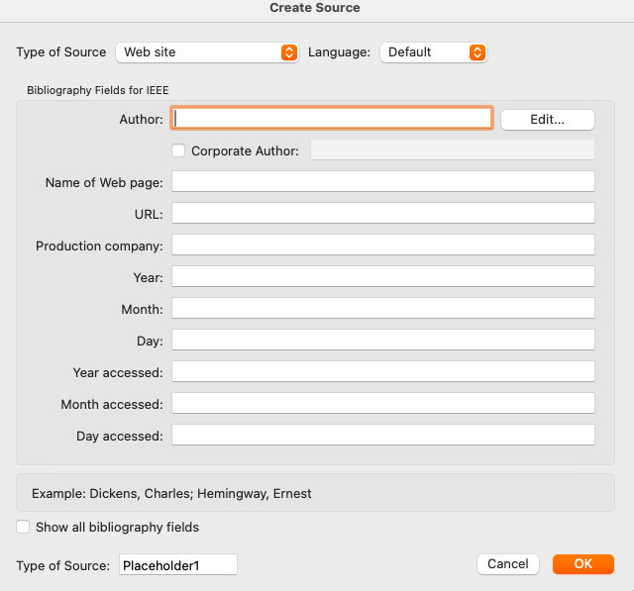
The final step is to press the + which is the Add New Source) button and make sure to fill in all the relevant details for the reference, such as the author’s name, title, year it was published and source type. After completing the form, I made sure to click OK, and Microsoft Word automatically generated the citation in the correct IEEE format.

Task 4: E-Portfolio Creation and Evaluation

Task 4 (a): E-Portfolio Creation
https://www.canva.com/design/DAG5PFt-yKM/WHzy6yl9hcRtTlLoo5IOgA/view?utm_content=DAG5PFt-yKM&utm_campaign=designshare&utm_medium=link2&utm_source=uniquelinks&utlId=h0b1cec7c8e
E-Portfolio Link:

Task 4 (b): Illustrative Review of E-Portfolio tool Selection

I have created my e-portfolio by using a tool such as Canva due to the fact it provides a wide variety of different templates which allows easy customisation and supports clear visual design. Canva has also made it simple to upload images, organise pages, and create a professional layout. One tool that was beneficial is its drag and drop tool. It helped me structure the content quickly, while also maintaining a clean and consistent style throughout my portfolio. I chose Canva because it is simple, efficitent and ideal to use for building visually appealing presentations.

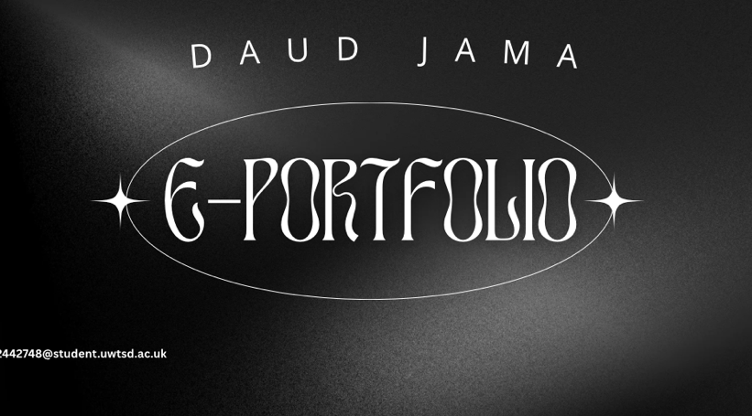
This screenshot displays the title page of my e-portfolio, showiing my name and the overall title of the portfolio

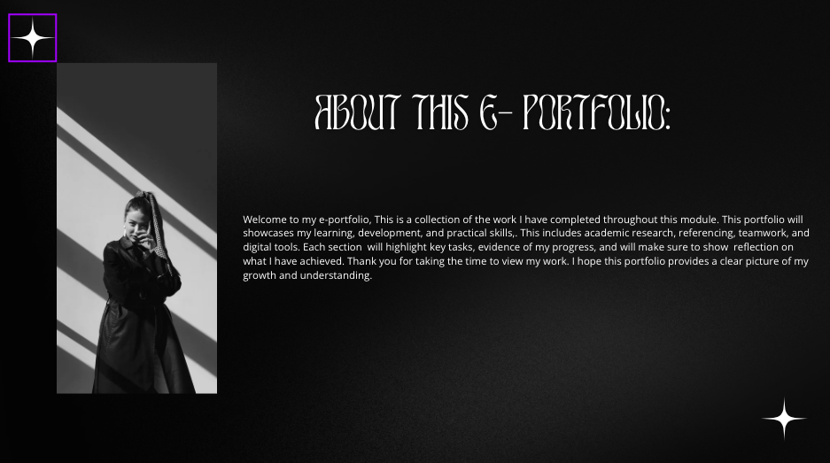
This screenshot shows the introduction slide of my portfolio. It gives a brief explanation as to what my portfolio is about and outlines the evidence and topics that will presented through out the slides.

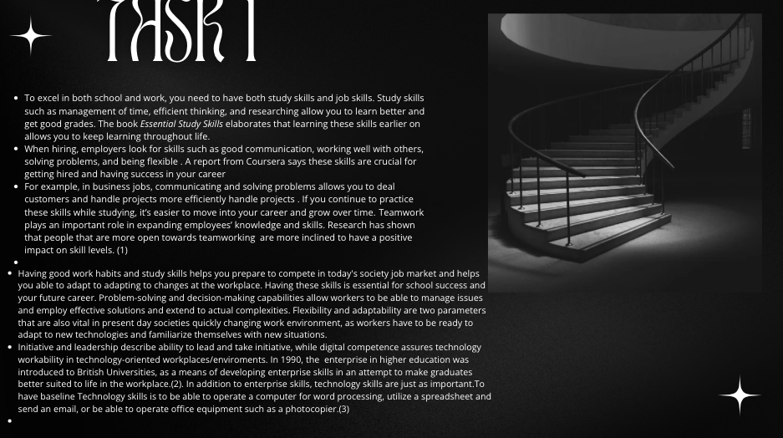This screenshot shows Task 1 from my e-portfolio, which focuses on the importance of study skills and job skills. It also explains how study skills such as time management, efficient thinking, and research can help students succeed academically and in different aspects of life. It also elaborates on how job skills like communication, teamwork and flexibility are hugely beneficial for career success.

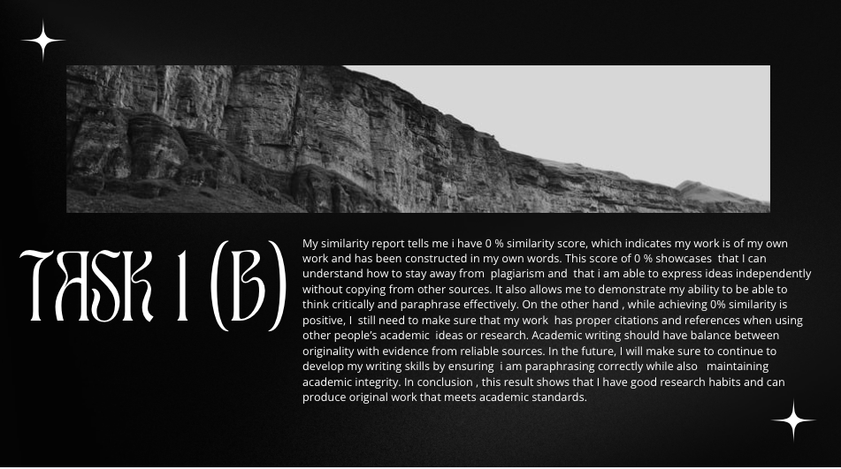

This screenshot shows Task 1b from my e-portfolio, which focuses on my similarity report. This report shows me a 0% similarity score (aside from references), displaying that my work is completely original and written in my own words. This slide also makes sure to highlight my ability to avoid plagiarism while thinking critically, and also paraphrase effectively. It also emphasizes the importance of including proper citations and references when using other people’s research.

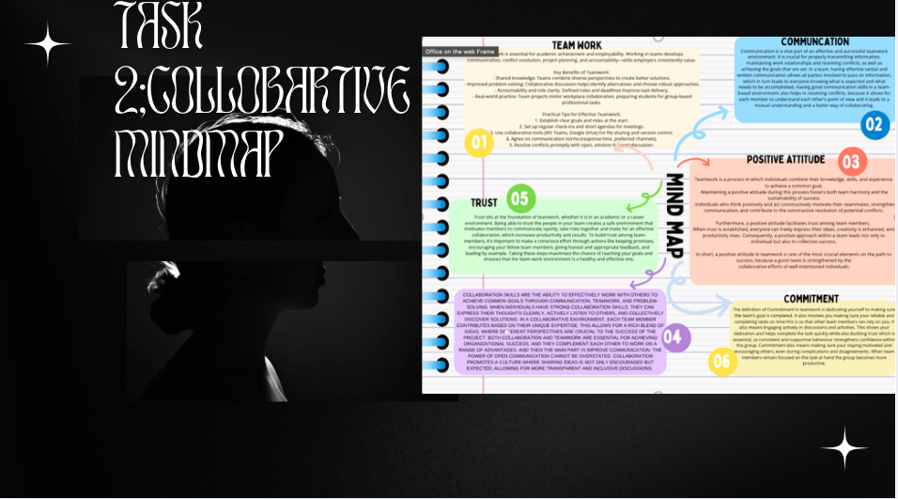
This screenshot shows Task 2 from my e-portfolio, displaying a collaborative mind map. This mind map shows teamwork and the collective ideas on a particular topic. It also highlights my ability to work with others while also contributing ideas, and visually represents information in a clear and structured way. This slide also makes sure to reflect my collaborative skills and my capacity to organize knowledge effectively in a group setting.

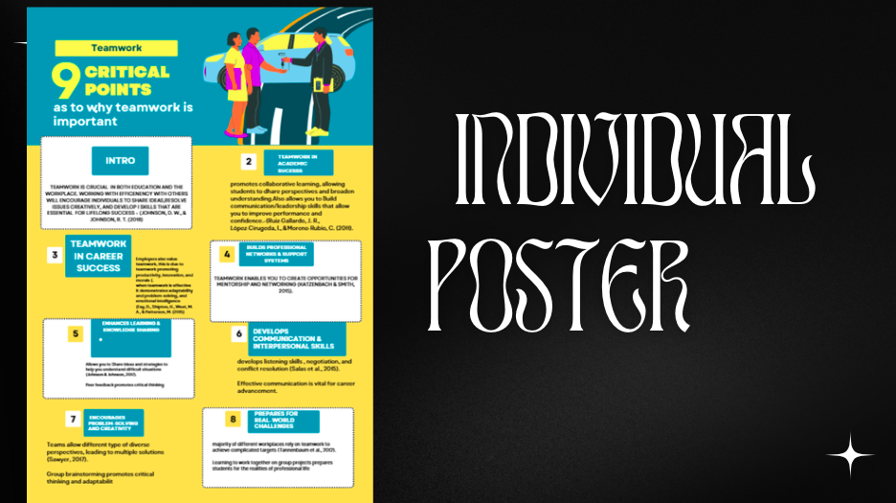

this screenshot shows a slide from my e-portfolio. This is a poster I created. This poster presents key information on why teamwork is important by combining text, images, and design elements to communicate ideas clearly. This task demonstrates my creativity, ability to summarize information concisely, and skill in using visual tools to convey a message effectively.

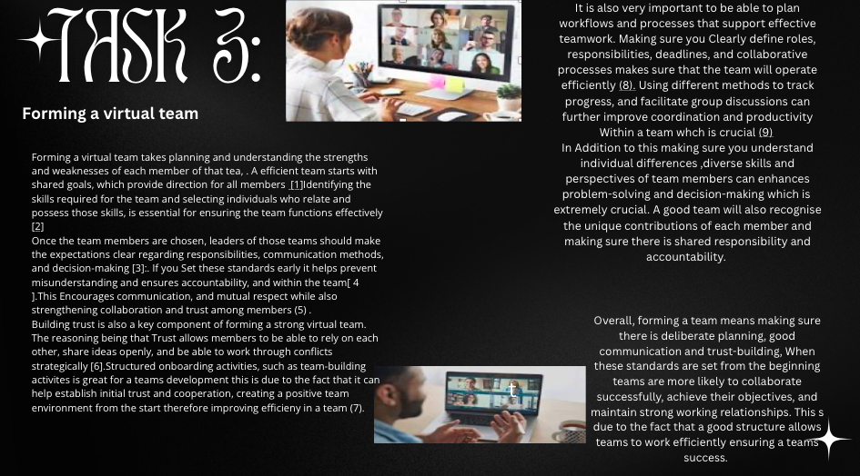
This screenshot shows Task 3 from my e-portfolio, which is explaining how to form an effective virtual team. It mainly highlights the importance of planning and making you are understanding team members’ strengths. This slide also makes sure to emphasise choosing members with the right skills, and also making sure you are encouraging good communication. It emphasises that trust and team-building activities help create a positive environment where members are in environment where they are able to work well together.

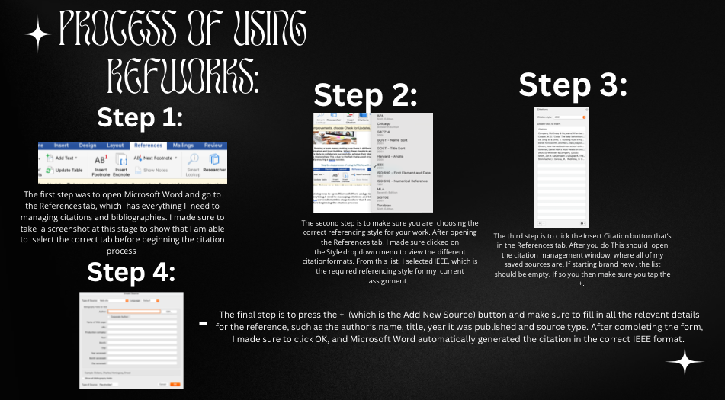
This screenshot shows a slide from my e-portfolio, which demonstrates how I used Microsoft Word’s referencing tool. The slide also explains how I generated citations and used the built-in features to follow IEEE standards. This task shows my ability to reference sources correctly.

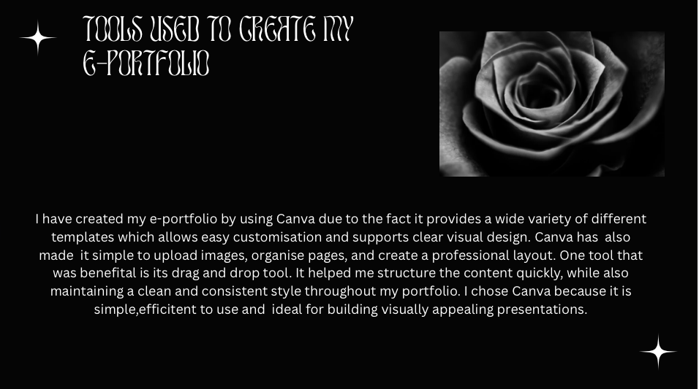
This screenshot shows a task rom my e-portfolio, where I elaborate on the digital tool I used ,which was Canva. The slide explained how I used Canva to design my poster and create visual content. It also highlights the features I used, such as templates.

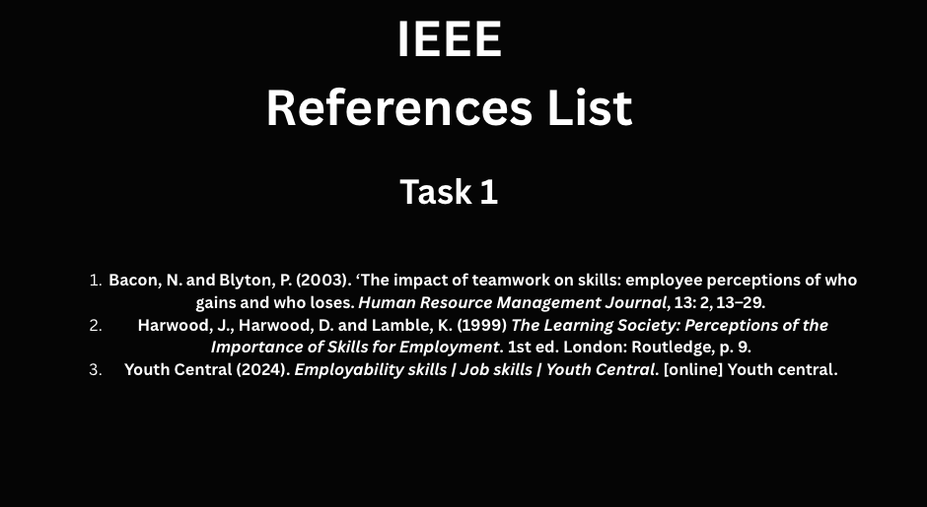
This screenshot displays the reference list i have included in my e-portfolio. It contains all the sources I used throughout the durations of my tasks, formatted correctly to follow IEEE standards. This slide also displays how I have supported my work with reliable evidence and used proper referencing to maintain academic integrity.

Conclusion

In conclusions, completing these tasks has allowed me to develop a variety of academic and workplace skills. I also learned how to produce original work, avoid plagiarism, and use proper referencing to maintain academic integrity. In addition to this Working on activities such as the mind map and teamwork poster has allowed me to improve my communication and problem-solving abilities. I have also gained experience using digital tools such as Canva and Microsoft Word’s referencing features, which helped me present information clearly and professionally.

Task 1 References:
- Bacon, N. and Blyton, P. (2003). ‘The impact of teamwork on skills: employee perceptions of who gains and who loses. Human Resource Management Journal, 13: 2, 13–29.
- Harwood, J., Harwood, D. and Lamble, K. (1999) The Learning Society: Perceptions of the Importance of Skills for Employment. 1st ed. London: Routledge, p. 9.
- Youth Central (2024). Employability skills | Job skills | Youth Central. [online] Youth central.

Task 3 References:

Bibliography

[1] | “Mckinsey & Company,” 2023. [Online]. Available: https://www.mckinsey.com/capabilities/people-and-organizational-performance/our-insights/teamwork-at-the-top. [Accessed 19 November 2025].
[2] | D. Goleman, “HBR’s Must-Reads on ,managing people,” p. 48, 1993.
[3] | K. Gibson, “Harvad business school online,” 2021. [Online]. Available: https://online.hbs.edu/blog/post/characteristics-of-an-effective-team. [Accessed 19 November 2025].
[4] | J. R. K. &. D. K. Smith, “The Discipline of Team,” pp. 111-120, 1993.
[5] | M. O. ". Cooper, “The daily behaviours that transform good teams into great ones,” Reworked, 21 july 2025. [Online]. Available: : https://www.reworked.co/collaboration-productivity/the-daily-behaviors-that-transform-good-teams-into-great-ones/. [Accessed 19 November 2025].
[6] | B. &. D. K. De Jong, “Building trust in high-performing teams.,” Technoogy innovation management review, 2012. [Online]. [Accessed 2025].
[7] | S. M. Gerosa and D. Redmiles, “Onboarding in agile teams:Techniques and challenges.,” 2019. [Online]. [Accessed 19 november 2025].
[8] | J. L. B. W. a. K. K. Derek Farnsworth, “Univeristy of florida IFAS Extension,” 2013. [Online]. [Accessed 19 november 2025].
[9] | M. &. Company, “Go,teams!When teams get healthier,the whole organisations benefits,” 2022. [Online]. [Accessed 2025 november 2025].

:

