

Intercultural Competence Report

Module Name
Foreign Languages and Cultural Awareness (BMIH5003)

Lecturer’s Name
Giulia Chifari

Student’s Name: Md Sohel Khan
Student ID: 2211256

Word Count
1,002 words

Executive summary
The report aims to understand how cultural values and practices influence the business of an organisation when it enters in foreign market. The GLOBE project analysis of India has helped to understand the cultural values and practices in the country. It also shows what type of leadership is acceptable in the country. In order to successfully operate the business in the Indian market, the manager of Diversity Hotel & Spa should be culturally intelligent and sensitive to the Indian culture. The recommendations can help the manager to successfully enter the Indian market.

Table of Contents
Executive summary 2
Introduction 4
Country Analysis of India 5
Importance of cultural intelligence and sensitivity 6
Conclusion 7
Recommendations 8
Reference List 9

Introduction
The Diversity Hotel & Spa in London is doing business successfully in its current country that encourages it to expand into foreign countries. The chosen foreign country is India that is culturally enriched. The cultural analysis will help to understand the international customs of India that will lead to a great customer service experience. This will also help in understanding the customer buying behaviour of India that is necessary for achieving organisational success.
India’s cultural overview
India is known as the seventh largest country in the world that was a colony of the British Empire from the 17th century to the mid-twentieth century. The country is located along with Nepal, Pakistan, Bhutan, Maldives, Sri Lanka and Bangladesh. This is why the culture of India is enriched with British customs and other traditional customers from around the world. The culture is known for its diversity and unity of different cultures, religious beliefs and languages (Schlösser et al., 2013). Although the major religion is Hinduism, there are a lot of languages that can be seen in India. However, India conducts its international business in English which helps to understand that the country is open to foreign businesses. The people of India believe that the guest is equivalent to God. This shows the importance that the hotel industry has in India. In India, the guests are paid the highest regard with great hospitality (Kang et al., 2012). As the direct contribution of hotels to the GDP of India is more than 40 billion dollars, starting a hotel industry in India is quite beneficial (Kumar and Sonker, 2022). The GDP rate is expected to reach around 68 billion dollars by 2027. Any hotel industry will have a good future in India because according to the history and statistics, it is clear that hotel industries are quite profitable in India. The need of travelling across the world for various purposes cannot be banned at all, this is why the hospitality culture of India will be extremely beneficial for India.

Country Analysis of India
The GLOBE project has studied more than 60 countries to understand the culture and cross-cultural leadership (Dorfman et al., 2012). The project tried to provide knowledge of the international environment to help business managers understand what measures and performance are needed to succeed in foreign markets. GLOBE uses nine quantitative dimensions to understand a country's culture: assertiveness, gender egalitarianism, future orientation, uncertainty avoidance, power distance, performance orientation, in-group collectivism, and institution collectivism (Abramson and Moran, 2018).
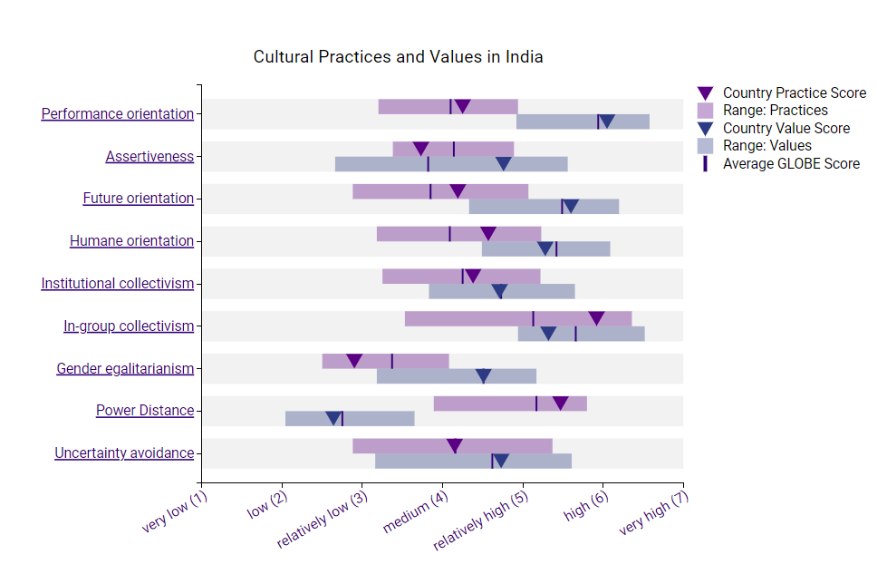
Figure 1: Cultural Dimensions of India
Source: GLOBE Project (2020)
Figure 1 shows the cultural values and practices of India. The country shows medium to high-performance orientation, assertiveness, future orientation, humane orientation and institutional collectivism (Pagda et al., 2021). Whereas the performance orientation, future orientation and humane orientation should be high level. The in-group collectivism shows a medium to high level whereas it should be relatively high to high level. Gender egalitarianism is relatively low whereas the value should be medium to high. In order to do business successfully and creatively, the power distance score should be low. In India, this dimension scored medium to high score. Lastly, the uncertainty avoidance dimension level is satisfactory in comparison with the values meaning the score it should be.
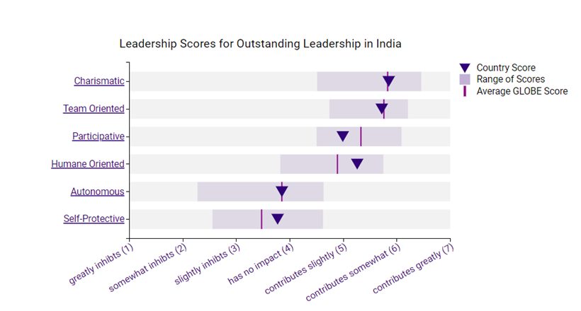
Figure 2: Leadership Dimensions of India
Source: GLOBE Project (2020)
Figure 2 shows the leadership dimensions that can be seen in India. It is clear that charismatic and team-oriented leadership contributes to the organisation on an average level. Participative leadership and human-oriented leadership contribute slightly to the organisation. Lastly, autonomous and self-protective leadership has no impact on the organisation (Nazarian et al., 2021). This is why an organisation should adopt charismatic or team-oriented leadership in India for implementing successful leadership.

Importance of cultural intelligence and sensitivity
The ability to connect and work effectively across different cultures is known as cultural intelligence. Every organisation should be sensitive to the culture in which the organisation is willing to operate (Göl and Erkin, 2019). Effective leadership and communication can be built if the sensitivity of a culture is understood properly. The importance of cultural intelligence and sensitivity are shown below:
- People who are culturally intelligent are better at communication that helps in the proper flow of information (Maheshkar and Sharma, 2018).
- The better communication helps in building stronger interpersonal relationships. The employees and business owners have a better understanding that leaves a positive impact on the business.
- When the leaders of an organisation are culturally sensitive, they understand the individual employees better (Chao et al., 2017). This helps in making better managers for the organisation. This is only possible when leaders understand the values deeply and give priority to them.
- It helps in attracting the top talent of the market that helps in achieving a competitive advantage. This brings long-term benefits to an organisation.
- Lastly, being culturally intelligent and sensitive will help in achieving global success while entering into a culturally enriched country India (Christiansen et al., 2020).

Conclusion
The aim of the report is to understand a foreign culture where the chosen organisation will operate its business. The chosen country for this report is India which is enriched with culture and customs. As the country is open to foreign businesses and provides great value to guests, the organisation can successfully operate its business In India. The dimensions of the GLOBE project are done to analyse the country that will help to enter India successfully.

Recommendations
The following are the recommendations that Diversity Hotel & Spa London can take while entering India to expand their business.
- The hotel should choose a location that will attract the tourists most. The number of international visitors and the number of domestic visitors should be kept in mind while choosing a location.
- Leadership plays a vital role in the success of an organisation and as the country shows high scores in charismatic leadership and team-oriented leadership, the organisation should adopt any one of these two (Abramson and Moran, 2018).
- The customers of India are always curious and provide great value to hospitality. This is why the hotel should provide an innovative experience to the customers.
- Safety and health should be the top priority of the hotel (Nain, 2018). The organisation should focus on maintaining hygiene and cleanliness as the Indian people are extremely concerned about this.
- Lastly, the managers should be flexible in communicating with workers and customers properly. The managers should be observant of any cultural changes.

Reference List
Abramson, N.R. and Moran, R. (2018) Managing Cultural Differences: Global Leadership for the 21st Century. 10th Ed. Abingdon: Routledge.
Chao, M.M., Takeuchi, R. and Farh, J.L. (2017) Enhancing cultural intelligence: The roles of implicit culture beliefs and adjustment. Personnel Psychology, 70(1), pp.257-292.
Christiansen, B., Branch, J.D. and Karmowska, J. (2020) Cultural Factors and Performance in 21st Century Businesses. Hershey : IGI Global.
Dorfman, P., Javidan, M., Hanges, P., Dastmalchian, A. and House, R. (2012) GLOBE: A twenty year journey into the intriguing world of culture and leadership. Journal of World Business, 47(4), pp.504-518.
GLOBE Project (2020) Results - India Globe Project. Available at: https://globeproject.com/results/countries/IND?menu=list#country.
Göl, İ. and Erkin, Ö. (2019) Association between cultural intelligence and cultural sensitivity in nursing students: A cross-sectional descriptive study. Collegian, 26(4), pp.485-491.
Kang, K.H., Stein, L., Heo, C.Y. and Lee, S. (2012) Consumers’ willingness to pay for green initiatives of the hotel industry. International journal of hospitality management, 31(2), pp.564-572.
Kumar, S. and Sonker, J. (2022) SUSTAINABLE HOTEL OPERATION IN INDIA. Ashok Yakkaldevi.
Maheshkar, C. and Sharma, V. (2018) Handbook of Research on Cross-Cultural Business Education. Hershey: IGI Global.
Nain, A. (2018) A study on major challenges faced by hotel industry globally. International Journal of Creative Research Thoughts, 6(1), 561-571.
Nazarian, A., Velayati, R., Foroudi, P., Edirisinghe, D. and Atkinson, P. (2021) Organizational justice in the hotel industry: revisiting GLOBE from a national culture perspective. International Journal of Contemporary Hospitality Management, 33(12), pp.4418-4438.
Pagda, Z., Bayraktar, S. and Jimenez, A. (2021) Exploring culture and leadership after 23 years: A replication of GLOBE project in Turkey. Journal of International Management, 27(1), p.100822.
Schlösser, O., Frese, M., Heintze, A.M., Al-Najjar, M., Arciszewski, T., Besevegis, E., Bishop, G.D., Bonnes, M., Clegg, C.W., Drozda-Senkowska, E. and Gaborit, M. (2013) Humane orientation as a new cultural dimension of the GLOBE project: A validation study of the GLOBE scale and out-group humane orientation in 25 countries. Journal of Cross-Cultural Psychology, 44(4), pp.535-551.

