Outline and critically assess the supposed justifications for either the practice of factory farming or the use of animals in research.
Factory farming is a system of farming in which a lot of animals are kept in small, closed areas, to produce large amounts of meat, diary, or eggs as cheaply as possible. Factory farming originates to the United States of America during World War 2 where farmers were subsidised for farming the land belonging to their neighbours in order to produce more food in a method that was more efficient and therefore being able provide the state with far more soldiers for the war effort. The subsidies continued long after the war to present day and the intensive/factory farming method of farming has become very popular due to the populations need cheap food after World War 2 and during the following extended harsh economic conditions created at that time. There were justifications made that support this farming practice despite its malpractice and mistreatment of animals, there have been many groups such as ALF(Animal Liberation front) and PETA (People for the Ethical Treatment of Animals). They have stopped certain issues such as the horse meat processing factories in the United States of America.
Factory farming animal products can be justified by its benefits to Human Welfare, these can be health benefits, fiscal benefits, or political benefits to name a few. With the factory farming of meat, in particular Chicken in battery cages, there has been an increased access to affordable protein in the market. ‘prior to the 1950’s large numbers of people died because of tuberculosis due to a simple lack of nourishment’ ‘the wide availability of cheap animal proteins both chicken and fish has put an end to that’. The amino acids int the protein helps create antibodies to fight off infections, this is a significant advantage to the increased welfare of the low-income proportion of the population. However, unsanitary conditions created by a larger demand of attention on a broader base than needed in free range farming, means that in the preparation of meat there is a greater risk of bacteria such as Salmonella and Campylobacter finding its way to the consumer. This risk can be voided by the careful handling of the meat overseen by Institutes such as BRC (British Retail Consultancy) though this is a critique that does not apply to the question at hand. Ester Boserup suggested in contrast to Thomas Malthus that as the world’s population increased there would be technological leaps to meet the rising demand of food by the populous, another justification for the use of factory farming can be that the increased yield provided by the intensive techniques are able to meet to demands of the larger population. Yet this can be dismissed as it applies more directly to the production of crops rather than animals.
There also exist the matter of its efficiency as a justification of its use a farming technique, in comparison to free range farming there can be almost double the space and therefore double the stock which makes for a higher yield. There is also the potential for greater wealth gain by pursuing Factory farming, this is due to there being government subsidies in countries like the USA in order to encourage farmers to produce more food. ‘The US government spends $38 billion each year to subsidize the meat and dairy industries.’ Despite this as a valid justification to factory farm, in a country where there is a greater availability of land that would be able to handle large-scale free-range farming, then the farmers choice between factory farming and free range farming becomes a choice of a moral dilemma versus greed. There is a social ignorance of the suffering of animals in factory farming settings because of there inconvenience or limited availability of knowledge about products to the uneducated or poor. Often, they do not have the privilege of being able to choose between the cheap and expensive food items based on moral objections. Another justification can be seen as the alternatives not being equal in ability to provide with either needs, demands or both for the population. As stated, ‘the alternative may be worse concludes a Stanford university study: a less productive agricultural system would destroy even more land, drive up greenhouse emissions and wreak havoc on biodiversity’. This implies how it would be worse for the environment to farm free range because of the efficiency of factory farming, yet this problem could be resolved over time rending it a short-term problem. If there were policies so ensure that people consumed less animal product, then less animal would be needed which could balance out the difference between high animal product consumption and factory farming and free-range farming and low animal products consumption. ‘Increased greenhouse emissions resulting from intensive farming practices are more than offset by the effects of land preservation’ as forementioned with addressing the climate there would be a greater benefit to animals and Humans if the consumption of animal product was lessened this would also offset the negative effects caused by transitioning to a way of farming that take equal consideration to all species involved. To offer another critique of this point, they very fact that something is offset does not mean that the effects of the mentioned greenhouse gasses are nullified, what it does in turn mean is that there is one are that has and produces a large amount of greenhouse gasses and then there are other areas that are not affected so comparatively clean from green house gasses. Or in other words offsetting will not balance out the difference between an area of land with green house pollution and a area without greenhouse pollution. ‘Only industrial farming can possibly meet the demands an increasing population and increased demand for food as a result of growing incomes’ there already is more than enough food to support the worlds growing population, the problem is that there is unequal distribution in the worlds food supply, also there can be achieved balance when the is enough food to feed the entire population then growth should slow down. This should work as long as the changes happen over a long period of time, so that the culture of having many kids to ensure you linage’s survival can be diminished by the reduced risks, it can be seen as an example in India when they gained food stability in the agricultural revolution in the mid 1900’s. it was achieved too fast for there to be a great change culturally to support this new found food ‘wealth’ as a result the population boomed and they started to suffer from over population which continued their plight so that they ended up balancing out the injection of food with an increase in people needing to be fed. To conclude this. There should be a balance in this to be able to balance food distribution to take pressure off of the factory farming and intensive farming methods currently utilised.
There is the argument that factory farming is better for animals’ welfare than free range farming this di due to there being a greater control over the environment in which they are in, for example they can suffer from the weather or even predatory attacks. ’It was easier to raise turkeys in the open. In expensive pastures, but that type of production really was hard on the turkeys. Protected from the weather and predators, todays turkeys may not be aware that they are in a morally reprehensible system’. This is a very niche justification as larger animals such as sheep and cattle are unlikely to be affected by the predator threat, however to the animals that predators would be a threat too it could be said that you are protecting more than the animal desired to be farmed as the will be limited ‘pest control’ of the natural system. It allows the farmed animal that would be a foreign body to food chain one that had other influences that could dramatically influence the natural chain out of it. Yet this can be invalid as animals have been farmed for such a long time, they would already be a part of the chain excluding humans and removing them in would actually affect others due to higher predators needing another food source or just missing a food source. ‘Crates protect the piglets from their mothers…pigs…being crushed…a real drag on the profit margin’ this too can be voided by the point that if there are piglet deaths then there is still not enough room in the cages, given that naturally it is not natural maternal instinct to step on your young, this provides an excellent point on how they should be allowed more room in birthing and raising of young. On the other side of this is that there can be a vet that can see to the health of each creature very readily in a conventional furrow layout that would take them a lot longer to do this in a normal manner. Another justification made was to do with balance of the world trade ‘because some countries may not share our sensibilities well enough to withdraw or amen free trade agreements to keep any semblance of livestock industry’ though an upset in the amount of animal products that are available to buy on the market would short term decrease there would be many other producers globally who could start to compete making it not only better for the animals but for under developed countries and the people to as there will be increased competition that will drive down the prices. Also, there are many tools that can be used if a country is being unfair in its trade terms, so that annoy that do not or will not comply to whatever agreement will be and can be ignored and made irrelevant. This provides a motivation for them to agree to the same measures as you are on.
In conclusion, factory farming has many justifications such as the forementioned human welfare, efficiency, animal welfare, and global warming. Though ‘agricultural advances between 1961 and 2005 have spared a portion of land larger than Russia to from development and reduced emissions by the equivalent of 590 giga tonnes of carbon dioxide’ this does not take into the considerations that the animals farms more efficiently produce more green house gases just not carbon dioxide.

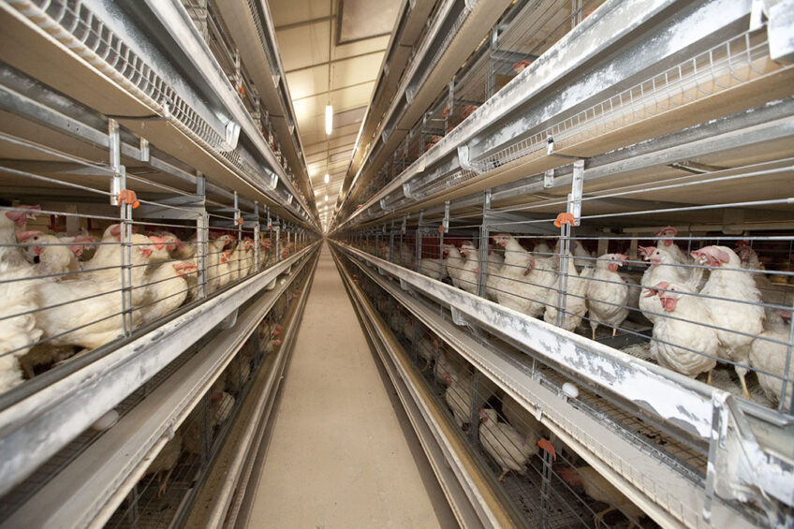
New bid to end cages for UK laying hens launched (2021) Poultry World. Available at: https://www.poultryworld.net/poultry/new-bid-to-end-cages-for-uk-laying-hens-launched/ (Accessed: November 9, 2022).

Bibliography
Factory farming (no date) Cambridge Dictionary. Available at: https://dictionary.cambridge.org/dictionary/english/factory-farming (Accessed: November 9, 2022).
Jay Rayner: Sure, it might be cruel, but intensive farming saves lives (2008) The Guardian. Guardian News and Media. Available at: https://www.theguardian.com/commentisfree/2008/jan/13/lifeandhealth.ruralaffairs (Accessed: November 9, 2022).
The Omnivore’s Delusion: Against the Agri-Intellectuals (no date). Available at: https://www.aei.org/articles/the-omnivores-delusion-against-the-agri-intellectuals/ (Accessed: November 9, 2022).
'only intensive farming' will feed Britain (2007) The Guardian. Guardian News and Media. Available at: https://www.theguardian.com/uk/2007/apr/18/foodanddrink.food (Accessed: November 9, 2022).
Removing the meat subsidy: Our cognitive dissonance around Animal Agriculture (2020) JIA SIPA. Available at: https://jia.sipa.columbia.edu/removing-meat-subsidy-our-cognitive-dissonance-around-animal-agriculture (Accessed: November 9, 2022).
Tollefson, J. (2010) Intensive farming may ease climate change, Nature News. Nature Publishing Group. Available at: https://www.nature.com/articles/465853a (Accessed: November 9, 2022).

