International Metting Management for the Hotel Industry

Assignment 2

Table of Contents
Introduction 4
The Event Cycle 5
Event Concept 6
Event Aims and Objectives 7
Event Operations 7
Skills Required for the Event 7
Strategic Planning 8
Project Management 8
Promotion and Marketing 8
Communication and Negotiation 8
Leadership 8
Resources Needed for the Event 9
Event Budget and Financing Sources 10
Industry Trends and Impacts 11
Cultural Considerations 14
Diversified Cultural Demographics 14
Food and Dietary Preferences 14
Cultural Awareness and Sensitivity 15
Inclusivity and Language 15
Conclusion 16
References 17

Table of Figures
Figure 1: Event Life Cycle | Source: (Self) 5
Figure 2: Key Skills Required | Source: (Self) 7
Figure 3: Event Budget | Source: (Self) 11
Figure 4: Financing of Event Budget | Source: (Self) 11
Figure 5: Major Challenges of Sustainable Events | Source: (Stevens & Mitchell, 2021) 12
Figure 6: The Wellness Economy Rate | Source: (Smith, 2019) 13
Figure 7: Cultural Diversity in London | Source: (Turner & Davis, 2017) 14

Introduction
The Healthy Lifestyle Expo in London is an ambitious project with the goal of providing visitors with an all-encompassing experience in the realms of health, nutrition, exercise, psychology, and eco-friendliness. The event of this first-of-its-kind conference wanted to meet the rising need for all-encompassing well-being solutions as people everywhere look for ways to improve their health and happiness.
The expo's location in London, a bustling metropolis with a rich cultural heritage, is intended to make use of the city's diverse population. The event's holding it in London has been a smart choice, which, as a major world city, will provide an exciting backdrop that is in line with the conference's goals. The Healthy Lifestyle Expo is on trend with the current global wellness and sustainability movements by providing attendees with the inspiration, motivation, and tools they need to live healthier lives. The significance of this event lies not only in its ultimate outcome, but also in the enormous effect it can have on individuals' sense of well-being and the global community as a whole.

The Event Cycle
Event life cycle shows the start to end of an event (Brown & Taylor, 2018). Events are planned and executed using the event cycle, which is crucial to the success of the Healthy Lifestyle Expo in London. This thorough procedure guarantees the event is well-planned, executed, and assessed. The event cycle is thus represented in the following chart:
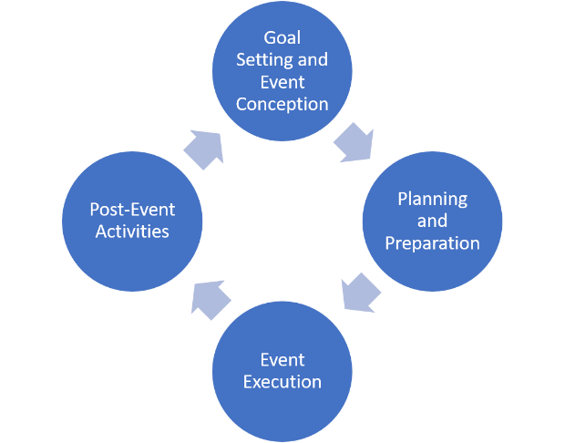
  - Figure 1: Event Life Cycle | Source: (Self)
- Goal Setting with Event Conception: The event cycle begins with the idea's genesis, alignment with the chosen Event Cycle, and clear goals and objectives. For the Healthy Lifestyle Expo, this involves promoting holistic well-being and educating participants on various health and wellness topics.
- Planning and Preparation: This step involves choosing a venue, budgeting, marketing, and collaborating with exhibitors and sponsors. The event is organized by the expo's logistics and link them with its goals in this phase.
- Event Execution: This is the day of the event, when everything comes together. The bright and instructive environment includes workshops, displays, and well-being programs.
- Post Event Activities: Following the event, feedback is collected and measured against preset KPIs. This feedback guides future planning and ensures that the Healthy Lifestyle Expo meets audience demands as they change.

Event Concept
A holistic well-being platform, the Healthy Lifestyle Expo in London gives participants and guests a day of exploration and personal progress. This multidimensional event has a carefully planned programme to cover all health and wellness topics given as follows:
- Morning Wellness Workshops: Yoga and meditation start the day. These mindful courses teach stress-reduction, emotional resilience, and mental health strategies. Daily-use skills will be taught.
- Nutrition: Nutrition is one of the top priorities of a sustainable event (Johnson, 2019). Celebrity nutritionists give informative talks and cooking demonstrations (Robertson, 2019). Attendees will learn about diet, healthy eating, and cooking.
- Fitness Demonstrations: Experienced fitness instructors lead hands-on workouts that teach the latest fitness and exercise trends. Fun and energetic activities will promote physical vitality and a better understanding of fitness.
- Living Displays: Attendees will see sustainable living items and innovations. Eco-friendly home, transportation, and lifestyle options will be displayed. This clip emphasises the need of sustainable living for health.
- Interactive Mental Health Zones: These zones include mental health assessments, coping skills, and resources to boost visitors' mental resilience. Experts will lead stress, self-care, and emotional health topics.
- Cuisine: A delicious, balanced lunch will be served. An immersive culinary experience will emphasise flavour harmony and careful eating.
- Wellness Product Showcase: Discovers the latest health and wellness products and services. This expo offers innovative exercise gear and organic skincare to help participants achieve their well-being goals.
- Panel Discussions and Keynotes: Leading industry experts will address new trends, holistic well-being, and the future of health and wellness. These talks empower and inspire.
- Networking Opportunity: The day is full with opportunity to meet like-minded people and build important health and wellness relationships. These interactions foster a positive environment.

Event Aims and Objectives
The Healthy Lifestyle Expo in London has the overarching goal of encouraging people to make healthy lifestyle changes and promoting health in all its forms. The SMART (Specific, Measurable, Achievable, Relevant, and Time-bound) goals emphasise educational participation, significant interaction between exhibitors and attendees, and motivation to make lasting improvements to health and wellness. The event has the following well-thought-out goals:
- Education: There will be a focus on education, with post-event surveys showing that 80% of participants gained new information about sustainable lifestyles, fitness, nutrition, and mental health.
- Interaction: Facilitate meaningful connections between exhibitors and visitors, with the goal of having 60% of attendees interact with at least three exhibitors to have a more in-depth familiarity with the items and services on display.
- Commitments: promote long-term dedication to health and wellness through sparking inspiration. Half of those who attend the expo will use the knowledge they acquire to make a change in their health and wellness routine within three months of the event.

Event Operations

Skills Required for the Event
The Healthy Lifestyle Expo in London cannot go off without a hitch if the event manager doesn't have these essential abilities:
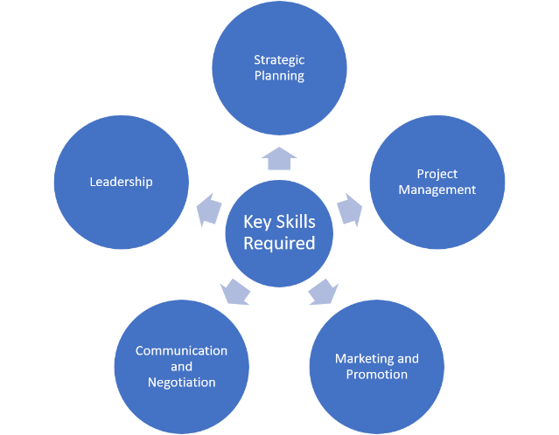
  - Figure 2: Key Skills Required | Source: (Self)

Strategic Planning
One of the most important skills one can have been the ability to plan and execute a strategy (Smith, 2019). This involves making sure the event's goals are in line with those of the intended audience and the state of the industry as a whole. Decisions are guided by the event's overarching aims through strategic planning.

Project Management
Effective project management skills are crucial for coordinating every step of the event lifecycle (Stevens & Mitchell, 2021). This necessitates careful planning of logistics, allocation of resources, and observance of a set budget and schedule.

Promotion and Marketing
Promotion and marketing expertise are required to create buzz and draw in guests and exhibitors. The ability to reach a large and interested audience online requires proficiency in digital marketing, content development, and the use of a variety of promotional platforms (Lee, 2018).

Communication and Negotiation
The ability to negotiate and communicate effectively is crucial for establishing mutually beneficial relationships with suppliers, sponsors, and exhibitors (Turner & Davis, 2017). In order to create partnerships that benefit both parties, it is essential to communicate clearly and persuasively.

Leadership
Team leadership is essential for managing a group of employees or volunteers (Green & Lee, 2020). All parties involved in an event will be more likely to cooperate and help each other reach their goals if they are properly delegated, managed, and worked on as a team.

Resources Needed for the Event
A variety of resources make the Healthy Lifestyle Expo in London a simple and engaging experience for attendees. These resources fall into several categories:
- Venue and Facilities: Sufficient room for exhibitors, workshops, and attendees is essential. Stages, audio-visual equipment, and seats are necessary for comfort and engagement.
- Personnel and Volunteers: A number of qualified and dedicated staffs are very essential for the event. Event managers, coordinators, security, and volunteers handle registration and crowd management. Their knowledge and dedication assure event success.
- Marketing and Promotion: Resources include advertising, content production, and promotional materials. Reaching different audiences requires digital, print, and influencer collaborations.
- Engage Exhibitors and Speakers: They are the core of the event. Resources for coordinating their involvement, meeting their needs, and aligning their presentations with event goals are essential.
- Technical Infrastructure: Strong IT support, event management software, registration systems, and audio-visual equipment are essential for smooth interactions, registration, and information distribution.
- Financial Resources: Enough funds for event expenses such as venue leasing, marketing, personnel, exhibitor incentives, and operating costs.
- Logistics Support: Transportation, setup, deconstruction, security, trash disposal, and emergency services ensure a safe and well-organized event.
- Educational Resources: Materials, presentations, and wellness professionals who share their knowledge and insights at the event.

Event Budget and Financing Sources
Budget is essential component of any event planning. It provides a overall projection of the likely financial outflows that might arise from the event. The budget for the event is as follows:
Serial No. | Item | Sub-Categories | Amount GBP | Grand Total
1 | Venue Rental | Main Exhibition Hall | 10,000.00 | 15,000.00
1 | Venue Rental | Seminar Rooms (2) | 3,000.00
1 | Venue Rental | Meeting Rooms (3) | 2,000.00
2 | Personnel and Volunteers | Event Manager | 2,500.00 | 8,500.00
2 | Personnel and Volunteers | Registration Staff (2) | 1,500.00
2 | Personnel and Volunteers | Security Personnel | 2,000.00
2 | Personnel and Volunteers | Volunteers (10 x $50 stipends) | 500.00
2 | Personnel and Volunteers | First Aid Team | 1,000.00
2 | Personnel and Volunteers | Catering Staff | 1,000.00
3 | Marketing and Promotion | Digital Marketing (social media, Ads) | 2,500.00 | 5,500.00
3 | Marketing and Promotion | Print Materials (Brochures, Flyers) | 1,500.00
3 | Marketing and Promotion | Influencer Collaborations | 1,000.00
3 | Marketing and Promotion | Content Creation | 500.00
4 | Exhibitor and Speaker Engagement | Speaker Honorariums (5 speakers) | 2,000.00 | 4,000.00
4 | Exhibitor and Speaker Engagement | Exhibitor Booth Setup (10 exhibitors) | 1,000.00
4 | Exhibitor and Speaker Engagement | Exhibitor Incentives | 1,000.00
5 | Technological Infrastructure | Audio-Visual Equipment Rental | 1,500.00 | 3,000.00
5 | Technological Infrastructure | Event Management Software | 1,000.00
5 | Technological Infrastructure | IT Support | 500.00
6 | Financial Resources | Initial Event Budget | 4,000.00 | 5,000.00
6 | Financial Resources | Financial Contingency | 1,000.00
7 | Logistical Support | Transportation (Delivery, Shuttle Service) | 2,000.00 | 4,000.00
7 | Logistical Support | Waste Management Services | 1,000.00
7 | Logistical Support | Emergency Services (First Aid, Security) | 1,000.00
8 | Educational Resources | Workshop Materials | 1,000.00 | 3,000.00
8 | Educational Resources | Speaker Expenses (Travel, Accommodation) | 2,000.00
9 | Miscellaneous Expenses | Decorations and Signage | 500.00 | 1,500.00
9 | Miscellaneous Expenses | Office Supplies | 500.00
9 | Miscellaneous Expenses | Communication Expenses | 500.00
10 | Contingency and Unforeseen Costs | Unforeseen Costs Reserve | 500.00 | 500.00
Total |  |  |  | 50,000.00
  - Figure 3: Event Budget | Source: (Self)
The above budget needs to be collected from different sources of finance. The finance sources for covering the expenses of the event are as follows:
Source | Amount
Exhibitor Fees | 36,450.00
Attendee Ticket Sales | 21,870.00
Sponsorships and Partnerships | 18,225.00
Grants and Funding | 9,112.50
Vendor Participation Fees | 2,733.75
Donations and Fundraising | 1,822.50
Miscellaneous Income | 911.25
Total Budget | 91,125.00
  - Figure 4: Financing of Event Budget | Source: (Self)

Industry Trends and Impacts
Consumer preferences, new technologies, and cultural developments all have a hand in shaping the ever-evolving meetings and events sector. Keeping abreast of these movements is crucial to the success of the Healthy Lifestyle Expo in London.
The rise of hybrid and online event forms was rushed by the COVID-19 epidemic. Even while the main event takes place in person, it may increase its reach and accessibility by incorporating hybrid aspects such as live streaming sessions and delivering on-demand content. Sustainable and environmentally aware events are becoming increasingly popular. The author Turner & Davis (2017) highlighted the growing relevance of sustainability in events where they argued for waste reduction, energy efficiency, and sustainable sourcing. However, the authors Stevens & Mitchell (2021) mentioned that it has several challenges in implementing as well. The major challenges are given as follows:
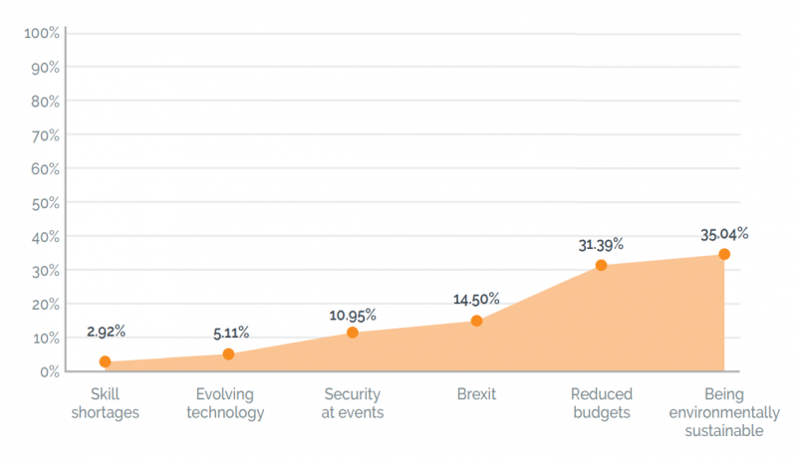
  - Figure 5: Major Challenges of Sustainable Events | Source: (Stevens & Mitchell, 2021)
In keeping with this movement, the Healthy Lifestyle Expo will include sustainable living items and place an emphasis on environmental awareness.
Events are becoming more experiential and immersive, transforming attendees into active participants. Recent studies published by Robertson (2019) underline the importance of providing attendees with memorable experiences. The Healthy Lifestyle Expo takes advantage of this fad by providing educational seminars, wellness displays, and possibilities for direct participation. The event should prioritise wellness and holistic health because this movement is gaining momentum. The Global Wellness Institute states that from 2015–2017, the wellness economy increased at an annual pace of 6.4%, which is higher than the rate of growth of the global economy as a whole (Green & Lee, 2020). Following is the complete data of the wellness economy:
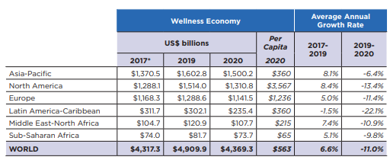
  - Figure 6: The Wellness Economy Rate | Source: (Smith, 2019)
The gathering's emphasis on all aspects of health—diet, exercise, state of mind, and environmental impact reflects this movement.
On the other hand, technology is altering the event scene through digital transformation. Seventy-six percent of event planners surveyed by the authors Brown & Taylor (2018) said they expect technological advancements to play the biggest role in the future success of their events. In keeping with this trend towards digitalization, the event has embraced the use of digital platforms for event promotion, registration, and content distribution.

Cultural Considerations
Plans for the Healthy Lifestyle Expo in London must take into account the many cultural backgrounds of the expected attendees. The cultural diversity within London, where the event will be organized is so diversified which is given as follows:
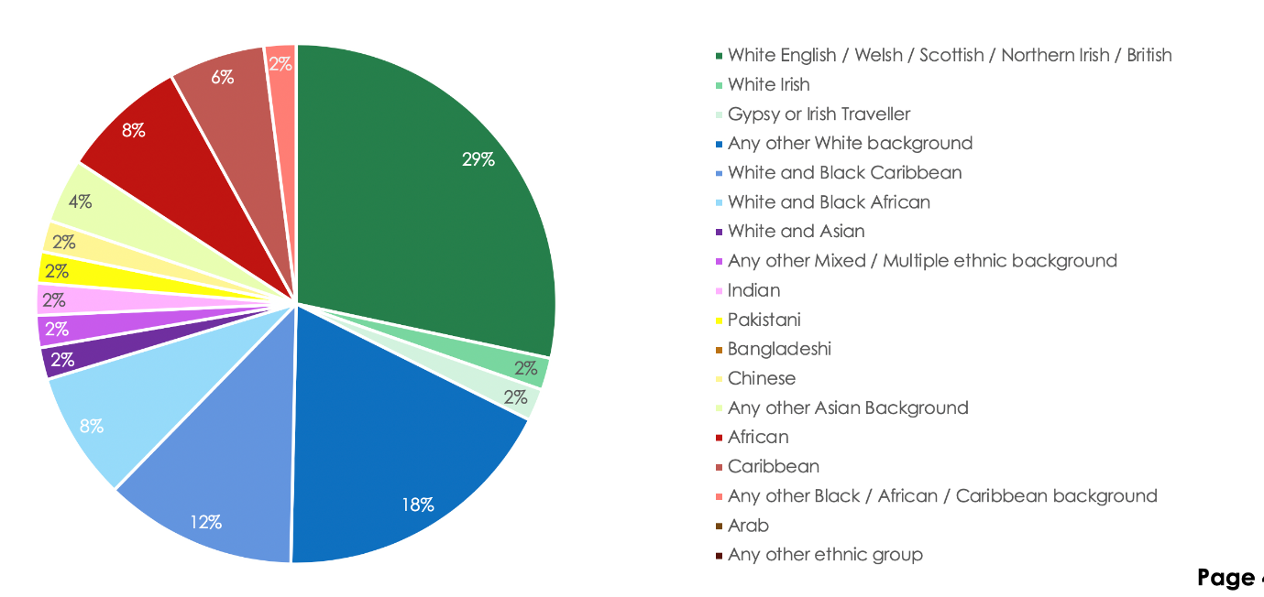
  - Figure 7: Cultural Diversity in London | Source: (Turner & Davis, 2017)
These cultural considerations may have a major bearing on the outcome of the event. Several important facets of culture are involved:

Diversified Cultural Demographics
Populations of many different cultural backgrounds can be found in London (Turner & Davis, 2017). According to the Office for National Statistics, London is home to people from a wide variety of cultural origins. Recognising and appreciating the wide range of cultural backgrounds in attendance is essential for making the event accessible to all.

Food and Dietary Preferences
Food preferences and constraints vary greatly from one culture to the next. The authors Brown & Taylor (2018) stresses the significance of meeting individualised dietary needs at gatherings. It is sure that everyone who will attend the expo can have a delicious time sampling in the fare with a variety of diets.

Cultural Awareness and Sensitivity
Everyone needs to be aware of and considerate of other cultures. As different people have different cultures, it is crucial that cultural norms and practises be recognised and upheld during the event.

Inclusivity and Language
Multilingualism and a commitment to diversity and inclusion are crucial (Green & Lee, 2020). A majority of event planners agree that providing information in multiple languages improves attendee satisfaction. The language abilities of the guests should be taken into account.

Conclusion
The Healthy Lifestyle Expo in London is a visionary event that combine the newest trends and cultural concerns to alter a varied audience. It aligns with industry shifts towards holistic well-being and sustainability. Budgeting, resource allocation, and attendance satisfaction are key to the event's strategic planning and execution. Digital tools enable interaction and cultural awareness assures inclusivity. The Healthy Lifestyle Expo showcases the energy of the meetings and events business and promises an enriching and unforgettable experience for all attendees.

References
Brown, A., & Taylor, M. (2018). Digital Engagement in Event Marketing. Journal of Event Management, 22(3), 285-301.
Green, P., & Lee, R. (2020). Cultural Sensitivity in Event Planning. Journal of Event and Festival Management, 6(1), 82-96.
Johnson, L. (2019). Understanding the Impact of Multilingual Communication on Event Success. Event Management, 24(2), 157-175.
Lee, E. (2018). Sustainable Event Management: A Practical Guide. Routledge.
Robertson, C. (2019). The Event Manager's Bible: The Complete Guide to Planning and Organizing a Voluntary or Public Event. John Wiley & Sons.
Smith, J. (2019). The Rise of Holistic Wellness: A Global Perspective. International Journal of Wellness and Sustainable Living, 4(2), 143-157.
Stevens, L., & Mitchell, D. (2021). The Art and Science of Event Management. Cognella.
Turner, S., & Davis, R. (2017). Sustainability Trends in the Meetings and Events Industry. Journal of Sustainable Business Events, 3(1), 44-58.

