

Detecting Anti-forensic Activity in NTFS File Systems
by
Joshua Lloyd

Supervisor: Carlene Campbell
Second Marker: Munya Murira

Project submitted as part of the requirements for the award of MSc Cybersecurity & Digital Forensics

September 2026

DECLARATION

I, .........Joshua Lloyd……… declare that I am the sole author of this Project; that all references cited have been consulted; that I have conducted all work of which this is a record, and that the finished work lies within the prescribed word limits.

This work has not previously been accepted as part of any other degree submission.

Signed : .............J.Lloyd.....................

Date : ..............07/09/26..................

FORM OF CONSENT

I ..................Joshua Lloyd………… hereby consent that my Project, submitted in candidature for the M.Sc. Applied Computing degree, if successful, may be made available for inter-library loan or photocopying (subject to the law of copyright), and that the title and abstract may be made available to outside organisations.

Signed : .............J.Lloyd.....................

Date : ................07/09/26.................

Table of Contents
Abstract 4
Chapter 1- Introduction 5
1.1 Context & Background 5
1.2 Research Problem 6
1.3 Research aim & Objectives. 7
1.4 Significance of research 8
1.4.1 Research Gap 8
Chapter 2 - Literature review 9
2.1 Overview of NTFS 9
2.2 Comparison of NTFS with FAT and FAT32 10
2.3 Anti-forensic Techniques in digital investigations 13
2.3.1 Detection of timestamp manipulation 14
2.3.2 Detection of Secure Deletion 15
2.3.3 Analysis of detection approaches 16
2.3.3 NTFS Alternate Data streams and data hiding 16
2.4 Detection Techniques & Correlation of evidence 17
2.5 Reliability and limitations of forensic artefacts 18
2.6 Manual and Automated detection 18
2.7 Related works 19
2.8 Synthesis 22
Chapter 3 - Research design & methodology 23
3.1Research philosophy – Pragmatism 23
3.2 Research Approach – Deductive 24
3.3 Methodological Choice – Mixed Methods 24
3.4 Research Strategy – Controlled Experiment 24
3.5 Time Horizon – Cross sectional 25
3.6 Data collection Methods 25
3.7 Data Analysis 25
3.8 Research design 26
3.9 Materials Table 28
Chapter 4 - Design Process 28
4.1 Introduction 28
4.2 Problem Formulation 28
4.3 Design 30
4.4 Implementation 31
4.5 Design Conclusion 32
4.6 Environment Build 33
Chapter 5 – Experiment and analysis 41
5.1 Experiment introduction 41
5.2 Testing 41
5.2.1 Baseline verification 41
5.2.2 Timestomping Test 43
5.2.3 Secure deletion Test 46
5.2.4 Automated extraction and comparison 49
5.2.5 Manual Autopsy Cross-Examination 51
5.3 Evaluation 53
5.3.1 Was timestomping successful? 53
5.3.2 Was secure deletion successful? 54
5.3.3 Cross referencing to related works 55
Chapter 6 – Conclusions & Recommendations 55
6.1 Summary 55
6.2 Conclusion 56
6.3 Recommendations for Further Research 56
Chapter 7 – Reflections 57
7.1 Introduction 57
7.2 Lessons Learnt 58
7.3 Things that could be done differently 58
7.4 Barriers experienced 58
7.5 Positives 58
7.6 Guidance to future students 59
7.7 Summary 59
Chapter 8 - References 60
Glossary 62
Appendices 63
Appendix A – Full-Size Diagrams 63
Appendix B – Hardware and Software Table 66
Appendix C – Python Source Code: extract_metadata.py 67
Appendix D – Python Source Code: compare_results.py 69
Appendix F – Full Test Case Log 70
Appendix G – Extraction and Comparison Data 71
Appendix H – Additional Evidence Screenshots 71
Appendix I – Project Plan / Gantt Chart 72

Abstract
This project Investigated whether timestamp manipulation commonly referred to as (Timestomping) and secure deletion within an NTFS file system in an automated manner than current existing tools allow. A controlled experiment was built in an isolated virtual environment, where files were timestomped using PowerShell and deleted using Sdelete using varied overwrite counts. By then using a python extraction script which automatically flagged tampering across the targeted timestamps files without the need for manual inspection, a cross check examination in autopsy then revealed that $FILE_NAME attributes and $STANDARD_INFORMATION’s MFT-Modified fields cannot be altered by using the methods set out in the project and retained their original data reproducing a discrepancy which was identified in the literature review as a valuable indicator. Secure deletion testing confirmed that the three target files were removed and were not recoverable by traditional filesystem access methods. These findings demonstrate that the automated detection of NTFS anti-forensic activity is achievable for certain information platform tampering, but also highlighting the need of scope expansion to include cross attribute automation in the form of $FILE_NAME to fully bridge the gap identified within the existing research.

Chapter 1- Introduction

Context & Background
Digital forensic investigations are an integral part of identifying, preserving, analysing and presenting digital evidence within modern computing environments. As digital devices continue to form a critical part in both personal and organisational activities, having the ability to recover and interpret digital evidence is becoming increasingly important for law enforcement and cybersecurity professionals. Within windows base systems, the New Technology File System (NTFS) is the most common amount file services and an invaluable source for forensic evidence. NTFS is such a string well of information due to it providing a rich collection of metadata and journaling mechanisms that record information that relates to file creation, modification, access and deletion. Key artefacts such as the master file table (MFT), update sequence number (USN) journal, and various timestamp attributes that enable investigators to reconstruct user activities, establish timelines and identify system events. These artefacts are often essential to determine how and when specific actions are taken on a system, making NTFS a significant focus within digital forensics.
However, despite the forensic value of NTFS, the effectiveness of an investigation is being constantly challenged by the development and use of anti-forensic techniques. Anti forensic refers to a range of methods designed to conceal, manipulate or destroy digital data which could be used as evidence in order to hinder forensic investigators and evade detection. As forensic tools and investigative methodologies continue to advance, attacker have similarly developed sophisticated counter techniques to undermine the integrity and reliability of evidence. Among the most encountered anti-forensic techniques is timestamp manipulation, also often referred to as "timestomping". Timestomping involved modifying the metadata to alter timestamps associated with file creation, modification, or access which misleads investigators and disrupts the reconstruction of event timelines. Since digital forensic investigations rely on timestamp information to establish a sequence of activity, the manipulation of this data can significantly affect the accuracy of findings during an investigation.
Similarly to timestamping, secure deletion techniques are techniques designed and focused on the permanent removal of data rather than manipulation, this is achieved by overwriting storage location, preventing traditional file recovery methods for reconstructing deleted information. Although standard file deletion often leaves recoverable data within the file system, secure deletion tools aim to eliminate these traces through one or multiple overwrite operations. Although these methods are more generally intended to prevent the recovery of data, it has been shown that secure deletion processes can themselves leave detectable artefacts within NTFS structures. Nevertheless, the presence of techniques with this ability increases the complexity of forensic investigations and can significantly increase the time and effort needed to identify relevant evidence.
The growing use of anti-forensic techniques presents a difficult challenge for digital forensic practitioners. By exploiting weaknesses within forensic tools, metadata structures and investigative procedures, these techniques significantly reduce the reliability of evidence and increase the likelihood of incomplete or inaccurate findings during and investigations. Furthermore, anti-forensic methods are often used in combination, making detection even more difficult. As a result of this there is an increasing need for robust detection mechanisms which are capable for identifying signs of timestamp manipulation, secure deletion and other forms of anti-forensic activity within these types of environments. Developing effective methods for detecting these behaviours is crucial for improving the reliability of digital investigations and maintaining the evidential value of forensic data.

Research Problem
Although existing research has demonstrated that both timestamp manipulation and secure deletion can leave detectable artefacts within NTFS, current digital forensic practises still face multiple limitations when attempting to identify and interpret said forms of anti-forensic activity. A significant limitation of this technology is that the detection techniques used are most often applied in isolation, with timestamp analysis and secure deletion detection treated as a separate investigative process. This approach can be problematic because anti-forensic activity does not occur through one specific technique. An individual attempting to conceal their malicious activity could manipulate timestamps before deleting or combine secure deletion with other methods of concealing evidence. Analysing each individual techniques may result in important relationships between different MTFS artefacts being missed, potentially reducing the overall effectiveness of investigation.
Furthermore, many existing detection approaches rely heavily on the manual interpretation of metadata inconsistencies by investigators. Investigators may also be required to compare timestamps across different NTFS artefacts, examine MFT records and analyse USN journal activity in order to identify inconsistencies that could indicate tampering. Although this approach can provide valuable evidence, it can also be very time consuming in particular when analysing large forensic images which contain thousands of files. The interpretation of these inconsistencies can also depend on the experience and personal judgement of the investigator. Differences in timestamps do not automatically indicate that there has been malicious activity, as legitimate processes can also produce unusual metadata on occasion. Therefore, it relies heavily on the manual interpretation of an investigator which can introduce inconsistencies and increase the possibility of human error.
Another limitation of current technologies is that they generally provide investigators with access to individual artifacts rather than presenting the evidence as part of an integrated anti-forensic detection process. Tools such as autopsy and FTK can provide access to important NTFS artifacts and assist with forensic analysis, but the identification on whether these artifacts collectively indicate a deliberate attempt of manipulation can still require significant investigator involvement.
Existing approaches also rarely provide a quantitative indication of the likelihood that the detected inconsistencies found are the result of intentional tampering. In the majority of cases, an investigator may identify several suspicious artefacts but are still required to make a subjective judgement regarding whether they represent anti-forensic activity.
The problem becomes increasingly significant when considering the mass volume of digital evidence that is generated by modern windows systems. To manually examine large forensic images of that size is highly inefficient and creates greater opportunity to be overlooked. An automated tool that is capable of systematically identifying any suspicious artefacts will massively improve efficiency of a forensic investigation while maintaining a clear connection between the original state the evidence was found in and the resulting findings of the screening. However automated tools must be designed very carefully as not every inconsistency can represent suspicious activity. The system would therefore need to be able to distinguish between normal NTFS behaviour and indicators provide stronger evidence of intentional manipulation.

Research aim & Objectives.
The aim of this research is to design and evaluate an automated framework for detecting timestamp manipulation and secure deletion artefacts in NTFS file systems. To achieve this, aim several objective need to be identified and met. Firstly, the study will analyse NTFS metadata structure relevant to forensic investigations. Secondly, it will simulate anti-forensic techniques, more specifically timestamp manipulation and secure deletion within a controlled environment. Thirdly an automated detection framework will be developed to identify anomalies within the NTFS metadata. Fourthly a weighted anomaly scoring model will be implemented to quantify the likelihood of tampering. Finally, the framework will be evaluated using quantitative performance metrics.
Aim:
To design and evaluate an automated framework for detecting timestamp manipulation and secure deletion artefacts in NTFS file systems.
Objectives:
- Analyse NTFS timestamp structures
- Simulate time stomping and secure deletion
- Complete a structured literature review on the chosen topics
- Implement automated detection tools
- Evaluate detection accuracy and reliability
- Documenet and analyse results

Significance of research
This research is significant to this topic in both academic and practical contexts. Form an academic perspective it contributes to the growing body of knowledge on anti-forensic detection by integrating the techniques that are typically studied in isolation. From a practical standpoint, the proposed framework has potential to enhance the efficacy and reliability of digital forensic investigations. By reducing the reliance on manual analysis and introducing a structed approach to tampering assessment this research will support more consistent and defensible forensic reporting. Additionally, it will provide a foundation for any future work in automated forensic analysis and the detection of more advanced anti forensic techniques.

Research Gap
The review of literature conducted so far has demonstrated that both timestamp manipulation and secure deletion are detectable within file systems under certain conditions however there are still several key limiting factors:
First, detection techniques are still largely studied in isolation, with little to no integration between different anti-forensic methods. This is problematic, as real-world environments often involve multiple techniques used in combination.
Secondly, many approaches rely on the manual intervention of analysis or use of tools, which reduces the scalability and increasing the risk of human error. The absence of an automated framework limits the practical application of these techniques in a large-scale investigation.
Thirdly, there is a severe lack of structured models for quantifying tampering likelihood. Most of the studies that we reviewed focus on identifying anomalies but do not provide a method for evaluating the significance.
Finally experimental evaluations are often limited, with few studies testing their approaches across multiple scenarios or using standard performance metrics.
These limitations highlight my research gap, which is the need for an automated, integrated NTFS forensic framework that combines timestamp manipulation detection analysis with a structured threat model. Upon completion of this research, it could also support further advancement to other file storage methods and additional anti-forensic techniques.

Chapter 2 - Literature review

2.1 Overview of NTFS
This Paper focuses on the NTFS (New technology file system) which is the primary file system used by modern windows operating systems. This file model was first introduced with windows NTFS, and it was designed to provide improved reliability, performance and security compared to predated file systems such as FAT and FAT32. NTFS is widely adopted because of its more advanced features which include metadata management, access controls, journaling and support for large storage volumes [1].
Within the NTFS file system every single object inside of it is a file and inherits all of the characteristics of a file. Therefore, this also includes metadata which defines the structure of the file itself. NTFS organises structures on disk volumes in for logical blocks. The most important feature of NTFS is the master file table (MFT) which is implemented in the system as a records array.[1] Every file and its directories has at least ONE entry within the MFT, this also includes the MFT itself, every single entry in the MFT is known as a file record and holds a default storage size of 1024 Bytes. The first 42 bytes in a record is reserved for the MFT entry header, and the remainder are used to store the attributes of the file [9].
An attribute is a small data structure that is used for a specific purpose for example:
- $STANDARD_INFORMATION: Contains core metadata such as timestamps (Modified, Accessed, Created, Entry Modified).
- $FILE_NAME: Stores file name details along with an additional set of timestamps.
- Data attribute: Contains the actual file content.
This attribute-based structure allows NTFS to maintain redundancy in metadata, which is particularly valuable in forensic analysis.
Due to the attribute-based structure of NTFS it's also provides additional forensic information beyond the conventional content of the files. NTFS maintains transaction and journaling information which concerns itself with changes to files and their directories [1, 5]. Examined these structures alongside other windows artefacts when investigating timestamp manipulation and it demonstrated the importance of cross-examining sources rather than relying on a singular timestamp [5]. This inparticulary relevant to forensic investigations because a timestamp anomaly does not automatically indicate malicious activity. Legitimate system processes can also produce inconsistences between timestamps, meaning that the additional evidence is required before manipulations can be confidently identified. [5]
One incredibly useful and defining feature of NTFS is its journaling capacity. Through data such as transaction logs, NTFS records any changes to the file system before they are altered. This helps improve the reliability of the system by enabling the recovery of data after unexpected crashes or shutdowns. Additionally, NTFS also support file permission and access controls through ACL’S (Access control lists), which allow administrators to define security policies for files and directories. This also enables support for encryption, compression and disk quotas, which make it suitable for personal and enterprise environments.
NTFS also supports additionally functionality such as alternate data streams (ADS), which can be used to associate additional information with a file. Huebener examined data hiding within NTFS and demonstrated the potential for NTFS structures to be used to conceal information [7]. Hermon singh also similarly investigated forensic techniques for detecting hidden information within the NTFS alternative data streams [10]. This Demonstrates that the forensic examination of NTFS should not be restricted to just visible files due to additional information existing within the underlaying file system structure.
The reason NTFS has been chosen for this paper is primarily due to its relevance in Digital forensic investigations as it preserves a large amount of metadata. The presence of multiple timestamped attributes across multiple structures which allows investigators to reconstruct file activities and detect any anomalies. As an example, inconsistences between timestamps stored between $STANDARD_INFORMATION and $FILE_NAME can indicate file manipulation.
Furthermore, unlike other file systems NTFS does not immediately remove file metadata upon deletion. They instead remain in the MFT until they are overwritten which provide opportunity for investigator to recover and analyse the data. There are also additional artefacts that can be found such as journaling logs which can offer insight into the history of the system activity.

2.2 Comparison of NTFS with FAT and FAT32
Although NTFS is the primary focus of this research, comparison with alternative file systems such as FAT and FAT32 is important as forensic techniques, and available artefacts differ according to the underlaying structure of the file system. FAT based systems predate NTFS within windows environments and use a considerably simpler approach in their structure centred around the file allocation table hence the name. FAT32 remains particularly relevant to digital forensics as it is still in used today on portable devices such as USB drives and SD cards. Toolan describes FAT as a relatively simple file system that is now primarily encountered exclusively on removable media, whereas NTFS is the standard windows file system.
A key difference between NTFS and FAT32 is how files and their associated information and organised. NTFS uses the MFT as its central file-record structure, whereas FAT32 relies upon directory entry and the file allocation table to manage its file allocation. [14] conducted a forensic comparison of NTFS and FAT32 and identified differences in areas including key structures, storage mechanisms, directories, file names, times, detection and encryption. Their research demonstrates that these structural differences directly influence various types of information that is available during forensic analysis.
From the forensic perspective, NTFS provides a larger number of interconnected artefacts that have the potential to be used to reconstruct activity within a system. The MFT provides information relating to files and directories, while logfile and Usn Journal can provide additional information and insights concerning the file-system activities. [1, 5]. FAT32 does not contain an equivalent to the NTFS structure, meaning that an investigator must rely heavily on directory entries, allocation information and other available system artefacts. However, this does not make FAT32 forensically insignificant alternatively it means that the method of investigation needs to be adapted to the structure of the file system that is being investigated.
The difference between both systems becomes important when examining deleted or wiped files. Nabity and Landry conducted a forensic comparison of both FAT32 and NTFS in relation to deleted files on their systems, demonstrating that the characteristics of the filesystems can affect the recovery and the interpretation of the information following the deletion of the files.[15] This research highlights the importance of considering the underlaying filesystem when evaluating the effectiveness of forensic recovery techniques.
Toolan [12] provides relevant evidence in their research because they examined windows file wiping tools across FAT32, exFAT and NTFS. Their findings demonstrate that FAT32 and exFAT directory structures and NTFS MFT entries could provide evidence that relates to the used of wiping tools and the rementants of affected files. In NTFS, $LogFile and $USNJRNL, together with windows registry information, provided additional evidence concerning wiping activity [12]. Their findings therefore demonstrate that anti-forensic activity can leave evidence across the system, but the nature and location of said evidence vary due to the file systems architecture.
The comparison therefore demonstrates that NTFS provides a particularly useful environment foe investigating anti-forensic behaviour as multiple sources of evidence can be correlated. However, this does not necessarily mean that NTFS us superior from a forensic perspective. FAT32 has a much simpler structure and remains important due to its presence in removeable media. Its simplicity can also make certain aspects of manual file system analysis much simpler to understand. Toolan notes that FAT provides an opportunity for the development of manual analysis skills due to its simple nature [13].
A further difference which concerns the alternate data streams. NTFS supports the use of multiple data streams which are associated with a file, providing additional opportunity for both legitimate functionality and data hiding [7, 10]. FAT32 does not provide an equivalent feature to the NTFS ADS mechanism. Rubarsky’s comparison also similarly identifies the ability of NTFS to support additional data streams as an important difference between NTFS and FAT32. [14]
Recent research also reinforces the idea of importance of considering filesystem differencve4s when analysing anti forensic activity. [16] examines FAT, NTFS, HFS and EXT from a forensic perspective and identifies the differences between their structures, operations characteristics and challenges associated with the collection of evidence. Their discussion highlighted the simplicity of FAT, the MFT and journaling capability of NTFS, and the different forensic considerations associated with the other file systems.
Additional research into file-system data hiding also suggests that ani-forensic opportunities are not restricted to NTFS. A 2025 study examined that data hiding techniques across NTFS, FAT and EXT file systems and demonstrated that different filesystem structures can create different opportunities for hiding information [17]. This also reinforces the importance of understanding the underlying structures when interpreting potential anti forensic activity.
Overall, the comparison between NTFS and FAT/FAT32 demonstrates that the forensic value of a file system is very closely related to the amount and type of information that it preserves. NTFS provides investigators with a larger amount of information with the use of MFT, multiple metadata attributes, journaling structures and additional functionality such as alternate data streams [1, 5, 7]. While FAT32 provides a simpler environment to work in centred around the file allocation table and its directory structures but can also contain useful evidence be relating to deleted and wiped files [12, 15]. Therefore, forensic investigators cannot assume that the same detection or recovery techniques will be effective across different files systems and produce equivalent results.
For the purpose of this research, NTFS remains the most appropriate focus as modern windows systems operate on this standard and due to its extensive metadata and journaling capabilities provide a source of evidence through which timestamp manipulation and secure deletion can be examined. The comparison with FAT and FAT32 is still nevertheless important because it demonstrates that the findings are specific to the NTFS environment structure and should not be generalised with other file systems.

2.3 Anti-forensic Techniques in digital investigations
Anti-forensic Techniques have become increasingly sophisticated over the years, which pose a significant challenge to digital investigations [2]. Provides a comprehensive review, categorising anti-forensic techniques into their respective categories such as data destruction, data obfuscation, data hiding and evidence manipulation. This work highlights the immense evolution of such techniques that are driven by the accessibility of anti- forensic tools and increasing awareness of bad actors.
A significant characteristic of anti-forensics is that various techniques target different stages of the forensic investigation. Timestomping primarily targets the interpretation of the information, because it attempts to alter the chronological meaning of the evidence found. Secure deletion in comparison targets the availability of evidence, because it attempts to prevent an investigator from recovering useful information in its original state. Data hiding techniques such as ADS target the visibility of information as they attempt to conceal files within their file structures and they may not be examined.
The distinction between these techniques are important because it demonstrates the anti-forensic behaviours cannot be addressed through a singular technique. An investigator must consider how the technique can be applied and effect the evidence and which secondary artefacts can still remain.
Horsman [19] introduced the concept of digital tools marks in the same context of file wiping software's, demonstrating that the processes that are used to manipulate evidence can itself leave behind traces. His research examined eight different wiping applications and attempted to determine whether the resulting traces could be associated with specific tools.
This also provides a broader insight into the interpretation of anti-forensics. An investigator's objective is to not only recover what a suspect tried to remove or destroy, they can also investigate how the suspect attempted to remove it.
Horsman and Errickson [21] also similarly argued that in the absence of an expected artefact may itself have significance when considered alongside the wider picture [21]. Their research also highlights the importance of consideration what should be present within the system itself and where an absence can be explained through the regular system activity.
However, this absence should not be automatically assumed to be subspinous and as proof as anti-forensic activity. Files can disappear through ordinary deletion, automatic system maintenance, overwriting and multiple other legitimate system processes. Therefore, the absence of such artefact or files should not be treated as an indicator of malicious intent.

2.3.1 Detection of timestamp manipulation
Timestamp manipulation also commonly referred to as “time stomping”, is a widely used anti-forensic technique. It involves manipulating file timestamps to obscure a timeline of events. The NFTS is particularly vulnerable to this method as it heavily relies on timestamp metadata for system activity reconstruction. [5] provides one of the most detailed analyses on artefacts in NTFS. Their work evaluates the reliability of multiple metadata attributes and showcases the inconsistencies between $STANDARD_INFORMATION and $FILE_NAME timestamps are signs of manipulation [1]. However, they also indicate that not all inconsistencies are sign of manipulation or malicious activities, as sometimes normal system processes may produce a similar pattern.
Building on top of this [4] proposes the use of Volume shadow copies to avoid suspicious timestamps. By comparing the current metadata with historical snapshots of system activity, they improved the detection reliability. While this approach can be effective, it is heavily dependent on the shadow copies availability which is not always present in a real working scenario which again limits it practical applications much like [5].
In a more recent study [3] introduces a structured approach to timestamp manipulation detection and focuses on the identifying patterns of inconsistency within the metadata. Their work represents a bigger step toward automation but still largely focuses on timestamp artefacts in isolation instead of paired. Additionally, this study does not fully address how detection methods perform when they are used with other anti-forensic techniques [9].
Another paper which reinforces this issue works on practical timestamp manipulation detection notes that an existing NTFS Journal based methods can produce false positives when applied to a real-time environment [20]. This is particularly relevant to the proposed idea because it demonstrates that a detection technique may perform successfully within a lab environment but become less effective when exposed to the complexity of a real running windows system.
Therefore, the practical investigation should establish a nominal baseline of regular system activity before any anti forensic techniques are applied. This would allow timestamp manipulation relationships which are produced by ordinary file creation, modification and deletion to be compared against relationship produced after timestomping.
Overall, the literature on Timestamp manipulation demonstrates that it is detectable throughout metadata analyses. However, existing approaches are either reliant on a specific feature or require manual intervention and interpretation which severely limits their scalability and consistency.

2.3.2 Detection of Secure Deletion
Secure deletion techniques aim to permanently remove data by overwriting storage to prevent the recovery of data. This is often achieved by using a specified tools set that perform multiple overwrite passes on a storage medium. Traditionally, methods such as these were largely assumed to be highly effective in eliminating forensic traces.
Secure deletion tools attempt to overcome this by overwriting or otherwise manipulating storage associated with the deleted data. However, the effectiveness of the techniques is dependent upon the storage technology being used.
However [6], challenges this through their “de-wimptimisation” approach. Their study found that wiping tool leave detectable artefacts, which include abnormal cluster allocation patterns and entropy data remnants. This finding is highly significant as it suggests that even when advanced data destruction methods are not largely effective. Despite the studies contributions to denouncing the assumption that wiping tools are highly effective the study also has its limitations. Firstly, the detection methods are mostly based on identifying static patterns, which may not translate well into a more sophisticated wiping technique, also the research conducted does not integrate its findings into a forensic framework, limiting its use in a real-world investigation.
Horsman's experimental work provides particularly useful evidence because it tested eight different tools rather than treating file wiping as a single uniform process [19]. The study investigated both NTFS and FAT32 and also identified digital tool marks and recoverable file-system metadata after wiping operations.
This is important to the project as it demonstrates that different wiping tools may not always produce identical forensic outcomes. A wiping technique may modify metadata differently depending on how the application performs the deletion operation.
Furthermore, evaluating secure deletion detection is often conducted inside of a controlled lab environment which can also raise questions about the effectiveness inside of a complex system. Due to this fact a need for more comprehensive testing and integration is needed alongside other detection methods.
Another important consideration is the difference between traditional magnetic storage and modernised solid-state storage. Techniques that rely upon overwriting specific physical location be more complicated on SSD’S because of mechanisms such as wear levelling and TRIM. Due to this difficulty, the relationship between the logical file-system state and the physical storage medium is not always straightforward.
This also means that the claims concerning the effectiveness of secure deletion should also be carefully restricted to the environment being tested. A result that is obtained from an NTFS volume running within a controlled virtual machine should not be interpreted as evidence as the same techniques will produce the same results on every volume.

2.3.3 Analysis of detection approaches
After examining the literature, it reveals that both timestamp manipulation and secure deletion detection both rely on the identification of anomalies with the NTFS structure. However, the approaches differ largely in their methodologies and limitations.
The use of timestamp manipulation techniques focuses on the metadata inconsistencies, leveraging the redundancy of NTFS file attributes. These methods are effective in practise but are highly prone to generating false positives due to legitimate processes in system behaviour can produce the same results. In contrast secure deletion relies on the data level of analysis, (e.g) entropy management and cluster allocation patterns, which are more robust but are not precise in identifying specific intentional actions.
More importantly, these two approaches are rarely combined in practise. Most studies focus on a singular type of anti-forensic technique, which results in weaker detection strategies. This lack of integration between multiple anti-forensic techniques severely limits the ability to detect complex scenarios in which multiple techniques are use simultaneously. In addition, the majority of existing approaches lack quantitative evaluations. While some studies have shown and demonstrate detection capabilities, very few provide a standardised metric such as accuracy, precision etc. This makes it more difficult to Compare the methods or assess their effectiveness.

2.3.3 NTFS Alternate Data streams and data hiding
Data hiding represents another critical area of anti-forensic research. [7] examined methods for hiding information within the NTFS structure and also demonstrated that the specific structure of the file system can be exploited to conceal information from the conventional tools used in forensic examination.
Alternate streams of data are also relevant because they allow additional information to be passed and associated with an existing stored file. This also means that an investigator that only examines conventional files and directories may fail to identify information stored within these additional streams.
R. Herman et al [10] further examined the forensic techniques used for identifying hidden information within NTFS. Their research reinforces the idea of examining alternate data streams when attempting to identify concealed data.
ADS is also relevant to anti-forensics as it illustrates how and attacker can avoid deleting or modifying an obvious file all while still concealing information within the same environment. Therefore, an investigation that exclusively focuses on visible files will miss relevant evidence.
The presence of ADS also supports the importance of metadata analysis. Hidden data streams can potentially be examined alongside timestamps. MFT information and other artefacts within NTFS. This provides investigators insight and opportunity identify relationships between both the visible and hidden data. ADS should be applied in use alongside timestamp and secure deletions detection rather than an entirely separate issue. All three techniques in combination demonstrate how the structure of NTFS can influence the availability of data and the interpretation of evidence.

2.4 Detection Techniques & Correlation of evidence
Literature increasingly supports that the principles of anti-forensic detection should rely upon the correlation between multiple sources of data rather than a singular indicator.
Palmbach and Breitinger [5] specifically expanded the method of timestamp analysis beyond the standard MFT and $logfile by investigating $USNJRNL, linked files and windows event logs. The findings demonstrate how different artefacts can provide and array of information whether it be through additional timestamp information or evidence from a particular program or executable process. This also creates the possibility of being able to reconstruct an event from multiple perspectives.
For example, if a files MFT timestamp indicates that it was created multiple months before an investigation. IF the USNJRNL contains evidence of a recent file creation and the prefetch shows information of a timestamp manipulation utility, the evidence then becomes a more substantial finding than a singular MFT timestamp.
However, this also does come to question the reliability. A study conducted by [5] as it introduces an important limitation. There findings suggest that none of the artefacts examined could withstand an active exploitation. Therefore, the correlation does not eliminate the limitation of individual artefacts, infact it provides investigators with additional opportunities to identify contradictions within the data.
The distinction is important for the proposed research. As the objective should not to be to identify a single artefact that proves manipulation. Instead, the investigation can assess whether or not a combination of artefacts provides a stronger pool of evidence.

2.5 Reliability and limitations of forensic artefacts
One of the most important findings from literature is that the forensic artefacts are not immune or permanent from manipulation.
Palmbach and Breitinger [5] research provides a particularly strong base of evidence for this limitation. Their study demonstrated whether artifacts commonly used for timestamp manipulation detection could survive a deliberate attempt to remove or edit them. They came to the conclusion that none of the artefacts that they tested could withstand an active exploitation this demonstrates that anti forensic techniques can potentially affect the evidence used to detect them.
This creates a substantial problem. If an attacker can understand how investigators identify timestomping, they may be able to deliberately target those specific detection mechanisms. Consequently, forensic investigators also cannot assume that in the absence of an artefact that there has been manipulation.
This is where the concept of confidence over certainty becomes especially important.
For example, and investigator can identify:
- Inconsistent MFT timestamps
- Evidence of timestamp Utility
- Contradictory Journal records
- An unusual sequence of file operations
As individuals these artefacts may have alternative explanations, however when combined together, they can provide a much stronger basis to conclude that there has been manipulation.

2.6 Manual and Automated detection
Automation within forensics has the potential to significantly reduce the time that is required to examine large volumes of digital evidence. However, the literature also demonstrates how automation introduces its own challenges.
Oh’s [20] research specifically identifies false positives as limitation of existing NTFS journal-based timestamp detection tools when moving from controlled environments to real world applications.
This is relevant to the topic as it demonstrates a limitation between the validity of experimental and operational capacity. A detection method that successfully identifies manipulated timestamps within a controlled environment is more likely to be true as the researcher knows exactly what has been manipulated in the system. However, in a real investigation there can be a multitude of legitimate system operations that can produce similar artefacts.
Therefore, automated system needs to able to distinguish:
Normal Behaviour - Suspicious behaviour – Probable Manipulation
Rather than:
Normal Behaviour – Manipulation

2.7 Related works
There have been several existing studies which have investigated the detection of anti-forensic activity within windows NTFS environments, providing a foundation for the proposed research. However, the approaches that are adopted within these previous studies vary considerably in terms of anti-forensic techniques that were investigated, the forensic artefacts analysed and the extent to which multiple detection methods are used together. By reviewing these studies, it provides the opportunity to identify any similarities within my proposed project while also enabling the establishment of how the projects differ from existing works.
One of the most directly related studies is work conducted by [3], which investigated methods for detecting timestamp manipulation within NTFS environments. The researchers examined a range of pre-existing detection approaches based on filesystems and OS artefacts then comparing the effectiveness. Their findings identified that NTFS based journal approaches are particularly effective for detecting timestamp manipulation. This being relevant to the proposed project because timestamp manipulation represents one of the two main focuses in anti-forensic techniques in the project. However, this study is mainly concerned with timestamp manipulation and does not provide the same level of practical investigation into secure deletion. The proposed project therefore expands into this area by investigating timestamp manipulation alongside additional anti-forensic techniques rather than treating timestomping as an isolated problem.
Earlier research conducted by [18] also investigated the detection of timestamp forgery within NTFS. Their research demonstrated that by examining the timestamps that are directly associated with a file may not be sufficient to determine whether manipulation has occurred. Instead, historical information that is contained within NTFS log records can provide additional evidence concerning changes made to file timestamps. This provides important support for the proposed project as it demonstrates the relevance of comparing current metadata with the historical activity of file systems. However much similar to the work of [3], the focus again primarily focuses on timestamp forgery. The proposed project looks to expand further by examining whether the use of cross artefact analysis can be applied when investigating both timestomping and secure deletion.
Palmbach and Breitinger [5] Also provide another closely related study through their examination of artefacts used to detect timestamp manipulation within NTFS. This research considered multiple artefacts, including USNJRNL, link files and windows event logs, rather than needing to rely Soley upon the timestamps stored within the MFT. This kind of approach is relevant to the project as it demonstrates the importance of correlating evidence from different techniques and areas of the environments. However, their research also highlighted a significant limitation: the reliability of forensic artefacts can be affected when an attacker is actively attempting to manipulate or remove them. Therefore, the existence of an artefact in an environment cannot be assumed to be conclusive evidence. The proposed project adopts a similar principle by evaluating multiple NTFS artefacts following controlled anti-forensic activities and then assessing how the artefacts can be consistently identified.
Research conducted by Mohamed and Khalid [4] also further demonstrates the importance of the examination of historical information when investigating suspicious timestamps. Their study investigated the use of volume shadow copies to identify suspicious NTFS timestamps. This provides additional information in regard to historical information that can be used to compare the state of a file against an earlier iteration. Although this approach provides a valuable insight into timestamp investigations, it is very dependent upon the availability of the appropriate volume shadow copy data. The proposed project instead places more emphasis on artefacts that are directly associated with NTFS and windows environment so that an investigation can evaluate the evidence found during a controlled activity.
Another significant similarity can also be identified between the proposed project and the work of [6] who developed the De-wimptimization approach for detecting traces of data wiping within NTFS. Their research is important because it moves beyond simply attempting to recover deleted files and instead investigates the traces generated by the wiping itself. The proposed project also follows a similar principle as by treating secure deletion as a forensic event rather than as a disappearance of a file. However, De-wimptimization places a considerable emphasis on the identification of the wiping activity using NTFS transaction logs and machine learning. In comparison, the proposed project is designed around a controlled investigation in which anti forensic activity is deliberately conducted and the results analysed. This will provide a more direct approach of examining the relationships between the action and the evidence generated.
Alharbi et al. [11] Provides a comparison through their examination into file-wiping tools on windows. Their study examined four file wiping tools across storage platforms including FAT32, exFAT and NTFS and investigated the changes to the file system metadata, link files, registry keys. Most importantly their research found that MFT, logfiles and USNJRNL can provide evidence relating to wiping activities and that additional structures, which include alternate data streams and were not wiped by the testing tools. This is relevant to the proposed project because it demonstrates that secure deletion cannot remove every single trace associated with the activity.
The proposed research is similar to [11] within its practical investigation of anti-forensic activities within windows NTFS. However, there is a significant difference in scop between the projects. [11] primary investigated file wiping tools, whereas the proposed project investigates timestamp manipulation alongside secure deletion. This allows the project to compare two different anti-forensic objectives: manipulating and interpreting the evidence found through timestamps and reducing the availability of evidence through deletion.
Horsman's [19] Research provides another important comparison between projects. Their investigation examined eight available file wiping tools and then attempted to identify tool marks which were left by those tools. The research conducted considered both FAT32 and NTFS and also investigated recoverable file metadata followed by wiping operations. This concept of digital tool marks is useful information as it changes the focus of anti-forensic investigations from just looking if evidence has been removed to examining whether the process used to remove that evidence has left traces itself. This concept has also been developed further by [21] who proposed that these tool marks that are left behind can assist investigators in determining what activity has occurred on a device. This is also closely aligned alongside the proposed project as the practical investigation will examine the artefacts generated after knowing anti-forensic actions. Therefore, rather than assessing whether the original file or timestamps can be recovered, the project can take a wider look at the forensic footprint produced by the activity.
Gonzalez Arias et al. [2] provides a broader perspective through their systematic review of anti-forensic computer techniques. Instead of focusing on a single technique their research instead examines a wider forensic landscape. This further supports the decision to investigate more than one anti-forensic technique within the proposed project. However, a systematic review does not provide the same experimental results as a controlled investigation. The proposed research therefore complements this paper by implementing selected techniques discussed in the literature and analysing their effects within an environment.
Another important area of comparison is the use of automated detection. Research conducted into timestamp tampering using machine learning has demonstrated that timestamp manipulation can potentially be detected automatically. One study developed a machine learning approach using a synthetic dataset that was generated within a controlled virtual environment and evaluated the results classification using measures which included accuracy, ROC curves, precision- recall curves and log losses. This demonstrates the potential for quantitative and automated detection of timestamp manipulation.
However, by making use of machine learning also introduces additional requirements that relate the construction of datasets and model validation. The proposed project does not seek to develop a machine learning classifier. Instead, it focuses on the identification and evaluation of the underlying forensic models generated by know anti-forensic actions. This creates the distinction between the two approaches. As machine learning focuses on the automatic classification of evidence whereas the proposed project narrows down on the understanding of forensic characters that could support automated detection.
A more recent study that was conducted by [20] highlights thew limitations associated with the reliance upon NTFS journal-based timestamp detection in a real-world environment. The study does note that the methods based on Logfile and USNJRNL can generate false results when moved beyond the limits of controlled experimentation. This is important when comparing with other research as it demonstrates why an experimental evaluation should consider both successful detections and incorrect detections.
Overall, the existing research is believed to provide strong evidence that NTFS contains highly valuable forensic artefacts that can support an investigation of anti-forensic activities. Previous studies have conducted research and investigated timestamp manipulation [3, 4, 5, 18], file wiping [6,11 ,19] data hiding [7, 10] and broader anti forensic techniques [2]. However, these studies more than frequently focus on a specific anti-forensic behaviour or detection technique. While a focused approach is valuable for understanding an individual technique, it can provide less opportunities to directly compare the characteristics of various forensic techniques within the same controlled environment. The proposed project therefore will share several characteristics with previous research all while adopting a broader experimental perspective.

2.8 Synthesis
The literature demonstrates that NTFS provides a large amount of information that can be used to assist in a forensic investigation. However, due to the complexity that makes NTFS so valuable it also creates challenges when trying to determine if data has been manipulated.
Timestamp manipulation demonstrates perfectly. Researchers have established the MFT timestamps. LogFile, USNJRNL and windows event logs can contribute to timestamp manipulation investigations [3, 5] However the testing of reliability shows that the artefacts are no immune to deliberate exploitation.
Similarly, secure deletion does not defiantly mean that every trace of an action has been erased. [19]’s Investigation of eight different wiping tools came to the conclusion that file wiping operations can still leave behind traces and recoverable metadata across both NTFS and FAT32.
The raises an important distinction between the destruction of evidence and the concealment of destruction. As a wiping tool may still successfully make the original file unavailable while leaving behind traces that the wiping process has occurred.
This literature suggests that anti forensic detection should look at the relationship between multiple artefacts rather than singular artefacts. A suspicious timestamp, missing file or unusual journal entry should not be automatically assumed to be treated as evidence of malicious intent. Rather investigators should determine whether multiple source locations support the same interpretation.

Chapter 3 - Research design & methodology
This project will be making use of the research onion to provide a structured methodology for the investigation of the us of anti-forensic techniques within a windows NTFS file system The research onion consists of multiple methodological layers, which include Research philosophy, research approach, methodological choice, research strategy, time horizon and data collection methods. Each layer will be considered to ensure that the methodology is appropriate for use in the practical nature of the investigation.

3.1Research philosophy – Pragmatism
The conducted research will adopt a pragmatist philosophy, as the project is concerned with the investigation of a practical cybersecurity and digital forensics issue and determining which forensic artefacts can assist in the identification of anti-forensic behaviours. Pragmatism is appropriate in the context of the project because the research is not restricted to a singular piece of evidence and can incorporate both qualitative observations and quantitative measurements.
For the project, this philosophy will support the analysis of NTFS data artefacts produced following the planned use of anti-forensic techniques, inparticular timestomping and secure deletion. The findings will then be assessed according to their practical usefulness for a digital investigator.

3.2 Research Approach – Deductive
A deductive research approach is adapted for the use of the project. The project will begin with existing academic research relating to NTFS platforms, timestamp manipulation and secure deletion. Existing literature will be used to set the expectations of the types of artefacts that will be identifiable following the experiment activity. The expectations will then be examined through the controlled experiment; the results will be compared alongside the findings that were identified in the examined literature to determine whether the expected forensic indicators can be observed within the environment.
The deductive approach therefore provides a logical linear progression from Existing theory -> Hypothesis/expectations -> practical investigation -> analysis of findings.

3.3 Methodological Choice – Mixed Methods
The project will use a mixed methods approach, combining qualitative and quantitively analysis.
The qualitative element will include the examination and interstation of NTFS artefacts and identifying the inconsistencies associated with timestomping and secure deletion. This allows to consider the meaning and the significant of individual artefacts.
The quantitative element will involve the recording and comparison of changes within the environment. Where appropriate the findings can be represented using tables, and comparisons and a potential likelihood score to investigate whether there were multiple indicators that could be combined to provide a more consistent assessment of activity.
By combining approaches will allow the project to investigate not whether evidence of forensic activity exists, but also how consistently and reliably the evidence can be identified.

3.4 Research Strategy – Controlled Experiment
The primary research strategy approach will be a controlled experiment. A controlled environment will be created using a windows system with an NTFS file system. Th experiment will then be designed so that nominal file activity can be first recorded before the planned implementation can be introduced.
The investigation focuses on two primary techniques:
- Timestamp manipulation (Timestomping)
- Secure deletion/File wiping
The artefacts that result from the experiment will then be examined and compared with the baseline previously established. Relevant artefacts, including MFT, USNJRNL and LogFile, will then be considered as potential sources of supporting evidence.
It is important that the experiment remains controlled as it allows individual variables to be isolated and also reduces the possibility that unrelated system activities will influence the results.

3.5 Time Horizon – Cross sectional
The project will a cross-sectional time horizon because the practical investigation will be conducted over a static period rather than observing behaviour in an environment over a long period of time.
Different activities will be conducted during the project period, with evidence collected from different stages. This will allow the establishment of a baseline, to introduce the selected anti-forensic techniques and examine the artefacts produced. Although the investigation does occur over a static period, multiple experimental processes can be conducted to assess whether similar results can be reproduced.

3.6 Data collection Methods
The primary source of data will be collected from the conducted controlled experiment. Test files will be created and their default state before the anti-forensic activity is introduced to the environment. Following the experiment, relevant NTFS metadata and the forensic artefacts will be collected for analysis.
The collected information will include the relevant metadata, timestamps and information gathered from NTFS structures such as MFT, USN journal and LogFile.
The project also collects secondary data from academic literature, including research concerning NTFS data forensic analysis, timestamp manipulation, secure deletion, file wiping, alternate data streams and the comparisons between NTFS and FAT/FAT32. This is the literature that will provide the theoretical foundation necessary for the practical finding to be evaluated.

3.7 Data Analysis
The evidence collected from the experiment will be analysed using a comparative approach. The results from the baseline environment will be compared against the results obtained following forensic activities.
The analysis will examine:
- Changes to relevant NTFS metadata
- Differences between the original and manipulated timestamps
- Evidence contained witing the supporting NTFS artefacts
- Potential traces remaining following secure deletion
- Consistency of findings across repeated experiments
- The reliability and limitations of individual forensic artefacts
- Whether combining multiple indicators provides stronger evidence than analysing individual artefacts independently.
These findings will be compared against the academic literature to determine whether the practical observations support or differ from previous research.

3.8 Research design
The research design for this project follows a controlled experiment design supported by an initial structured literature review. This approach has been selected for the project because the overall aim is to investigate how anti-forensic techniques can affect the availability, reliability and interpretation of evidence within an NTFS file system. The initial research aims to establish an understanding of NTFS and anti-forensic techniques that can be deployed within its structure through existing academic literature before moving on toward the planned practical experimentation.
This experiment will focus on the usage of timestomping and secure deletion. A controlled windows environment will be required using the NTFS system and will be established foe the practical stages of the investigation. Test files will initially be created to observe and record baseline metadata and system processes to later compare with the finished experimental task.
Following on from the baseline stage, timestomping and secure deletion techniques will be investigated separately. By keeping the techniques separate will allow their individual effects in NTFS forensic evidence to be examine without introducing unnecessarily introducing multiple variables. The relevant NTFS artefacts, including the master file table, USNJRNL and LogFile, will be examined where applicable to determine whether the information relating to the original activity remains available.
The data collected from this process will then be analysed using a comparative analysis approach, information that was obtained before and after each anti-forensic techniques were deployed will be compared to identify any changes within the files metadata and relevant NTFS artefacts. In relation to timestomping, particular attention will be given to the differences between the original and manipulated timestamps, while other information retrieved from other NTFS artefacts will be examined to determine whether inconsistencies exist between the manipulated timestamps and any other available evidence.
For the secure deletion investigation, the analysis will focus on determining whether evidence relating to deleted or wiped files can still remain within the NTFS structure. The results of post deletion will be compared against the original file baseline to establish what information has been lost, altered or retained. Any remaining artefacts will then be assessed according to their value as a potential forensic target.
This analysis will also consider the reliability of the artefacts found during the experiment. Rather than treating one source of information as conclusive, the project will then proceed to compare evidence from multiple artefacts sources in the NTFS structure to determine whether they provide a consistent or conflicting information. This will also allow the research to assess whether the combination of multiple artefacts provides a stronger base of evidence for anti-forensic activity than relying upon individual indicators.
Where appropriate, the experiments can also be repeated to determine whether similar indicators can be produced consistently using the same methods. The results from the repeated experiments will then be compared to identify any patterns that show up frequently. This will also help in the assessment of the reliability and repeatability of the identified forensic indicators and allow limitations within the findings to be documented.
A quantitative element will also be introduced where suitable data is available for use. The measurable indicators identified during the experimental stages can be recorded and compared between different scenarios. A structured score approach may also be considered to implement in order to assess the overall strength of multiple indicators associated with the potential anti-forensic activity. This would be especially useful and used as an investigative measure rather than a definite probability of deliberate malicious activity.
Finally, the practical findings of the project will be compared against the existing literature that has been reviewed throughout the project. This will allow the research to determine whether the findings of the experiment support or differ from previous research into NTFS forensic artefacts, timestamp manipulation and secure deletion. The analysis will not only consider what evidence has been identified, but how reliably it is and how consistently it can be identified and what potential value it can hold in a digital forensic investigation.

3.9 Materials Table
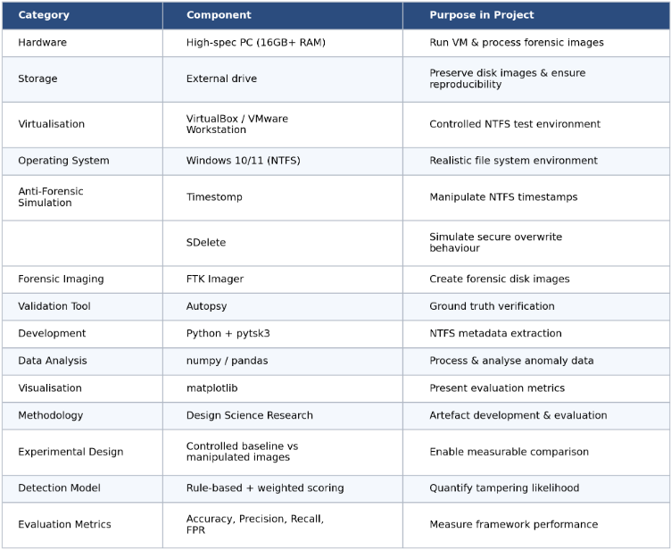
Figure 3.1 Table of materials required to undertake the practical elements of the project.

Chapter 4 - Design Process

4.1 Introduction
The implementation of the proposed research will involve developing a controlled windows-based NTFS testing environment using OracleVM the selected anti-forensic techniques can be investigated without affecting the host system or any unrelated data. The environment will be designed to isolate the experiments and provide a stable space for collecting and analysing forensic evidence. An architecture diagram will be used to illustrate the relationship between the host machine and the subsequent virtual platforms.

4.2 Problem Formulation
The problem that the project aims to solve is that timestamp manipulation and secure deletion within NTFS are only currently detected using approaches that are applied in isolation, they rely heavily on the manual interpretation of investigators, and they also rarely provide a quantitive means of the likelihood of tampering. This project aims to address this problem by simulating these anti-forensic techniques within a controlled NTFS environments and combine the evidence from multiple NTFS artefacts.
The general method used for solving this problem is as follows: a controlled NTFS environment will be constructed, a baseline of nominal activity will then be recorded, timestomping and secure deletion will then be applied to the test files and the resulting data will be compared against the nominal activities using a similar principle of penetration testing workflow of build -> attack -> analyse.
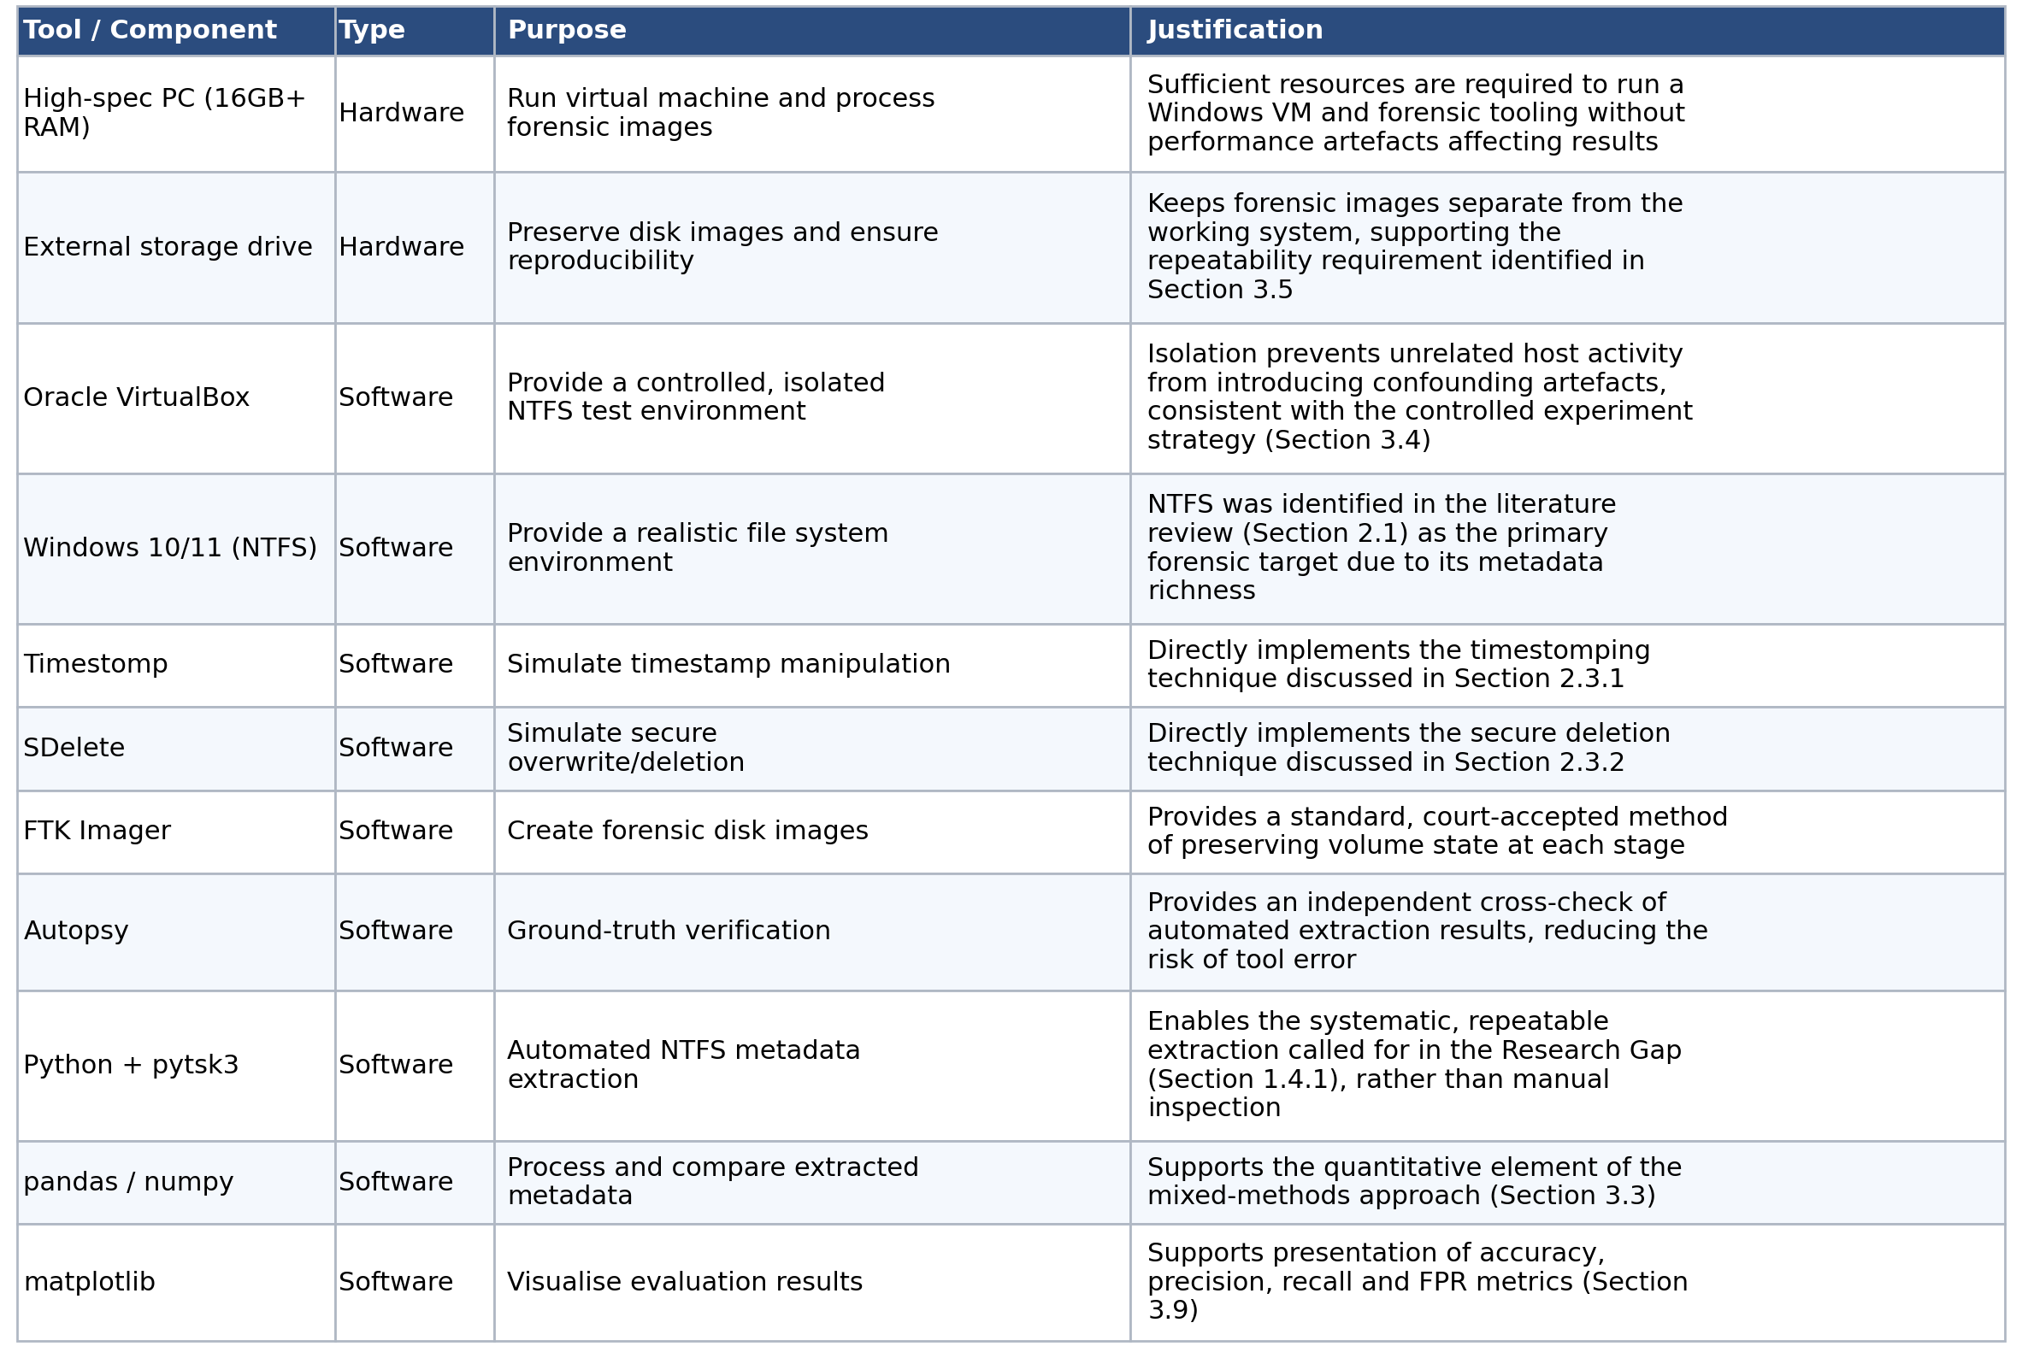
Figure 4.1 Table to show the purpose and justifications of use for each tool.
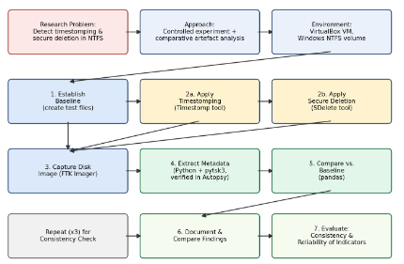
Figure 4.2 Block diagram to show the flow of the practical elements from creation to completion.
Figure illustrates the planned approach as a block diagram, from the problem to evaluation.

4.3 Design
The design of the testing environment follows directly from its methodology which was set in chapter 3 and the reviewed literature in chapter 2. The decision to isolate two anti-forensic techniques into separate controlled tests allows the environment to form a shape around each technique so it can be ran against an identical, baseline, and the findings that the NTFS artefacts can be cross correlated other than being examined in isolation shapes the idea of multiple independent extractions with verifications rather than a singular tool.
Layout and structure:
The environment will consist of a host machine running virtual box, inside the host machine a singular windows NTFS virtual machine will be created and isolated from the network. Then the anti-forensic tools will be run inside of the environments against the testing files. FTK imager will then be used to capture the stare of the disk image at each stage, which can then be used to directly analyse any changes in data through the host machine: autopsy will also be ran independently to verify the image file, while a python script will extract metadate in a structured format to make it readable and for the comparison in pandas and the virtualisation in matplotlib.
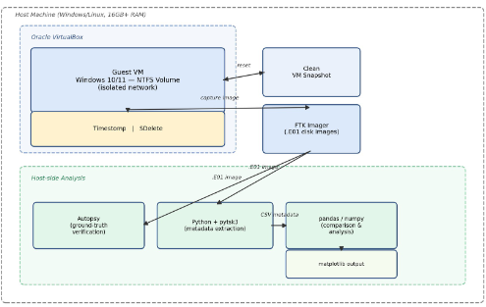
Figure 4.3 Figure shows the planned test environment architecture and the layout of components.

4.4 Implementation
This section sets out the steps taken to build the test environment and carry out each planned test.

Planned environment build steps:

- Install oracle virtual box on the host machine
- Create a new virtual machine with a fixed size virtual hard disk formatted in NTFS and allocated sufficient RAM and CPU resources.
- Install windows 10/11 onto the virtual machine using the default desktop settings
- Set the VM’s Network adapter to disabled to prevent external traffic interference
- Take a clean VM snapshot after installation, to serve as a restore point for repeatable testing
- Install timestomp, sdelete, FTK imager and autopsy, and configure Python extraction on the host.
Planned Baseline test steps:
- Create fixed file set on the NTFS volume
- Capture disk image using FTK imager (Label baseline.E01)
- Run the python extract script against the baseline to extract metadata files and record.
- Extract USN journal and LogFile from the same image for comparison
- Verify the sample of extracted data within autopsy.
Planned timestomping Procedure:
- Reset the VM to recreate the baseline files
- Select folder subset as manipulation target and run timestomp against them, ensuring to record the exact command used.
- Capture the post manipulation image and re-run extractions script
- Extract USNJournal and LogFile and compare the results against the baseline to identify timestamp discrepancies and retained evidence of the original baseline.
- Repat to assess consistency
Planned secure deletion test procedure:
- Reset the VM for a clean snapshot
- Select the files for deletion and run SDelete, record the command and pass count.
- Capture the post deletion image and examine the resulting MFT entries, logfiles and USN Journal for residual traces.
- Cluster analyse for residual data or entropy patterns in the file's location
- Repat steps for constancy.

Planned comparison and documentation:
Each of the tests will be logged using a test case template. Once all planned tests have been run, the consolidated data will be analysed by using pandas to help identify patters and inconsistencies between the files metadata structures and also to assess how consistently these indicators appear across repeated tests. The results will then be put into matplotlib to produce visualisation of results.

4.5 Design Conclusion
This chapter has presented and outlined the design and the planned implementation of the experiment into anti-forensic activity within an NTFS environment. Section 2 formulates the research problem previously discussed in chapter 1 and outlines the general approach needed to perform a controlled experiment supported by cross reference NTFS artefact analysis, alongside with hardware and software specifically selected and their justifications of use. Section 3 presents the design of the testing environment, which links the separation of timestomping and secure deletion into a distinct controlled test, by using multiple independent extraction and verification tools, as discussed in the earlier chapters. Section 4 sets the steps needed to follow for building the environment and carrying out the anti-forensic procedures, alongside the planned approach to compare and document the evidence gathered during the experiment. Together these sections establish the necessary steps for project completion.

4.6 Environment Build
Oracle virtual box was downloaded and installed on the host machine (Figure 4.1) and a new virtual machine was created with the label NTFS_Forensics_Test.
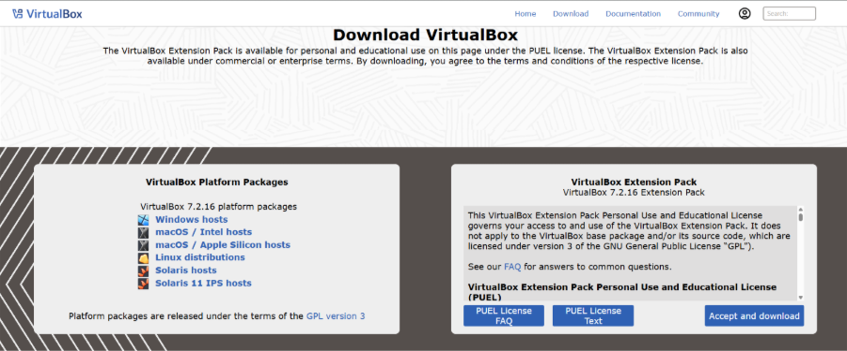
Figure 4.1 - VirtualBox 7.2.16 downloaded from site
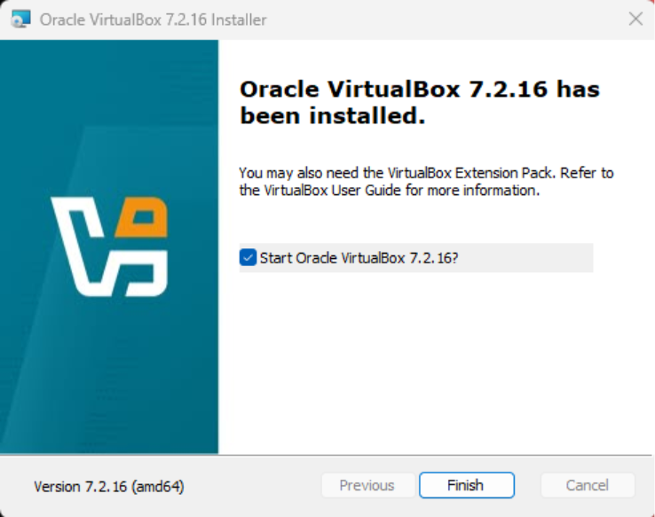
Figure 4.2 - Virtual box 7.2.16 installation completed on host machine
The virtual machine was then configured for windows 11 installation (figure 4.3)
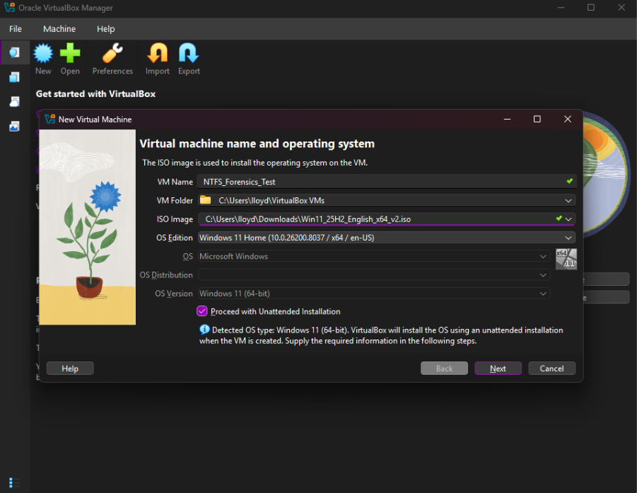
Figure 4.3 virtual machine name and operating system configuration

Virtual hardware was allocated as 8192 MB of memory, 2CPU’s and originally 80gb of storage however this was increased to 250gb for insurance this allowed for overhead on the machine if needed.
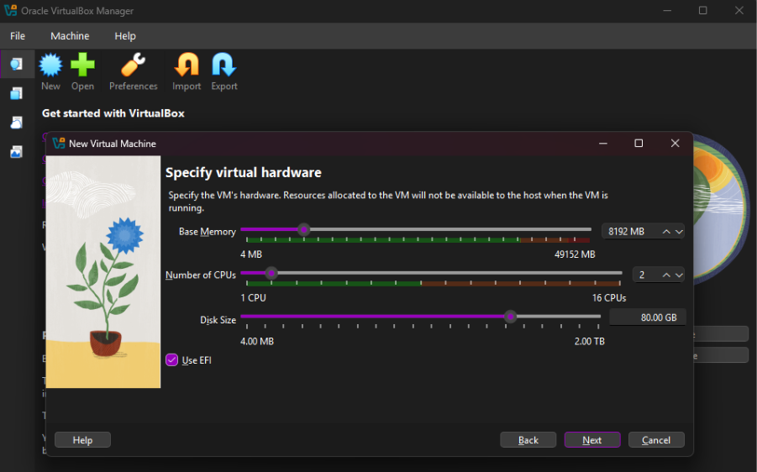
Figure 4.4 Virtual hardware specification for VM
Once windows was installed, the host side environment was prepared: a python virtual environment was created (ntfs_env), and PowerShell's execution policies were updated to allow scripts to run on the system, this was due to it being initially blocked by the systems default policies (Figure 4.5). FTK imager and autopsy were also installed on the host machine for later analysis.
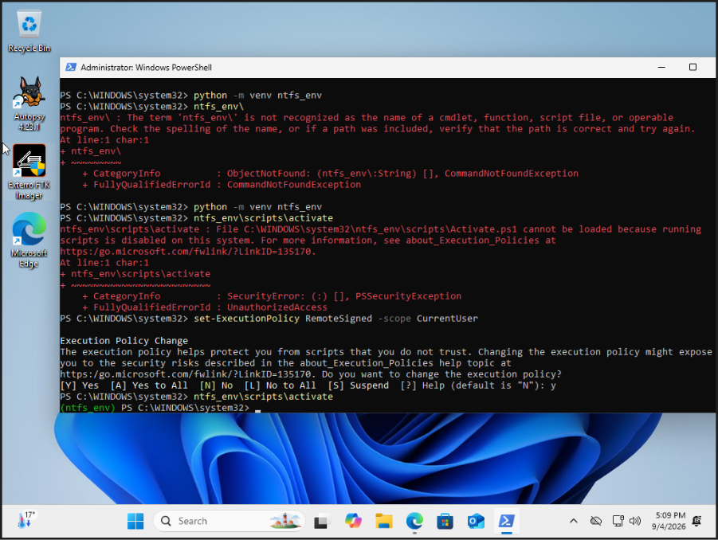
Figure 4.5 - Python virtual environment created and activated on the host machine, following the execution policy correction.
Required python packages were installed into the host environment a pip list was used to confirm their installation, packages included pytsk3, pandas, numpy and matplotlib. (Figure 4.6)
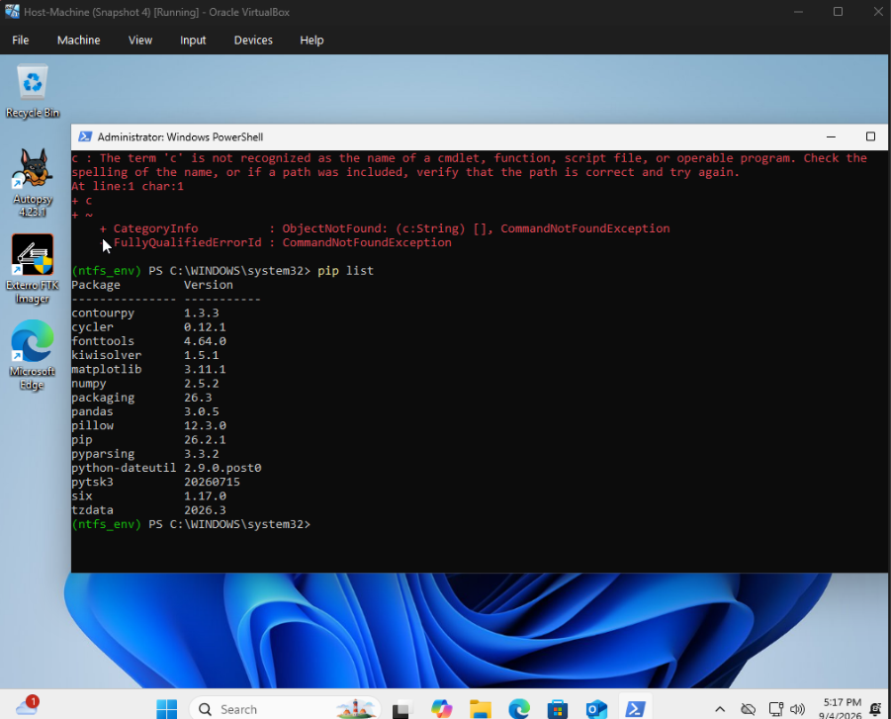
Figure 4.6 - Confirmed package installation within the python environment
During the setup, windows device encryption was enabled on the test VM. However, due to autopsy requiring a professional licence for BitLocker decryption it was disabled prior to any configurations made (Figure 4.7), This would be to ensure the readability of the files through the course of the experiment.
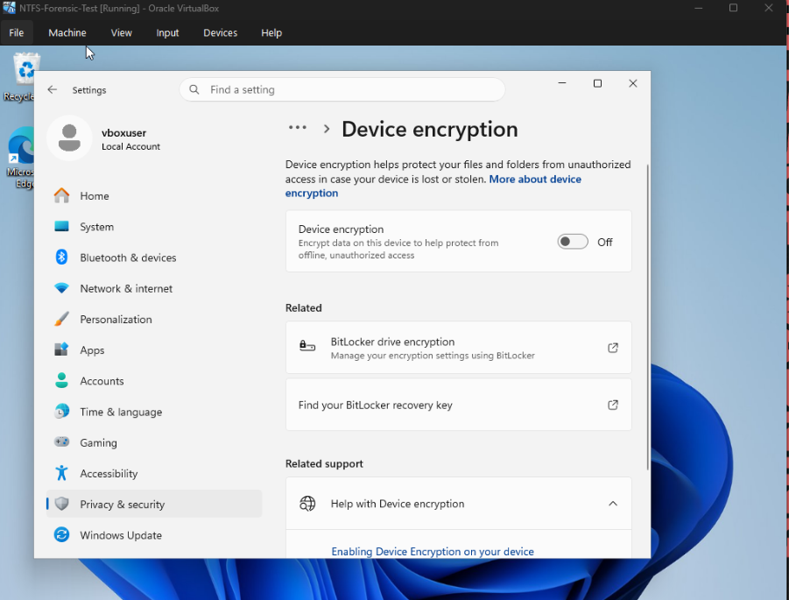
Figure 4.7 Device Encryption Disabled on the guest VM
With the timestomp equivalent provided by PowerShell natively, sdelete was installed on the test VM and six test files were then created (TS_File1 etc) in c:\testfiles. A directory listing at this stage then confirms the creation of all test files needed to conduct the experiment.
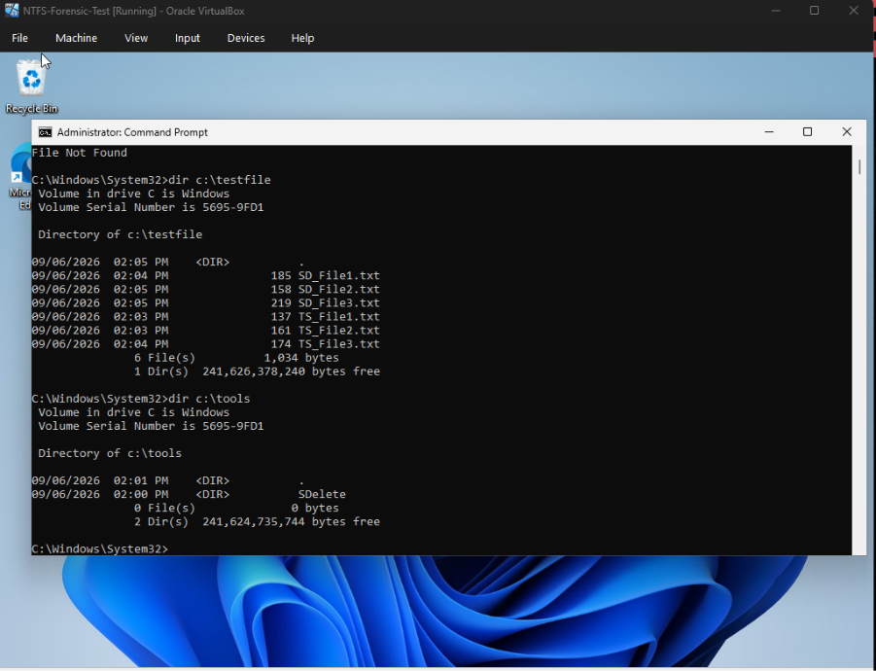
Figure 4.8 Confirmed presence of all six test files and the tools prior to the baseline image.
The environment was now fully configured at this stage – network isolated, tools installed and test files put in place a baseline image was then captured by using FTK imager (Figure 4.9) and its MD5/SHA-1 hashes were verified, confirming that the image was capture without corruption (See chapter 5, Figure 5.1)
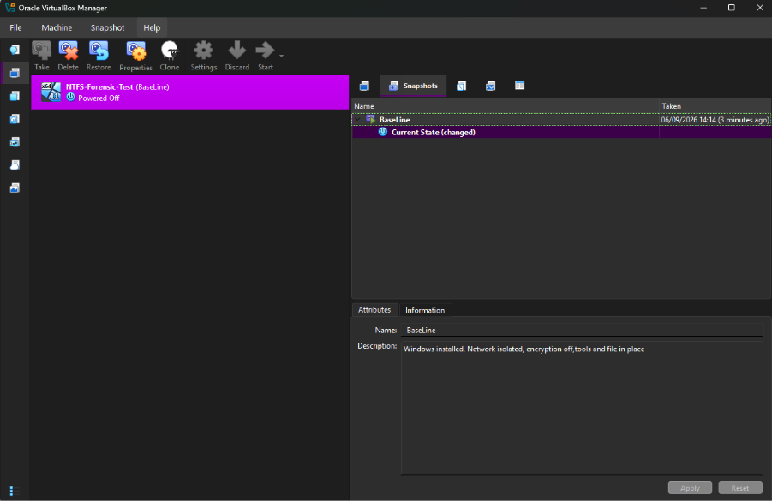
Figure 4.9 - Baseline disk image captured, representing the state of the environment prior to experimentation

Chapter 5 – Experiment and analysis

5.1 Experiment introduction
This chapter present the practical execution of the experiment that was designed and planned out in chapter 4. Section 5.2 walkthrough the practical actions took throughout the testing process using screenshots captured at each stage. Section 5.3 then evaluates these results, by benchmarking the outcomes against the set expectation discussing in the literature review (Chapter 2) and then discusses what the findings mean in relation to the original research problem and set objectives.

5.2 Testing

5.2.1 Baseline verification
With the environment build and ready for testing as discussed in chapter 5 a baseline image was captured prior to the anti-forensic techniques being applied to the environment. This baseline serves as the ground against which every result in the chapter is compared.
The integrity of the baseline image was confirmed via FTK imagers built in hashing: the MD5 and SHA-1 hashes after acquisition matches the hashes recorded at the time of imaging, with no identified bad blocks (Figure 5.10). This is confirmation that the image was captured without any corruption and can be relied upon for a point of reference.
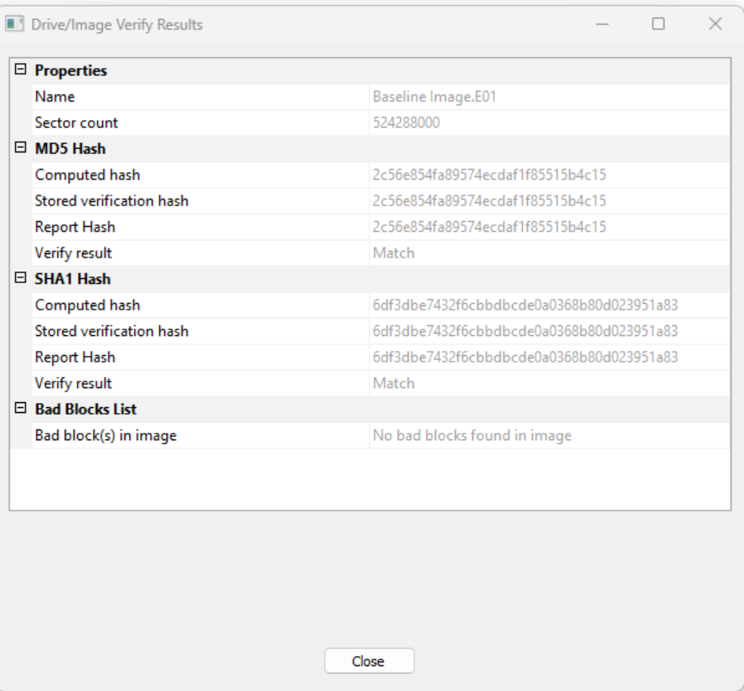
Figure 5.1 - MD5/SHA-1 hash verification of the baseline image
The baseline was also opened in autopsy to confirm visually that the volumes and the created test files had, real-world timestamps prior to alteration (Figure 5.2).
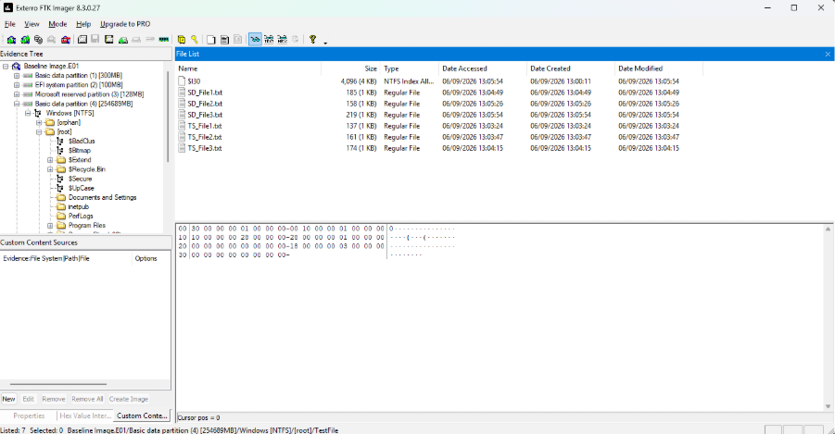
Figure 5.2 Verification of partitions and files within baseline
The metadata for the created files were inspected directly within autopsy, confirming that created, modified and accessed timestamps were consistent with the file's genuine creation times (Figure 5.3)
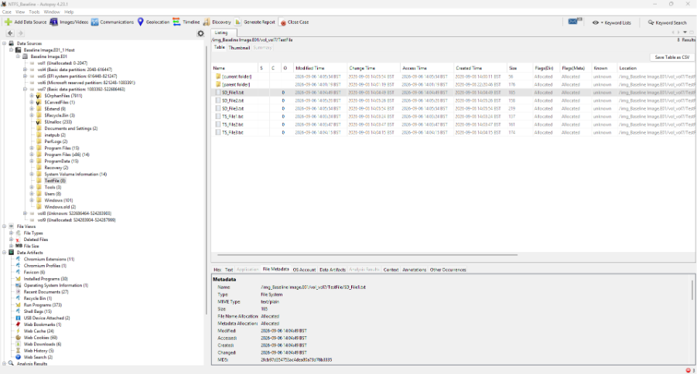
Figure 5.3 Unmodified metadata showing accurate timestamps

5.2.2 Timestomping Test
Rather than using a third-party tool timestamp manipulation was carried out using PowerShell's native object-property assignment against the $STANDARD_INFORMATION data fields. This approach was adapted for practicality and provenance reasons discussed in chapter 4.
In the first run, TS_File1.txt’s $STANDARD_INFORMATION data was set to fabricated values to January 2015, by using PowerShell's get-item output before and after the change confirms the manipulation was applied to the file-system level not just displayed differently (Figure 5.4)
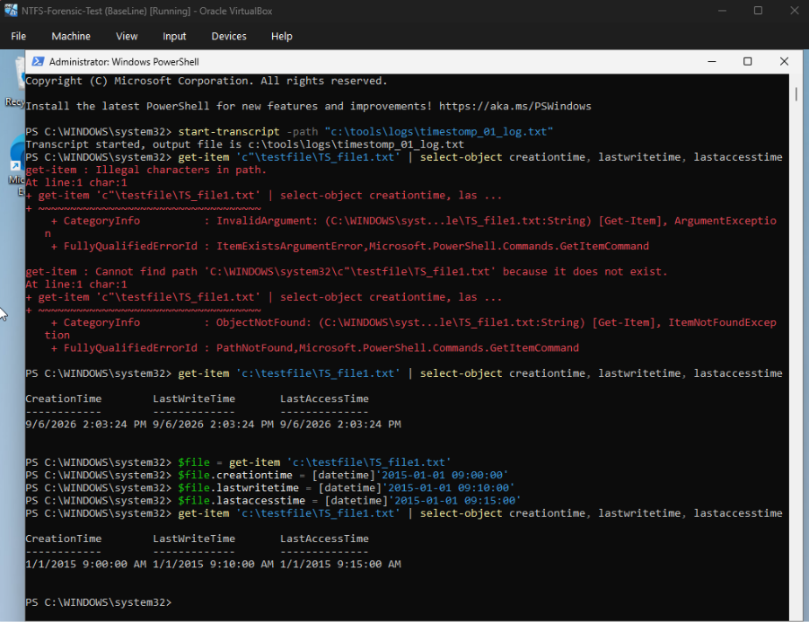
Figure 5.4 - TS_File1.txt timestamps altered via PowerShell (1st run)
The secondary run targeted TS_File2.txt. Several date strings were rejected before a valid format was used to set the $STANDARD_INFORMATION data to March 2015 (Figure 5.5). These initial errors were left visible in the evidence log as an honest record of the process and did n0ot affect the file prior to the corrected use commands succeeding
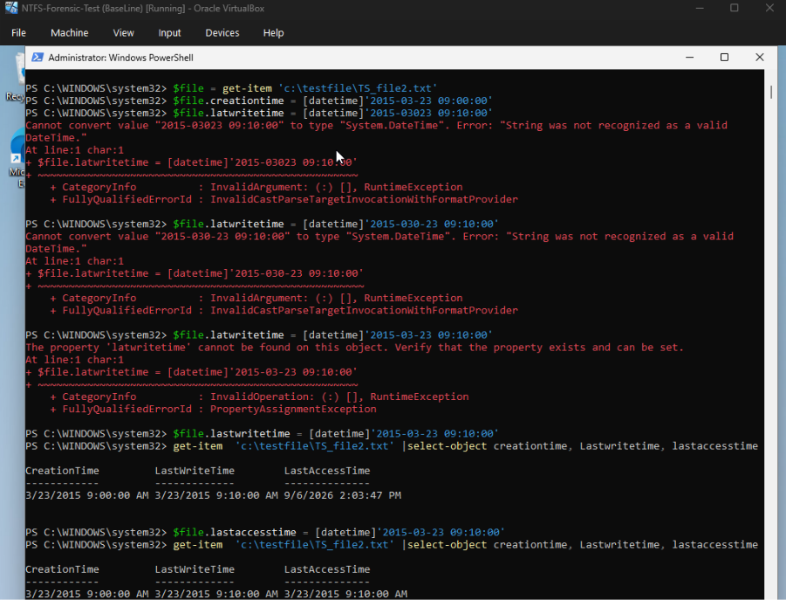
Figure 5.5 - TS_Fole2.txt Timestamps altered in PowerShell (2ND run)
The third run applied the same command and set the same values of March 2015 to TS_File3.txt’s three $STANDARD_INFORMATION fields and again confirmed via get-item before and after (Figure 5.6).
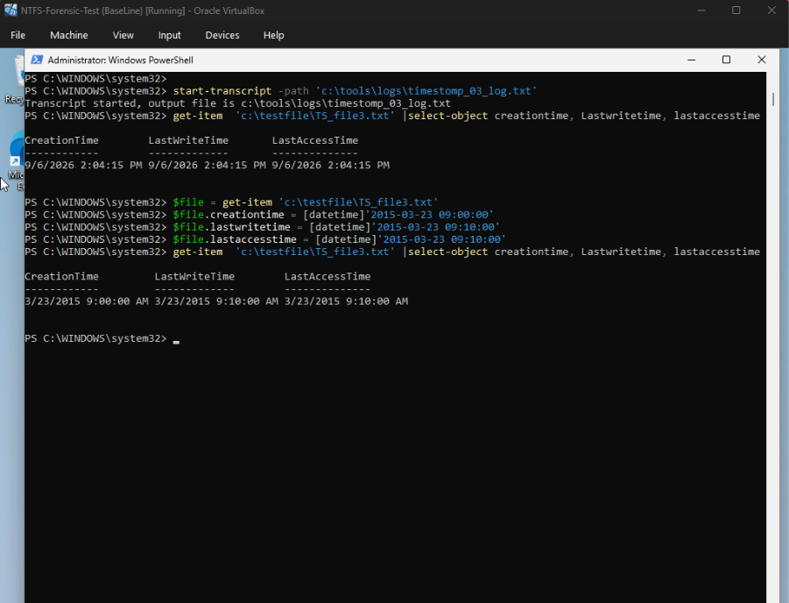
Figure 5.6 - TS_File3.txt timestamps altered via PowerShell

5.2.3 Secure deletion Test
The secondary test of secure deletion was carried out using Sdelete (Sysinternals), by varying the overwrite passes across the three target files allowed a comparison of weaker versus stronger overwrite settings. The first run applied 3 passes to SD_File1.txt (Figure 5.7) an initial attempt failed die to a directory path error which was then corrected before the deletion succeeded.
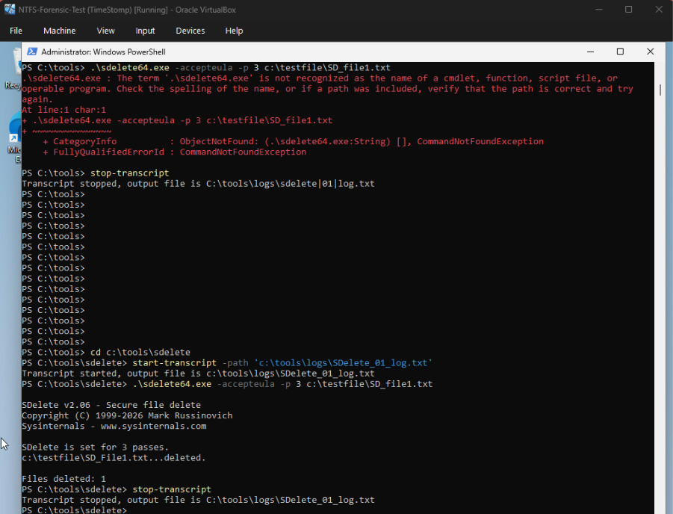
Figure 5.7 - SDelete run 1 2 overwrite passes conducted
Following the deletion of the first file a directory listing confirmed that SD_File1.txt was removed from the testing file while the remain files stayed untouched. (Figure 5.8)
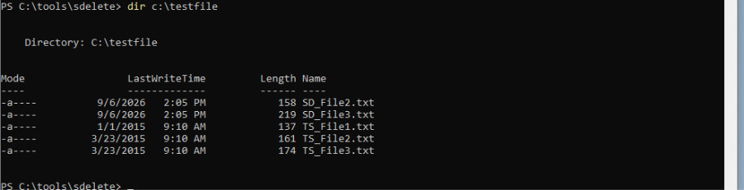
Figure 5.8 Confirmation of SD_File1.txt deletion and continuity of remaining files
The second run only applied a single overwrite pass, to represent a weaker anti-forensic effort for comparison. The third run applied 7 passes to the final file SDFile3.txt. A final directory listing displays that all three SD_Files we deleted while the timestomping files remained (Figure 5.9)
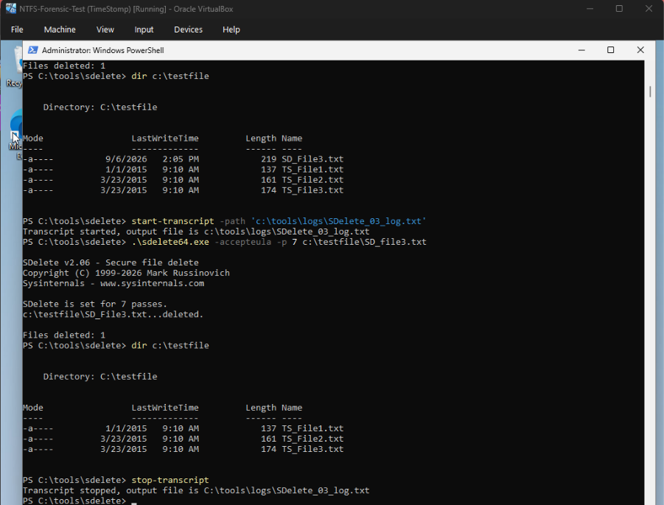
Figure 5.9 - Final Directory listing confirming that all target files have been deleted
A final image was taken of the virtual machine and was confirmed via the same MD5/SHA-1 verification process used for the baseline (Figure 5.10). The hashes matched the stored verification hashes with no bad blocks and as hoped differs from the baseline hashes, confirming that the disk content was changed between the two images.
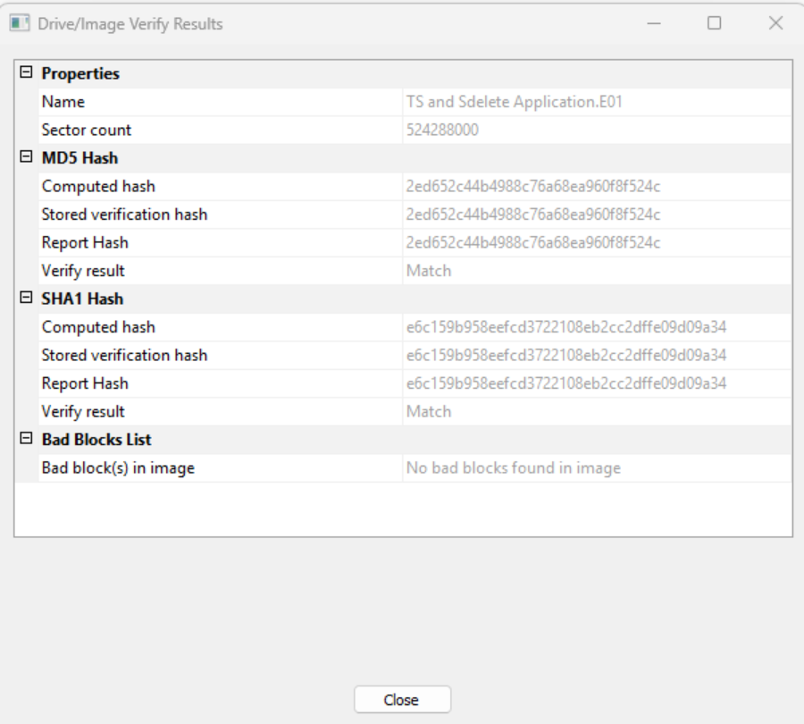
Figure 5.10 - Hash verification of the final post-technique image

5.2.4 Automated extraction and comparison
A python/pytsk3 extraction script was used to get $STANDARD_INFORMATION timestamps directly from the disk images. Theis stage consisted of two unanticipated tool-level obstacle, both of which were resolved during the testing stage rather than being planned for during the design stage: firstly pytsk3 was not able to parse the E01 file format which was produced by FTK imager, instead it was reporting a false positive of encryption; secondly once images were converted to a different format (RAW), the script initially could not locate the root of the intended volume because the test files resided under a folder called ‘testfile’ at the root of the volume, rather than the intended path. Figure 5.11 shows the debug process, which includes the scripts change to automatically detect the current NTFS partition offset within a raw image.
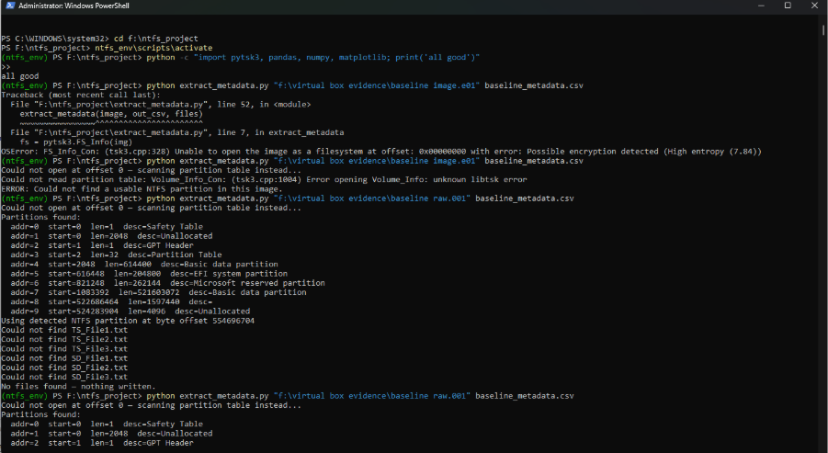
Figure 5.11 - Extraction script trouble shooting E01 to RAW format
Once the script had been corrected it was then run against the baseline image which extracted the metadata of the 6 target files and then against the post-technique image which successfully extracted the three TSFiles, while reporting the SDFiles as missing as intended. A comparison script was then run between the baseline and post-techniques states. (Figure 5.12).
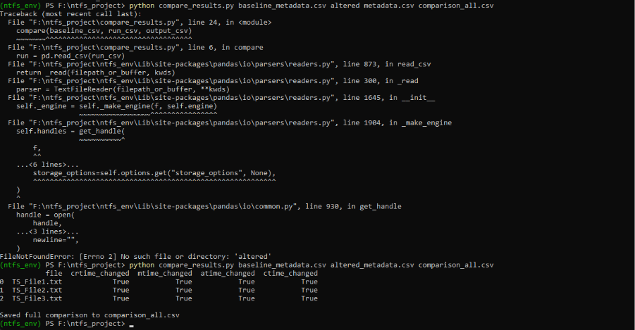
Figure 5.12 Automated comparison output

Result summarised in table 5.1
File | crtime | mtime | atime | ctime
TS_File1.txt | True | True | True | True
TS_File2.txt | True | True | True | True
TS_File3.txt | True | True | True | True
Table 5.1 - Automated comparison results for the timestomped files
The following secure deletion outcome was derived from the extraction scripts inability to locate any of the three SD_Files by its path in the post-technique image in table 5.2.
File | Passes | Found Via Dir/PowerShell? | Found Via python extraction?
SD_File1.txt | 3 | No | No
SD_File2.txt | 1 | No | No
SD_File3.txt | 7 | No | No
Table 5.2 - Secure deletion outcomes across varied overwrite passes

5.2.5 Manual Autopsy Cross-Examination
In order to validate these automated results, the baseline and the post-technique images were examined via autopsy. The baseline image confirmed the presence of all six files with consistent timestamps (Figure 5.13), which corroborates Figure 5.3.

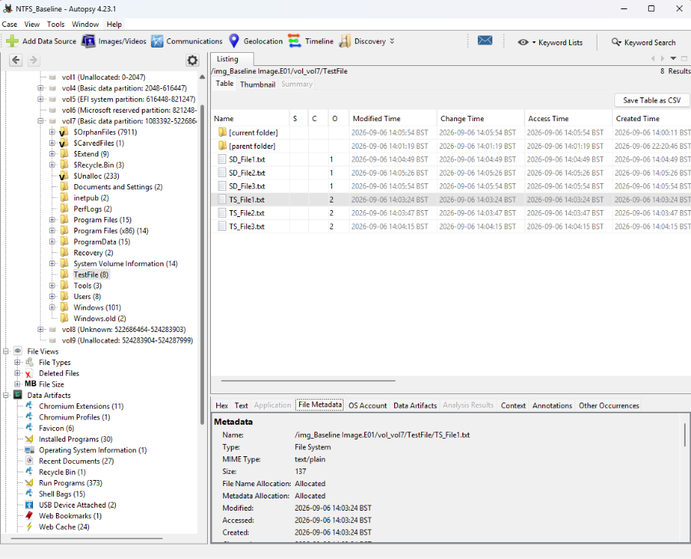
Figure 5.13 - Autopsy view of baseline image, confirming consistent timestamps
By examining TSFile1.txt within the post-technique image unveiled a result which was not directly visible from the $STANDARD_INFORMATION extraction, when the raw MFT attribute value was inspected the $STANDARD INFORMATION data all reflected the fabricated values as intended. However, $STANDARD_INFORMATION own MFT field along with all four $FILE_NAME attributes timestamps retained their genuine, real creation times. (Figure 5.14) This is summarised in table 5.3.
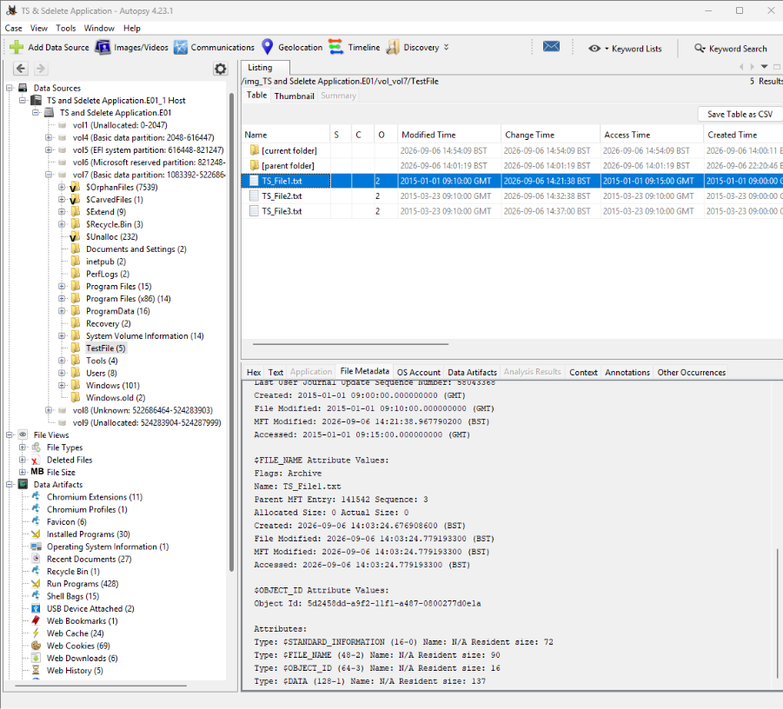
Figure 5.14 - Manual attribute inspection of File discrepancies
Attribite | Created | Modified | MFT Modified | Accessed
$STANDARD_INFORMATION | 2015-01-01 09:00 | 2015-01-01 09:10 | 2016-09-06(Unaltered) | 2015-01-01 09:15
$FILE_NAME | 2026-09-06(Unaltered) | 2026-09-06(Unaltered) | 2026-09-06(Unaltered) | 2026-09-06(Unaltered)
Table 5.3 - $STANDARDINFORMATION & $FILENAME attribute comparison for TS_File.txt
Finally, and attempt was made to locate any residual traces of the three files that were deleted via Sdelete by using autopsy's keyword search tool. However, the search did not complete successfully, autopsy reported that there wasn't any indexed file as Solr indexing had not been enabled during the ingest (Figure 5.15). As an alternative, autopsy's deleted files can be browsed manually, by sorting the files alphabetically a manual search was conducted in an attempt to locate the three SD_Files; none of the three could be located with this method either. The deleted view provided 8,617 entered across the image, the overwhelming majority were unrelated artefacts and windows update data, none of the target files could be found among them.
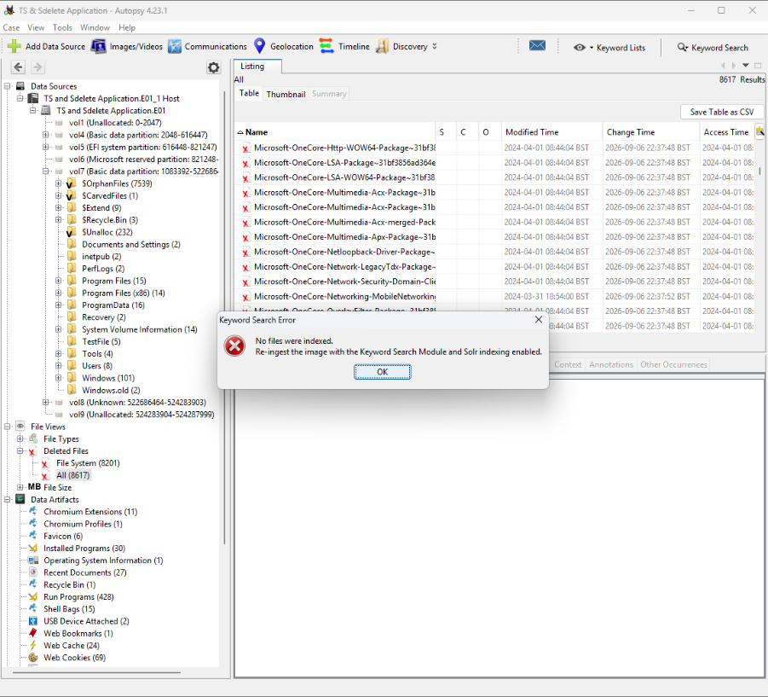
Figure 5.15 - Keyword search attempt for deleted files, halted by missing slor indexing

5.3 Evaluation

5.3.1 Was timestomping successful?
The conducted timestomp tests succeeded in both cases relevant to this project being the anti-forensic technique itself succeeded in the alteration of the file timestamps that a casual inspection via File explorer or a Get-Item call would rely on, and the detection of manipulation succeeded in automatically flagging every one of the four extracted $STANDARD_INFORMATION data fields as they were changed across all three tested files (Table 5.1) without the requirement of a manual inspection.
A more significant finding however is that based on the manual autopsy cross-examination the $FILENAME attributes, and the MFT modified sub-fields of $STANDARDINFORMATION, could not itself be altered through this method and retained its genuine creation time (Table 5.3). This is consistent with the reviewed literature in section 2.3.1 which identifies the $FILE_NAME materially harder to falsify than $STANDARD_INFORMATION as it is not exposed to the standard WIN32surface tools such as PowerShell's properties setters that most timestomp utilities operate against. The produced results represent an expected asymmetry and properly interpret the kind of cross-attribute inconsistencies that the research gap identified in section 1.4.1 which calls for an automated framework.
A significant limitation of the extraction script however is that it can only read $STANDARD_INFORAMATION via pytsk3’s meta objects, it cannot independently extract the $FILE_NAME’S own timestamps. As it was implemented in the project the automated component could only report that the $STANDARD_INFORMATION had changed relative to its baseline it could not on its own produce that data in Table 5.3 That comparison had to be made by manual attribute inspection through autopsy. This is an important mark in the projects claim of automating detection; however the most significant forensic finding was obtained manually, which indicates that the extraction of the scripts scope should be widened in relation to any future work conducted.

5.3.2 Was secure deletion successful?
The Sdelete testing succeeded in the removal of all three target files from the normal path-based access regardless of the pass count assigned during deletion, none of the three files could be located using a standard directory listing via PowerShell or via the extraction scripts path-based file-lookup (Table 5.2). This is consistent with documented Sdelete behaviours and with expectations from section 2.3.2, that a complaint secure deletion tool can render a file unrecoverable through ordinary filesystem means even from a singular pass.
However, the project ability to evaluate deeper into the recoverability of files (e.g. whether MFT slack, $MFT entry remnants, or any unallocated clusters retain any trace evidence of deleted files names or content) which is a more forensically interesting question asked in section 2.3.2 was not fully achieved. The keyword search tool based in autopsy which was intended for use to test this was returned with no result as Solr indexing had not been enabled prior to ingest (Figure 5.15), rather than returning a confirmation of absence of matches through that method. A manual search was conducted in an alphabetical sorting as a substitute method also could not locate any relevant files among 8,617 entries. Being taken together these two checks can provide a reasonable support for the conclusion that the three files were not recoverable by filename within autopsy. However, neither method can constitute a full content-level or unallocated-space search, so from this experiment it cannot be concluded that no trace of the deleted content had existed anywhere on that volume.

5.3.3 Cross referencing to related works
The overarching pattern of the test results including the successful automated detection of $STANDARDINFORMATION manipulation, but the reliance on a manual inspection to surface $FILENAME discrepancies, mirrors a core critique made of the existing forensic tools in chapter 2: that the detection capability exists in its principle (Autopsy can display both attributes) but is not operational as an automatic indicator (Autopsy cannot identify the mismatch itself). The python extraction and comparison method moves slightly past that line by automating the comparison of a baseline image and an altered image for the filed you choose to extract, but as the experiment has shown it is limited to $STANDARD_INFORMATION this scope unfortunately does not fully close the gap which was identified in the literature. However, this is a fair and useful outcome for a project similar in kind: it validates the research problem premise using real, reproducible evidence also while identifying the specific extensions needed to fully realise the project original aim.

Chapter 6 – Conclusions & Recommendations

6.1 Summary
This project set out with the aim to investigate whether timestamp manipulation (Timestomping) and secure deletion within an NTFS environment could be detected in an automated compared to current existing forensic tools. Chapter 1 first establishes the research problem: the detection of anti-forensic techniques typically relies heavily on manual examination interesting artefacts with no means of automated cross referencing across multiple NTFS structures. Chapter 3 then leads on to review relevant literature on NTFS internals, timestomping, secure deletion and also existing detection methods, therefore identifying the research gap around automated, evidence-based detections noting that $FILE_NAME is considerable harder to manipulate as it is not affected by surface WIN32 API’S that most tampering tools operate against/
Chapter 3 sets out to design the experiments approach and chapter 4 then details the design and implementation of the isolated VirtualBox-based NTFS environment, together with a pytsk3 pipeline which was intended to automate the extraction and comparison of file metadata across both disk images. Chapter 5 then presents the results of this experimentation, a baseline was captured, three files were timestomped using PowerShell across multiple fields and three additional files were securely deleted using SDelete with a range of overwrite passes. Both automated and manual processes were carried out, and the evidence was analysed and evaluated against the expectations set out in the literature review.

6.2 Conclusion
This research designed, built and executed a controlled experiment to test whether NTFS anti-forensic activity could be automatically detected through disk image comparison, and also produced real reproducible evidence to address that question. The main output of the project were: a repeatable, isolated testing environment; a python-based extraction and comparison pipeline which is capable of flagging changes to $STANDARD_INFORMATION timestamps between a baseline image and an altered image and a set of findings drawn from the practical pipeline to genuine timestomping and secure deletion activity.
If the conclusions of the project can be drawn across preceding chapters, there are three main findings that stand out. Firstly, the automated pipeline could successfully and consistently detect tampering across $STANDARD_INFORMATION attributes across the timestomped files, without the requirements of manual examination which directly demonstrates that automated detection on this kind is achievable. Secondly and more significantly, by manually inspecting attributes in autopsy revealed that $FILENAME timestamps, and $STANDARD_INFORMATION’S own MFT-modified fields, cannot be altered by the techniques used during the course of the project and retained their original attribute information. This reproduces results of the same robustness of the $FILENAME system described in the literature review and also represents the cross-attribute inconsistency the research problem identified as highly valuable but under-automated. Lastly the same finding exposes the project limitation in the automated pipeline can only extract $STANDARDINFORMATION, this means that the most forensically significant result of the experiment was obtained manually. Due to this the research question can be answered as yes, the automated detection of anti-forensic NTFS activity was demonstrated as achievable for $STANDARD_INFORMATION level, however the project current implementation does not yet fully close its gap, since it still requires manual intervention.
Overall, the project met the core aim of building and testing an automated NTFS anti-forensic framework and also succeeded in generating insight into both the strengths of the approach and also the specific respect which the current scop falls short of realising the fully potential.

6.3 Recommendations for Further Research
The research conducted throughout the course of this project has surfaced several areas further work would extend or strengthen these findings:
- Extend the automated extractions to $FILE_NAME – the extraction script could be extended to read $FILE_NAME attribute stamps alongside $STANDARD_INFORMATION
- Re-run the secure deletion keyword search with Solr indexing verified – this would allow for further genuine content-level and unallocated space search for residual data in relation to secure deletion tools and deleted files.
- Compare PowerShell based timestomping approaches with dedicated tools – the current project used PowerShell as a substitution for practical reasons. By repeating the experiment with a tool with equal or higher capability would strengthen the findings.
- Increase the sample size and isolate individual test runs –a larger sample, combined with a full snapshot between each run would allow stronger statistical claim and direct comparisons.
- Develop a classification model – building further upon the automated flagging demonstrated in the project future projects could develop a machine learning model that can combine multiple indicators into a tampering likelihood score.
- Expand the test environment across multiple machines – By repeating the experiment across different windows versions would establish how specific these findings are to the sole tested environment.

Chapter 7 – Reflections

7.1 Introduction
The project went as expected, even if the route always wasn't smooth. Every objective that was set out to achieve was met and is show in the write-up, even though I started the project with limited hands-on experience of NTFS internals and forensic tools a lot of it was learned through experimentation and reviewing documentation, tutorials and working through errors one by one.
Thorough out the project I picked up a few useful skills, which I think will help with my career progression going forward:
- Problem solving under pressure – almost every stage threw up an error working through one by one calmly is a skill I think is highly valuable
- Verification and attention to detail – I learned to check my work through each step and paid attention to where things were going wrong for correction.
- Prioritising tasks - Deciding what to fix first when multiple things were broken at one taught me a lot about what is blocking progress and what is an inconvenience
- Planning and scheduling – Layout out roughly which stage I would roughly be at early, so I didn't have to panic and just adjust timescales

7.2 Lessons Learnt
To verify every step before moving on, instead of assuming everything worked
To not assume that two tools or file formats are compatible because they are deemed as “standard” platforms
Break down problems into smaller pieces to make them easier to solve
To manage my tome accordingly when something eats into the schedule
Identify and prioritise tasks earlier on into the project rather than reacting to them when they occur
How to meet the planned objectives, even when the path wasn't the original one planned

7.3 Things that could be done differently
I defiantly could have started the practical build earlier, so that the repeated environment issues didn't eat into my time as much.
The approach to troubleshooting could have been a little bit more structured as a lot of the setup issue came from not double-checking things which would have saved a lot of time.
I could have dedicated more time to the tricker technical tasks
Perhaps some consultation with people who have done NTFS forensic work before could have helped me avoid some issue.

7.4 Barriers experienced
Not enough time, especially when the issues started popping up one after another
Limited experience with forensic image formats going in, which meant a lot of the learning happened reactively instead of in advance.
Self-management with multiple things breaking with little time it was difficult to move passed the issues.

7.5 Positives
Being willing to adapt the initial plan helped a lot and was a big part of being able to complete the project on time.
Good guidance feedback along the way was a great help in shaping the direction of the written and practical activity.
Having access to good documentation for resources made a big difference when things went wrong.

7.6 Guidance to future students
- Identify the topic you want to work on EARLY and do smaller testing build before tackling the bigger tasks
- Have a clear concise plan but always expect the need to adapt it
- Always stay motivated and break tasks down into smaller part to make them more understandable and to keep you focused
- Don't be afraid to ask questions whether they are staff or a student
- Always follow the guidance given to you buy your tutor

7.7 Summary
Learning is always a process, I have treated every problem that has risen in this project as a chance to improve rather than look at it as a plain obstacle.
Any project can be completed if you break it down into smaller parts and have the right support.

Chapter 8 - References

[1] B. Carrier, File System Forensic Analysis. Addison-Wesley, 2005.
[2] R. González Arias et al., “Systematic Review: Anti-Forensic Computer Techniques,” Applied Sciences, vol. 14, no. 12, p. 5302, 2024. DOI: 10.3390/app14125302.
[3] J. Oh, S. Lee and H. Hwang, “Forensic Detection of Timestamp Manipulation for Digital Forensic Investigation,” IEEE Access, vol. 12, pp. 72544–72565, 2024. DOI: 10.1109/ACCESS.2024.3395644.
[4] A. Mohamed and C. Khalid, “Detection of suspicious timestamps in NTFS using volume shadow copies,” International Journal of Computer Network and Information Security, vol. 13, no. 4, pp. 62–69, 2021.
[5] D. Palmbach and F. Breitinger, “Artifacts for Detecting Timestamp Manipulation in NTFS on Windows and Their Reliability,” Forensic Science International: Digital Investigation, vol. 32, p. 300920, 2020. DOI: 10.1016/j.fsidi.2020.300920.
[6] D. B. Oh, K. H. Park and H. K. Kim, “De-Wipimization: Detection of data wiping traces for investigating NTFS file system,” Computers & Security, vol. 99, p. 102034, 2020. DOI: 10.1016/j.cose.2020.102034.
[7] E. Huebner, D. Bem and C. K. Wee, “Data hiding in the NTFS file system,” Digital Investigation, vol. 3, no. 4, pp. 211–226, 2006. DOI: 10.1016/j.diin.2006.10.005.
[8] Z. Kai, C. En and G. Qinquan, “Analysis and implementation of NTFS file system based on computer forensics,” 2010. DOI: 10.1109/ETCS.2010.434.
[9] C. Vanini et al., “Understanding strategies and challenges of timestamp tampering for improved digital forensic event reconstruction,” Proceedings of the Digital Forensics Doctoral Symposium, 2025.
[10] R. Hermon, U. Singh and B. Singh, “Forensic techniques to detect hidden data in alternate data streams in NTFS,” 2022. DOI: 10.1109/IBSSC56953.2022.10037507.
[11] R. AlHarbi, A. AlZahrani and W. A. Bhat, “Forensic analysis of anti‐forensic file-wiping tools on windows,” Journal of Forensic Sciences, vol. 67, no. 2, pp. 562–587, 2022.
[12] F. Toolan, File System Forensics. Wiley, 2025, ch. 5, “The FAT File System,” and ch. 7, “The NTFS File System.” DOI: 10.1002/9781394289820.
[13] K. L. Rusbarsky, C. Smith, J. L. Brunty and T. Fenger, “A Forensic Comparison of NTFS and FAT32 File Systems,” American Academy of Forensic Sciences, 2013.
[14] P. Nabity and B. J. L. Landry, “Recovering Deleted Files: A Forensic Comparison of FAT32 and NTFS File Systems,” Proceedings of the Southwest Decision Sciences Institute, 2010.
[15] H. S. Gandhi and A. D. Deshmukh, “Understanding File System Forensics: FAT, NTFS, HFS, and EXT,” in Digital Forensics in the Age of AI, IGI Global, 2025, ch. 7. DOI: 10.4018/979-8-3373-0857-9.ch007.
[16] “Data hiding in file systems: Current state, novel methods, and a standardized corpus,” Forensic Science International: Digital Investigation, 2025, p. 301984. DOI: 10.1016/j.fsidi.2025.301984.
[17] M. Galhuber and R. Luh, “Time for Truth: Forensic Analysis of NTFS Timestamps,” in Proc. 16th Int. Conf. Availability, Reliability and Security (ARES), 2021, pp. 1–10, doi: 10.1145/3465481.3470016.
[18] G.-S. Cho, “A computer forensic method for detecting timestamp forgery in NTFS,” Computers & Security, vol. 34, pp. 36–46, 2013, doi: 10.1016/j.cose.2012.11.003.
[19] G. Horsman, “Digital tool marks (DTMs): A forensic analysis of file wiping software,” Australian Journal of Forensic Sciences, vol. 53, no. 1, pp. 96–111, 2021, doi: 10.1080/00450618.2019.1640793.
[20] J. Oh, “A practical approach to detecting file timestamp manipulation for digital forensic investigations,” Expert Systems with Applications, vol. 293, Art. no. 128630, 2025, doi: 10.1016/j.eswa.2025.128630.
[21] G. Horsman and D. Errickson, “When finding nothing may be evidence of something: Anti-forensics and digital tool marks,” Science & Justice, vol. 59, no. 5, pp. 565–572, 2019, doi: 10.1016/j.scijus.2019.06.004.

Glossary
Term | Definition
Anti-forensics | Techniques deliberately used to conceal, alter, or destroy digital evidence in order to hinder or mislead a forensic investigation.
Alternate Data Stream (ADS) | An NTFS feature allowing additional, hidden data streams to be attached to a file beyond its primary content, sometimes exploited for data hiding.
Autopsy | A free, open-source digital forensics platform used in this project for manual examination and cross-verification of disk images.
Baseline image | A forensic disk image captured before any anti-forensic technique is applied, used as the unaltered reference point for comparison.
BitLocker / Device Encryption | Windows' built-in full-disk encryption feature. It was disabled on the test VM during this project because Autopsy's free edition cannot decrypt a BitLocker-protected volume without a paid licence.
Controlled experiment | A research strategy in which variables are deliberately manipulated within an isolated environment to observe their effect, used as this project's core research strategy.
Design Science Research | A research methodology focused on the creation and evaluation of a practical artefact (in this case, the detection framework and testing pipeline) to address a defined problem.
EWF / E01 | Expert Witness Format — a common forensic disk image container format produced by tools such as FTK Imager. This project found it was not reliably parsed by pytsk3 without conversion.
FAT / FAT32 | File Allocation Table — an older file system used as a comparative reference against NTFS in the literature review.
FTK Imager | A free forensic imaging tool used in this project to capture and verify (via MD5/SHA-1 hashing) disk images at each stage of testing.
Hash verification (MD5/SHA-1) | The process of computing a cryptographic checksum of a file or image and comparing it to a previously recorded value to confirm the data has not been altered or corrupted.
Master File Table ($MFT) | The central NTFS structure that stores metadata (including timestamps) for every file and directory on an NTFS volume.
MACB times | Shorthand for the four commonly examined timestamp categories: Modified, Accessed, Created, and (MFT Entry) Changed.
NTFS | New Technology File System — the primary Windows file system examined throughout this project, chosen for its rich metadata structures.
Partition offset | The byte position at which a file system begins within a larger disk image. This project's extraction script required logic to auto-detect this offset when reading raw disk images.
pytsk3 | A Python binding for The Sleuth Kit (TSK), used in this project to programmatically read NTFS metadata directly from disk images.
Raw (dd) image | An uncompressed, sector-by-sector forensic image format. This project switched to Raw format after encountering EWF/E01 parsing issues with pytsk3.
SDelete | A Microsoft Sysinternals command-line tool used in this project to perform secure file deletion via multiple overwrite passes.
Secure deletion | An anti-forensic technique that overwrites a file's data (and potentially its metadata) to prevent recovery through normal or forensic means.
$STANDARD_INFORMATION | An NTFS metadata attribute storing a file's Created, Modified, Accessed, and MFT-Modified timestamps. This is the attribute most commonly targeted and altered by timestomping.
$FILE_NAME | A separate NTFS metadata attribute that also stores timestamp information. It is significantly harder to falsify than $STANDARD_INFORMATION, making discrepancies between the two attributes a valuable forensic indicator.
Timestomping | An anti-forensic technique involving the deliberate manipulation of a file's timestamps to mislead a forensic timeline reconstruction.
$UsnJrnl (USN Journal) | An NTFS journal that records changes made to files and directories on a volume, providing a potential secondary source of evidence for detecting tampering.
Volume Shadow Copy | A Windows feature that creates point-in-time snapshots of a volume, potentially preserving historical file states useful for forensic comparison.
VirtualBox | The virtualisation software used to build the isolated Windows test environment in which all experimental activity was conducted.

Appendices

Appendix A – Full-Size Diagrams
The full-resolution versions of Figure 4.0 (Overall Experimental Workflow) and Figure 4.5 (Test Environment Architecture) from Chapter 4 are shown below at full size.
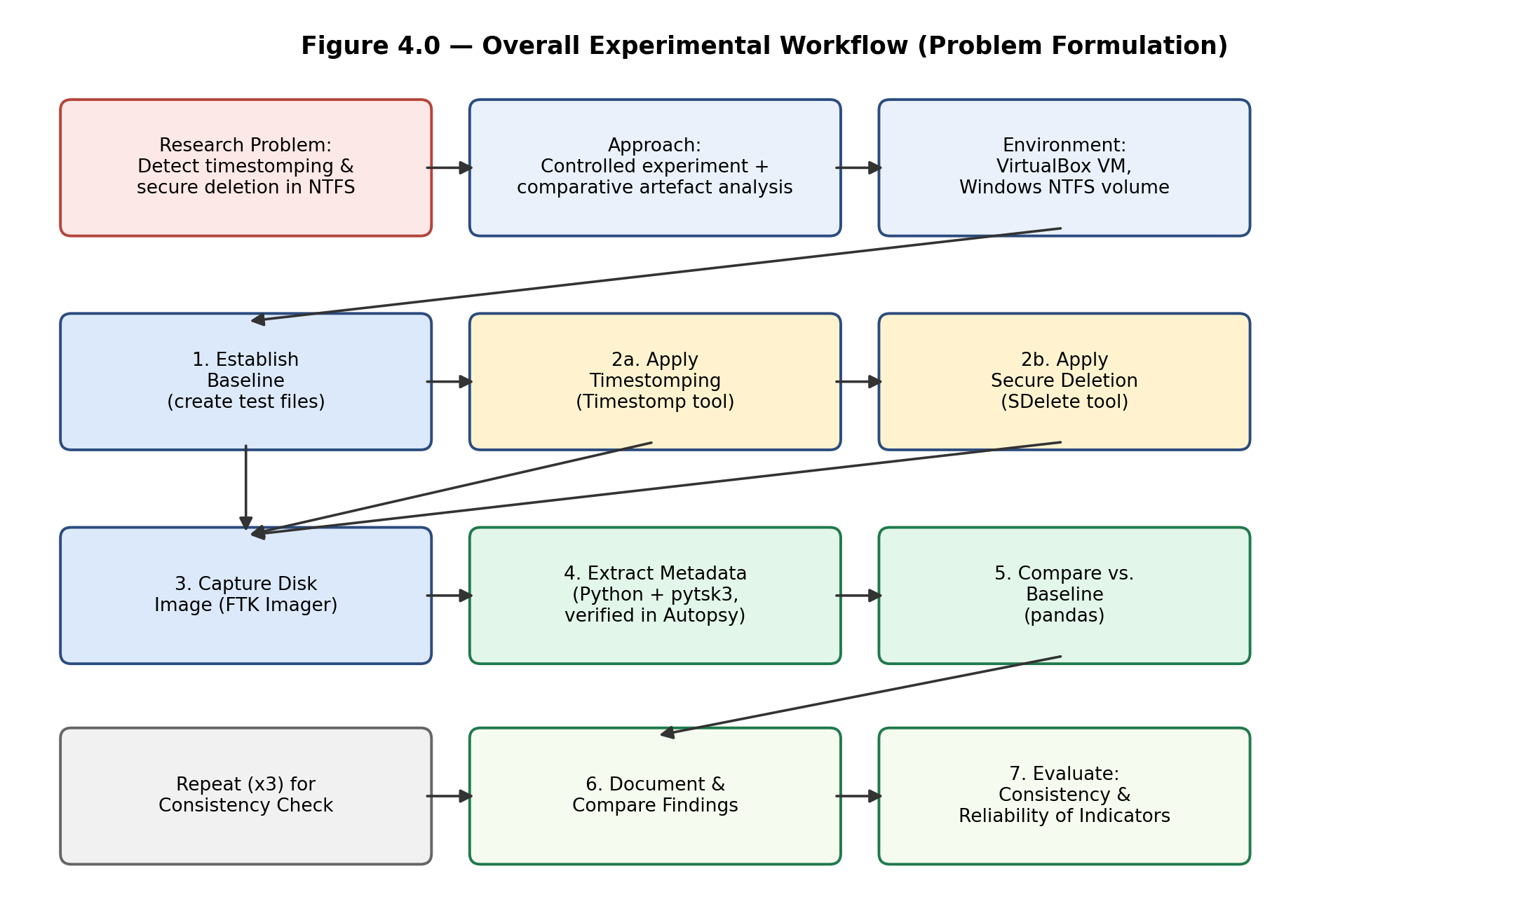
Figure A.1 – Overall Experimental Workflow (full size)

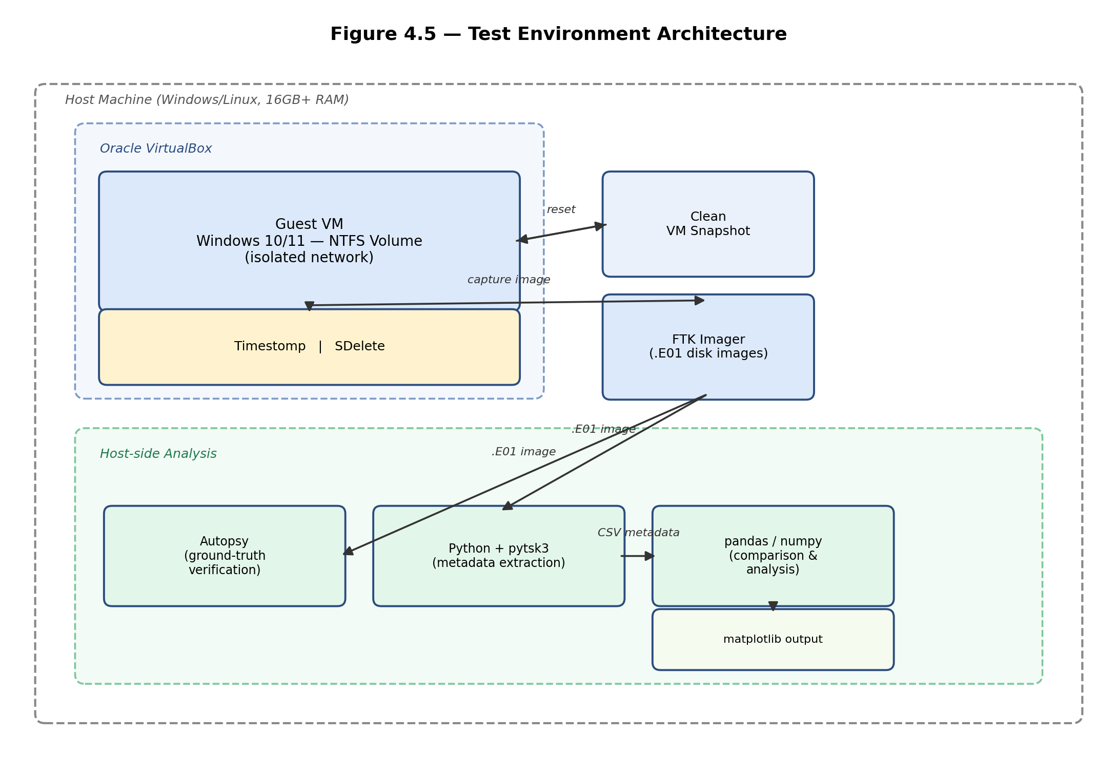
Figure A.2 – Test Environment Architecture (full size)

Appendix B – Hardware and Software Table
The complete hardware and software table (Table 4.1), reproduced in full below.
Tool / Component | Type | Purpose | Justification
High-spec PC (16GB+ RAM) | Hardware | Run virtual machine and process forensic images | Sufficient resources are required to run a Windows VM and forensic tooling without performance artefacts affecting results
External storage drive | Hardware | Preserve disk images and ensure reproducibility | Keeps forensic images separate from the working system, supporting the repeatability requirement identified in Section 3.5
Oracle VirtualBox | Software | Provide a controlled, isolated NTFS test environment | Isolation prevents unrelated host activity from introducing confounding artefacts, consistent with the controlled experiment strategy (Section 3.4)
Windows 10/11 (NTFS) | Software | Provide a realistic file system environment | NTFS was identified in the literature review (Section 2.1) as the primary forensic target due to its metadata richness
Timestomp / PowerShell | Software | Simulate timestamp manipulation | Directly implements the timestomping technique discussed in Section 2.3.1
SDelete | Software | Simulate secure overwrite/deletion | Directly implements the secure deletion technique discussed in Section 2.3.2
FTK Imager | Software | Create forensic disk images | Provides a standard, court-accepted method of preserving volume state at each stage
Autopsy | Software | Ground-truth verification | Provides an independent cross-check of automated extraction results, reducing the risk of tool error
Python + pytsk3 | Software | Automated NTFS metadata extraction | Enables the systematic, repeatable extraction called for in the Research Gap (Section 1.4.1), rather than manual inspection
pandas / numpy | Software | Process and compare extracted metadata | Supports the quantitative element of the mixed-methods approach (Section 3.3)
matplotlib | Software | Visualise comparison results | Supports presentation of comparative findings between baseline and post-technique conditions

Appendix C – Python Source Code: extract_metadata.py
The complete, final version of the NTFS metadata extraction script. This version automatically detects the correct NTFS partition offset within a raw disk image, falling back to a partition-table scan if the filesystem cannot be opened directly at byte offset 0.
import pytsk3
import csv
import sys
def find_ntfs_offset(img):
"""Scan the partition table and return the byte offset of the NTFS/basic data partition."""
try:
vol = pytsk3.Volume_Info(img)
except Exception as e:
print(f"Could not read partition table: {e}")
return None
print("Partitions found:")
best_partition = None
for part in vol:
desc = part.desc.decode(errors="ignore") if isinstance(part.desc, bytes) else part.desc
print(f" addr={part.addr} start={part.start} len={part.len} desc={desc}")
# Pick the largest partition that isn't one of the tiny EFI/reserved ones
if part.len > 100000: # skip partitions smaller than ~50MB in sectors
if best_partition is None or part.len > best_partition.len:
best_partition = part
if best_partition is None:
return None
return best_partition.start * 512 # sector size is normally 512 bytes
def extract_metadata(image_path, output_csv, target_files):
img = pytsk3.Img_Info(image_path)
# First try opening at offset 0 (works for raw single-volume images)
fs = None
try:
fs = pytsk3.FS_Info(img)
print("Opened filesystem directly at offset 0.")
except Exception:
print("Could not open at offset 0 — scanning partition table instead...")
offset = find_ntfs_offset(img)
if offset is None:
print("ERROR: Could not find a usable NTFS partition in this image.")
return
print(f"Using detected NTFS partition at byte offset {offset}")
fs = pytsk3.FS_Info(img, offset=offset)
rows = []
for filename in target_files:
try:
f = fs.open(f"/TestFile/{filename}")
except OSError:
print(f"Could not find {filename}")
continue
meta = f.info.meta
rows.append({
"file": filename,
"mft_entry": meta.addr,
"size": meta.size,
"crtime": meta.crtime,
"mtime": meta.mtime,
"atime": meta.atime,
"ctime": meta.ctime,
})
if not rows:
print("No files found — nothing written.")
return
with open(output_csv, "w", newline="") as f_out:
writer = csv.DictWriter(f_out, fieldnames=rows[0].keys())
writer.writeheader()
writer.writerows(rows)
print(f"Wrote {len(rows)} rows to {output_csv}")
if __name__ == "__main__":
image = sys.argv[1]
out_csv = sys.argv[2]
# For the BASELINE image, keep all six filenames below.
# For an individual timestomp_0X.E01 or sdelete_0X.E01 image,
# edit this list down to just that run's one target file,
# e.g. files = ["TS_File1.txt"]
files = [
"TS_File1.txt", "TS_File2.txt", "TS_File3.txt",
"SD_File1.txt", "SD_File2.txt", "SD_File3.txt",
]
extract_metadata(image, out_csv, files)

Appendix D – Python Source Code: compare_results.py
The complete, final version of the baseline-versus-run comparison script, taking the baseline and run CSV filenames as command-line arguments.
import pandas as pd
import sys
def compare(baseline_csv, run_csv, output_csv):
baseline = pd.read_csv(baseline_csv)
run = pd.read_csv(run_csv)
merged = baseline.merge(run, on="file", suffixes=("_baseline", "_run"))
for col in ["crtime", "mtime", "atime", "ctime"]:
merged[f"{col}_changed"] = merged[f"{col}_baseline"] != merged[f"{col}_run"]
result_cols = ["file", "crtime_changed", "mtime_changed", "atime_changed", "ctime_changed"]
print(merged[result_cols])
merged.to_csv(output_csv, index=False)
print(f"\nSaved full comparison to {output_csv}")
if __name__ == "__main__":
# Usage: python compare_results.py baseline_metadata.csv timestomp_01_metadata.csv comparison_timestomp_01.csv
baseline_csv = sys.argv[1]
run_csv = sys.argv[2]
output_csv = sys.argv[3]
compare(baseline_csv, run_csv, output_csv)

Appendix F – Full Test Case Log
The complete test case table for all seven runs conducted during the experiment.
Test ID | Objective | Target File | Command Used | Expected Outcome | Actual Outcome | Evidence File
BASE-01 | Establish ground truth | All 6 files | N/A (file creation only) | Real, consistent timestamps for all files | Confirmed — all 6 files present with real timestamps | baseline.E01
TS-01 | Alter Created/Modified/Accessed | TS_File1.txt | $file.creationtime/lastwritetime/lastaccesstime = [datetime]'2015-01-01 09:00/09:10/09:15' | $SI shows fabricated Jan 2015 dates | Confirmed — $SI altered; $FN and $SI MFT-Modified retained real date | TS and Sdelete Application.E01
TS-02 | Alter Created/Modified | TS_File2.txt | $file.creationtime/lastwritetime/lastaccesstime = [datetime]'2015-03-23 09:00/09:10/09:10' | $SI shows fabricated March 2015 dates | Confirmed — all three $SI fields altered | TS and Sdelete Application.E01
TS-03 | Alter Created/Modified/Accessed | TS_File3.txt | $file.creationtime/lastwritetime/lastaccesstime = [datetime]'2015-03-23 09:00/09:10/09:10' | $SI shows fabricated March 2015 dates | Confirmed — all three $SI fields altered | TS and Sdelete Application.E01
SD-01 | 3-pass secure overwrite | SD_File1.txt | sdelete64.exe -accepteula -p 3 C:\TestFile\SD_File1.txt | File unrecoverable via path lookup | Confirmed — not found via dir, PowerShell, or Python extraction | TS and Sdelete Application.E01
SD-02 | 1-pass secure overwrite | SD_File2.txt | sdelete64.exe -accepteula -p 1 C:\TestFile\SD_File2.txt | File unrecoverable via path lookup | Confirmed — not found via dir, PowerShell, or Python extraction | TS and Sdelete Application.E01
SD-03 | 7-pass secure overwrite | SD_File3.txt | sdelete64.exe -accepteula -p 7 C:\TestFile\SD_File3.txt | File unrecoverable via path lookup | Confirmed — not found via dir, PowerShell, or Python extraction | TS and Sdelete Application.E01

Appendix G – Extraction and Comparison Data
$STANDARD_INFORMATION timestamp values (human-readable) for each timestomped file, baseline versus post-technique, as extracted by extract_metadata.py and confirmed via Get-Item.
File | Field | Baseline (real) | Post-Technique (altered)
TS_File1.txt | Created | 9/6/2026 2:03:24 PM | 1/1/2015 9:00:00 AM
TS_File1.txt | Modified | 9/6/2026 2:03:24 PM | 1/1/2015 9:10:00 AM
TS_File1.txt | Accessed | 9/6/2026 2:03:24 PM | 1/1/2015 9:15:00 AM
TS_File2.txt | Created | 9/6/2026 2:03:47 PM | 3/23/2015 9:00:00 AM
TS_File2.txt | Modified | 9/6/2026 2:03:47 PM | 3/23/2015 9:10:00 AM
TS_File2.txt | Accessed | 9/6/2026 2:03:47 PM | 3/23/2015 9:10:00 AM
TS_File3.txt | Created | 9/6/2026 2:04:15 PM | 3/23/2015 9:00:00 AM
TS_File3.txt | Modified | 9/6/2026 2:04:15 PM | 3/23/2015 9:10:00 AM
TS_File3.txt | Accessed | 9/6/2026 2:04:15 PM | 3/23/2015 9:10:00 AM

comparison_all.csv — automated comparison output (compare_results.py), showing which $STANDARD_INFORMATION fields were flagged as changed relative to baseline:
file | crtime_changed | mtime_changed | atime_changed | ctime_changed
TS_File1.txt | True | True | True | True
TS_File2.txt | True | True | True | True
TS_File3.txt | True | True | True | True

Appendix H – Additional Evidence Screenshots
Supporting screenshots captured during testing that were not included in the main chapters.
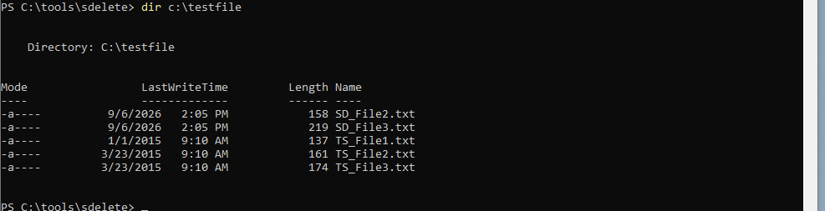
Figure H.1 – Intermediate directory listing after SD_File1.txt deletion, prior to the SD_File2.txt and SD_File3.txt runs

Appendix I – Project Plan / Gantt Chart
The original Gantt chart (as submitted at project proposal stage) and the actual Gantt chart (reflecting the real course of the project) are shown below.
Original (Planned) Gantt Chart
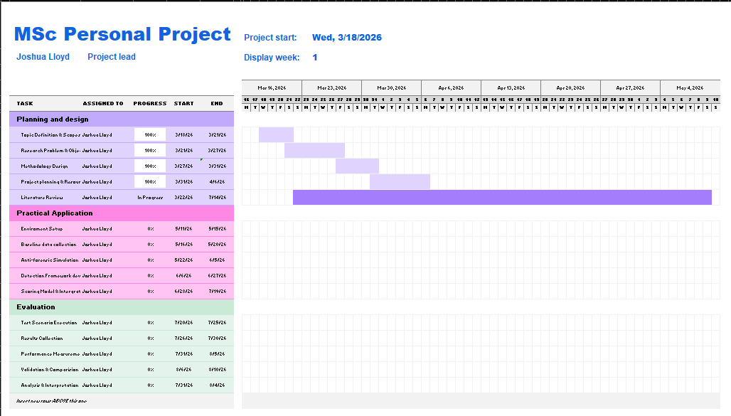
Figure J.1 – Original planned Gantt chart

Actual Gantt Chart
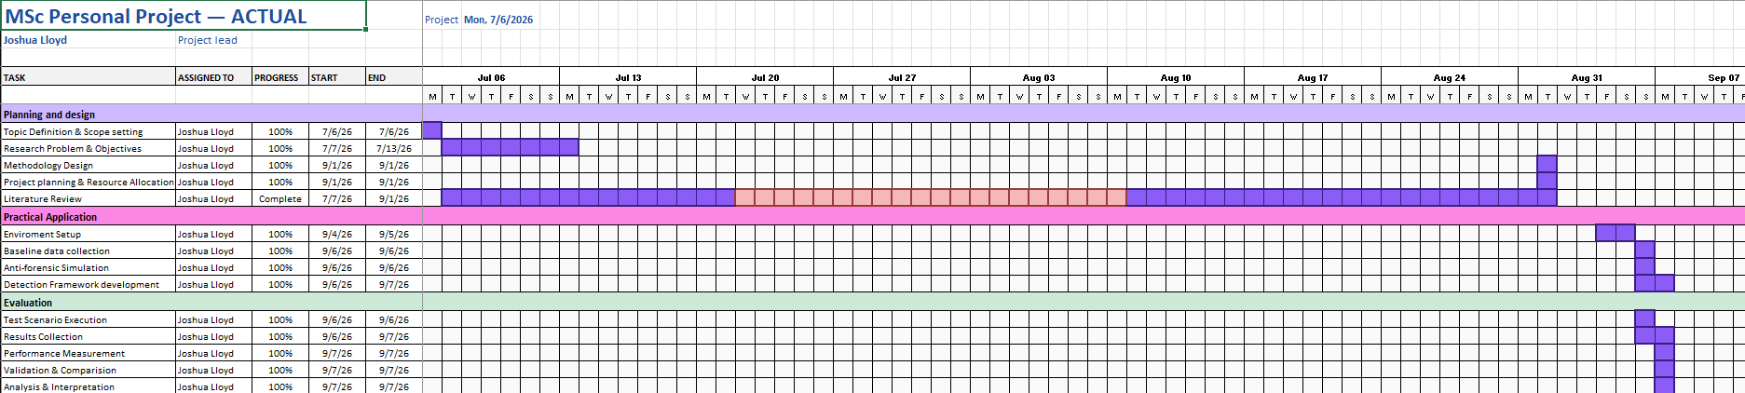
Figure J.2 – Actual Gantt chart, reflecting the real course of the project

