

BMMB7013

Strategic Management

Jayne Williams

Developing a new landscape for customer care——Taking Amazon's fresh market as an example

Hu Siyuan
2010087

Developing a new landscape for customer care
——Taking Amazon's fresh market as an example

1.Executive summary
More and more customer service is shifting from offline to online, and the company begins to regard online customer service as an opportunity to provide strategic and experience-oriented customer service. Under the uncertain background of the future, how to establish sustainable competitive advantage through personalized user care is a problem that every enterprise should consider.

Amazon's business strategy has achieved great success. This paper aims to discuss how Amazon's user care strategy will develop in the future. By using PESTEL model, five forces model model, VRIO model and Porter value chain, this paper makes an in-depth analysis of Amazon's external and internal environment, and makes a final summary with SWOT model. At the same time, it discusses its competitors, customer experience and dynamic organization ability. Finally, this paper looks forward to the new prospect of Amazon's user care strategy in the next 3-5 years.

2.Introduction
According to Meakey's(2020, p.3) research in 2020, many companies now claim to provide emotional support for "customer care" in order to cultivate their core competitive advantages, and these "customer care" are not equal to the previous "customer service", but a more empathetic and detailed business strategic deployment. In the fast-developing information age, companies reshape their relationship with users through information technology, which is a win-win choice in most cases (Gorry and Westbrook, 2011). In rare cases, the abuse of technology may erode user care, which is counterproductive (Mckinsey,2013). How to build the core competitiveness of enterprises from the level of "customer care" and how to make the core competitiveness of enterprises sustainable are all urgent problems to be studied.

David(2017) believes that there is no doubt that Amazon has become a giant in the field of e-commerce. At present, it involves e-books, food, games, advertising, baby products, retail, logistics, warehousing, medical care and other industries. New services such as mobile phones, artificial intelligence and cloud computing may be developed in the future. Today, in the world e-commerce field, Amazon has an unparalleled position in the world online sales market. It is Amazon's global strategic goal to become the most "people-oriented" company in the world, and strive to make buyers use the convenience of the Internet to search for the products they want and present them to consumers at the lowest price as much as possible. Amazon uses predatory pricing (ultra-low price) and personalized pricing to track the number of purchases-the more purchases, the lower the discount, and adjusts the price according to the price of competitors(Shelanski,2012). Amazon's founders and their teams are moving towards the future with the strategy of sustainable development. However, in the process of strategic transformation, challenges and opportunities will inevitably coexist (Jindal et al.2020). The main purpose of this paper is to predict Amazon's user care strategy in the next five years (2020-2025).

3 Strategic analysis
Steven MacDonald(2021, p.2) pointed out that in the next 10 years, more companies will shift their strategic focus to tapping customer value, that is, customer care, in order to enhance customer loyalty. Loyal leaders' income growth rate is about 2.5 times that of their peers in the same industry, and will achieve 2-5 times shareholder return in the next 10 years (Maekey, 2020). Amazon's globalization strategy urges it to do a lot of business in the international market. These include the following regions/countries: USA, Canada, UK, Spain, France, Italy, Germany, Brazil and China. Therefore, PESTEL, industry and other external environments will have an impact on Amazon's business.

3.1 Macro Analysis of External Environment

1. Politics
The political event of Britain's exit from the European Union will reduce the loyalty of Amazon's British users. In May 2020, Amazon officially launched the Pan-European Logistics Project, aiming at helping European sellers export their products or helping other sellers export their products to Europe. However, after Britain's exit from the EU, the labor loss in the British labor market is serious, especially in the period of 2016-2019 (Simionescu, 2020). As Amazon, which has just opened up the British market, its labor cost is bound to increase. As the most direct contact window with customers, the shortage of front-line customer service staff will cause the decline of user service quality and directly affect the user's service experience.

On the other hand, the exchange rate will also be affected. In the next 3-5 years, the impact of exchange rate on Amazon user loyalty may be negative. In 2020, the exchange rate of British pound went down (Nilavongse, 2020), which was another test for Amazon's pan-European logistics project. Products exported from Britain will be asked by buyers to lower prices or increase discounts. Customers' questioning or dissatisfaction with website prices will lead to the estrangement between users and companies, which will have a negative impact on user loyalty (Slack, 2020).

2. Society
In the next 3-5 years, the panic caused by the Covid-19 outbreak may still have a negative impact on Amazon's user loyalty. The emergence of Covid-19 epidemic has opened the distance between consumers and enterprises. Starting from April 2020, more and more people choose to cancel unnecessary outings, and they will stay at home, isolate viruses and increase the use of online social media (Chang, 2020). They chose Amazon's fresh one-hour delivery service. In this special period, the probability of customers complaining about unsafe operation of delivery personnel or failing to reach the promised speed is greatly increased. Amazon's customer service center has changed from traditional call center to digital network customer service. Although it is more convenient, compared with the surge of complaining users, the number of customer service is in short supply, and the time to respond to customer needs becomes longer, which will greatly reduce users' loyalty to Amazon.

(1)Under the influence of the epidemic, GDP shrank by 2.2% in the first quarter and 20.4% in the second quarter of 2020, which is the largest quarterly decline since 1955 (see Table 1 and Table 2).
(2)Global e-commerce development in 2019: the global online retail transactions totaled US$ 3,535 billion, which is expected to reach US$ 6,542 billion in 2023. In 2019, electronic retail accounted for 14.1% of the total global retail sales. By 2023, this figure is expected to reach 22%. (see picture. 1) (Feng, 2020).
(3)The operating cost is getting higher and higher. Due to the increase of transportation and labor costs, some couriers are facing increasing pressure on their own platforms.
Table 1 British GDP growth in the first half of 2020 (%).
 | Feb | Marc | April | May | June | February-June | April-June
GDP | 0.0 | -6.9 | -20.0 | 2.4 | 8.7 | -17.2 | -20.4
Services | 0.0 | -7.5 | -18.5 | 10.5 | 7.7 | -17.6 | -19.9
Industrial production | 0.4 | -4.3 | -20.4 | 6.2 | 9.3 | -11.6 | -16.9
Manufacturing | 0.9 | -5.2 | -24.6 | 8.3 | 11.0 | -14.2 | -20.2
Construction | -1.8 | -5.4 | -40.2 | 7.6 | 23.5 | -24.8 | -35.0
Agricultural | 0.0 | -0.9 | -5.7 | 1.0 | 2.7 | -3.1 | -4.8
Source: The Office for National Statistics 2020
Table 2 Britain has experienced the biggest GDP decline for five times on record.
 | Percentage of GDP decline (%) | Influencer factors
Q2 2020 | -20.4 | Coronavirus 19 pandemic
Q1 1974 | -2.7 | The coal miners went on strike
Q2 1958 | -2.4 | Economic crisis of 1958
Q1 2020 | -2.2 | Coronavirus 19 pandemic
Q4 2008 | -2.0 | The 2008 financial crisis
Source: The Office for National Statistics 2020
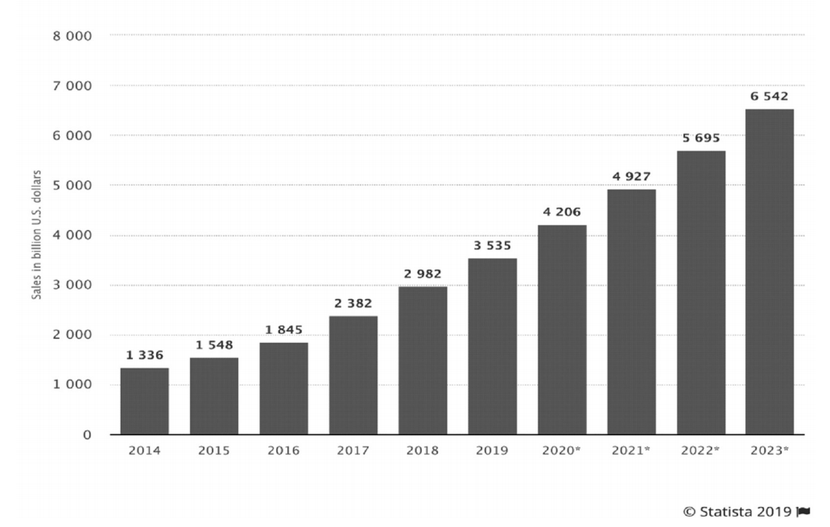
Figure 1 Total global online retail transactions

3. Technology
The emergence of 5G has changed people's attitude towards science and technology. In the next 3-5 years, 5G should sink from industry to civilian use, and ordinary people can enjoy the convenience brought by 5G (Tahir, 2020). For Amazon's distribution service, 5G can make online order positioning more accurate, delivery service faster and more personalized, bring comfortable shopping experience to users and improve user loyalty (Duan, 2020).

Rich and convenient payment methods, researchers' innovation in mobile technology, and the wide use of smart terminals have greatly improved users' shopping satisfaction (Boden, 2020). More and more people are willing to support e-commerce instead of wasting their time on shopping. As a top high-tech company, Amazon represents the highest level in the field of cloud computing, so the company's cost of storing, managing and using data is significantly reduced, which is an important reason for Amazon's cost leadership strategy to continue, and the biggest beneficiaries of low prices are consumers (Ouda, 2020).

4. Ecological
As early as 2018, Amazon launched the drone launch business, which is a comfort to environmentalists. Because the increase of UAV distribution business means the decrease of truck and automobile distribution business, the power system of UAV uses green energy such as electric energy as "booster", which is low-carbon and environmentally friendly. It will increase users' perception of Amazon's trust, thus enhancing users' loyalty. In addition, as a technology enthusiast, if he can receive products from Amazon drones at home, he will definitely increase the frequency of using Amazon e-commerce websites in the future, because he always expects to receive products from drones again (Kirschstein, 2020).

However, the data shows that Amazon used about 5 billion bags in all its businesses in 2017, which shows that the pollution generated by Amazon during transportation cannot be ignored. As the strongest competitor in the new retail industry, Wal-Mart put forward a plan to reduce waste in 2025 (McGee, 2020).

3.2 Micro-analysis of external environment

1.New entrants
With people's understanding of online shopping ability and obvious technological development, the market scale of online fresh shopping becomes larger and larger. Marketline(2019) published a survey data, about 27% of British people will choose to shop online. According to the online and offline segment market value 2020 data of CBS, the sales of online fresh market will exceed 14.4 billion pounds in 2021, and it will still keep a steady growth trend year by year. Changes in market size are often closely related to people's lives. It is estimated that the total population of Britain will increase by 3.0% in 2021 compared with 2016, and the growth rate of the elderly over 60 years old is 9.2%, which means that the population base of online shopping market will further expand(Worldmeter,2021). According to the global sales data released by Amazon in 2015, the UK is Amazon's third largest market after the United States and Germany, of which 6.31 billion pounds out of 84.2 billion pounds comes from the UK fresh market.
Therefore, judging from the scale of online fresh food market in the UK, the market scale of e-commerce retail is still expanding. For today's Amazon online fresh food business in the UK, the threat of potential entrants is very small.
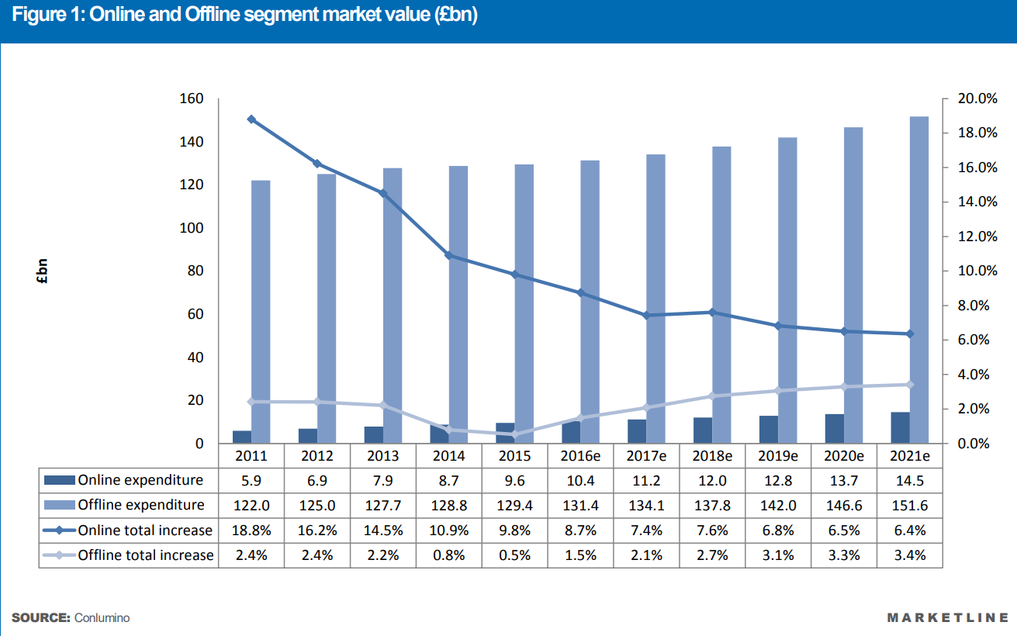

But at the same time, Amazon is widely regarded as the leader of e-commerce, which has many reasons. Amazon has always been committed to bringing merchants and sellers together to make them cooperate with each other, so as to achieve its goal of becoming one of the largest electronic retailers (Rigby,2011). It is this unique concept that provides consumers with an online shopping platform for shopping and service. At the same time, Amazon will use its meager profits for reinvestment in the next quarter to stimulate consumers' shopping enthusiasm. Lauren(2020) pointed out that this mode has gradually become a symbol of Amazon's freshness, which has virtually established barriers for new entrants and made itself one of the most popular online retail websites.

2.Buyers
Studies have shown that when a person chooses between the same products, they tend to choose lower products, and lower prices than competitors can make consumers choose Amazon products. Therefore, Amazon, which enters the UK market at a loss, will certainly get a lot of opportunities to serve customers. Amazon uses price robots and large databases to record competitors' prices, and obtains a sensitive "price perception", which is always slightly lower than competitors' prices for the same product (Mckinsey&Company,2019). It is this small profit concession that made Amazon get a lot of praise for its price advantage when it first entered the UK market (Berg and Knights,2019).

Before Amazon entered the British fresh market, it had a high reputation and a loyal customer base, which meant that Amazon had a first-Mover advantage in e-commerce (Rigby,2011). In addition, Amazon's excellent software system service brings smooth browsing experience of e-commerce platform to British customers, while Amazon's own logistics distribution service is free, which greatly improves consumers' satisfaction in new markets. It is precisely because Amazon has mastered most of the consumer preferences in the fresh e-commerce market that it can make bold changes, because the more consumer information it obtains, the more it has a say in the industry, especially for Amazon, a company that has always been "customer-centered". The more choices consumers have, the greater their bargaining power will naturally be. Amazon has to compete with competitors' prices and lower its own prices to retain consumers（Kucuk&Krishnamurthy,2007）.

3.Substitutes
For Amazon, the threat of alternatives is small. The replacement of Amazon online store is the traditional offline physical retail store. However, considering that Amazon has tried its best to create the best online shopping experience for users, physical stores cannot pose a threat to Amazon's online e-commerce business for the time being (Thuilas and Wiart,2020). With its unique technology and logistics strategy, Amazon has more team and experience in online sales than any grocery store. This will give it advantages in online marketing, technical realization of a convenient and fast e-commerce website and provision of good services.

4.Suppliers
As Amazon enters the British food industry, it is the company's responsibility to purchase food from hygienic, qualified and local suppliers to ensure that the products maintain good standards. Amazon can only use suppliers' products to represent its own products. There are more than 130,000 different products in its online supermarkets, and there are suppliers from all over the world behind these products. How to maintain the quality of suppliers and how to select excellent suppliers is extremely important for Amazon, because as the only medium to connect with customers, products represent Amazon's reputation. At the same time, Amazon's reputation and name will attract various brands and sellers. Local small businesses will seize this opportunity to recommend their fresh agricultural products to Amazon. Localization of agricultural suppliers means shortening the supply time, and it also means that the products delivered to customers are fresher, and it is easier to meet Amazon's promise of "one-hour supply" of fresh food.

Therefore, in the field of online fresh supermarkets, Amazon suppliers have strong bargaining power. Because the advantages and disadvantages of local suppliers are the decisive factors for Amazon to open up the UK e-commerce fresh food field. With the implementation of Amazon's global strategy, more and more suppliers have joined the plan. In addition, Amazon has higher requirements on suppliers, so suppliers have no bargaining power over Amazon (Lazzarini et al.2020).

5.Competitors
It can be known that the e-commerce market is growing faster than the offline market, which means that the physical retail market is close to saturation, while the immature e-commerce sector can continue to accommodate more enterprises in the next few years(Bones&Hammersley,2015). Moreover, Amazon's pricing strategy will certainly disrupt the market order in the short term. Amazon has many competitors. In the e-commerce retail industry, Wal-Mart, ebay, Alibaba and so on(Turban et.al,2015). In Britain, it is mainly the big four retailers-Tesco, ASDA, Sainsbury's and Morrison.Morrison, as one of Britain's four retail giants, will also be threatened by Amazon's participation.

3.3Internal analysis
Next is the internal analysis of Amazon. Since the external environment of Amazon has been analyzed in macro environment and industry analysis before, the next analysis will focus on the internal organization of Amazon.

1.Internal competitive advantage analysis-VRIO
As an e-commerce company focusing on online retailing at first, and then expanding to provide various Internet and cloud computing services, Amazon.com Company can use VRIO model to help Amazon explain that enterprises can grow and maintain their position in the industry. The VRIO model is used to guide the company's decision-makers to take appropriate strategic plans to compete with competitors, such as Google, IBM and Microsoft. Amazon uses its key capabilities, despite the fact that it needs to create new key capabilities and strengthen existing capabilities to minimize interference from multinational companies (Grisworld, 2016).

Amazon's more and more online business is one of its non-core skills, which is important to Amazon now and helps Amazon enhance its competitive advantage. However, this skill is imitative and exists in its competitors, such as Google and Microsoft. Secondly, Amazon's diversified Internet services are also one of Amazon's main businesses. Different from competitors such as Google and IBM, Amazon's Internet services are diversified and rich in categories, and more and more products with its own brands are launched to enhance Amazon's market share.

Secondly, Amazon's integrated distribution network is also one of its non-core skills. Amazon's supply chain competition means that Amazon allows multiple third-party suppliers to compete directly. Such resources improve the quality of Amazon's products and are the competitive advantage. But it is still reproducible because other companies can reach similar strategic agreements to promote the quality of their products.

Amazon's core competitiveness lies in its high market value and strong brand effect in the global market. Brand equity is difficult to imitate, and Amazon also gives full play to the advantage of this core competitiveness.

In this VRIO evaluation, high market value is regarded as a feasible source of competitive advantage. This core competence is very important, because it means that it is very convenient for Amazon.com companies to expand and diversify their financing and investment companies.

2.Porter Value Chain Analysis
Porter's general value chain analysis is a method to identify professional activities that can generate value and competitive advantage until the value proposition is effective in a specific market.See the table below for analysis summary（Table 3）

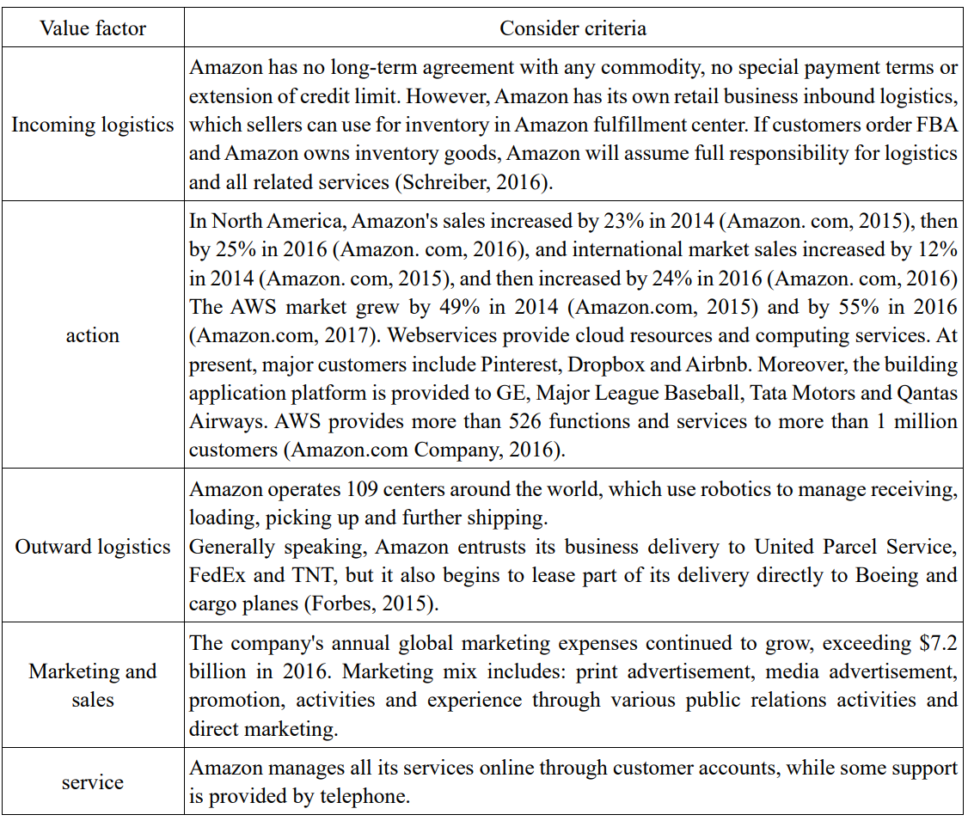
Table 3. Amazon Value Chain

3.4SWOT summary

1. Advantages
Customer-centered vision. The vision of Amazon founder is to build the most customer-centered company in the world. Secondly, he wants to create a place where customers can buy anything.

Product diversification. At present, Amazon has nearly 39% of the e-commerce market share in the United States, while Wal-Mart ranks second only with over 5%. This is an amazing leading advantage, especially Wal-Mart, which is the largest retailer in terms of revenue in the world. However, Amazon's first-Mover advantage helps it maintain its leading position in the competition, allowing the company to build a strong distribution and logistics network and accumulate a huge consumer base. Today, nearly 50% of Internet users in the United States start searching from Amazon when shopping online, and the number of members of Amazon Prime subscription service is even higher. As a result, during the epidemic, Amazon's market share was actually expanding, and its e-commerce revenue growth was also accelerating. Despite Amazon's success, e-commerce accounts for less than 15% of total retail sales in the United States and about 16% of total global retail sales. Although not everything can be easily sold online, this number shows that Amazon has plenty of opportunities in the next few years. The following table 4 shows the growth rate of Amazon's e-commerce sales revenue in recent four years.

Table 4 Amazon's 2016-2019 e-commerce sales revenue growth rate
Age | 2016 | 2017 | 2018 | 2019
E-commerce revenue growth | 23.1% | 22.6% | 18.2% | 17.7%
Source: Amazon.com

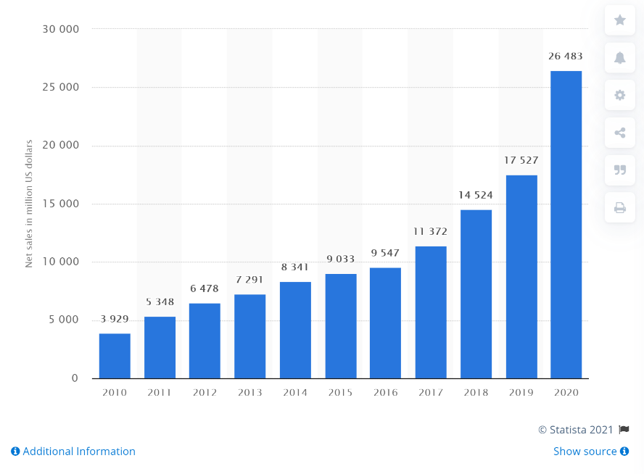
Advanced technology. Amazon has been deeply cultivating overseas for many years before entering the UK, and has rich market experience. Amazon was founded in 1994, and its business model has achieved great success overseas before entering the UK (Roy,2020). In the UK market, where the development of e-commerce was still in its infancy at that time, Amazon, which had a mature e-commerce business model, had already won at the starting line. UK from 2010 to 2020 is shown in Figure 2.
Figure 2 Amazon's sales revenue in the UK from 2010 to 2020

Amazon has the ability to transform internal functional business into external profitable business. For example, the cloud computing service, the predecessor of which is Amazon's self-built technology platform for website development, was originally used as a tool to support the development of Amazon's e-commerce business, and Amazon restructured it into a saleable external network service. In the process of commercialization, Amazon can precipitate a batch of indicators and data, and judging by business indicators, Amazon can quickly find out whether the tools it developed and used have lagged behind its competitors significantly. Amazon has developed a mature cross-border e-commerce supply chain.

Personal privacy policy. The moral hazard faced by Internet information age every day is the privacy of customer data, which not only relates to what kind of information Internet enterprises should collect, but also relates to how Internet enterprises preserve and protect this information. Recently, some Internet companies have been exposed to sell customer information lists to other suppliers, which has aroused the anger of many customers. Amazon has already issued clear regulations and declared that all customer information is only used to estimate and help customers make shopping options, and will not be used for profit.

2. Disadvantages
Honesty. Although it has been mentioned above that Amazon has made a guarantee against customer groups that it will not disclose customer information, it is not 100%. According to the European Union's privacy directive, information can only be transferred to an area with sufficient privacy protection if the individual expresses his consent, and the premise of these actions is that this customer information transfer activity is legal. According to an empirical study, the most important reason for an enterprise to retain customers is the safety of customers and enterprises in the transaction process.

Competitors. According to Forbes, e-commerce giant Amazon has surpassed Wal-Mart to become the largest retailer in the world. According to the comprehensive scores of revenue, profit, assets and market value of listed companies, Forbes got the Forbes Global 2000 list in 2019. On this list, Amazon jumped 25 places to 28th place, while Wal-Mart fell 5 places to 29th place, which is enough for Amazon to take away the title of the world's largest retailer from Wal-Mart. However, according to a recent report by researchers from Moody's Investors Service, Amazon still lags behind Wal-Mart in some areas. According to the report, since Amazon acquired Whole Foods Supermarket and provided distribution services through Amazon fresh, it generated as much as $20 billion in grocery revenue in 2018. However, Wal-Mart, which also owns Sam member store, has generated 270 billion dollars in revenue, and Sam member store is the largest chain grocery store in the world. Moody's also pointed out that retail sales still favor physical stores, and 85% of transactions are still conducted in physical stores. Wal-Mart has more than 11,360 retail departments around the world, which is another victory for Wal-Mart.

Suppliers. Amazon has gradually developed its own supplier network. With the expansion of internationalization, the same product may come from different suppliers, and the product quality cannot be unified. Therefore, sometimes the delivery time and quality of products can't be guaranteed, which has a great negative impact on Amazon's customer relationship management. Karst-Brown and Evaristo (2001) pointed out that for enterprises, the relationship with suppliers and customers and goodwill should be taken seriously and should be regarded as important resources of enterprises.

3. Opportunities
Trend of technological innovation. Amazon applied for a Click-to-Order Patent (SCA) as early as 20 years ago, because this is Amazon's patent, so competitors can't copy it. This patent helps Amazon automatically recommend other similar products to customers according to the products purchased by customers before, which is very intimate and valuable to customers.

Development trend of electronic commerce. As an e-commerce company that originated in the United States and succeeded in many markets around the world, Amazon has established a mature overseas supplier relationship and an efficient logistics system. On the one hand, Amazon has increased its investment in building logistics centers in the early stage, and on the other hand, it has hired logistics management experts as company executives, who are responsible for supply chain construction. Attaching importance to the hard power and soft technology of logistics makes Amazon's logistics distribution speed increase and logistics cost decrease, making it invincible in the price competition of cross-border e-commerce. Amazon's network service module, cloud computing service, provides convenience for small and medium-sized developers through economies of scale and hardware foundation. Users can use the full-featured platform at a cost far lower than the cost of building traditional infrastructure. After users grow and develop on the platform, the conversion cost increases, and the dependence on the cloud service platform increases, which brings sustained profits to Amazon. Amazon not only provides users with network services, but also provides corresponding training courses, so that users can learn how to use Amazon's cloud service platform through online and offline training courses.

4. Threats
Complexity of cost. Although part of Amazon's cost is technical cost, a large part depends on Amazon's storage cost of its inventory goods. With the diversification of commodities, rent, labor cost and storage cost will all increase, which will lead to an increase in cost, which also means a decline in profits. If these problems cannot be solved in time, Amazon will eventually fall into a loss state.
New challenges brought by new products.

New challenges brought by new products. Amazon was originally a platform for buying and selling books. At present, he has diversified his products and started to enter the field of fresh products, but these items are difficult to preserve, transport and return, which poses new challenges to Amazon's logistics supply management; Secondly, non-information products such as music and video cannot be returned or exchanged, which is also the reason for the estrangement between Amazon and customers.

Combining the previous internal and external analysis results, the swot analysis diagram of Amazon is obtained, as shown in Figure 3 below.
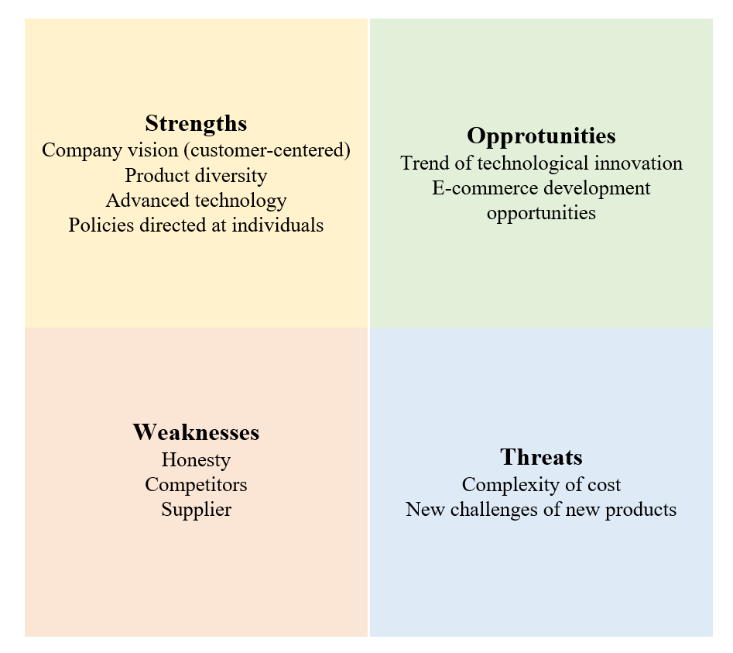
Figure 3 Amazon SWOT Summary

4 Strategic Choice

4.1Strategic Position
Based on the above analysis, we can know that Amazon has been able to maintain sustainable competitive advantage based on two operational strategies. These are low-cost leaders and customer differentiation.

Amazon's pursuit of low-cost leadership is mainly based on price. We believe that providing customers with low prices is the foundation of our future success. We seek to partially alleviate the cost of lowering prices over time by achieving higher sales volume, negotiating better terms with suppliers and improving operational efficiency. Amazon ensures that it offers products of the same quality as other companies at a much cheaper price. Compared with physical retailers, Amazon should put the cost leadership strategy at the core. Amazon has huge storage facilities and processing capacity in the world, which makes it have economies of scale. This in turn gives it a cost advantage. But in terms of service, it is different-so it is a hybrid. Amazon is very keen on customer feedback, and Bezos has spread customer attention as a mantra throughout the organization. At the same time, according to the previous price comparison between Amazon and its competitors, we can find that Amazon is sensitive to commodity prices.

Amazon offers differentiation to current and potential customers through design, quality or convenience by choosing different strategies from competitors. Because of the revolutionary potential of Internet in communication and communication, the new business developed around e-commerce makes new strategies and decisions feasible. Therefore, we chose the delta model strategic locking, which was developed by Dean Vader of Si Long School of Management, Massachusetts Institute of Technology, and his colleagues to help enterprise managers clarify and implement effective business strategies. Its essence is to define the whole industry through differentiation. Just like all Apple products have separate systems, IOS. In other words, enterprises often achieve the purpose of retaining customers by controlling supporting facilities in their own products.

4.2 Strategic direction
Reduce the business that will be saturated. Amazon's physical book business is nearly saturated. Amazon has made huge profits in the 2-3 years after launching kindle e-reader, and Kindle has become a new window for users to contact Amazon. It has even become a mobile device for Amazon's self-promotion, and it has virtually squeezed Amazon's initial physical book business. According to Statista's survey data, e-books are a profitable market in Britain, and their per capita e-book income is obviously higher than many similar markets. In 2017, the sales volume of e-books in Britain was 11.15 euros per person, 5.74 euros in Canada and 5.11 euros in Germany. Statista predicts that the user base of e-books will increase significantly, from 950.5 million in 2019 to 1.11 billion in 2023, which is undoubtedly a good trend for Amazon (Hussain, 2017).

At the same time, the scale of the e-commerce market continues to grow (Soni, 2020). According to the previous data analysis, the online fresh food market has maintained a steady growth momentum, while the offline physical store market is close to saturation. Therefore, in order to save costs, Amazon should reduce the physical book service and put more resources into the e-book business in 2021. At the same time, physical stores have become less and less creative, and the operation of physical stores has been cancelled, and employees have been retrained to serve customers, which not only improves the quality of user services, but also reduces the possibility of mismatch between labor costs and profits (Punj, 2020).

Vigorously develop decisive information technology in the future. E-commerce industry is based on the Internet, relying on information technology such as logistics system, supply chain establishment and database maintenance. Without them, it will lose its competitiveness. In the future, Amazon should take technology research and development as its core business, master the right to speak technology, and be the "definer" of future information technology. For example, the trend of electronic information is big data and cloud computing, which is also reflected on Amazon's official website, where when consumers open Amazon pages on their mobile devices, the homepage always pushes themselves to what they want to buy recently or what they are browsing recently. Behind this "care" is the cloud storage of big data, which records every customer's shopping preferences and pushes the results, namely. Send products you think you should like to your mobile device through calculation processing. This service optimizes consumers' choice by using electronic computing technology, which saves customers' time and improves customer satisfaction to a certain extent.

5.Strategies Recommendation
Further develop Amazon's own brand and market the base they built to loyal customers. Strategic investment in selling private brand products further enhances Amazon's valuation at low cost on Amazon platform. Amazon has entered many companies that they can acquire, and labeled itself personally through their accelerator projects. Amazon.com can list more private brands on its website, list other products, and they will see more revenue.

For strategic proposal 1, the impact on the company will be to build a loyal customer base for the industry and make the products unique. Products must have something that other competitors don't. It is easy for Amazon to create such attractive products by selling products at low prices or adding other functions to ordinary products. Amazon has a large group of loyal customers. Instead of focusing on building a loyal team, they should continue to grow and expand, so that customers can enjoy the products so much that they tell others in their daily life. They can also include the idea of cooperating with products already produced, which need a little promotion of sales and marketing. This may be beneficial to both sides. Risk factors of strategy 1 may include the lack of resources and the price of resources. The resources of new products began to decrease. Unless you propose 23 alternative routes to produce products, Amazon may eventually buy the smallest source that is expensive because of its value. This may affect the financial aspects of the business and may lose Amazon's current outstanding performance. The second risk is organizational culture. We suggest choosing different product sources or outsourcing to other companies in different countries. Amazon's decision to cooperate or create products may affect some employees' views on the company and its future. This may lead to disputes and lack of unnecessary work. The best way to solve this problem is for Amazon to contact their employees and ask for their opinions before making products. Instead of voting in person, vote for each part of the company to show the percentage of approval and disapproval of products and Amazon culture by each group. The environment may also be affected. New products bring new factories for storage and production. Is the product poisonous? Does the product need a large enough land to influence nature and people around it? The Environmental Protection Agency and the Occupational Safety and Health Administration do free tests for the company, which is likely to take up a job opportunity. Amazon ensures the safety of the company and the community in the world

By applying the current business knowledge to the following aspects, we can further expand the grocery market and develop efficient grocery delivery business for more Amazon customers. At present, Amazon.com and Amazon.com are two grocery-based services provided by Amazon. There will be more entities. Cost: The hardware cost of each Amazon Go store is about $1 million. At present, there are 21 Amazon convenience stores there that offer "free checkout" shopping. Amazon has the opportunity to extend this model to most large and medium-sized cities in 2010 and finally go global. Amazon can use their acquisition of Whole Foods Company to expand the company and contact more customers to deliver groceries through these stores.
Understand what customers really want.
As time goes by, people will pay more and more attention to personalized experience. However, according to the current situation of eavesdropping on smart phones, privacy issues will follow. However, people are gradually increasing the importance of personality. Therefore, improving users' personalized experience will be the core of user relationship management strategy.

Google acquired NEST Labs for US$ 3.2 billion to understand customers' preferences for smart home, so as to enhance the user experience of follow-up services. For Amazon, users' preferences or short-term needs can be collected from its search engine, and products that may be needed can be pushed on everyone's homepage. This will not only minimize the time for users to browse unnecessary products, but also give users the illusion that Amazon can read minds.

But in the short term, snooping on user search engines will enhance user experience and loyalty to a certain extent. However, if we adopt such a potential data integration strategy for a long time, we may eventually receive complaints from users.

Omni-directional procurement
Achieve overall consistency and transparency across channels, and give priority to providing customers with the most important seamless experience. Customize customer relationship management for each customer, and understand customer preferences in the whole process. Omni-channel experience is that the company hopes to provide a seamless channel to satisfy customers' preferences and actively guide them to choose the most effective solution. However, at present, users expect more and more consistent information, so it is necessary to communicate information transparently through all channels.

However, it is impossible to have a perfect omni-channel experience, and most companies will focus on the most important two or three channels, which needs to be adjusted to a "customer-centered" strategic mentality. This method can also make employees solve their own needs more effectively before customers ask questions, and create a kind of "pleasure" to meet emotional needs.

Continuous development of digital surgical tools
Advanced technology will be used for targeted deployment and allocation of human resources to match the super-personalized user nursing management strategy. A first-class organization considers and understands how to improve the user experience, and then distinguishes itself by technologies that can provide specific functions. Amazon adheres to the strategy of "continuously investing in the development of operational tools" and continuously invests in R&D expenses in four aspects: global registration, global product selection, global promotion and global distribution. In the next 3-5 years, these four aspects will still have a significant impact on user satisfaction and loyalty, and Amazon should increase investment to realize the development of comprehensive digital operation tools.
Pay more attention to customer center
As consumers increasingly choose to shop in comfortable homes instead of physical stores, the demand for Amazon distribution centers and customer service centers is surging.

According to McKinsey's data, the average annual turnover of 60% comes from the contract center, and even the first-class enterprises have 20% turnover from the contract center. Therefore, by consciously establishing talent delivery channels for contract centers, this employee training model can effectively relieve customer service pressure and improve customer satisfaction.

References List
- Ayaz, M., Ammad-Uddin, M., & Baig, I. (2017). Wireless sensor’s civil applications, prototypes, and future integration possibilities: A review.IEEE Sensors Journal,18(1), pp.4-30.

- Baiman, S., & Rajan, M. V. (2002). The role of information and opportunism in the choice of buyer‐supplier relationships.Journal of Accounting Research, 40(2),pp.247-278.

- Bankinfo security(2017).Verizon Breach: 6 Million Customer Accounts Exposed.Availiable at:https://www.bankinfosecurity.com/verizon-breach-6-million-customer-accounts-exposed-a-10107(Accessed: 4 March 2021)

- Barney, J. B. (1995). Looking inside for competitive advantage. Academy of Management Perspectives,9(4), pp.49-61.

- Boden, J., Maier, E., and Wilken, R. (2020). The effect of credit card versus mobile payment on convenience and consumers’ willingness to pay. Journal of Retailing and Consumer Services,52, pp.101-110.

- Bones, C., & Hammersley, J. (2015). Leading Digital Strategy: Driving business growth through effective e-commerce. Kogan Page Publishers.

- Daniela Coppola(2021).Amazon Prime - Statistics & Facts.Availiable at: https://www.statista.com/topics/4076/amazon-prime/ (Accessed:4 March 2021)

- David Kirkpatrick(2017) Has Amazon outgrown its 'e-commerce giant' label? Availiabe at: https://www.retaildive.com/news/has-amazon-outgrown-its-e-commerce-giant-label-1/436175/(Accessed: 1 December 2020)

- Duan, W., Gu, J., Wen, M., Zhang, G., Ji, Y., and Mumtaz, S. (2020). Emerging technologies for 5G-IoV networks: Applications, trends and opportunities.IEEE Network,34(5), pp.283-289.

- Drouin, M., McDaniel, B. T., Pater, J., & Toscos, T. (2020). How parents and their children used social media and technology at the beginning of the COVID-19 pandemic and associations with anxiety.Cyberpsychology, Behavior, and Social Networking, 23(11), pp.727-736.

- Feng Y. (2020). Amazon's growth strategy in the next five years. International public relations, No.102(06), pp.195-198.

- Gorry, G. A., and Westbrook, R. A. (2011). Once more, with feeling: Empathy and technology in customer care. Business Horizons, 54(2), pp.125-134.

- Hussain, A., Mkpojiogu, E. O., Musa, J. A., and Mortada, S. (2017, October). A user experience evaluation of amazon kindle mobile application. In AIP conference proceedings ,1891(1), pp. 20-32.

- Jindal, R. P., Gauri, D. K., Li, W., & Ma, Y. (2020). Omnichannel battle between Amazon and Walmart: Is the focus on delivery the best strategy?.Journal of business research, 122, pp.270-280.

- Kaarst-Brown, M. L. & Evaristo, J. R. (2001). Physical retailing takes on internet retailing: A preliminary model of book retailer Web strategies based on perceived threats and opportunities. In Proceedings of the 34th Hawaii International Conference on System Science. pp. 1-9.

- Kirschstein, T. (2020). Comparison of energy demands of drone-based and ground-based parcel delivery services. Transportation Research Part D: Transport and Environment,78, pp.102-120.

- Kucuk, S. U., & Krishnamurthy, S. (2007). An analysis of consumer power on the Internet. Technovation,27(1-2), 47-56.

- Lauren Debter(2019). Amazon Surpasses Walmart As The World's Largest Retailer.Availiable at: https://www.forbes.com/sites/laurendebter/2019/05/15/worlds-largest-retailers-2019-amazon-walmart-alibaba/?sh=393a3c834171(Accessed: 4 March 2021)

- Markey, R. (2020). Are You Undervaluing Your Customers?. Harvard Business Review,98(1), pp.42-50.

- McKinsey Global Institute (2013) Disruptive technologies: Advances that will transform life, business, and the global economy.Avaliable at: https://www.mckinsey.com/~/media/McKinsey/Business%20Functions/McKinsey%20Digital/Our%20Insights/Disruptive%20technologies/MGI_Disruptive_technologies_Executive_summary_May2013.pdf(Accessed: 1 December 2020)

- Orel, F. D., & Kara, A. (2014). Supermarket self-checkout service quality, customer satisfaction, and loyalty: Empirical evidence from an emerging market. Journal of Retailing and Consumer services,21(2), pp.118-129.

- Ouda, G. K.(2020).Cloud computing service providers: A comparative study. Samarra Journal of Pure and Applied Science,2(1), pp.76-89.

- Ratnasingham, P. (2006). A SWOT analysis for B2C e-commerce: the case of Amazon. com.International Journal of Cases on Electronic Commerce (IJCEC), 2(1), pp.1-22.

- Roy, D. (2020). ‘Formulation of BCG Index (BCGI): An empirical study on Wal-Mart and Amazon (1999–2018)’. Journal of Transnational Management,25(1), pp.30-56.

- Shelanski, H. A. (2012). Information, innovation, and competition policy for the Internet. U. Pa. L. Rev.,161, 1663.

- Simionescu, M., Streimikiene, D., and Strielkowski, W. (2020). What Does Google Trends Tell Us about the Impact of Brexit on the Unemployment Rate in the UK?. Sustainability,12(3), pp.101-110.

- Soni,V. D. (2020). Emerging Roles of Artificial Intelligence in ecommerce. International Journal of trend in scientific research and development,4(5), pp.223-225.

- Statista(2019). Share of respondents who own a eReader/Kindle computing device in the United Kingdom (UK) in 2019, by generation.Availiable at:

- Thuillas, O., and Wiart, L. (2020). Amazon, what else?-Inventory of alternative online bookstore platforms.Études digitales, 2019(8), pp.105-120

- Todd Bishop (2021). Amazon Web Services posts record $13.5B in *profits* for 2020 in Andy Jassy’s AWS swan song.Availiable at: https://www.geekwire.com/2021/amazon-web-services-posts-record-13-5b-profits-2020-andy-jassys-aws-swan-song/(Accessed: 4 March 2021)

- Treanor, T. (2010). Amazon: Love them? Hate them? Let’s follow the money. Publishing research quarterly,26(2), pp.119-128.

- Turban, E., King, D., Lee, J. K., Liang, T. P., & Turban, D. C. (2015). Retailing in electronic commerce: Products and services. In Electronic Commerce(pp. 103-159). Springer, Cham.

- Worldometer(2021),U.K. Population 2021.Availiabe at: https://www.worldometers.info/world-population/uk-population/( Accessed: 1 March 2021)

- Wu, K., Wheatley, S., & Sornette, D. (2021). Inefficiency and predictability in the Brexit Pound market: a natural experiment. The European Journal of Finance,27(3), pp.239-259.

